TASK 1 – COMMANDS

rose31@Rose-Laptop31:~$ pwd
/home/rose31
rose31@Rose-Laptop31:~$ mkdir my_folder
rose31@Rose-Laptop31:~$ cd my_folder
rose31@Rose-Laptop31:~/my_folder$ touch my_file.txt
rose31@Rose-Laptop31:~/my_folder$ nano my_file.txt
rose31@Rose-Laptop31:~/my_folder$ cat my_file.txt
Hello All,

Content in "my-file.txt"

Basic commands: pwd, cd, cd.., rm, rm -r, mkdir, touch, cat, nano\vim\vi, mv, cp

rose31@Rose-Laptop31:~/my_folder$ ls
my_file.txt
rose31@Rose-Laptop31:~/my_folder$ ls -l
total 4
-rw-r--r-- 1 rose31 rose31 121 Dec 22 09:03 my_file.txt
rose31@Rose-Laptop31:~/my_folder$ touch another_file.txt
rose31@Rose-Laptop31:~/my_folder$ cat another_file.txt
rose31@Rose-Laptop31:~/my_folder$ nano another_file.txt
rose31@Rose-Laptop31:~/my_folder$ cat another_file.txt
Hello All,

Content in "another_file.txt" is:

Advanced commands:

1. For Filtering: grep, sort, uniq, wc, head, tail, tr, sed, awk

2. For Redirection: >, >>, <
rose31@Rose-Laptop31:~/my_folder$ ls -l
total 8
-rw-r--r-- 1 rose31 rose31 163 Dec 22 09:06 another_file.txt
-rw-r--r-- 1 rose31 rose31 121 Dec 22 09:03 my_file.txt
rose31@Rose-Laptop31:~/my_folder$ cat another_file.txt >> my_file.txt
rose31@Rose-Laptop31:~/my_folder$ cat my_file.txt
Hello All,

Content in "my-file.txt"

Basic commands: pwd, cd, cd.., rm, rm -r, mkdir, touch, cat, nano\vim\vi, mv, cp

Hello All,

Content in "another_file.txt" is:

Advanced commands:

1. For Filtering: grep, sort, uniq, wc, head, tail, tr, sed, awk

2. For Redirection: >, >>, <
rose31@Rose-Laptop31:~/my_folder$

OUTPUT

"my_file.txt" has been created, and its contents are displayed below.

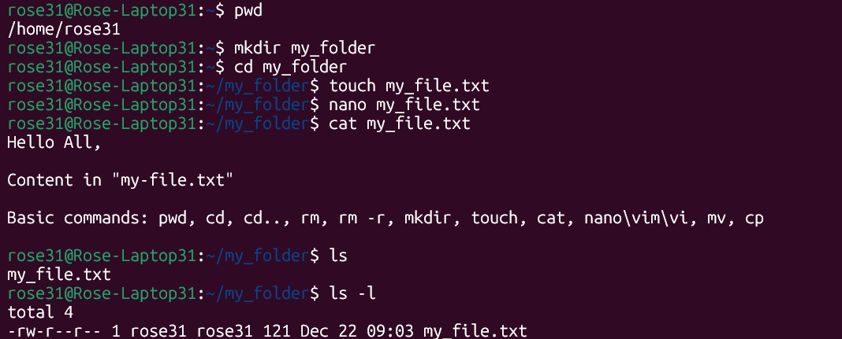

"another_file.txt" has been created, and its contents are displayed below.

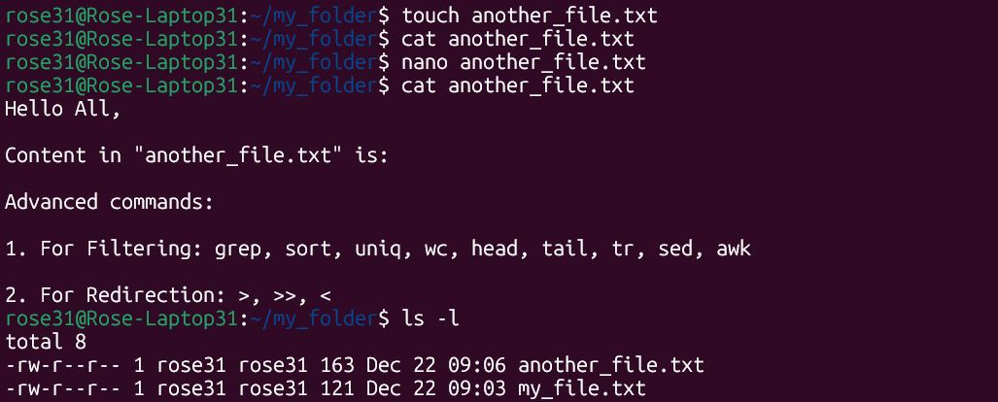

Added content inside "another_file.txt" to "my_file.txt", showed the new content, and listed everything in the folder.

