TASK2: COMMANDS

rose31@Rose-Laptop31:~$ pwd
/home/rose31
rose31@Rose-Laptop31:~$ mkdir task2
rose31@Rose-Laptop31:~$ ls
task2
rose31@Rose-Laptop31:~$ cd task2
rose31@Rose-Laptop31:~/task2$ touch file01.txt
rose31@Rose-Laptop31:~/task2$ touch file02.txt
rose31@Rose-Laptop31:~/task2$ touch file03.txt
rose31@Rose-Laptop31:~/task2$ touch file04.txt
rose31@Rose-Laptop31:~/task2$ touch file05.txt
rose31@Rose-Laptop31:~/task2$ for i in {06..20};
> do touch file$i.txt
> done
rose31@Rose-Laptop31:~/task2$ ls
file01.txt file03.txt file05.txt file07.txt file09.txt file11.txt file13.txt file15.txt file17.txt file19.txt
file02.txt file04.txt file06.txt file08.txt file10.txt file12.txt file14.txt file16.txt file18.txt file20.txt
rose31@Rose-Laptop31:~/task2$ mv file01.txt file01.yml
rose31@Rose-Laptop31:~/task2$ for i in {02..05};
> do mv file$i.txt file$i.yml
> done
rose31@Rose-Laptop31:~/task2$ ls
file01.yml file03.yml file05.yml file07.txt file09.txt file11.txt file13.txt file15.txt file17.txt file19.txt
file02.yml file04.yml file06.txt file08.txt file10.txt file12.txt file14.txt file16.txt file18.txt file20.txt
rose31@Rose-Laptop31:~/task2$ ls | head -5
file01.yml
file02.yml
file03.yml
file04.yml
file05.yml
rose31@Rose-Laptop31:~/task2$ ls | tail -5
file16.txt
file17.txt
file18.txt
file19.txt
file20.txt
rose31@Rose-Laptop31:~/task2$

OUTPUT

A total of 20 files were created inside a directory named 'task2'. The first 5 files were manually created one by one using individual commands, while the remaining 15 files were created all at once. And renamed first 5 files to .yml extension:

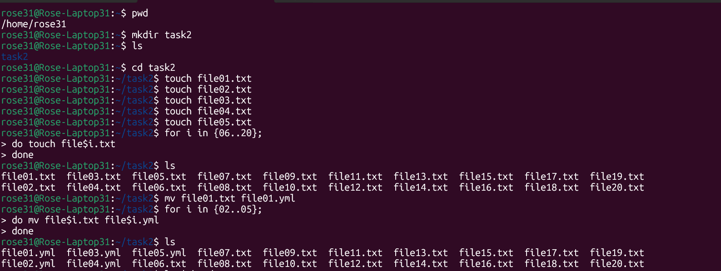

Printed the latest created top 5 files among the total no of files:

