Step1: VPC Details: (test-my-vpc)
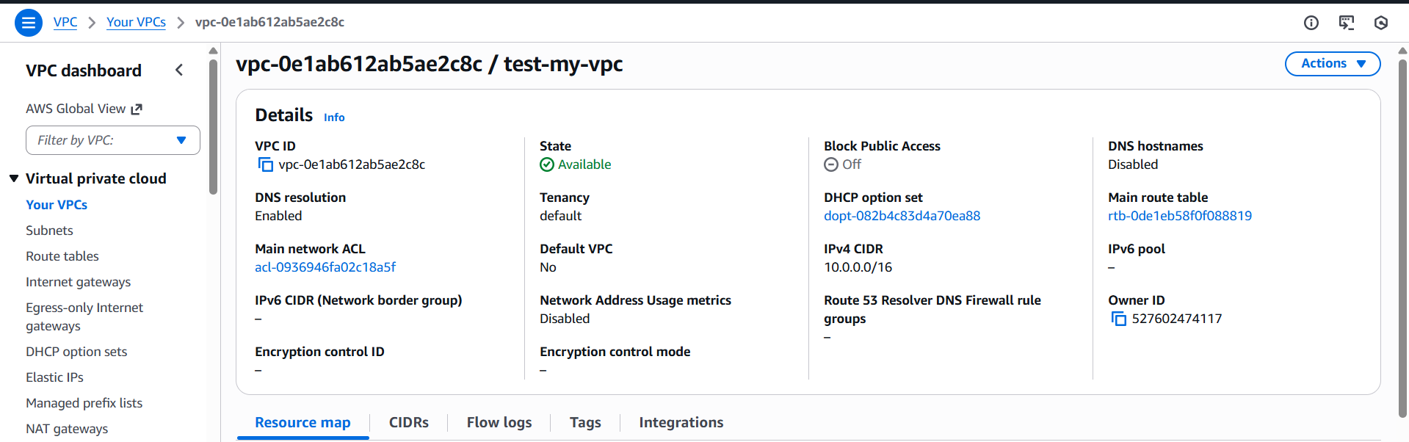

Step 2: Subnets
Public Subnet with CIDR 10.0.1.0/24 (test-public-subnet-1)

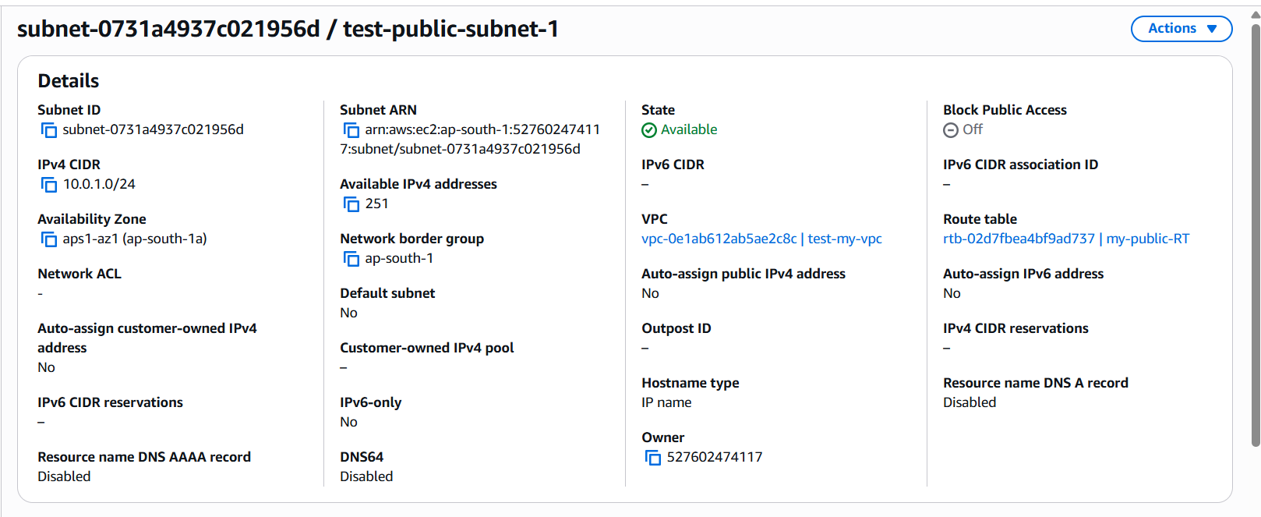

Private Subnet with CIDR 10.0.2.0/24 (test-private -subnet-1)
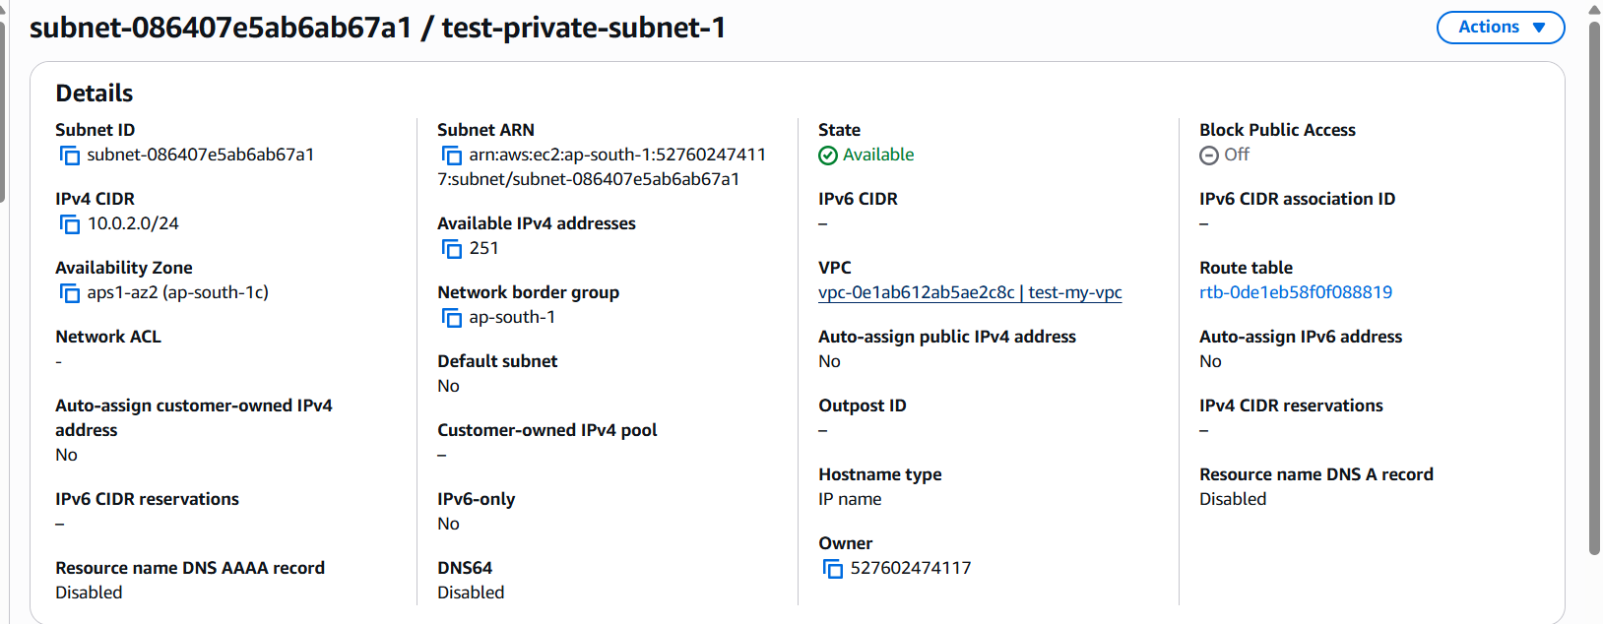

Step 3: Internet Gateway (Attached)
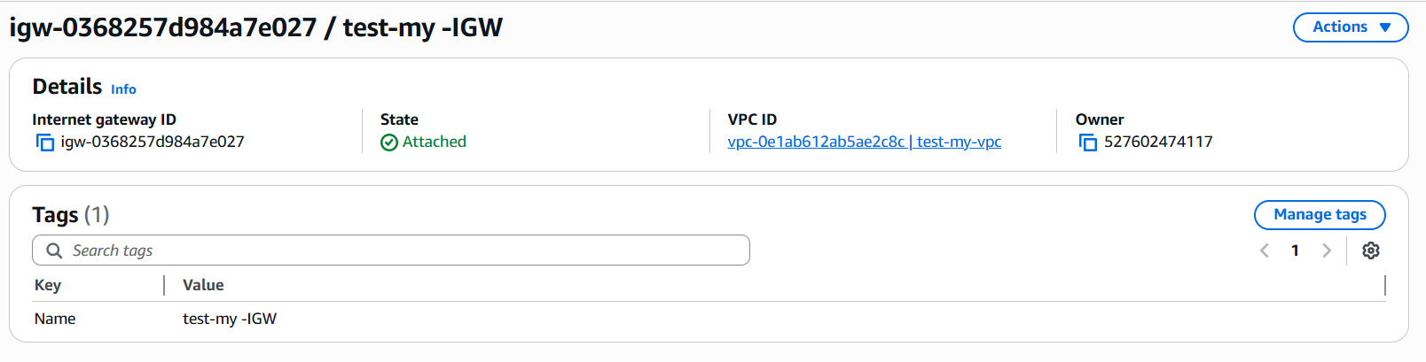
Step 4: Route Table
Screenshot of the Route Table associated with the public subnet:
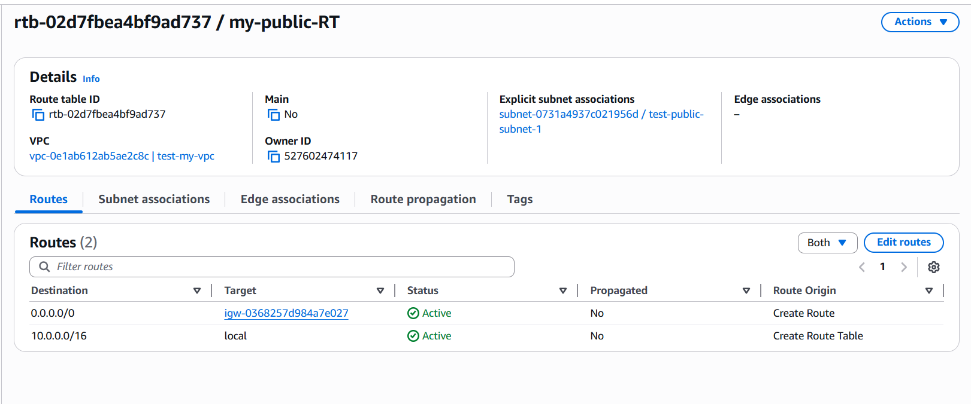

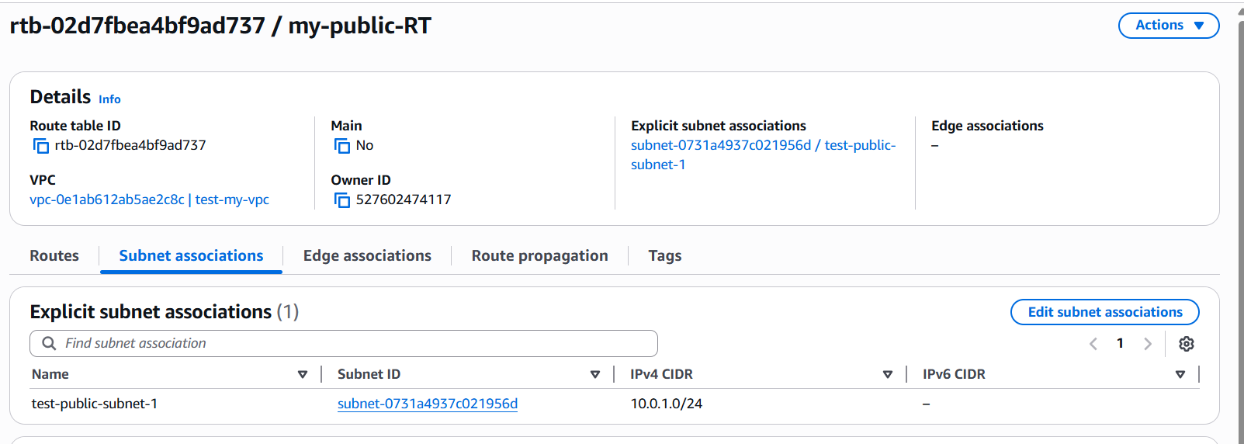

Step 5: EC2 Instance
Screenshot of the EC2 Instances list showing:
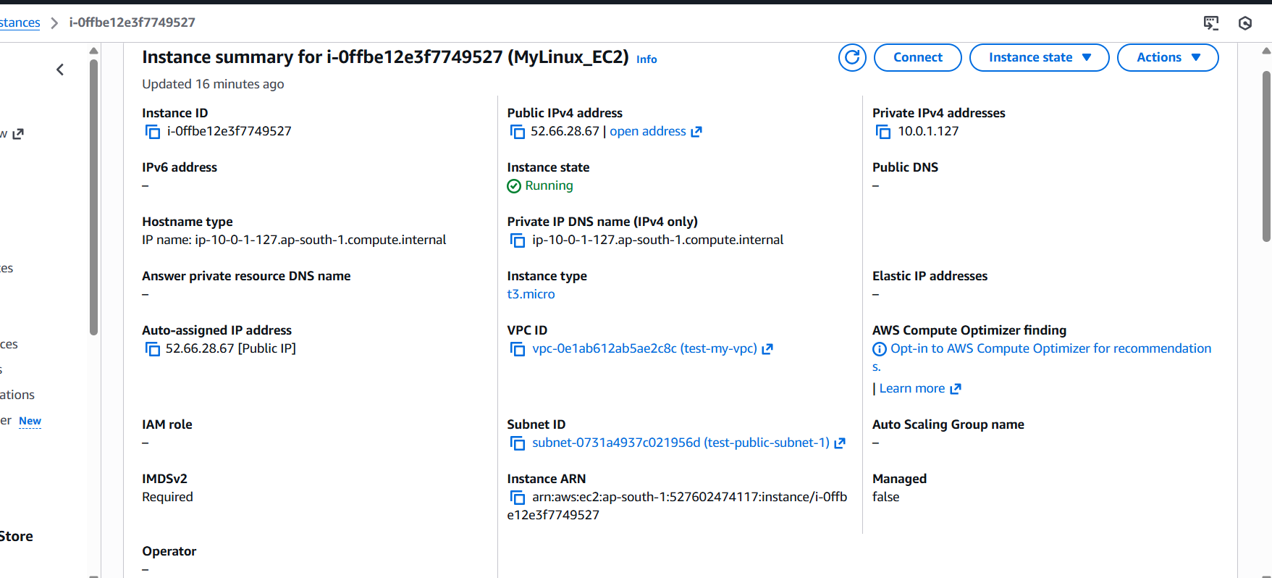

OUTPUT: Connectivity Test
