Directory with scripts (ls):
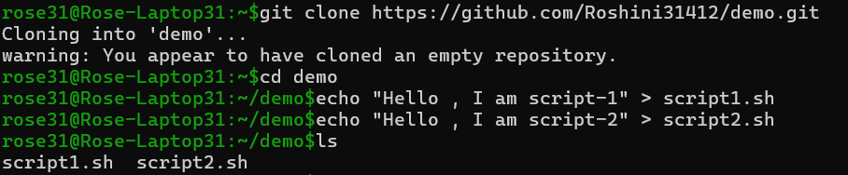

Repo init :
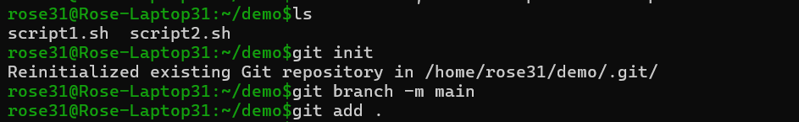

First commit (git log --oneline).
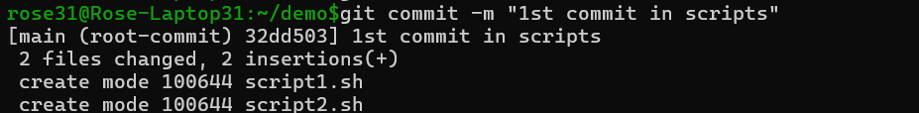
Remote linking (git remote -v).

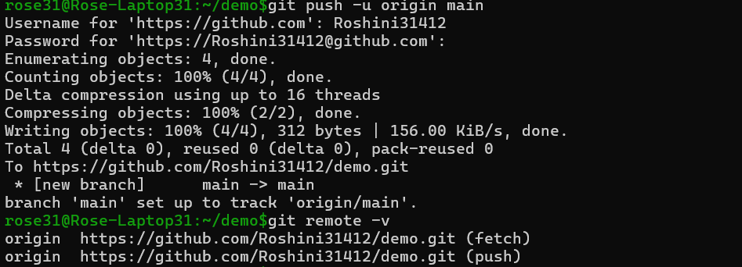

GitHub repo page after push (Took screenshot of final output so please ignore feature.sh)

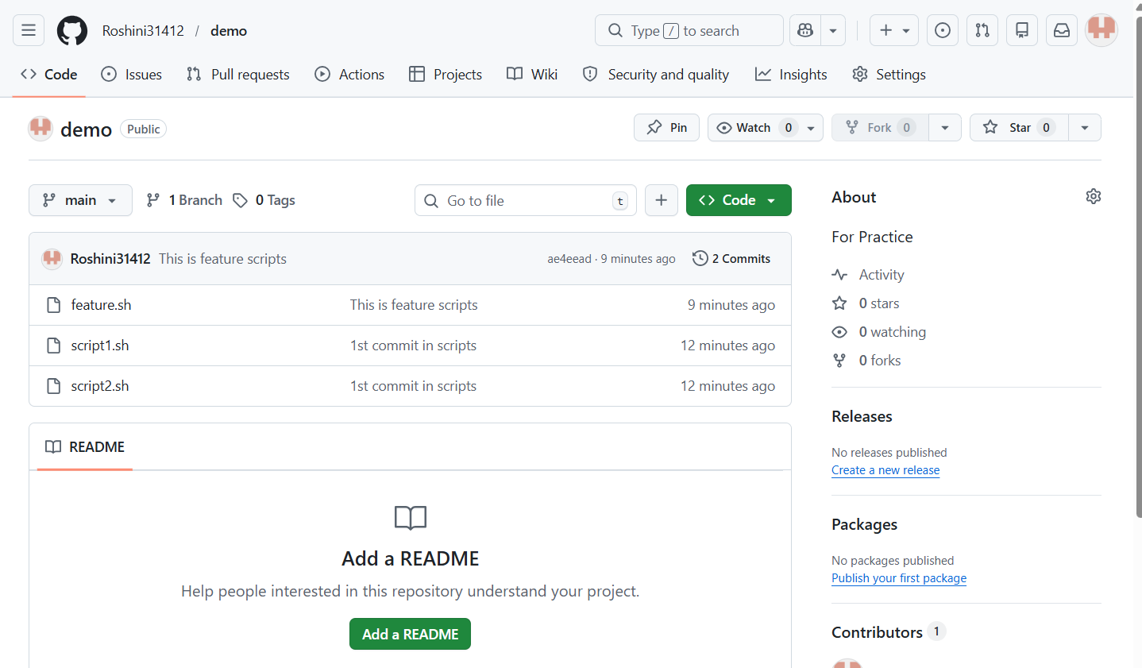
Merge commit graph (git log --graph).
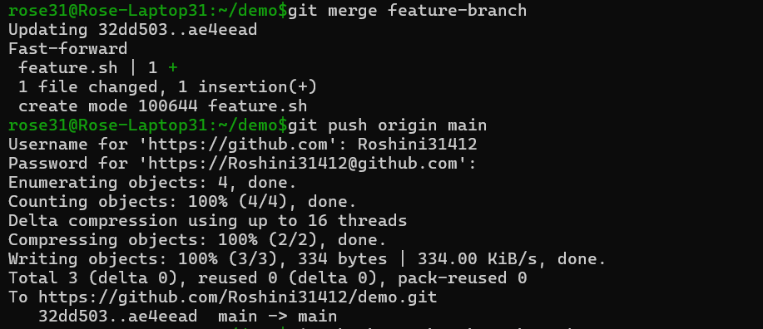

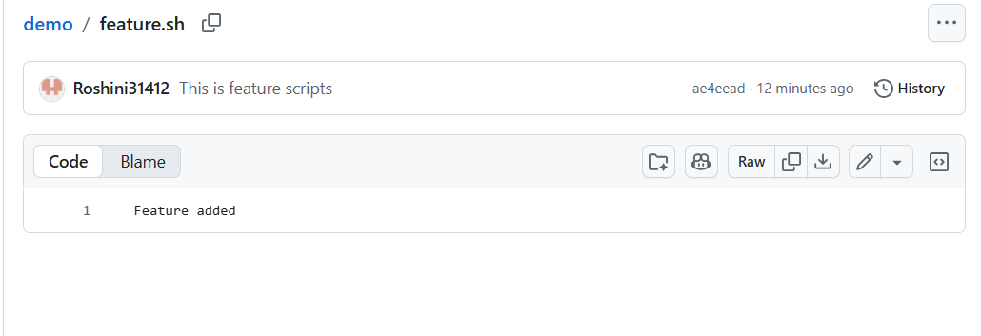
Rebase linear history :
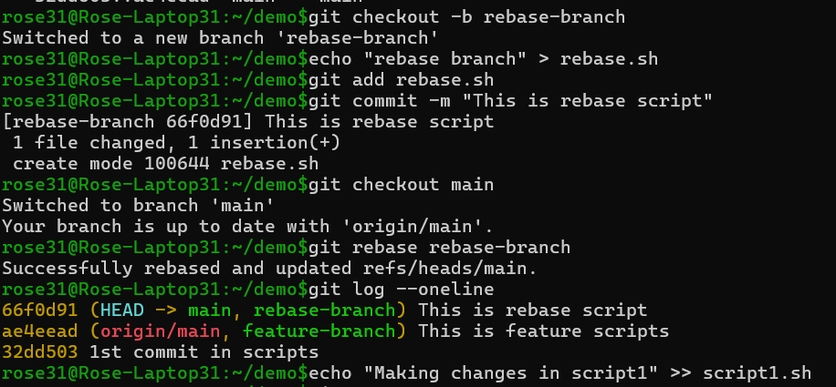

Stash before/after (git status, git stash list).
