**ALGORAND**

Algorand (ALGO) is both a digital currency and blockchain platform. The Algorand platform is designed to process many transactions quickly, similar to a main payments processor like Mastercard or Visa. Algorand can host other cryptocurrencies and blockchain-based projects, making it a direct competitor to Ethereum. ALGO, the platform’s native currency, is used to secure the Algorand blockchain and pay processing fees for Algorand-based transactions.

Blockchain ecosystems are like cities: each one provides value that draws people to visit — ranging from business opportunities, community, entertainment, infrastructure, local governance, to plain personal preference. As the industry matures, people will have more reasons to visit different ecosystems, driving more value into cross-chain applications.

In order to access your source blockchain in new ecosystems, you need a reliable way to verify its “state” (a snapshot of account balances and transactions) in the new environment. This trustless infrastructure is currently missing from the market, so people have turned to trusted intermediaries

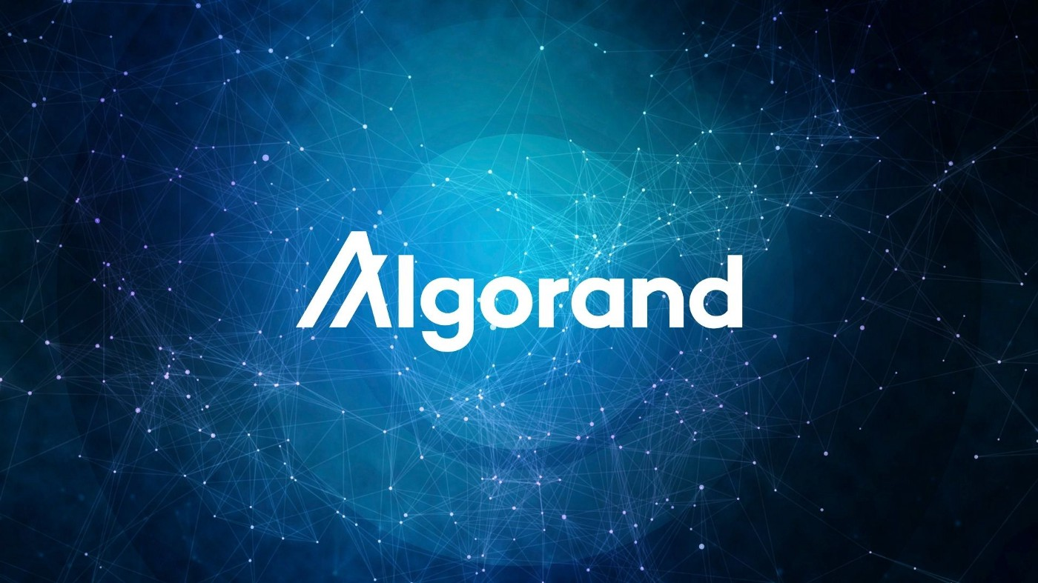

**Interoperability Problem**

Blockchain communities are looking for reliable ways to use their favorite dApps without paying expensive gas fees, dealing with network outages, or trusting intermediaries with their valued assets.

Developers want to build on fast and inexpensive blockchains like Algorand, and want immediate access to an expanded user base and liquidity scattered across several ecosystems.

**Bridging Solutions**

To solve these interoperability problems, many companies have built bridges that move assets across blockchains. These “bridged” assets can be freely used in the target chain’s ecosystem: lent out as collateral for a loan, traded for another asset, or simply held in a wallet.

Introducing Algorand State Proofs: new blockchain infrastructure that connects Algorand to the broader world. ASPs are an [immutable chain of proofs](https://people.csail.mit.edu/nickolai/papers/micali-compactcert-eprint.pdf) that attest to the state of the Algorand blockchain. They let anyone track Algorand transactions, balances, and application data in low-power environments like a phone, smartwatch, and even inside a blockchain smart contract, without compromising on security — each ASP is produced by the same decentralized network that reaches [consensus](https://www.algorand.com/technology/pure-proof-of-stake) on new blocks.

Due to their lightweight, portable nature, ASPs can be used to update Algorand light clients in other ecosystems. To lower costs in fee-constrained environments like Ethereum, Algorand will also produce even more compact zk-SNARK proofs that can be used to keep light clients up to date.

Applications like bridges, oracles, and wallets can query these light clients to cryptographically verify Algorand state in a simple, trustless manner. For example, say Alice wants to send Bob 10 AliceCoins from Algorand to Ethereum. AliceCoins are extremely valuable, so they want to make sure the tokens arrive quickly, safely, and without permission from or trust in an intermediary. Alice can send these tokens directly to Bob’s Ethereum wallet via a trustless bridge whose code-base is open to the public.

Similarly, the bridge can trustlessly mint and release bridged Ethereum assets into the Algorand ecosystem using Ethereum light clients.

**Features of Algorand Partners with Circles**

Here are the main features which are provided by **Algorand’s PoS blockchain**.**Decentralization .** Algorand is currently the only network that solves the **[Blockchain Trilemma](https://www.algorand.com/resources/blog/silvio-micali-lex-fridman-algorand-and-the-blockchain-trilemma/" \t "_blank)**.This means that Algorand can provide **true decentralization, security along scalability.**

**Security**

Algorand is an **unforkable blockchain** that has **no single point of failure**, so a **51% attack is almost impossible**.

**Scalability**

the protocol can scale nicely **without compromising block speed and final output.**

**Low-cost**

the **standard transaction cost** on Algorand is **about 0.001 ALGO per transaction**, which makes a big difference for payment systems, while Ethereum’s transaction fee is**at least 37 GWEI** on press time which is**2.45 USD**, according to[the Ethereum Gas Tracker](https://etherscan.io/gastracker).

**Developer-friendly.**

Developers can get exposure to a**massive set of tools and features which includes smart contracts, a wide range of assets including atomic transfers**.

**Algorand should be your best choice**to develop a payment infrastructure**as its smart contracts can be configured in many ways.**