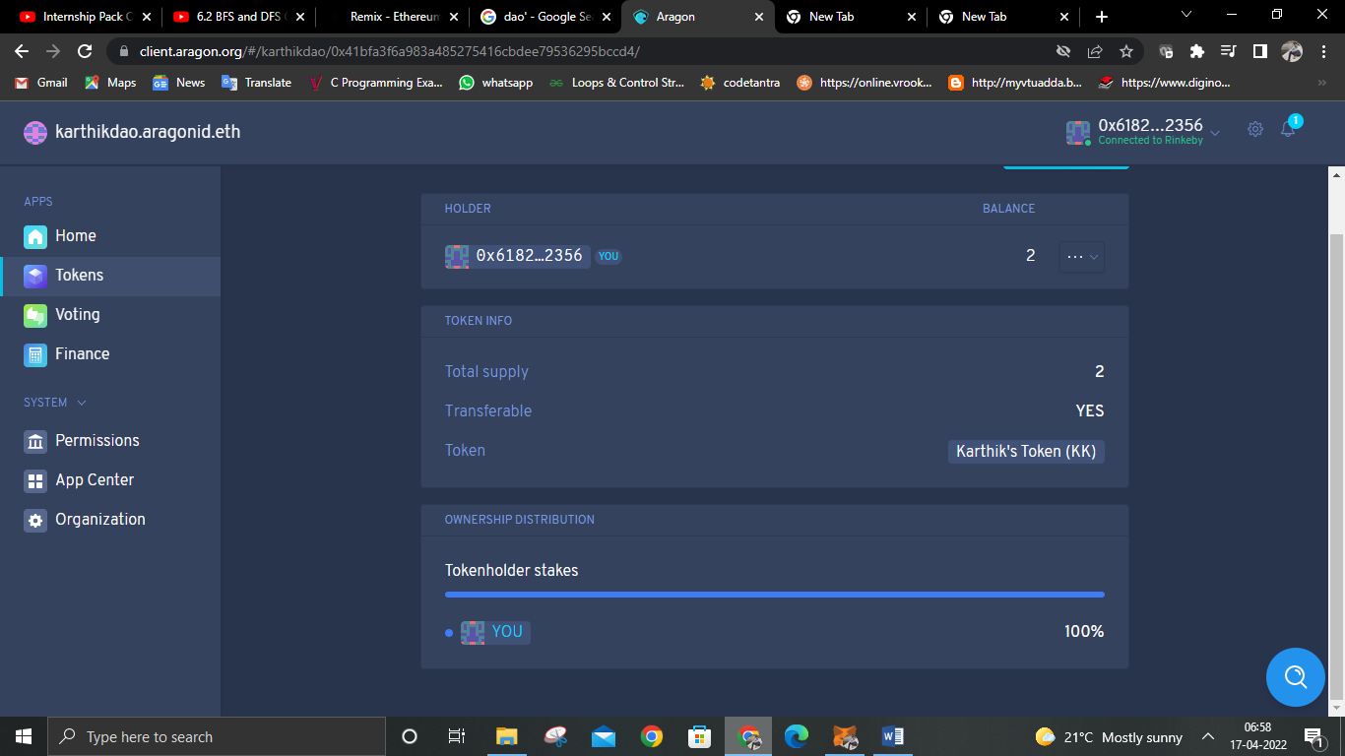

***DAO***



***Meta Verse***

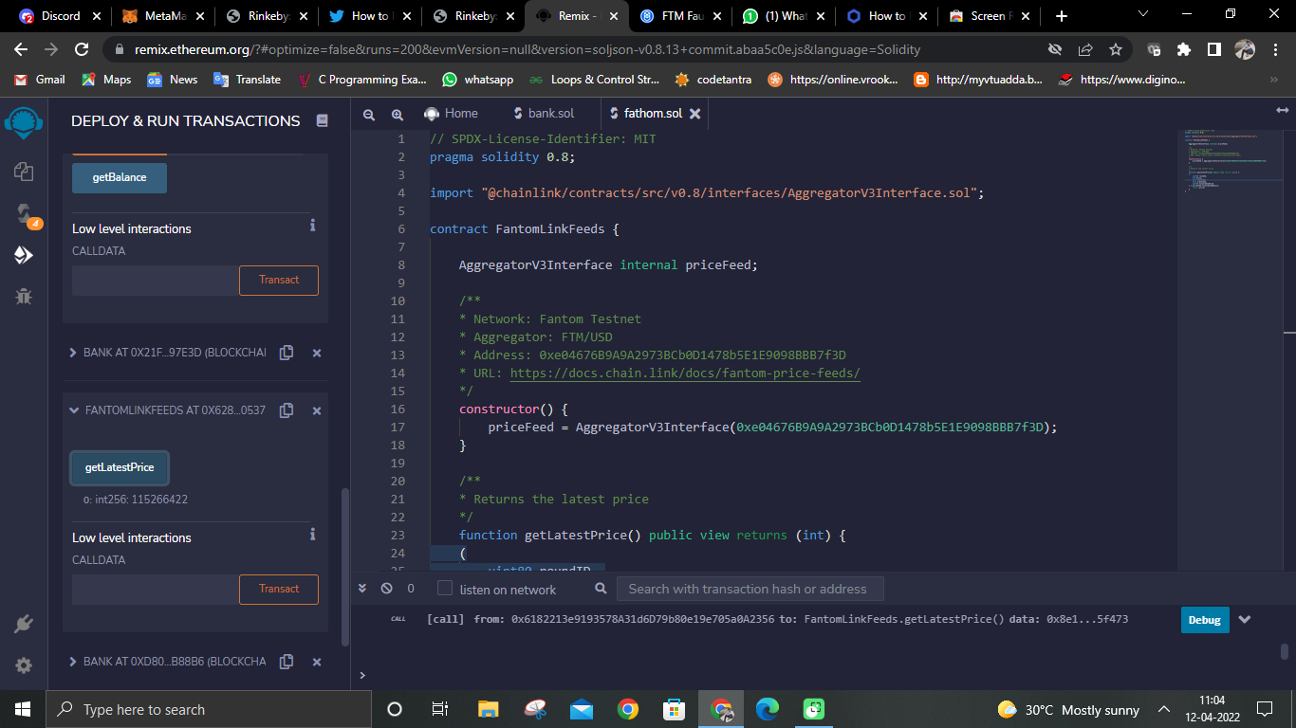

***Token***

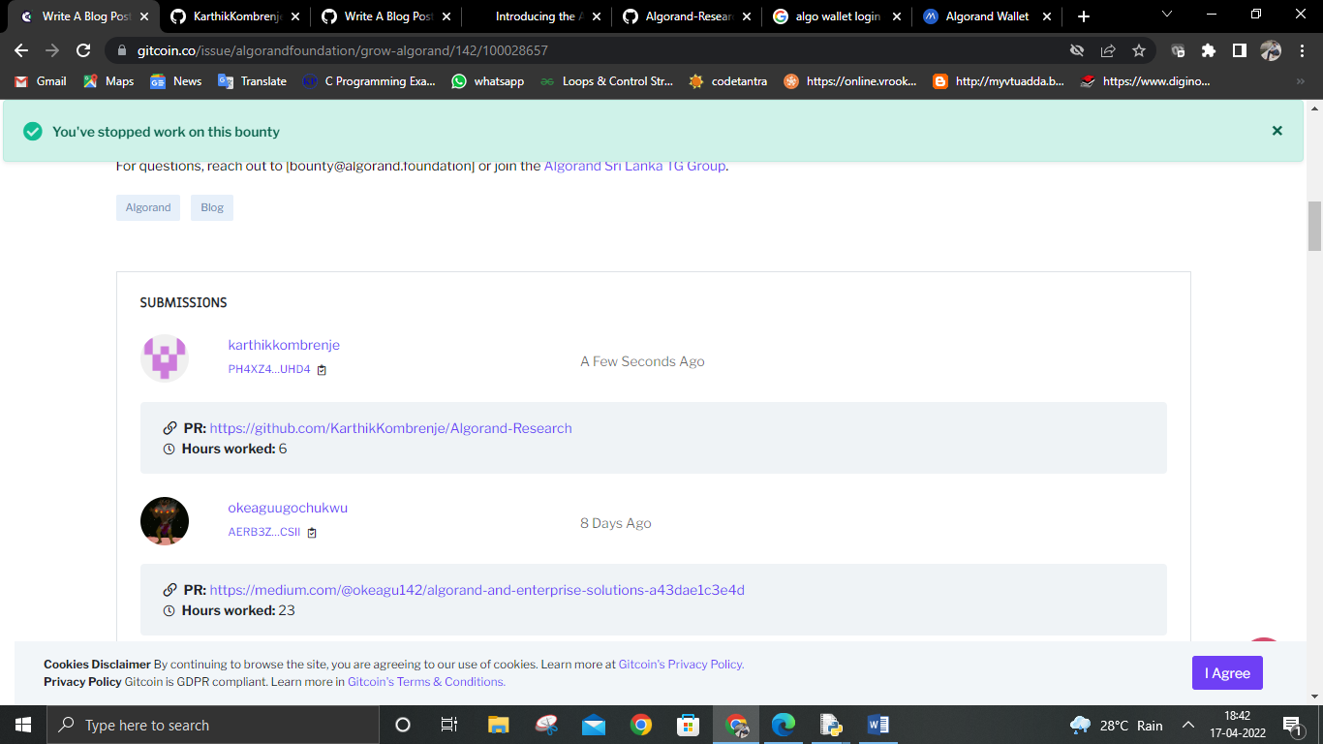

***Bounty Submission***

***White paper vs Light Paper***

**White paper**

A white paper is an in-depth, authoritative report on a specific issue or topic that you can use as a resource. It’s intended to educate and persuade readers about your expertise and knowledge of the problem by explaining the issues around it and how they’re being addressed.

**Light Paper**

A light paper is a document that describes the architecture of an application. This type of documentation also provides general guidance for developers, which means it has to be easy to read and understand by non-technical team members. A well-written light paper can help reduce project risks because everyone involved in development will know what’s expected from them before they start working on the product or feature.

***DEFI APP TRADING PROTOCOL***

