Manual Test Cases
Job application workflow: HireKiwi QA Engineer assessment
Document | Manual test cases, High priority first, with screenshots
Date | 13 October 2026
Systems under test | Live portal https://crew.tinobritty.me/jobs (read-only).

1. Coverage against the brief
Case type | Count
Positive | 14
Negative | 5
Boundary | 2

Execution order (quick list)
Priority | Case IDs
High | LST-01, LST-03, LST-04, LST-05, LST-07, LST-15, LST-16, LST-21
Medium | LST-02, LST-06, LST-08, LST-11, LST-12, LST-13, LST-17, LST-18, LST-20, XBR-04
Low | LST-09, LST-10, LST-19

2. High priority cases (8)

LST-01 Salary shows its pay period
Priority | High | Type | Positive
Requirement | R1 Job listings | Environment | Live portal
Severity if it fails | Major | Execution | Manual
Status | Fail | Bug report | Raised, see Bug Reports
Preconditions | Live portal reachable at https://crew.tinobritty.me/jobs. Note whether you are signed in or signed out. Read-only: nothing is submitted or changed.
Test data | QA Engineer card
Steps | 1. Open /jobs.  2. Find the QA Engineer card.  3. Read the salary shown on the card.
Expected result | The salary states its period, for example "per month" or "per year".
Actual result | Card shows "₹37,500 - ₹40,000" with no period. Assumed monthly (x12 = ₹4.5 to 4.8 lakh a year).
Notes | Evidence: evidence/live-portal/ev8-qa-one-space.png

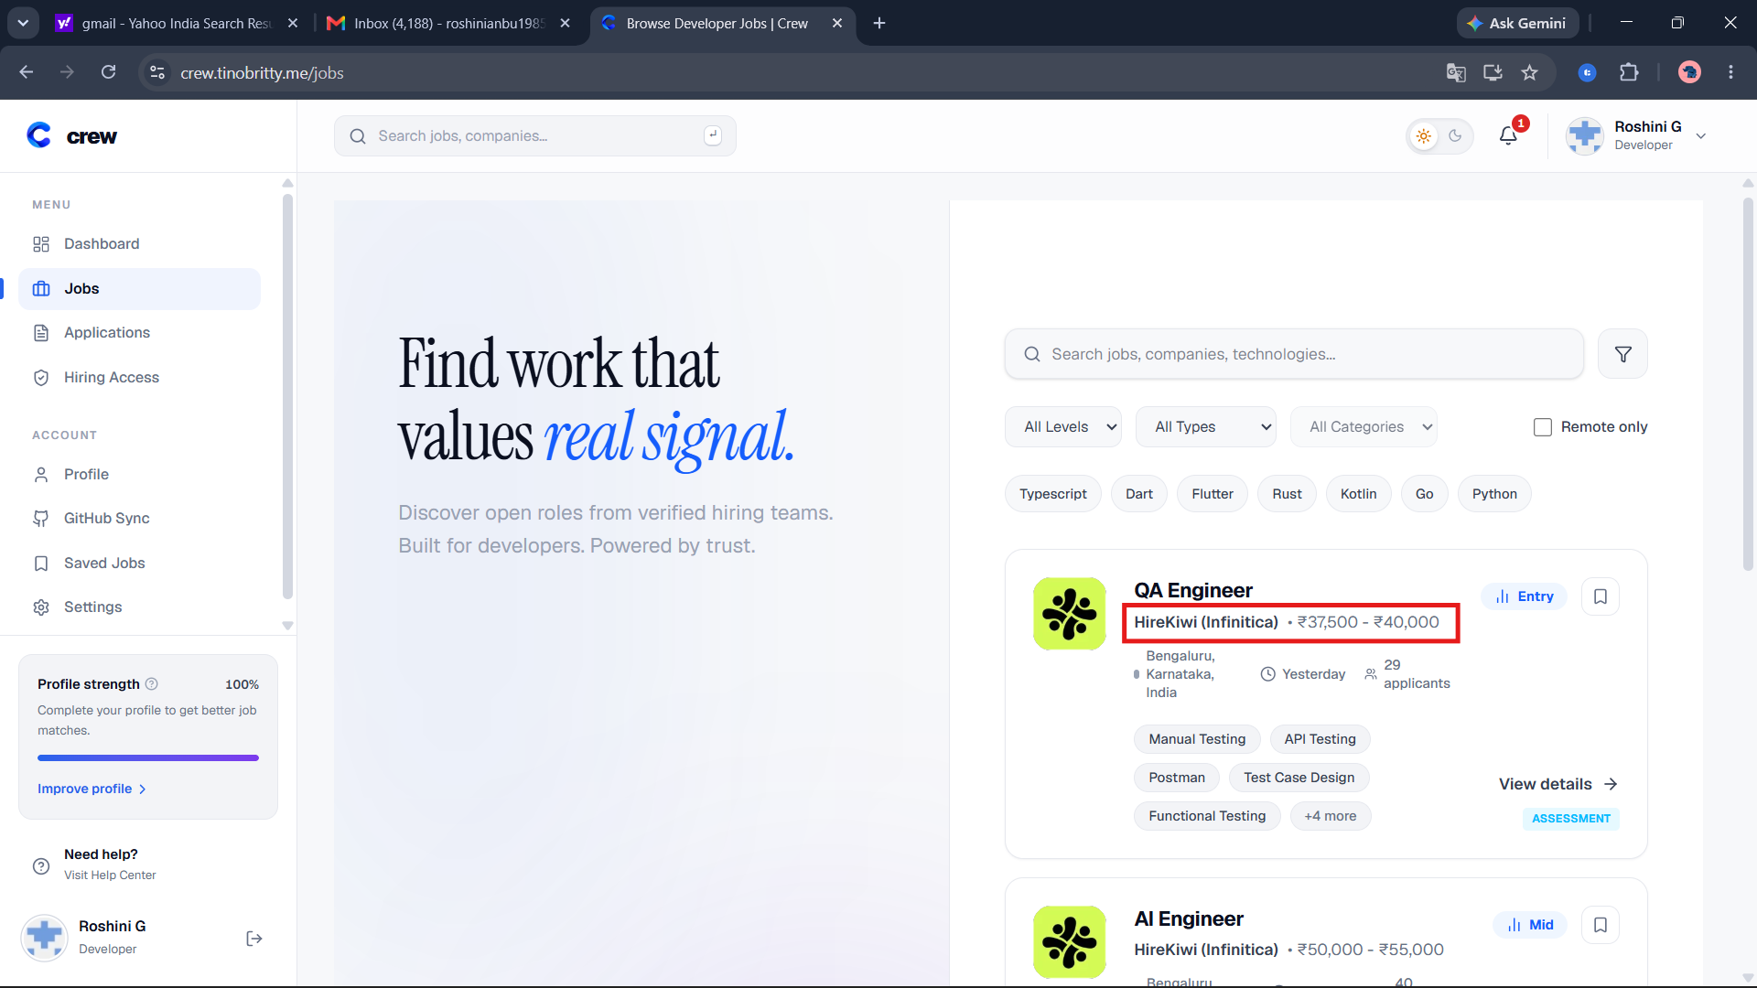

LST-03 Card data matches the detail page
Priority | High | Type | Positive
Requirement | R1 Job listings | Environment | Live portal
Severity if it fails | Major | Execution | Manual
Status | Pass | Bug report | -
Preconditions | Live portal reachable at https://crew.tinobritty.me/jobs. Note whether you are signed in or signed out. Read-only: nothing is submitted or changed.
Test data | QA Engineer
Steps | 1. Open /jobs.  2. Note title, company, salary, level and location on the QA Engineer card.  3. Click View details.  4. Compare the same fields on the detail page.  5. Check that a description and an experience requirement are shown.
Expected result | All fields match. A description and an experience requirement are shown.
Actual result | Card fields matched the detail page. Description and experience requirement were checked.

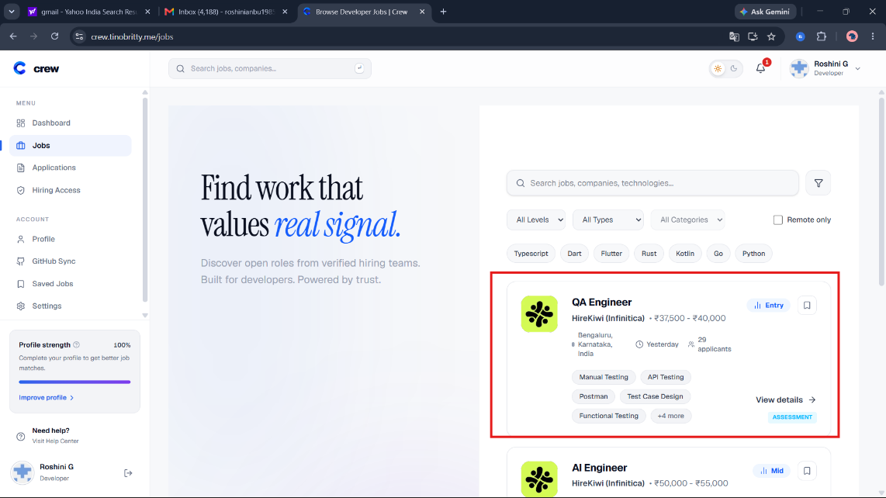

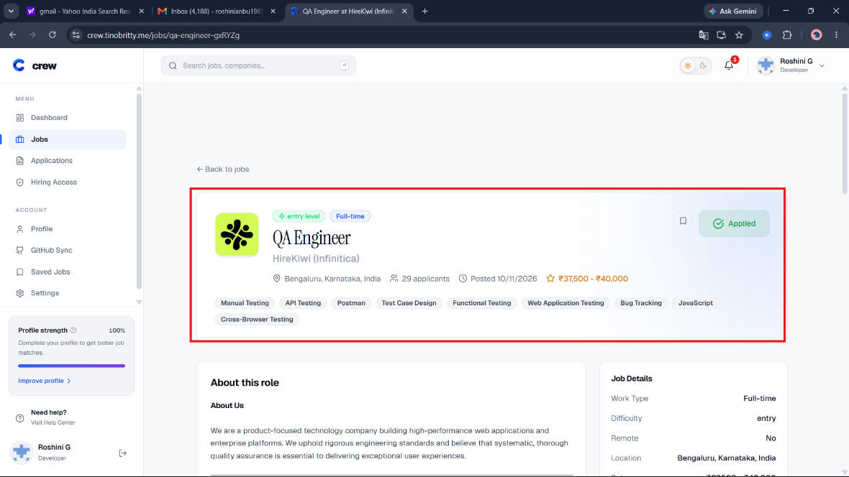

LST-04 Level and Remote filters return correct counts
Priority | High | Type | Boundary
Requirement | R1 Job listings | Environment | Live portal
Severity if it fails | Major | Execution | Manual
Status | Pass | Bug report | -
Preconditions | Live portal reachable at https://crew.tinobritty.me/jobs. Note whether you are signed in or signed out. Read-only: nothing is submitted or changed.
Test data | Level: Entry, Mid, Senior, Staff. Remote only. Mid plus Remote only.
Steps | 1. Open /jobs.  2. Pick each level in turn and note the number of jobs.  3. Tick Remote only and note the number.  4. Pick Mid and tick Remote only together.
Expected result | Entry 1, Mid 3, Senior 0, Staff 0, Remote only 1, Mid plus Remote only 1. Zero results show "No jobs found".
Actual result | All counts matched the expected values.

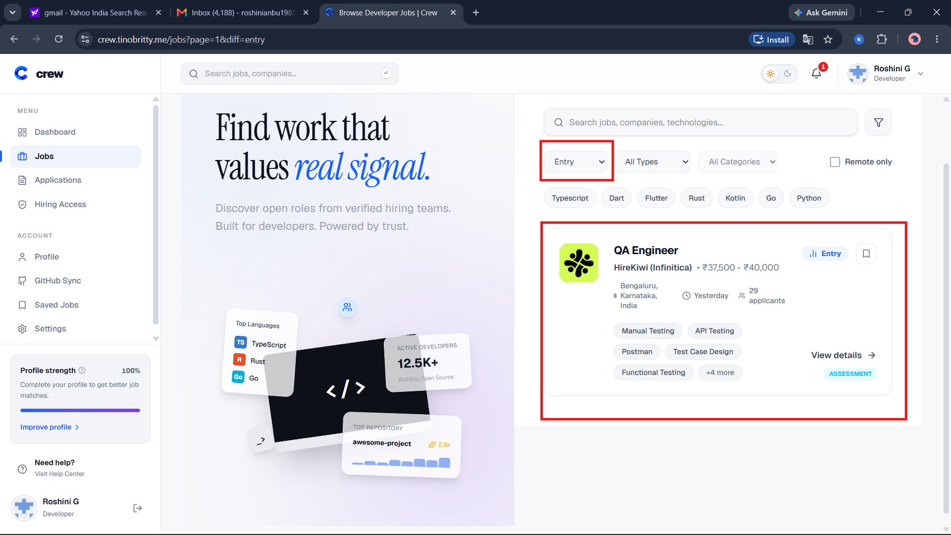

LST-05 Search finds the right job
Priority | High | Type | Positive
Requirement | R1 Job listings | Environment | Live portal
Severity if it fails | Major | Execution | Manual
Status | Pass | Bug report | -
Preconditions | Live portal reachable at https://crew.tinobritty.me/jobs. Note whether you are signed in or signed out. Read-only: nothing is submitted or changed.
Test data | Search term: qa
Steps | 1. Open /jobs.  2. Type qa in the search box and press Enter.
Expected result | Only QA Engineer is listed. The URL contains q=qa.
Actual result | Only QA Engineer listed. URL was /jobs?q=qa.
Notes | Evidence: evidence/live-portal/ev1-search-qa-network.png

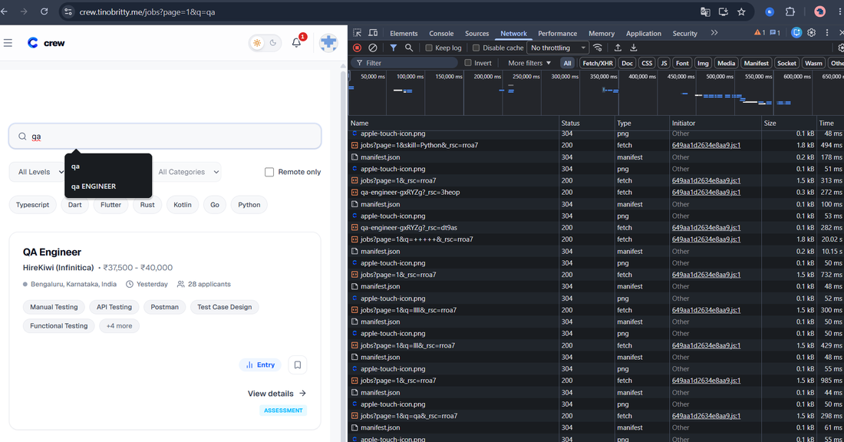

LST-07 Job links open the right role and Back keeps filters
Priority | High | Type | Positive
Requirement | R2 Navigation | Environment | Live portal
Severity if it fails | Major | Execution | Manual
Status | Fail | Bug report | Raised, see Bug Reports
Preconditions | Live portal reachable at https://crew.tinobritty.me/jobs. Note whether you are signed in or signed out. Read-only: nothing is submitted or changed.
Test data | Any job; level filter Mid
Steps | 1. Open /jobs.  2. Click a job title and confirm the matching job opens.  3. Go back and click View details on the same job.  4. Apply the Entry filter, open a job, then press Back.
Expected result | The correct job opens each time. After Back the Entry filter is still applied.
Actual result | After opening the QA Engineer detail page and pressing Back, the Entry filter resets instead of remaining selected.

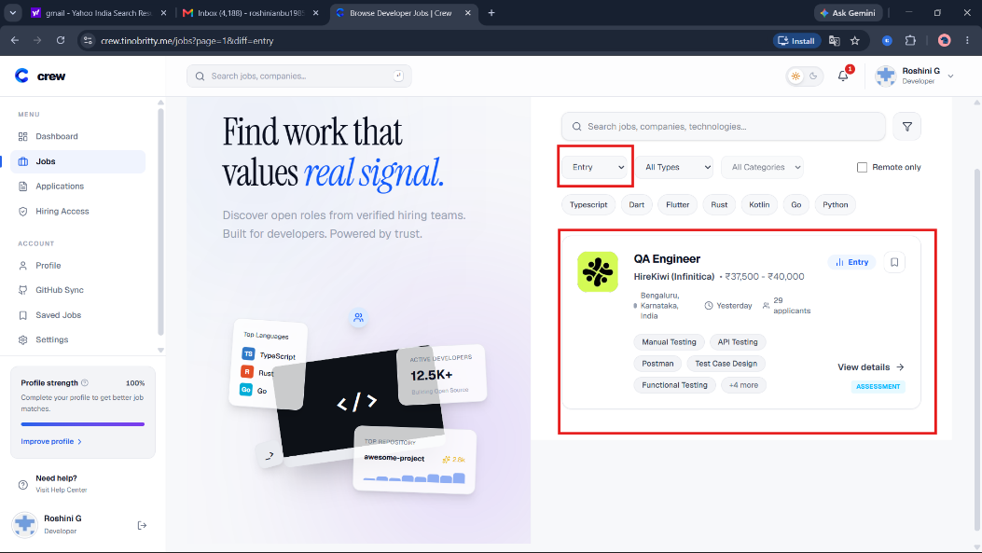

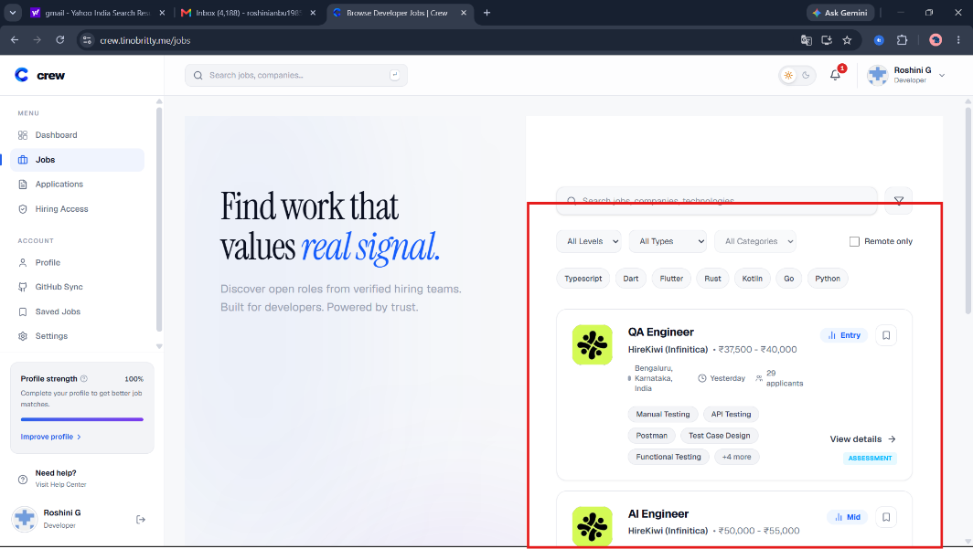

LST-15 Filter button opens the filter options
Priority | High | Type | Positive
Requirement | R1 Job listings | Environment | Live portal
Severity if it fails | Major | Execution | Manual
Status | Fail | Bug report | Raised, see Bug Reports
Preconditions | Live portal reachable at https://crew.tinobritty.me/jobs. Note whether you are signed in or signed out. Read-only: nothing is submitted or changed.
Test data | Funnel-shaped filter button beside the search box.
Steps | - Open the job listings page.  - Click the funnel-shaped filter button beside the search box.  - Observe whether a filter panel, menu, or additional filter options appear.  - If options appear, check whether they can be used and dismissed.
Expected result | Clicking the filter button opens the intended filter options, allowing the user to access the available filtering controls.
Actual result | Clicking the filter button beside the search box did not open any filter options or panel.

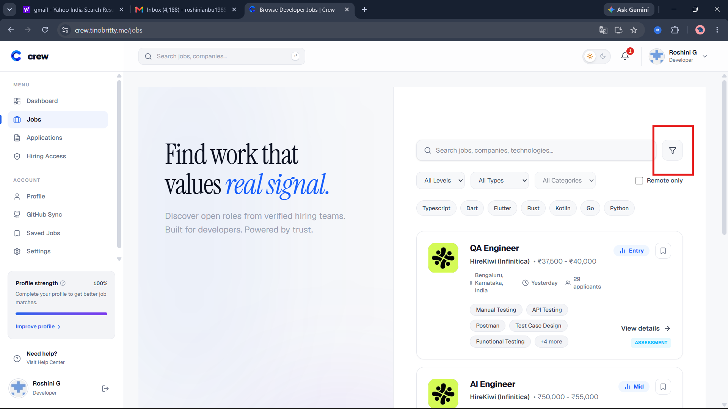

LST-16 Detail page shows a description, responsibilities and a requirements section
Priority | High | Type | Positive
Requirement | R1 Job listings | Environment | Live portal
Severity if it fails | Minor | Execution | Manual
Status | Pass | Bug report | -
Preconditions | Live portal reachable at https://crew.tinobritty.me/jobs. Read-only: do not submit, save, bookmark or change anything.
Test data | QA Engineer
Steps | 1. Open the QA Engineer detail page.  2. Check for a role description.  3. Check for a list of responsibilities.  4. Check for a list of requirements or qualifications.
Expected result | Description, responsibilities and requirements are all present and readable (the brief says candidates "view requirements").
Actual result | The description, responsibilities, and requirements are clearly provided. The page behaved as expected.

LST-21 Signed-out user is asked to sign in to apply and nothing is submitted
Priority | High | Type | Negative
Requirement | R2 Navigation | Environment | Live portal
Severity if it fails | Minor | Execution | Manual
Status | Partially verified | Bug report | -
Preconditions | Live portal reachable at https://crew.tinobritty.me/jobs. Read-only: do not submit, save, bookmark or change anything. Use a signed-out (private) window.
Test data | QA Engineer
Steps | 1. In a private window open the QA Engineer detail page.  2. Find the apply button.  3. Click it ONCE and stop as soon as the sign-in screen appears. Do not sign in.
Expected result | The button says "Sign in to Apply" and leads to a sign-in screen. No application is created.
Actual result | The signed-out user is shown the “Sign in to Apply” button. Signing in is required to proceed with the application.
Notes | Application submission was not attempted. Testing stopped before sign-in, as required by the read-only testing rules.

3. Medium priority cases (10)

LST-02 A job without salary shows a label
Priority | Medium | Type | Negative
Requirement | R1 Job listings | Environment | Live portal
Severity if it fails | Minor | Execution | Manual
Status | Fail | Bug report | Raised, see Bug Reports
Preconditions | Live portal reachable at https://crew.tinobritty.me/jobs. Note whether you are signed in or signed out. Read-only: nothing is submitted or changed.
Test data | Open Source Core Contributor card
Steps | 1. Open /jobs.  2. Find the Open Source Core Contributor card.  3. Look for a salary line.
Expected result | A label such as "Not disclosed" appears where the salary would be.
Actual result | No salary line and no label on the card.
Notes | Evidence: evidence/live-portal/ev9-open-source-no-salary.png

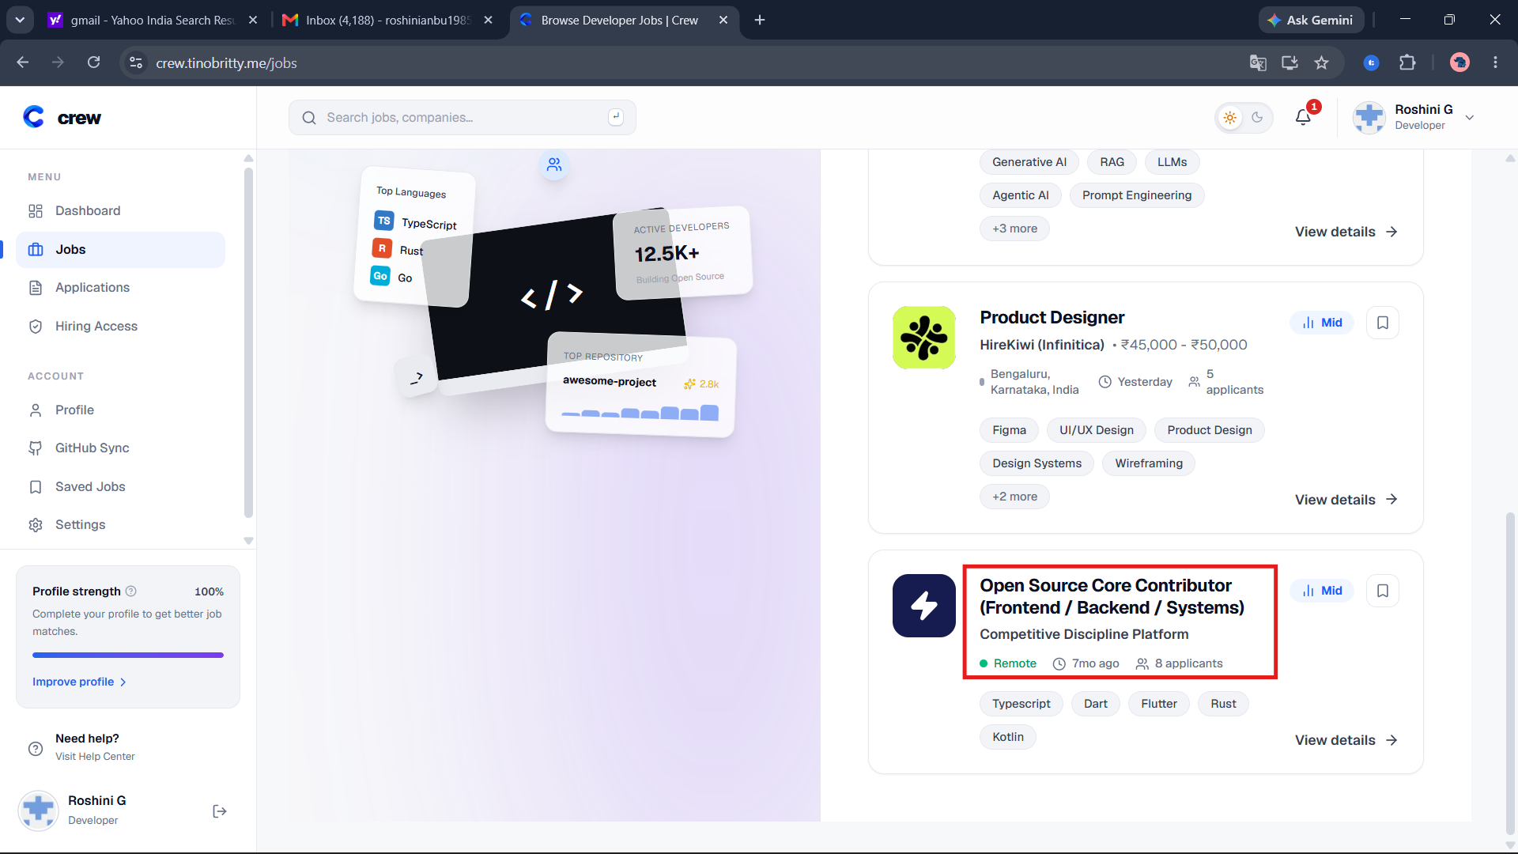

LST-06 Search ignores extra spaces
Priority | Medium | Type | Negative
Requirement | R1 Job listings | Environment | Live portal
Severity if it fails | Minor | Execution | Manual
Status | Fail | Bug report | Raised, see Bug Reports
Preconditions | Live portal reachable at https://crew.tinobritty.me/jobs. Note whether you are signed in or signed out. Read-only: nothing is submitted or changed.
Test data | Spaces only (7). "qa" plus 1 trailing space. "qa" plus 2 trailing spaces.
Steps | 1. Open /jobs.  2. Press the spacebar 7 times in the search box and press Enter.  3. Search qa plus one trailing space.  4. Search qa plus two trailing spaces.
Expected result | Spaces are trimmed. A spaces-only search lists all jobs. Both qa searches list QA Engineer.
Actual result | Spaces only: "No jobs found" with an empty-looking box. One space: QA Engineer listed. Two spaces: "No jobs found".
Notes | Evidence: evidence/live-portal/ev4-spaces-only-search.png, ev7-qa-two-spaces.png, ev8-qa-one-space.png

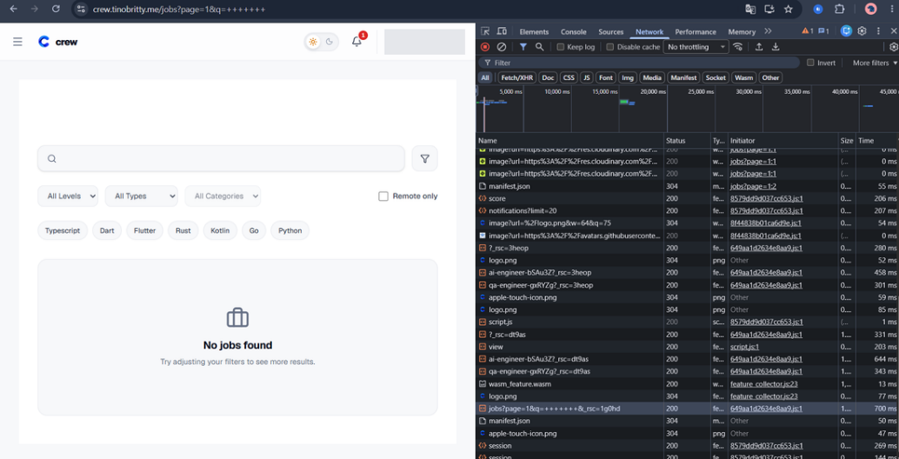

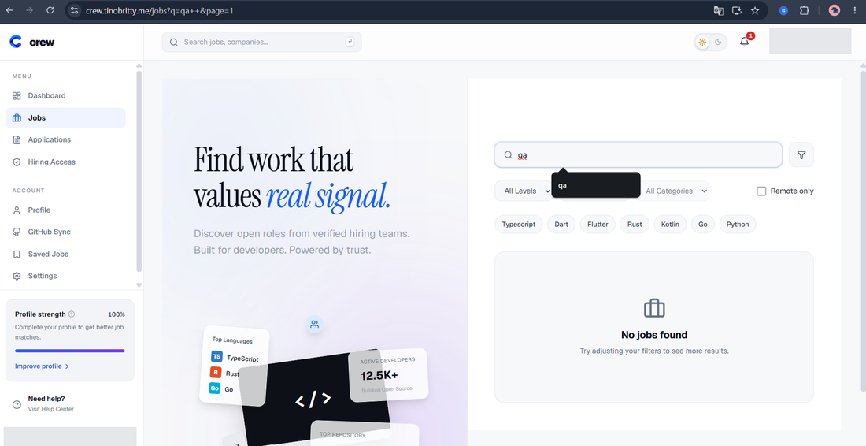

LST-08 Unknown job address shows a 404 page
Priority | Medium | Type | Negative
Requirement | R2 Navigation | Environment | Live portal
Severity if it fails | Minor | Execution | Manual
Status | Pass | Bug report | -
Preconditions | Live portal reachable at https://crew.tinobritty.me/jobs. Note whether you are signed in or signed out. Read-only: nothing is submitted or changed.
Test data | /jobs/type=mid
Steps | 1. Open /jobs/type=mid (a made-up job address).
Expected result | A clear 404 page appears.
Actual result | Page showed "404 This page could not be found."
Notes | Evidence: evidence/live-portal/ev3-fake-url-404.png

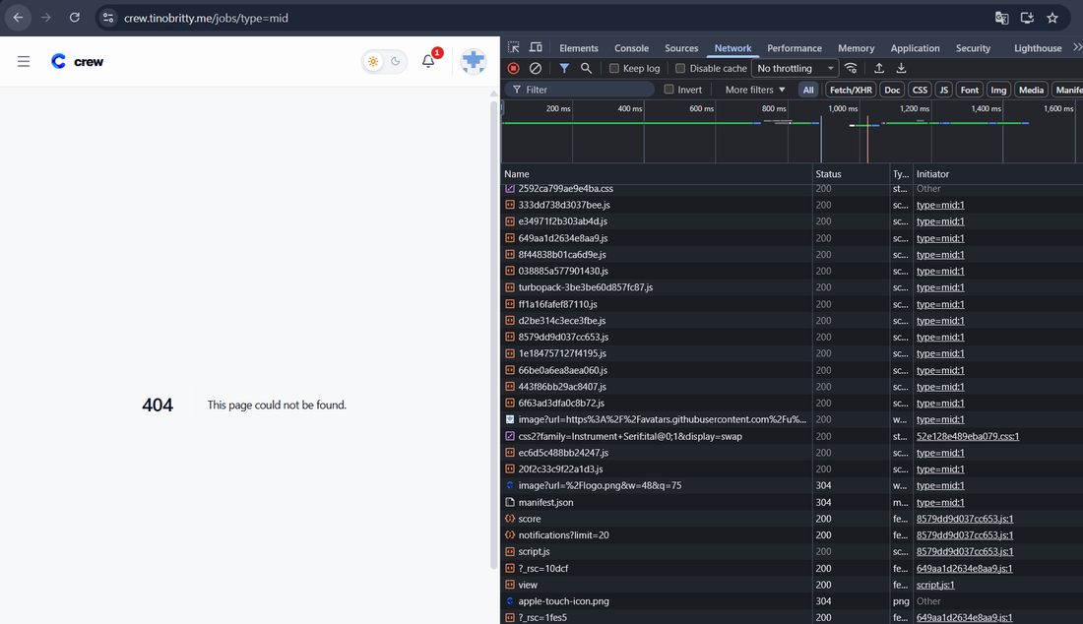

LST-11 Type filter returns only matching jobs
Priority | Medium | Type | Positive
Requirement | R1 Job listings | Environment | Live portal
Severity if it fails | Major | Execution | Manual
Status | Pass | Bug report | -
Preconditions | Live portal reachable at https://crew.tinobritty.me/jobs. Note whether you are signed in or signed out. Read-only: nothing is submitted or changed.
Test data | Type dropdown, each option
Steps | 1. Open /jobs.  2. Pick each option in the Type dropdown in turn.  3. Check the jobs listed after each pick.
Expected result | Only jobs of the chosen type are listed.
Actual result | Behaved as expected

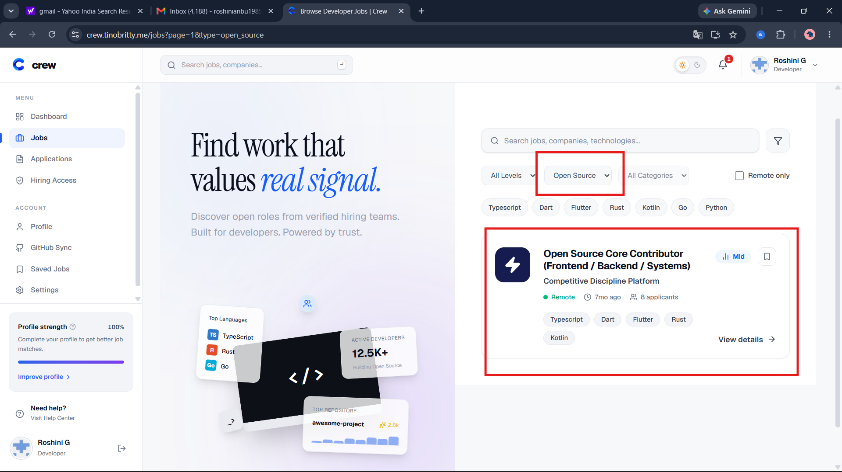

LST-12 Category filter returns only matching jobs
Priority | Medium | Type | Positive
Requirement | R1 Job listings | Environment | Live portal
Severity if it fails | Major | Execution | Manual
Status | Pass | Bug report | -
Preconditions | Live portal reachable at https://crew.tinobritty.me/jobs. Note whether you are signed in or signed out. Read-only: nothing is submitted or changed.
Test data | Category dropdown, each option
Steps | 1. Open /jobs.  2. Pick each option in the Category dropdown in turn.  3. Check the jobs listed after each pick.
Expected result | Only jobs in the chosen category are listed.
Actual result | Behaved as expected

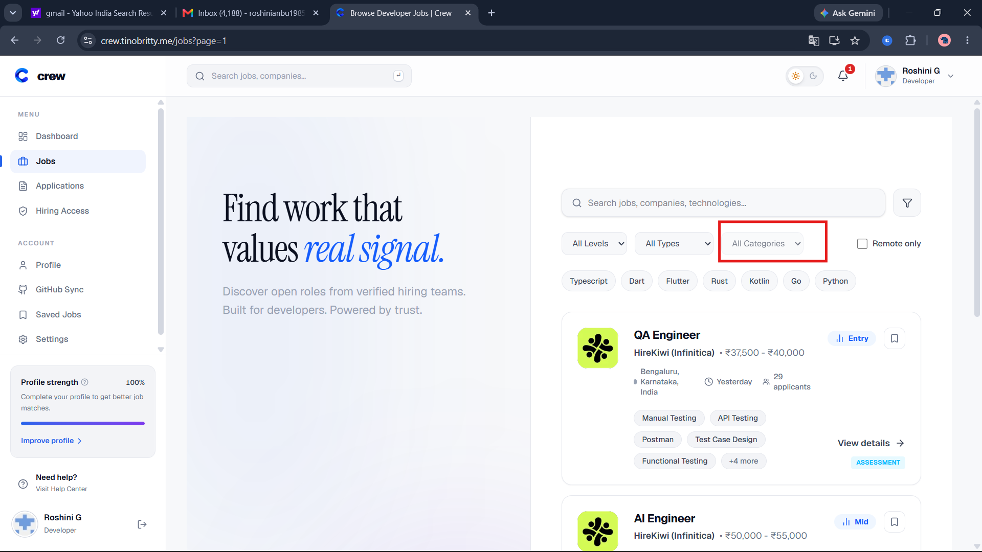

LST-13 Skill chip filters the list
Priority | Medium | Type | Positive
Requirement | R1 Job listings | Environment | Live portal
Severity if it fails | Major | Execution | Manual
Status | Pass | Bug report | -
Preconditions | Live portal reachable at https://crew.tinobritty.me/jobs. Note whether you are signed in or signed out. Read-only: nothing is submitted or changed.
Test data | Chip: Typescript
Steps | 1. Open /jobs.  2. Click the Typescript skill chip.  3. Check the jobs listed.
Expected result | Only jobs tagged with that skill are listed.
Actual result | Behaved as expected (tester-confirmed).
Notes | Chips behave as single-select. Treated as a design choice, not a defect.

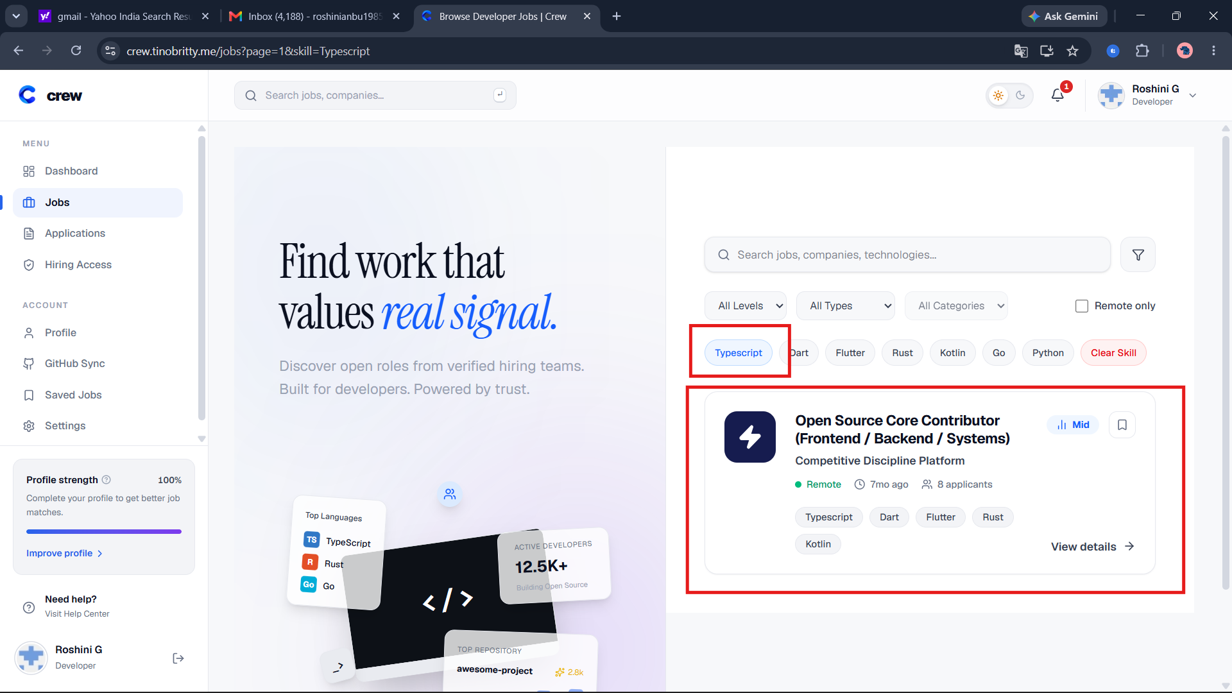

LST-17 Search ignores letter case
Priority | Medium | Type | Positive
Requirement | R1 Job listings | Environment | Live portal
Severity if it fails | Minor | Execution | Manual
Status | Pass | Bug report | -
Preconditions | Live portal reachable at https://crew.tinobritty.me/jobs. Read-only: do not submit, save, bookmark or change anything.
Test data | qa, QA, Qa, qA
Steps | 1. Open /jobs.  2. Search for "qa" and press Enter. Note the jobs listed.  3. Repeat with "QA", "Qa" and "qA".
Expected result | All four searches list the same jobs (QA Engineer).
Actual result | All four searches (qa, QA, Qa, qA) returned the same result: QA Engineer.

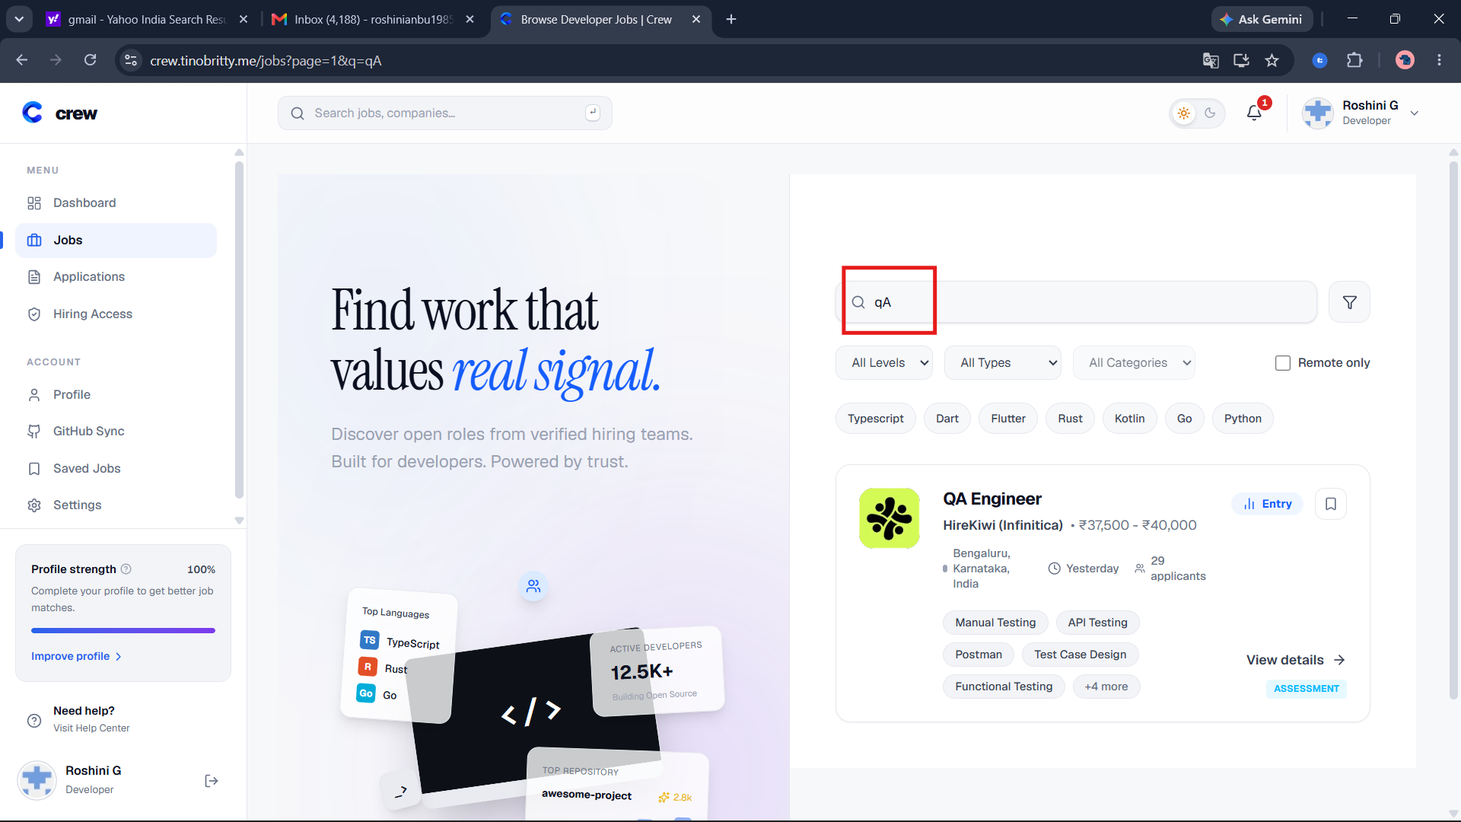

LST-18 Search with special characters and very long text does not break the page
Priority | Medium | Type | Negative
Requirement | R1 Job listings | Environment | Live portal
Severity if it fails | Minor | Execution | Manual
Status | Pass | Bug report | -
Preconditions | Live portal reachable at https://crew.tinobritty.me/jobs. Read-only: do not submit, save, bookmark or change anything.
Test data | <script>alert(1)</script> | 100% | a&b=c | 300 letters "a" | emoji
Steps | 1. Open /jobs.  2. Search for each value in turn, pressing Enter.  3. Watch for browser dialogs, error pages or broken layout.  4. Clear the search.
Expected result | No dialog opens, no error page appears, the text is shown as plain text and the page says "No jobs found" or lists matches. The list returns when the search is cleared.
Actual result | All five search inputs returned “No jobs found.” No browser alerts or error pages appeared, and the page remained usable.
Notes | Safe: it only changes the address bar query, no data is written.

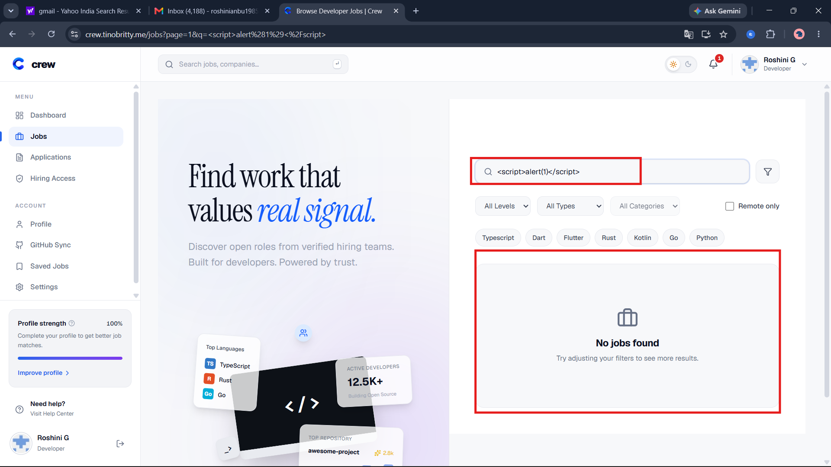

LST-20 A job opens in a new tab and survives refresh, Back and Forward
Priority | Medium | Type | Positive
Requirement | R2 Navigation | Environment | Live portal
Severity if it fails | Minor | Execution | Manual
Status | Pass | Bug report | -
Preconditions | Live portal reachable at https://crew.tinobritty.me/jobs. Read-only: do not submit, save, bookmark or change anything.
Test data | Any job
Steps | 1. Right-click (or Ctrl+click) a job title and open it in a new tab.  2. Do the same with View details.  3. In the new tab press Refresh.  4. Press Back, then Forward.
Expected result | The same, correct job opens each time. Refresh keeps the same job. Back and Forward move between pages without errors.
Actual result | Job title and View details navigation work correctly. Refresh, Back and Forward work as expected. The empty card area is not clickable.

XBR-04 Listing page is usable at 375 px width (phone size)
Priority | Medium | Type | Positive
Requirement | R6 Cross-browser behaviour | Environment | Live portal
Severity if it fails | Minor | Execution | Manual
Status | Pass | Bug report | -
Preconditions | Live portal reachable at https://crew.tinobritty.me/jobs. Read-only: do not submit, save, bookmark or change anything. Use the Chrome device toolbar (iPhone SE, 375 x 667).
Test data | 375 px viewport
Steps | 1. Open /jobs in the device toolbar at 375 px.  2. Check for sideways scrolling.  3. Use search and one filter.  4. Open one job.
Expected result | No sideways scrolling, filters and cards are readable, the job opens.
Actual result | At 375 px width, the listing page displayed correctly without horizontal scrolling. Search, filters, job cards and job details were usable and readable.

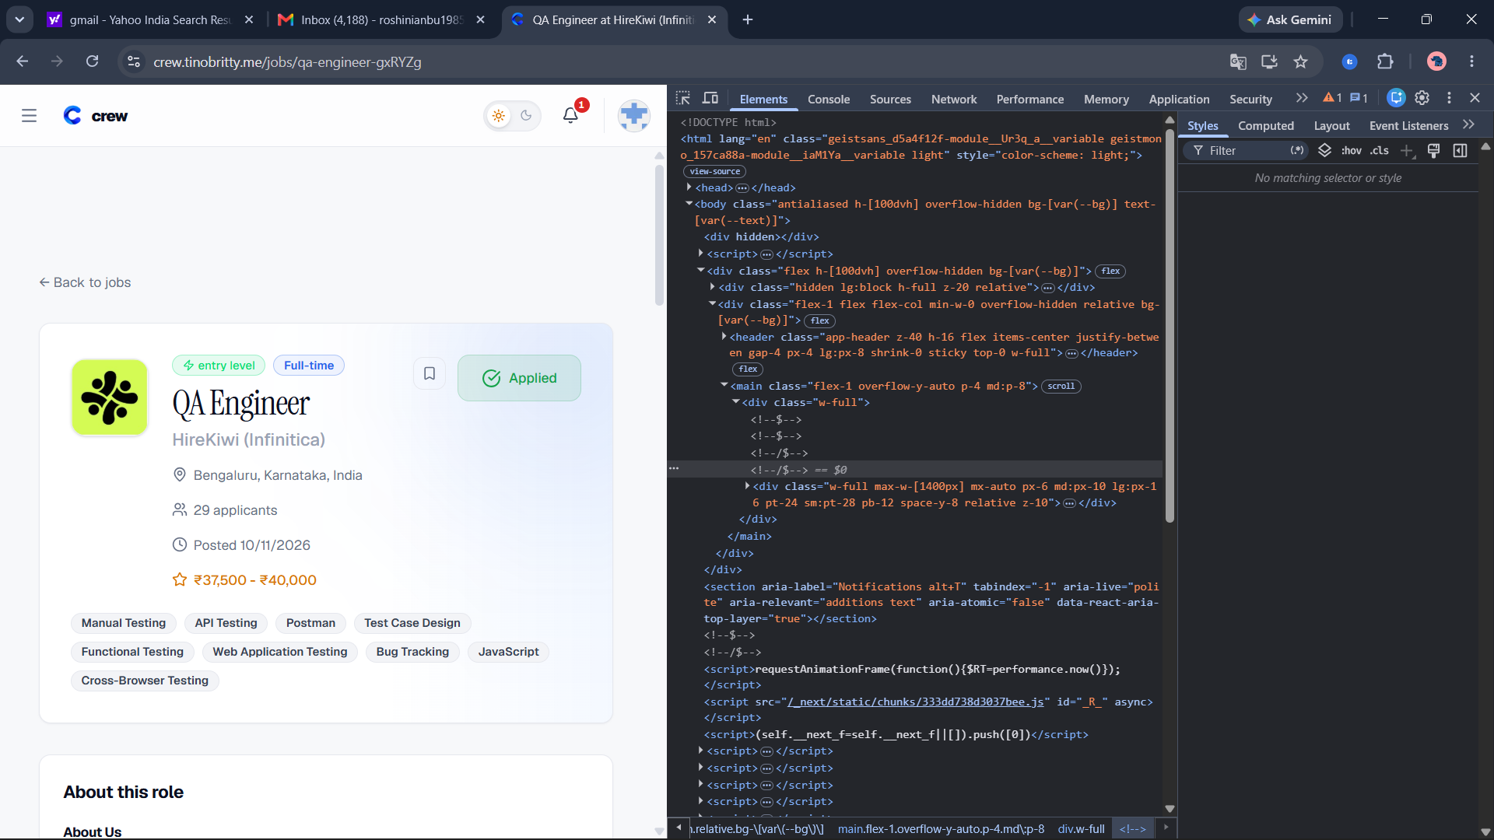

4. Low priority cases (3)

LST-09 Invalid URL parameters are handled consistently
Priority | Low | Type | Boundary
Requirement | R2 Navigation | Environment | Live portal
Severity if it fails | Minor | Execution | Manual
Status | Fail | Bug report | Raised, see Bug Reports
Preconditions | Live portal reachable at https://crew.tinobritty.me/jobs. Note whether you are signed in or signed out. Read-only: nothing is submitted or changed.
Test data | page=0, page=abc, page=-1, type=abc
Steps | 1. Open /jobs?page=0.  2. Open /jobs?page=abc.  3. Open /jobs?page=-1.  4. Open /jobs?type=abc.
Expected result | Invalid values fall back or are explained, in the same way for all of them.
Actual result | page=0 and page=abc show jobs. page=-1 shows "No jobs found". type=abc shows 0 jobs while the dropdown reads "All Types".

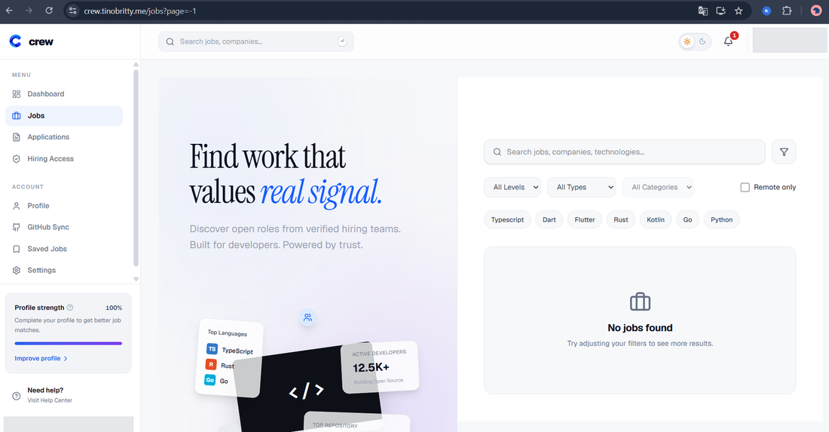
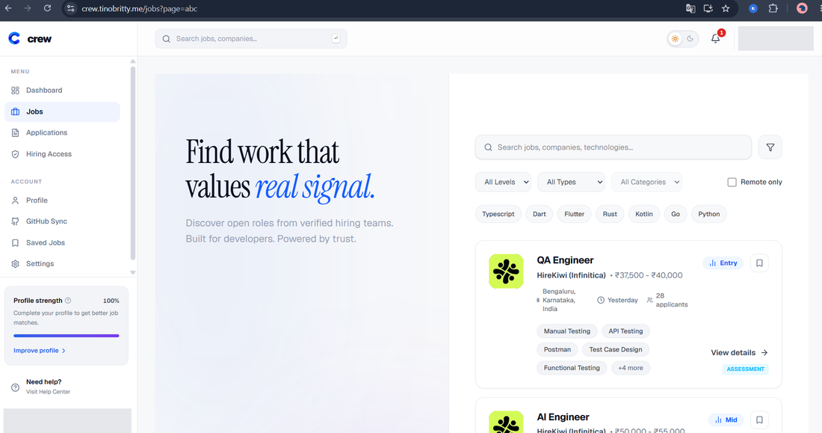

LST-10 Whole job card is clickable
Priority | Low | Type | Positive
Requirement | R2 Navigation | Environment | Live portal
Severity if it fails | Minor | Execution | Manual
Status | Fail | Bug report | Raised, see Bug Reports
Preconditions | Live portal reachable at https://crew.tinobritty.me/jobs. Note whether you are signed in or signed out. Read-only: nothing is submitted or changed.
Test data | Any job card
Steps | 1. Open /jobs.  2. Click the empty area inside a card, away from the title and View details.
Expected result | The job opens, or the page shows that only the link is clickable.
Actual result | Nothing happened. Title and View details both open the job.

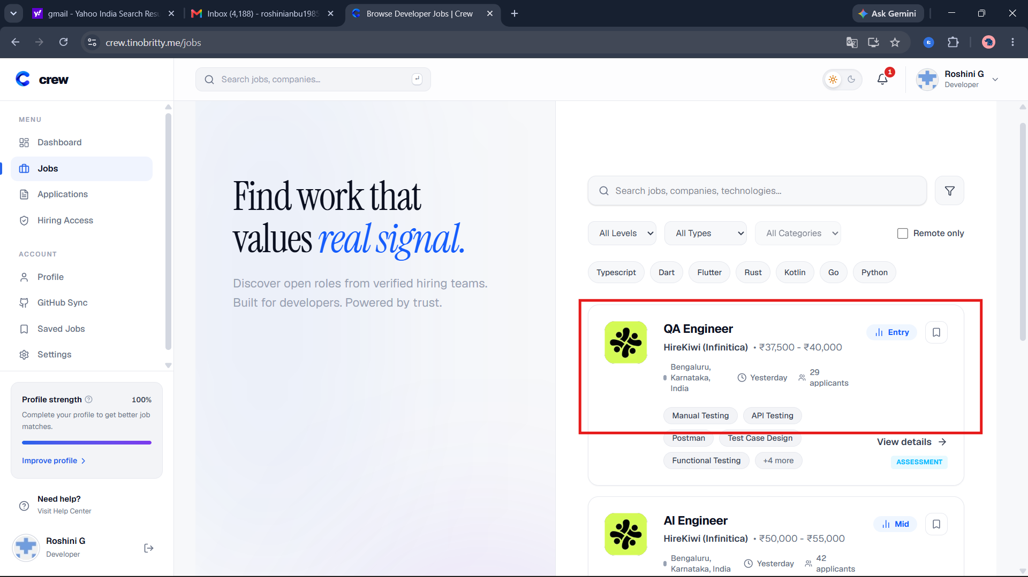

LST-19 Posted date and applicant count agree between card and detail page
Priority | Low | Type | Positive
Requirement | R1 Job listings | Environment | Live portal
Severity if it fails | Minor | Execution | Manual
Status | Fail | Bug report | Raised, see Bug Reports
Preconditions | Live portal reachable at https://crew.tinobritty.me/jobs. Read-only: do not submit, save, bookmark or change anything.
Test data | QA Engineer
Steps | 1. On /jobs note the posted time ("Yesterday") and the applicant count on the QA Engineer card.  2. Open the detail page straight away and note the posted date and applicant count.  3. Compare.
Expected result | Both pages show the same applicant count and a posted date that matches "Yesterday". The date format is unambiguous for Indian users (for example 11 Oct 2026).
Actual result | The job card shows “Yesterday” (12/10/2026), but the detail page shows “Posted 10/11/2026” (11 October 2026 in MM/DD/YYYY format). The dates do not match.
