AUTOMATED TEST CASES
HireKiwi QA Engineer Assessment
Reviewed: 13 October 2026 | Browsers: Chromium, Firefox, WebKit | Frameworks: Playwright, Cucumber
Document | Automated Test Cases
Project | HireKiwi QA Engineer Assessment
Review date | 13 October 2026
Test environment | Local mock application (Node 22)
Automation tools | Playwright Test 1.56.0, Cucumber 13
Browsers | Chromium, Firefox, WebKit
Scope | Validation, submission, error-handling and responsive/cross-browser checks. Live-portal checks are read-only and listed only as future improvements.

1. Test Index and Coverage Summary
Test category | Count | Explanation
Documented automated test scenarios | 19 | Main test-case entries in this document
High-priority scenarios | 9 | P1
Medium-priority scenarios | 9 | P2
Low-priority scenarios | 1 | P3
Individual Playwright tests | 39 | Automated checks reported in the Playwright suite
Cucumber scenarios | 38 | BDD scenarios reported in the Cucumber suite
The 19 documented scenarios are the main test-case entries. The 39 Playwright tests and 38 Cucumber scenarios are execution counts: data-driven checks can expand one documented scenario into several Playwright tests, and Cucumber may overlap functionally with Playwright. Do not add these counts together as unique scenarios.

1.1 Priority-wise Scenario Index
Priority | Scenarios | Test case IDs
High (P1) | 9 | VAL-01, VAL-02, VAL-04, SUB-01, SUB-02, SUB-03, ERR-01, ERR-02, XBR-01
Medium (P2) | 9 | VAL-03, VAL-05, VAL-06, VAL-07, VAL-08, SUB-04, ERR-03, ERR-04, XBR-02
Low (P3) | 1 | SUB-05
Total | 19 | All of the above

2. Execution Setup and Commands
Environment: Node 22; Playwright Test 1.56.0; Cucumber 13; local mock application. Each test opens the form with its own unique job ID.
Command | Purpose
npm run test:smoke | Run the 4 @smoke Playwright tests as a quick health check.
npm run test:p1 | Run High-priority Playwright tests (18 tests).
npm run bdd:p1 | Run High-priority Cucumber scenarios.
npm run test:chromium | Run all 39 Playwright tests on Chromium.
npm run test:firefox / npm run test:webkit | Run the suite on Firefox or WebKit with one worker each.
All commands are defined in package.json. Playwright starts the mock server by itself, so npm start is only needed if you want to try the form by hand.

3. Documented Automated Test Cases
Each case uses the same fields: priority, requirement, test type, preconditions, test data, steps, expected result, the automation scenario, execution status and linked bug.

3.1 Form Validation (R3)
VAL-01 All required fields empty
Priority | High (P1) Requirement: R3 Form validation Type: Playwright + Cucumber
Preconditions | Mock server running (npm start); application form opened with a unique job ID. Form is empty.
Test Data | None – all fields left empty.
Test Steps | - Open the local mock application form.  - Leave all fields empty.  - Submit the form and inspect field errors, focus and network activity.
Expected Result | Full name, email and experience are flagged. Focus moves to the first invalid field. The optional cover note is not flagged. No request is sent.
Automation Scenario (Gherkin) | @VAL-01 @P1 @smoke @negative  Scenario: Empty form flags every required field and sends nothing  When I submit the application  Then every required field shows an error  And the first invalid field has the focus  And the cover note is not flagged  And no request is sent to the server
Execution Status | Pass (Playwright + Cucumber)
Linked Bug | None documented

VAL-02 Invalid email formats are rejected
Priority | High (P1) Requirement: R3 Form validation Type: Playwright + Cucumber
Preconditions | Mock server running (npm start); application form opened with a unique job ID.
Test Data | Invalid emails: plain | a@ | @b.com | a@b | a b@c.com | a@@b.com
Test Steps | - Open the local mock application form.  - Submit an otherwise valid form once for each invalid email value.  - Check the email validation message and confirm no request is sent.
Expected Result | Each value is rejected with an email error. No confirmation is shown and no request is sent.
Automation Scenario (Gherkin) | @VAL-02 @P1 @negative  Scenario Outline: Invalid email formats are rejected  When I submit a valid application with the email "<email>"  Then the "email" field shows the error "valid email address"  And no confirmation is shown  And no request is sent to the server  Examples:  | email |  | plain |  | a@ |  | @b.com |  | a@b |  | a b@c.com |  | a@@b.com |
Execution Status | Pass (Playwright + Cucumber)
Linked Bug | None documented

VAL-03 Valid email formats are accepted
Priority | Medium (P2) Requirement: R3 Form validation Type: Playwright + Cucumber
Preconditions | Mock server running (npm start); application form opened with a unique job ID.
Test Data | Valid emails: a@b.co | first.last+tag@sub.example.com
Test Steps | - Open the local mock application form.  - Submit a valid application with each email in the test data.  - Verify both are accepted and saved.
Expected Result | Both email formats are accepted and saved.
Automation Scenario (Gherkin) | @VAL-03 @P2 @positive  Scenario Outline: Valid email formats are accepted  When I submit a valid application with the email "<email>"  Then the application is accepted  Examples:  | email |  | a@b.co |  | first.last+tag@sub.example.com |
Execution Status | Pass (Playwright + Cucumber)
Linked Bug | None documented

VAL-04 Blank names are rejected; real names are trimmed
Priority | High (P1) Requirement: R3 Form validation Type: Playwright + Cucumber
Preconditions | Mock server running (npm start); application form opened with a unique job ID.
Test Data | Names made of: 5 spaces | 3 tabs | 3 non-breaking spaces | 3 zero-width spaces. Valid name with outer spaces: " Asha Raman "
Test Steps | - Open the local mock application form.  - Submit the form with each whitespace-only name value.  - Submit again with a valid name that has leading and trailing spaces.  - Check the validation message and the saved/confirmed name.
Expected Result | Blank names are rejected like an empty name. The valid name is saved without the outer spaces.
Automation Scenario (Gherkin) | @VAL-04 @P1 @negative @edge  Scenario Outline: A name with no visible characters is rejected  When I submit a valid application with a full name made only of <kind>  Then the "fullName" field shows the error "Enter your full name."  And no request is sent to the server  Examples:  | kind |  | spaces |  | tabs |  | non-breaking spaces |  | zero-width spaces |  Scenario: Spaces around a real name are removed before saving  When I submit a valid application with the full name " Asha Raman "  Then the confirmation shows the name "Asha Raman"  And the server stored the full name "Asha Raman"
Execution Status | Pass (Playwright + Cucumber)
Linked Bug | None documented

VAL-05 Name length limits (2 to 60 characters)
Priority | Medium (P2) Requirement: R3 Form validation Type: Playwright + Cucumber
Preconditions | Mock server running (npm start); application form opened with a unique job ID.
Test Data | Names of 1, 2, 60 and 61 characters.
Test Steps | - Open the local mock application form.  - Submit names of 1, 2, 60 and 61 characters.  - Verify acceptance or rejection at each boundary.
Expected Result | 1 and 61 characters are rejected. 2 and 60 characters are accepted.
Automation Scenario (Gherkin) | @VAL-05 @P2 @boundary  Scenario Outline: Name length limits are 2 to 60 characters  When I submit a valid application with a full name of <length> characters  Then the full name is <result>  Examples:  | length | result |  | 1 | rejected |  | 2 | accepted |  | 60 | accepted |  | 61 | rejected |
Execution Status | Pass (Playwright + Cucumber)
Linked Bug | None documented

VAL-06 Experience limits (whole number 0 to 20)
Priority | Medium (P2) Requirement: R3 Form validation Type: Playwright + Cucumber
Preconditions | Mock server running (npm start); application form opened with a unique job ID.
Test Data | Experience values: -1 | 0 | 20 | 21 | 1.5 | abc
Test Steps | - Open the local mock application form.  - Submit experience values -1, 0, 20, 21, 1.5 and abc.  - Verify validation, and numeric storage for accepted values.
Expected Result | -1, 21, 1.5 and abc are rejected. 0 and 20 are accepted and stored as numbers.
Automation Scenario (Gherkin) | @VAL-06 @P2 @boundary  Scenario Outline: Years of experience must be a whole number from 0 to 20  When I submit a valid application with the years of experience "<value>"  Then the years of experience is <result>  Examples:  | value | result |  | -1 | rejected |  | 0 | accepted |  | 20 | accepted |  | 21 | rejected |  | 1.5 | rejected |  | abc | rejected |
Execution Status | Pass (Playwright + Cucumber)
Linked Bug | None documented

VAL-07 Cover note limit (500 characters)
Priority | Medium (P2) Requirement: R3 Form validation Type: Playwright + Cucumber
Preconditions | Mock server running (npm start); application form opened with a unique job ID.
Test Data | Cover notes of 500 and 501 characters.
Test Steps | - Open the local mock application form.  - Enter cover notes of 500 and 501 characters.  - Check validation and the displayed character counter.
Expected Result | 500 characters are accepted. 501 are rejected. The counter shows the exact length.
Automation Scenario (Gherkin) | @VAL-07 @P2 @boundary  Scenario Outline: Cover note limit is 500 characters  When I submit a valid application with a cover note of <length> characters  Then the cover note is <result>  Examples:  | length | result |  | 500 | accepted |  | 501 | rejected |
Execution Status | Pass (Playwright + Cucumber)
Linked Bug | None documented

VAL-08 Special and non-English input
Priority | Medium (P2) Requirement: R3 Form validation Type: Playwright + Cucumber
Preconditions | Mock server running (npm start); application form opened with a unique job ID.
Test Data | Name 1: <script>alert(1)</script> | Name 2 (Tamil): ரோஷினி
Test Steps | - Open the local mock application form.  - Submit the script-like text as the name and verify it is displayed literally.  - Submit the Tamil name and verify it remains unchanged.
Expected Result | Script text is shown as plain text and never runs. The Tamil name is saved and shown intact.
Automation Scenario (Gherkin) | @VAL-08 @P2 @negative @security  Scenario: Script text is shown as plain text and never runs  When I submit a valid application with the full name "<script>alert(1)</script>"  Then the confirmation shows the name "<script>alert(1)</script>"  And no browser dialog opened  Scenario: A Tamil name is accepted and shown unchanged  When I submit a valid application with the full name "ரோஷினி"  Then the confirmation shows the name "ரோஷினி"  And the server stored the full name "ரோஷினி"
Execution Status | Pass (Playwright + Cucumber)
Linked Bug | None documented

3.2 Submission Behaviour (R4)
SUB-01 A valid application succeeds and saves exactly one record
Priority | High (P1) Requirement: R4 Submission behaviour Type: Playwright + Cucumber
Preconditions | Mock server running (npm start); application form opened with a unique job ID.
Test Data | Asha Raman | asha.raman@example.com | 3 years | short cover note
Test Steps | - Open the local mock application form.  - Enter the valid applicant details from the test data.  - Submit once.  - Check the confirmation and verify the stored record.
Expected Result | A confirmation with a reference number (APP-0001 format) appears. The form is hidden. The server holds exactly one record with the typed values.
Automation Scenario (Gherkin) | @SUB-01 @P1 @smoke @positive  Scenario: A valid application shows a confirmation and saves one record  When I submit a valid application  Then I see a confirmation with my name and a reference number  And the form is hidden  And the server stores exactly 1 application  And the stored application has my typed details
Execution Status | Pass (Playwright + Cucumber)
Linked Bug | None documented

SUB-02 Repeated submit sends one request
Priority | High (P1) Requirement: R4 Submission behaviour Type: Playwright + Cucumber
Preconditions | Mock server running (npm start); application form opened with a unique job ID. Server response delayed by 800 ms.
Test Data | Valid applicant details.
Test Steps | - Configure the mock server to delay its response by 800 ms.  - Fill the form with valid applicant details.  - Double-click Submit, then verify request and record counts.  - Repeat with two immediate submit events while the first is pending.
Expected Result | Only one request is sent and one record is saved. While pending, the button is disabled and reads "Submitting…".
Automation Scenario (Gherkin) | @SUB-02 @P1 @smoke @negative  Scenario: Double-clicking Submit sends only one request  Given the server takes 800 ms to answer  When I fill in the form with valid details  And I double-click the Submit button  Then the Submit button is disabled and reads "Submitting…"  And I see a confirmation  And the server received exactly 1 request  And the server stores exactly 1 application  Scenario: A second submit event while the first is pending is ignored  Given the server takes 800 ms to answer  When I fill in the form with valid details  And two submit events fire back to back without a click  Then I see a confirmation  And the server received exactly 1 request  And the server stores exactly 1 application
Execution Status | Pass (Playwright + Cucumber)
Linked Bug | None documented

SUB-03 Duplicate application is rejected
Priority | High (P1) Requirement: R4 Submission behaviour Type: Playwright + Cucumber
Preconditions | Mock server running (npm start); application form opened with a unique job ID. One valid application already submitted.
Test Data | Same email as the first application, second time in capital letters.
Test Steps | - Submit one valid application.  - Attempt a second application using the same email in different letter case.  - Check the duplicate warning, retained form values and record count.
Expected Result | A message says the candidate has already applied. No second confirmation is shown. Typed details are kept. Still only one record.
Automation Scenario (Gherkin) | @SUB-03 @P1 @negative  Scenario: Applying twice with the same email is rejected  Given I have already submitted a valid application  When I apply again with the same email in capital letters  Then the form shows the message "already applied"  And no confirmation is shown  And my typed details are still in the form  And the server stores exactly 1 application
Execution Status | Pass (Playwright + Cucumber)
Linked Bug | None documented

SUB-04 Refreshing after success does not resend
Priority | Medium (P2) Requirement: R4 Submission behaviour Type: Playwright + Cucumber
Preconditions | Mock server running (npm start); application form opened with a unique job ID. One valid application already submitted.
Test Data | Valid applicant details.
Test Steps | - Submit a valid application.  - Refresh the page after the success confirmation.  - Verify the form is empty and the server still contains one record.
Expected Result | A fresh, empty form appears. Still only one record.
Automation Scenario (Gherkin) | @SUB-04 @P2 @negative  Scenario: Refreshing after success does not create a second record  Given I have already submitted a valid application  When I refresh the page  Then I see an empty application form  And the server stores exactly 1 application
Execution Status | Pass (Playwright + Cucumber)
Linked Bug | None documented

SUB-05 Enter key submits once
Priority | Low (P3) Requirement: R4 Submission behaviour Type: Playwright + Cucumber
Preconditions | Mock server running (npm start); application form opened with a unique job ID.
Test Data | Valid applicant details.
Test Steps | - Open the local mock application form.  - Enter valid applicant details.  - Press Enter from the email field.  - Verify exactly one request and one stored application.
Expected Result | The form submits exactly once.
Automation Scenario (Gherkin) | @SUB-05 @P3 @positive  Scenario: Pressing Enter in a field submits once  When I fill in the form with valid details  And I press Enter in the email field  Then I see a confirmation  And the server received exactly 1 request  And the server stores exactly 1 application
Execution Status | Pass (Playwright + Cucumber)
Linked Bug | None documented

3.3 Error Handling (R5)
ERR-01 Server error 500 keeps the details and allows a retry
Priority | High (P1) Requirement: R5 Error handling Type: Playwright + Cucumber
Preconditions | Mock server running (npm start); application form opened with a unique job ID. Server configured to return HTTP 500, then recover.
Test Data | Valid applicant details.
Test Steps | - Configure the server to return HTTP 500.  - Submit a valid application and inspect the error state and retained values.  - Restore the server and retry without retyping.  - Verify the final confirmation and stored record count.
Expected Result | A plain-language error appears. Typed data is kept and nothing is saved. The retry succeeds without retyping.
Automation Scenario (Gherkin) | @ERR-01 @P1 @smoke @negative  Scenario: A server error shows a clear message and allows a retry  Given the server fails with status 500  When I submit a valid application  Then the form shows the message "Something went wrong on our side"  And no confirmation is shown  And the Submit button is enabled  And my typed details are still in the form  And the server stores exactly 0 applications  When the server recovers  And I submit the application again  Then I see a confirmation  And the error message is gone  And the server stores exactly 1 application
Execution Status | Pass (Playwright + Cucumber)
Linked Bug | None documented

ERR-02 Network failure stops loading and keeps the details
Priority | High (P1) Requirement: R5 Error handling Type: Playwright + Cucumber
Preconditions | Mock server running (npm start); application form opened with a unique job ID. Submission request aborted to simulate a dropped connection.
Test Data | Valid applicant details.
Test Steps | - Fill the form with valid applicant details.  - Abort the submission request to simulate a network failure.  - Check the error message, button state, retained values and record count.
Expected Result | An error message appears. The button returns to "Submit application". Typed data is kept and nothing is saved.
Automation Scenario (Gherkin) | @ERR-02 @P1 @negative  Scenario: A network failure stops the loading and keeps the details  Given the network connection drops  When I submit a valid application  Then the form shows the message "Could not reach the server"  And the Submit button is enabled and reads "Submit application"  And no confirmation is shown  And my typed details are still in the form  And the server stores exactly 0 applications
Execution Status | Pass (Playwright + Cucumber)
Linked Bug | None documented

ERR-03 Slow response shows a loading state
Priority | Medium (P2) Requirement: R5 Error handling Type: Playwright + Cucumber
Preconditions | Mock server running (npm start); application form opened with a unique job ID. Server response delayed by 3 seconds.
Test Data | Valid applicant details.
Test Steps | - Configure the server response delay to 3 seconds.  - Submit a valid application.  - Inspect the loading state while waiting.  - Verify the confirmation appears after the response.
Expected Result | The button is disabled and reads "Submitting…". The form is marked busy. After the answer, the confirmation appears.
Automation Scenario (Gherkin) | @ERR-03 @P2 @boundary  Scenario: A slow response shows a loading state until the answer arrives  Given the server takes 3000 ms to answer  When I fill in the form with valid details  And I click the Submit button  Then the Submit button is disabled and reads "Submitting…"  And the form is marked as busy  And I see a confirmation  And the server stores exactly 1 application
Execution Status | Pass (Playwright + Cucumber)
Linked Bug | None documented

ERR-04 A server rejection of one field appears next to that field
Priority | Medium (P2) Requirement: R5 Error handling Type: Playwright + Cucumber
Preconditions | Mock server running (npm start); application form opened with a unique job ID. Server configured to return HTTP 400 with an email-field error.
Test Data | Valid applicant details.
Test Steps | - Configure the server to return HTTP 400 with an email-field error.  - Submit a valid application.  - Check the email error placement, focus, button state and retained details.
Expected Result | The message appears beside the email field. The field is flagged and focused. Other fields are untouched. Typed details are kept.
Automation Scenario (Gherkin) | @ERR-04 @P2 @negative  Scenario: A field error from the server appears next to that field  Given the server rejects the email with "This email address is not accepted."  When I submit a valid application  Then the "email" field shows the error "This email address is not accepted."  And the email field is flagged and has the focus  And the full name field is not flagged  And the Submit button is enabled  And my typed details are still in the form
Execution Status | Pass (Playwright + Cucumber)
Linked Bug | None documented

3.4 Cross-browser and Responsive (R6)
XBR-01 Whole suite passes on Chromium, Firefox and WebKit
Priority | High (P1) Requirement: R6 Cross-browser behaviour Type: Playwright
Preconditions | playwright.config.js defines projects: chromium, firefox, webkit.
Test Data | Full Playwright suite (39 tests) run on each browser project.
Test Steps | - Run the full Playwright suite against Chromium.  - Run the same suite against Firefox and WebKit with one worker each.  - Compare results across browsers.
Expected Result | All tests give the same result in all three browsers.
Automation Scenario (Gherkin) | Scenario Outline: The whole suite passes on every browser  Given the test suite is configured for "<browser>"  When I run the suite  Then all tests give the same result as on Chromium  Examples:  | browser |  | chromium |  | firefox |  | webkit |
Execution Status | Pass (Playwright)
Linked Bug | None documented

XBR-02 Form fits a 375 px wide screen
Priority | Medium (P2) Requirement: R6 Cross-browser behaviour Type: Playwright
Preconditions | Mock server running (npm start); application form opened with a unique job ID. Viewport set to 375 × 667.
Test Data | Viewport 375 × 667 px.
Test Steps | - Open the mock application form at a 375 × 667 viewport.  - Check horizontal overflow and whether all fields remain visible.  - Check that Submit is reachable and at least 44 px tall.
Expected Result | No sideways scrolling. Every field is inside the screen. The Submit button is reachable and at least 44 px tall.
Automation Scenario (Gherkin) | Scenario: Form fits a 375 px wide screen  Given I open the application form on a 375 x 667 screen  Then there is no sideways scrolling  And every field is inside the screen  And the Submit button is reachable and at least 44 px tall
Execution Status | Pass (Playwright)
Linked Bug | None documented

4. Automation Execution Results
Test suite | Browser | Result | Execution status
Playwright | Chromium | 39/39 passed | Passed
Cucumber | Chromium | 38/38 scenarios passed (258 steps) | Passed
Playwright | Firefox | 39/39 passed | Passed
Playwright | WebKit | 39/39 passed | Passed
All suites were run on 13 October 2026. Firefox and WebKit were run with one worker each. A screenshot from each browser is shown in section 6, and the full set is in the evidence folder.

5. Future Improvements
The following items are ideas for future work. They are not implemented and are not counted in the 19 documented scenarios or in the passing execution counts.
Proposed ID | Improvement | Priority | Source / Effort
ERR-05-A | A hung request is cancelled after a time-out and the form works again | High | ERR-05 / S
SUB-07-A | Lost response after the server saved: retry creates no duplicate | High | SUB-07 / S
API-02-A | Two parallel POSTs with the same email give one 201 and one 409 | High | API-02 / S
LST-05-A | Live portal: searching "qa" lists only QA Engineer | High | LST-05 / S
LST-01-A | Live portal: the salary on the QA Engineer card states its pay period | High | LST-01 / S
XBR-01-A | CI workflow runs the suite on Chromium, Firefox and WebKit | High | XBR-01 / M
API-01-A | API rejects wrong data types with 400 | Medium | API-01 / S
VAL-09-A | Email edge cases (leading dot, double dot, 254 and 255+ characters) | Medium | VAL-09 / S
VAL-10-A | Name length is counted on visible characters | Medium | VAL-10 / S
SUB-06-A | Same email on another job is accepted; other email on same job is accepted | Medium | SUB-06 / S
ERR-06-A | Status matrix: 429, 502, 503, 504 and HTML error body | Medium | ERR-06 / S
ERR-07-A | Browser goes offline while submitting | Medium | ERR-07 / S
ERR-08-A | Oversized request gets a specific message | Medium | ERR-08 / S
LST-06-A | Live portal: search trims leading and trailing spaces | Medium | LST-06 / S
LST-08-A | Live portal: an unknown job address shows a 404 page | Medium | LST-08 / S
LST-09-A | Live portal: invalid URL parameters fall back consistently | Low | LST-09 / S

6. Screenshots
CHROME TEST CASES:
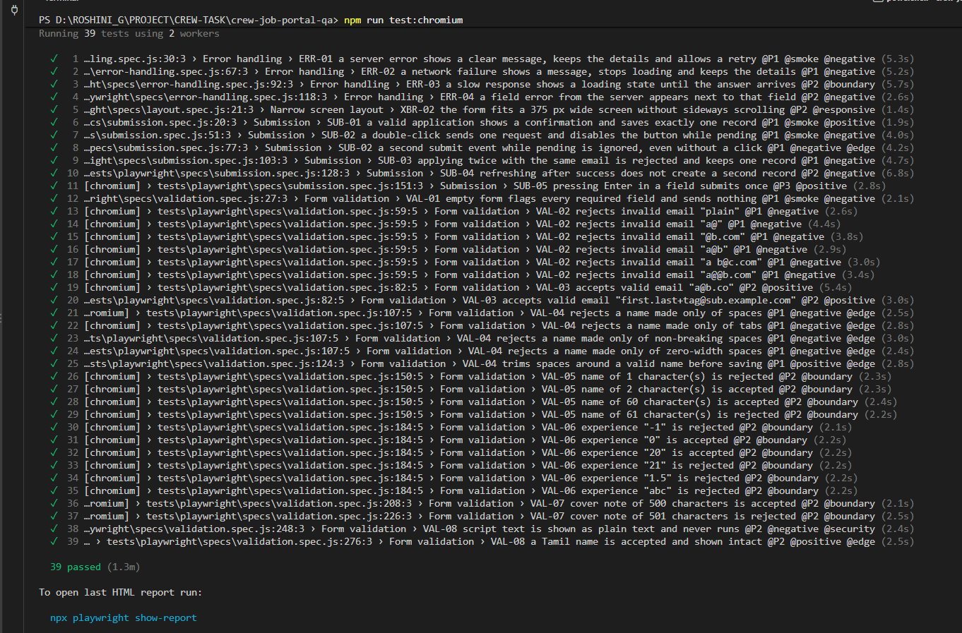

FIREFOX TEST CASE:
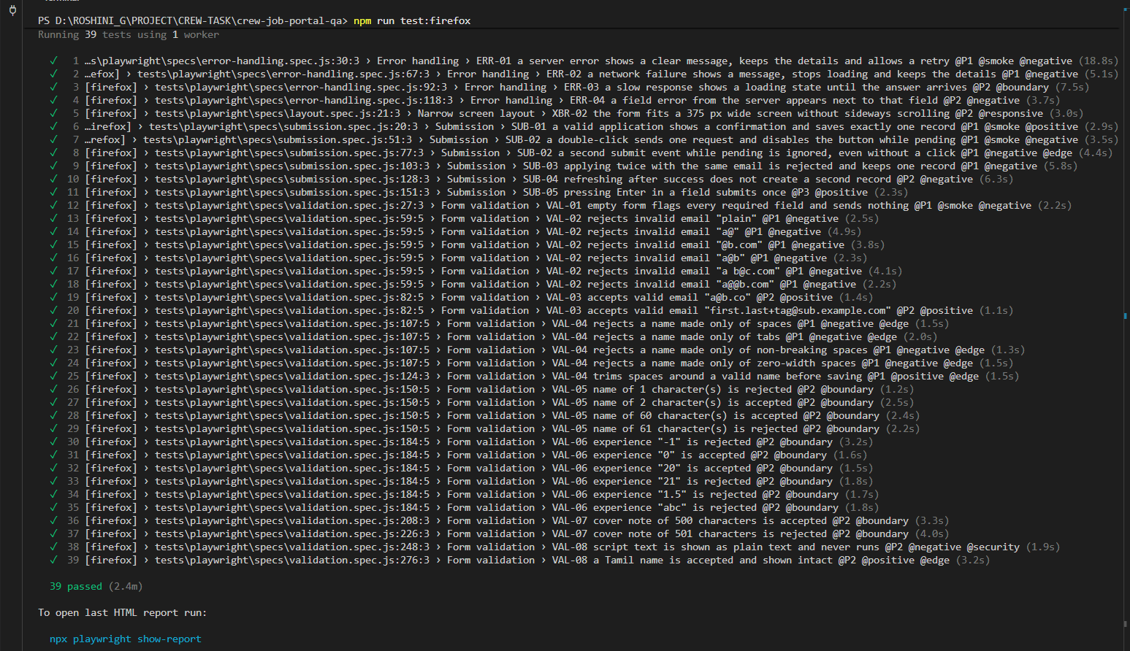

WEBKIT TEST CASE:
