Bug Reports
Live portal https://crew.tinobritty.me/jobs: HireKiwi QA Engineer assessment
Date found | 13 October 2026
Environment | Live portal, Chrome on desktop, signed in. Read-only: nothing was submitted or changed.
Source | Failed manual cases in 1_Manual_Test_Cases

Summary
ID | Title | Severity | Priority | Test case
BUG-01 | Salary on the card has no pay period | Major | High | LST-01
BUG-02 | Job without a salary shows no label | Minor | Low | LST-02
BUG-03 | Search handles extra spaces inconsistently | Minor | Medium | LST-06
BUG-04 | Selected filter is lost after pressing Back | Major | High | LST-07
BUG-05 | Filter button beside the search box does nothing | Major | High | LST-15
BUG-06 | Invalid page and type values in the URL behave inconsistently | Minor | Low | LST-09
BUG-07 | Empty area of a job card is not clickable | Minor | Low | LST-10
BUG-08 | Card and detail page show different posted dates | Minor | Medium | LST-19

Severity: Major means a key function or key information is wrong or unusable. Minor means a small defect with an easy workaround. Priority is how soon it should be fixed.

BUG-01 Salary on the card has no pay period
Severity / Priority | Major / High
Test case | LST-01
Preconditions | Live portal reachable at https://crew.tinobritty.me/jobs.
Steps to reproduce | 1. Open /jobs.  2. Find the QA Engineer card.  3. Read the salary shown on the card.
Expected result | The salary states its period, for example "per month" or "per year".
Actual result | The card shows "₹37,500 - ₹40,000" with no period. It can only be guessed as monthly (x12 = ₹4.5 to 4.8 lakh a year). A reader could take it as a yearly salary.
Evidence | ev8-qa-one-space.png (QA Engineer card)
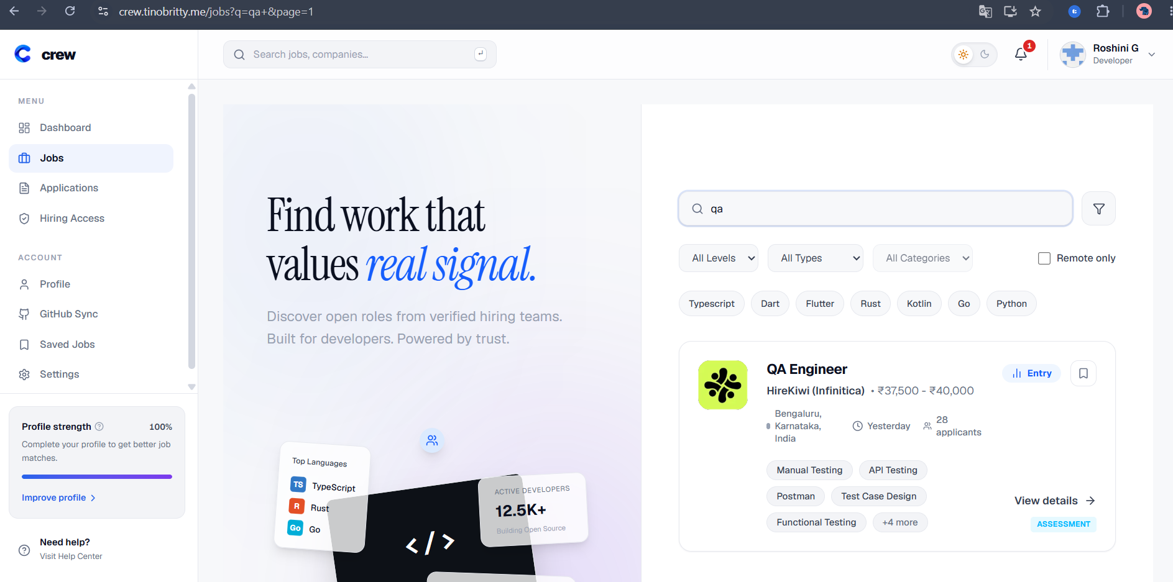
QA Engineer card with a salary and no pay period

BUG-02 Job without a salary shows no label
Severity / Priority | Minor / Low
Test case | LST-02
Preconditions | Live portal reachable at https://crew.tinobritty.me/jobs.
Steps to reproduce | 1. Open /jobs.  2. Find the Open Source Core Contributor card.  3. Look for a salary line.
Expected result | A label such as "Not disclosed" appears where the salary would be.
Actual result | No salary line and no label. The card looks incomplete next to the others.
Evidence | ev9-open-source-no-salary.png
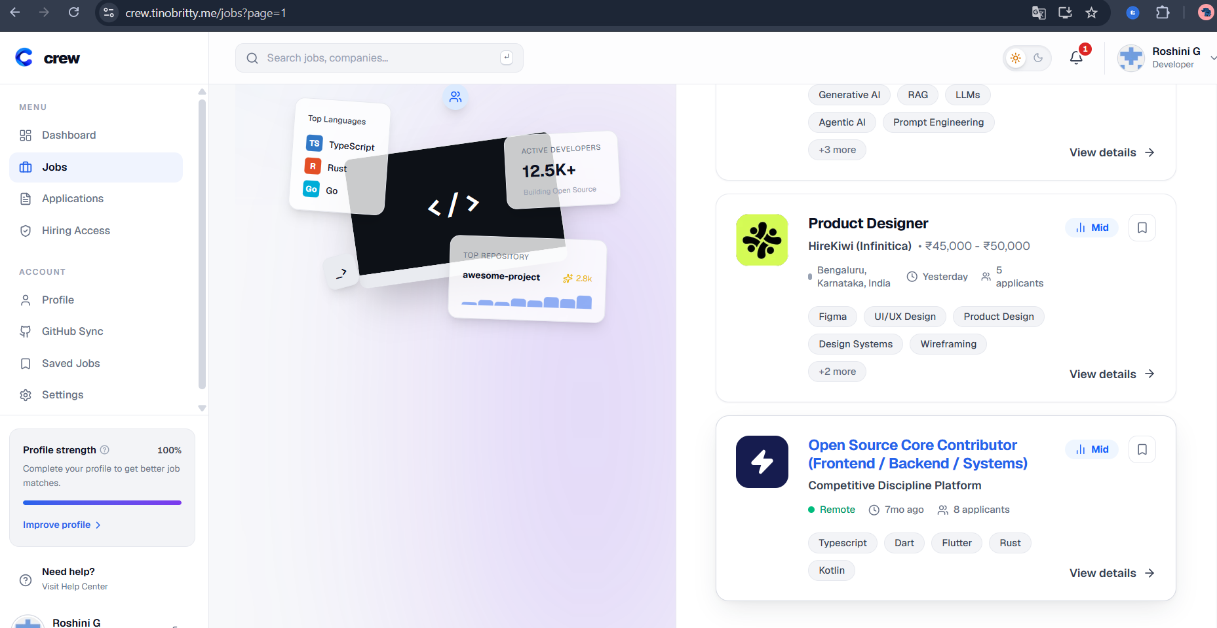
Open Source Core Contributor card with no salary line

BUG-03 Search handles extra spaces inconsistently
Severity / Priority | Minor / Medium
Test case | LST-06
Preconditions | Live portal reachable at https://crew.tinobritty.me/jobs.
Steps to reproduce | 1. Open /jobs.  2. Press the spacebar 7 times in the search box and press Enter.  3. Search "qa" followed by one space.  4. Search "qa" followed by two spaces.
Expected result | Spaces are trimmed. A spaces-only search lists all jobs. Both "qa" searches list QA Engineer.
Actual result | Spaces only: "No jobs found". One trailing space: QA Engineer is listed. Two trailing spaces: "No jobs found". The result depends on the number of spaces.
Evidence | ev4-spaces-only-search.png, ev7-qa-two-spaces.png, ev8-qa-one-space.png
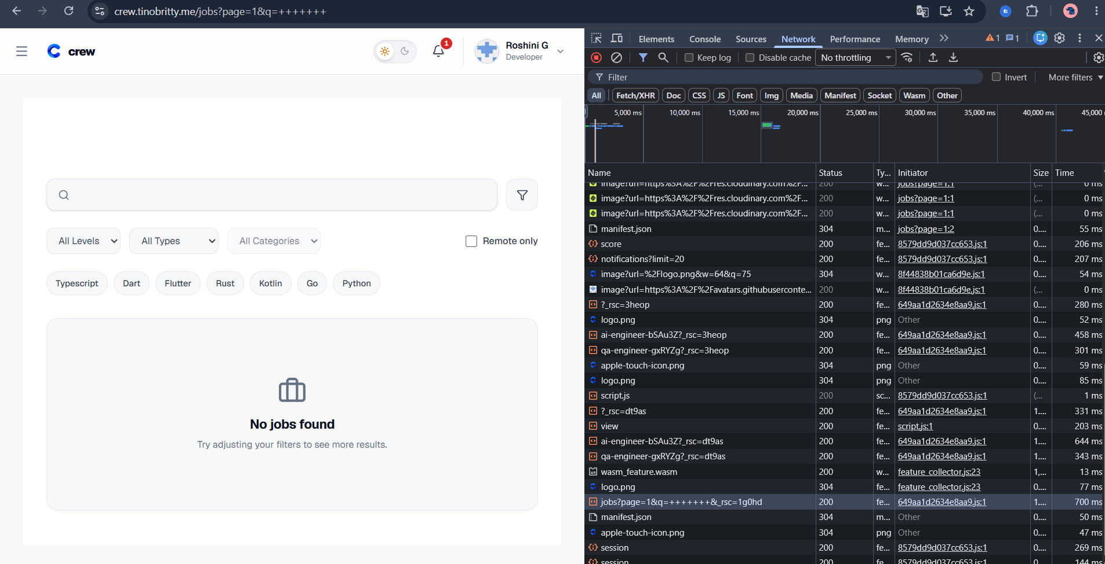
Spaces-only search shows "No jobs found"
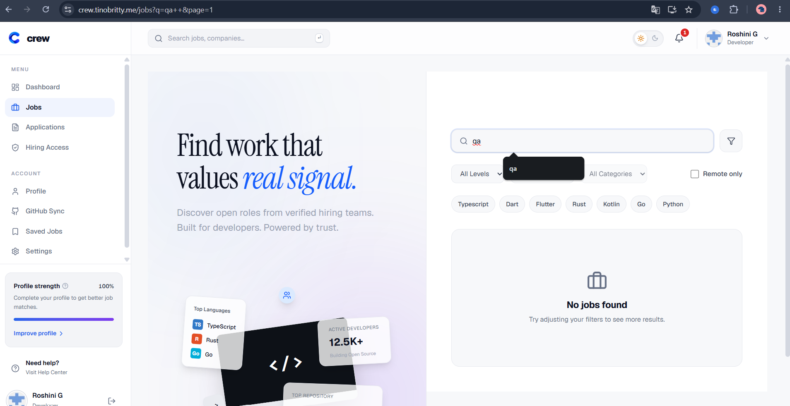
"qa" plus two spaces shows "No jobs found"

BUG-04 Selected filter is lost after pressing Back
Severity / Priority | Major / High
Test case | LST-07
Preconditions | Live portal reachable at https://crew.tinobritty.me/jobs.
Steps to reproduce | 1. Open /jobs.  2. Select the Entry level filter.  3. Open the QA Engineer job.  4. Press the browser Back button.
Expected result | The list returns with the Entry filter still selected.
Actual result | The Entry filter is reset, so the candidate has to choose it again.
Evidence | ev10-lst07-entry-filter-applied.png, ev11-lst07-filter-reset-after-back.png
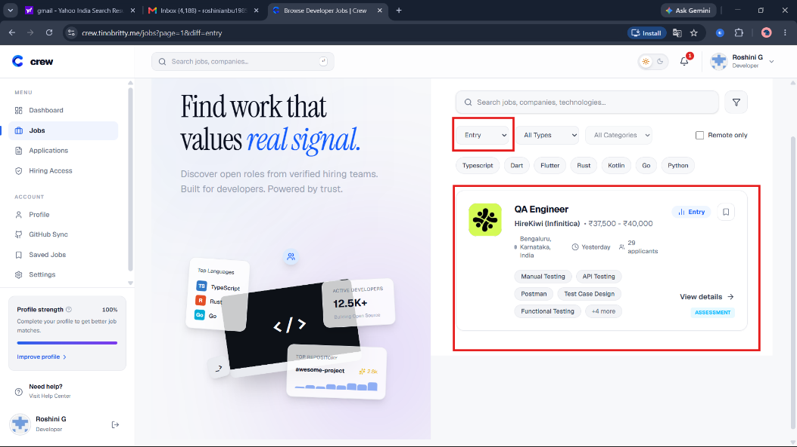
Entry filter applied before opening the job
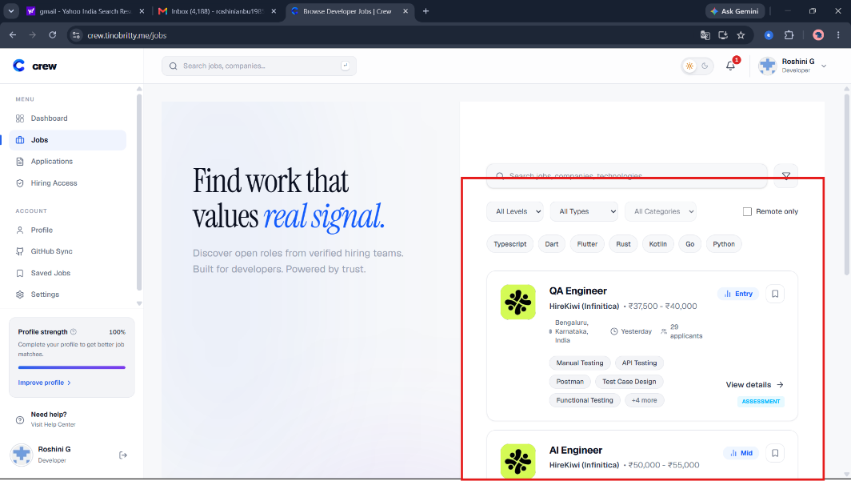
After Back: the filter shows "All Levels" again

BUG-05 Filter button beside the search box does nothing
Severity / Priority | Major / High
Test case | LST-15
Preconditions | Live portal reachable at https://crew.tinobritty.me/jobs.
Steps to reproduce | 1. Open the job listings page.  2. Click the funnel-shaped filter button beside the search box.  3. Watch for a panel, menu or extra options.
Expected result | A filter panel or menu opens with filtering controls that can be used and closed.
Actual result | Nothing opens. The button gives no response.
Evidence | ev12-lst15-filter-button.png (the filter button is marked in red)
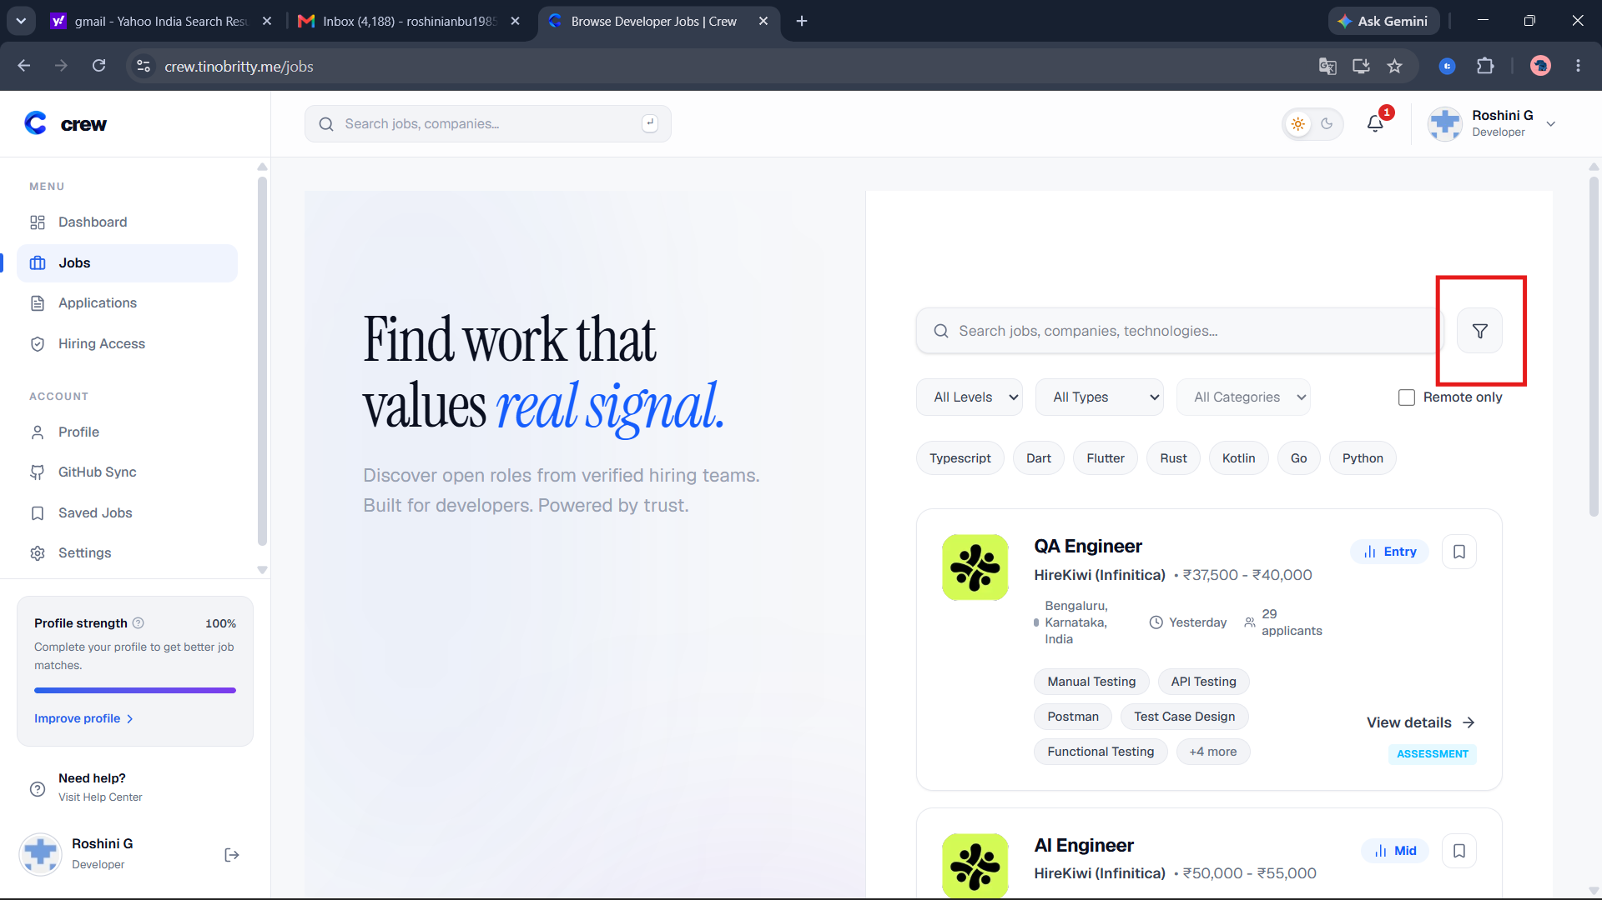
The filter button beside the search box (marked); clicking it opens nothing

BUG-06 Invalid page and type values in the URL behave inconsistently
Severity / Priority | Minor / Low
Test case | LST-09
Preconditions | Live portal reachable at https://crew.tinobritty.me/jobs.
Steps to reproduce | 1. Open /jobs?page=0, then /jobs?page=abc, then /jobs?page=-1.  2. Open /jobs?type=abc.
Expected result | Invalid values fall back to a default or are explained, in the same way for all of them.
Actual result | page=0 and page=abc show jobs. page=-1 shows "No jobs found". type=abc shows 0 jobs while the dropdown still reads "All Types", so the page contradicts itself.
Evidence | ev5-page-minus1.png, ev6-page-abc.png, ev2-diff-mid-type-abc.png
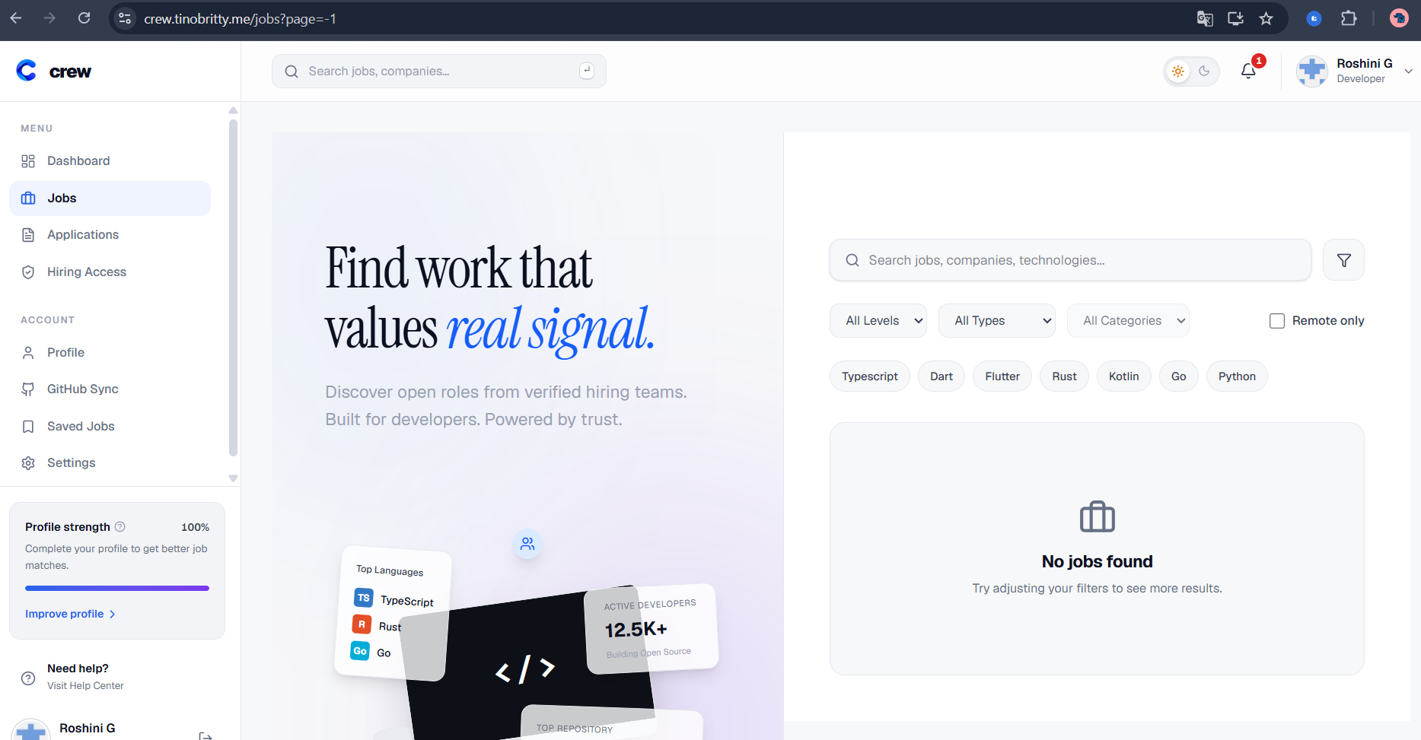
page=-1 shows "No jobs found"
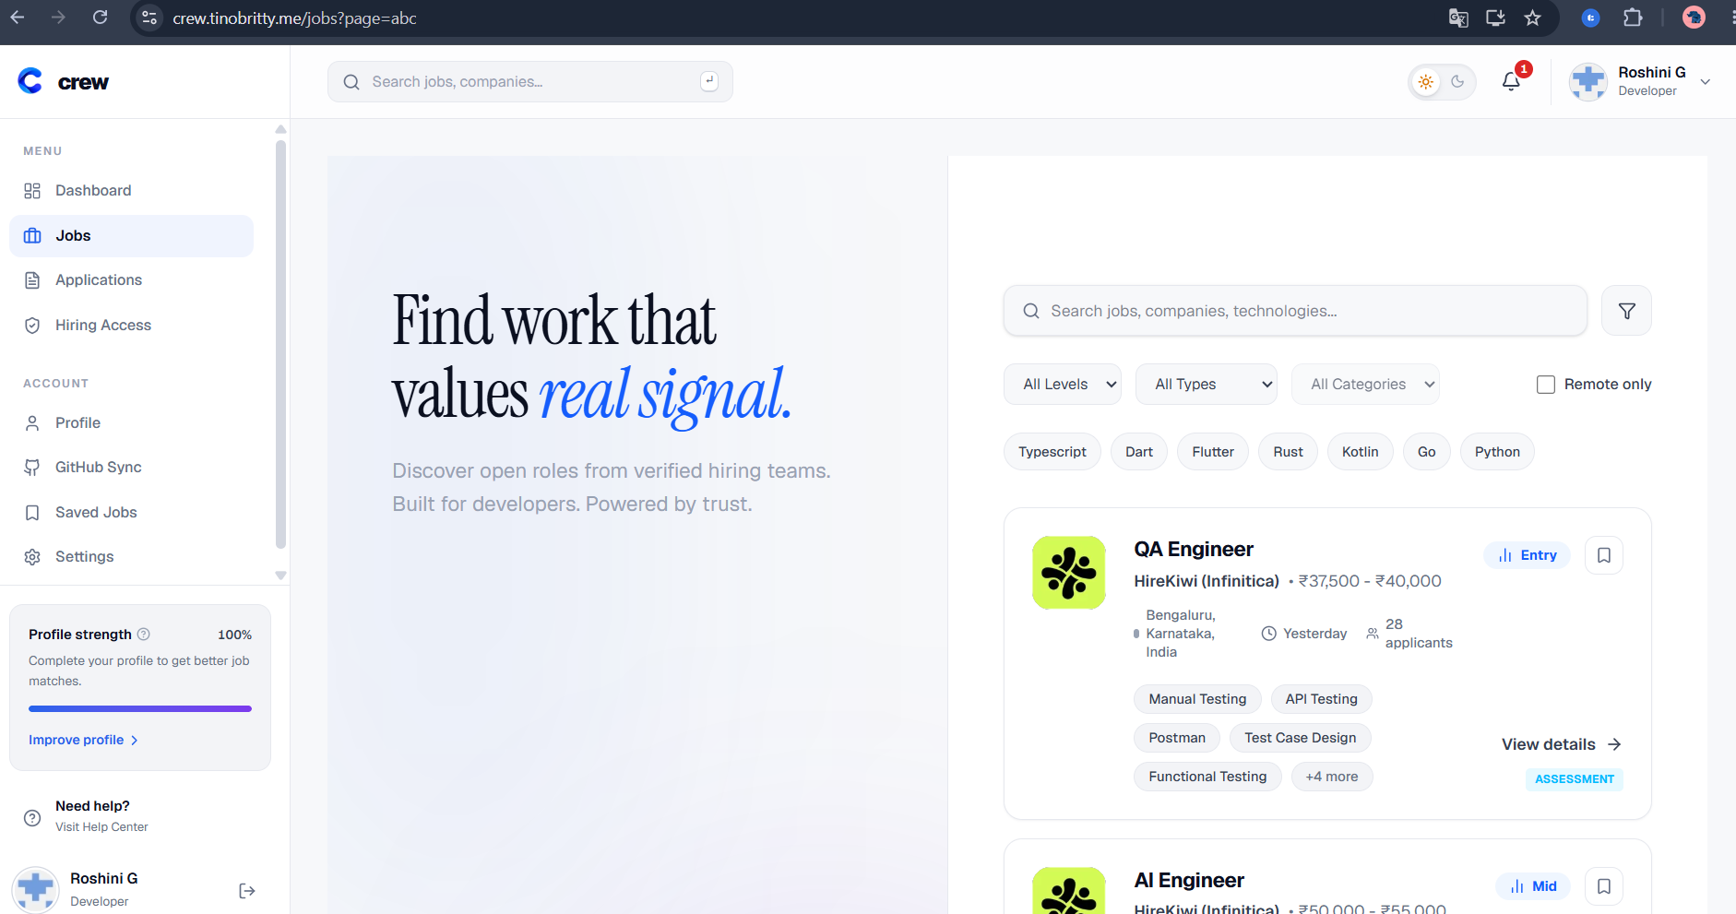
page=abc shows jobs

BUG-07 Empty area of a job card is not clickable
Severity / Priority | Minor / Low
Test case | LST-10
Preconditions | Live portal reachable at https://crew.tinobritty.me/jobs.
Steps to reproduce | 1. Open /jobs.  2. Click the empty area inside a job card, away from the title and the View details button.
Expected result | The job opens, or the page makes clear that only the title and button are links.
Actual result | Nothing happens. Only the title and View details open the job.
Evidence | ev13-lst10-card-empty-area.png (the empty card area is marked in red)
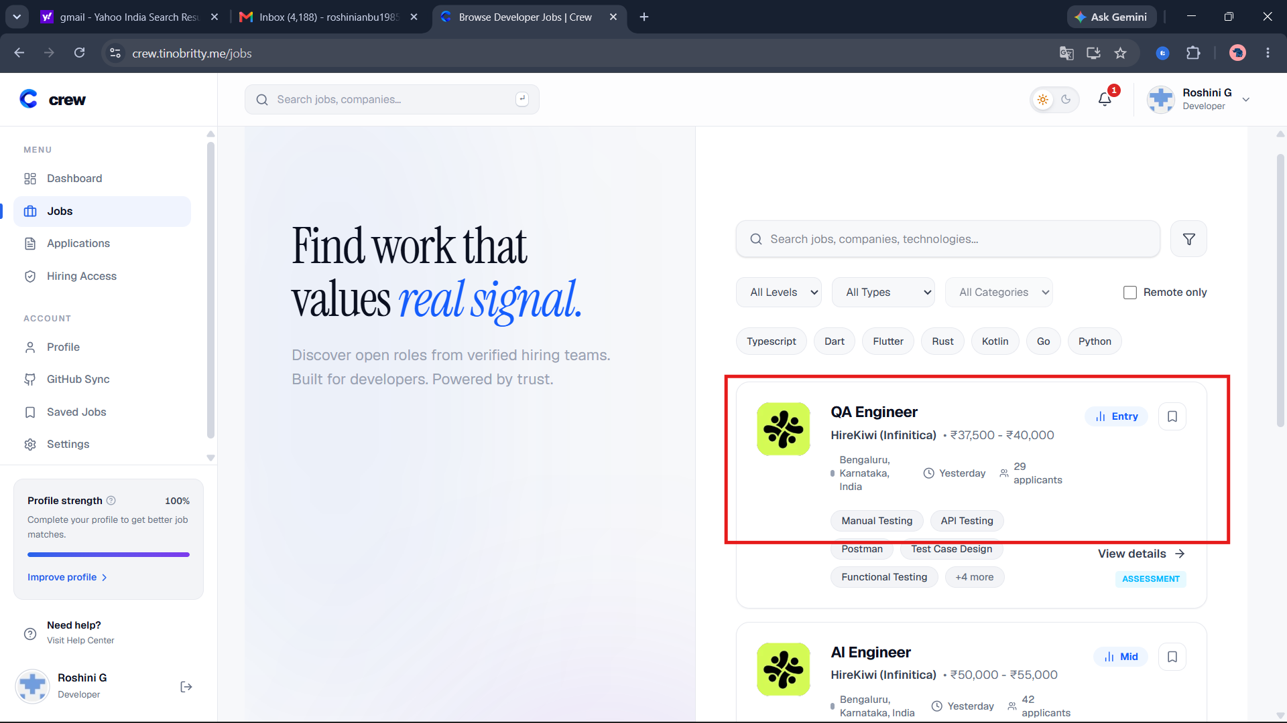
The marked empty area of the card does not respond to a click

BUG-08 Card and detail page show different posted dates
Severity / Priority | Minor / Medium
Test case | LST-19
Preconditions | Live portal reachable at https://crew.tinobritty.me/jobs.
Steps to reproduce | 1. Open /jobs and note the posted time and applicant count on the QA Engineer card.  2. Open the detail page straight away.  3. Compare the posted date.
Expected result | Both pages show the same date, in a format that is clear for Indian users, for example 12 Oct 2026.
Actual result | The card says "Yesterday" (12/10/2026), but the detail page says "Posted 10/11/2026", which is 11 October 2026 in MM/DD/YYYY format. The two dates do not match and the format is easy to misread as 10 November.
Evidence | ev14-lst19-card-yesterday.png, ev15-lst19-detail-posted-date.png
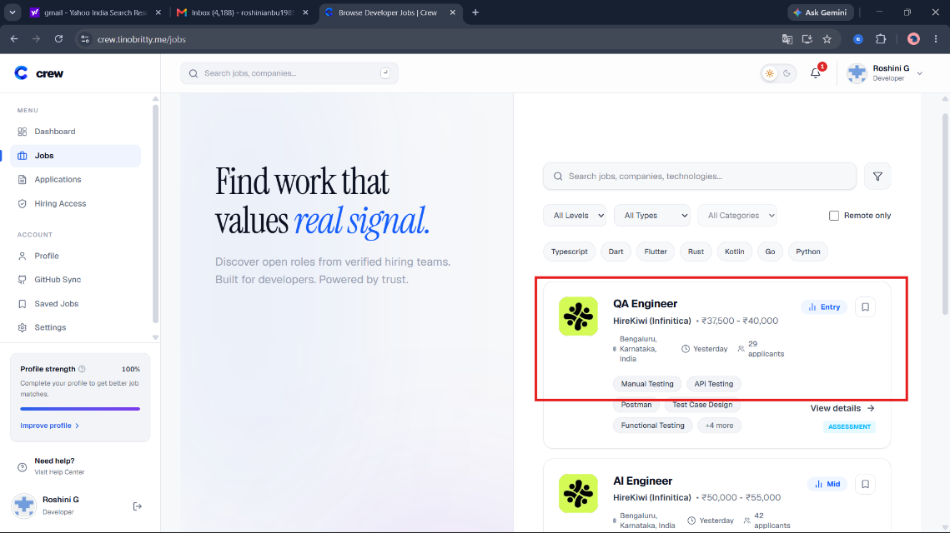
Card: posted "Yesterday"
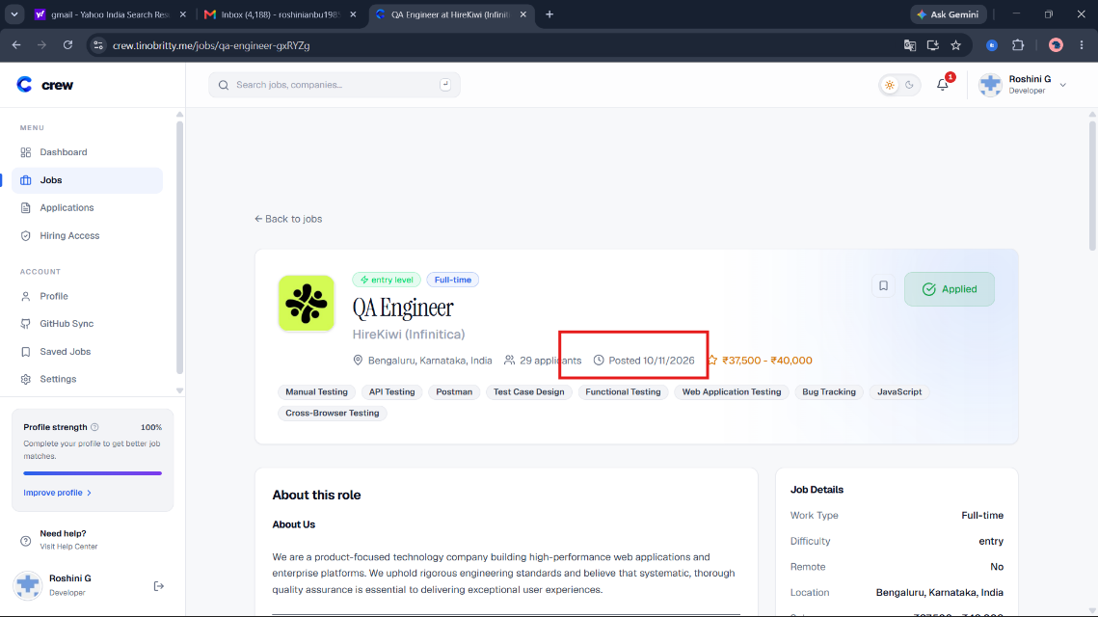
Detail page: "Posted 10/11/2026"

