**Enterprise Standards and Best Practices for It Infrastructure (sub code)**

**B.Sc. Special Honors Degree**

**in**

**Information Technology**

**4th Year**

**Lab 02– Create your first Amazon RDS Database**

**.**



**Objectives:**

Creating a MySQL DB Instance and Connecting to a Database on a MySQL DB Instance

**Introduction:**

**Amazon Relational Database Service (Amazon RDS)** is a web service that makes it easy to set up, operate, and scale a relational database in the cloud. You can migrate existing applications and tools that utilize a relational database to the Amazon Web Services because Amazon RDS offers access to the capabilities of a MySQL, Oracle, SQL Server, and the PostgreSQL database engine. Amazon RDS provides cost-efficient and resizable capacity while managing time-consuming database administration tasks. This efficiency frees you to focus on your applications and business.

This lab is focused on Amazon RDS. Follow along and learn to create and use your first RDS database with Amazon AWS.

The easiest way to create a DB instance is to use the AWS Management Console. Once you have created the DB instance, you can use standard MySQL utilities such as MySQL Workbench to connect to a database on the DB instance.

**Exercise:**

***Task:*** To complete this lab, perform the following tasks:

1. [Creating a MySQL DB Instance](http://docs.aws.amazon.com/AmazonRDS/latest/UserGuide/CHAP_GettingStarted.CreatingConnecting.MySQL.html#CHAP_GettingStarted.Creating.MySQL)
2. [Connecting to a Database on a DB Instance Running the MySQL Database Engine](http://docs.aws.amazon.com/AmazonRDS/latest/UserGuide/CHAP_GettingStarted.CreatingConnecting.MySQL.html#CHAP_GettingStarted.Connecting.MySQL)
3. [Deleting a DB Instance](http://docs.aws.amazon.com/AmazonRDS/latest/UserGuide/CHAP_GettingStarted.CreatingConnecting.MySQL.html#CHAP_GettingStarted.Deleting.MySQL)

## **Prerequisites**

## Before you begin, you must complete the tasks in the [Setting Up for Amazon RDS](http://docs.aws.amazon.com/AmazonRDS/latest/UserGuide/CHAP_SettingUp.html) section before you can create or connect to a DB instance.

**Step 1: Creating a MySQL DB Instance**

The basic building block of Amazon RDS is the DB instance. This is the environment in which you will run your MySQL databases.

In this lab, you create a DB instance running the MySQL database engine called *west2-mysql-instance1*, with a *db.m1.small* DB instance class, 15 GB of storage, and automated backups enabled with a retention period of one day.

**To create a MySQL DB instance**

1. Sign in to the AWS Management Console and open the Amazon RDS console at <https://console.aws.amazon.com/rds/>.
2. In the top right corner of the Amazon RDS console, choose the region in which you want to create the DB instance.
3. In the navigation pane, choose Instances.
4. Choose Launch DB Instance. The Launch DB Instance Wizard opens on the Select Engine page.
5. On the Select Engine page, choose the MySQL icon and then choose Select for the MySQL DB engine.
6. On the Specify DB Details page, specify your DB instance information. The following table shows settings for an example DB instance. When the settings are as you want them, choose next.

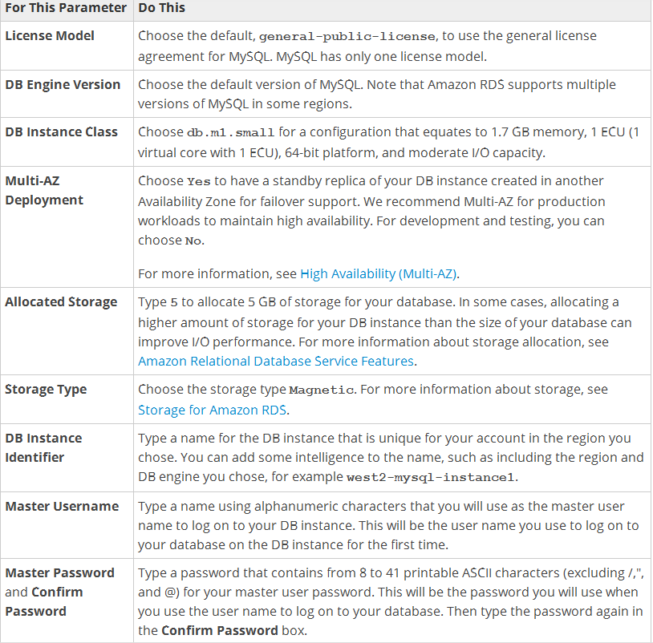

1. On the Configure Advanced Settings page, provide additional information that RDS needs to launch the MySQL DB instance. The table shows settings for an example DB instance. Specify your DB instance information, then choose Launch DB Instance
2. On the RDS console, the new DB instance appears in the list of DB instances. The DB instance will have a status of **creating** until the DB instance is created and ready for use. When the state changes to **available**, you can connect to a database on the DB instance. Depending on the DB instance class and store allocated, it could take several minutes for the new DB instance to become available.

**Step 2: Connecting to a Database on a DB Instance Running the MySQL Database Engine**

Once Amazon RDS provisions your DB instance, you can use any standard SQL client application to connect to a database on the DB instance. In this example, you connect to a database on a MySQL DB instance using MySQL monitor commands. One GUI-based application you can use to connect is MySQL Workbench.

**To connect to a database on a DB instance using MySQL monitor**

* Type the following command at a command prompt on a client computer to connect to a database on a MySQL DB instance using the MySQL monitor. Substitute the DNS name for your DB instance for <endpoint>, the master user name you used for <mymasteruser>, and the master password you used for <password>.

PROMPT> mysql -h <endpoint> -P 3306 -u <mymasteruser> -p

* You will see output similar to the following.

Welcome to the MySQL monitor. Commands end with ; or \g.

Your MySQL connection id is 350

Server version: 5.1.32-log MySQL Community Server (GPL)

Type 'help;' or '\h' for help. Type '\c' to clear the buffer.

mysql>

**Step 3:Deleting a DB Instance**

Once you have connected to the sample DB instance that you created, you should delete the DB instance so you are no longer charged for it.

**To delete a DB instance with no final DB snapshot**

1. Sign in to the AWS Management Console and open the Amazon RDS console at <https://console.aws.amazon.com/rds/>.
2. In the Instances list, choose the DB instance you wish to delete.
3. Choose Instance Actions, and then choose Delete from the dropdown menu.
4. Choose **No** in the Create final Snapshot? drop-down list box.
5. Choose Yes, Delete.