CodeWatchdog Project Review
Architecture, code behavior, risks, vulnerabilities, and implementation plan
Reviewed path: D:\machine_learning_projects\code-watch-dog | Date: 28 July 2026

Executive Summary
CodeWatchdog is intended to be an AI-powered GitHub pull-request review bot. A GitHub webhook calls a FastAPI endpoint when a PR is opened, the app fetches the PR diff, sends the diff to a model reviewer, parses the returned JSON, and posts a formatted review comment back to the PR.
The current repository is a prototype, not production-ready. It has a clear idea and a small codebase, but a fresh setup cannot run successfully as documented. The current app has missing dependencies, import path problems, a removed or renamed review function, webhook authentication missing, unpinned dependencies, no tests, and fragile LLM-response parsing.
Most urgent fixes are: restore the runtime path, add the missing Groq dependency, move demo code behind a main guard, validate GitHub webhook signatures, add request timeouts and error handling, pin dependencies, and add a minimal test suite.

Project Snapshot
Area | Finding
Purpose | Automated pull-request review bot using FastAPI, GitHub webhooks, GitHub API, and Groq/Ollama model review.
Repository size | Small prototype: 3 tracked app files plus README, LICENSE, requirements, and .gitignore. One untracked helper file is present.
Current Git state | app/groq_review.py is modified; app/ollamacheck.py is untracked. These were reviewed as current local state.
Runtime status | Syntax compilation passes, but a fresh dependency install followed by importing app.main fails.
Dependency status | requirements.txt is unpinned and missing the groq package used by app/groq_review.py.
Security status | Webhook endpoint accepts unsigned JSON and trusts payload fields without validating that the request came from GitHub.

Architecture Graph
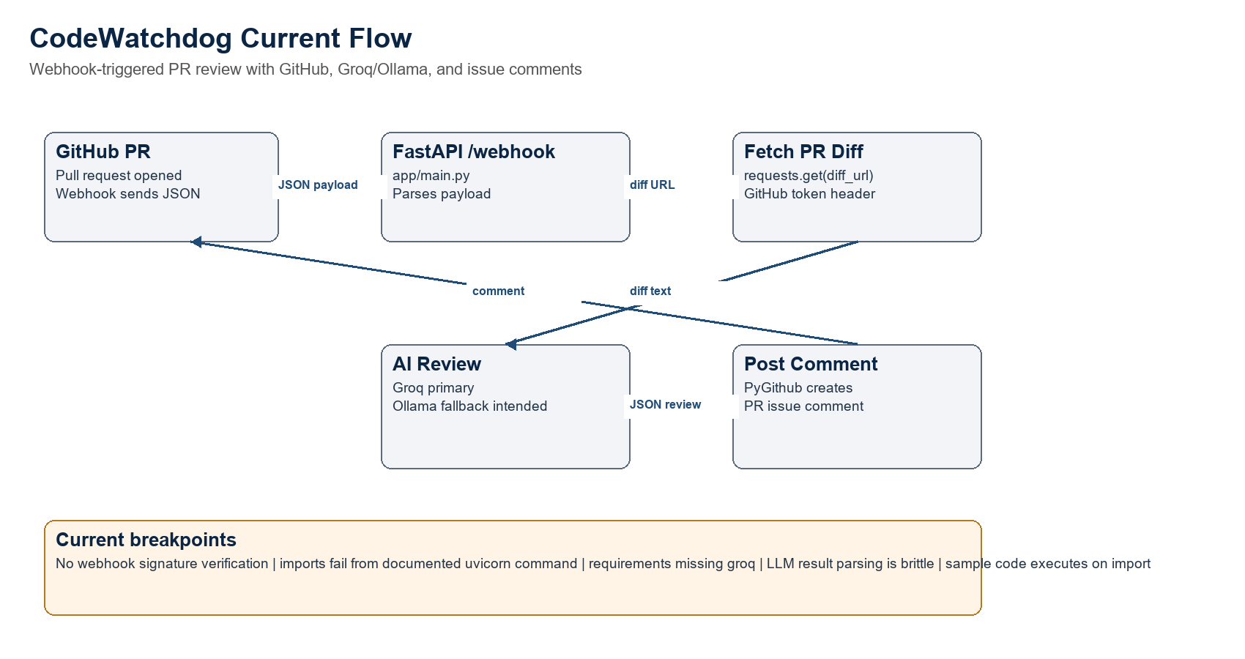
Figure 1. Current intended request path and observed breakpoints.

How The Code Works
- GitHub ends a pull_request webhook to POST /webhook.
- app/main.py reads the JSON body and ignores events whose action is not opened.
- For opened PRs, it extracts pull_request.number, repository.full_name, and pull_request.diff_url.
- It calls requests.get(diff_url) with the GitHub token and passes the diff text to the AI review function.
- The review function is intended to call Groq first and Ollama as fallback.
- app/github_utils.py extracts JSON from the model response, formats Markdown, and posts a PR issue comment through PyGithub.

File-by-File Code Review
File | Role | Important Observations
app/main.py | FastAPI webhook entrypoint. | Imports PR_Agent from groq_review, but the local groq_review.py no longer defines PR_Agent. It fetches diffs synchronously with no timeout, does not check HTTP status, and does not validate webhook signatures.
app/groq_review.py | Model review provider. | Defines use_groq_for_review, use_ollama_for_review, and review_code. It executes example code at import time, which can trigger model calls just by importing the module. It imports groq, but groq is absent from requirements.txt.
app/github_utils.py | GitHub comment publisher. | Parses model JSON using a greedy regex, assumes required fields exist, and swallows most exceptions by printing errors. The token error message asks for GITHUB_TOKEN but the code reads GitHub_token.
app/ollamacheck.py | Local Ollama experiment. | Untracked helper script that posts to localhost Ollama. It is not wired into the app and should be moved to tests/tools or removed from production source.
requirements.txt | Dependency declaration. | Lists package names only. No version pins, no groq package, no dev/test tooling, no lock file.
.env | Local secrets file. | Contains configured key names, but keys are not shown in this report. .gitignore includes .env, which is correct.

Confirmed Runtime Problems
- Fresh install/import check failed after installing requirements: importing app.main from the project root fails with ModuleNotFoundError: No module named 'groq_review'.
- When the app folder is added directly to the import path, importing main then fails with ModuleNotFoundError: No module named 'groq' because requirements.txt does not include groq.
- After groq is installed, another failure is expected because main.py imports PR_Agent, but groq_review.py currently defines review_code instead.
- groq_review.py runs demo code during module import. In a web server, this can cause unexpected LLM/API calls on startup or import.
- The checked virtual environment does not contain the app dependencies, so it cannot currently run the FastAPI app.

Security and Vulnerability Review
Severity | Issue | Evidence | Impact | Fix
Critical | No GitHub webhook signature validation. | main.py reads request.json() directly and does not inspect X-Hub-Signature-256. | Anyone who can reach /webhook can forge payloads and cause the app to fetch diffs and post comments using the GitHub token. | Add WEBHOOK_SECRET and verify HMAC-SHA256 against the raw request body before parsing JSON.
High | Prompt injection through untrusted PR diff. | Raw diff content is sent directly to the LLM as review input. | A malicious PR can try to override the reviewer instructions or force malformed/hostile output. | Use system/developer prompt separation, wrap diff as untrusted data, require schema validation, and limit model authority.
High | No timeouts or status checks for outbound HTTP. | requests.get(diff_url) and requests.post(ollama_api_key) have no timeout and do not call raise_for_status(). | Webhook worker can hang, fail silently, or process an error page as a code diff. | Set short timeouts, check status codes, retry only safe failures, and return controlled errors.
High | Weak dependency reproducibility. | requirements.txt has no pinned versions. | Different installs can produce different dependency trees; security audit results are not stable. | Use pinned requirements or pyproject/lock file plus Dependabot/pip-audit in CI.
Medium | Fragile JSON extraction from LLM output. | github_utils.py uses re.search(r'\{.*\}', review, re.DOTALL). | Nested braces or extra content can break parsing; missing keys can crash comment generation. | Use structured-output mode if available, json.loads on full response, and Pydantic validation.
Medium | Secrets can be exposed through logs or exception text. | The app prints review content and URLs; broad exceptions print raw messages. | Sensitive code diff content or provider errors may leak into logs. | Use structured logging, redact tokens/secrets, avoid printing full diff/model output in production.
Medium | No repository allowlist. | repo_name comes from the webhook payload and is trusted. | If webhook auth is absent or weak, the app can be abused against any repo the token can access. | After signature validation, enforce an allowed repo/org list and least-privilege tokens.
Low | No request/event idempotency. | No use of X-GitHub-Delivery header. | Retries or duplicate deliveries can create duplicate comments. | Store delivery IDs or comment markers and make processing idempotent.

Risk Graph
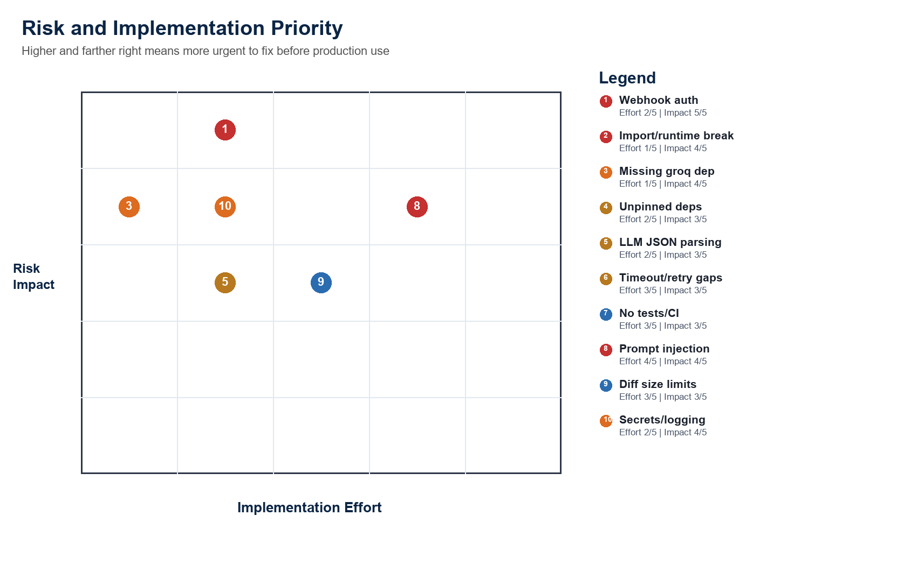
Figure 2. Relative risk impact and implementation effort for the main fixes.

Dependency and Supply-Chain Review
- A pip-audit run against requirements.txt resolved the unpinned dependencies and reported no known vulnerabilities in that resolved set on 28 July 2026.
- Because the requirements are unpinned, that audit is not reproducible. A later install could resolve different versions.
- The source imports groq, but requirements.txt does not declare groq. A new developer following the README will not get a working environment.
- The existing .venv appears to contain notebook/kernel packages rather than the app runtime packages. It should not be treated as the canonical environment.
- Recommended baseline: create pyproject.toml or pinned requirements.txt, add requirements-dev.txt for pytest/ruff/pip-audit, and commit a lock file if the team wants deterministic deployments.

What A New Person Should Know
Concept | Plain-English Explanation
Webhook | GitHub sends the server a message when a pull request is opened.
Diff | The changed code in the pull request. This is what the model reviews.
Groq | Hosted LLM provider used as the primary review engine.
Ollama | Local fallback model server, intended to run on the developer or deployment machine.
PyGithub | Python library used to post the final review as a GitHub PR comment.
FastAPI | Web framework exposing /webhook.
Review JSON | The model is asked to return score, feedback, security_issues, suggestions, and summary.

Recommended Implementation Plan
Phase 1: Make the app run locally.
- Add app/__init__.py and change imports to package-relative imports such as from app.groq_review import review_code or from .groq_review import review_code.
- Update main.py to call review_code or restore PR_Agent with the intended name.
- Add groq to requirements.txt and pin every runtime dependency.
- Move groq_review.py demo code under if __name__ == '__main__': or delete it.
- Add a README command that matches the actual import path: uvicorn app.main:app --reload.
Phase 2: Secure the webhook before public exposure.
- Add WEBHOOK_SECRET and verify X-Hub-Signature-256 over the raw request body.
- Reject missing/invalid signatures before calling request.json().
- Check X-GitHub-Event is pull_request and action is one of the supported actions.
- Add allowed repositories or allowed organization checks.
- Use a fine-grained token with only the minimum repositories and permissions needed.
Phase 3: Make model review reliable.
- Separate trusted instructions from untrusted diff content.
- Limit diff size and summarize or skip huge files/binary files.
- Validate model output with Pydantic before posting to GitHub.
- Provide a fallback comment when model output is invalid instead of silently failing.
- Add retry/backoff for transient provider failures and explicit timeouts for every network call.
Phase 4: Add tests and CI.
- Unit test webhook signature verification.
- Unit test model JSON validation with good, missing-field, and malformed responses.
- Mock GitHub and Groq/Ollama calls in tests.
- Add CI for pytest, linting, import check, and pip-audit.

Suggested Target Structure
A maintainable next version should separate web routing, security validation, provider clients, review schema, and GitHub posting:
Path | Responsibility
app/main.py | FastAPI app creation and route registration only.
app/routes/webhook.py | Webhook endpoint orchestration.
app/security/github_webhook.py | Signature validation and delivery-id handling.
app/services/github_client.py | Fetch diff and post review comments.
app/services/review_provider.py | Groq/Ollama calls, retries, and timeout policy.
app/models/review.py | Pydantic schema for review output.
tests/ | Unit and integration tests with mocked external services.
pyproject.toml | Pinned dependency groups, tool config, lint/test settings.

Definition of Done Before Production
- Fresh clone can run with documented commands.
- Webhook requests require valid X-Hub-Signature-256.
- All outbound HTTP has timeouts, status checks, and safe error handling.
- Dependencies are pinned and audited in CI.
- No demo/model call executes at import time.
- Model output is schema-validated before posting.
- At least unit tests cover webhook validation, payload parsing, review parsing, and GitHub comment formatting.
- Logs redact secrets and avoid dumping full diffs or model output in production.

Evidence Collected
- Syntax compilation passed for app/main.py, app/groq_review.py, app/github_utils.py, and app/ollamacheck.py.
- Fresh install from requirements.txt followed by importing app.main failed with ModuleNotFoundError: No module named 'groq_review'.
- Importing with the app folder directly on sys.path failed with ModuleNotFoundError: No module named 'groq'.
- pip-audit against requirements.txt reported no known vulnerabilities in its resolved dependency set, but that result depends on unpinned resolution.
- Git state showed one modified tracked file and one untracked helper file.
- .env was inspected only for key names; secret values were not copied into this report.

External References
- GitHub recommends creating a webhook secret and validating incoming payloads against that token to verify they came from GitHub and were not tampered with.
- GitHub webhook best practices include using a webhook secret, HTTPS/SSL verification, checking event type/action, responding quickly, and using X-GitHub-Delivery.
- pip-audit scans Python environments or requirements for packages with known vulnerabilities using the Python Packaging Advisory Database.

