LABCYCLE-2

1.Create two activites from the first activity move to second activity on button click.
Activity main.xml
<LinearLayout android:layout_width="match_parent"
android:layout_height="match_parent"
android:orientation="vertical"
android:gravity="center"
xmlns:android="http://schemas.android.com/apk/res/android">
<Button
android:layout_width="wrap_content"
android:layout_height="wrap_content"
android:text="move"
android:layout_gravity="center"
android:id="@+id/b"
android:onClick="move"/>
</LinearLayout>
mainactivity.java
package com.example.sjcet.cycle21;
import android.support.v7.app.AppCompatActivity;
import android.os.Bundle;
import android.view.View;
import android.content.Intent;
import android.widget.Button;
public class MainActivity extends AppCompatActivity {
Button b;
@Override
protected void onCreate(Bundle savedInstanceState) {
super.onCreate(savedInstanceState);
setContentView(R.layout.activity_main);
b = findViewById(R.id.b);
}
public void move(View view) {
openNewActivity();
}
public void openNewActivity(){
Intent intent = new Intent(this, NewActivity.class);
startActivity(intent);
}
}
activitynew.xml

<LinearLayout android:layout_width="match_parent"
android:layout_height="match_parent"
android:orientation="vertical"
android:gravity="center"
xmlns:android="http://schemas.android.com/apk/res/android">
<TextView
android:layout_width="match_parent"
android:layout_height="match_parent"
android:text="welcome to new activity"
android:gravity="center"/>
</LinearLayout>

newactivity.java
package com.example.sjcet.cycle21;
import android.support.v7.app.AppCompatActivity;
import android.os.Bundle;
public class NewActivity extends AppCompatActivity {
@Override
protected void onCreate(Bundle savedInstanceState) {
super.onCreate(savedInstanceState);
setContentView(R.layout.activity_new);
}
}
Output
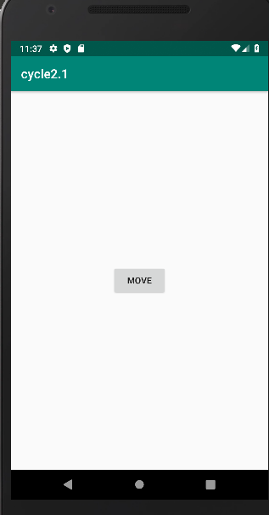
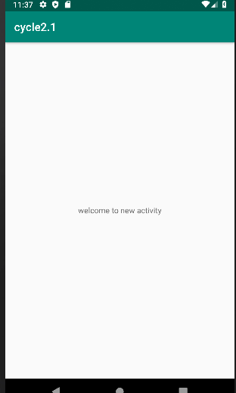

2.Create an activity and move to facebook login page on button click.
Activity main.xml
<LinearLayout android:layout_width="match_parent"
android:layout_height="match_parent"
android:orientation="vertical"
android:gravity="center"
xmlns:android="http://schemas.android.com/apk/res/android">

android:layout_width="wrap_content"
android:layout_height="wrap_content"
android:id="@+id/b1"
android:text="move"
android:onClick="move"/>
</LinearLayout>
mainactivity.java
package com.example.sjcet.facebook;
import android.support.v7.app.AppCompatActivity;
import android.os.Bundle;
import android.view.View;
import android.widget.Button;
import android.net.Uri;
import android.content.Intent;
public class MainActivity extends AppCompatActivity {
Button b1;
@Override
protected void onCreate(Bundle savedInstanceState) {
super.onCreate(savedInstanceState);
setContentView(R.layout.activity_main);
b1= findViewById(R.id.b1);
}
public void move(View view) {
Intent intent = new Intent(Intent.ACTION_VIEW,Uri.parse("https://facebook.com"));
startActivity(intent);
}
}

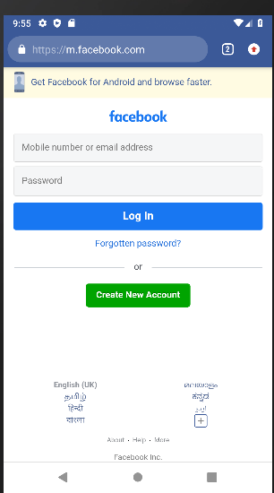
Output
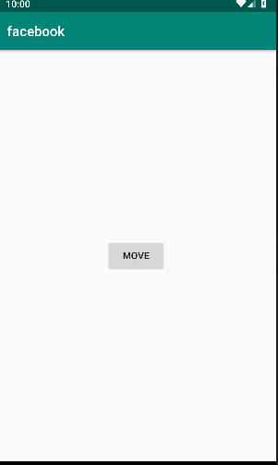

3.Read a message in first activity and pass it to the second activity on a button click.
<LinearLayout
android:layout_height="match_parent"
android:layout_width="match_parent"
android:orientation="vertical"
android:layout_gravity="center"
xmlns:android="http://schemas.android.com/apk/res/android" >
<EditText
android:id="@+id/msg"
android:layout_width="match_parent"
android:layout_height="wrap_content"
android:hint="Enter Message" />
<Button
android:id="@+id/snd"
android:layout_width="wrap_content"
android:layout_height="wrap_content"
android:text="Send"
android:layout_gravity="center"
android:onClick="click"/>
</LinearLayout>
JAVA:
package com.example.sjcet.c2_p2;
import android.content.Intent;
import android.support.v7.app.AppCompatActivity;
import android.os.Bundle;
import android.view.View;
import android.widget.Button;
import android.widget.TextView;
public class MainActivity extends AppCompatActivity {
TextView msg;
Button snd;
@Override
protected void onCreate(Bundle savedInstanceState) {
super.onCreate(savedInstanceState);
setContentView(R.layout.activity_main);
msg=findViewById(R.id.msg);
snd=findViewById(R.id.snd);
}
public void click(View view) {
String str = msg.getText().toString();
Intent intent=new Intent(getApplicationContext(),Main2Activity.class);
intent.putExtra("Message_Key",str);
startActivity(intent);
}
}
XML:
<LinearLayout android:layout_height="match_parent"
android:layout_width="match_parent"
android:orientation="vertical"
xmlns:android="http://schemas.android.com/apk/res/android" >
<TextView
android:id="@+id/rcv"
android:layout_width="match_parent"
android:layout_height="wrap_content"
android:gravity="center"/>
</LinearLayout>
JAVA:
package com.example.sjcet.c2_p2;
import android.content.Intent;
import android.support.v7.app.AppCompatActivity;
import android.os.Bundle;
import android.widget.TextView;
public class Main2Activity extends AppCompatActivity {
TextView rcv;
@Override
protected void onCreate(Bundle savedInstanceState) {
super.onCreate(savedInstanceState);
setContentView(R.layout.activity_main2);
rcv=findViewById(R.id.rcv);
Intent intent = getIntent();
String str = intent.getStringExtra("Message_Key");
// display the string into textView
rcv.setText(str);
}

Output
