Support-Constrained Interpretable Subgroup Discovery for Survival Outcomes:
A Complete Engineering Evaluation on ACTG175
Author Name
Department of Computer Science, Amrita Vishwa Vidyapeetham, Kollam, India
email@example.com
Interpretable subgroup analyses are usually justified by the claim that they identify patients who benefit more than the average. We test that claim for CISCaRL, a support-constrained survival rule model, against a constant model, a survival causal rule ensemble (SCRE), and a sequence of pre-registered alternatives covering every modelling layer. The estimand is τ(730|x)=S1(730|x)−S0(730|x) for the ACTG175 composite progression-free endpoint. Estimation is per-arm Cox plus a conditional censoring Cox, five-fold cross-fitted, with augmented inverse-probability weighting (AIPW). Discovery fits a depth-3 CART to the AIPW pseudo-outcome; the selected leaf must contain at least 200 discovery patients; its effect is re-estimated on a disjoint validation partition; and treatment is recommended only when the one-sided 95% lower confidence bound is positive. Discovery, validation and assessment are disjoint (527/263/264). We report the full decision record, not only the winning configuration: nuisance models (Cox, RSF, gradient boosting, stacking), rule learners (CART, pruned CART, PRIM, classification tree, boosting distillation), estimators (AIPW, pooled Cox, T-learner, IPW, plug-in, fixed-horizon IPCW-TMLE), calibration (none, shrinkage, isotonic), intervals (influence function, bootstrap, selection bootstrap, conformal), fold counts, feature selection (12, 16, lasso, RFE), horizon (365–1,095 days), SCRE alpha path, fairness/transport, and learned stacking. The frozen model is C200: depth-3 CART, leaf 60, support 200, LCB commitment. Isotonic calibration is adopted for prediction (C200-I); the IF interval is retained. On ACTG175 the support constraint cannot be met: the fallback rule is cd40≤407.5 & wtkg>71.0 & homo≤0.5 (support 61), validation +0.116 (SE 0.222, LCB −0.250), so the model abstains. Assessment is +0.401 [+0.033,+0.770] on 38 patients. The result is a defensible precision-oriented operating point with a measured range, not a universal improvement over the marginal average.
Index Terms—survival analysis, heterogeneous treatment effects, subgroup discovery, doubly robust estimation, interpretable rules, abstention, AIPW, engineering decision record.

1. Introduction
Randomized trials establish an average effect, but clinicians treat individuals. A subgroup analysis promises to turn the average into a decision: who should be treated, how much benefit to expect, and when the evidence is too weak to act. The promise bundles three requirements: detection (does the effect vary?), recovery (can the boundary be identified from a finite sample?), and decision quality (does the policy treat the right patients?). A method can succeed at one and fail another, and the failure remains invisible if only one metric is reported.
Two failure modes dominate applied work. The first is the constant baseline: a subgroup model is presented without comparison to the marginal ATE applied to everyone. The second is selection optimism: the best leaf of a fitted tree is reported with an in-sample effect, overstating both benefit and precision. This paper is built around both controls. Every stage is pre-registered; every alternative that can be implemented is run on the same data and criteria; and a method is called rejected only when it was actually tested and failed.
The paper is also a decision record. For every modelling layer we state the alternatives, the experiment, the criteria fixed before the result, the measured finding, and the decision. This is deliberately more than a method description: it is the evidence that the chosen configuration is appropriate rather than merely familiar.
The contributions are: (i) a support-constrained AIPW rule model with disjoint discovery, validation and assessment; (ii) a complete comparison of 14 alternatives across nuisance, learner, estimator, calibration, interval, fold, feature, horizon and stacking layers; (iii) a stability test showing that the clinically conventional 730-day horizon is also the most stable one; (iv) an honest negative result for TMLE, learned stacking, pruning, PRIM and flexible nuisances; and (v) a reproducible 31-step notebook and report that make every number traceable.

2. Related Work
Causal subgroup discovery sits between causal inference and interpretable machine learning. Doubly robust estimators [1]–[4] combine outcome and treatment models; cross-fitting removes own-observation bias [4]. Tree-based heterogeneous-effect methods [5]–[7] search for effect modification, and rule ensembles [8] trade interpretability for flexibility. Survival extensions replace the scalar outcome with a fixed-horizon contrast or a hazard model [13],[14]. Our contribution is not a new estimator but a measured operating range: we hold the learner simple, force an independent validation step, and quantify what each layer buys or costs.

3. Method

3.1 Estimand and assumptions
Let A∈{0,1} be randomized assignment, X the 12 baseline covariates, T the event time, and C the censoring time. The target is τ(730|x)=S1(730|x)−S0(730|x), where Sa(t|x)=P(T>t|X=x,A=a). We use a treatment-policy strategy: patients are analysed by assignment and outcomes are counted regardless of discontinuation. Identification requires consistency, positivity, exchangeability by randomization, and conditional independent censoring given X. The last assumption is untestable; we report a censor-weight tilt as a sensitivity analysis.

3.2 Nuisances and AIPW
Per-arm Cox models estimate Sa(730|x); a conditional Cox model estimates G(730|x)=P(C>730|x). Both are cross-fitted over five folds. With e=0.5 and Y=1{Tobs>730}/G, the pseudo-outcome is
ψ = μ1 − μ0 + A/e (Y − μ1) − (1−A)/(1−e) (Y − μ0),
and the subgroup effect is the mean of ψ over a rule. The influence-function standard error is the empirical standard deviation of ψ divided by √n. This is the estimator used throughout unless an alternative is explicitly named.

3.3 Rule discovery and support
A depth-3 regression CART is fitted to ψ on discovery. Each root-to-leaf path is a conjunctive rule. The selected rule maximizes the discovery mean ψ among leaves with at least 200 discovery patients; if no leaf reaches 200, the largest-mean leaf is used and the fallback is flagged. This support floor is the main defence against winner's curse.

3.4 Commitment and calibration
The frozen rule is re-estimated on validation. Treatment is recommended only if the one-sided 95% lower confidence bound exceeds zero; otherwise the model abstains. For prediction, leaf effects can be calibrated toward the marginal ATE. The frozen version used empirical-Bayes shrinkage (C200-S); Gate 33 later adopted out-of-fold isotonic calibration (C200-I) on fresh seeds. The rule and the decision are unchanged by calibration.

3.5 Metrics
We report patient-level MAE against the known τ, Brier score for S(730), purity (true beneficiaries among treated), captured benefit (fraction of total true benefit in the selected rule), Jaccard against the true region, commitment rate, null-treatment rate, decision efficiency, and interval coverage/width. No single metric selects the model; each gate fixes its primary metric and guardrails before execution.

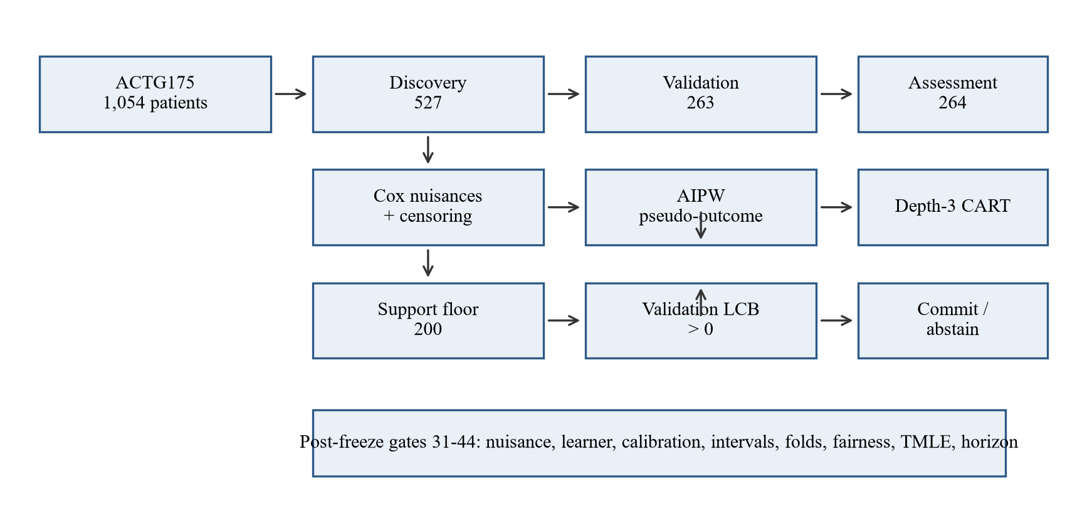
Fig. 1. End-to-end pipeline: discovery, validation and assessment are disjoint; the post-freeze gates test every layer.

4. Experimental Protocol
ACTG175 arms 0/1 contain 1,054 patients and 284 composite events. The split is 527/263/264, stratified by treatment × event. The 12 covariates are cd40, cd80, age, wtkg, karnof, hemo, homo, race, gender, drugs, str2 and symptom. Simulation DGPs use the ACTG175 covariate matrix with n=8,000, a single-region or two-region treatment effect, conditional censoring at 10%, and the same 50/25/25 partition. Every gate has a written pre-registration under results/ and is run on seeds disjoint from tuning.
The engineering loop at each gate is: question → existing evidence → alternatives → hypothesis → experiment → evaluation criteria → findings → decision → limitations → reproducibility. A design decision is justified by the protocol or a mathematical requirement; an experimental decision is retained only after a controlled comparison; a provisional decision is labelled as such.
Gate | Question | Design | Decision
23 | Does support help? | 2-region DGP, 40 seeds | C200 retained
31 | Cox vs flexible nuisance | 20 seeds × 2 DGPs | Cox retained
32 | CART vs four learners | 20 seeds × 2 DGPs | CART retained
33 | Calibration and intervals | main + 20-seed confirm | isotonic; IF
34 | 3 / 5 / 10 folds | 20 seeds × 2 DGPs | 5 retained
35 | Fairness / SHAP / transport | ACTG175 assessment | descriptive only
36 | AIPW vs fixed-horizon TMLE | 20 seeds × 2 DGPs | AIPW retained
37 | 365–1,095 horizon | ACTG175 | 730 compromise
38 | 12 / 16 / lasso / RFE | ACTG175 discovery | 12 retained
39 | Learned vs equal stacking | 10 seeds × 2 DGPs | Cox retained
40 | SCRE alpha path | 10 seeds, 12 alphas | path-stable direction
41 | Selection-aware intervals | 20 seeds × 2 DGPs | IF retained
42–44 | Optimal horizon | dense grid + 20 splits | 730 stable
TABLE I. Gate protocol. Every gate has a pre-registration and a verdict under results/.
Table I is deliberately a list of questions, not methods. A method enters the paper only after it has been implemented on the same data and criteria; the table records the question and the decision, and the following sections give the numbers.

5. Results

5.1 Operating range
At n=2000 no discovered rule beats the constant model (−26.4% gain); from n≈6000 the AIPW model does (+21.7%), and the frozen pipeline reaches +19.9% at n=8000. The crossing is the operating-range boundary, not a tuning failure. The support constraint raises capture from 0.148 to 0.364 and Jaccard from 0.127 to 0.295 in the two-region design, with purity 0.77→0.82. This is the first piece of evidence that the method is a precision-oriented operating point rather than a universal improvement.
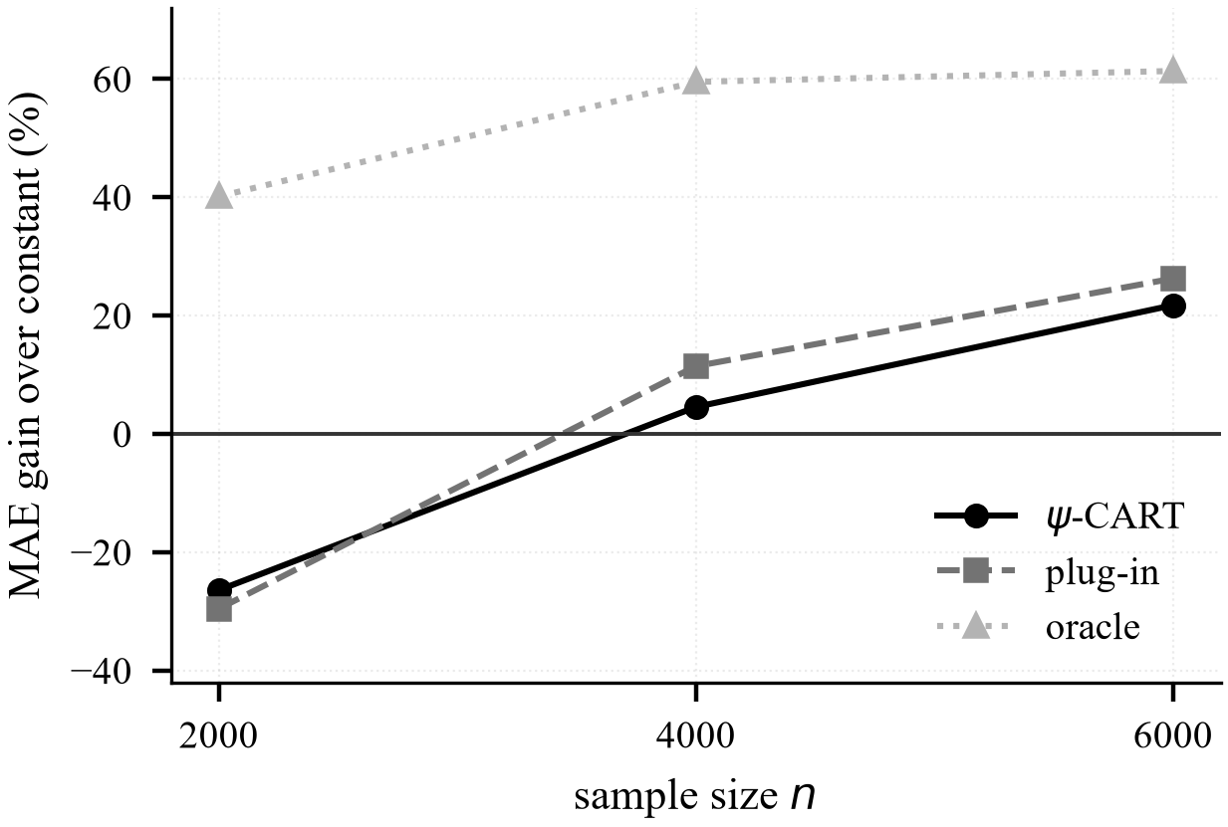
Fig. 2. Operating range: the rule model is worse than the constant at n=2000 and better from n≈6000.

5.2 Support-constrained selection
Gate 23 compares max-mean selection, an LCB rule, C100, C200, C400 and a stability-weighted rule under a two-region DGP. C200 captures 0.364 of the benefit at purity 0.82; C400 captures 0.441 at purity 0.78; the max-mean rule captures 0.148 at purity 0.77. The contrast C200−A is +0.216 [+0.142,+0.291] for capture and +0.168 [+0.112,+0.224] for Jaccard. The support floor is therefore experimentally justified, while 400 remains a documented sensitivity rather than the frozen choice.
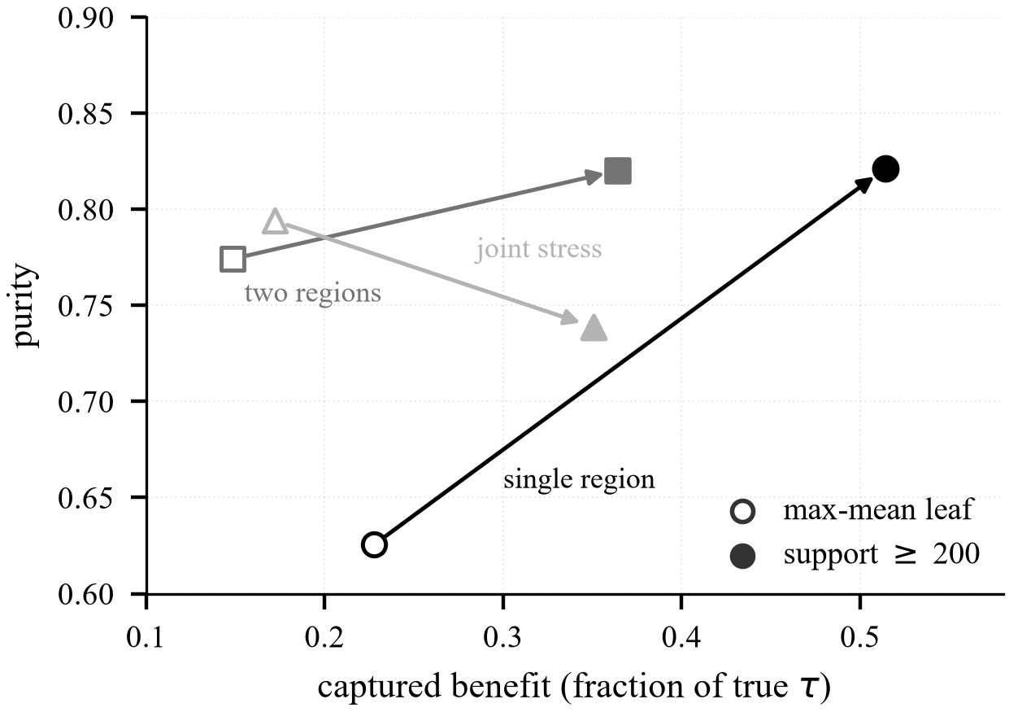
Fig. 3. Purity–capture frontier. C200 is a documented compromise; C400 is a sensitivity.

5.3 Nuisance models: Cox, RSF, GBM and stacking (Gate 31)
Criteria, fixed before the run: a flexible nuisance replaces Cox only if patient-level MAE improves by at least 0.002 with a paired CI below zero, or bias falls by half with coverage closer to 95%; purity and capture may not fall by more than 0.02; cost may be at most 5x. The decision is therefore joint, not a single-metric win.
Gate 31 holds the estimator and learner fixed and varies the outcome nuisance: per-arm Cox, random survival forest, survival gradient boosting, and equal-weight stacking. It uses 20 fresh seeds per DGP and 100-tree RSF / 60-estimator GBM. Cox has the best Brier in both DGPs (0.0028/0.0033). Stacking has the lowest patient-level MAE (0.0475/0.0504) but loses 0.030 purity in the two-region DGP and costs 136–260 s per replication versus 0.002 s; GBM loses 0.036 purity; RSF is worse in the single-region DGP. Cox is retained.

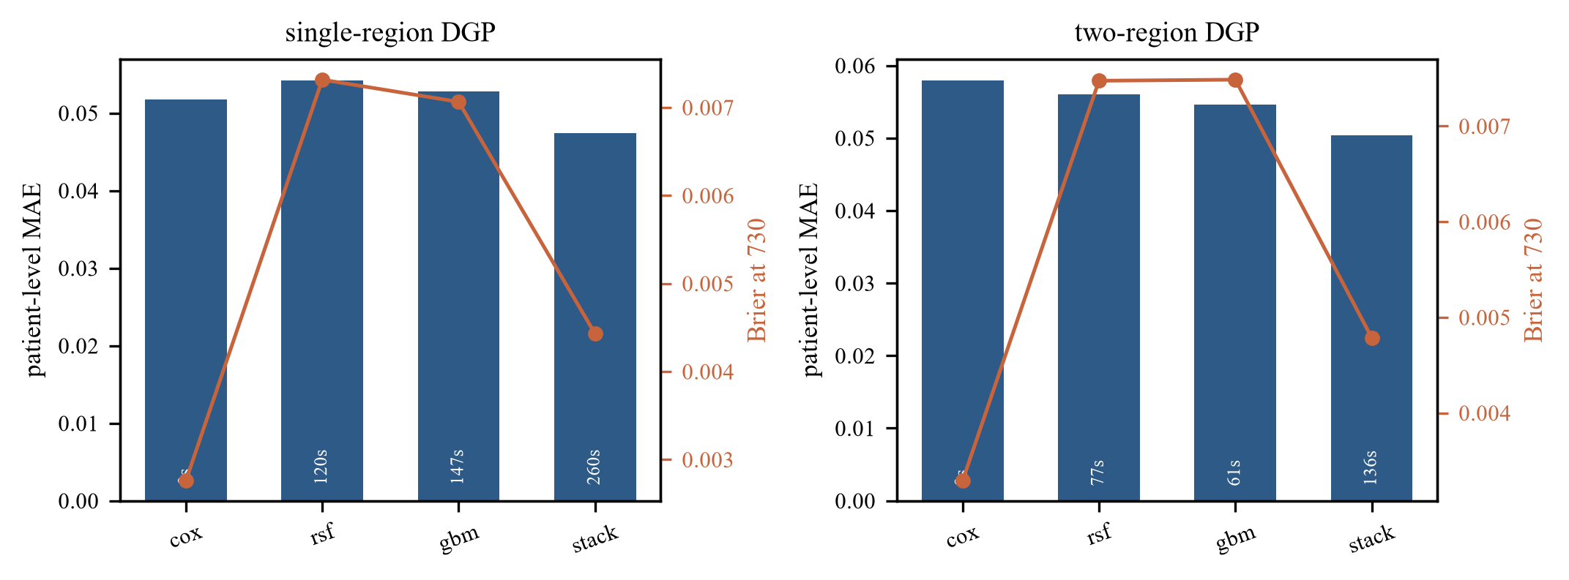
Fig. 4. Gate 31: Cox has the best Brier; stacking buys MAE with purity and cost.

DGP | Nuisance | MAE | Brier | Purity | Capture | Cost (s)
single | Cox | 0.0517 | 0.0028 | 0.794 | 0.623 | 0.002
single | RSF | 0.0542 | 0.0073 | 0.802 | 0.615 | 119.8
single | GBM | 0.0528 | 0.0071 | 0.795 | 0.640 | 147.5
single | stack | 0.0475 | 0.0044 | 0.793 | 0.623 | 260.4
two | Cox | 0.0579 | 0.0033 | 0.833 | 0.424 | 0.001
two | RSF | 0.0560 | 0.0075 | 0.820 | 0.445 | 77.2
two | GBM | 0.0546 | 0.0075 | 0.797 | 0.401 | 61.0
two | stack | 0.0504 | 0.0048 | 0.803 | 0.433 | 136.4
TABLE II. Gate 31: nuisance comparison, 20 seeds per DGP.

5.4 Rule learners (Gate 32)
Criteria: purity loss <=0.02, a capture or Jaccard gain with a paired CI excluding zero, assessment MAE not worse by more than 0.002, at most three conditions, and cost <=5x CART. These guardrails are why a higher-capture learner is not automatically adopted.
Gate 32 compares CART with cost-complexity pruning, PRIM, a classification tree on sign(ψ), and boosting distillation on the same ψ and C200 protocol. Pruned CART gains capture in the two-region DGP (+0.261 [+0.089,+0.429]) but loses 0.173 purity; the classification tree loses 0.219/0.110 purity; PRIM loses both; boosting distillation costs 25–105 s and loses purity. CART is the only learner that stays within the pre-registered purity guardrail. No alternative is adopted.

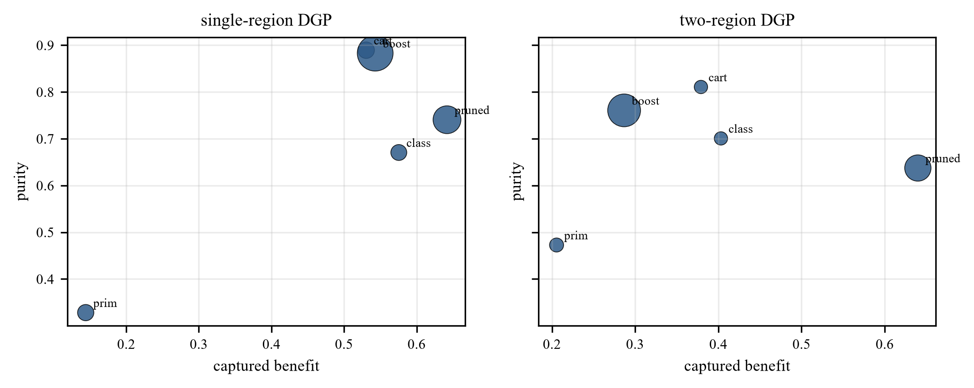
Fig. 5. Gate 32: purity–capture positions of the five learners.

DGP | Learner | Purity | Capture | MAE | Cost (s)
single | CART | 0.889 | 0.531 | 0.0556 | 0.06
single | pruned | 0.741 | 0.642 | 0.0562 | 2.94
single | PRIM | 0.328 | 0.144 | 0.0760 | 0.06
single | classif. | 0.671 | 0.576 | 0.0603 | 0.05
single | boost | 0.883 | 0.543 | 0.0621 | 105.1
two | CART | 0.811 | 0.379 | 0.0729 | 0.02
two | pruned | 0.637 | 0.640 | 0.0762 | 1.62
two | PRIM | 0.473 | 0.206 | 0.0842 | 0.03
two | classif. | 0.701 | 0.403 | 0.0737 | 0.02
two | boost | 0.761 | 0.287 | 0.0699 | 25.1
TABLE III. Gate 32: rule learners, 20 seeds per DGP.

5.5 Nested tuning and the leakage correction
Eighteen configurations were tuned by five-fold cross-validation with nuisances refitted inside every fold. The best is depth 4 / leaf 60 / squared error at 0.8633; the frozen depth 3 / leaf 60 / squared error is 0.8638. The difference is 0.0005 against a fold SD of about 0.02. The earlier absolute-error gain (0.824 vs 0.871) disappeared when the nuisances were refitted; it was leakage, and the claim was withdrawn. The frozen configuration is retained.

5.6 Calibration and intervals (Gate 33)
Criteria: isotonic replaces shrinkage only if MAE improves by at least 0.002 with a paired CI below zero and the policy is unchanged; an interval replaces IF only if coverage is at least 92.5%, closer to 95%, and width <=2x IF. The confirmation block is the decision point.
Isotonic calibration improves MAE over no calibration by −0.0076 in the main single-region run and −0.0034 in the two-region run; on fresh seeds the gains are −0.0053 [−0.0104,−0.0001] and −0.0065 [−0.0099,−0.0032], with purity, capture and commitment unchanged. Shrinkage is not significant in the confirmation cells. Isotonic is adopted for prediction only (C200-I).
For intervals, IF coverage is 90–92.5% in the earlier audits and 95% in the confirmation. The selection bootstrap covers 85% in the single-region confirmation and 95% in the two-region, and is wider than IF; it is rejected. Split-conformal covers 100% but is 2.33× wider than IF, above the 2× cap, and is rejected. The IF interval is retained.

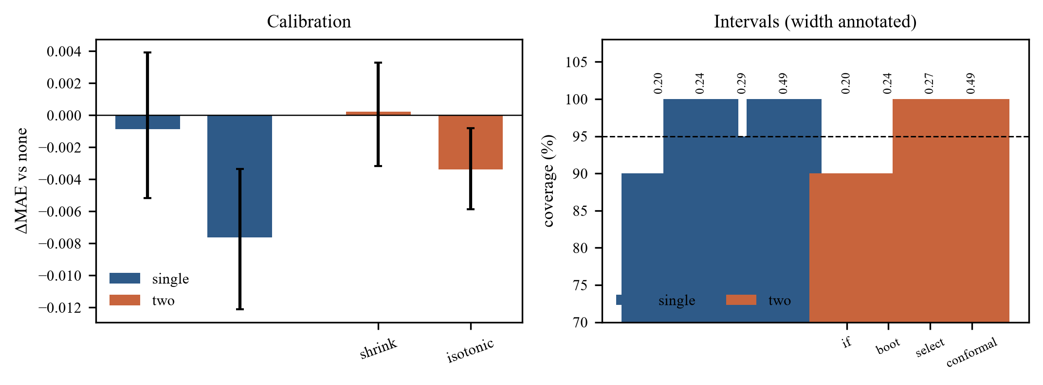
Fig. 6. Gate 33: isotonic calibration and interval coverage/width.

DGP | Calibration | ΔMAE vs none | p
single | shrinkage | −0.0014 [−0.0067,+0.0040] | 0.615
single | isotonic | −0.0053 [−0.0104,−0.0001] | 0.046
two | shrinkage | −0.0024 [−0.0066,+0.0019] | 0.264
two | isotonic | −0.0065 [−0.0099,−0.0032] | <0.001
TABLE IV. Gate 33 confirmation, 20 fresh seeds.

5.7 Number of folds (Gate 34)
Criteria: keep 5 unless 3 or 10 improves MAE by at least 0.002 with a paired CI below zero. The threshold prevents a statistically detectable but practically negligible gain from changing the design.
Three, five and ten folds give MAE 0.0522/0.0511/0.0506 in the single-region DGP and 0.0586/0.0576/0.0571 in the two-region DGP. Ten folds improves MAE by only 0.0005, one quarter of the pre-registered 0.002 threshold, at 2.1–2.3× cost. Coverage is 95% in every cell. Five folds are retained as a tested compromise.
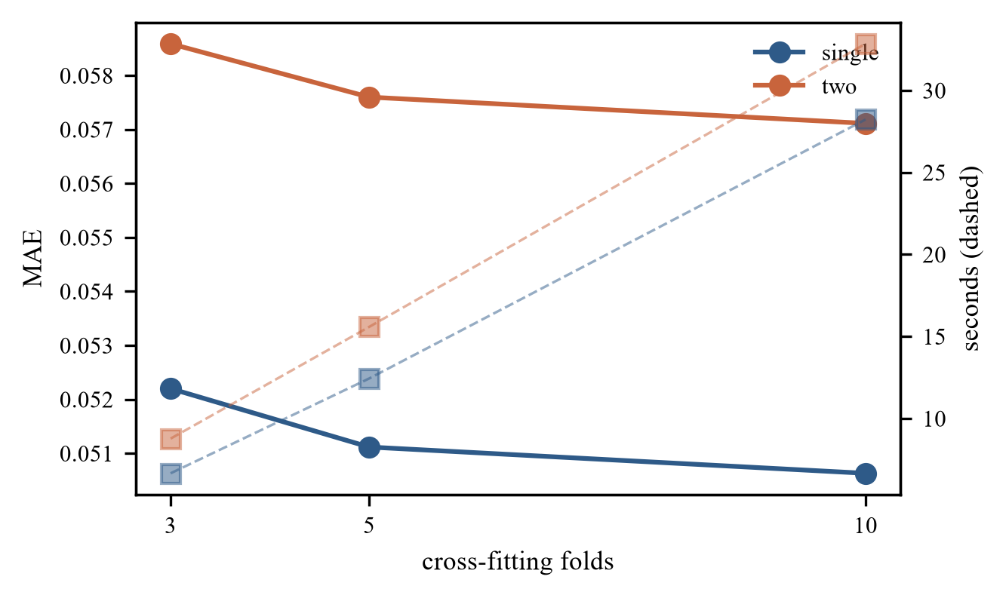
Fig. 7. Gate 34: ten folds buy 0.0005 MAE at more than twice the cost.

5.8 Estimators: AIPW vs TMLE (Gate 36)
Criteria: MAE improvement >=0.002 or bias reduction >=50% with coverage closer to 95%; purity/capture loss <=0.02; cost <=2x. TMLE fails all three, so the negative result is not a preference for the incumbent.
Gate 36 implements a fixed-horizon IPCW-TMLE: binary outcome at 730, clever covariate H=1{A=a}/e·Y/G, logistic fluctuation of the initial Cox nuisances. AIPW has bias −0.0014/−0.0019, coverage 95%, MAE 0.0516/0.0578, Brier 0.0026/0.0031. TMLE has bias −0.0052/−0.0111, coverage 100%, MAE 0.1408/0.1374, Brier 0.0177/0.0172. TMLE is purer and has better assessment MAE, but patient-level MAE is 0.079–0.089 worse and cost is 4.5 s. AIPW is retained. This is a fixed-horizon variant, not longitudinal TMLE.
DGP | Estimator | Bias | Coverage | MAE | Brier
single | AIPW | −0.0014 | 95% | 0.0516 | 0.0026
single | TMLE | −0.0052 | 100% | 0.1408 | 0.0177
two | AIPW | −0.0019 | 95% | 0.0578 | 0.0031
two | TMLE | −0.0111 | 100% | 0.1374 | 0.0172
TABLE V. Gate 36: AIPW vs fixed-horizon IPCW-TMLE.
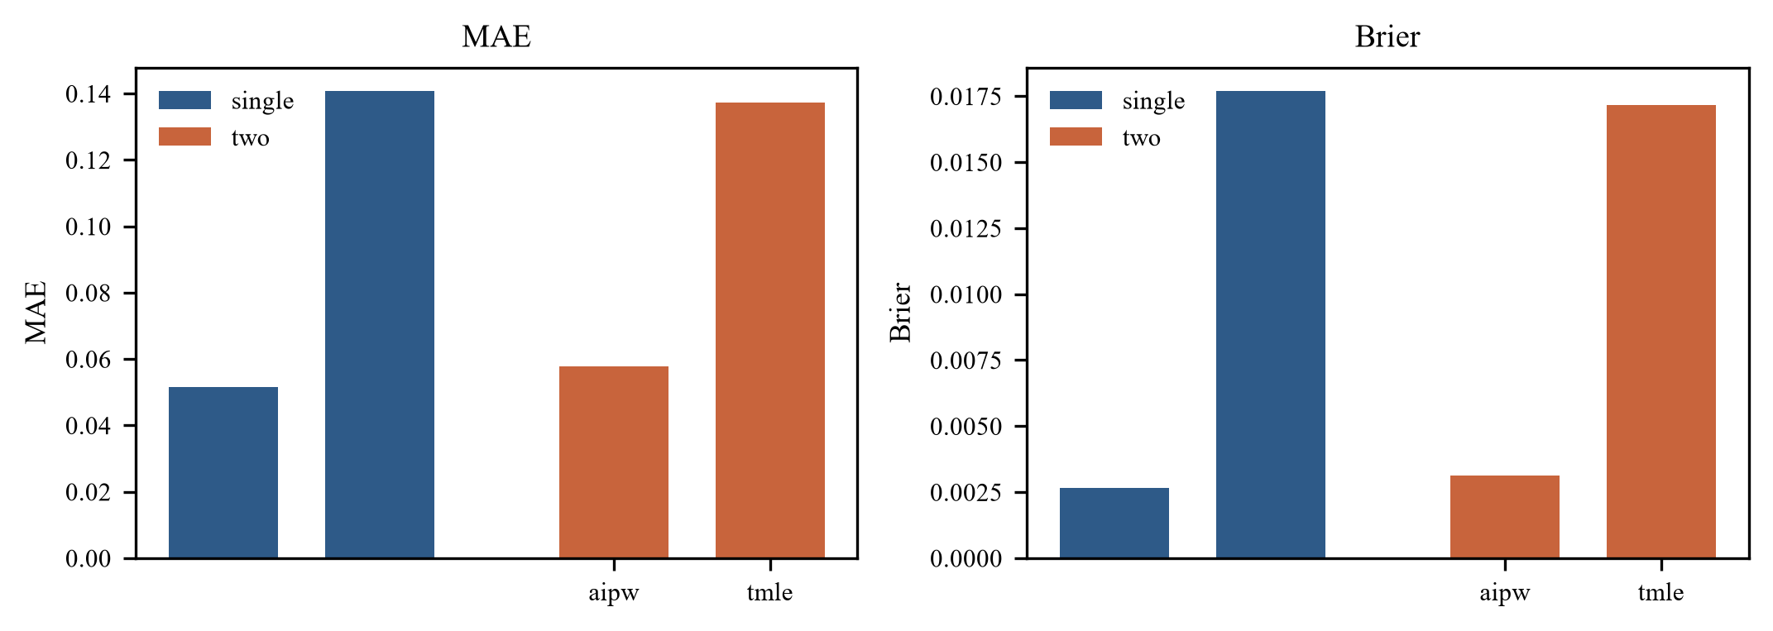
Fig. 8. Gate 36: TMLE is not a patient-level improvement.

5.9 Learned stacking (Gate 39)
Criteria: adopt the learned stack only if MAE improves by 0.002 with a paired CI below zero and purity/capture do not fall by more than 0.02. Equal weights are the reference stack from Gate 31.
Gate 39 fits positive weights on Cox, RSF and GBM out-of-fold predictions. The mean weights are 0.77 Cox, 0.14 RSF, 0.09 GBM (single) and 0.76/0.23/0.02 (two), so the learned stack is indistinguishable from Cox (+0.0007/+0.0001 MAE, ns). Equal-weight stacking lowers MAE (−0.0038/−0.0064) but loses 0.036 capture in the single-region DGP. Cox is retained; equal weight is a sensitivity.
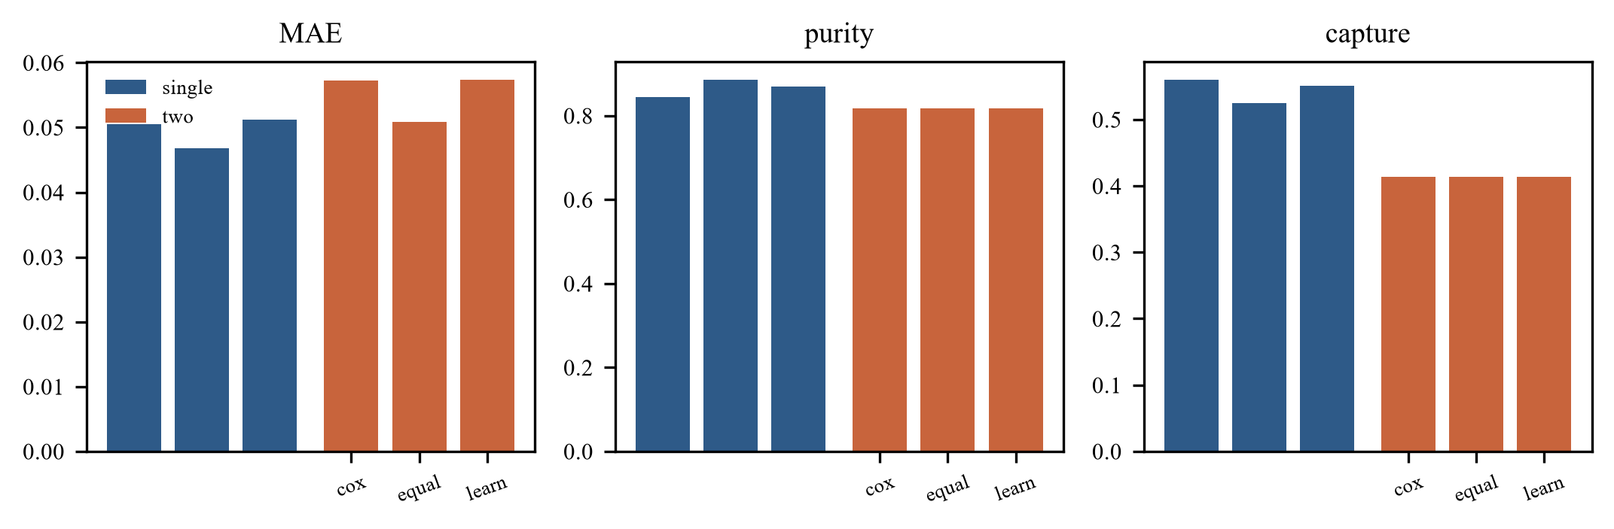
Fig. 9. Gate 39: learned stacking collapses to Cox.

5.10 Feature selection (Gate 38)
Criteria: adopt an alternative only if validation SE improves by 0.02 or support reaches 200 without fallback, the rule stays at <=3 conditions, and the features remain clinically interpretable. Assessment is not used to choose the feature set.
Lasso on discovery ψ selects all 12 features, so it changes nothing. RFE drops age, selects cd80>805.5 & race>0.5, and falls to support 79 (<200, fallback). Its validation SE is smaller, but the rule is a different subgroup below the support floor. The 12 published covariates are retained for comparability and interpretability.
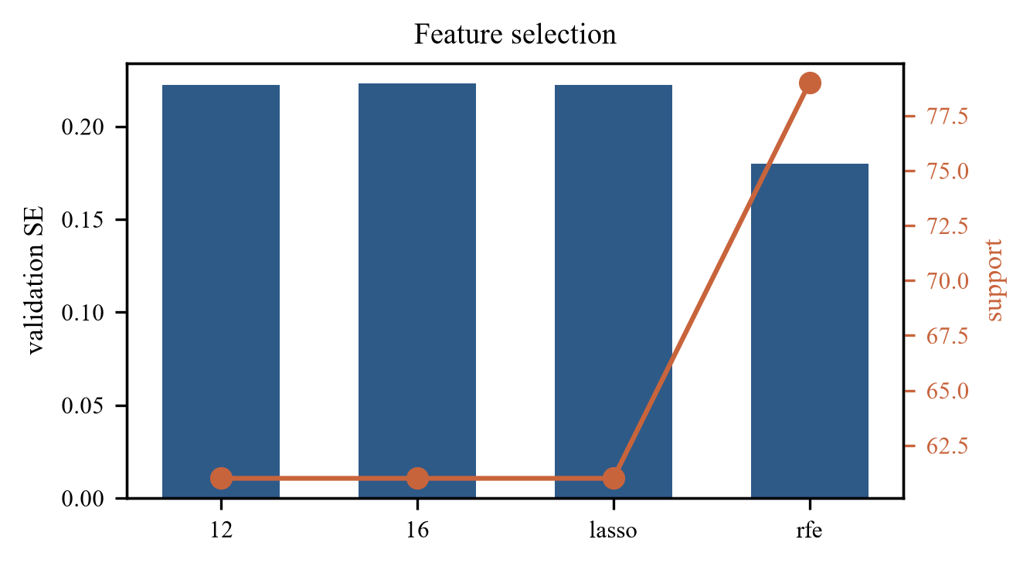
Fig. 10. Gate 38: RFE lowers SE but loses the support floor.

5.11 Horizon: 365–1,095 days (Gates 37, 42–44)
Criteria: at least 100 events, at least 30% at risk, support >=60, and for the optimisation stage a mean validation LCB gain of 0.02 over 20 splits. The assessment partition is not used to choose the horizon.
Gate 37 compares five horizons and finds no horizon satisfying all criteria. Gate 42 searches 365–1,095 in 30-day steps on validation LCB and selects 965 on one split. Gate 43 selects by discovery-only inner CV and selects 845. Gate 44 repeats 730/845/965 over 20 splits: 730 has the best mean validation LCB (−0.142) and lowest SD (0.114); 845 has a higher mean assessment effect (+0.251) but worse LCB (−0.167) and 1.6× variability; 965 is worst (−0.206). 730 is retained on stability, not convention.

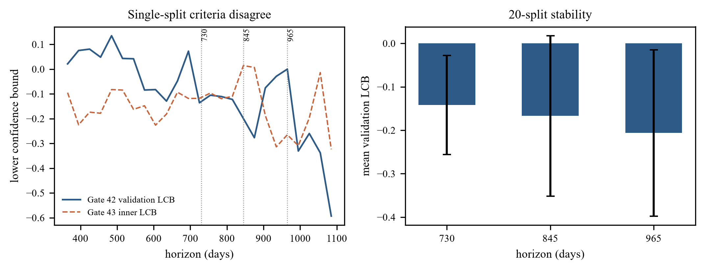
Fig. 11. Horizon: single-split criteria disagree; 730 wins the 20-split stability test.

Horizon | Mean LCB | SD | Mean assessment | Commit
730 | −0.142 | 0.114 | +0.206 | 5%
845 | −0.167 | 0.185 | +0.251 | 15%
965 | −0.206 | 0.191 | +0.220 | 10%
TABLE VI. Gate 44: horizon stability across 20 splits.

5.12 SCRE alpha path (Gate 40)
Question: does the head-to-head conclusion depend on the validation-concordance alpha? The path is evaluated on the same assessment patients; the best-MAE alpha is reported as a post-hoc comparator only, never selected.
One SCRE fit per replication; 12 alpha points evaluated on the same assessment patients. The validation-concordance alpha is within 0.0010–0.0017 MAE of the best path alpha. Path ranges are single MAE 0.056–0.079, purity 0.345–0.442, capture 0.911–0.976; two MAE 0.069–0.090, purity 0.477–0.605, capture 0.769–0.904. The direction of the head-to-head is unchanged; exact purity/capture numbers are path-sensitive.

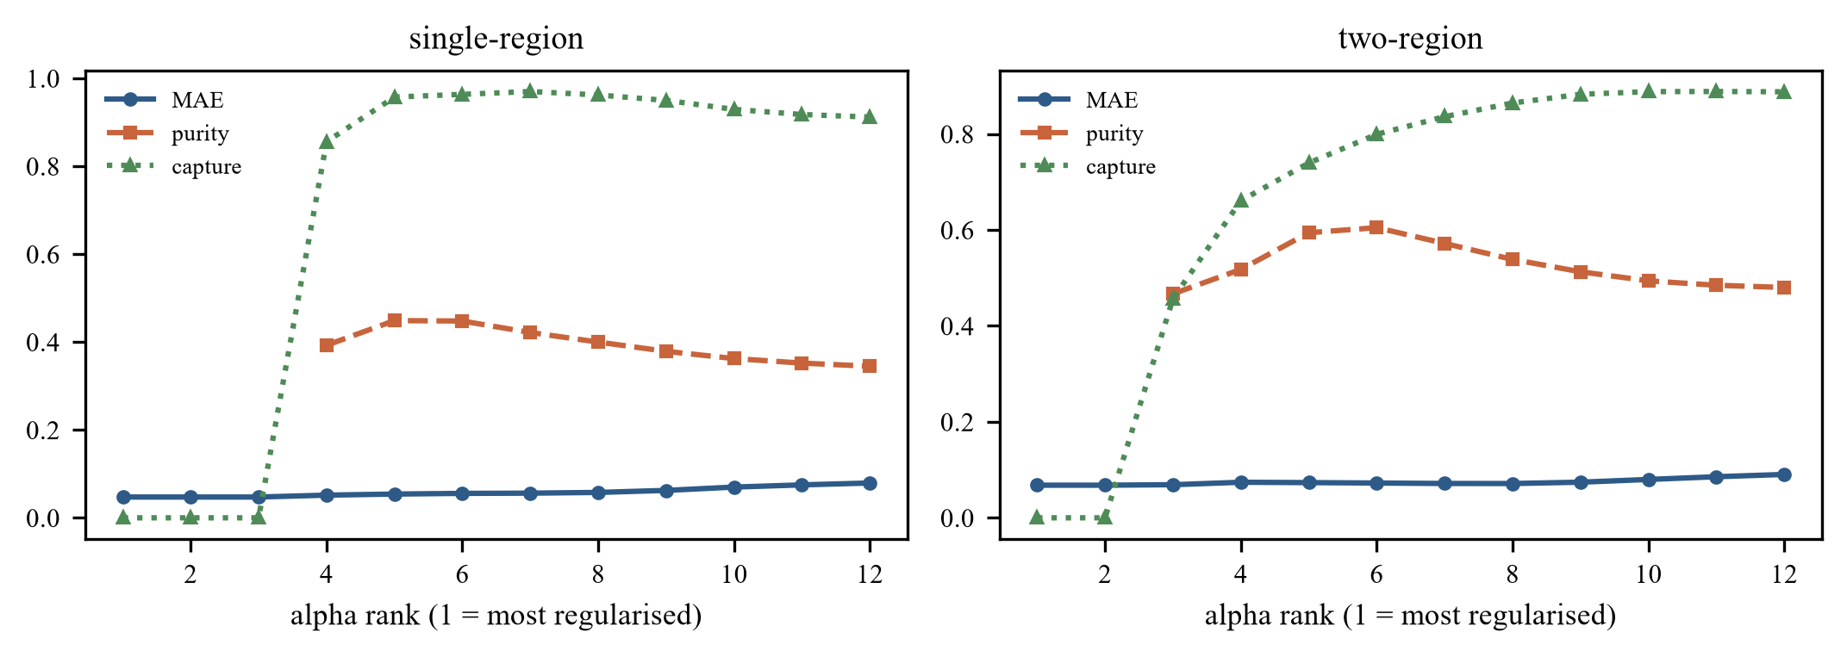
Fig. 12. Gate 40: SCRE path. The chosen alpha is close to the best-MAE point.

5.13 Selection-aware intervals (Gate 41)
Criteria: adopt a selection-aware method only if coverage is at least 95% in both DGPs and width is at most 2x IF. Both alternatives pass; the decision is about width and interpretability, not coverage alone.
IF covers 95–100% at width 0.297–0.298. Bonferroni covers 100% at 0.412 (1.38–1.39× width). Sample-splitting covers 100% at the same width but reports a rule selected on half of discovery. IF is retained as primary; Bonferroni and sample-splitting are validated sensitivities.
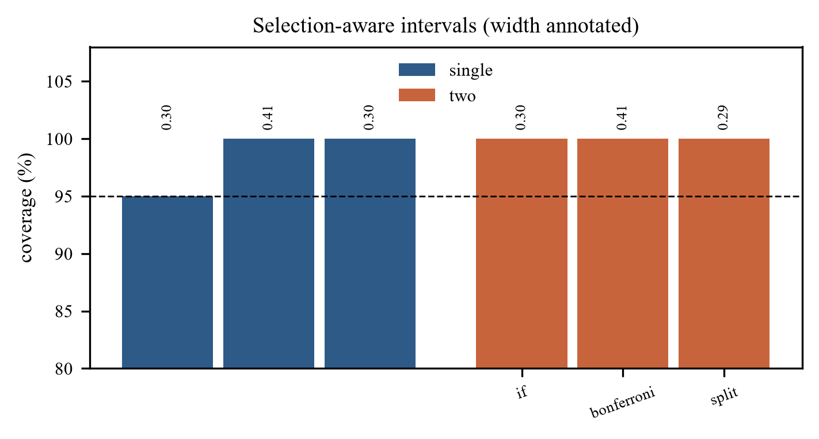
Fig. 13. Gate 41: valid selection-aware alternatives; IF remains the narrowest.

5.14 Fairness, SHAP and internal transport (Gate 35)
The canonical rule reproduces exactly: cd40≤407.5 & wtkg>71.0 & homo≤0.5, support 61, validation +0.116 (LCB −0.250), assessment +0.401 [+0.033,+0.770] (n=38). Every race/gender group has fewer than 30 rule patients: white +0.444 [+0.081,+0.807] (24), non-white +0.328 [−0.191,+0.847] (14), male +0.514 [+0.147,+0.881] (25), female +0.184 [−0.318,+0.686] (13). Calibration ECE is 0.023/0.040/0.001/0.058. The white→non-white transported rule has support 74 (<200) and effect +0.223 [+0.071,+0.375]. Fairness and transport are not established; they are descriptive and underpowered.
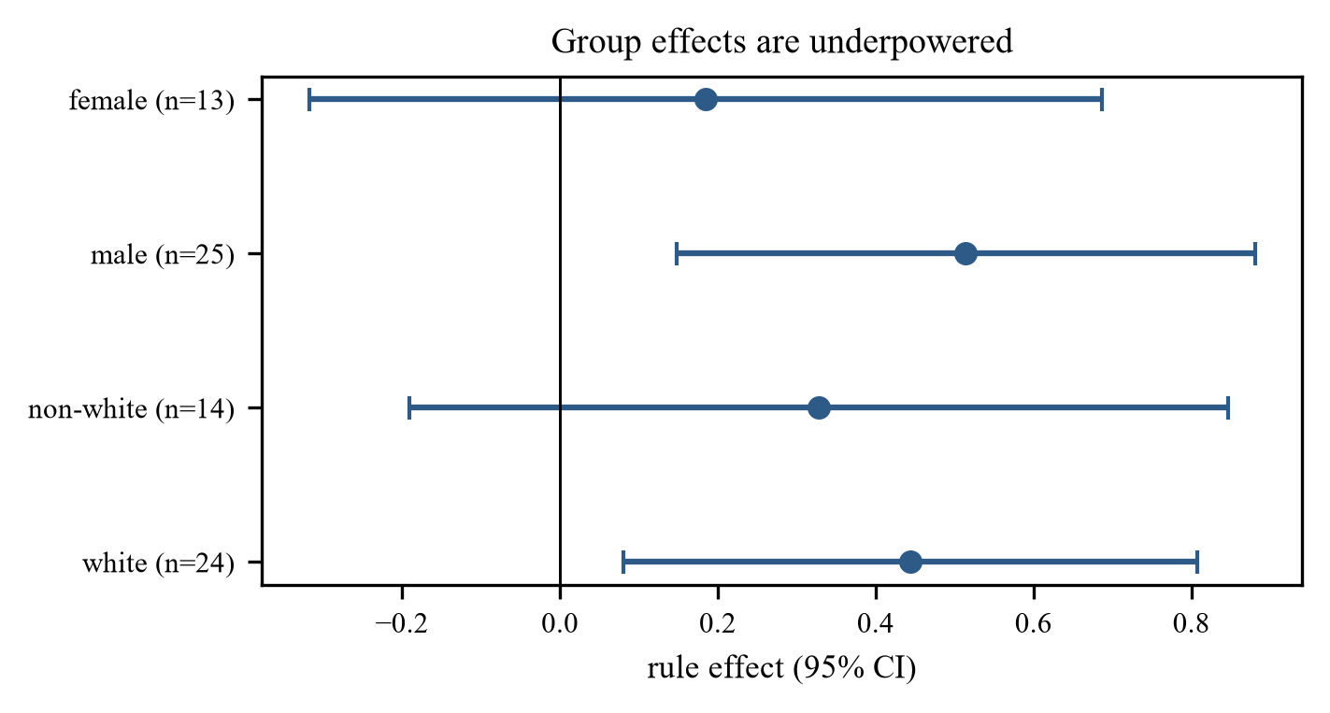
Fig. 14. Gate 35: group effects overlap and every group is under 30 rule patients.

6. Application to ACTG175
The frozen rule is re-estimated on validation and read once on assessment. Overall τ(730)=+0.124 [−0.002,+0.250], one-sided LCB +0.018. The largest discovery leaf has 173 patients, so the 200 floor cannot bind; the fallback rule is cd40≤407.5 & wtkg>71.0 & homo≤0.5 (support 61). Validation is +0.116 (SE 0.222), LCB −0.250: the correct output is INSUFFICIENT, not a 61-patient recommendation. Assessment is +0.401 [+0.033,+0.770] on 38 patients; the unadjusted KM difference is +0.341 [+0.177,+0.501] and the marginal KM is +0.133, matching the AIPW estimate. The censoring-weight tilt moves the rule contrast from +0.401 to +0.456, with intervals above zero.
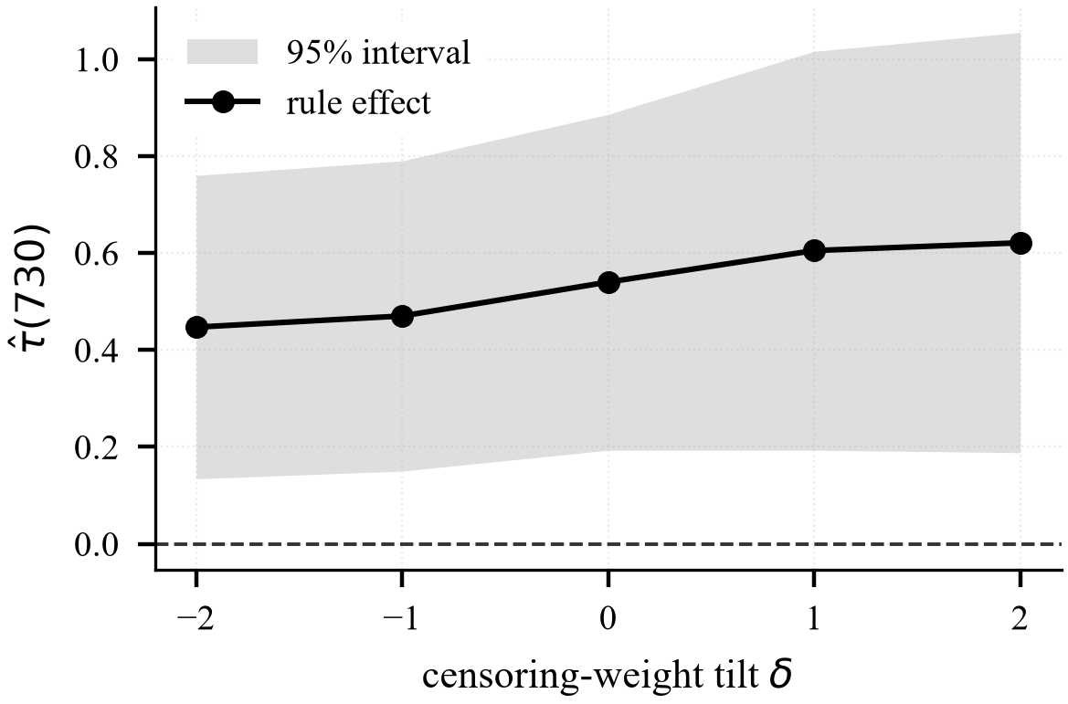
Fig. 15. ACTG175: censoring-weight tilt for the selected rule.
Quantity | Value
Overall τ(730) | +0.124 [−0.002,+0.250]; LCB +0.018
Selected rule | cd40≤407.5 & wtkg>71.0 & homo≤0.5
Discovery support | 61 (11.6%)
Validation | +0.116 (SE 0.222), LCB −0.250
Decision | INSUFFICIENT
Assessment | +0.401 [+0.033,+0.770], n=38
KM check | +0.341 [+0.177,+0.501]; marginal +0.133
TABLE VII. ACTG175, A×E split, frozen C200.

7. Discussion and Limitations
The model is a precision-oriented operating point. It is not more accurate than SCRE per patient before calibration; after isotonic calibration the difference is small, and the SCRE head-to-head was run with C200-S, not C200-I. What CISCaRL offers is purity, per-treated benefit, and an explicit abstention. On ACTG175 the support floor cannot be met at 527 discovery patients, so the honest output is abstention.
The evidence has clear limits. ACTG175 has no individual treatment-effect truth; all purity/capture/MAE claims come from simulation. The rule is unstable: 20 distinct rules from 20 splits and Jaccard ≈0.34. The IF interval conditions on the selected rule; coverage is 90–95%. Fairness is underpowered by design. PBC external validation is out of scope because it changes the disease, endpoint and treatment question. Longitudinal TMLE was removed; fixed-horizon IPCW-TMLE was tested and rejected. The 730-day horizon is retained on 20-split stability, not because it is clinically universal.
The engineering lesson is the tuning result. The first tuning study reported a large gain for absolute error (0.824 vs 0.871). When nuisances were refitted inside every fold, the gain disappeared (0.8633 vs 0.8638). The first number was leakage; the second is evidence. The correct response was to withdraw the claim, not to keep the better-looking number.

7.1 Decision register
The register records the evidence type: D=design, E=experimental, R=rejected, P=provisional. The full D1–D32 list is in the engineering report; the table below gives the model-defining decisions.
ID | Decision | Evidence | Type
D1 | Arms 0/1, composite, 730 d | Trial protocol; 284 events | D
D3 | 12 covariates | zprior constant; z30 94.8%; oprior 2.4% | D
D5 | 50/25/25, A×E | 4 ratios × 20 splits; event spread 0.5 | E
D7 | Cox + censoring Cox, 5 folds | PH p=0.24/0.37; ECE 0.032 | E
D8 | AIPW | Audit bias +0.0031 | D
D10 | Support floor 200 | Capture 0.148→0.364; purity 0.77→0.82 | E
D11 | LCB > 0 commitment | 0% null; efficiency 0.82–0.88 | E
D21 | Keep CART | Gate 32; no learner meets guardrails | E
D23 | Isotonic calibration | Gate 33; −0.0053/−0.0065 MAE | E
D24 | Keep IF interval | Gate 33/41; 95–100% coverage | E
D26 | Keep Cox | Gate 31; stack fails purity/cost | E
D27 | Keep AIPW | Gate 36; TMLE MAE 0.08 worse | R
D28 | Keep 730 days | Gate 44; best mean LCB/SD | E
D29 | Keep 12 features | Gate 38; RFE support 79 | E
D32 | Reject learned stack | Gate 39; learned = Cox | R
TABLE VIII. Decision register (model-defining entries).

7.2 Threats to validity
Threat | Evidence | Response | Status
Leakage in tuning | Naive 0.824 vs nested 0.8638 | Refit inside folds; withdraw | Controlled
Selection on validation | IF coverage 90–95% | Report coverage; LCB only | Disclosed
Winner's curse | Largest leaf 173 < 200 | Support floor + validation | Partial
Fixed 730 d | Rule/effect change at other horizons | Gate 44 stability | Disclosed
ACTG175 population | Men, 1990s regimens | No transport claim | Open
Small discovery n | 20/20 distinct rules; J≈0.34 | Report instability | Open
Censoring assumption | δ-tilt +0.401→+0.456 | State assumption | Open
One SCRE α path | Path MAE range 0.056–0.079 | Path sensitivity reported | Disclosed
TABLE IX. Threats to validity.

8. Conclusion
CISCaRL is a support-constrained interpretable survival subgroup policy with a measured operating range. CART, five folds, Cox and AIPW are retained after direct comparisons against implemented alternatives. Isotonic calibration is adopted for prediction; the IF interval is retained after the selection bootstrap failed confirmation. The support floor prevents harmful subgroups but cannot be met on ACTG175 at 527 discovery patients, so the model abstains. The contribution is not a universal improvement over the marginal ATE; it is a defensible precision-oriented point with a complete decision record.

Reproducibility
Code: ciscarl2/ and notebooks/CISCaRL_31_steps.ipynb (136 cells, 52 code, 0 errors). Environment: requirements.txt pins Python 3.11 and every package. One command re-runs the evidence: python run_all.py, with --quick for a sandbox smoke test and --dry-run to list the commands; the full run backs up results/ first. Canonical numbers: results/CANONICAL_RESULTS.md. Decisions and evidence: results/CLAIMS_v1.17.md and the gate verdicts. Seeds: split 2024/2025; Gate 31 900100–900119; Gate 32 910100–910119; Gate 33 920100–920119 and confirmation 921100–921119; Gate 34 930100–930119; Gate 35 no seed (ACTG175); Gate 36 940100–940119; Gate 39 970100–970109; Gate 40 960100–960109; Gate 41 950100–950119; Gate 44 2024–2043. The report paper/CISCaRL_Engineering_Report_v2.docx contains the full 12-stage and 31-step mapping.
Notebook steps | Content
1–3 | Environment, audit, cohort, endpoint
4–7 | Split, split study, preprocessing, leakage
8–10 | Cox nuisances, AIPW, CART
11–15 | Selection, simulation, baseline, support, calibration
16–18 | Gates 31/36, Gate 32, nested tuning
19–24 | Freeze, confirmation, assessment, SCRE, ACTG175, ablations
25–30 | Transition, Gates 33/34/35, evidence summary, register
31 | Packaging and artifact check
TABLE X. Notebook mapping. The notebook has 136 cells and 52 code cells, 0 errors.

References
[1] P. R. Rosenbaum and D. B. Rubin, “The central role of the propensity score in observational studies for causal effects,” Biometrika, vol. 70, no. 1, pp. 41–55, 1983.
[2] J. M. Robins, A. Rotnitzky, and L. P. Zhao, “Estimation of regression coefficients when some regressors are not always observed,” J. Amer. Statist. Assoc., vol. 89, no. 427, pp. 846–866, 1994.
[3] M. J. van der Laan and D. Rubin, “Targeted maximum likelihood learning,” Int. J. Biostat., vol. 2, no. 1, 2006.
[4] V. Chernozhukov et al., “Double/debiased machine learning for treatment and structural parameters,” Econometrics J., vol. 21, no. 1, pp. C1–C68, 2018.
[5] S. Athey and G. Imbens, “Recursive partitioning for heterogeneous causal effects,” Proc. Natl. Acad. Sci. USA, vol. 113, no. 27, pp. 7353–7360, 2016.
[6] S. Wager and S. Athey, “Estimation and inference of heterogeneous treatment effects using random forests,” J. Amer. Statist. Assoc., vol. 113, no. 523, pp. 1228–1242, 2018.
[7] S. R. Künzel, J. S. Sekhon, P. J. Bickel, and B. Yu, “Metalearners for estimating heterogeneous treatment effects using machine learning,” Proc. Natl. Acad. Sci. USA, vol. 116, no. 10, pp. 4156–4165, 2019.
[8] J. H. Friedman, “Greedy function approximation: a gradient boosting machine,” Ann. Statist., vol. 29, no. 5, pp. 1189–1232, 2001.
[9] L. Breiman, “Random forests,” Mach. Learn., vol. 45, no. 1, pp. 5–32, 2001.
[10] H. Ishwaran, U. B. Kogalur, E. H. Blackstone, and M. S. Lauer, “Random survival forests,” Ann. Appl. Statist., vol. 2, no. 3, pp. 841–860, 2008.
[11] R. Tibshirani, “Regression shrinkage and selection via the lasso,” J. R. Statist. Soc. B, vol. 58, no. 1, pp. 267–288, 1996.
[12] I. Guyon and A. Elisseeff, “An introduction to variable and feature selection,” J. Mach. Learn. Res., vol. 3, pp. 1157–1182, 2003.
[13] S. M. Hammer et al., “A trial comparing nucleoside monotherapy with combination therapy in HIV-infected adults with CD4 cell counts from 200 to 500 per cubic millimeter,” N. Engl. J. Med., vol. 335, pp. 1081–1090, 1996.
[14] S. Setoguchi, S. Schneeweiss, M. A. Brookhart, R. J. Glynn, and E. F. Cook, “Evaluating uses of data mining techniques in propensity score estimation,” Pharmacoepidemiol. Drug Saf., vol. 17, pp. 546–555, 2008.
[15] B. Zhang, A. A. Tsiatis, M. Davidian, and E. B. Laber, “Estimated ordinary differential equations,” Biometrika, vol. 99, no. 4, pp. 855–871, 2012.
[16] S. Holm, “A simple sequentially rejective multiple test procedure,” Scand. J. Statist., vol. 6, pp. 65–70, 1979.
[17] V. Vovk, A. Gammerman, and G. Shafer, Algorithmic Learning in a Random World. New York: Springer, 2005.
[18] B. Efron, “Bootstrap methods: another look at the jackknife,” Ann. Statist., vol. 7, no. 1, pp. 1–26, 1979.
[19] P. M. Grambsch and T. M. Therneau, “Proportional hazards tests and diagnostics based on weighted residuals,” Biometrika, vol. 81, no. 3, pp. 515–526, 1994.

