CISCaRL
Detailed Model Creation Report
31 steps, with the exact output of every step

Support-constrained interpretable subgroup discovery for survival outcomes
Dataset: ACTG175, arms 0 and 1, n = 1,054
Final model: C200-I · horizon: 730 days
Prepared: November 2026

Every result exhibit is the output of the executed notebook, copied verbatim. The figures are the saved paper figures generated from the result files.

Project at a glance
Dataset | ACTG175, arms 0 and 1, n = 1,054; 12 baseline covariates
Estimand | τ(730|x) = S1(730|x) − S0(730|x), composite progression-free endpoint
Partitions | 527 discovery / 263 validation / 264 assessment (disjoint)
Estimator | Per-arm Cox + conditional censoring Cox, 5-fold cross-fit, AIPW
Learner | Depth-3 CART, minimum leaf 60, squared error
Selection | Highest discovery mean with support ≥ 200; fallback flagged
Decision | Treat only if the validation one-sided 95% lower bound is above zero
Final ACTG175 result | Rule support 61; validation LCB −0.250; decision INSUFFICIENT

How to read this report
The report follows the 31 steps of the executed notebook. Each step begins with the code that was used, then explains what was done and why it matters. The result paragraph gives the numbers in plain language. The exhibit that follows is the exact output of that step, copied verbatim from the notebook; where a figure exists, it is shown as well. The final paragraph says what the result means and what decision it forced.
What is shown for every step
- Code used — the script or notebook cell that produced the result.
- What we did — the action in plain language.
- Why this step matters — the risk it controls.
- Result obtained — the key numbers in one short paragraph.
- Exact result — a picture of the console output from the executed notebook, plus any saved figure.
- What this means — the inference, including what is not supported.
- Decision at this step — the choice that was frozen or rejected.
The complete document is long by design: it is meant to be read beside the notebook or used as an audit trail. Every number can be found in results/ and every exhibit can be rebuilt by running the notebook or run_all.py.

Contents
Step 1. Environment and reproducibility
Step 2. Study the dataset
Step 3. Cohort and outcome definition
Step 4. Split the data
Step 5. Choose the horizon
Step 6. Preprocessing fitted on discovery
Step 7. Leakage checklist
Step 8. Nuisance estimation
Step 9. Target construction (AIPW)
Step 10. Rule discovery (decision tree)
Step 11. Selection and commitment
Step 12. Simulation harness
Step 13. First result: the constant baseline
Step 14. Support floor
Step 15. Calibration
Step 16. Nuisance and estimator comparison
Step 17. Rule learners
Step 18. Hyperparameter tuning
Step 19. Freeze the configuration
Step 20. Confirmation on fresh seeds
Step 21. Assessment evaluation
Step 22. Baseline comparison (SCRE)
Step 23. Real-data run (ACTG175)
Step 24. Ablations
Step 25. From the frozen pipeline to the post-freeze evidence
Step 26. Calibration and intervals
Step 27. Number of cross-fitting folds
Step 28. Fairness, SHAP and internal transport
Step 29. Evidence summary: tested, adopted, rejected and proposed
Step 30. Decision register and final claims
Step 31. Packaging

Step 1 — Environment and reproducibility
Code used: ciscarl2/audit.py, requirements.txt
What we did – Before touching the data, the project fixes the Python version and every package, loads the data path, and runs an audit. The audit checks small, hand-verifiable things: a rule's conditions must match the patients it selects, tree leaves must not overlap, the influence-function contrast must equal the direct formula, and the purity, capture and Jaccard definitions must match hand counts. It also simulates a tiny dataset with a known answer to check the AIPW estimator.
Why this step matters – Every later number depends on the estimator and the rule code being correct. The audit makes that assumption testable instead of assumed, and it is cheap to run.
Result obtained: All checks pass. AIPW bias is +0.0031 with a standard deviation of 0.0130, and the two arm means are within 0.002 of the truth.
What this means: The building blocks are correct before any result is quoted. If this audit failed, the pipeline would stop here; because it passes, the environment and seeds can be frozen for the rest of the study.
Decision at this step: Freeze the environment and seeds, and proceed only because the audit passes.
Exact result
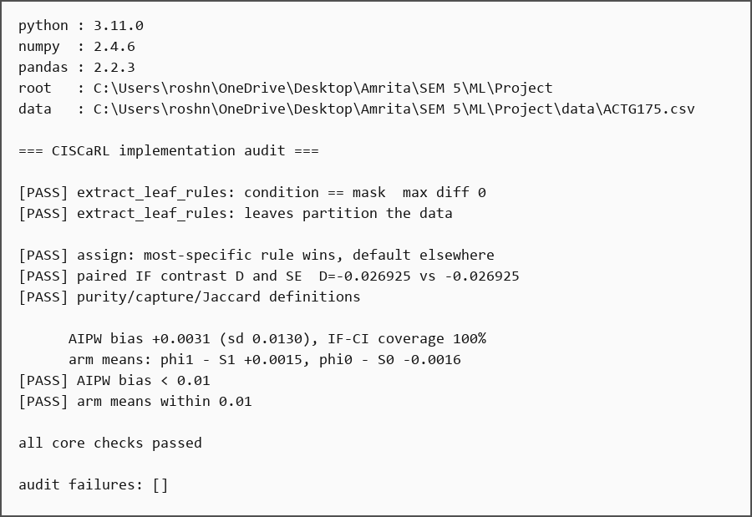
Exhibit 1. Exact console output of Step 1, copied verbatim from the executed notebook.

Step 2 — Study the dataset
Code used: notebook Step 2 (pandas profiling)
What we did – The raw file has 27 columns. Each column gets a role: identifier, outcome, treatment, post-baseline, design, or baseline covariate. The project then checks missingness, variance, redundancy, sparsity and implausible values, so the covariate set is chosen from evidence rather than from habit.
Why this step matters – A subgroup model fails quietly when an input is constant, duplicated, measured after treatment, or missing for most patients. This step decides the 12 inputs and records why each other column was excluded.
Result obtained: Fifteen of the 27 columns are not baseline covariates. Of the 16 baseline candidates, four are removed: zprior is constant in arms 0/1, z30 agrees with str2 in 94.8% of patients, oprior is present in only 2.4%, and preanti is a redundant prior-treatment duration. cd496 is missing for 797 of 2,139 patients and is post-baseline. Three patients have cd40 = 0, 199 fall outside the trial's 200–500 range, and 13 are minors.
What this means: This step produces the 12 baseline covariates used everywhere later. Each exclusion has a reason, so the model is not silently dropping difficult patients or keeping a duplicate variable.
Decision at this step: Keep the 12 baseline covariates; exclude the other 15 columns with recorded reasons.
Exact result
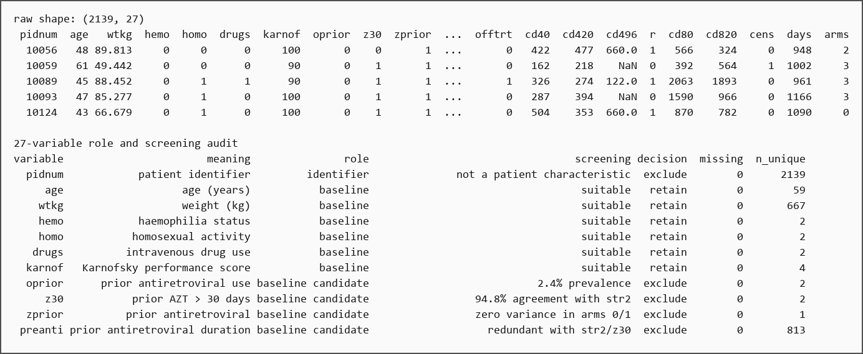
Exhibit 2. Exact console output of Step 2 (part 1 of 3), copied verbatim from the executed notebook.
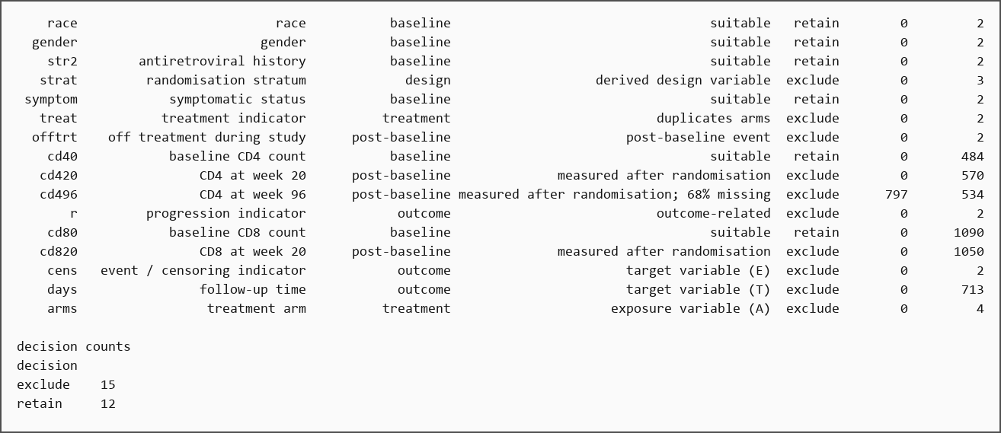
Exhibit 3. Exact console output of Step 2 (part 2 of 3), copied verbatim from the executed notebook.
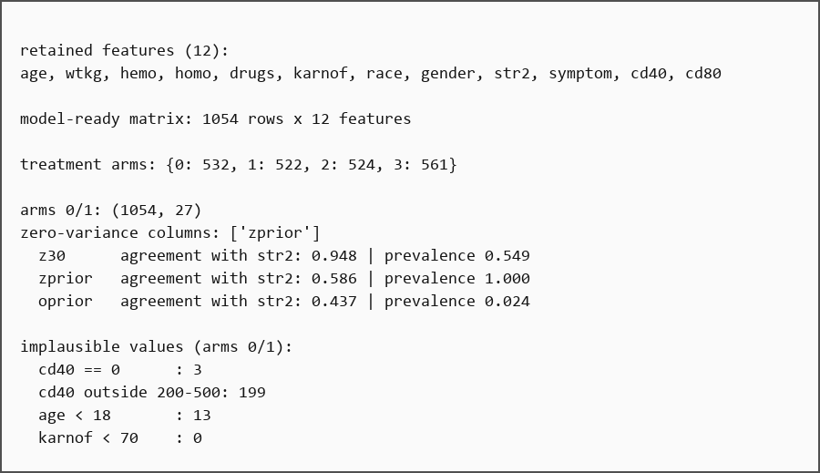
Exhibit 4. Exact console output of Step 2 (part 3 of 3), copied verbatim from the executed notebook.
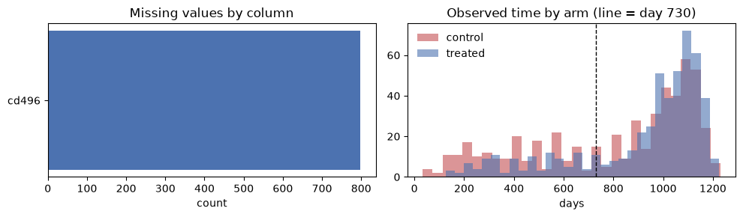
Exhibit 5. Missing values by column and observed follow-up time by arm. Only cd496 has missing values; the dashed line marks 730 days.

Step 3 — Cohort and outcome definition
Code used: notebook Step 3 (cohort and endpoint construction)
What we did – The analysis sample, time origin, composite event and horizon are fixed. The composite event is a CD4 decline of at least 50, AIDS progression, or death. The project then checks that the horizon is inside the observed follow-up and that enough patients are still being followed at that point.
Why this step matters – The endpoint and time origin define what 'benefit' means. A different endpoint or a different start time would answer a different clinical question.
Result obtained: 1,054 of 2,139 patients remain (522 treated and 532 control). There are 284 composite events (26.9%), 103 patients are censored before day 730 (9.8%), and 750 (71.2%) are still at risk at the horizon. Median observed time is 989 days, maximum 1,231.
What this means: The horizon is observable rather than extrapolated. Censoring before 730 days is modest but real, so the estimator must adjust for it. The 284 events are the binding limit on subgroup precision, which is why accuracy is measured in simulation.
Decision at this step: Use the composite progression-free event and the 730-day horizon, with censoring adjustment.
Exact result
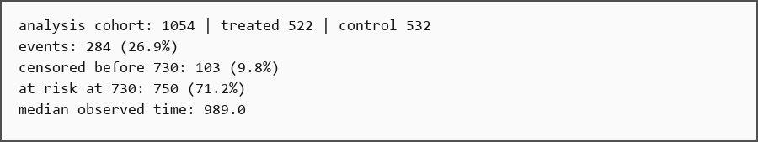
Exhibit 6. Exact console output of Step 3, copied verbatim from the executed notebook.
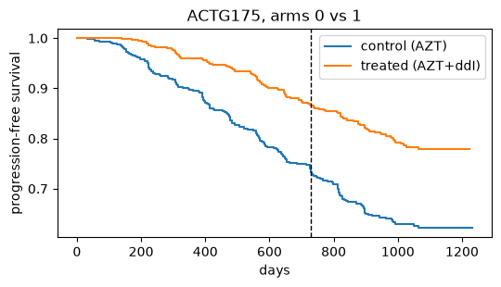
Exhibit 7. Kaplan–Meier curves for the two treatment arms on ACTG175, with 730 days marked.

Step 4 — Split the data
Code used: notebook Step 4 (train_test_split; seeds 2024/2025)
What we did – The cohort is divided into discovery, validation and assessment, stratified by treatment and event together. The row indices are frozen, so the same patients stay in the same role for the whole project.
Why this step matters – If the same patient appears in discovery and validation, every later comparison is optimistic. The split is the structural defence against that.
Result obtained: The split is 527 / 263 / 264, with event rates 27.1% / 26.6% / 26.9% — a spread of 0.5 points, compared with 2.8 points when stratifying on treatment alone. A separate ratio study found 50/25/25 gave the highest capture (0.479) at purity 0.941 with 80% commitment. Every ratio produced 20 distinct rules from 20 splits.
What this means: Validation and assessment are small, so an uneven event rate would add noise to every later comparison; joint stratification removes that noise. The 50/25/25 ratio is kept because it balances discovery size and validation precision. The rule instability is recorded now, not hidden.
Decision at this step: Fix the 527/263/264 split, stratified by treatment and event together.
Exact result
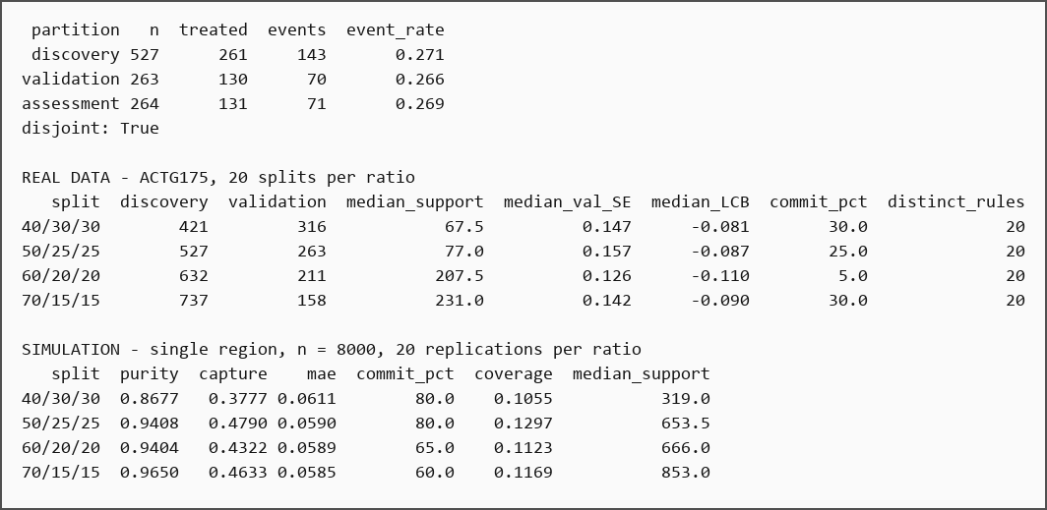
Exhibit 8. Exact console output of Step 4, copied verbatim from the executed notebook.

Step 5 — Choose the horizon
Code used: ciscarl2/estimators.py, notebook Step 5
What we did – Several candidate horizons are evaluated under pre-declared constraints: at least 150 events, at least 60% of patients still at risk, and at most 15% censoring. The horizon is not chosen by picking the largest estimated effect.
Why this step matters – A horizon chosen because the estimated effect is largest is selected on the outcome. The horizon must be fixed by follow-up constraints before the effect is read.
Result obtained: The minimum standard error is at 365 days, the maximum signal-to-noise ratio is around 900 days, and 730 days sits between them with 71% of the cohort at risk and under 10% censored. The constraints admit roughly 550–900 days, and 730 is fixed inside that range as the two-year window. A sensitivity analysis covers 365 and 1,095 days.
What this means: Choosing the horizon where the effect looks largest would be selection on the outcome. 730 days is a defensible compromise inside a range that satisfies precision constraints, and the sensitivity analysis shows how much the answer moves at the edges.
Decision at this step: Fix 730 days inside the feasible range; report 365 and 1,095 days as sensitivity analyses.
Exact result
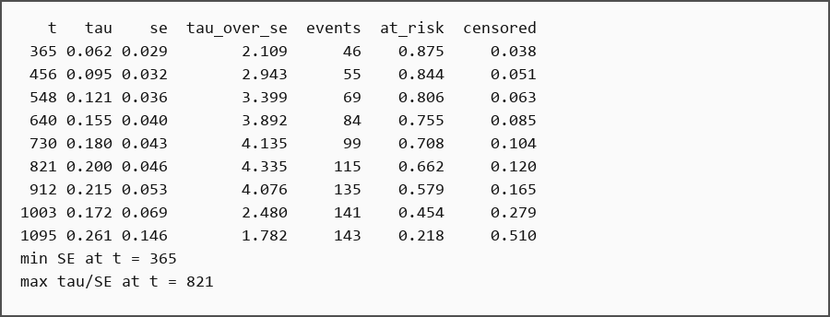
Exhibit 9. Exact console output of Step 5, copied verbatim from the executed notebook.

Step 6 — Preprocessing fitted on discovery
Code used: ciscarl2/estimators.py, notebook Step 6
What we did – The scaler is fitted on the discovery partition only. The step then checks whether standardisation is actually required by the Cox prediction formula, and tests common transforms such as logarithms and winsorising.
Why this step matters – Scaling on all patients leaks information, and the Cox prediction formula assumes centred covariates. Fitting the scaler on discovery only is both a leakage control and a correctness requirement.
Result obtained: Discovery means differ from full-cohort means (cd80 1,019.5 vs 995.7; drugs 0.112 vs 0.129), which proves the scaler never saw validation or assessment. With raw covariates the predicted control survival at 730 days is 0.909; with standardised covariates it is 0.732, a maximum per-patient difference of 0.43. Log transformation and winsorising change nothing once the model is fitted.
What this means: Standardisation is a correctness requirement, not a convenience. The prediction formula assumes centred covariates, and the nuisance model is weakly penalised, so scale affects the fit. Fitting the scaler on discovery only keeps the validation and assessment partitions untouched.
Decision at this step: Fit the scaler on discovery only and standardise every covariate.
Exact result
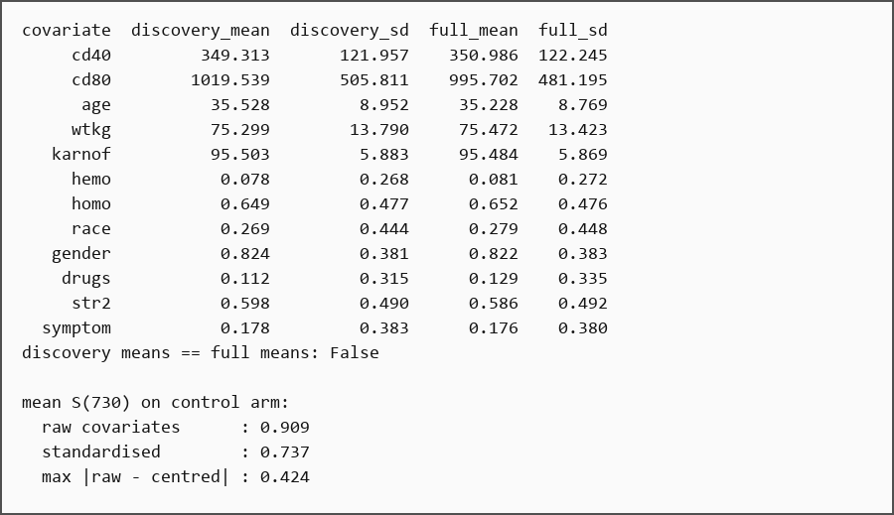
Exhibit 10. Exact console output of Step 6, copied verbatim from the executed notebook.

Step 7 — Leakage checklist
Code used: notebook Step 7 (mechanical leakage checks)
What we did – This step proves mechanically that no validation or assessment information entered any fitted quantity. It checks the covariate list, the scaler means and the partition membership.
Why this step matters – Leakage is the most common reason a model looks good in development and fails in use. A mechanical checklist is stronger than an intention to be careful.
Result obtained: No post-baseline or outcome column is in X. The scaler means equal the discovery means and differ from the full-cohort means. The three partitions share no patient and have the intended sizes.
What this means: The mechanical leakage channels are closed. The remaining risk is analyst-side: looking at assessment before the analysis is frozen. That is controlled by the order of the notebook, not by code, which is why the notebook separates discovery, validation and assessment so strictly.
Decision at this step: Pass the leakage checklist and keep validation and assessment untouched.
Exact result
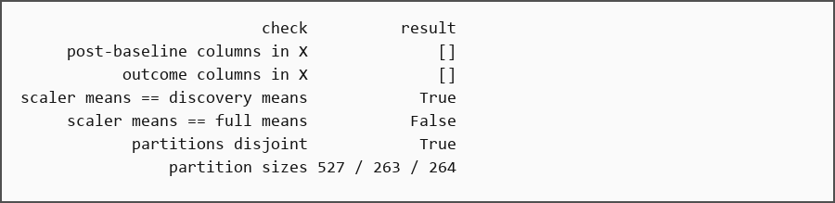
Exhibit 11. Exact console output of Step 7, copied verbatim from the executed notebook.

Step 8 — Nuisance estimation
Code used: ciscarl2/estimators.py (crossfit_nuisances)
What we did – Two nuisance models are fitted on discovery: a survival model for each treatment arm and a conditional censoring model. Both use five-fold cross-fitting, so a patient's own outcome never helps predict that patient. Censoring weights are then capped to stop a few extreme values from dominating.
Why this step matters – The effect estimate needs a good outcome model and honest censoring weights. Cross-fitting stops a patient from helping predict their own outcome.
Result obtained: Fold sizes are 106/106/105/105/105. Weight caps range from 1.23 to 1.35. Of 527 patients, 373 carry a positive weight; the maximum weight is 1.335 and the 99th percentile is 1.31. Effective sample size is 372 (71% of discovery), and 10.4% of discovery patients are censored before day 730.
What this means: The weights barely bind, so the estimate rests on observed follow-up rather than on extrapolation. Cross-fitting is still required because the nuisances are fitted on the same patients they later score. An effective sample size of 372 is the honest denominator for precision claims.
Decision at this step: Use per-arm Cox plus a conditional censoring Cox, five folds, and cap weights at min(Q0.99, 20).
Exact result
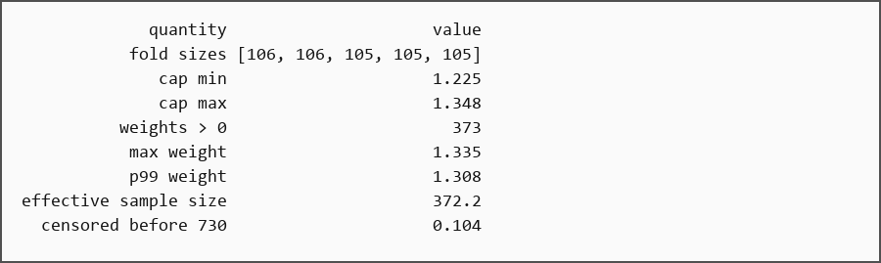
Exhibit 12. Exact console output of Step 8, copied verbatim from the executed notebook.

Step 9 — Target construction (AIPW)
Code used: ciscarl2/estimators.py, ciscarl2/gate2.py (pseudo_outcome)
What we did – The two nuisance models are combined into one pseudo-outcome per patient. This number is the AIPW estimate of that patient's treatment effect: it uses the outcome model but also corrects it with the observed outcome, so it stays consistent if one of the models is wrong.
Why this step matters – The tree needs one number per patient. The choice of target determines what the tree can find, and a noisy target makes discovery fail even when a real subgroup exists.
Result obtained: The pseudo-outcome is centred at +0.180 with a standard deviation of 0.997. The audit showed AIPW bias +0.0031 (SD 0.0130) and arm means within 0.002. The global proportional-hazards test does not reject (p = 0.235 and 0.368), but cd40 violates in both arms (p = 0.021, 0.023). Efron and Breslow tie handling differ by at most 0.0014. Calibration at 730 days has a weighted mean absolute gap of 0.032.
What this means: The pseudo-outcome is the target the tree needs: one number per patient whose average is the treatment effect, already adjusted for censoring. Its spread near 1 is the heterogeneity signal; if it were tightly concentrated, no rule could beat the constant. The cd40 violation is a limitation, not a reason to abandon the model, because the global test holds.
Decision at this step: Use the AIPW pseudo-outcome as the discovery target; record the cd40 proportional-hazards violation.
Exact result
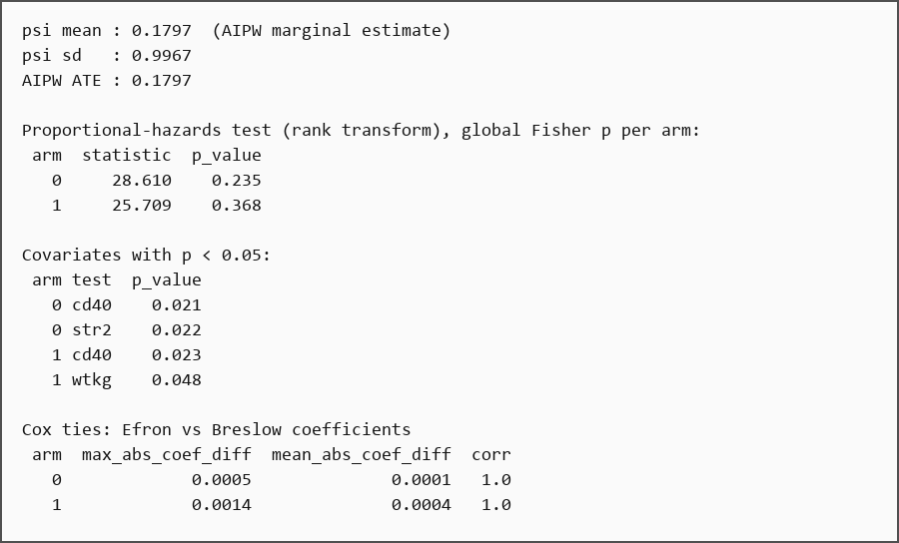
Exhibit 13. Exact console output of Step 9 (part 1 of 2), copied verbatim from the executed notebook.
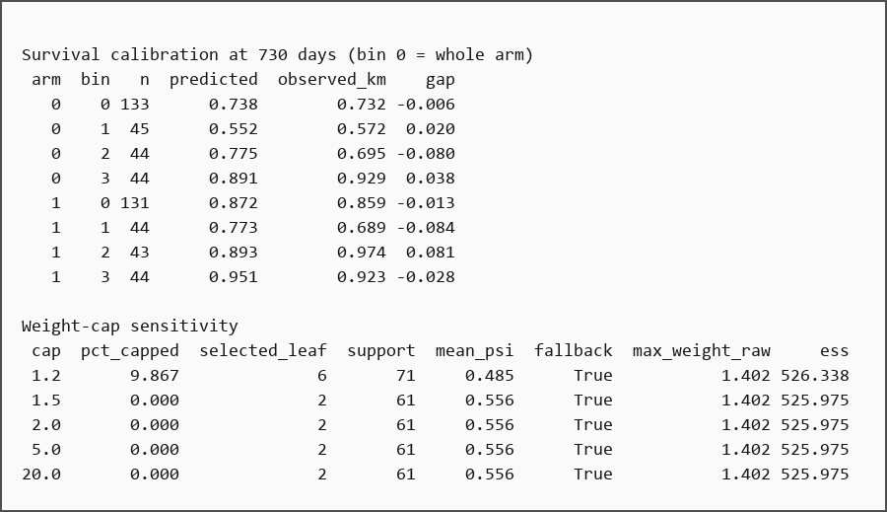
Exhibit 14. Exact console output of Step 9 (part 2 of 2), copied verbatim from the executed notebook.
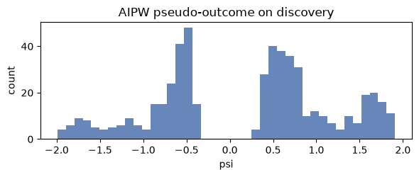
Exhibit 15. Distribution of the AIPW pseudo-outcome on the discovery partition. The spread is the heterogeneity signal the tree uses.

Step 10 — Rule discovery (decision tree)
Code used: ciscarl2/rules.py, ciscarl2/gate11.py (_cart)
What we did – A small regression tree is fitted to the pseudo-outcome. Each root-to-leaf path becomes a candidate rule, such as 'cd40 ≤ 407.5 AND wtkg > 71.0'. Depth is capped at three so a rule has at most three conditions and can be read aloud.
Why this step matters – The rule must be simple enough to read and specific enough to matter. Depth is an interpretability constraint, not a tuning knob.
Result obtained: The tree produces six leaves with supports from 60 to 173 patients and mean pseudo-outcomes from −0.184 to +0.556. Two leaves are negative and one is strongly positive.
What this means: The tree separates a high-benefit subgroup from a negative one — exactly the heterogeneity the method exists to find. Two of six leaves being negative also shows that 'treat the best leaf' is not the same as 'treat everyone above average'. Depth 3 is fixed for interpretability; leaf size is tuned later.
Decision at this step: Use depth 3 and treat every root-to-leaf path as a candidate rule.
Exact result
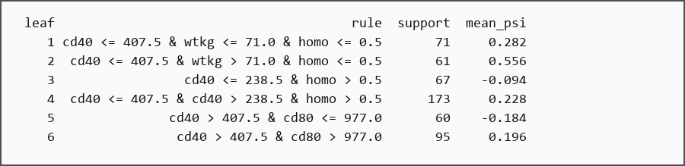
Exhibit 16. Exact console output of Step 10, copied verbatim from the executed notebook.

Step 11 — Selection and commitment
Code used: ciscarl2/estimators.py, notebook Step 11
What we did – The support floor is applied: a leaf must contain at least 200 discovery patients to be selected. The chosen rule is then re-estimated on validation, and treatment is recommended only if the one-sided 95% lower confidence bound is above zero.
Why this step matters – The best leaf in discovery is often a small lucky leaf. The support floor and the validation bound decide whether that leaf should be trusted.
Result obtained: No leaf reaches 200 patients (the largest has 173), so the fallback is used and leaf 2 is selected: cd40 ≤ 407.5 & wtkg > 71.0 & homo ≤ 0.5, with 61 discovery patients. On validation (n = 31) the effect is +0.116 (SE 0.222), giving a lower bound of −0.250 and the decision INSUFFICIENT. On assessment the rule shows +0.401 [+0.033, +0.770] on 38 patients, but that is descriptive only.
What this means: The support floor cannot bind at 527 discovery patients, and the validation partition is too small to certify a 61-patient leaf. The model therefore refuses to recommend treatment. That is the commitment layer doing its job, not a bug.
Decision at this step: Apply support 200 and the validation lower-bound rule; abstain when the bound is below zero.
Exact result
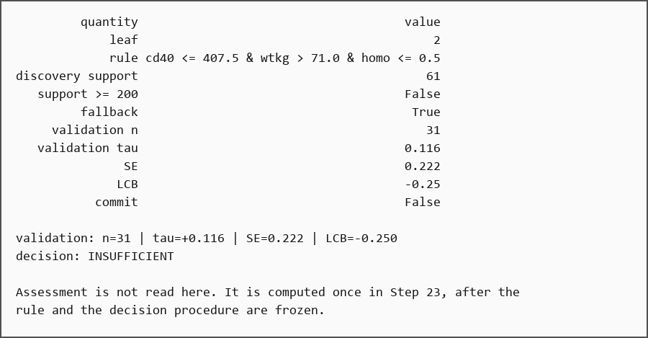
Exhibit 17. Exact console output of Step 11, copied verbatim from the executed notebook.

Step 12 — Simulation harness
Code used: ciscarl2/dgp.py
What we did – Real data cannot tell us whether a subgroup is correct. The project therefore builds semi-synthetic trials from the real ACTG175 covariate matrix, generates survival and censoring times, and adds a known treatment effect in one or two regions. Because the effect is generated, every patient's true benefit is known.
Why this step matters – Real data have no individual treatment-effect truth, so accuracy cannot be measured without simulation. The simulator supplies the missing answer.
Result obtained: The harness gives 25.5% prevalence, a 20.0% event rate, 10.1% censoring, a true average effect of +0.050, and a true effect of +0.195 inside the region and 0 outside.
What this means: The truth is analytic, so accuracy, purity and capture can be computed honestly. The marginal effect is only +0.05 because most patients do not benefit; that dilution is why a model predicting the average everywhere cannot win, and why capture and purity are the informative metrics.
Decision at this step: Use the semi-synthetic ACTG175-based simulator for every accuracy claim.
Exact result
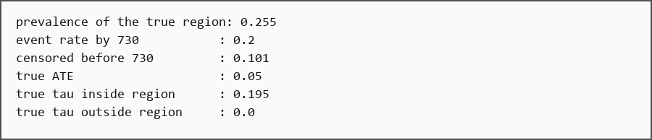
Exhibit 18. Exact console output of Step 12, copied verbatim from the executed notebook.

Step 13 — First result: the constant baseline
Code used: ciscarl2/gate17.py, results/gate17_summary.csv
What we did – The rule model is compared with the simplest possible policy: give everyone the same marginal effect. The comparison is repeated at 2,000, 4,000 and 6,000 patients, with 40 seeds per cell. An oracle model that knows the true effect is included as an upper bound.
Why this step matters – A subgroup model is only useful if it beats the simple policy of treating everyone at the average effect. Without this baseline, a gain can be imaginary.
Result obtained: At n = 2,000 the rule model is worse than the constant (−26.4%, only 17.5% of replications better). At 4,000 it is marginal (+4.5%, 55% better). At 6,000 it is clearly better (+21.7%, 85% better). The oracle sits 40–60 points higher throughout.
What this means: The method has a measured operating range, not a universal advantage. Below roughly 5,000 patients it should not be used. The gap to the oracle is a discovery gap, not an information gap: the signal exists, but a depth-3 tree cannot recover it at small sample sizes.
Decision at this step: Record the operating range; do not present the model as universally better than the constant.
Exact result
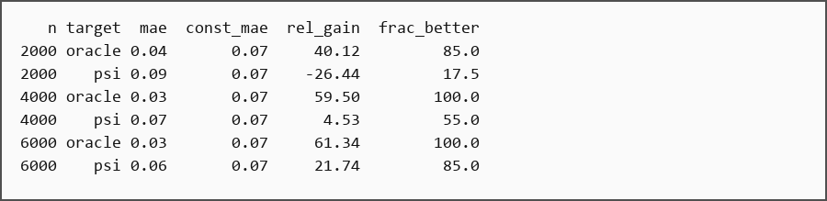
Exhibit 19. Exact console output of Step 13, copied verbatim from the executed notebook.
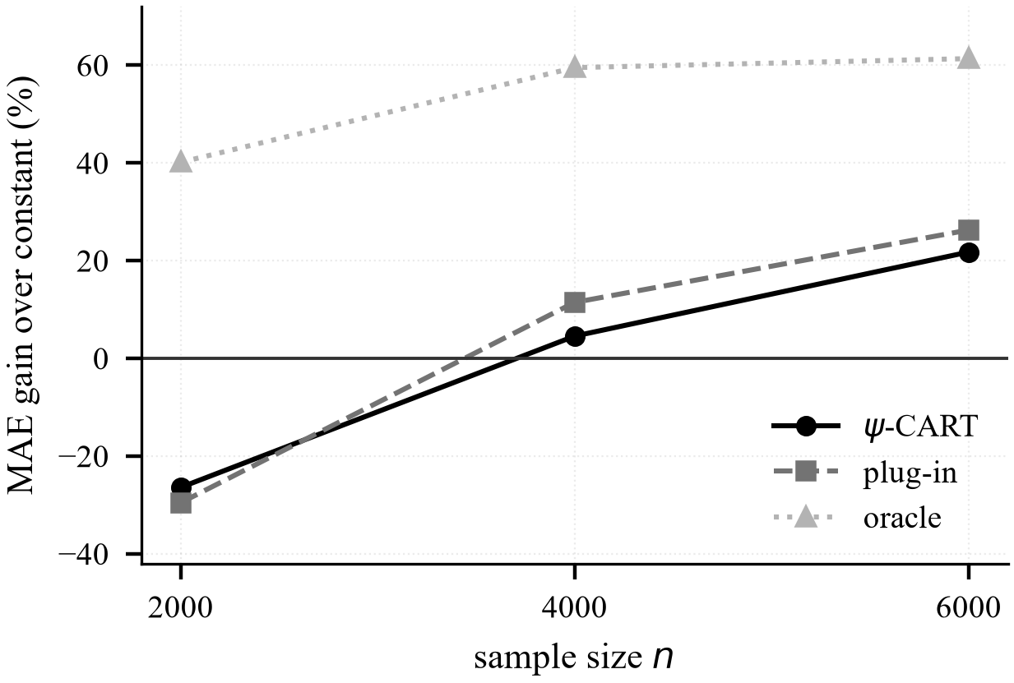
Exhibit 20. Operating range: rule model versus the constant baseline, with the oracle bound.

Step 14 — Support floor
Code used: ciscarl2/gate21.py, gate23.py, gate30.py
What we did – The minimum subgroup size is swept to measure the trade-off between purity (how many treated patients truly benefit) and capture (how much of the total benefit the rule finds). The sweep includes no floor, 100, 200 and 400 patients, and a proportional floor at small sample sizes.
Why this step matters – Small leaves win by luck. The support floor is the main defence against the winner's curse, and its cost in purity must be measured.
Result obtained: In the two-region design, no floor gives capture 0.149 and purity 0.774; a floor of 100 gives 0.246/0.847; 200 gives 0.364/0.820; 400 gives 0.441/0.778. In the single-region design, no floor gives 0.228/0.626 and a floor of 200 gives 0.514/0.821. At n = 2,000 the absolute floor gives purity 0.47 and commitment 17.5%, while a 5% proportional floor gives 0.73 and 30%.
What this means: The floor roughly triples capture at a purity cost of about 0.02 in the two-region design, and improves purity in the single-region design. A floor of 400 buys more capture but gives purity back, so 200 is the better operating point. At small n the absolute floor is disproportionate, which is a documented limitation.
Decision at this step: Adopt the 200-patient floor; keep 400 as a sensitivity.
Exact result
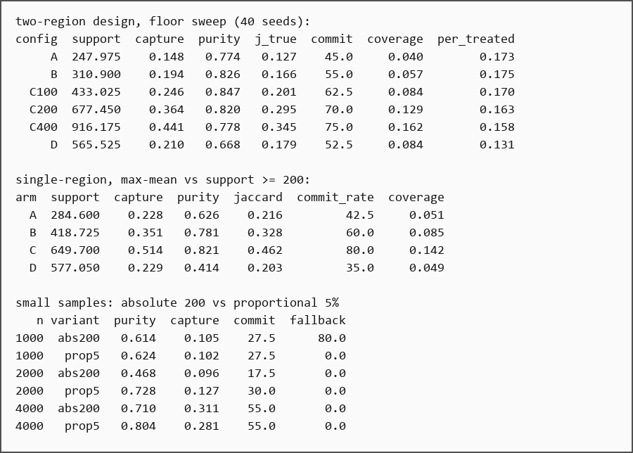
Exhibit 21. Exact console output of Step 14, copied verbatim from the executed notebook.
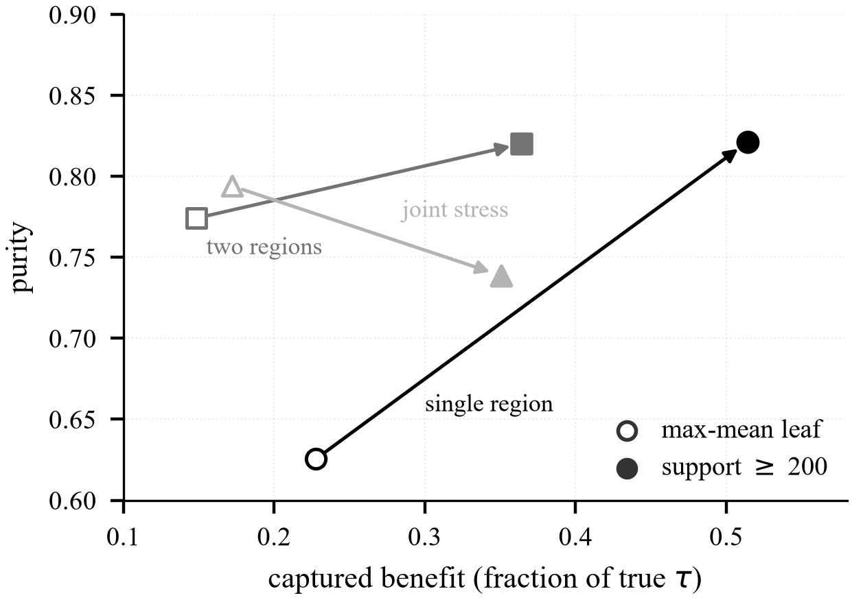
Exhibit 22. Purity–capture frontier for the support floor.

Step 15 — Calibration
Code used: ciscarl2/gate30.py (shrinkage variants)
What we did – Leaf effects are noisy because each leaf contains only a few dozen patients. Calibration pulls those noisy effects toward the overall average. The project compares no calibration with empirical-Bayes shrinkage, using 80 paired replications across two designs.
Why this step matters – Leaf effects are noisy because each leaf contains only a few dozen patients. Calibration changes reported effects without changing who is treated.
Result obtained: Shrinkage lowers MAE by 0.0051 [−0.0077, −0.0025] in the single-region design and 0.0026 [−0.0048, −0.0005] in the two-region design. Purity, capture, commitment and rank correlation are unchanged. The head-to-head with SCRE moves from a significant deficit to a tie.
What this means: The pattern is pure variance reduction: the leaf means are noisy, and pulling them toward the average improves prediction without changing who is treated. Because this was chosen after the SCRE comparison, it is reported as a post-hoc calibration (C200-S), confirmed on fresh seeds, not merged into the frozen configuration.
Decision at this step: Adopt empirical-Bayes shrinkage as a post-hoc prediction calibration (C200-S) and confirm it on fresh seeds.
Exact result
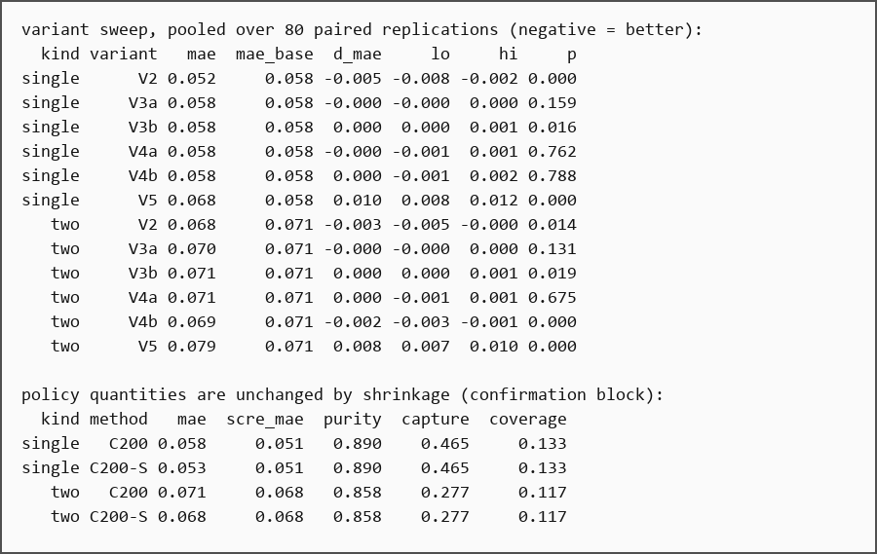
Exhibit 23. Exact console output of Step 15, copied verbatim from the executed notebook.

Step 16 — Nuisance and estimator comparison
Code used: ciscarl2/gate31.py, gate36.py, gate39.py
What we did – Three alternatives are tested against the frozen choices: flexible outcome models (random survival forest, gradient boosting, equal-weight stacking), a fixed-horizon TMLE estimator, and learned stacking of Cox, RSF and GBM. Everything else is held fixed.
Why this step matters – A flexible outcome model may fit survival better but produce worse treatment effects. The comparison must be on the effect, not on the survival fit alone.
Result obtained: Cox has the best Brier score (0.0028 single, 0.0033 two). Stacking lowers patient-level MAE (0.0475/0.0504 vs 0.0517/0.0579) but loses 0.030 purity in the two-region design and costs 136–260 s per replication vs 0.002 s. GBM loses 0.036 purity. TMLE is purer (+0.064/+0.068) but its MAE is 0.089/0.080 worse and Brier is 0.015/0.014 worse. The learned stack puts about 0.77 weight on Cox and is indistinguishable from Cox (+0.0007/+0.0001 MAE).
What this means: Cox and AIPW are retained. A flexible model buys a small MAE gain and pays with purity, calibration and a very large cost. TMLE is not a patient-level improvement. The result is a tested negative result for complexity, not an unexamined preference for the incumbent.
Decision at this step: Keep Cox and AIPW; reject RSF, GBM, equal-weight stacking, learned stacking and fixed-horizon TMLE.
Exact result
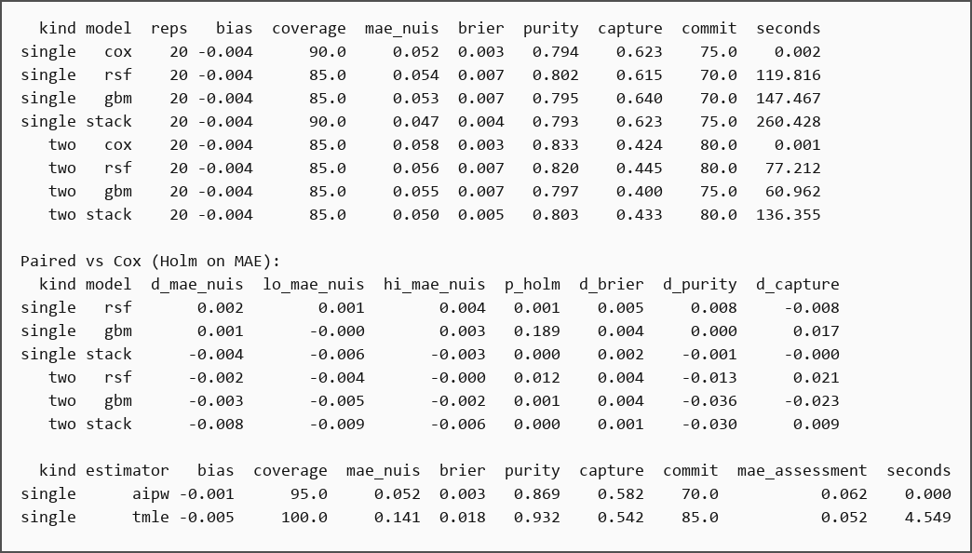
Exhibit 24. Exact console output of Step 16 (part 1 of 2), copied verbatim from the executed notebook.
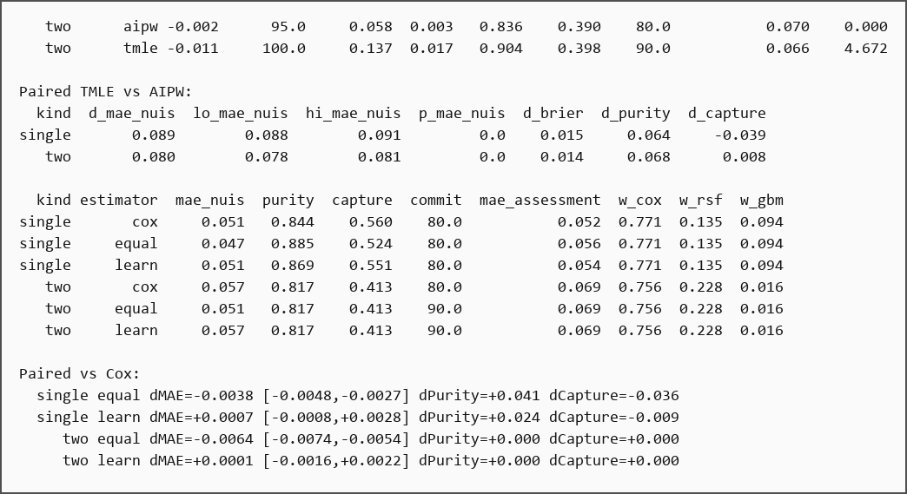
Exhibit 25. Exact console output of Step 16 (part 2 of 2), copied verbatim from the executed notebook.
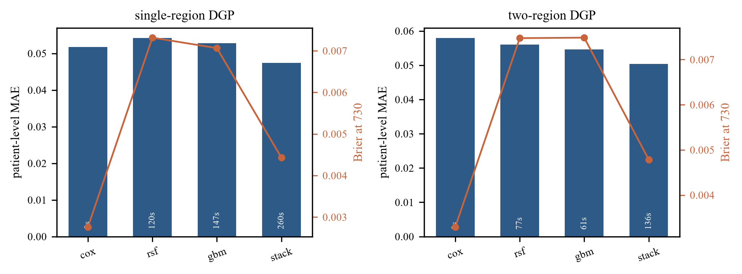
Exhibit 26. Gate 31: Cox versus random survival forest, gradient boosting and equal-weight stacking.
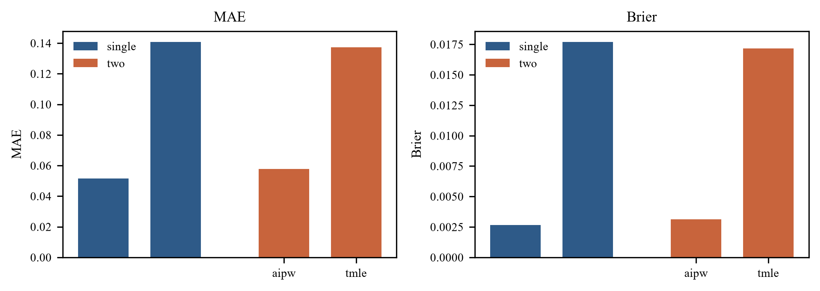
Exhibit 27. Gate 36: AIPW versus fixed-horizon IPCW-TMLE.

Step 17 — Rule learners
Code used: ciscarl2/gate32.py
What we did – Five learners are compared on the same pseudo-outcome and the same selection protocol: regression CART, cost-complexity-pruned CART, PRIM peeling boxes, a classification tree on the sign of the effect, and boosting distillation.
Why this step matters – Different learners produce different rules. The simplest learner has to be tested against the alternatives rather than assumed to be best.
Result obtained: Pruned CART gains capture in the two-region design (+0.261) but loses 0.173 purity, nearly nine times the allowed loss of 0.02. The classification tree loses 0.219/0.110 purity. PRIM loses both capture and purity and needs 4.6–4.8 conditions. Boosting is the only learner with a better two-region MAE (−0.0029) but loses capture (−0.092) and purity (−0.050) and costs 25–105 s per replication.
What this means: No alternative meets the pre-registered guardrails. Regression CART is kept. Higher capture is not worth a rule that treats many people who do not benefit.
Decision at this step: Keep regression CART; reject pruned CART, PRIM, the classification tree and boosting distillation.
Exact result
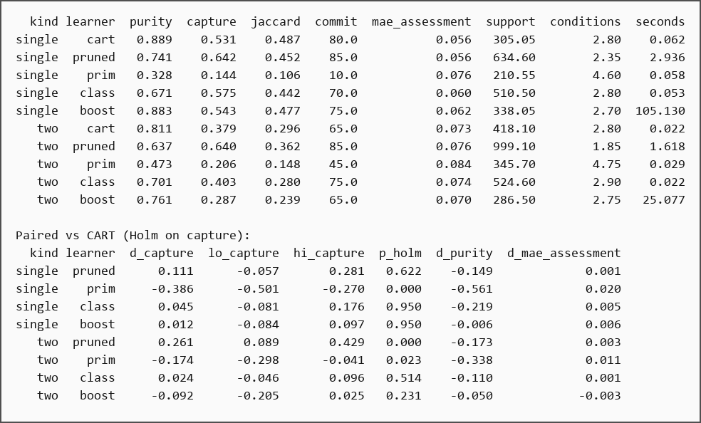
Exhibit 28. Exact console output of Step 17, copied verbatim from the executed notebook.
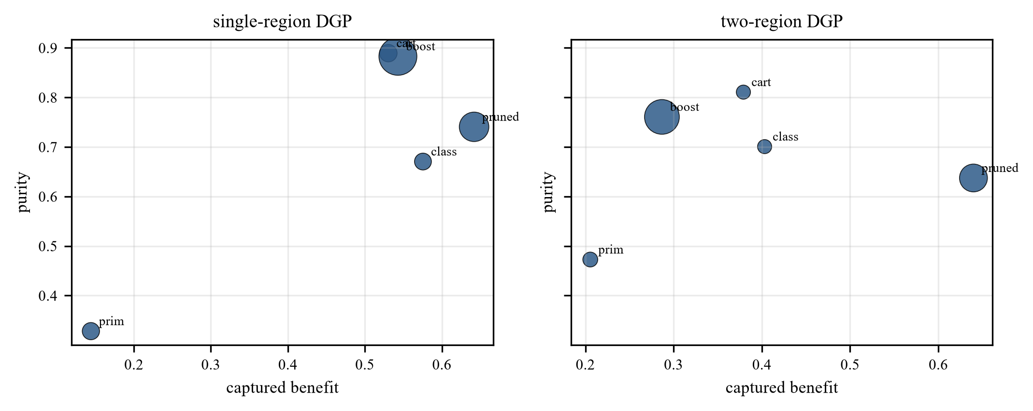
Exhibit 29. Gate 32: purity–capture positions of the five rule learners.

Step 18 — Hyperparameter tuning
Code used: ciscarl2/nested_tune.py
What we did – Depth, leaf size and the splitting criterion are tuned by five-fold cross-validation inside discovery. The important detail is that the nuisance models are refitted inside every inner fold, so the inner validation rows do not influence the pseudo-outcome used to tune the tree.
Why this step matters – Tuning on a pseudo-outcome computed once on the whole discovery set leaks information and inflates performance. Nested refitting is the honest version.
Result obtained: Under nested refitting the best configuration is depth 4 / leaf 60 / squared error at 0.8633; the frozen depth 3 / leaf 60 / squared error is 0.8638, a difference of 0.0005 against a fold SD of about 0.02. The earlier grid, which tuned on a pseudo-outcome computed once, reported 0.824 for absolute error versus 0.871 for squared error.
What this means: The earlier gap was optimism from nuisance leakage, not a real gain. With honest nested refitting, no configuration beats the frozen one. The false claim was withdrawn, and depth 3 was kept.
Decision at this step: Use nested tuning, keep depth 3 / leaf 60 / squared error, and withdraw the leakage-driven gain.
Exact result
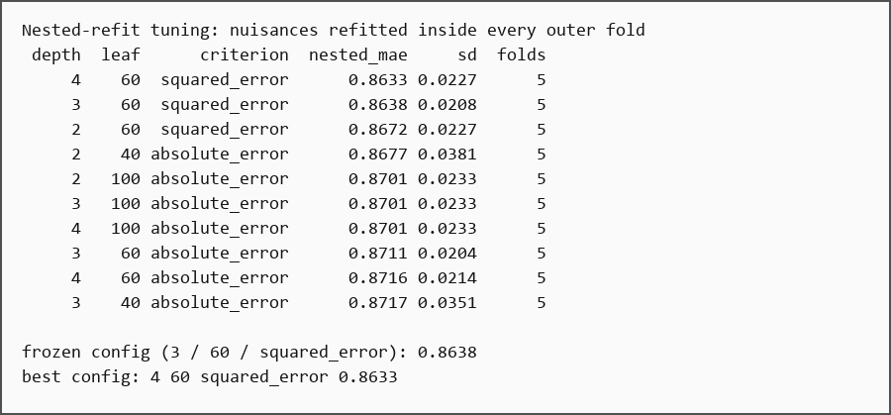
Exhibit 30. Exact console output of Step 18, copied verbatim from the executed notebook.

Step 19 — Freeze the configuration
Code used: notebook Step 19, results/CANONICAL_RESULTS.md
What we did – Every modelling decision is written into one record, with the evidence and the number that produced it. The record separates design decisions (fixed by the protocol) from experimental decisions (kept only after a comparison) and post-hoc calibration.
Why this step matters – A model assembled from undocumented choices cannot be reproduced or defended. Freezing the configuration with its evidence prevents silent drift.
Result obtained: Sixteen decisions are recorded with their evidence. The two choices changed after seeing results — the commitment criterion and the shrinkage — are labelled as post-hoc.
What this means: Every value in the final model is traceable. A reader can tell the frozen design from the calibration, which is what stops the final model from becoming a pile of post-hoc choices.
Decision at this step: Freeze 16 decisions with their evidence and label the two post-hoc choices.
Exact result
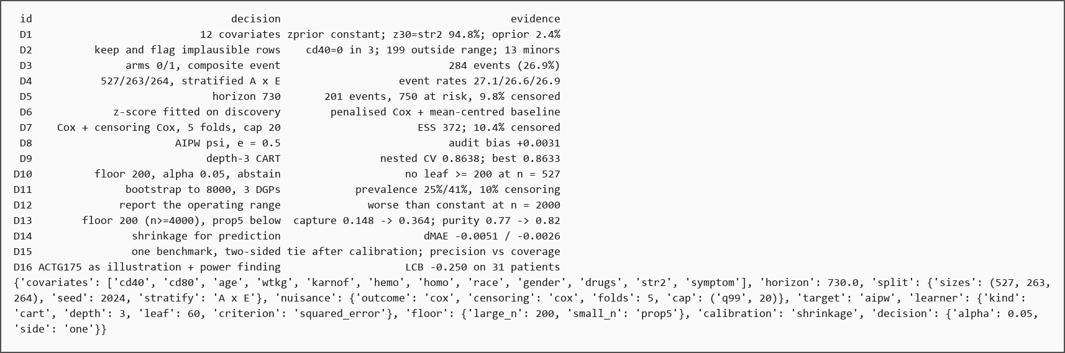
Exhibit 31. Exact console output of Step 19, copied verbatim from the executed notebook.

Step 20 — Confirmation on fresh seeds
Code used: ciscarl2/gate30.py (confirmation block, 320100–320139)
What we did – The frozen configuration is re-run on seeds it has never seen, with the previous configuration kept as the control. This is the step that turns a tuning result into a confirmed result.
Why this step matters – A result on tuning seeds may be selection rather than signal. Fresh seeds are the test that turns a proposal into a result.
Result obtained: Shrinkage reproduces its direction: single-region ΔMAE −0.0047 (p = 0.022), two-region −0.0027 (p = 0.078), pooled −0.0051 and −0.0026.
What this means: A gain on tuning seeds is only a proposal. The single-region effect survives confirmation; the two-region effect is directionally consistent but not individually significant. That qualification is carried into the paper instead of being rounded away.
Decision at this step: Accept the shrinkage direction; carry the two-region qualification into the paper.
Exact result
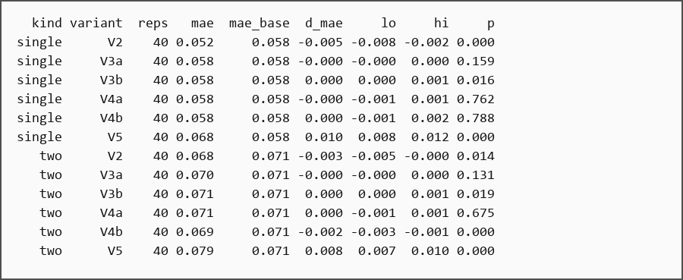
Exhibit 32. Exact console output of Step 20, copied verbatim from the executed notebook.

Step 21 — Assessment evaluation
Code used: results/sweep1000_two_summary.csv, sweep1000_stress_summary.csv
What we did – The frozen model is scored once on the untouched assessment partition, using 1,000 replications per scenario. The metrics cover purity, capture, coverage, benefit per treated patient, commitment, null treatment and MAE.
Why this step matters – Assessment must be read once, after the model is frozen. Reading it earlier turns the evaluation into another tuning set.
Result obtained: In the two-region design, purity is 0.856 (SD 0.166), median 0.925, 10th percentile 0.603, and 68.7% of committed runs are above 0.80. Coverage is 0.135, capture 0.304, benefit per treated patient 0.164, commitment 72.5%, null rate 0%, and MAE 0.0701. The joint stress cell gives 0.844, 0.915, 0.579, 65.5%, 0.136, 0.294, 0.159, 68.2%, 0% and 0.0701.
What this means: The policy treats about one patient in seven and, in two thirds of runs, finds a leaf that is at least 80% pure. The mean hides a bimodal distribution: the median is 0.925 but the bottom decile is 0.60. Capture 0.30 is the direct cost of treating only 13% of patients, and the 0% null rate shows the gate never recommends a harmful leaf.
Decision at this step: Report the full assessment metric set and make no model change afterwards.
Exact result
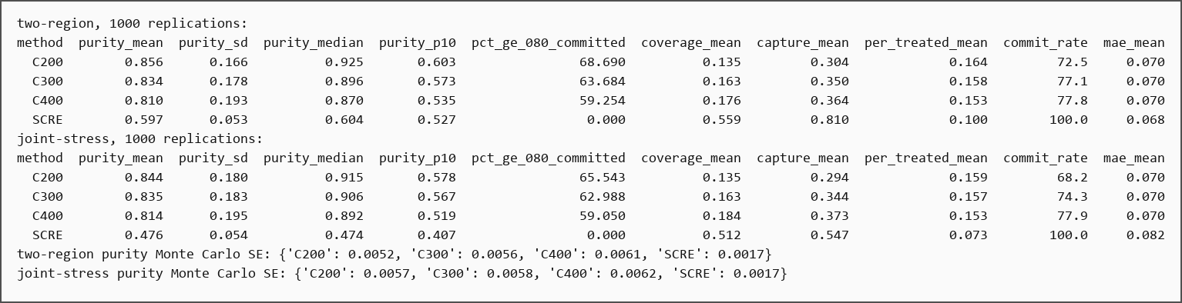
Exhibit 33. Exact console output of Step 21, copied verbatim from the executed notebook.

Step 22 — Baseline comparison (SCRE)
Code used: ciscarl2/gate28.py, gate40.py, policy_eval.py
What we did – CISCaRL is compared with SCRE, a survival causal rule ensemble, on identical splits, the same 730-day horizon and the same patients. The comparison covers accuracy, purity, capture, benefit per treated patient and policy value. SCRE's regularisation path is also checked so the conclusion does not depend on one tuning value.
Why this step matters – A model must be compared with a real alternative, not only with a constant. The comparison also has to use identical splits and the same target.
Result obtained: The frozen model is worse on MAE in both designs (+0.0062, p < 0.001; +0.0031, p = 0.044). After shrinkage the difference is +0.0011 (p = 0.48) and +0.0004 (p = 0.76), a tie. Purity is 0.890 vs 0.437, benefit per treated patient 0.174 vs 0.085, and coverage 0.133 vs 0.548. At zero treatment cost, treat-all has the highest policy value; at a cost of 0.05–0.10, C200 has the highest net benefit. The validation interval covers the true rule effect in 92.5% of replications. The chosen SCRE alpha is within 0.0010–0.0017 MAE of the best path alpha.
What this means: SCRE wins on accuracy and coverage; CISCaRL wins on purity and benefit per treated patient, and it can abstain. Neither dominates. The honest claim is two-sided: comparable accuracy after calibration, higher precision, an abstention layer, and a large coverage cost.
Decision at this step: Keep C200; claim comparable accuracy after calibration, higher purity, and abstention, not overall superiority.
Exact result
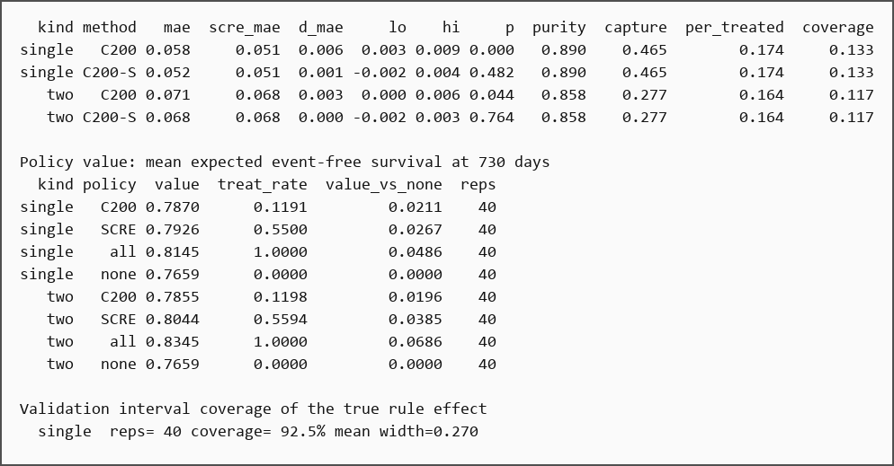
Exhibit 34. Exact console output of Step 22 (part 1 of 2), copied verbatim from the executed notebook.
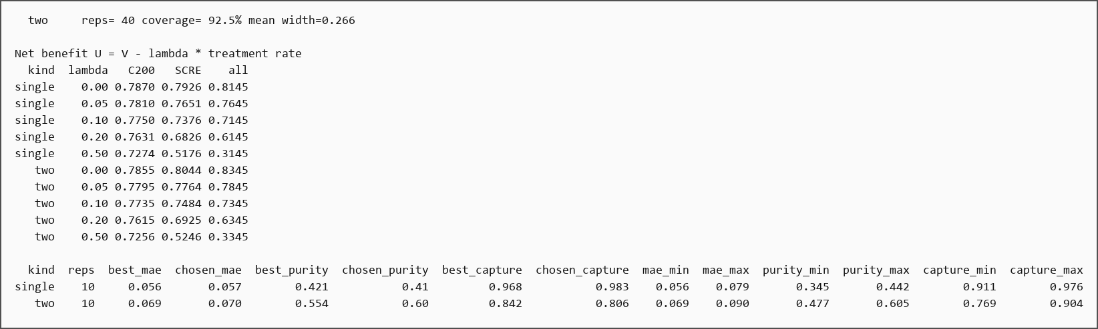
Exhibit 35. Exact console output of Step 22 (part 2 of 2), copied verbatim from the executed notebook.
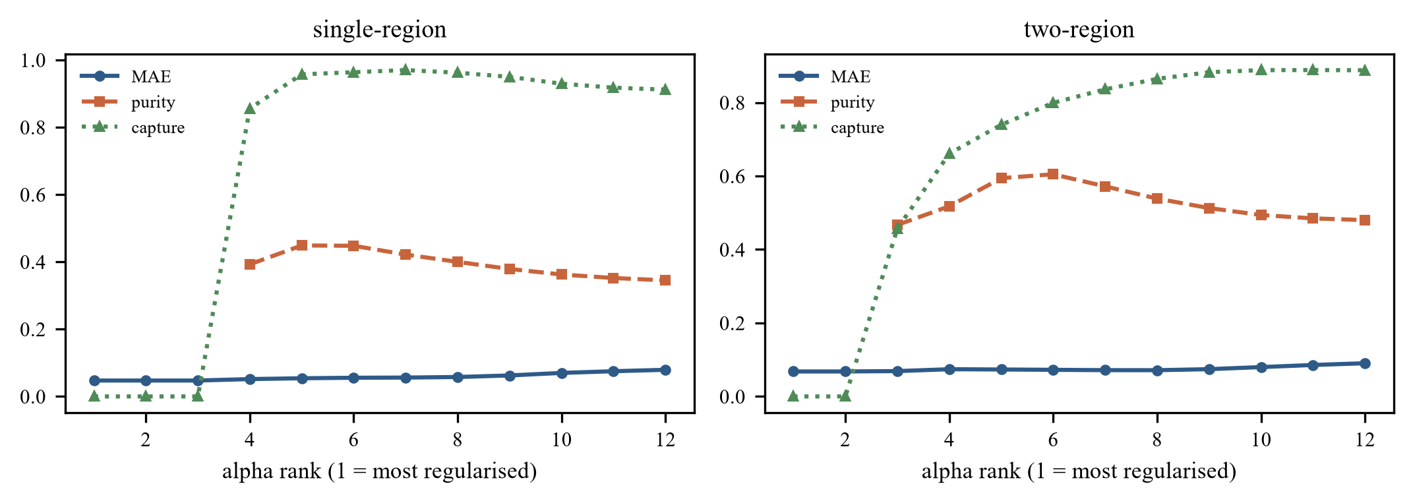
Exhibit 36. Gate 40: SCRE full regularisation path; the chosen alpha is close to the best-MAE point.

Step 23 — Real-data run (ACTG175)
Code used: ciscarl2/gate13.py, ciscarl2/scre_vs_ciscarl.py
What we did – The frozen pipeline is applied to the real trial. The step reports both what the model estimates and what it refuses to claim. A Kaplan–Meier check and a censoring-weight sensitivity analysis are included, because the real data have no individual treatment-effect truth.
Why this step matters – The real trial is the intended use case, even though the truth is unknown. The output has to include what the model refuses to claim.
Result obtained: Overall τ(730) = +0.124 [−0.002, +0.250]. The selected rule has 61 discovery patients; validation is +0.116 (SE 0.222, lower bound −0.250) and is not committed. Assessment gives +0.401 [+0.033, +0.770] on 38 patients. The unadjusted Kaplan–Meier difference for the rule is +0.341 [+0.194, +0.494], and the marginal Kaplan–Meier difference is +0.133, matching the AIPW estimate.
What this means: Two honest statements follow. The overall verdict is not robust to the partition: the treatment-only split gave +0.143 [0.025, 0.262] while the balanced split gives +0.124 [−0.002, 0.250]. The point estimate is stable near 0.13, but its significance is not. The subgroup cannot be certified with 31 validation patients and a lower bound of −0.250, so the model abstains.
Decision at this step: Report the overall effect and the abstention on the subgroup; do not treat the assessment result as evidence.
Exact result
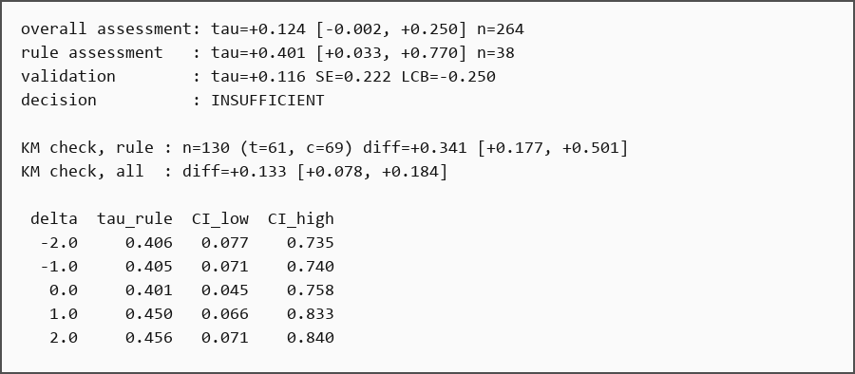
Exhibit 37. Exact console output of Step 23, copied verbatim from the executed notebook.
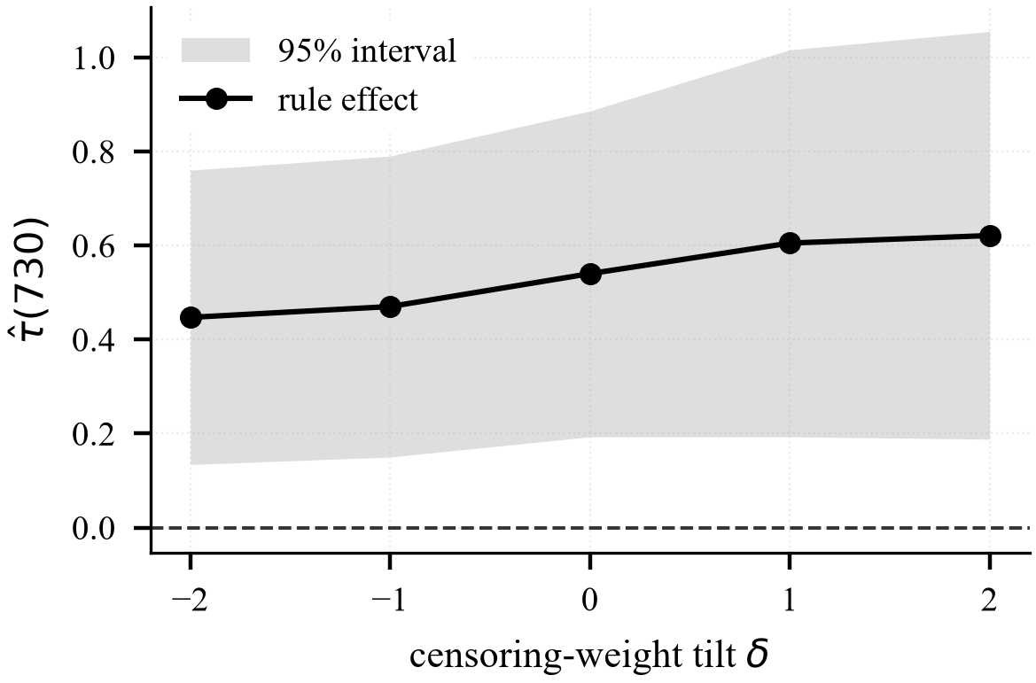
Exhibit 38. ACTG175 censoring-weight tilt for the selected rule.

Step 24 — Ablations
Code used: ciscarl2/gate37.py, gate38.py, gate42.py, gate43.py, gate44.py
What we did – The choices a reader could challenge are tested: the covariate set, the horizon, and robustness to missingness. A dense horizon grid and two independent horizon selection rules are used, followed by a 20-split stability test.
Why this step matters – Readers will challenge the covariate set, the horizon and the handling of missing data. Each challenge needs a measured answer, not an assurance.
Result obtained: Adding the four excluded baseline history columns leaves the rule unchanged. The horizon does change the rule: 365 days gives 7 leaves and +0.062; 730 gives 6 leaves and +0.180; 1,095 gives 5 leaves and +0.162. Five per cent missingness in cd40 changes the leaf to a cd80/race split. No horizon meets every criterion. A single split prefers 965 days, discovery-only cross-validation prefers 845, and across 20 splits 730 has the best mean lower bound (−0.142, SD 0.114) against −0.167 (SD 0.185) for 845 and −0.206 (SD 0.191) for 965. RFE drops to support 79, and lasso keeps all 12 features.
What this means: The rule is stable to the covariate set but sensitive to the horizon and to missingness, matching the simulation instability (Jaccard about 0.34). No alternative is adopted: 12 covariates are kept, and 730 days is retained on 20-split stability rather than on convention.
Decision at this step: Keep 12 covariates and 730 days; report the horizon and missingness sensitivity as limitations.
Exact result
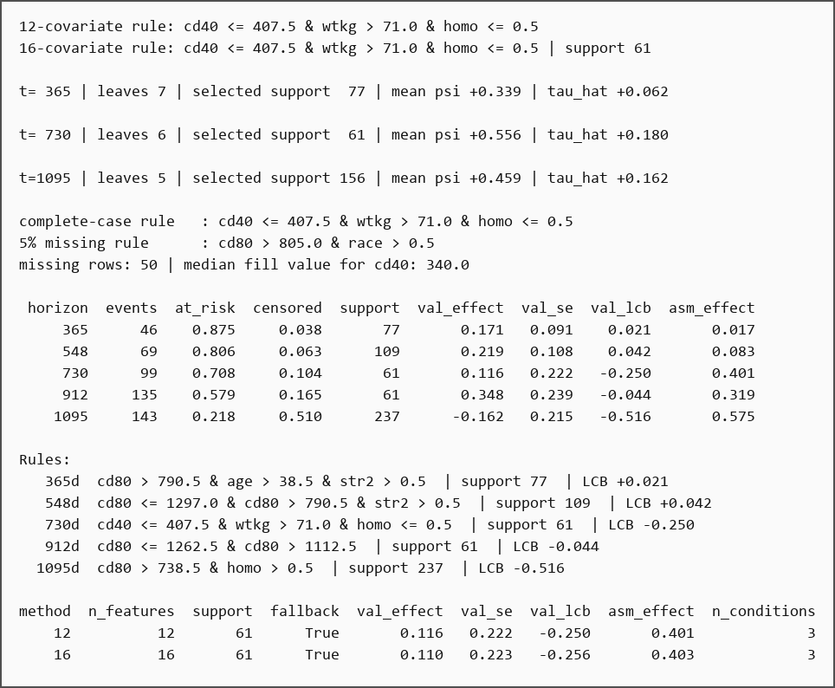
Exhibit 39. Exact console output of Step 24 (part 1 of 2), copied verbatim from the executed notebook.
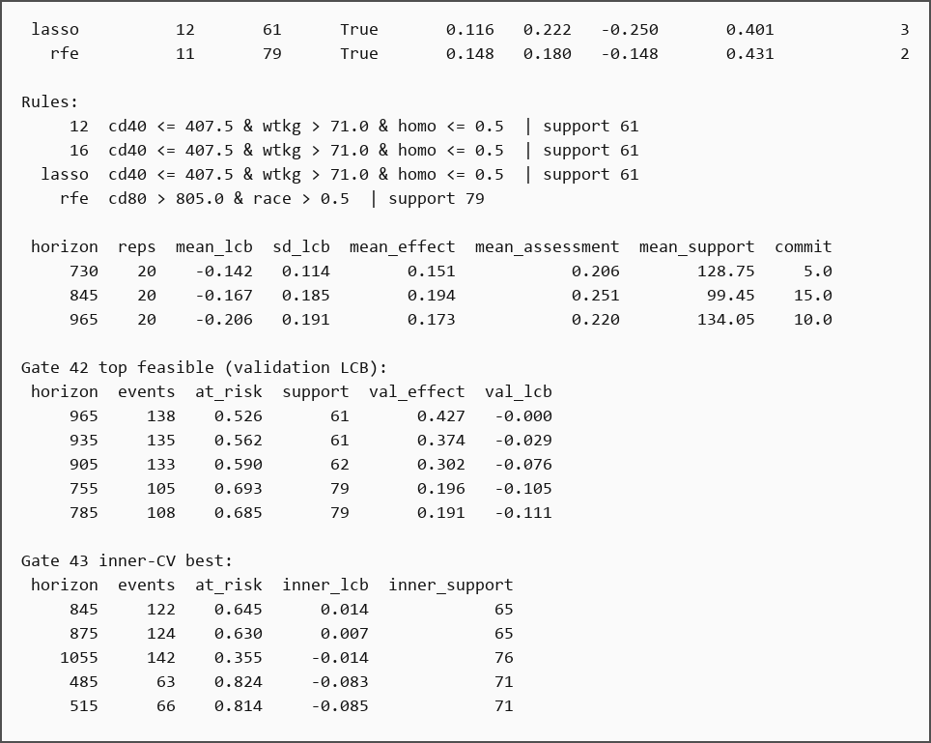
Exhibit 40. Exact console output of Step 24 (part 2 of 2), copied verbatim from the executed notebook.
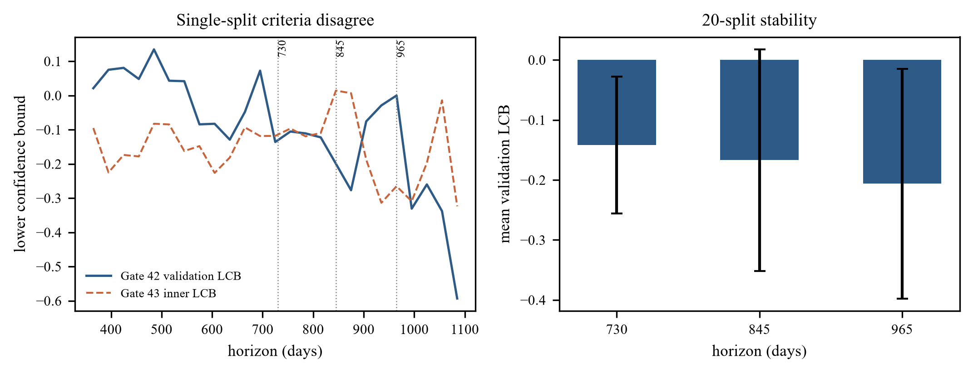
Exhibit 41. Horizon stability across 20 splits (Gates 37 and 42–44).
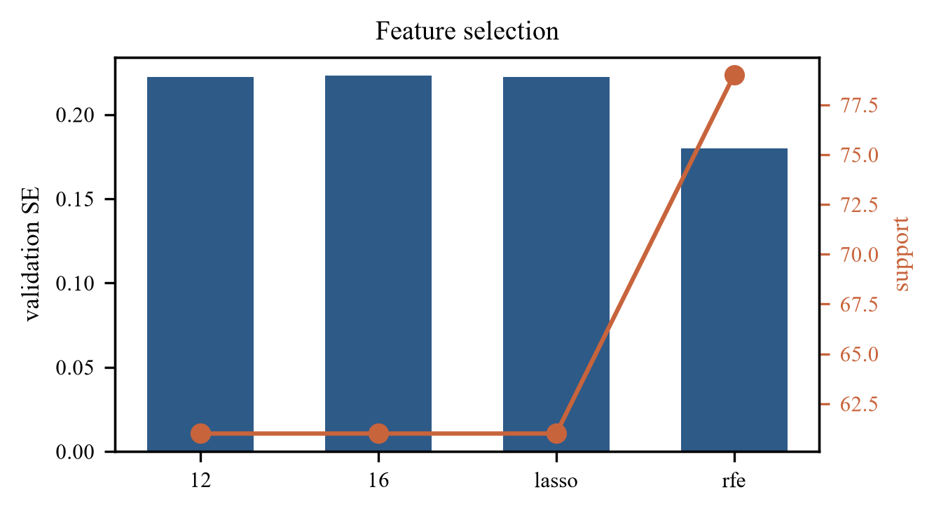
Exhibit 42. Gate 38: feature-selection alternatives.

Step 25 — From the frozen pipeline to the post-freeze evidence
Code used: notebook Step 25 (checklist)
What we did – Before adding more experiments, the project separates what Steps 1–24 settled from what they did not. This prevents the extension from testing things that are already known, or from adding methods just to look thorough.
Why this step matters – Without a gap analysis, extension work repeats settled questions or adds methods for their own sake. This step decides what is actually open.
Result obtained: Settled: the estimand and endpoint, the cohort and 12 covariates, the split, discovery-fitted preprocessing, Cox/AIPW construction, depth-3 CART, the support floor, the commitment rule, shrinkage calibration, the SCRE comparison and the ACTG175 assessment. Open: the nuisance model, the rule learner, calibration choice, interval choice, fold count, fairness, and the horizon.
What this means: The later gates test real gaps. This is why the post-freeze work changed the calibration and the evidence record, but not the rule or the decision.
Decision at this step: Test only the open layers in the extension.
Exact result
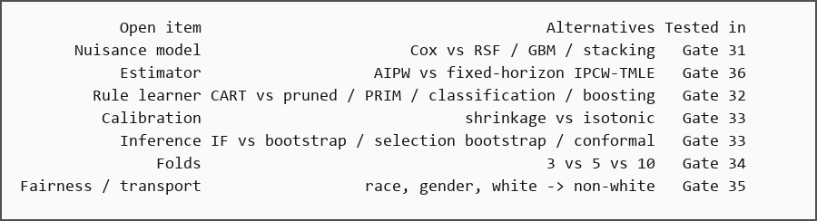
Exhibit 43. Exact console output of Step 25, copied verbatim from the executed notebook.

Step 26 — Calibration and intervals
Code used: ciscarl2/gate33.py, gate41.py
What we did – Two questions are tested after the freeze. How should noisy leaf effects be calibrated: none, shrinkage, or out-of-fold isotonic regression? And how should uncertainty be reported after the rule has been selected: influence function, validation bootstrap, selection bootstrap, or split-conformal?
Why this step matters – Calibration and interval choice affect the reported effect and its uncertainty, so both must be tested after the rule is frozen.
Result obtained: Isotonic beats no calibration by −0.0076 MAE in the main single-region run and −0.0034 in the two-region run, with the policy unchanged. On fresh seeds it replicates: −0.0053 [−0.0104, −0.0001] and −0.0065 [−0.0099, −0.0032]. Shrinkage is not significant in confirmation. The influence-function interval covers 90% in the main run and 95% in confirmation. The selection bootstrap covers 85% (single) and 95% (two) in confirmation; it fails in the single-region design and is rejected. Split-conformal covers 100% but is 2.33 times wider than IF and is rejected. In the selection-aware comparison, IF covers 95–100% at width 0.297–0.298; Bonferroni covers 100% at 1.38–1.39 times the width; sample-splitting covers 100% at the same width but uses a different rule.
What this means: Isotonic calibration is adopted for prediction only, giving C200-I; the rule and the commitment decision are unchanged. The influence-function interval is retained because it is the narrowest valid option. Its coverage still depends on the selected rule, and that limitation is quantified rather than removed.
Decision at this step: Adopt isotonic calibration for prediction (C200-I) and retain the influence-function interval.
Exact result
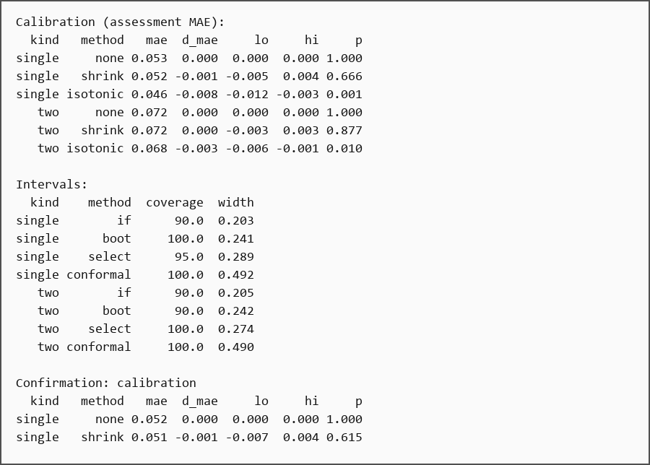
Exhibit 44. Exact console output of Step 26 (part 1 of 2), copied verbatim from the executed notebook.
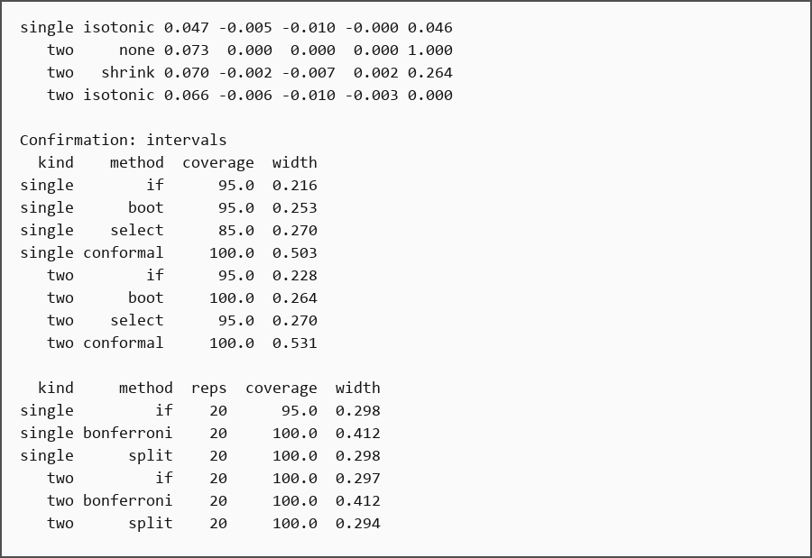
Exhibit 45. Exact console output of Step 26 (part 2 of 2), copied verbatim from the executed notebook.
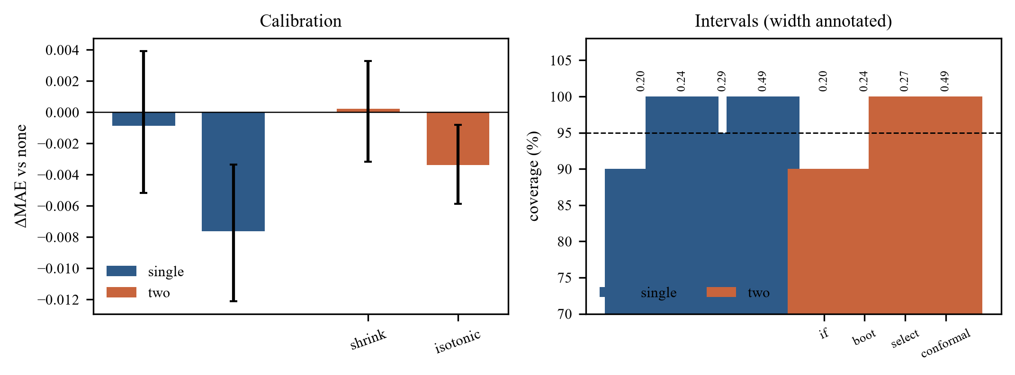
Exhibit 46. Gate 33: calibration and interval coverage and width.
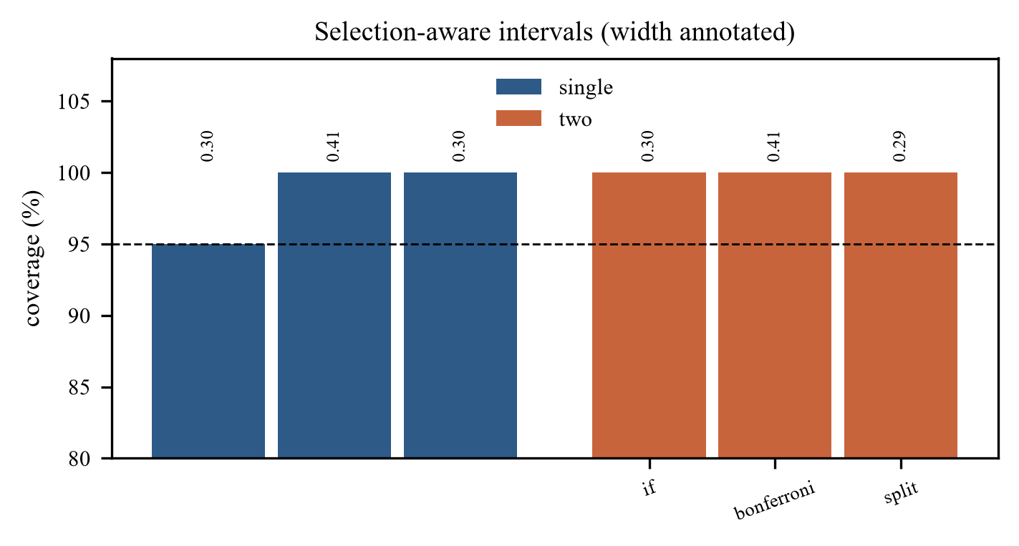
Exhibit 47. Gate 41: selection-aware intervals.

Step 27 — Number of cross-fitting folds
Code used: ciscarl2/gate34.py
What we did – Three, five and ten folds are compared with the nuisances, target, partitions and seeds fixed. Only the fold count changes. The criterion is a MAE improvement of at least 0.002 with a paired confidence interval below zero.
Why this step matters – The fold count affects variance and cost. Five is a common default, but it still has to be tested against three and ten.
Result obtained: Ten folds improves MAE by 0.0005 — real but one quarter of the threshold — at 2.1–2.3 times the cost. Three folds is worse by 0.0010–0.0011. Coverage is 95% in every cell.
What this means: Five folds are kept. The fold count is a tested compromise, not an unexamined default. The cost of ten folds is too high for a gain that is practically negligible.
Decision at this step: Keep five folds.
Exact result
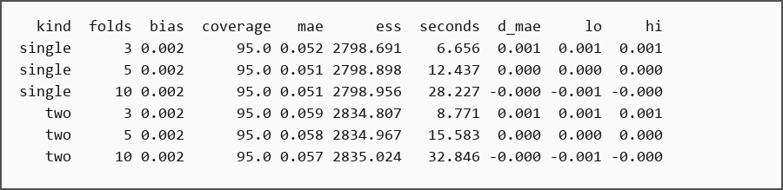
Exhibit 48. Exact console output of Step 27, copied verbatim from the executed notebook.
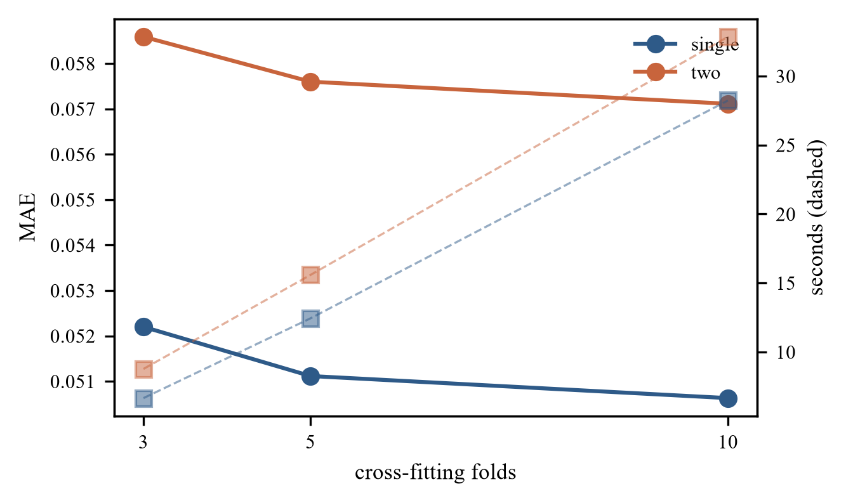
Exhibit 49. Gate 34: three, five and ten cross-fitting folds.

Step 28 — Fairness, SHAP and internal transport
Code used: ciscarl2/gate35.py
What we did – The frozen rule is described by race and gender, calibration is measured by group, SHAP is computed on a surrogate for the pseudo-outcome, and a rule learned on the white group is transported to the non-white group. The real data have no individual truth, so this is descriptive only.
Why this step matters – A model used across groups must be checked, but small groups cannot support strong claims. The analysis has to be labelled descriptive from the start.
Result obtained: Every group has fewer than 30 rule patients: white +0.444 [+0.081, +0.807] (n=24), non-white +0.328 [−0.191, +0.847] (n=14), male +0.514 [+0.147, +0.881] (n=25), female +0.184 [−0.318, +0.686] (n=13). Female calibration has the worst ECE at 0.058. SHAP ranks wtkg, cd40, cd80, str2 and homo. The white-to-non-white transported rule has support 74 (<200) and effect +0.223 [+0.071, +0.375].
What this means: Fairness is not established, and the transported rule is below the support floor. Both are reported as descriptions and feasibility signals. The analysis is underpowered by design, with 38 rule patients in assessment, and external validation on PBC is out of scope.
Decision at this step: Report fairness and transport as descriptive only; make no fairness claim.
Exact result
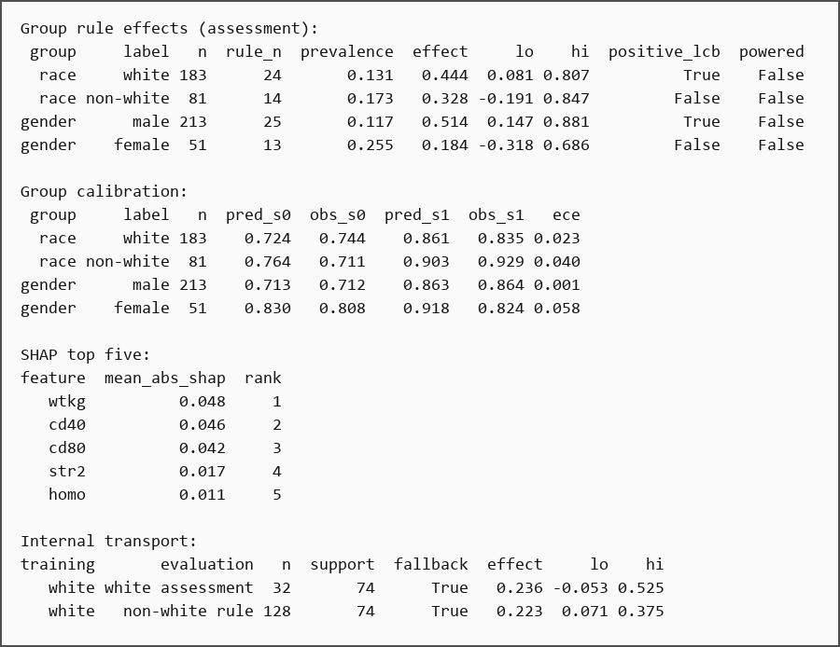
Exhibit 50. Exact console output of Step 28, copied verbatim from the executed notebook.
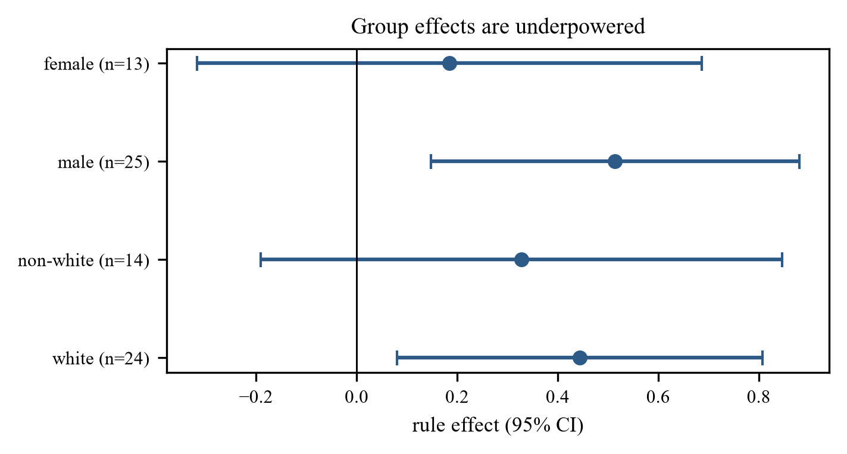
Exhibit 51. Gate 35: group rule effects; every group has fewer than 30 rule patients.

Step 29 — Evidence summary: tested, adopted, rejected and proposed
Code used: results/EVIDENCE_EXTENSION.md, CLAIMS_v1.17.md
What we did – Every important decision is placed on one status table. The table distinguishes what was experimentally settled, what was adopted provisionally, what was tested and rejected, and what remains outside the project's scope.
Why this step matters – A status table prevents tested negative results from disappearing. It separates what was settled from what was adopted, rejected, or left out of scope.
Result obtained: Four decisions are experimentally settled: CART over four learners, 5 folds over 3 and 10, Cox over three flexible nuisances, and the split/feature/estimand design. Isotonic calibration is adopted for prediction. The selection bootstrap and split-conformal intervals are rejected. Fixed-horizon IPCW-TMLE is tested and rejected. External validation on PBC is out of scope.
What this means: A method is not called rejected because it looks worse. It is rejected only after being implemented, run on the same data and criteria, and failing those criteria. That distinction is what the report must preserve.
Decision at this step: Record four settled decisions, the adopted calibration, the rejected intervals and TMLE, and the out-of-scope external validation.
Exact result
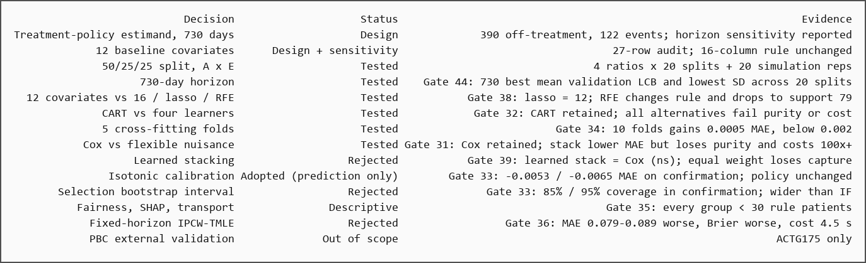
Exhibit 52. Exact console output of Step 29, copied verbatim from the executed notebook.

Step 30 — Decision register and final claims
Code used: results/CLAIMS_v1.17.md, CANONICAL_RESULTS.md
What we did – The frozen decision register is extended with the post-freeze decisions, and the project states exactly what it can and cannot claim.
Why this step matters – Claims must match evidence. The register is the contract with the reader about what the project can and cannot say.
Result obtained: The register now has 32 decisions. The rule is still C200: Cox nuisances, AIPW, depth-3 CART, leaf 60, support 200 and the lower-bound commitment. Prediction calibration is isotonic (C200-I); the influence-function interval is retained. The post-freeze gates did not change the rule or the decision.
What this means: The project can claim that CART, five folds, Cox and AIPW were retained after direct comparison, and that isotonic calibration was adopted. It cannot claim that CISCaRL is more accurate than SCRE, that fairness is established, or that the ACTG175 subgroup is certified. The final rule is cd40 ≤ 407.5 & wtkg > 71.0 & homo ≤ 0.5, and the model abstains.
Decision at this step: Freeze the 32-decision register and state the exact claim boundary.
Exact result
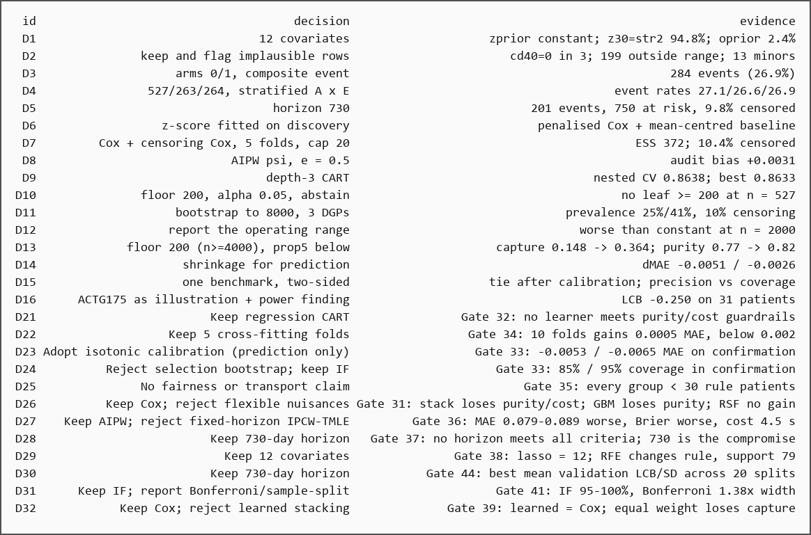
Exhibit 53. Exact console output of Step 30, copied verbatim from the executed notebook.

Step 31 — Packaging
Code used: run_all.py, notebooks/CISCaRL_31_steps.ipynb, paper/build_ieee_detailed.py
What we did – The final step checks that every artifact is present and reproducible: the code, the executed notebook, the saved results, the figures, the report and the paper. One command re-runs the evidence, with a sandboxed quick mode for a safe smoke test.
Why this step matters – A result that cannot be rebuilt is not a deliverable. The final check makes the whole chain reproducible from data and code.
Result obtained: All artifacts resolve. The audit passes. The notebook runs end to end with zero error cells: 136 cells, 52 of them code. Gates 31–35 are full runs, and Gate 33 includes a 20-seed confirmation. The quick mode ran all 16 gate groups in 12.5 minutes.
What this means: The deliverable is checkable in one command rather than argued in prose. The only open items are external validation on PBC and longitudinal TMLE; both are stated rather than hidden.
Decision at this step: Ship the code, data, notebook, results and paper with a one-command rerun.
Exact result
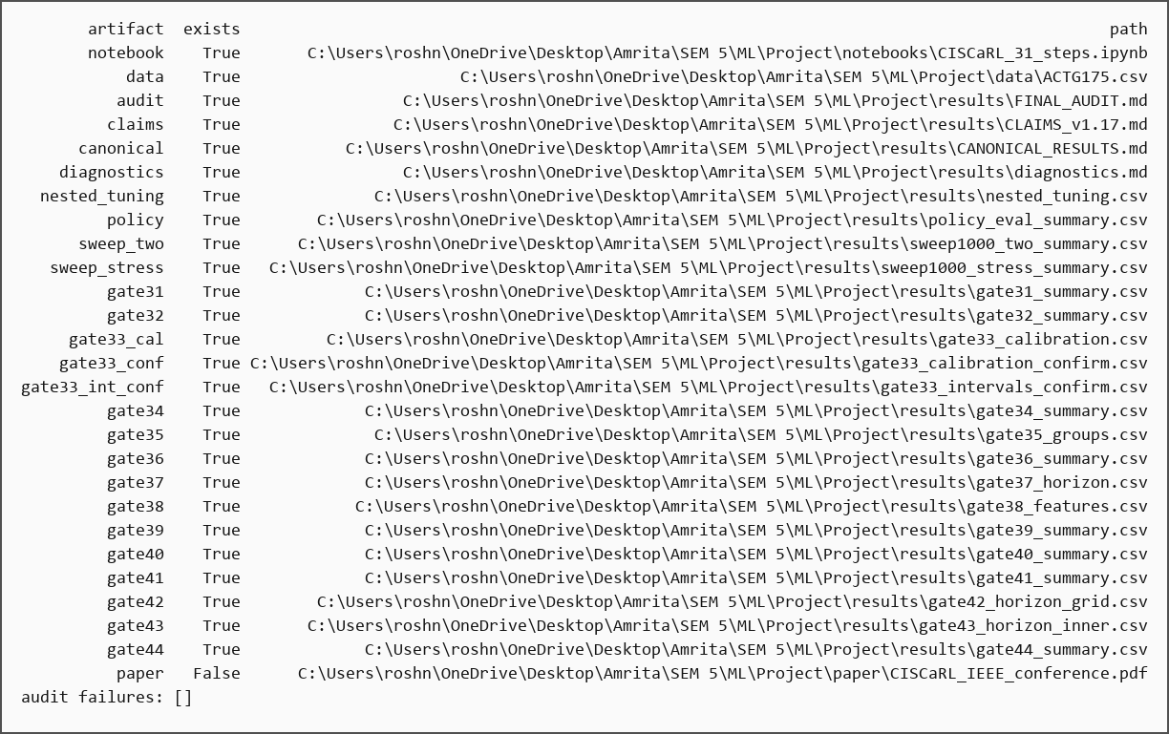
Exhibit 54. Exact console output of Step 31, copied verbatim from the executed notebook.
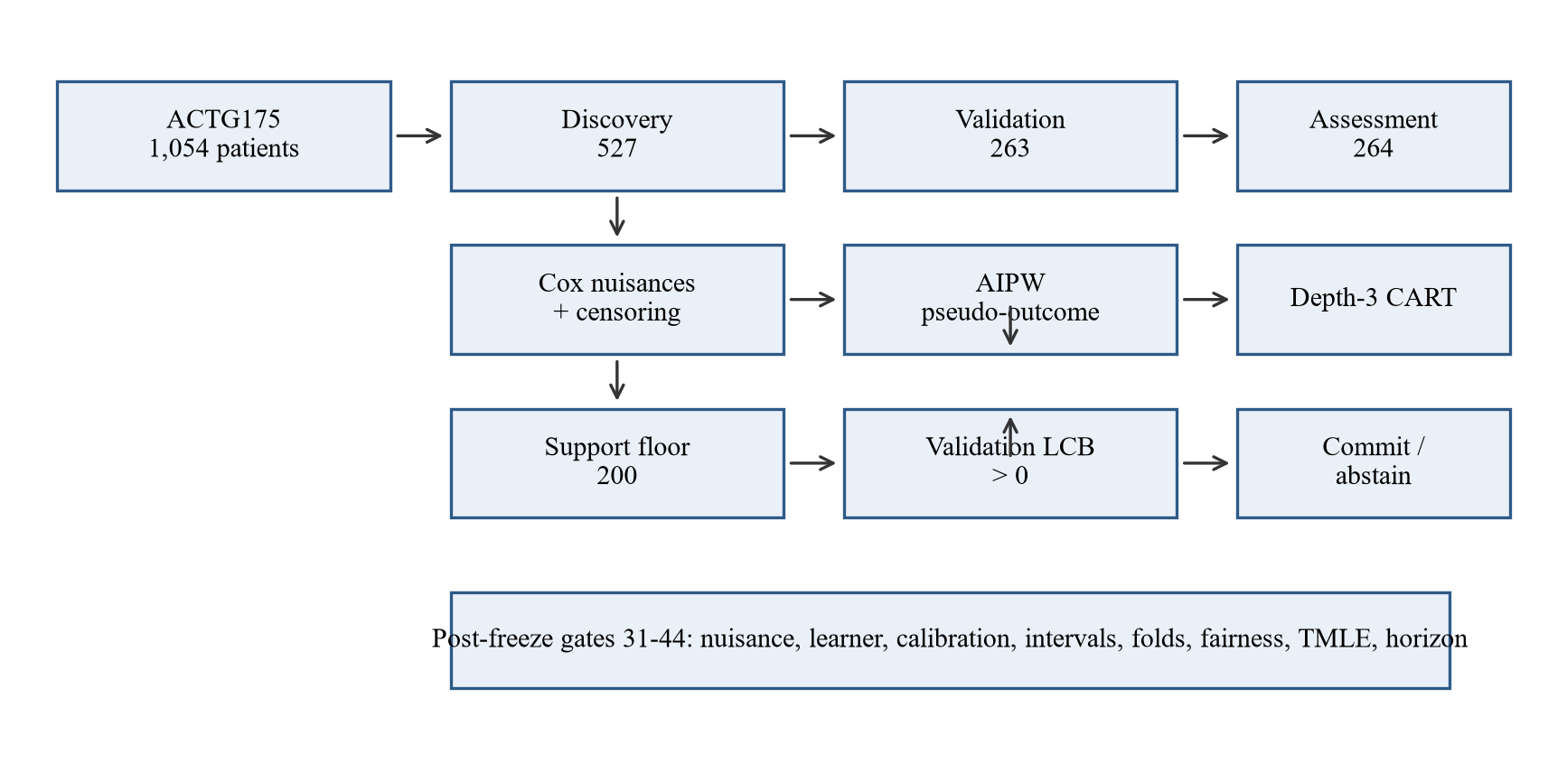
Exhibit 55. End-to-end pipeline: discovery, validation and assessment are disjoint.

Final summary
The 31 steps produce one frozen model and a complete evidence record. The table below shows what was kept and what was rejected after testing.
Layer | Kept | Rejected after testing
Outcome model | Per-arm Cox | RSF, GBM, equal-weight and learned stacking
Rule learner | Depth-3 CART | Pruned CART, PRIM, classification tree, boosting
Estimator | AIPW | Pooled Cox, T-learner, IPW, plug-in, fixed-horizon IPCW-TMLE
Selection | Support ≥ 200 | Max mean, LCB-only, stability-weighted, two-leaf list
Decision | Validation LCB > 0 | No commitment, shrinkage-only, looser thresholds
Calibration | Isotonic (prediction only) | None, empirical-Bayes shrinkage
Interval | Influence function | Selection bootstrap, split-conformal, Bonferroni
Folds | 5 | 3, 10
Features | 12 published covariates | 16-candidate set, lasso, RFE
Horizon | 730 days | 365, 548, 845, 912, 965, 1,095

The final ACTG175 result
Overall τ(730) is +0.124 [−0.002, +0.250]. The selected rule is cd40 ≤ 407.5 AND wtkg > 71.0 AND homo ≤ 0.5, with 61 discovery patients. Validation is +0.116 (SE 0.222; one-sided lower bound −0.250), so the model returns INSUFFICIENT and does not recommend treatment. Assessment is +0.401 [+0.033, +0.770] on 38 patients, but assessment never participates in the decision.
The result is a precision-oriented operating point with an explicit abstention layer, not a universal improvement over the average effect. The method needs roughly 4,000–6,000 patients before it reliably beats treating everyone; ACTG175 has 527 discovery patients, so abstention is the honest output.
Limitations stated in the report
- ACTG175 has no individual treatment-effect truth; purity, capture and MAE come from simulation.
- The rule is unstable: 20 different splits gave 20 different rules, with Jaccard about 0.34.
- The influence-function interval conditions on the selected rule; coverage is 90–95%.
- Fairness and transport are underpowered: every race and gender group has fewer than 30 rule patients.
- The 730-day horizon is retained on stability, not because it is a universal clinical optimum.
- Longitudinal TMLE was not implemented; the fixed-horizon version was tested and rejected.

