**Objective:**

The objective of this experiment is to design, with the help of circuit simulation, and experimentally verify the performance of a voltage regulator circuit using Zener diodes.

**Materials and Equipment:**

* Two Zener diodes (3.6 V, Zener breakdown voltage)
* Four 1 kΩ resistors (R1, R2, R3, R4)
* A variable potentiometer
* Multimeter
* Analog Board (ADALM 1000)

**Part I: Simulation Study (Using LT SPICE)**

1.1-1.7) <https://drive.google.com/file/d/16q_eHQueYTlH1P5m8bE7Uos6LDI8jIkA/view?usp=drive_link>

Data Analysis:

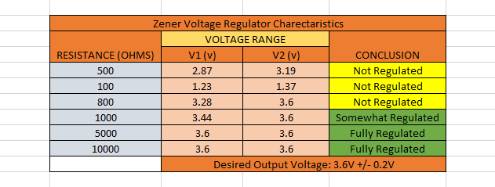

1.8)

<https://drive.google.com/file/d/1M-1-_PTdZVUXKbx-WZqx93IdiJXkdwM9/view?usp=drive_link>

Data Analysis: (Green- Partially Regulated)  
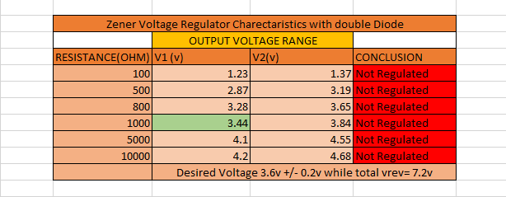

1.9-1.10)

<https://drive.google.com/file/d/1k04CjpKTrEITPKN1yXbckzSl8Zg_Ltod/view?usp=drive_link>

Data Analysis:

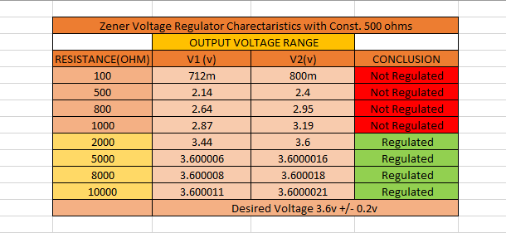

Part 2) Analog Board: Physically Experimenting part1

R1= 330ohms, 1 Zener Diode, Load Resistance: 2000ohms  
<https://drive.google.com/file/d/1e2ydsbGBKQn_l2LxWCkQbBC4ZUTKJnWI/view?usp=drive_link>