Objective:

1. To construct a Wheatstone bridge using resistors, calculate and measure the node voltages and its output voltage.
2. Additionally, to investigate the effect of adding a capacitor across the output to filter unwanted AC components.

Materials and Equipment:

* Four 75 kΩ resistors (R1, R2, R3, R4), Two 1 kΩ resistors , Two 10 kΩ resistors, One 330 ohm and 3300-ohm resistor.
* Capacitor (in nF range) and one Multimeter.
* Analog Board (ADALM 1000)

**Part 1  
1.1- 1.5)**

[**https://drive.google.com/file/d/1G7wQuqfPQFNOn8VbKAQ5y0bL7_Jkjy1q/view?usp=sharing**](https://drive.google.com/file/d/1G7wQuqfPQFNOn8VbKAQ5y0bL7_Jkjy1q/view?usp=sharing)

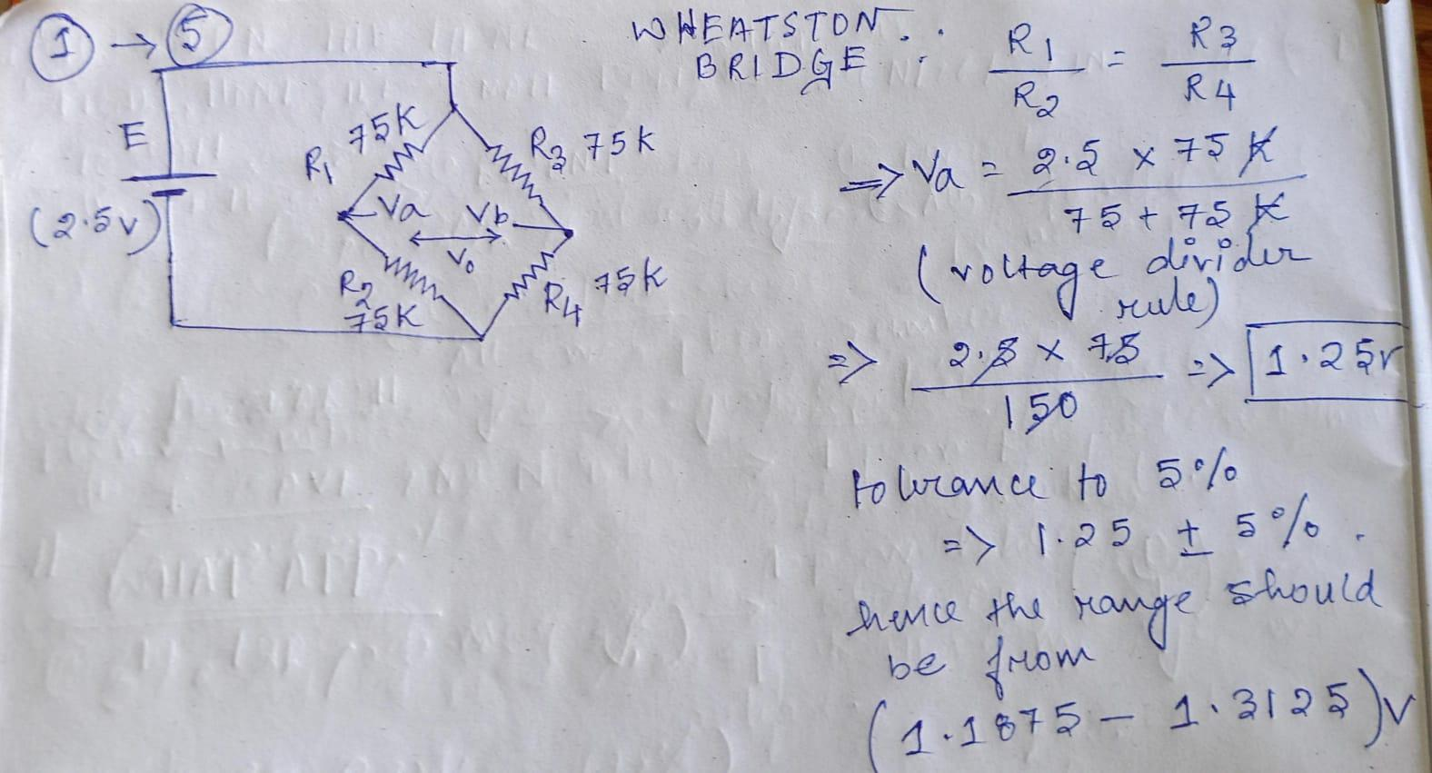

**1.6)**[**https://drive.google.com/file/d/1C55LdGTuwnGUL1ifgOqNZd0t1CwUIn_w/view?usp=drive_link**](https://drive.google.com/file/d/1C55LdGTuwnGUL1ifgOqNZd0t1CwUIn_w/view?usp=drive_link)

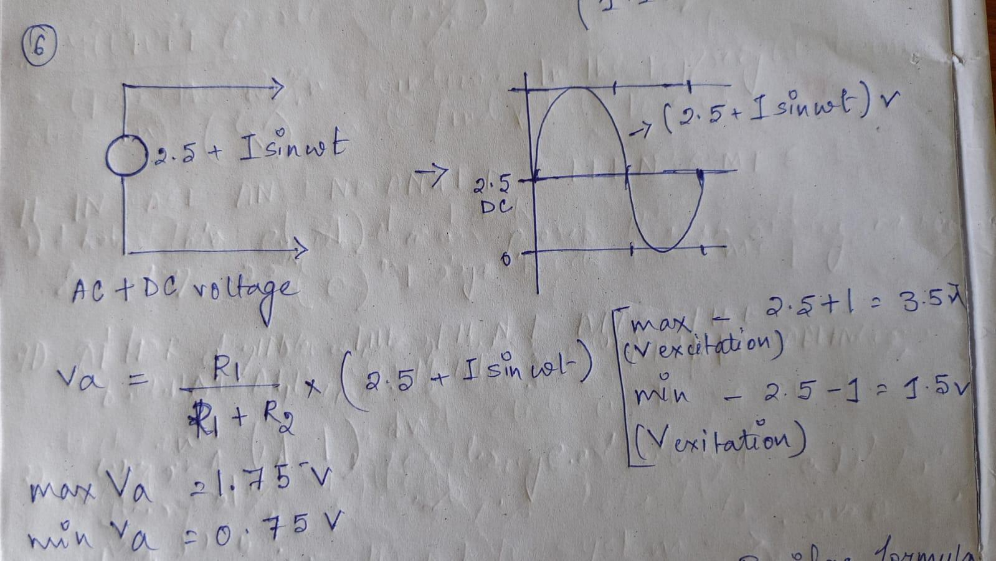 **1.7) (Extra use of 330 ohm and 3300 ohm resistors)**

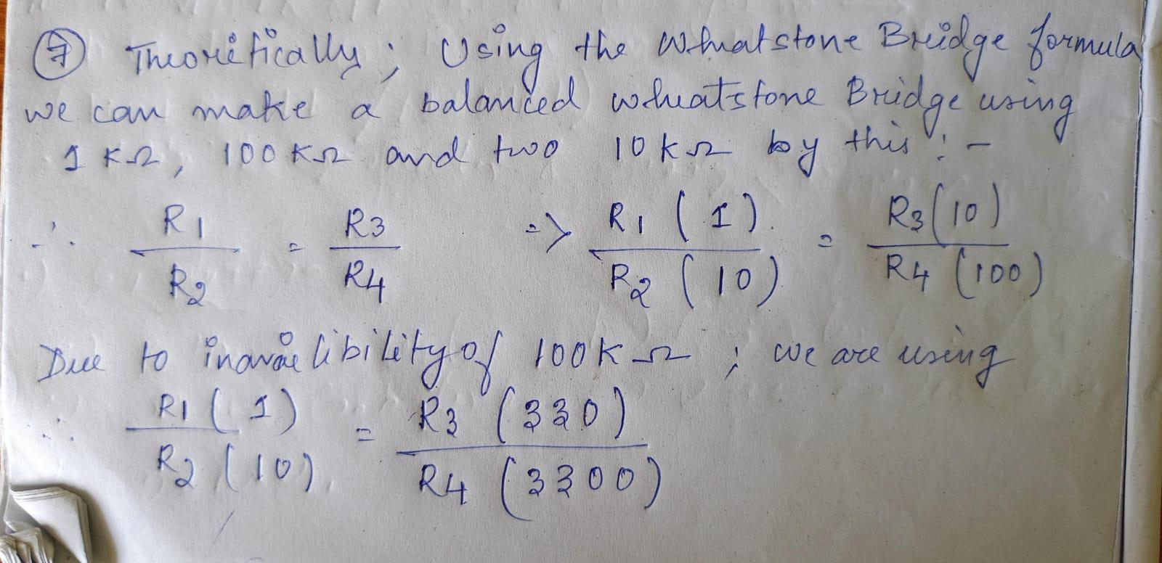 **Part 2  
2.1- 2.4)**[**https://drive.google.com/file/d/1eNiYFPheslhCQx56CrjoOOGS4gOGS5JI/view?usp=drive_link**](https://drive.google.com/file/d/1eNiYFPheslhCQx56CrjoOOGS4gOGS5JI/view?usp=drive_link) 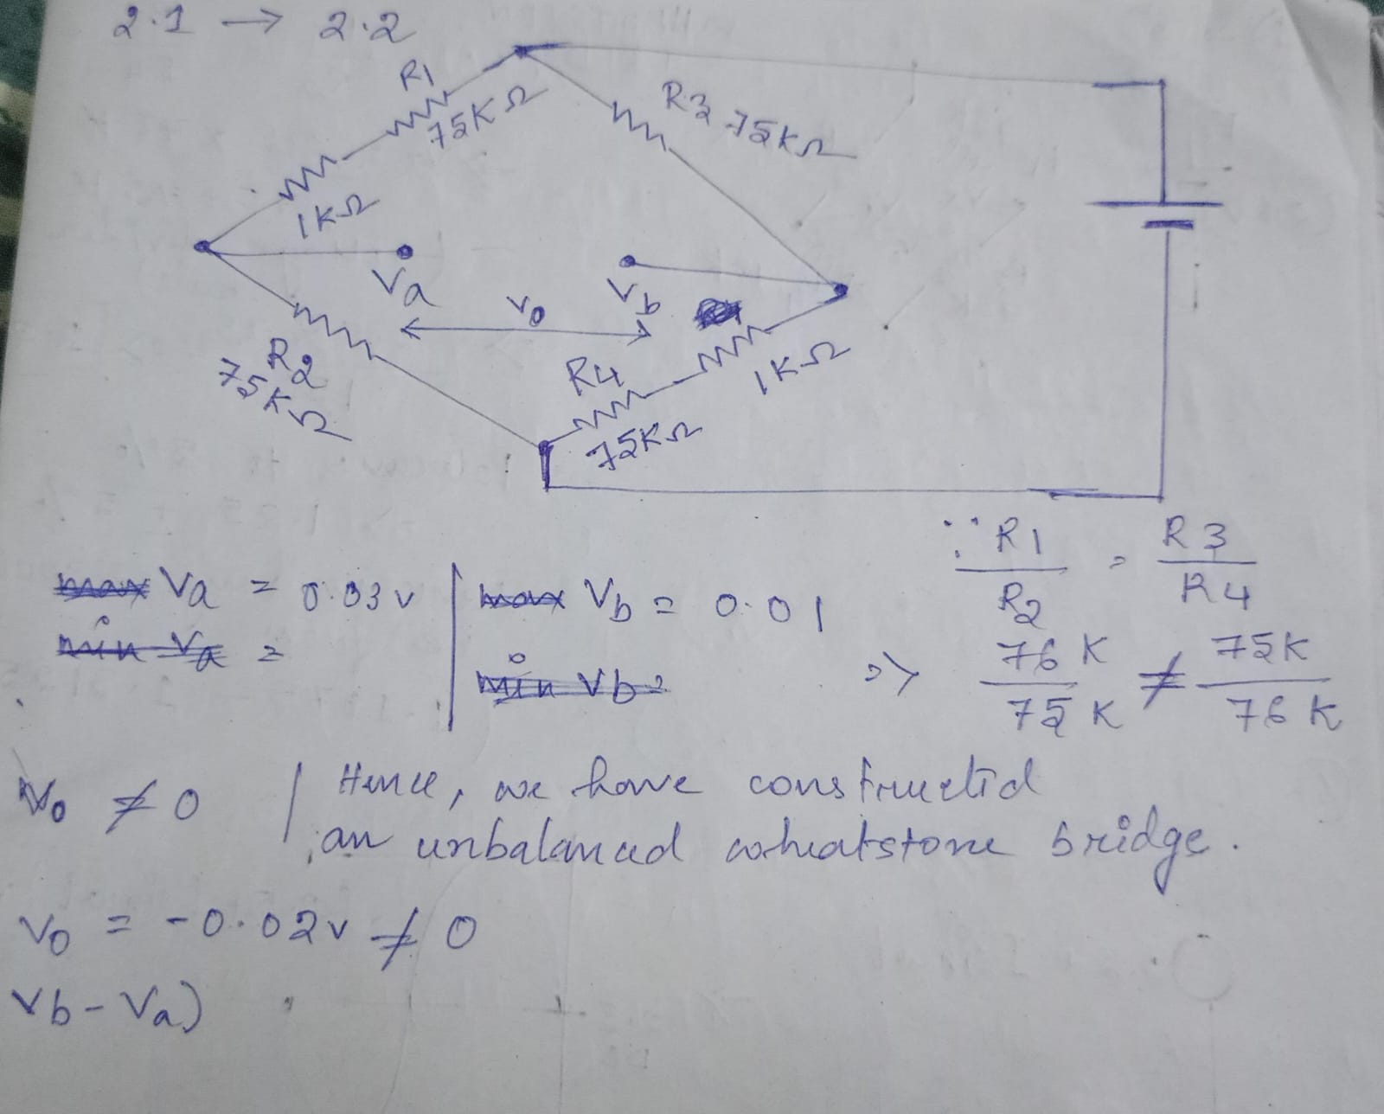

**Part 3  
3.1-3.4)   
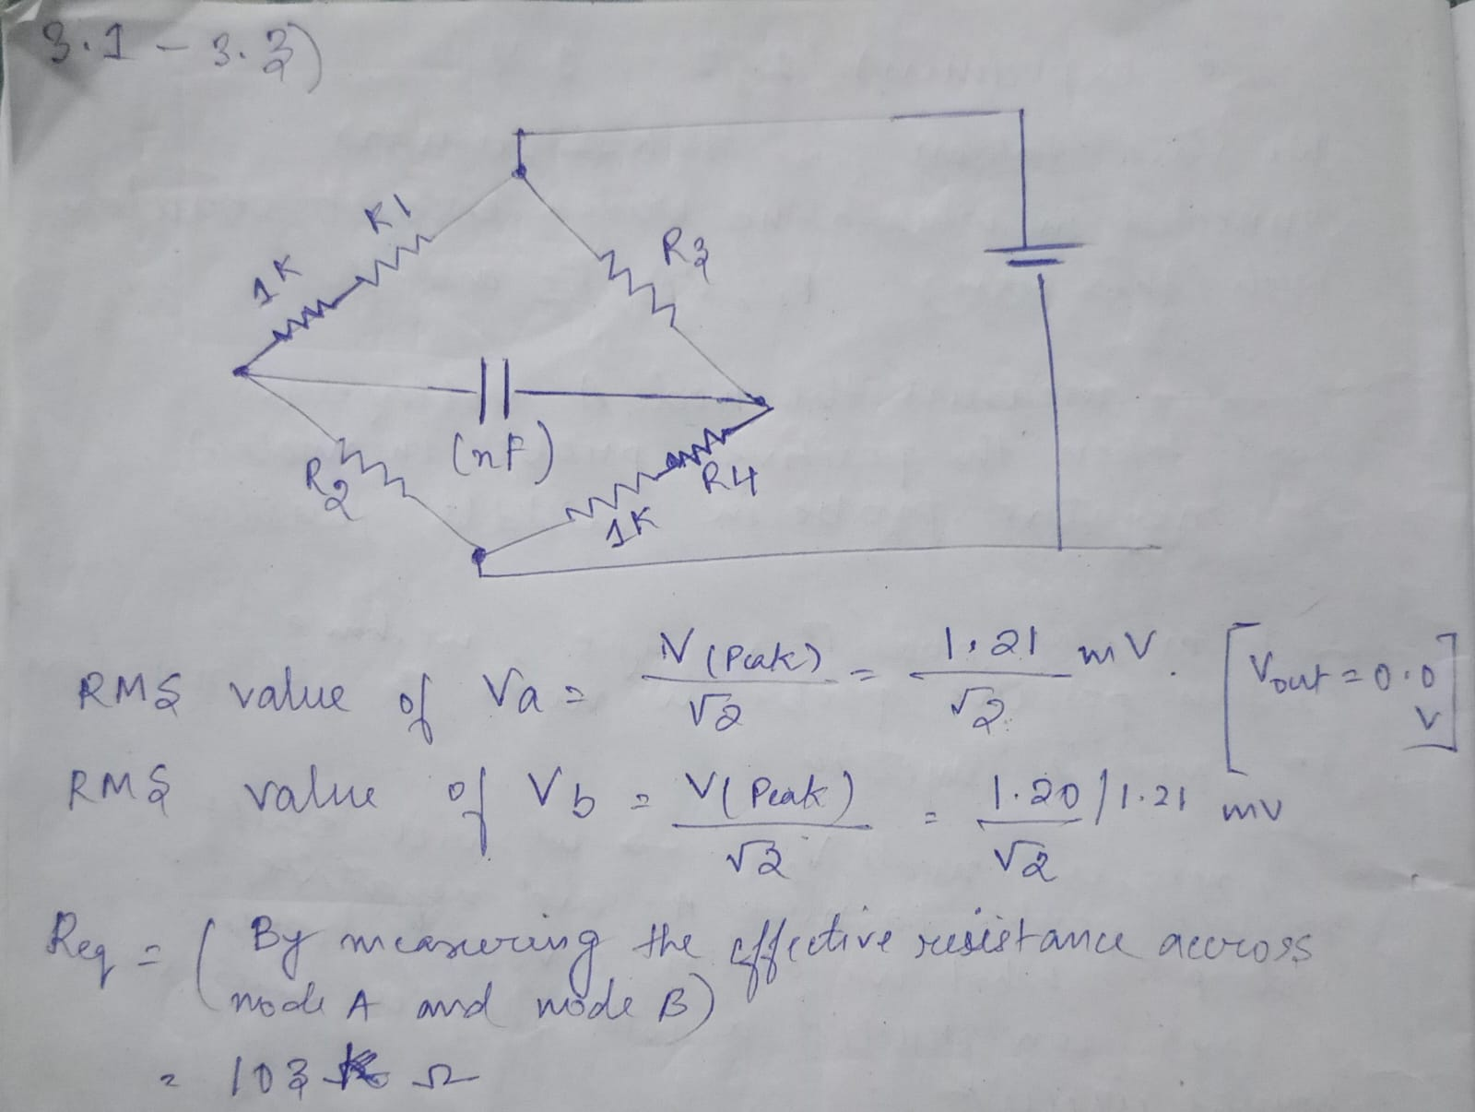**

**3.5-3.6)**

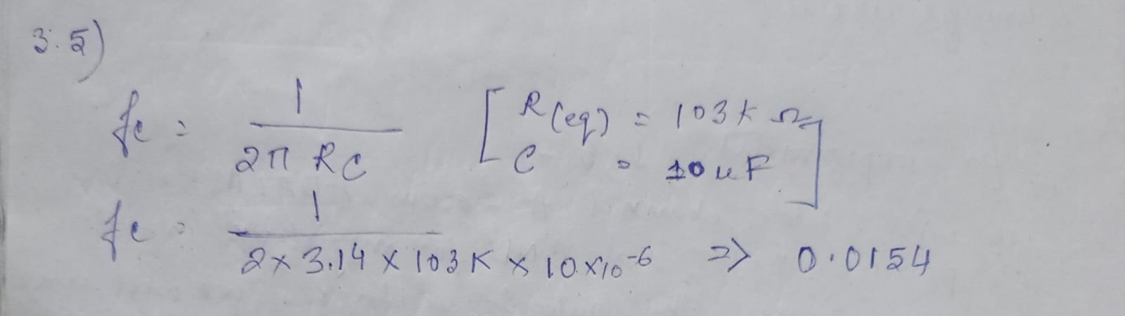

**3.7-3.12)  
