**AIM: Comparative Analysis of BJT and MOS Transistor Driver Circuits for LED  
  
Materials and Equipment:**

● BJT

● N-channel MOSFET

● LED

● One 1 kΩ Potentiometer

● 1 kΩ resistors

● Breadboard

● Connecting wires

● Multimeter

● Analog Board (ADALM 1000)  
  
**Part 1: Transistor Characterization Experiment**set potentiometer resistance: 0.18uA.  
 **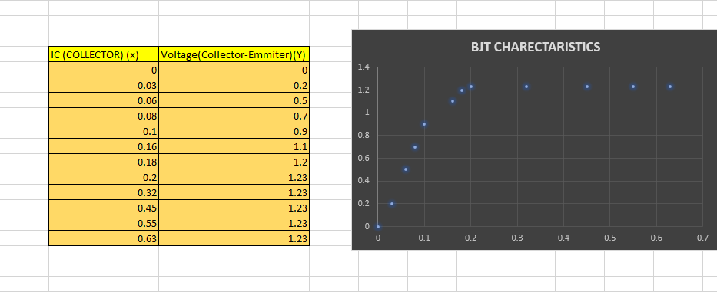  
  
  
  
Part 2: BJT Driver Circuit  
  
  
Part 3: MOS Transistor Driver Circuit  
  
  
Part 4: Light-Dependent Resistor (LDR) Controlled LED Circuit**