**Objective:**

To understand the current-voltage (I-V) characteristics of various types of diodes through practical experimentation.

To apply the knowledge gained from studying diode characteristics to design and analyze a half-wave rectifier circuit.

**Materials and Equipment:**

* Diode (suitable for experimentation)
* 1 kΩ resistor
* 10 kΩ load resistor
* Capacitor (suitable for filtering), 10 muF
* Analog Board (ADALM 1000) with software interface
* Multimeter (for voltage and current measurements)

**Diagram to be followed for the circuit:**  
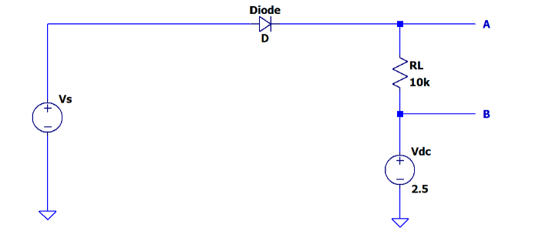

**PART 1  
1.1-1.4)  
Forward Biased circuit**[**https://drive.google.com/file/d/17xrx1ZpGfFV23DPCF5Nn0qOizw-41RTU/view?usp=drive_link**](https://drive.google.com/file/d/17xrx1ZpGfFV23DPCF5Nn0qOizw-41RTU/view?usp=drive_link) **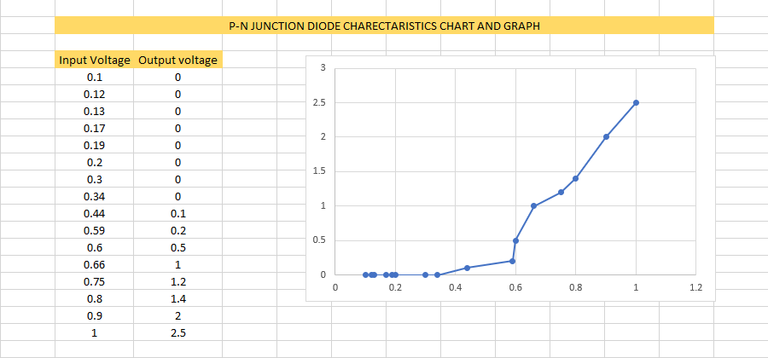  
  
Reverse Biased Circuit:**[**https://drive.google.com/file/d/1cj4B4LpBt7t0KlzNgduLBzHMk1HSIJ4z/view?usp=sharing**](https://drive.google.com/file/d/1cj4B4LpBt7t0KlzNgduLBzHMk1HSIJ4z/view?usp=sharing)

**PART 2  
2.1-2.3)  
Half Wave Rectifier**[**https://drive.google.com/drive/folders/1PfWQRkPKYD--XSr_2QxNmj7Qyp7pRAG_?usp=sharing**](https://drive.google.com/drive/folders/1PfWQRkPKYD--XSr_2QxNmj7Qyp7pRAG_?usp=sharing)

**2.4-2.5)  
 Introducing a 10 muF capacitor**

[**https://drive.google.com/file/d/1usFFLIYk7HPjdc2Sf4eBGFGhPTnXWQSp/view?usp=drive_link**](https://drive.google.com/file/d/1usFFLIYk7HPjdc2Sf4eBGFGhPTnXWQSp/view?usp=drive_link)

**2.6)**Rectification efficiency is close to 40% (40.6 %) (ANS) 

**Ripple Factor is:  
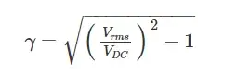** close to 1.21 (ANS)

**PART 3)  
With a LED diode**[**https://drive.google.com/file/d/1ZA1_7XkfSTAkx_wf3MWN_M8bjVLBYGr7/view?usp=drive_link**](https://drive.google.com/file/d/1ZA1_7XkfSTAkx_wf3MWN_M8bjVLBYGr7/view?usp=drive_link)

**PART 4)   
With a Zener Diode and 330 Ohm resistance.**[**https://drive.google.com/file/d/1EodOuL1xt-6tWyvx8IX4M7rY32Doj0DF/view?usp=drive_link**](https://drive.google.com/file/d/1EodOuL1xt-6tWyvx8IX4M7rY32Doj0DF/view?usp=drive_link)