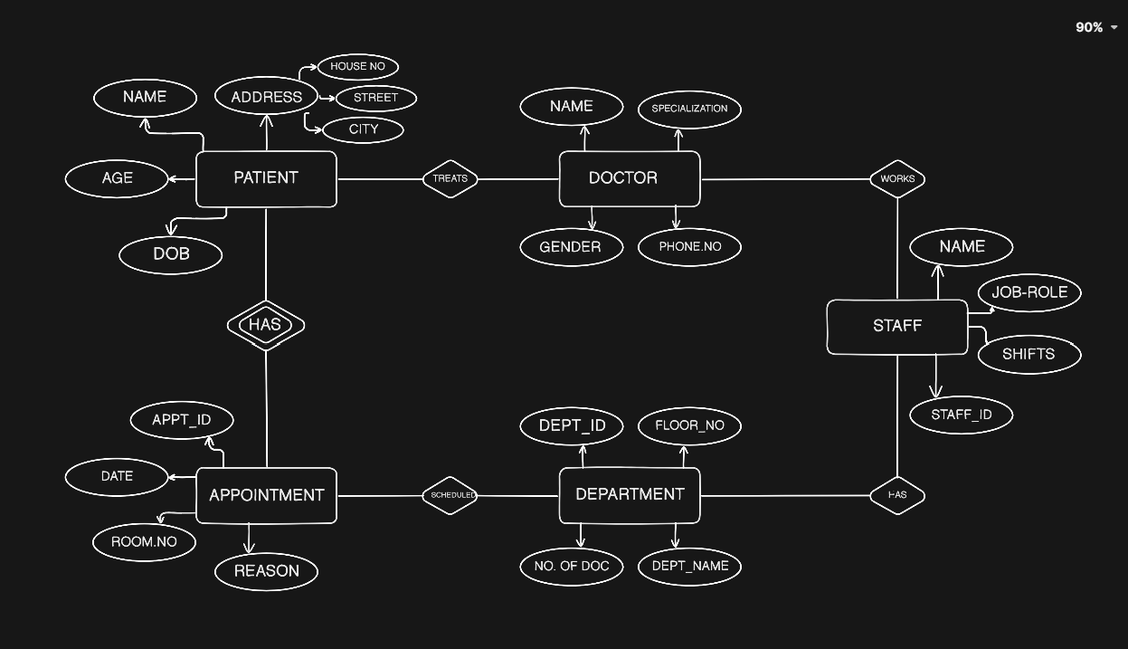
8 DIFFERENT KEYS FROM WHOLE DIAGRAM

PATIENT+NAME = CANDIDATE KEY
PATIENT+ADDRESS = CANDIDATE KEY
PATIENT+DOB = CANDIDATE KEY
DOCTOR+NAME = CANDIDATE KEY
STAFF+STAFF_ID = PRIMARY KEY
DEPARTMENT+DEPT_ID = PRIMARY KEY
APPOINTMENT+APPT_ID=PRIMARY KEY
DOCTOR+PHONE.NO = CANDIDATE KEY

