Roshni.KL
1RUA25BCA0089
SECTION: B
SUB QUERIES IN SQL
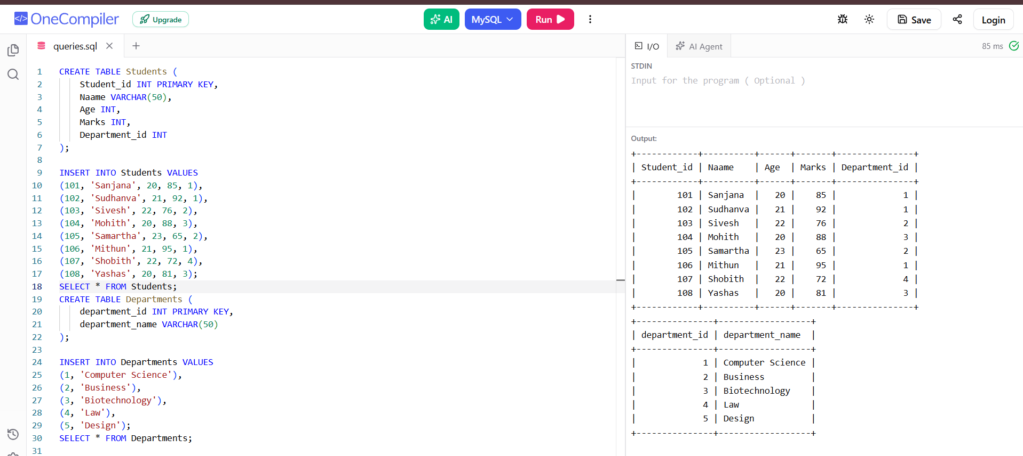
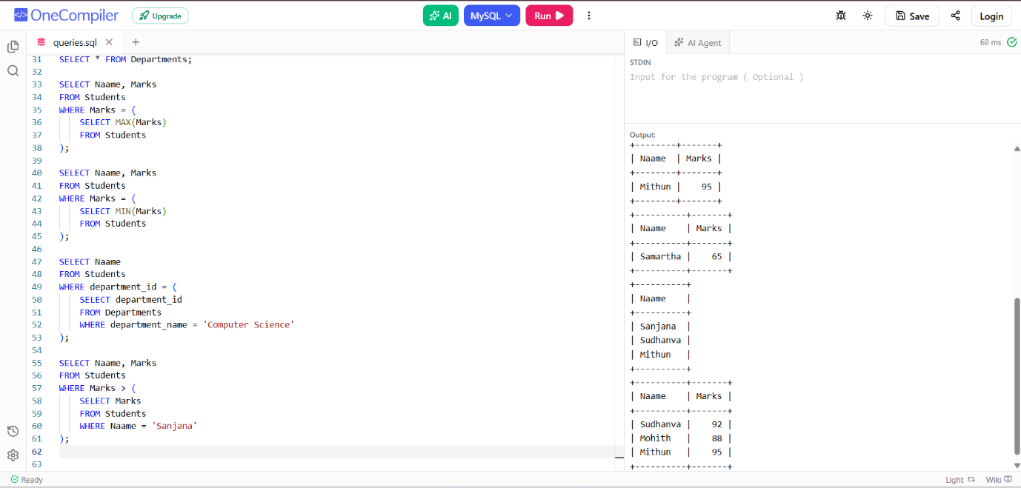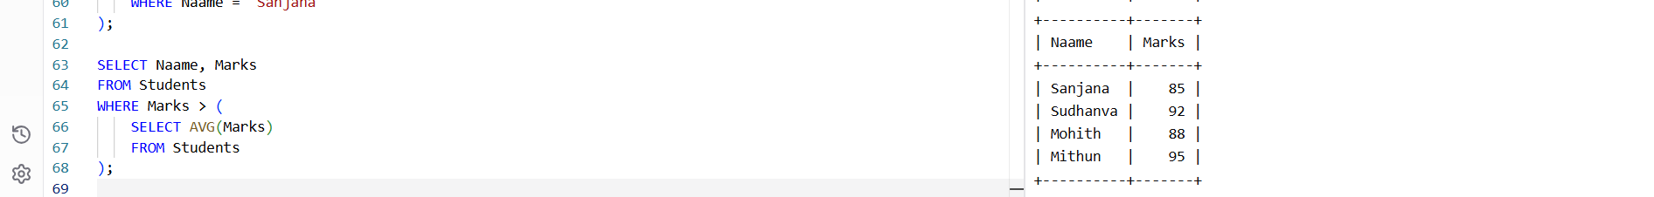
- Students who scored highest marks
- Students who scored lowest marks
- Finding student who come from cs department
- Students who scored higher than Sanjana
- Students who scored more than average marks
JOINS IN SQL
- INNER JOIN
- LEFT JOIN
- RIGHT JOIN
- FULL OUTER JOIN
- CROSS JOIN



