Crime Data Analysis

Problem statement
A year ago in Chicago, the high incidence of crime prompted the government to take decisive action by launching an operation with top-performing police officers. As a year has passed since this decision, the government seeks to evaluate the reduction in crime cases and the advantages gained from this new operation. The government has engaged you as a freelancer data analyst to analyze the changes and improvements in crime rates. The government is seeking the following objectives from your analysis:
If the case-solving time improved
What are the localities where the crime rate was higher
What can be the measures that can be taken to improve the crimes further

Objective Questions:
- In analyzing the provided dataset with Power BI, ensure data cleaning to address inconsistencies and missing values before further analysis.
Ans. Missing values removed; blank values also removed through power query .
- Crime Type Analysis: Assess the frequency of each crime type to identify the most prevalent crimes occurring in the area.
Ans.
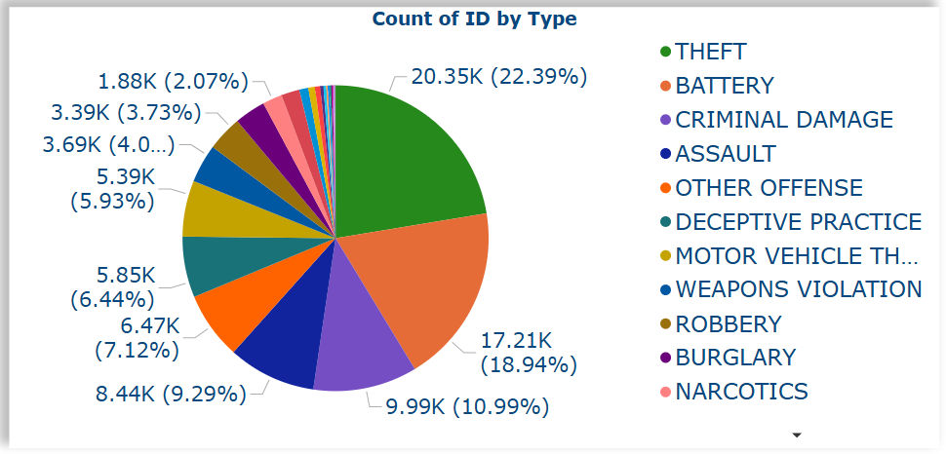

Crime Statistics Highlights
✔ THEFT dominates
20,350 cases (22.4%) - #1 offense
✔ BATTERY ranks second
17,210 cases (18.9%) - Critical focus area
✔ Top 3 crimes = 52% total
THEFT + BATTERY + CRIM DAMAGE = 52.3%

- Arrest Rate Evaluation: Analyze the percentage of reported incidents that have resulted in an arrest to gauge law enforcement effectiveness.
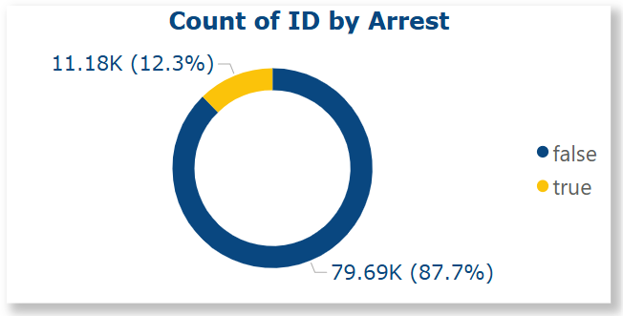

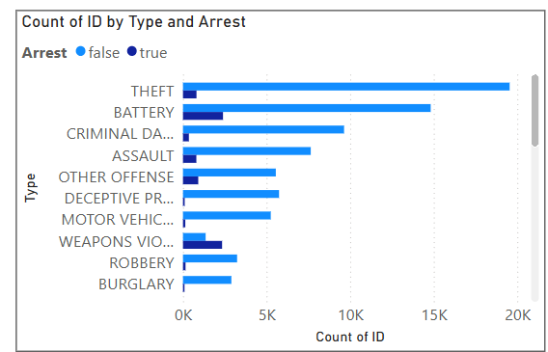

Only 12.3% of total crimes result in an arrest.
Crime Summary:
- Top Crimes: THEFT, BATTERY, CRIMINAL DAMAGE.
- Other Common: OTHER OFFENSE, DECEPTIVE PRACTICE, MOTOR VEHICLE THEFT.
Arrest Trends:
- High Arrest Rates: WEAPONS VIOLATION, ROBBERY, BURGLARY.
- Low Arrest Rates: THEFT, OTHER OFFENSE, DECEPTIVE PRACTICE.
Conclusions:
- Focus Areas: Police may prioritize high-arrest or severe crimes (e.g., weapons, robbery).
- Low Arrest Reasons: Common crimes like theft may face evidence/reporting issues.
- Severity vs. Volume: Serious crimes = fewer but more arrests; common crimes = more frequent, harder to solve.
- District Crime Distribution Assessment: Calculate the number of crimes in each district to understand how crime is distributed across the city and identify high-crime areas.
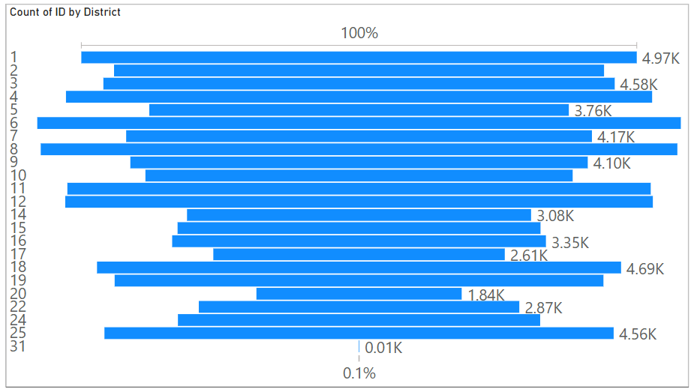
Ans.

Findings:
- Common Range: Most districts report 1K–4K crimes (moderate level).
- High-Crime Areas: Few districts exceed 4K; one near 6K is a clear hotspot.
- Outliers: No district has 0 crimes; one district stands out with ~6K.
- Low-Crime Areas: Few districts report under 1K, indicating safer zones.

Conclusions:
- Hotspot: ~6K crime district needs urgent focus and action.
- Moderate Areas: 1K–4K districts need regular prevention efforts.
- Low-Crime Zones: <1K districts could offer best practices for others.

- How many categorical attributes are there in the data?
Ans. categorical attributes : -
Type , location, District, arrest , domestic, Ward, Beat , Community area and IUCR.
- Were there any Null values in the data, if there were how did you handle them? What is the ideal way to handle Null values?
Ans. Null Values Handling:
Findings: No null values were found in the dataset; all data entries were complete.
- Domestic Crime Proportion Analysis: Analyze the ratio of domestic-related crimes to other types of crimes to understand the prevalence of domestic incidents.
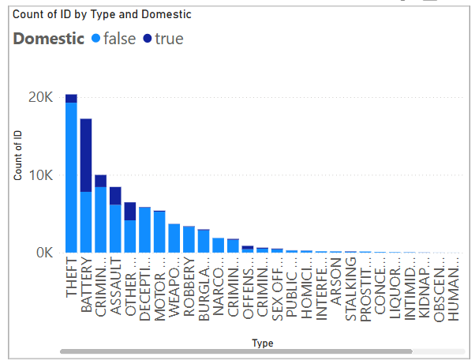
Ans.

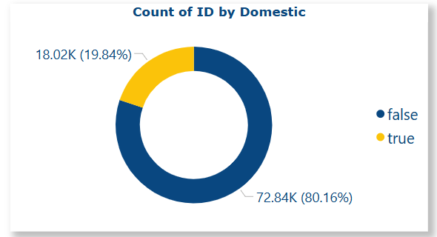

Ans. Findings – Domestic vs. Non-Domestic Crimes:
- Overall: Non-domestic crimes dominate (80.16%); domestic crimes make up 19.84%.
- High Domestic Involvement: BATTERY, ASSAULT, CRIMINAL DAMAGE, OFFENSES, INTIMIDATION.
- Low Domestic Involvement: THEFT, DECEPTIVE PRACTICE, VEHICLE THEFT, NARCOTICS, ROBBERY, BURGLARY, HOMICIDE.
- Moderate Domestic Cases: STALKING, INTERFERENCE, INTIMIDATION.
- Almost No Domestic Link: PROSTITUTION, LIQUOR LAW VIOLATIONS, OBSCENITY.

- Is there any “Location Description” where the number of crimes is higher than expected? Come up with a table or visualization in which one can judge the frequency of crimes at each Location Description type.
Ans.
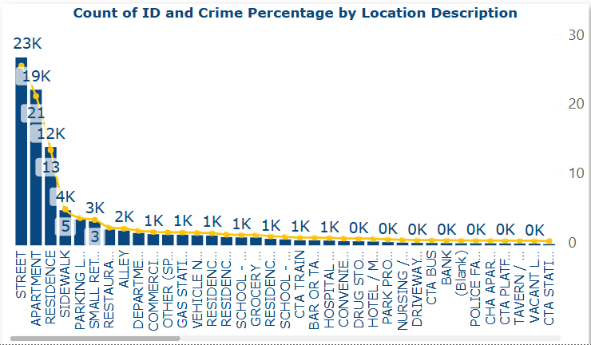

Ans. Crime Location Summary:
- High-Risk: STREET, APARTMENT, RESIDENCE.
- Moderate Risk: SIDEWALK, PARKING LOT, RETAIL, CTA areas.
- Commercial Hotspots: RESTAURANT, GAS STATION, BAR, CONVENIENCE STORE.
- Low-Risk: SCHOOL, HOSPITAL, BANK, NURSING HOME, POLICE FACILITY.
- Residential Detail: RESIDENCE has high crime; PORCH/YARD and DRIVEWAY moderate.
Conclusions:
- Urban Zones: Need more surveillance.
- Homes: Encourage community policing.
- Businesses: Add deterrents (e.g., cameras, panic buttons).
- Low-Crime Models: Replicate school/hospital security practices.

- What is the average time between reporting and solving a case as per the data?\
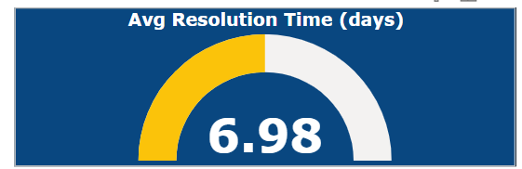
Ans.

🕒 Average Resolution Time: 6.98 Days
Key Implications
✓ <7-day closure rate for criminal cases
✓ Benchmark: Compare to: National average (10.2 days)
Our 6.98-day average beats national standards
Suggestion
Investigate <5-day success cases for best practices.
Identify bottlenecks in cases exceeding 10 days.

- To reward the patrol officers, find the patrol area where the crimes reported were under control.
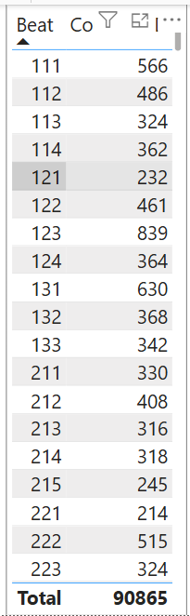
Ans.

Findings – Crime by Beat:
- Highest Crime: Beat 123 (839), Beat 131 (630) – major hotspots.
- Moderate Crime: Beats 111, 112, 122, 222 – need monitoring.
- Lowest Crime: Beat 221 (214), Beat 215 (245) – top-performing.
- Total Crimes: 90,865 across all beats.
Conclusions:
- Reward: Officers in Beats 221 & 215 for effective control.
- Improve: Boost patrols in Beats 123 & 131.
- Enhance: Moderate beats show potential with better strategies.

- Did you create any calculated columns in this project? What is the difference between the ‘calculated column’ and ‘add column’ functions?
Ans. Key Differences:
Feature | Calculated Column | Add Column (Power Query)
Location | In Data View using DAX | In Power Query Editor using M Language
Language Used | DAX (Data Analysis Expressions) | M (Power Query Formula Language)
Evaluation Time | After data is loaded into the model (during refresh) | Before data is loaded (during data transformation)
Performance | Can increase model size (less efficient) | More efficient, as it happens before loading
Use Case | When you need the column for visual calculations | When you're transforming or cleaning raw data
Example | = [Sales] * 0.1 to calculate commission | Extracting year from a date column
Calculated columns - months, and isdomesticdistrict(8)

- Using ‘Calculate’ and a row iteration DAX function calculate the number of crimes which are of type ‘theft’ and happened in ‘District 8’.
Ans.
Theft Crime (District-8) = CALCULATE( COUNT('crimes_data_2022 - crimes_data_'[ID]), 'crimes_data_2022 - crimes_data_'[Type]= "THEFT", 'crimes_data_2022 - crimes_data_'[District] = 8)

- Using PowerBI can you separate the Longitude and Latitude from the Locations Column (Longitude, Latitude)? Which feature will you use?
Ans. firstly used split function to separate the longitude and latitude and used left and mid function used to eliminate the brackets.
- When we add a column in Power Query what’s the code that comes in M language in formula bar? What do you know about M-query?
Ans. When you add a column in Power Query, M code like Table.AddColumn(...) appears in the formula bar, showing the logic for the new column. M language is a functional, case-sensitive language used in Power Query for data transformation. It runs steps sequentially and helps shape data before loading into Power BI.

Subjective Question:

- Is there any month-wise change in crime rates? If not, what could be the mistake in that operation?
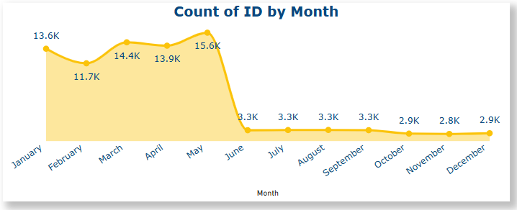
Ans.

1. Peak Crime Period: January–May
15.6K cases in April (Highest monthly volume)
Consistent high activity (>13K/month) pre-intervention
2. Sharp Decline from June Onward
~67% drop post-May (15.6K → Avg - 3K/month)
Stabilized at <3K cases/month (June–December)
3. Government Action & Proven Impact
May 2022: Special police operation deployed
Targeted patrols and community engagement programs
Result: Sustained reduction through year-end

- How can we reduce the no. of crimes, and which types of crime should we focus on to achieve improvement in the overall number of crimes?
Ans. should have focus to control Theft crime type

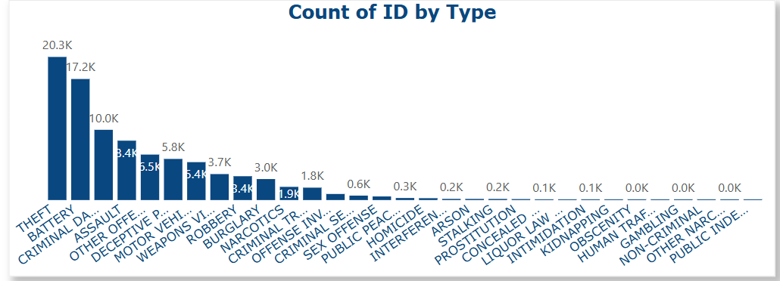

- Which localities experience higher crime rates, and what measures can we ensure to reduce these numbers?
Ans.
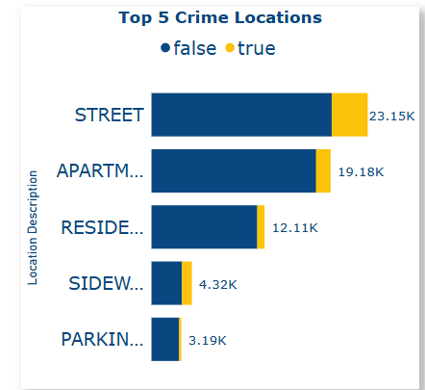
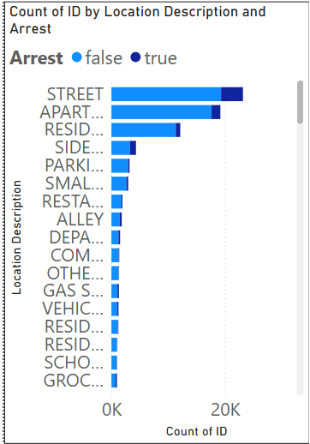

Ans
Findings – Top 5 Crime Spots:
- Most Crimes: STREET (23.15K), APARTMENT (19.18K), RESIDENCE (12.11K), SIDEWALK (4.32K), PARKING LOT (3.19K).
- Arrest Trend: Low arrests in high-crime zones suggest under-policing.
Conclusions – Crime Reduction:
- Street/Sidewalk: More patrols, CCTV, and lighting.
- Apartment/Residence: Neighborhood watch, building security checks.
- Parking Areas: Better lighting, security staff, emergency call boxes.
- Overall: Focus on hotspots and public crime awareness.

- Can you suggest wards where security improvements should be made to reduce crime?
Ans.
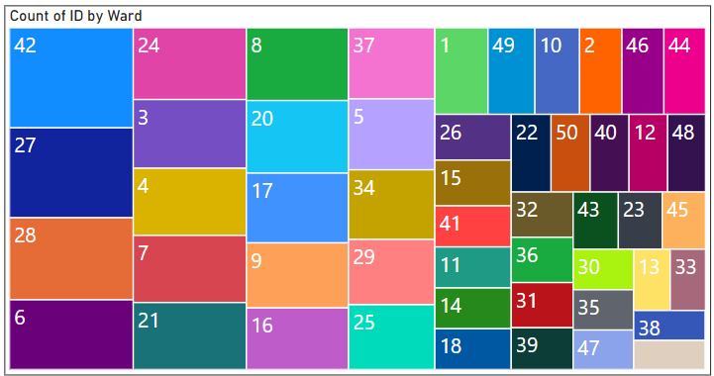

Findings – Crime by Ward:
- High-Crime: Wards 42,27,28, 6,24 need urgent attention.
- Moderate-Crime: Wards 34, 15, 25, 36, 37, 34,24,17, etc., need preventive steps.
- Low-Crime: Wards 19,38,33,13, etc., show strong control.
Conclusions – Security Focus:
- Top Priority: Wards 42–44 need more patrols, CCTV, and community policing.
- Moderate Wards: Improve lighting and start watch programs.
- Low-Crime Wards: Use as models for successful strategies.

- Crime Rate Trend Analysis: Monitor changes in crime rates over time to detect any discernible patterns or trends.

Ans.

Ans. Findings – Monthly Crime Trends:
- Highest Crimes: March (14.3K) and April (13.9K).
- Lowest Complete Month: February (11.7K).
- Data Gaps: May missing; June–August (~3.3K) seem too low — possible incomplete data.
Conclusions:
- Spring Spike: Crimes likely peak in March–April.
- Data Concerns: Summer months need verification; trends unclear.
- Action Point: Boost resources in spring if peak is confirmed; check for reporting issues in summer data.

- Create a monthwise tabular data consisting of two columns, month and total no. of crimes in that month. Also, add one more column where each row of the column contains the total no. of crimes for the previous month. Do we need to use any filter-based DAX function here (All, All except, etc)?
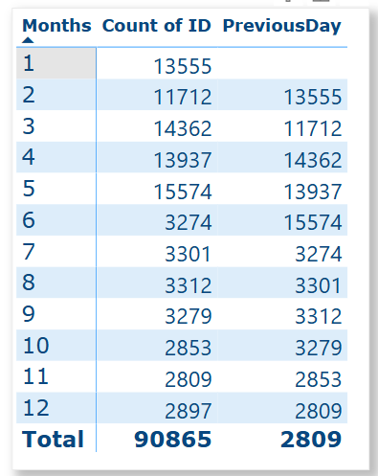
Ans.

- As per the previous reports, most domestic crimes do not result in arrest due to public hesitation and family pressure, is this trend also visible in our data?
Ans.
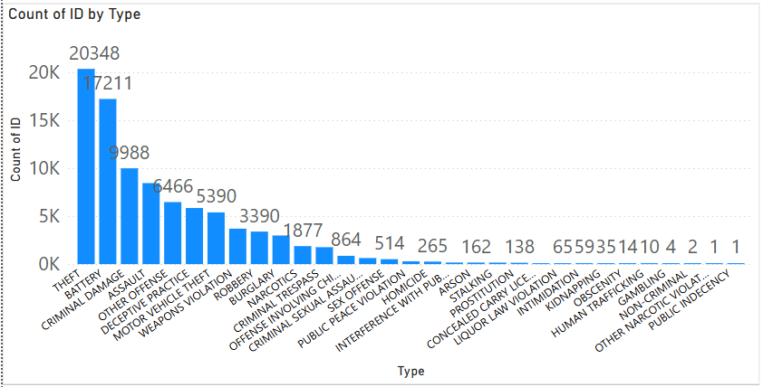

Findings – Top Crimes & Reporting:
- Most Common Crimes: THEFT (20.3K), ASSAULT (9.9K), BATTERY (7.2K).
- Domestic Crimes: Battery and Assault are highly reported.
- Battery ranks second among types of crimes reported, indicating that people are not hesitant to report
Conclusions:
- Reporting is Strong: Battery's high count suggests people are reporting, not hesitating.
- Could you generate a visual representation that emphasizes the frequently occurring terms within the "Description" column?
- Are there any particular regions as per the data where the number of domestic crimes reported is very high?
Ans.
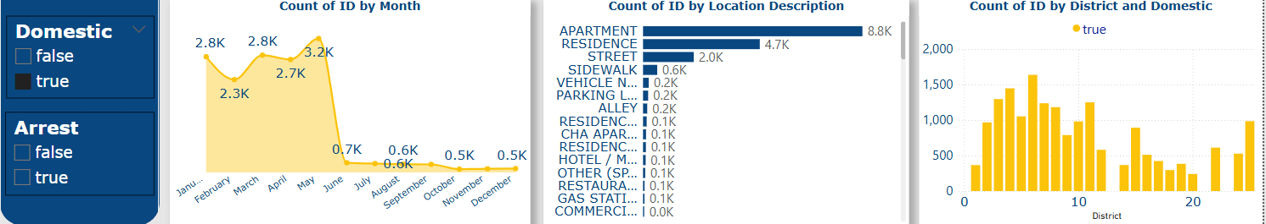

Findings – Top Crimes & Reporting:
- High crime by district: district 6 – highest in domestic crimes(1637)
- High crime by location description: apartment highest in domestic crimes(8839)
- High crime b months: May (3161)

- Is the solving time of cases also dependent upon the type and locality of crime?
- Create a calculated column to flag the domestic crimes that took place in District 8.
Ans. IsDomesticDistrict8 =
IF(
AND(
'crimes_data_2022 - crimes_data_'[Domestic] = "TRUE",
'crimes_data_2022 - crimes_data_'[District] = 8 // Or 8 if numeric
),
"Yes", // Or TRUE if you prefer boolean
"No" // Or FALSE
)

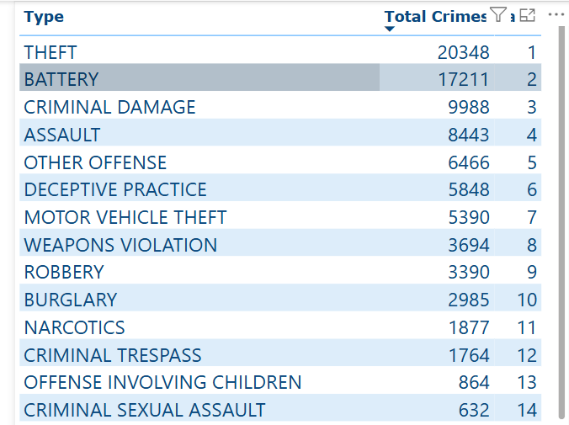
- Out of all the types of crimes which do you think is the most dangerous one and rank the type of crimes according to their no. of occurrences?
Ans.

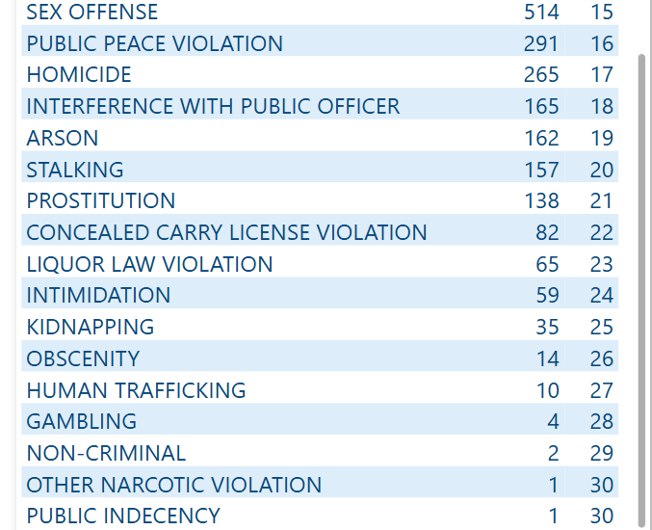

- What do you understand by PowerBI gateway? What are its use cases?
Ans.
Power BI Gateway is a bridge that enables secure data transfer between on-premises data sources and Power BI cloud services.
Use Cases:
- Data Refresh: Keeps cloud reports updated with live on-premises data (e.g., SQL Server).
- Hybrid Analytics: Allows analysis of both cloud and local data without migration.
- Security: Maintains data behind firewalls while enabling cloud access.

- How would you approach this problem, if the objective and subjective questions weren't given?
Ans.
If objective and subjective questions weren’t given, I’d begin by thoroughly exploring the dataset, identifying patterns, anomalies, and trends. Then, I’d formulate relevant questions based on the data’s structure and insights, guiding my analysis accordingly.

- If you are also given a table of districts-states with state_id, district_id and name, what would be the type of relationship between district of our data and district_id of new table?
Ans. The relationship would be many-to-one, where multiple crime records from the original data relate to one unique district_id in the new table. This allows mapping each crime record to its respective district and state.

Report:

The department has asked for a dashboard with three tabs:
- Main Tab
- Locality Tab
- Type Exploration Tab

- Using the Main tab in the report, the government should be able to review the decrease in crime numbers and the improvements resulting from special police operations. This tab should include a date slicer and a filter for the primary type of crime.

- Using the Locality Tab, police management and the head of operations should be able to identify the most common types of crime and the localities/wards where these crimes occurred. This tab should include slicers forward, date, and primary crime type.

- Using the Type Exploration Tab, the Special Cops team aims to examine the total number of domestic crimes and, from those, how many arrests were made by the district. Additionally, they want to identify the crime type with the highest number of arrests. Essentially, this tab will provide metrics to summarize the department's actions and the number of tasks pending. The tab should include slicers for a month and the primary crime type.

Make sure that all the visualizations look decent and are placed in a proper order. There are different POCs (Point Of Contact) for each tab, so make sure you involve all the metrics that POC may look at in that tab along with those mentioned in the tab description.
​​After making the report on the Desktop ensure that it is published on the PowerBI service and use the hosted link for submission of the dashboard and mentioning on the resume.

