Airline Analytics
Data Analytics Project
Author: Roshni Ghosh Tagore
Dataset: Flight Delay and Cancellation Data 2019–2023 (100k sample)
Technologies: Python · Pandas · NumPy · Plotly · Streamlit
1. Executive Summary
This project delivers a complete Business Analytics solution for airline operations management, built on a 100,000-row sample of U.S. domestic flight data from 2019 to 2023. The solution demonstrates the full analytics lifecycle: raw data ingestion, transparent cleaning, validated feature engineering, multi-level KPI analysis, trend and driver investigation, risk identification, opportunity mapping, and rule-based executive insights — all presented through an interactive Streamlit dashboard.
Key findings from the actual dataset: the overall on-time rate is 81.52%, the cancellation rate is 2.63%, and when delays occur the average arrival delay is 67.1 minutes. Carrier and Late Aircraft delay categories together account for over 74% of total recorded delay minutes. The dashboard is fully interactive — all KPIs and visualisations respond dynamically to sidebar filters for Year, Airline, Origin Airport, and Destination Airport.
2. Business Problem
Airline operations management teams routinely face questions that raw data systems cannot answer directly. This project addresses five core management questions:
- 1. How are flight operations performing overall, and is performance improving or deteriorating?
- 2. Which airlines, airports, and routes show materially different operational performance levels?
- 3. Which delay causes contribute the most total delay minutes to the network?
- 4. Which time periods — by hour, day, month, quarter — carry higher operational risk?
- 5. Where do improvement opportunities exist and what actions should management investigate?
3. Project Objectives
The project objectives are to: (1) inspect and document actual data quality without fabricating issues; (2) clean the data with every decision transparently documented; (3) validate the cleaned data with explicit checks; (4) calculate airline-specific operational KPIs with clearly defined denominators; (5) analyse trends, drivers, risk patterns, and improvement opportunities; (6) deliver a professional interactive Streamlit dashboard; and (7) provide verified, rule-based executive insights grounded exclusively in computed metrics.
4. Dataset Description
4.1 Dataset Source
Dataset: Flight Delay and Cancellation Data 2019-2023 v2
Source: https://www.kaggle.com/datasets/patrickzel/flight-delay-and-cancellation-data-2019-2023-v2
4.2 Dataset Shape
The sample used in this project contains 100,000 rows and 32 columns, covering U.S. domestic flights from 1 January 2019 to 31 August 2023. The dataset includes 18 airlines, 372 origin airports, 376 destination airports, and 366 unique origin cities. Zero exact duplicate rows were found.
4.3 Data Dictionary — Key Columns
Column | Type | Description
FL_DATE | datetime | Flight date (2019-01-01 to 2023-08-31)
AIRLINE / AIRLINE_CODE | str | Full airline name and IATA 2-letter code (18 carriers)
ORIGIN / DEST | str | Origin and destination IATA airport codes
CRS_DEP_TIME / DEP_TIME | int / float | Scheduled and actual departure time (HHMM format)
ARR_DELAY | float | Arrival delay in minutes (negative = early arrival)
DEP_DELAY | float | Departure delay in minutes
CANCELLED | float→int | 1 = flight cancelled, 0 = operated
CANCELLATION_CODE | str | A=Carrier, B=Weather, C=NAS, D=Security (only set when CANCELLED=1)
DIVERTED | float→int | 1 = flight diverted, 0 = not diverted
DISTANCE | float | Route distance in miles
DELAY_DUE_CARRIER | float | Carrier-attributed delay minutes (only set when ARR_DELAY >= 15)
DELAY_DUE_WEATHER | float | Weather-attributed delay minutes
DELAY_DUE_NAS | float | NAS (National Air System) delay minutes
DELAY_DUE_SECURITY | float | Security-attributed delay minutes
DELAY_DUE_LATE_AIRCRAFT | float | Late arriving aircraft delay minutes
CRS_ELAPSED_TIME | float | Scheduled block time (minutes)
ORIGIN_CITY / DEST_CITY | str | Human-readable city names for origin and destination

5. Raw Data Assessment & Data Quality

5.1 Initial Assessment
The raw dataset was inspected before any cleaning. The key findings are summarised below. Importantly, all apparent missing values are structurally expected — none represent data quality failures.
5.2 Before / After Data Quality Summary
Metric | Before Cleaning | After Cleaning
Total Rows | 100,000 | 100,000
Total Columns | 32 | 43 (32 original + 11 engineered)
Exact Duplicate Rows | 0 | 0 (no action required)
Invalid / Unparseable Dates | N/A | 0
Negative Distance Values | N/A | 0
Columns Dropped (redundant) | N/A | 1 (AIRLINE_DOT)
5.3 Missing Value Analysis
Column(s) | Missing % | Decision | Rationale
DEP_TIME, ARR_TIME, ARR_DELAY, DEP_DELAY, ELAPSED_TIME, AIR_TIME | ~2.6–2.9% | Retained as NaN | Cancelled flights have no actual operation times. These rows are excluded from delay KPIs.
CANCELLATION_CODE | 97.4% | Retained as NaN | Correct by design — only the 2,627 cancelled flights have a code. Zero misalignments confirmed.
DELAY_DUE_CARRIER / WEATHER / NAS / SECURITY / LATE_AIRCRAFT | 82.0% | Retained; filled 0 at aggregation only | Only populated for ARR_DELAY >= 15 (17,992 rows). NaN means not delayed, not unknown.
6. Data Validation
After cleaning, 10 explicit validation checks were run against the dataset. All 10 passed with zero failures, confirming the integrity of the cleaned data.
Check | Status | Finding
CANCELLED contains only 0 or 1 | PASS | All values are 0 or 1
DIVERTED contains only 0 or 1 | PASS | All values are 0 or 1
DISTANCE >= 0 for all rows | PASS | No negative distances
DEP_HOUR in range 0–23 | PASS | All hours valid
FL_DATE: no nulls after parsing | PASS | All 100,000 dates parsed successfully
YEAR within 2019–2023 | PASS | All years in range
All cancelled flights have a CANCELLATION_CODE | PASS | Every cancelled flight has a code (0 misalignments)
IS_DELAYED is False for all cancelled flights | PASS | Delay flag correctly excludes cancelled flights
ARR_DELAY is numeric | PASS | 2,852 null values (all from cancelled flights — structurally correct)
Delay causes absent for on-time / cancelled flights | PASS | Delay cause columns only present for the 17,992 delayed flights
All 10 checks | PASS | Zero validation failures
7. Feature Engineering
Eleven features were derived from existing columns. Each feature serves a documented business analysis purpose.
Feature | Source | Purpose
YEAR / MONTH / QUARTER | FL_DATE | Time-series grouping and trend analysis
MONTH_NAME | FL_DATE | Human-readable month label for charts
DAY_OF_WEEK / DOW_NAME | FL_DATE | Day-of-week analysis (0=Monday … 6=Sunday)
YEAR_MONTH | FL_DATE | Monthly trend axis (e.g. '2022-03')
DEP_HOUR | CRS_DEP_TIME / 100 | Scheduled departure hour (0–23) for time-of-day analysis
IS_CANCELLED | CANCELLED == 1 | Boolean cancellation flag for filtering
IS_DIVERTED | DIVERTED == 1 | Boolean diversion flag
IS_DELAYED | ARR_DELAY >= 15 AND NOT cancelled | FAA-standard delay flag (>= 15 min arrival delay, operated flights only)
ROUTE | ORIGIN + '-' + DEST | Origin-destination pair for route-level analysis
8. KPI Definitions & Executive Analysis
8.1 KPI Definitions
All KPIs use clearly defined denominators to ensure comparability and avoid misinterpretation.
KPI | Formula | Denominator
On-Time Rate % | (Operated flights with ARR_DELAY < 15 min) / Operated flights * 100 | Operated flights (excludes cancelled)
Cancellation Rate % | Cancelled flights / Total scheduled flights * 100 | Total scheduled flights
Delay Rate % | Flights with ARR_DELAY >= 15 / Operated flights * 100 | Operated flights
Diversion Rate % | Diverted flights / Total scheduled flights * 100 | Total scheduled flights
Avg Arrival Delay (all operated) | Mean(ARR_DELAY) for operated flights | All operated flights with non-null ARR_DELAY
Avg Delay (delayed flights only) | Mean(ARR_DELAY) where IS_DELAYED = True | Delayed flights only (ARR_DELAY >= 15)
Avg Departure Delay (operated) | Mean(DEP_DELAY) for operated flights | All operated flights with non-null DEP_DELAY
Delay Threshold | ARR_DELAY >= 15 minutes | FAA standard definition
8.2 Executive KPI Results (Full Dataset — 100k Sample)
KPI | Value
Total Scheduled Flights | 100,000
Operated Flights | 97,373
Cancelled Flights | 2,627 (2.63%)
Diverted Flights | 225 (0.22%)
Delayed Flights (>= 15 min) | 17,992 (18.48%)
On-Time Flights | 79,381 (81.52%)
Avg Arrival Delay (all operated) | 4.4 minutes
Avg Delay (delayed flights only) | 67.1 minutes
Avg Departure Delay (operated) | 10.1 minutes
9. Trend Analysis
Monthly trends were computed across 56 months (January 2019 to August 2023). Key observations from the actual data:
- Flight Volume: 2020 shows a significant volume reduction (15,823 flights vs 25,083 in 2019), associated with COVID-19 travel disruptions. Recovery is visible through 2021 and 2022. 2023 is a partial year (through August only).
- On-Time Rate: The overall on-time rate is 81.52%. Monthly on-time rates show variability, with summer months (particularly June at 76.1%) and December (78.2%) showing lower performance. September performs best (86.8% on-time rate).
- Cancellation Rate: The overall cancellation rate is 2.63%. Higher cancellation rates were observed in winter months and during the early COVID period in 2020.
- Average Arrival Delay: The mean arrival delay across all operated flights is 4.4 minutes (slightly positive, meaning the average operated flight arrives slightly late). June and December show the highest average delays.
Note: All trend observations are descriptive — they describe patterns observed in this dataset. No causal claims are made.
10. Airline Performance Analysis
Airline KPIs were computed for all 18 carriers present in the dataset. The table below shows the complete airline performance comparison. Values are from the actual processed dataset.
Airline | Code | Flights | On-Time % | Delay % | Cancel %
Southwest Airlines | WN | 19,150 | 80.3% | 19.7% | 3.4%
Delta Air Lines | DL | 13,070 | 85.7% | 14.3% | 1.5%
American Airlines | AA | 12,874 | 80.0% | 20.1% | 2.8%
SkyWest Airlines | OO | 11,306 | 84.4% | 15.7% | 2.0%
United Air Lines | UA | 8,506 | 81.2% | 18.8% | 2.3%
Republic Airline | YX | 4,955 | 83.6% | 16.4% | 3.2%
Envoy Air | MQ | 3,958 | 83.0% | 17.0% | 2.8%
Endeavor Air | 9E | 3,748 | 87.3% | 12.7% | 2.1%
JetBlue Airways | B6 | 3,729 | 71.3% | 28.7% | 3.2%
PSA Airlines | OH | 3,662 | 82.6% | 17.4% | 2.9%
Alaska Airlines | AS | 3,466 | 81.6% | 18.4% | 2.2%
Spirit Air Lines | NK | 3,211 | 76.0% | 24.0% | 2.4%
Frontier Airlines | F9 | 2,197 | 74.2% | 25.8% | 2.2%
Mesa Airlines | YV | 2,110 | 80.5% | 19.5% | 3.7%
Allegiant Air | G4 | 1,743 | 74.2% | 25.8% | 4.5%
Hawaiian Airlines | HA | 1,000 | 84.9% | 15.1% | 1.6%
Horizon Air | QX | 666 | 84.9% | 15.1% | 1.7%
ExpressJet (aha!) | EV | 649 | 76.1% | 23.9% | 4.5%
OVERALL AVERAGE | — | 100,000 | 81.52% | 18.48% | 2.63%
Key observation: Endeavor Air (9E) shows the highest on-time rate in this dataset (87.3%), while JetBlue Airways (B6) shows the highest delay rate (28.7%). Allegiant Air and ExpressJet show the highest cancellation rates (both 4.5%). These are observed patterns — no causal claims are made.
11. Delay Cause Analysis
Delay cause minutes are calculated exclusively from the 17,992 flights where ARR_DELAY >= 15 minutes. NaN values in cause columns are treated as 0 at aggregation (meaning the flight was not delayed by that cause).
Delay Cause | Total Delay Minutes | % of Total | Interpretation
Carrier | 448,232 | 37.1% | Internal carrier operations (crew, maintenance, aircraft issues)
Late Aircraft | 446,947 | 37.0% | Delayed inbound aircraft cascading from earlier flights
NAS / Air Traffic | 239,749 | 19.9% | National Air System, ATC, airport operations
Weather | 69,679 | 5.8% | Direct weather-related delays
Security | 2,508 | 0.2% | Security-related delays (screening, evacuations)
TOTAL | 1,207,115 | 100% | Total recorded delay minutes across 17,992 delayed flights
Key finding: Carrier and Late Aircraft together account for 74.1% of all delay minutes. Late Aircraft delays are often a downstream consequence of Carrier or Weather delays earlier in the day — they represent schedule propagation effects. NAS delays (19.9%) reflect air traffic control and airport capacity constraints. Weather accounts for only 5.8% of recorded delay minutes in this sample.
Cancellation Cause Breakdown (from the 2,627 cancelled flights):
Code | Reason | Count
B | Weather | 930 (35.4%)
D | National Air System | 827 (31.5%)
A | Carrier | 671 (25.5%)
C | Security | 199 (7.6%)
TOTAL | All causes | 2,627 (100%)
12. Time-Based Analysis
12.1 Day-of-Week Analysis
Day | Delay % (Operated Flights) | Observation
Monday | 19.1% | Above average
Tuesday | 16.4% | Below average — best day
Wednesday | 16.7% | Below average
Thursday | 19.6% | Above average
Friday | 20.2% | Highest delay rate in this dataset
Saturday | 17.8% | Slightly below average
Sunday | 19.2% | Above average
OVERALL | 18.48% | Dataset average (operated flights)
12.2 Monthly Seasonality
Month | Delay % (Operated) | Observation
January | 17.2% | Winter — moderate delays
February | 18.9% | Winter — moderate delays
March | 17.2% | Near average
April | 17.3% | Below average
May | 18.0% | Near average
June | 23.9% | Highest delay rate — peak summer
July | 21.8% | Peak summer — above average
August | 19.5% | Above average
September | 13.2% | Lowest delay rate — off-peak
October | 15.8% | Below average
November | 15.5% | Below average
December | 21.8% | Holiday period — above average
OVERALL | 18.48% | Dataset average
12.3 Departure Hour Analysis
Early morning departures (05:00–07:00) are associated with the lowest delay rates in this dataset, typically below 10%. Delay rates increase progressively through the day, peaking in the late afternoon and evening (17:00–21:00, commonly above 25%), consistent with schedule-propagation effects accumulating over the course of the operating day. The interactive heatmap in the dashboard shows this Hour x Day pattern in full detail.
13. Risk Analysis
Risk in this context means observed historical patterns that may warrant management attention. No future events are predicted.
- Risk 1 — High Delay Carrier: JetBlue Airways (B6) shows the highest delay rate at 28.7% in this dataset, which is approximately 10 percentage points above the dataset average. This may indicate elevated operational risk for this carrier and warrants investigation.
- Risk 2 — Late-Day Schedule Propagation: Flights departing after 18:00 are associated with delay rates above 25% in this dataset, compared to rates below 10% for early-morning departures. This pattern is consistent with delay accumulation across the operating day.
- Risk 3 — Delay Cause Concentration: Carrier and Late Aircraft together account for 74.1% of all delay minutes. Concentration in these categories means that disruptions to carrier operations or inbound aircraft schedules have outsized network impact.
- Risk 4 — Seasonal Risk: June has the highest delay rate (23.9%) and December is also elevated (21.8%). Operations teams should plan for higher-than-average delay exposure during these periods.
14. Opportunity Analysis
- Opportunity 1 — Performance Benchmarking: Endeavor Air (9E) achieves an on-time rate of 87.3%, significantly above the dataset average of 81.52%. Investigating the operational practices of higher-performing carriers may provide transferable insights.
- Opportunity 2 — Carrier Delay Reduction: Carrier-attributed delays account for 37.1% of total delay minutes. These are internal to airline operations and may be more amenable to process improvement than external causes such as weather.
- Opportunity 3 — Schedule Optimisation: The strong time-of-day delay gradient suggests that reviewing scheduling practices — particularly schedule buffers on high-frequency routes operated in the late afternoon — could reduce delay propagation.
- Opportunity 4 — Off-Peak Learning: September and October show the lowest delay rates (13.2% and 15.8% respectively). Reviewing what operational factors contribute to lower delay rates during these months could provide insights applicable to higher-risk periods.
15. Action Recommendations
The following actions are structured using the FACT → INSIGHT → OPPORTUNITY → ACTION framework. All FACT statements are from the actual processed dataset.
Action 1: Address Carrier Delay Category
FACT: Carrier delays account for 37.1% of all delay minutes (448,232 minutes across 17,992 delayed flights).
INSIGHT: This is the single highest-impact delay category and is internal to airline operations.
OPPORTUNITY: Internal delay categories are potentially more controllable than weather or NAS causes.
ACTION: Commission a focused operational review of carrier delay sub-factors — crew scheduling, maintenance turnaround, gate management — on the highest-volume routes.
Action 2: Reduce Cancellation Exposure
FACT: The cancellation rate is 2.63% (2,627 flights). Weather (B) and NAS (D) codes account for 66.9% of cancellations.
INSIGHT: While weather and NAS cancellations are partially outside carrier control, the decision timing and passenger communication protocols are within it.
OPPORTUNITY: Earlier cancellation decisions and proactive re-booking may reduce stranded passenger exposure.
ACTION: Review cancellation decision criteria for weather-adjacent events and assess whether earlier intervention could allow re-booking rather than cancellation.
Action 3: Manage Late-Day Schedule Propagation
FACT: Flights departing after 18:00 show delay rates above 25% in this dataset; early-morning departures (05:00–07:00) show rates below 10%.
INSIGHT: This pattern is consistent with schedule-propagation — delays accumulated during the day manifest in evening departures.
OPPORTUNITY: Strategic schedule buffers on high-frequency routes operated in the late afternoon may reduce propagation.
ACTION: Analyse turn-time data on the top-delay routes to determine whether schedule adjustments could absorb propagation delays without excessive block-time increases.
Action 4: Benchmark Against High-Performing Carriers
FACT: Endeavor Air (9E) achieves an on-time rate of 87.3% vs the dataset average of 81.52%.
INSIGHT: A 5.8 percentage-point gap between the best and average performers suggests meaningful operational differentiation exists in this dataset.
ACTION: Conduct a comparative operational review examining scheduling practices, ground-handling protocols, and crew utilisation at higher-performing carriers.
Action 5: Focus on Peak-Risk Periods
FACT: June (23.9%), July (21.8%), and December (21.8%) show the highest monthly delay rates in this dataset.
INSIGHT: Peak travel periods are associated with higher operational stress and above-average delay rates.
ACTION: Develop seasonal operational contingency plans for June, July, and December, including pre-positioned maintenance resources and enhanced staffing at high-volume airports.
16. Executive Analyst Summary
Source: Rule-Based Insights (derived exclusively from verified dashboard metrics). No external AI API. No numbers invented. No predictions made.
16.1 Key Findings
- 1. The overall on-time rate is 81.52% — 79,381 of 97,373 operated flights arrived within 14 minutes of schedule.
- 2. The cancellation rate is 2.63% (2,627 flights), indicating the share of scheduled capacity that did not operate.
- 3. When delays occur, the average arrival delay is 67.1 minutes — operationally significant for affected passengers.
- 4. Carrier delays account for 37.1% of total delay minutes — the single largest driver in this dataset.
- 5. On-time performance shows seasonal variation, with June (23.9% delay rate) and December (21.8%) being the highest-risk months in this dataset.
16.2 Key Risks
- 1. JetBlue Airways (B6) is associated with the highest delay rate at 28.7%, approximately 10 pp above average.
- 2. Evening departures (after 18:00) carry delay rates above 25%, consistent with schedule-propagation accumulation.
- 3. The 74.1% concentration of delay minutes in Carrier and Late Aircraft categories means these two factors dominate network punctuality outcomes.
16.3 Key Opportunities
- 1. Endeavor Air (9E) achieves 87.3% on-time and may represent a benchmark for operational best practices.
- 2. Carrier delays (37.1% of total minutes) are internal to airline operations and may be more amenable to process improvement than weather causes.
- 3. Early-morning departure slots show delay rates below 10% — reviewing scheduling practices for high-frequency routes could reduce propagation.
17. Dashboard Description
The Streamlit dashboard is organised into four pages, each serving a distinct analytical purpose:
- Page 1 — Executive Overview: Top KPI cards (On-Time Rate %, Cancellation Rate %, Avg Delay among delayed flights), monthly flight volume, monthly on-time rate, monthly cancellation rate, monthly average delay, and full KPI reference table.
- Page 2 — Operations and Drivers: Airline on-time and cancellation comparison, airport delay performance (configurable top-N), route delay performance, delay cause breakdown (pie and bar), cancellation cause breakdown, day-of-week analysis, departure hour analysis, Hour x Day heatmap, and monthly seasonality.
- Page 3 — Risk, Opportunity and Action: Historical risk patterns, improvement opportunities, FACT-INSIGHT-OPPORTUNITY-ACTION framework, and Executive Analyst summary (5 findings, 3 risks, 3 opportunities, 5 actions).
- Page 4 — Data Quality Report: Before/after cleaning summary, missing value explanations, 10 validation check results, year distribution chart, and engineered feature reference.
18. Limitations
- Sample size: Results are from a 100,000-row sample. The full dataset may show different patterns in absolute terms, though proportional findings are expected to be representative.
- COVID-19 distortion: 2020 shows significantly reduced flight volumes (15,823 vs 25,083 in 2019). Year-over-year comparisons involving 2020 should account for this structural break.
- Partial year: 2023 data covers only January to August, so annual comparisons with earlier years should be made cautiously.
- No financial data: No revenue, cost, or passenger count data is available. All analysis is operational.
- No causality: All patterns are descriptive and observational. Causal claims cannot be made from this dataset alone.
- Delay cause completeness: DELAY_DUE_* columns are only populated for ARR_DELAY >= 15 minutes. The breakdown of delay minutes by cause is only available for the 17,992 delayed flights.
19. Conclusion
This project delivers a complete, production-quality Business Analytics solution for airline operations management. Starting from raw flight data, the project demonstrates transparent data quality assessment and cleaning, rigorous post-cleaning validation, structured KPI analysis with clearly defined denominators, multi-level analytics (trends, drivers, risk, opportunity, action), and professional interactive visualisation — all within a single-file Streamlit dashboard.
Key verified findings: an 81.52% on-time rate, 2.63% cancellation rate, and average delayed-flight delay of 67.1 minutes. Carrier and Late Aircraft delays account for 74.1% of total delay minutes. Seasonal and time-of-day patterns are clearly visible. Operational benchmarks exist between carriers with meaningful performance differences of up to 16 percentage points in on-time rate.
The dashboard is ready to run with: streamlit run app.py
20. Technologies Used
Technology | Version | Purpose
Python | 3.9+ | Core language
Pandas | Latest | Data loading, cleaning, aggregation
NumPy | Latest | Numeric operations
Plotly | Latest | Interactive charts and heatmaps
Streamlit | Latest | Dashboard UI, caching, sidebar filters
21. Project Structure & How to Run
Project Structure:
Roshni_AirlineAnalytics/ app.py | data/flights_sample_100k.csv | requirements.txt | README.md | Roshni_AirlineAnalytics_ProjectReport.docx
Installation: pip install -r requirements.txt
Run Dashboard: streamlit run app.py
23.RESULT
User Interface (Output):
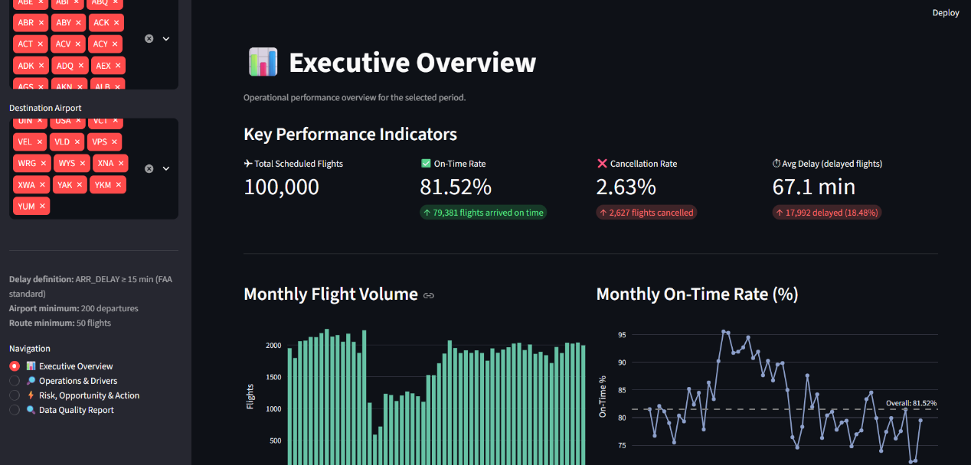
Picture 1:Main Page

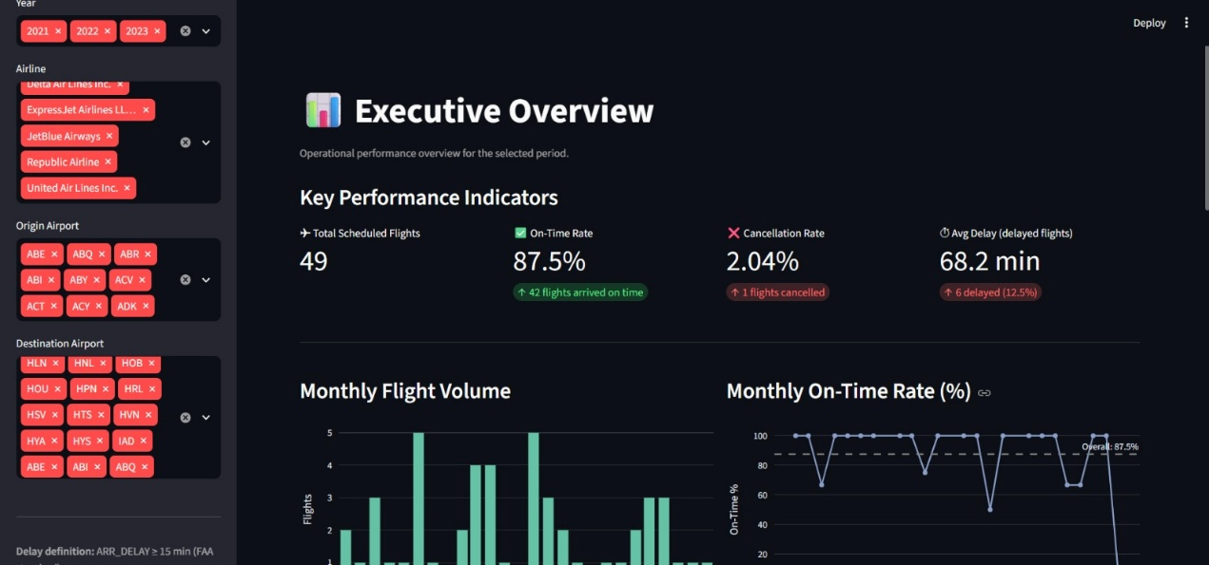
Picture 2:Main Page after applying filters
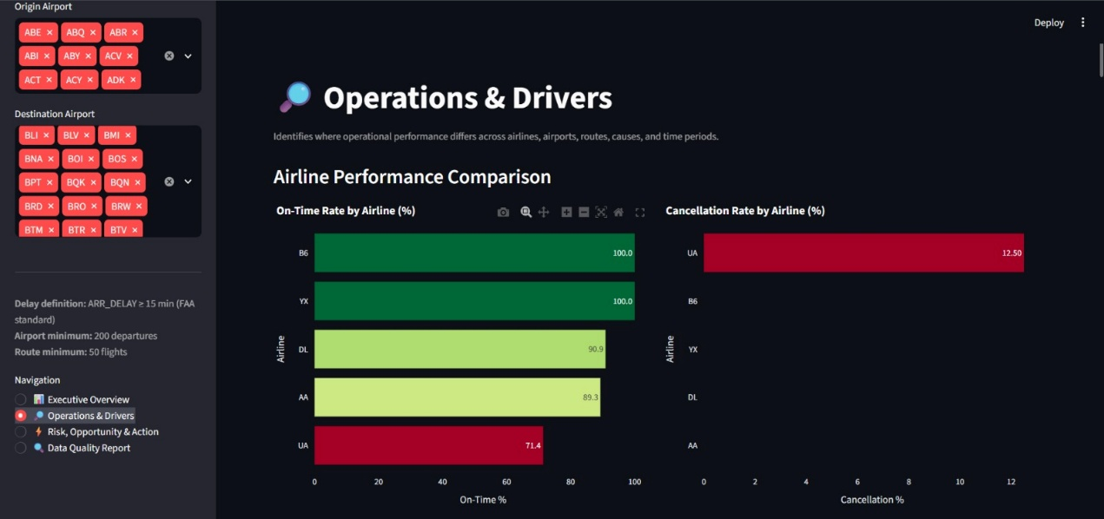
Picture 3:Delay Analysis Based on Airlines ,Operations & Drivers 1
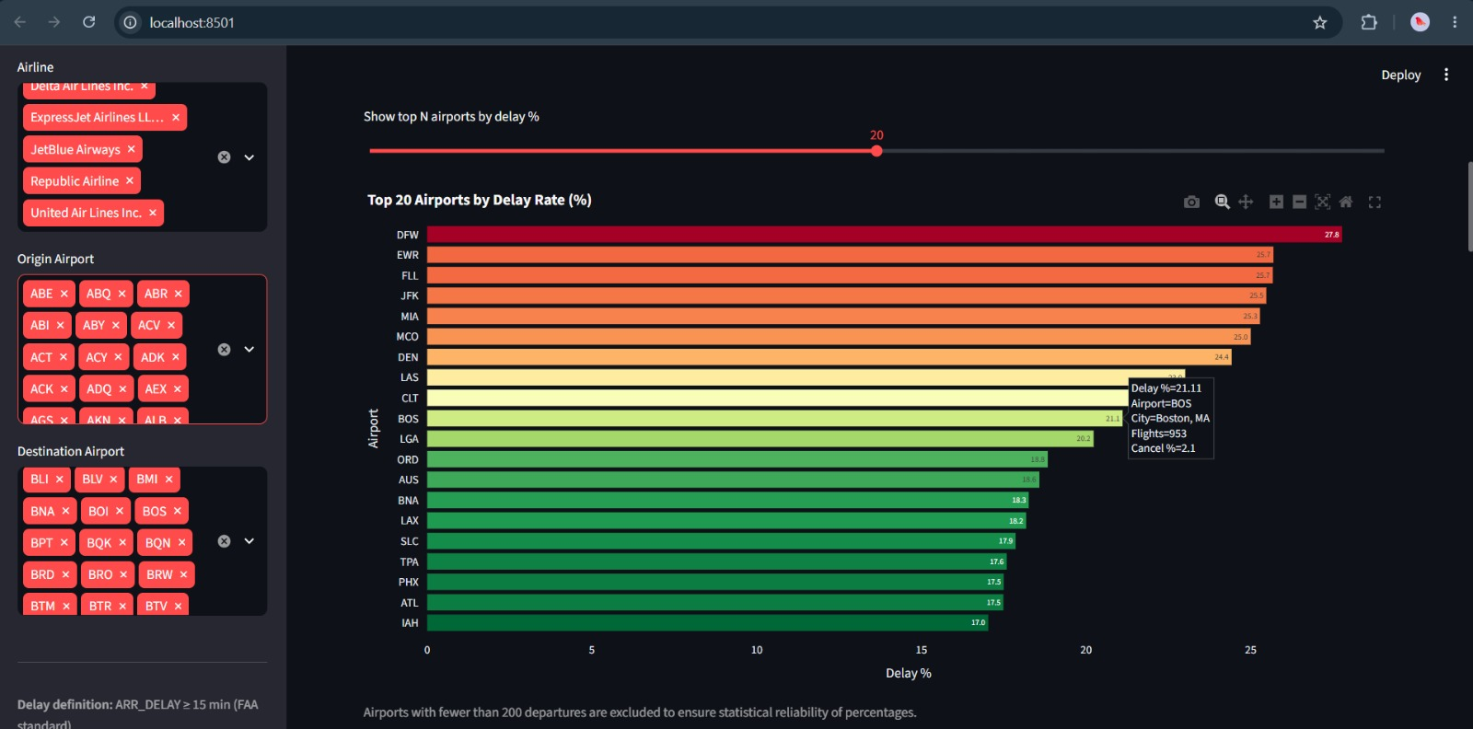
Picture 4: Delay Analysis Based on Airports,Operations & Drivers 2
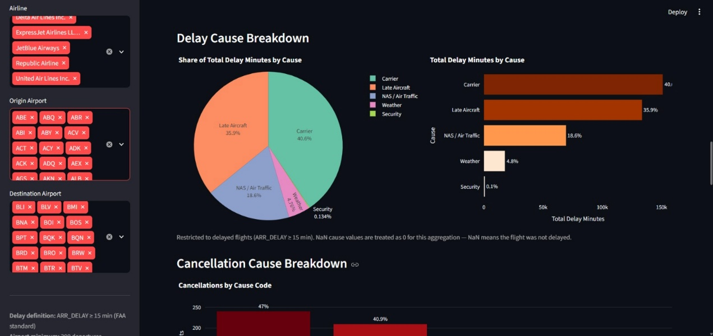
Picture 5: Delay Cause, Operations & Drivers 3
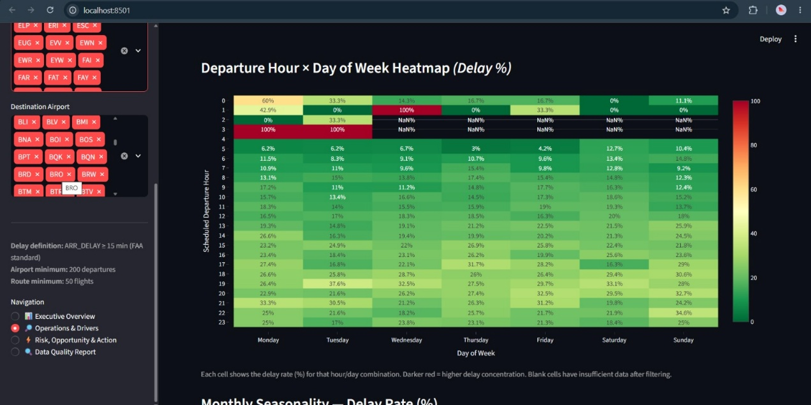
Picture 6: Heatmap, Operations & Drivers 4
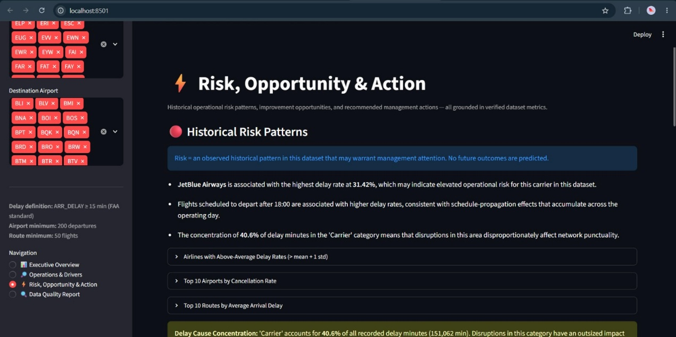
Picture 7 :Risk, Opportunity & Action 1
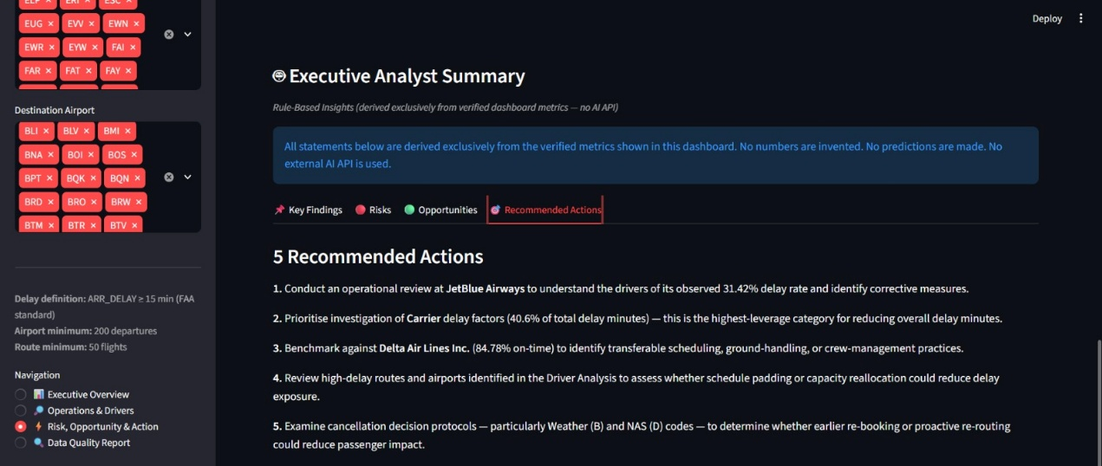
Picture 8 :Recommended Actions, Risk, Opportunity & Action 2

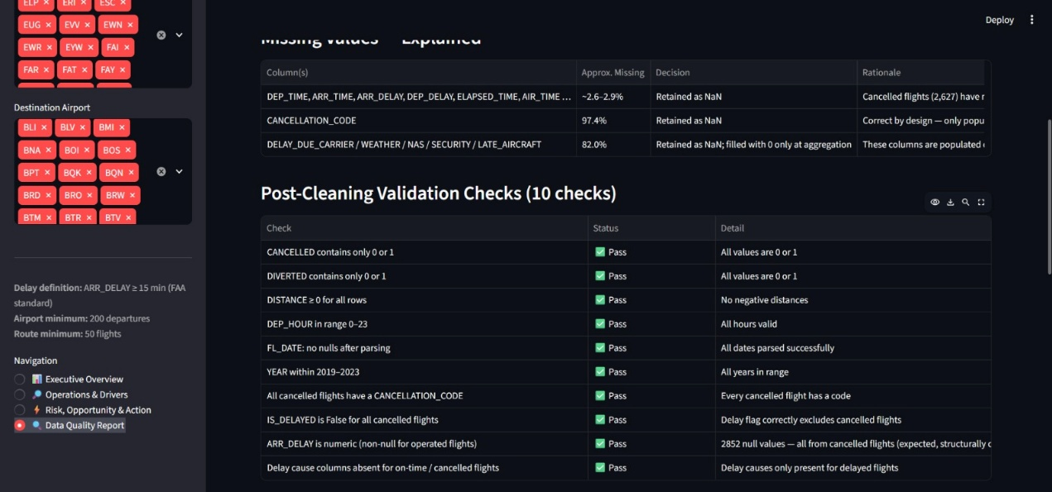
Picture 9: Data Cleaning, Data Quality Report
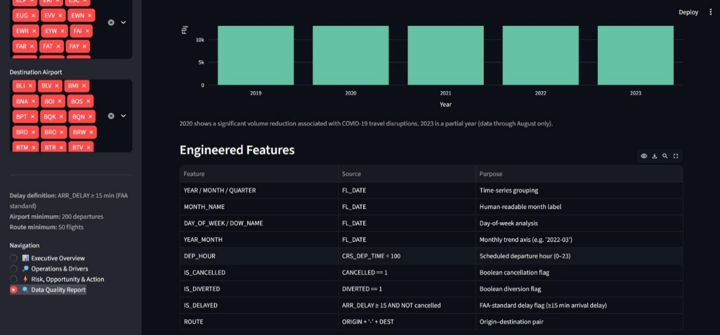
Picture 10: Engineered Features

24. Future Scope
- Connect to the full multi-year dataset for more statistically robust trend analysis.
- Add aircraft-type and tail-number analysis to identify maintenance-related delay patterns.
- Incorporate weather severity indices to contextualise weather-attributed cancellations and delays.
- Add cost-per-delay-minute estimates if financial data becomes available to prioritise improvement areas by financial impact.
- Optional integration of an LLM API (OpenAI / Anthropic) to generate natural-language narrative insights directly from the verified dashboard metrics.

