**COMPONENT 3**

**EStock Market App Azure deployment**

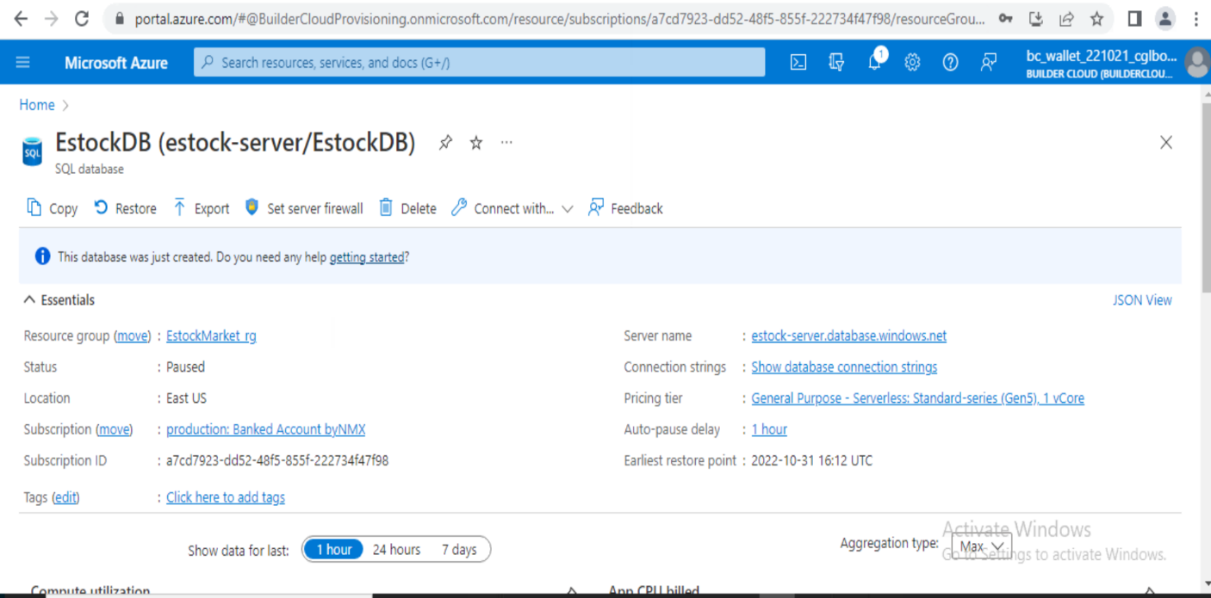**1.Database has been created in azure and the connection string for of the database**

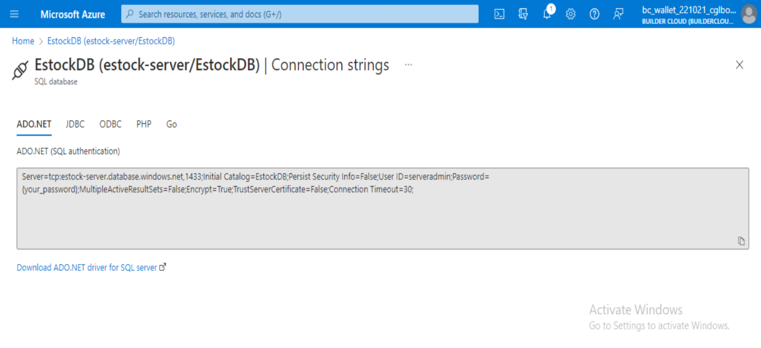

**2. Resource Group**

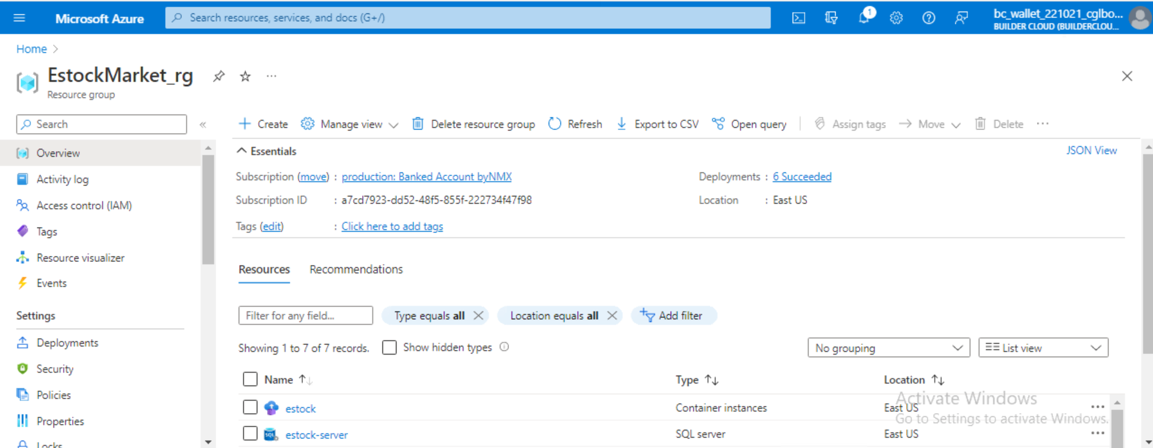

**3. Container registry for storing the docker images for both API and for front end part.**

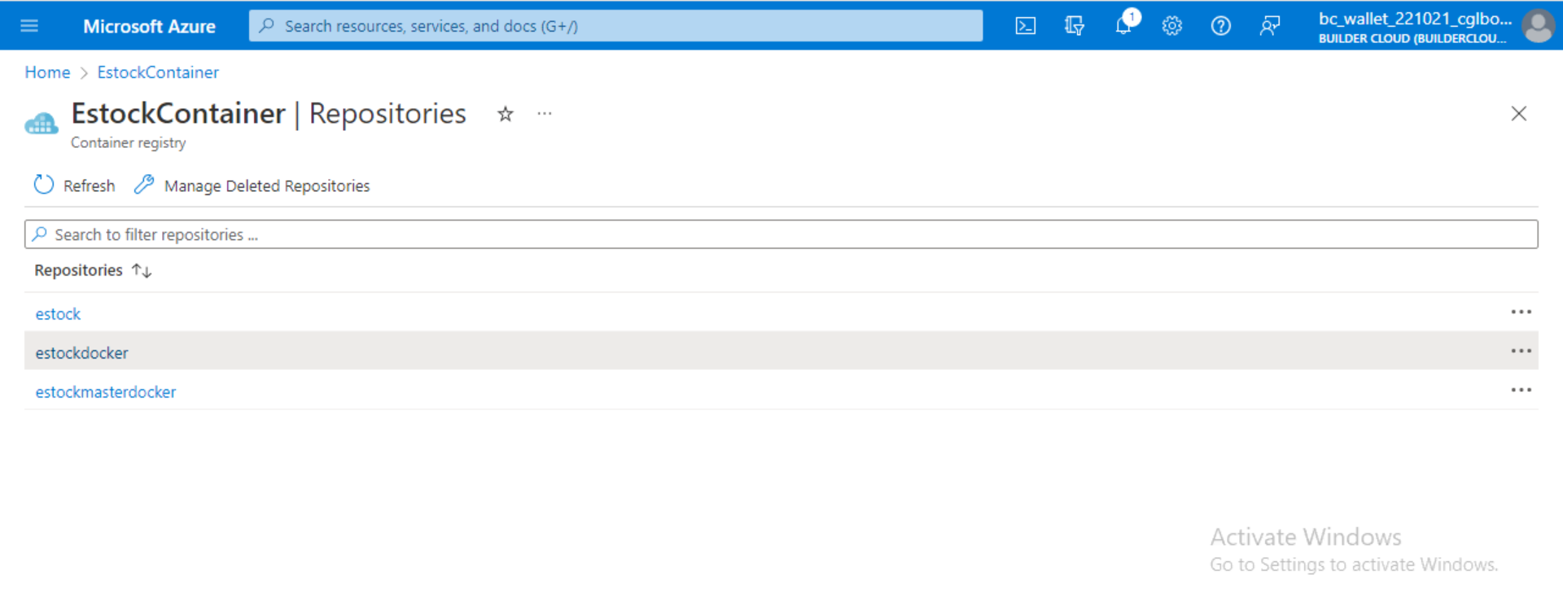

**4.Created the Docker Image and deployed in container**

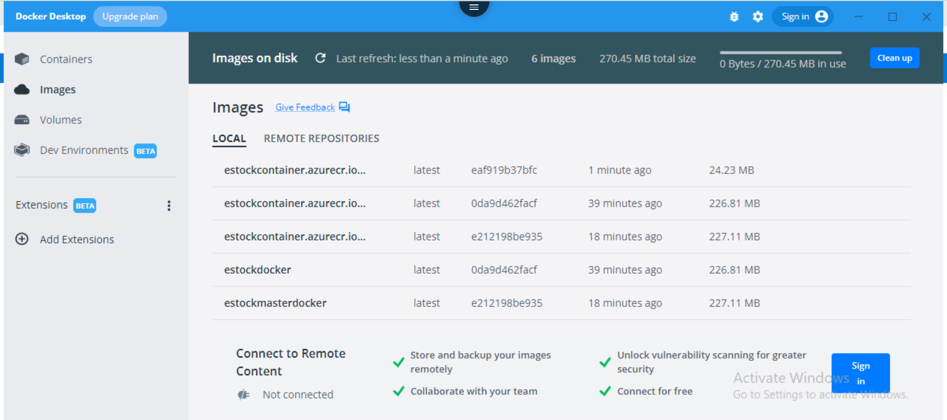

**5. Container instance for API(EStocks) and generated the swagger end points in azure**.

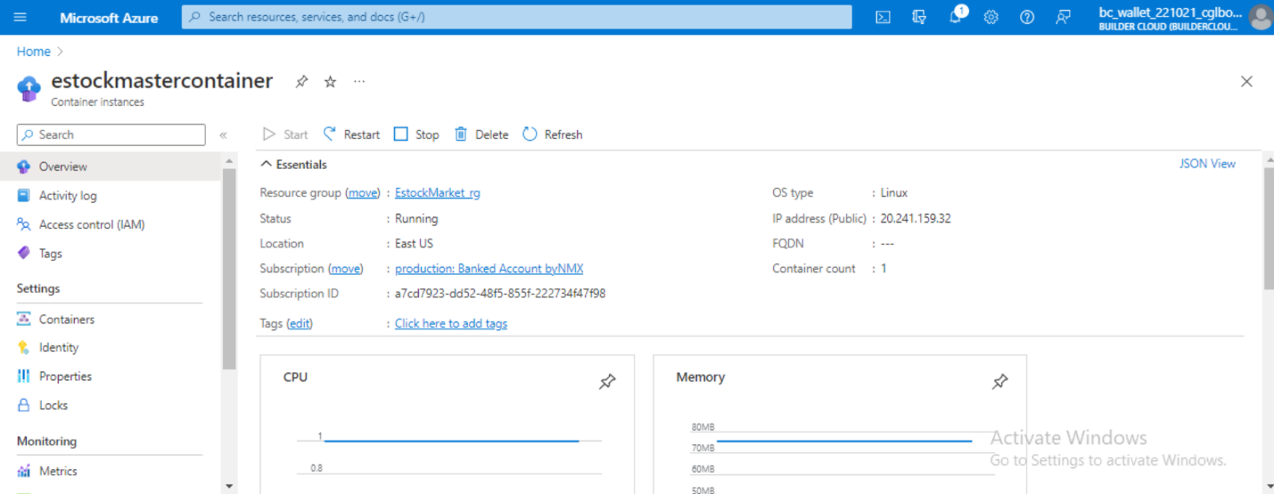

**6. Container instance for API(EstocksService) and generated the swagger end points in azure.**

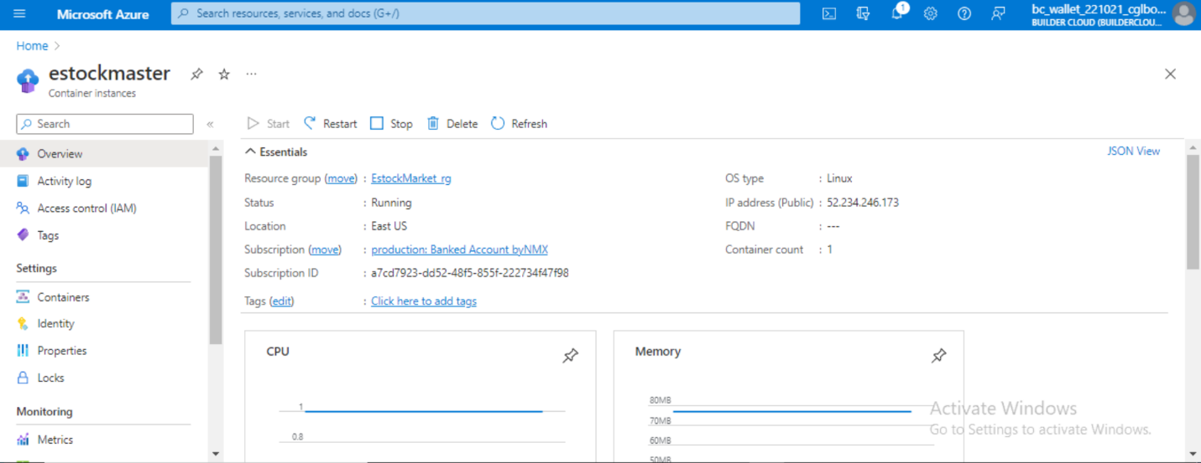

**7. Container instance of Estock UI(Angular)and the endpoints for the UI has been generated.**

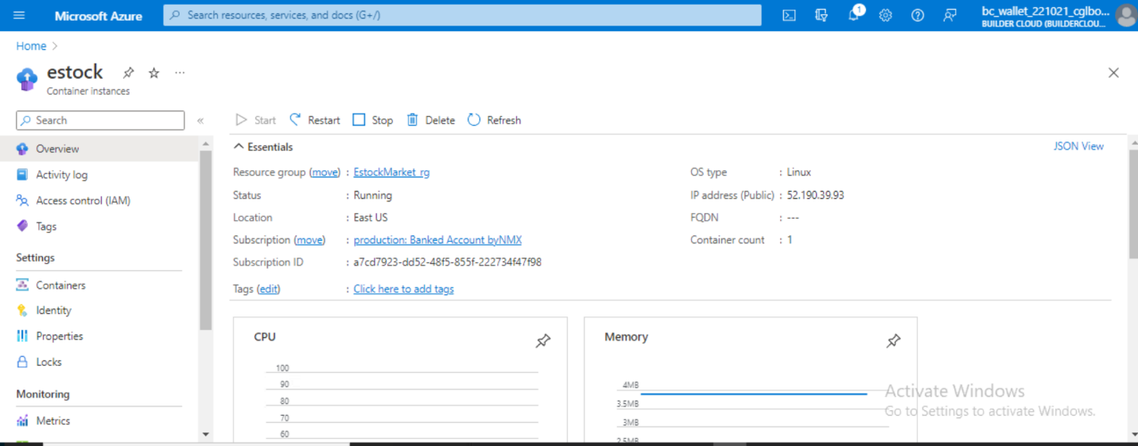

**End points for swagger and the UI**

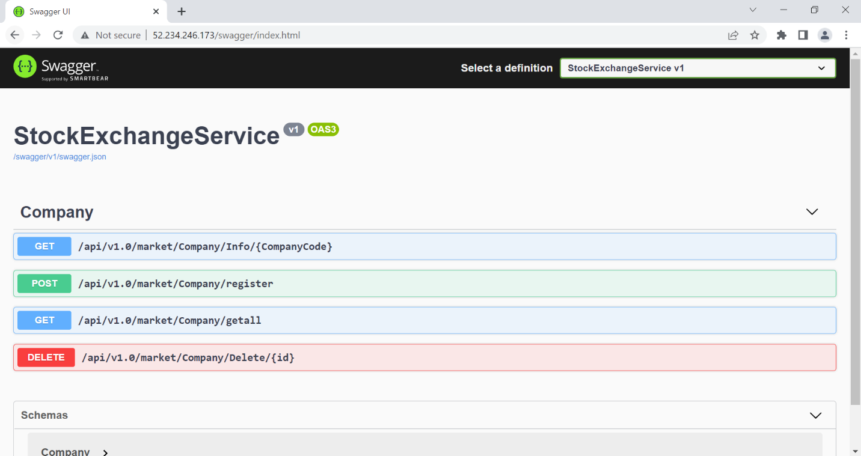1.API swagger end points(EStocksService) : 52.234.246.173/swagger/index.html

2.API swagger end points(EStocks) : 20.241.159.32/swagger/index.html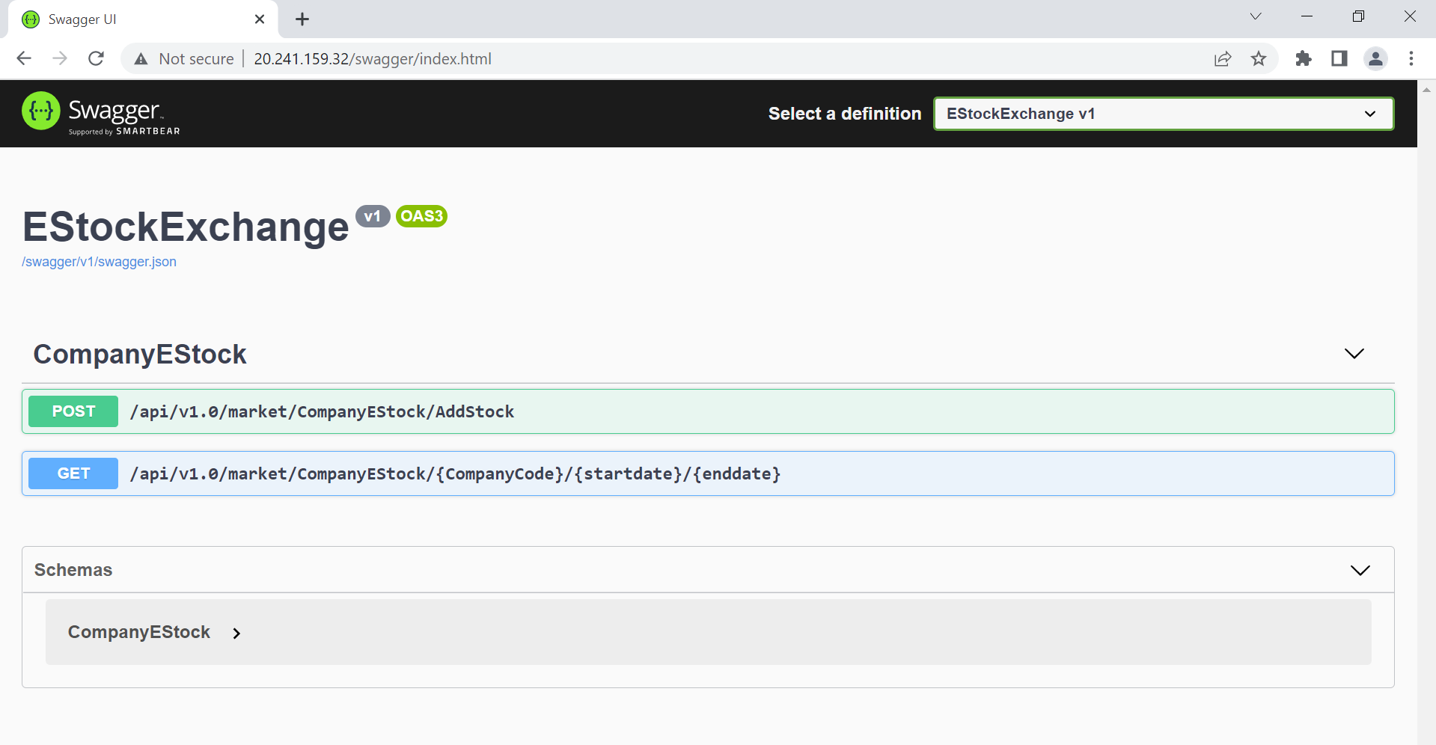

3.UI end points : 52.190.39.93

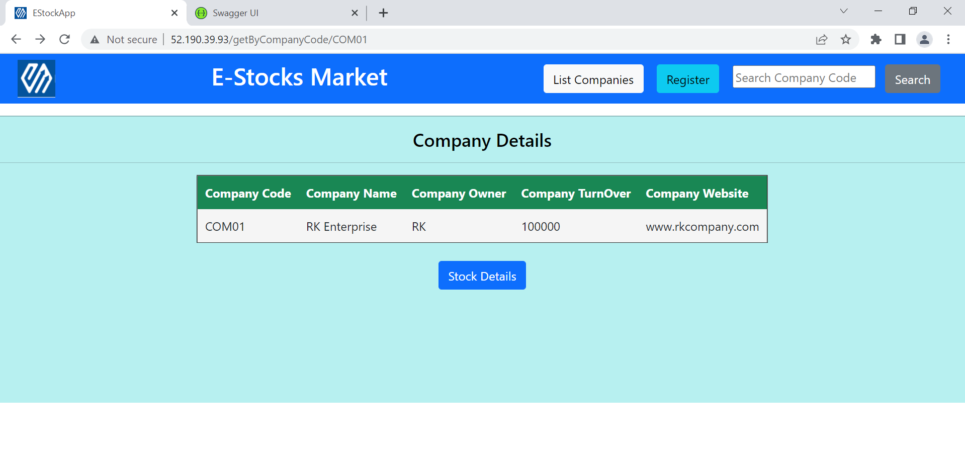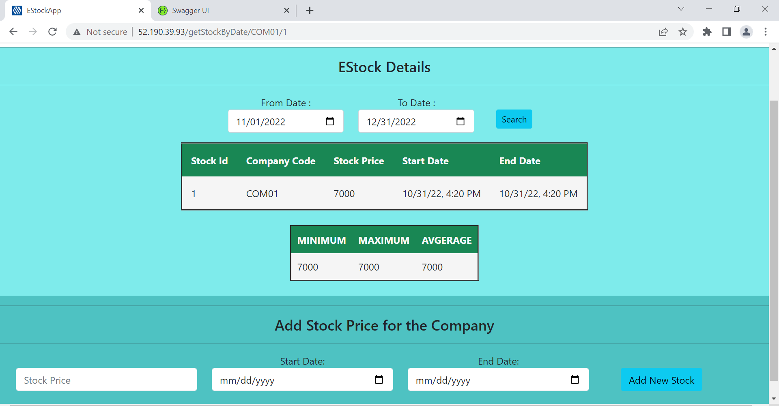

**GItHub link** : https://github.com/RoshniKrishnan7/Estock_Main