**COMPONENT 3**

**Tweet Application Azure deployment**

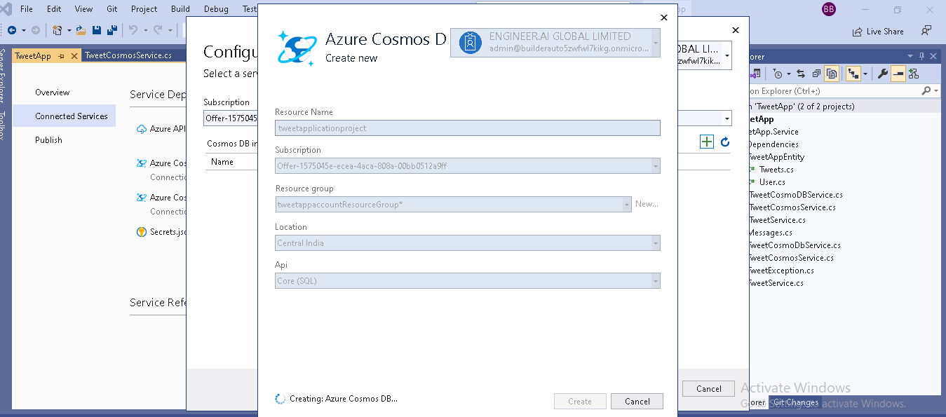1.Created the NoSQL instance of Azure Cosmos DB as a database for the TweetApp Api and changed the queries to fetch and insert the data into Cosmos db.

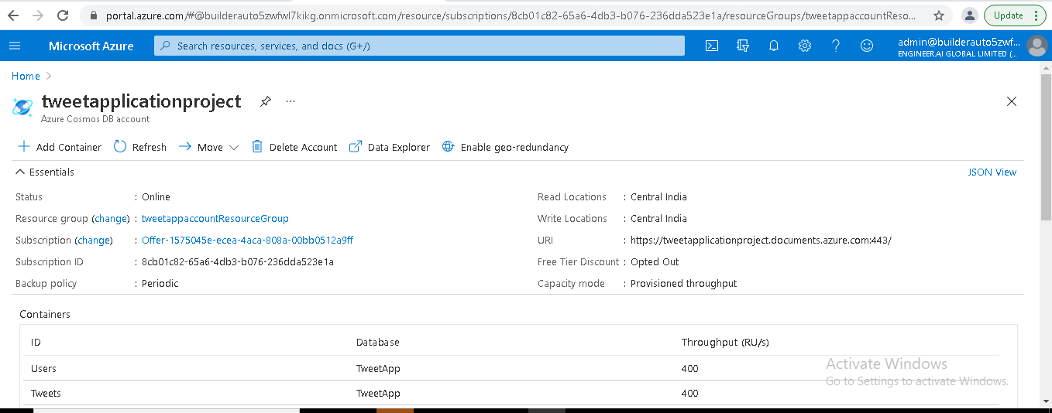

2.Created the instance for Api Management services in Azure portal.

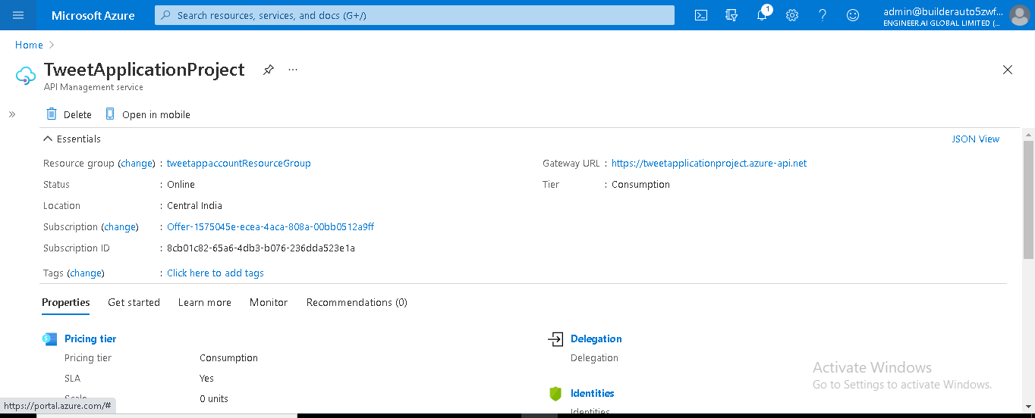

3.Created the instance for Azure App service in Azure portal.

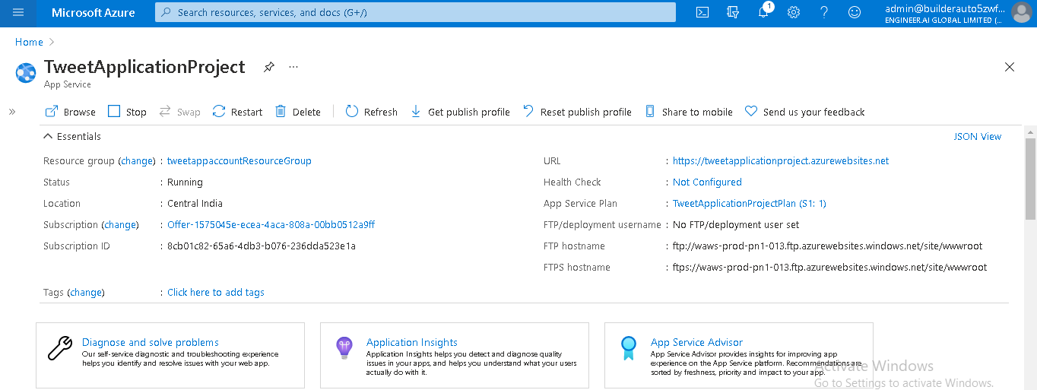

4. Deployed backend api to Azure Automation in Azure portal.

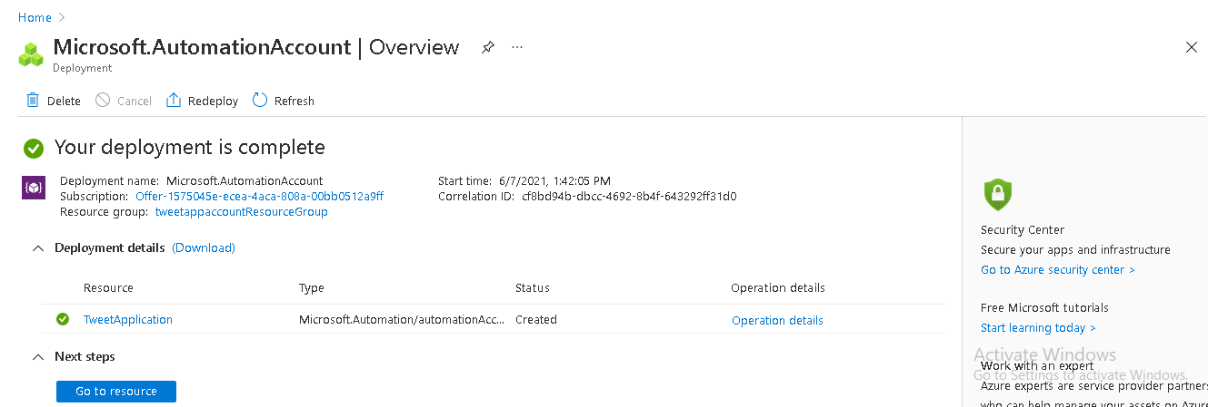

5.Created the Docker Image but not able to run image due local proxy errors

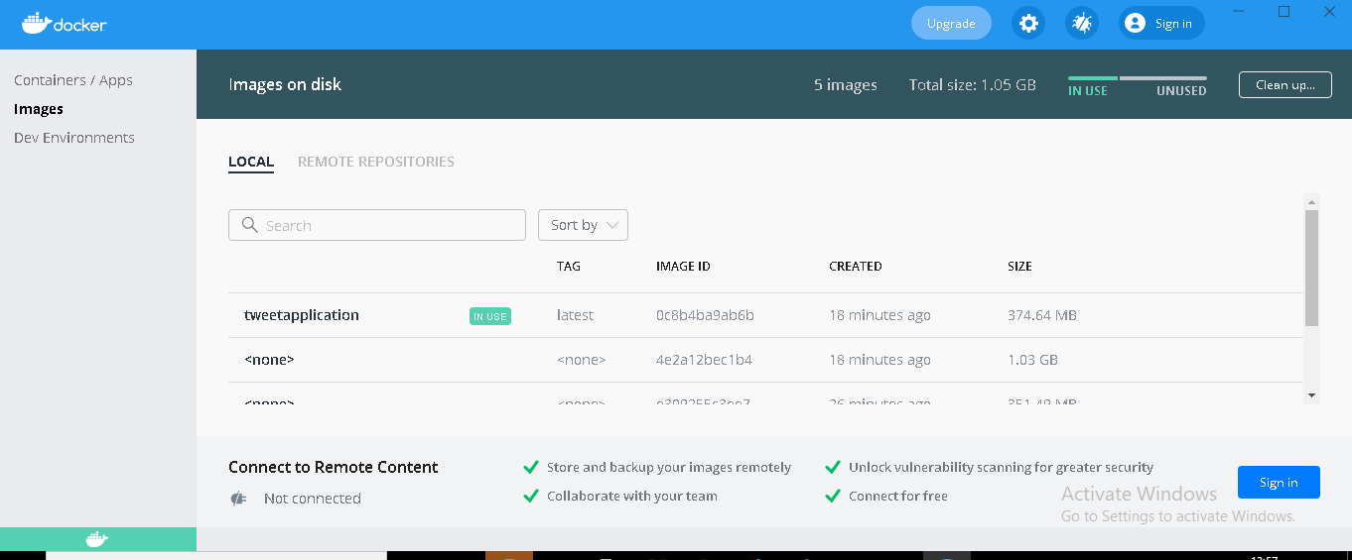

6. Deployed the Asp.net core web application into API management service instance with app service instance.

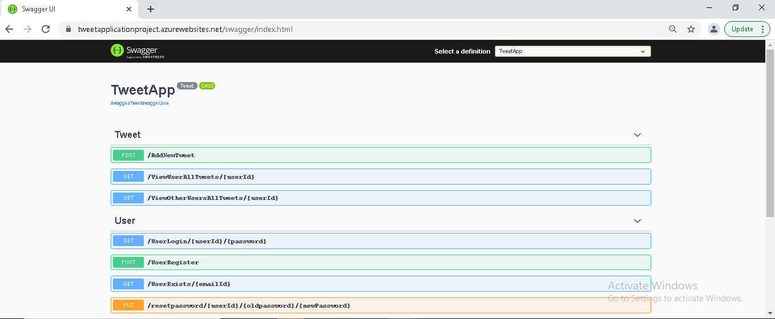

**Azure URL**: https://tweetapplicationproject.azurewebsites.net/swagger/index.html

I have changed the code so I have shared the github link along with this .Please have a look into it.

**GItHub link** : https://github.com/RoshniKrishnan7/TweetApp_Azure-CosmosDb/blob/main/TweetAppCaseStudy_Azure-CosmosDb.zip