Command Line Music Player

Design document
Date : <22/09/2019>

AllGo Embedded Systems Pvt Ltd

Version History
Version Number | Date | Author(s) | Remarks
0.1 | 07/08/2019 | Chandrala, Sidha | Initial version
0.2 | 21/08/2019 | Chandrala, Sidha | Added refrences, randomization section, changed API definition, sequence diagrams, traceability matrix

Table of Contents
1. Introduction 3
1.1. About the Project 3
1.2. References 3
1.3. Definitions, Acronyms & Abbreviations 3
1.4. Document Conventions 3
1.5. Intended Audience 3
2. Overview of the System 4
3. System Architecture 5
3.1. Terminal 5
3.2. Application 5
3.3. API 5
4. API definition 6
5. Use Case Diagram 8
6. Sequence Diagrams 9
6.1. Playback 9
6.2. Pause 9
6.3. Next 10
6.4. Pervious 11
6.5. Stop 12
6.6. Resume 13
6.7. Seek 14
6.8. Volume up 15
6.9. Volume Down 16
6.10. Error cases 17
7. State Diagram 18
8. Randomization 19
9. Interface 19
10. Assumptions and Limitations 19
11. Traceability 19

1. Introduction
This document explains the high level and low level design for the development of Command Line Music Player for induction training program at Allgo Embedded Systems.

1.1. About the Project
The purpose of this project is to develop a new music player with playback functionality. This music player will be capable of playing any WAVE file through command line, based on the platform and feature requirements as detailed in SRS document.

1.2. References
The list of reference documents / resources is given below:
- SOW
- SRS – SRS_CLIMP_V0.3.doc
- ALSA project - the C library reference - https://www.alsa-project.org/alsa-doc/alsa-lib/group___p_c_m___h_w___params.html#gaad4ba98b2f66baa5360b9a85f064a3e9
- Alsa Opensrc Org - https://alsa.opensrc.org/HowTo_Asynchronous_Playback
- Sequence Diagrams - http://plantuml.com/sequence-diagram

1.3. Definitions, Acronyms & Abbreviations

S.No. | Terms | Definitions
1 | WAVE | WAVE form Audio File
2 | OS | Operating System
3 | ALSA | Advanced Linux Sound Architecture
4 | PCM | Pulse Code Modulator

1.4. Document Conventions
A requirement or behaviour stated as 'shall' and 'must' is a mandatory feature, without which the product is deemed as 'not fulfilling' the requirements'.
A requirement or behaviour stated as 'should' is a 'nice-to-have' feature. Not implementing this is not a breach of requirements, however, all attempts shall be made to meet this in subsequent releases of the software.
A requirement or behaviour stated as 'may' is a low-priority' feature. Not implementing this is not a breach of requirements. Taking up such feature implantation is subject to prevailing terms and conditions at the specific situation.

1.5. Intended Audience
This document is intended for the Customer, Business team, Management, Developers, Integration engineers and Testers.

2. Overview of the System
The comand line music player is an audio player with only playback functonality. It shall take path of file or playlist name to be played. The display will show the name of current song being played along with meta data which is present in the file. The user can pause, resume, seek and stop currently playing song. User can also change current song using next and previous options. This product shall also feature option for changing the volume levels. The application shall also randomize the playlist on user choice.
The application should have forward and rewind option, along with an option to seek by 10 sec. It may also have an option for volume enhancement.

3. System Architecture
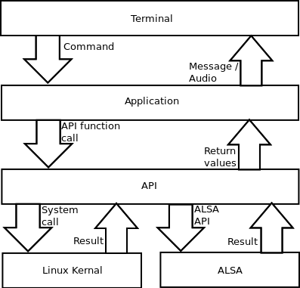

The above figure illustrates the working context of our music player.

3.1. Terminal
Terminal will be used by the user to start and interact with the application. Terminal here refers to linux bash.
- Input commands will be given to application layer to process further.
- Terminal will provide output to user depending on the return value from application layer.

3.2. Application
This is the central module which will directly interact with user and API module as well.
- This module will take user commands as input from terminal.
- This module will output either audio or some useful messages to the terminal.

3.3. API
API layer will contain all the modules which will interact with ALSA and linux kernal to provide all the mentioned features in SRS.

4. API definition
1. status cl_mp_play(char *acFilepath)
- Parameters
  - acFilepath path of the audio file.
- Returns
  - 0 on success otherwise a negative error code.
- Description
  - This function will start the playback.

2. status cl_mp_pause()
- Parameters
  - Does not take any parameter.
- Returns
  - 0 on success otherwise a negative error code.
- Description
  - This function will pause the playback.

3. char * cl_mp_next()
- Parameters
  - Does not take any parameter.
- Returns
  - file path of the next song on success otherwise a negative error code.
- Description
  - This function will play the next track.

4. char * cl_mp_prev()
- Parameters
  - Does not take any parameter
- Returns
  - file path of the previous song on success otherwise a negative error code.
- Description
  - This function will play the previous track.

5. status cl_mp_stop()
- Parameters
  - Does not take any parameter.
- Returns
  - 0 on success otherwise a negative error code
- Description
  - This function will stop the current playback.

6. status cl_mp_resume()
- Parameters
  - Does not take any parameter.
- Returns
  - 0 on success otherwise a negative error code
- Description
  - This function will resume the palyback.

7. status cl_mp_seek(char *acTime)
- Parameters
  - acTime time in HH:MM:SS format.
- Returns
  - 0 on success otherwise a negative error code
- Description
  - This function will jump to specific time of the current tack.

8. status cl_mp_vol_up()
- Parameters
  - Does not take any input.
- Returns
  - 0 on success otherwise a negative error code
- Description
  - This function will increase the volume.

9. status cl_mp_vol_down()
- Parameters
  - Does not take any parameter.
- Returns
  - 0 on success otherwise a negative error code
- Description
  - This function will decrease the volume.

5. Use Case Diagram
The figure below shows the various use cases of Command Line Music Player.
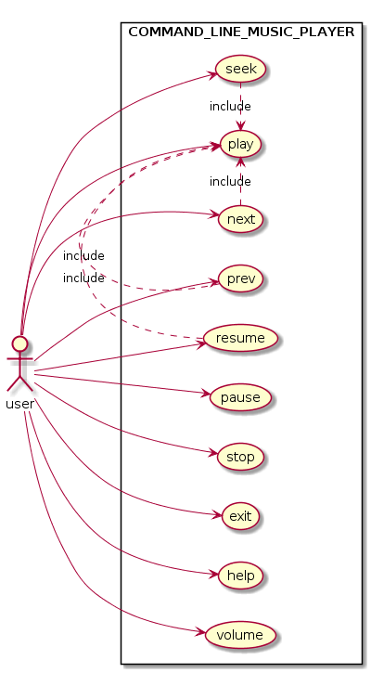

6. Sequence Diagrams

6.1. Playback
The following diagram shows the sequence of steps taken to start the playback.
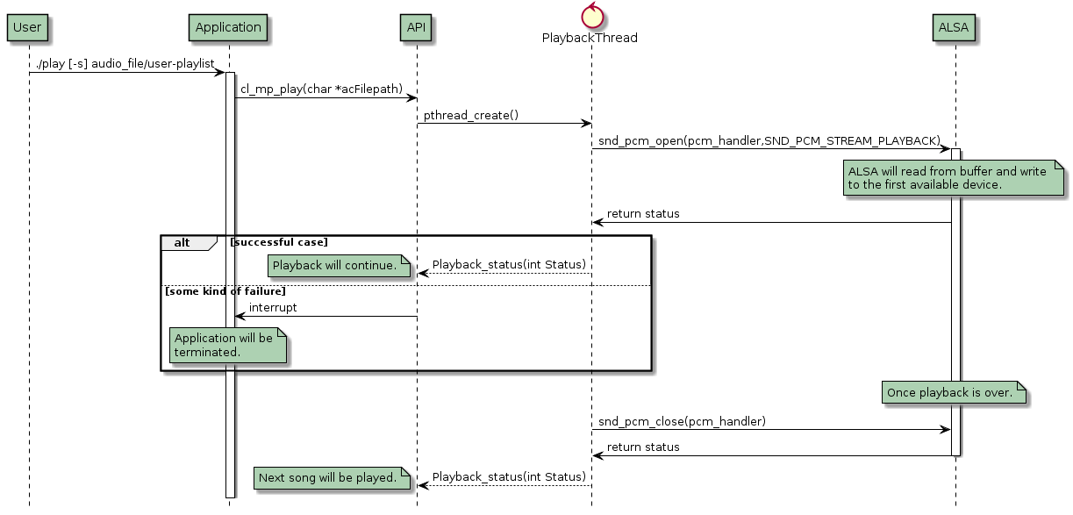

6.2. Pause
The following diagram shows the sequence of steps taken to pause the playback.
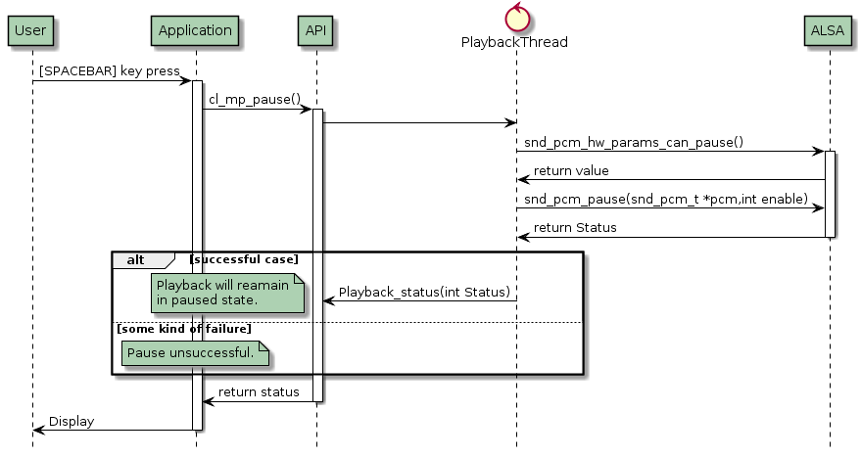

6.3. Next
The following diagram shows the sequence of steps taken to play the next song.

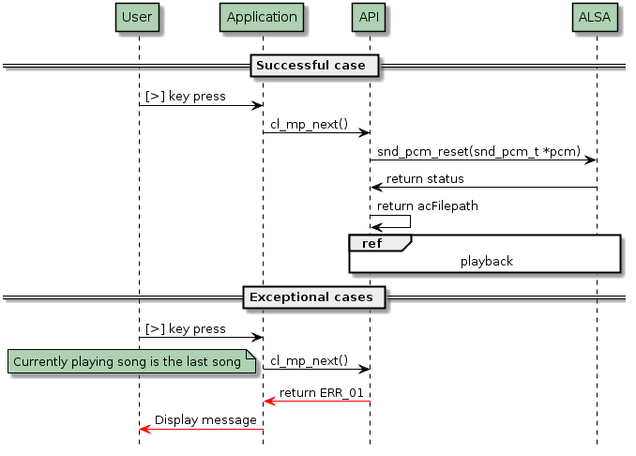

6.4. Pervious
The following diagram shows the sequence of steps taken to play the previous song.
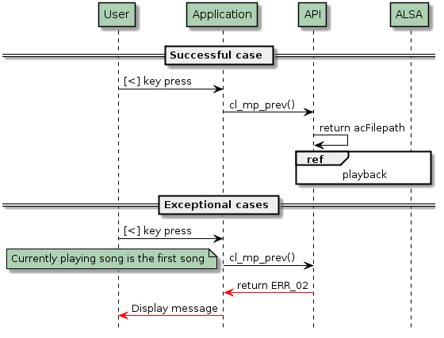

6.5. Stop
The following diagram shows the sequence of steps taken to stop the playback.
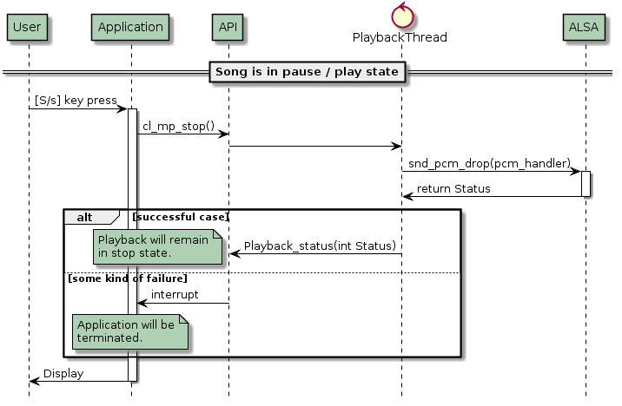

6.6. Resume
The following diagram shows the sequence of steps taken to resume the playback.
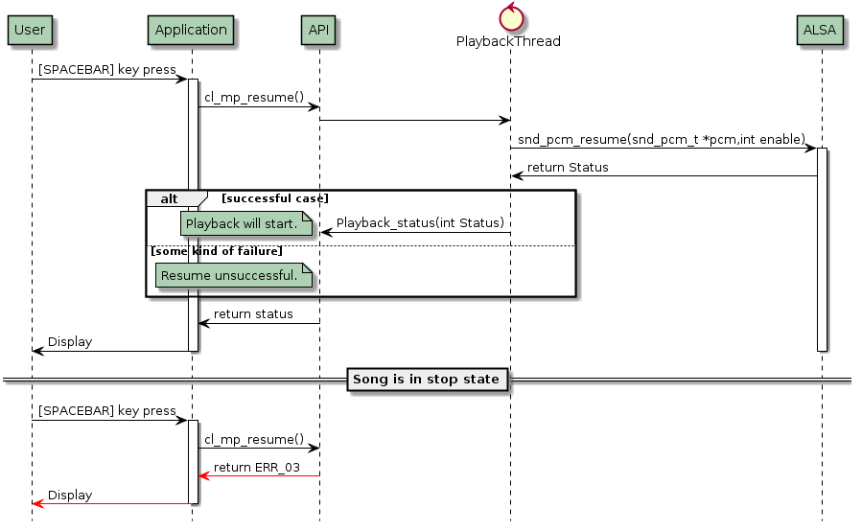

6.7. Seek
The following diagram shows the sequence of steps taken to perform seek operation.
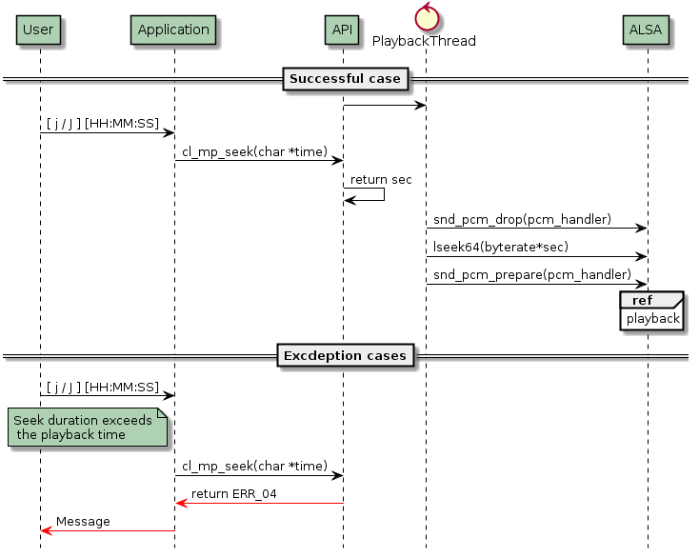

6.8. Volume up
The following diagram shows the sequence of steps taken to increase the volume.
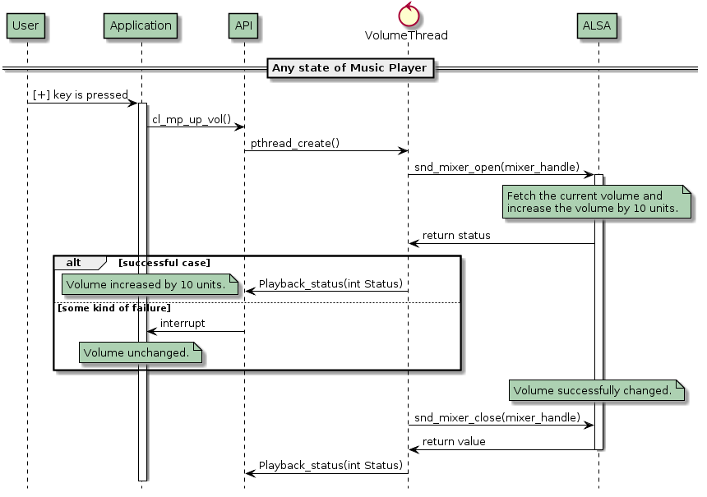

6.9. Volume Down
The following diagram shows the sequence of steps taken to decrease the volume.
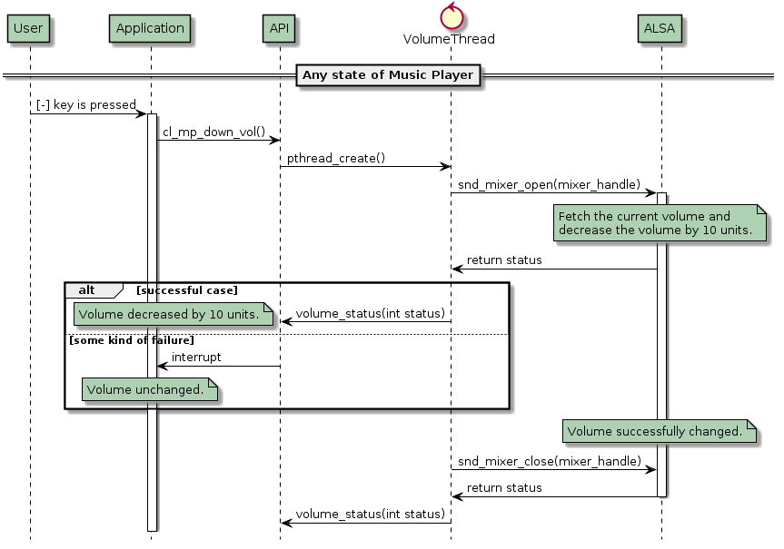

6.10. Error cases
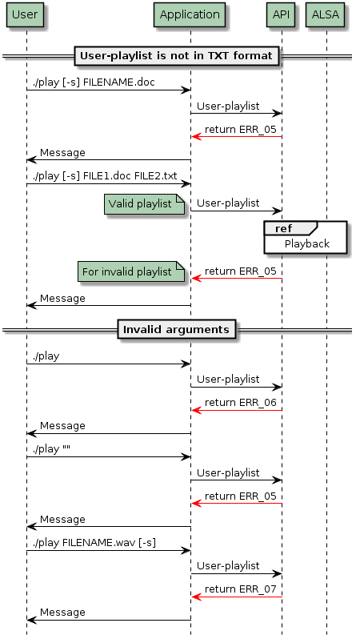

7. State Diagram
The state diagram below shows, only the valid trasition among different states.
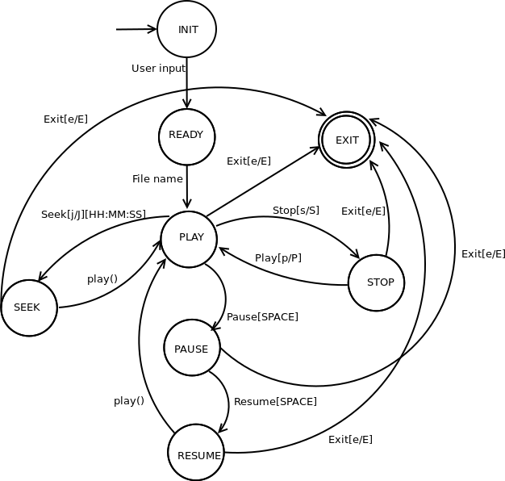

8. Randomization
aiPlaylistSongCount[argc-2] //Each element of this array keeps count of songs in a playlist and for audio file //keep count as 1
iTotalSong = sum(aiPlaylistSongCount) //This variable will keep sum of aiPlaylistSongCount
aiSongIndex[iTotalSong] //All elements of this array will have respective index number

//Use Fisher-Yates shuffle algorithm to shuffle aiSongIndex.

//To map the song name through aiSongIndex use below algorithm
iIndex = 0 iN = aiSongIndex[i]
while iN > 0 and iN > aiPlaylistSongCount[iIndex] :
iN -= aiPlaylistSongCount[iIndex]
iIndex++
//Go to the argv[iIndex+2] playlist and seek to the iN^{th} line.

9. Interface
Linux command line interface is being used as part of this project.

10. Assumptions and Limitations
- If there are same audio files present in two or more playlist then all the instances of songs will be played ( Songs will be repeated).
- In this document song is used as a general term to indicate any audio file in WAVE format.

11. Traceability
SNo | Requirment ID | Design Document Section | Status | Comments
1 | F_PL_MP_1 | DES_SEC_6.1
2 | F_PL_MP_2 | DES_SEC_6.1
3 | F_PL_MP_3 | DES_SEC_6.1
4 | F_PL_MP_4 | DES_SEC_6.1
5 | F_PL_MP_5 | DES_SEC_6.1, DES_SEC_8
6 | F_PL_MP_6 | DES_SEC_6.1, DES_SEC_8
7 | F_PL_MP_7 | DES_SEC_6.1
8 | F_PL_MP_8 | DES_SEC_6.1
9 | F_PL_MP_9 | DES_SEC_6.3
10 | F_PL_MP_10 | DES_SEC_6.3
11 | F_PL_MP_11 | DES_SEC_6.4
12 | F_PL_MP_12 | DES_SEC_6.4
13 | F_PL_MP_13 | DES_SEC_6.3
14 | F_PL_MP_14 | DES_SEC_6.4
15 | F_PL_MP_15 | DES_SEC_6.3
16 | F_PL_MP_16 | DES_SEC_6.4
17 | F_PL_MP_17 | DES_SEC_6.2
18 | F_PL_MP_18 | DES_SEC_7
19 | F_PL_MP_19 | DES_SEC_7
20 | F_PL_MP_21 | DES_SEC_6.6
21 | F_PL_MP_22 | DES_SEC_6.6
22 | F_PL_MP_23 | DES_SEC_6.7
23 | F_PL_MP_24 | DES_SEC_6.7
24 | F_PL_MP_25 | DES_SEC_6.5
25 | F_PL_MP_26 | DES_SEC_7
26 | F_PL_MP_27 | DES_SEC_7
27 | F_PL_MP_28 | DES_SEC_6.8
28 | F_AF_MP_1 | DES_SEC_6.1
29 | F_AF_MP_2 | DES_SEC_6.1
30 | F_AF_MP_3 | DES_SEC_6.1
31 | F_AF_MP_4 | DES_SEC_6.1
32 | F_AF_MP_5 | DES_SEC_6.1, DES_SEC_8
33 | F_AF_MP_6 | DES_SEC_6.1
34 | F_AF_MP_7 | DES_SEC_6.1
35 | F_AF_MP_8 | DES_SEC_6.1
36 | F_AF_MP_9 | DES_SEC_6.3
37 | F_AF_MP_10 | DES_SEC_6.3
38 | F_AF_MP_11 | DES_SEC_6.4
39 | F_AF_MP_12 | DES_SEC_6.4
40 | F_AF_MP_13 | DES_SEC_6.3
41 | F_AF_MP_14 | DES_SEC_6.4
42 | F_AF_MP_15 | DES_SEC_6.3
43 | F_AF_MP_16 | DES_SEC_6.4
44 | F_AF_MP_17 | DES_SEC_6.2
45 | F_AF_MP_18 | DES_SEC_7
46 | F_AF_MP_19 | DES_SEC_7
47 | F_AF_MP_21 | DES_SEC_6.6
48 | F_AF_MP_22 | DES_SEC_6.6
49 | F_AF_MP_23 | DES_SEC_6.7
50 | F_AF_MP_24 | DES_SEC_6.7
51 | F_AF_MP_25 | DES_SEC_6.5
52 | F_AF_MP_26 | DES_SEC_7
53 | MP_ERR_1 | DES_SEC_6.8
54 | MP_ERR_2 | DES_SEC_6.8
55 | MP_ERR_3 | DES_SEC_6.8
56 | MP_ERR_4 | DES_SEC_6.8
57 | MP_ERR_5 | DES_SEC_6.8
58 | MP_ERR_6 | DES_SEC_6.8
59 | MP_ERR_7 | DES_SEC_6.8
60 | MP_ERR_8 | DES_SEC_6.8
61 | MP_ERR_9 | DES_SEC_6.8
62 | MP_ERR_10 | DES_SEC_6.8

