Android RACE

Design document
Date : <03/27/2018>

AllGo Embedded Systems Pvt Ltd

Version History
Version Number | Date | Author(s) | Remarks
0.1 | 27/3/2018 | Ashutosh S | Initial version
0.2 | 30/5/2018 | Shrivatsa Hande | Updated for new architecture.  Added sequence diagram for conn/disconnection case.

Table of Contents

Table of Contents 3
2. System Overview 4
3. System Architecture 5
6. Modules Design 9

Introduction

Purpose
This design document is for porting RACE 2.0 components to Android O automotive version and leveraging the production quality stack running on Linux. This document also covers RACE integration with CarPlay on USB and WiFi. The intended audience of this document is the RACE Android and Linux teams.

Scope
This document provides the overall picture of the Android components, native and Java for this porting. This document does not go into implementation details of any new modules or the reused RACE 2.0 Linux modules. Detailed design of each component is not in scope of this document.

1.3 Overview
This document first shows the high level component diagram showing interaction between each. Next sections will describe functionality of each component.

1.4 Reference
MediaService API chm
DeviceManager API chm
Android RACE SRS document

1.5 Definitions and Acronyms

Acronyms | Definition
MTP | Media Transfer Protocol
RACE | Robust automotive something
iAP | iPod accessory protocol
USB | Universal serial bus

System Overview
From RACE 2.0 Linux stack, we will be reusing the MediaService module which talks to RACE library and device manager service. OSAL for RACE will be reused from an earlier device manager port on Android for iPod support which was used in production programs like Coagent.

This project will cover only the iPod and MTP features from RACE, as USB support is already present in Android. From RACE 2.0, MediaService module will be used as it is with a Java interface. Same is applicable for the device manager, API sections for MirroringControl and AppControl.
From Android, CarUsbHandler will be the entry point of device detection for iPod, MTP and CarPlay. CarPlay application will be reused from the CarPlay Android product stack.

System Architecture

Architectural Design
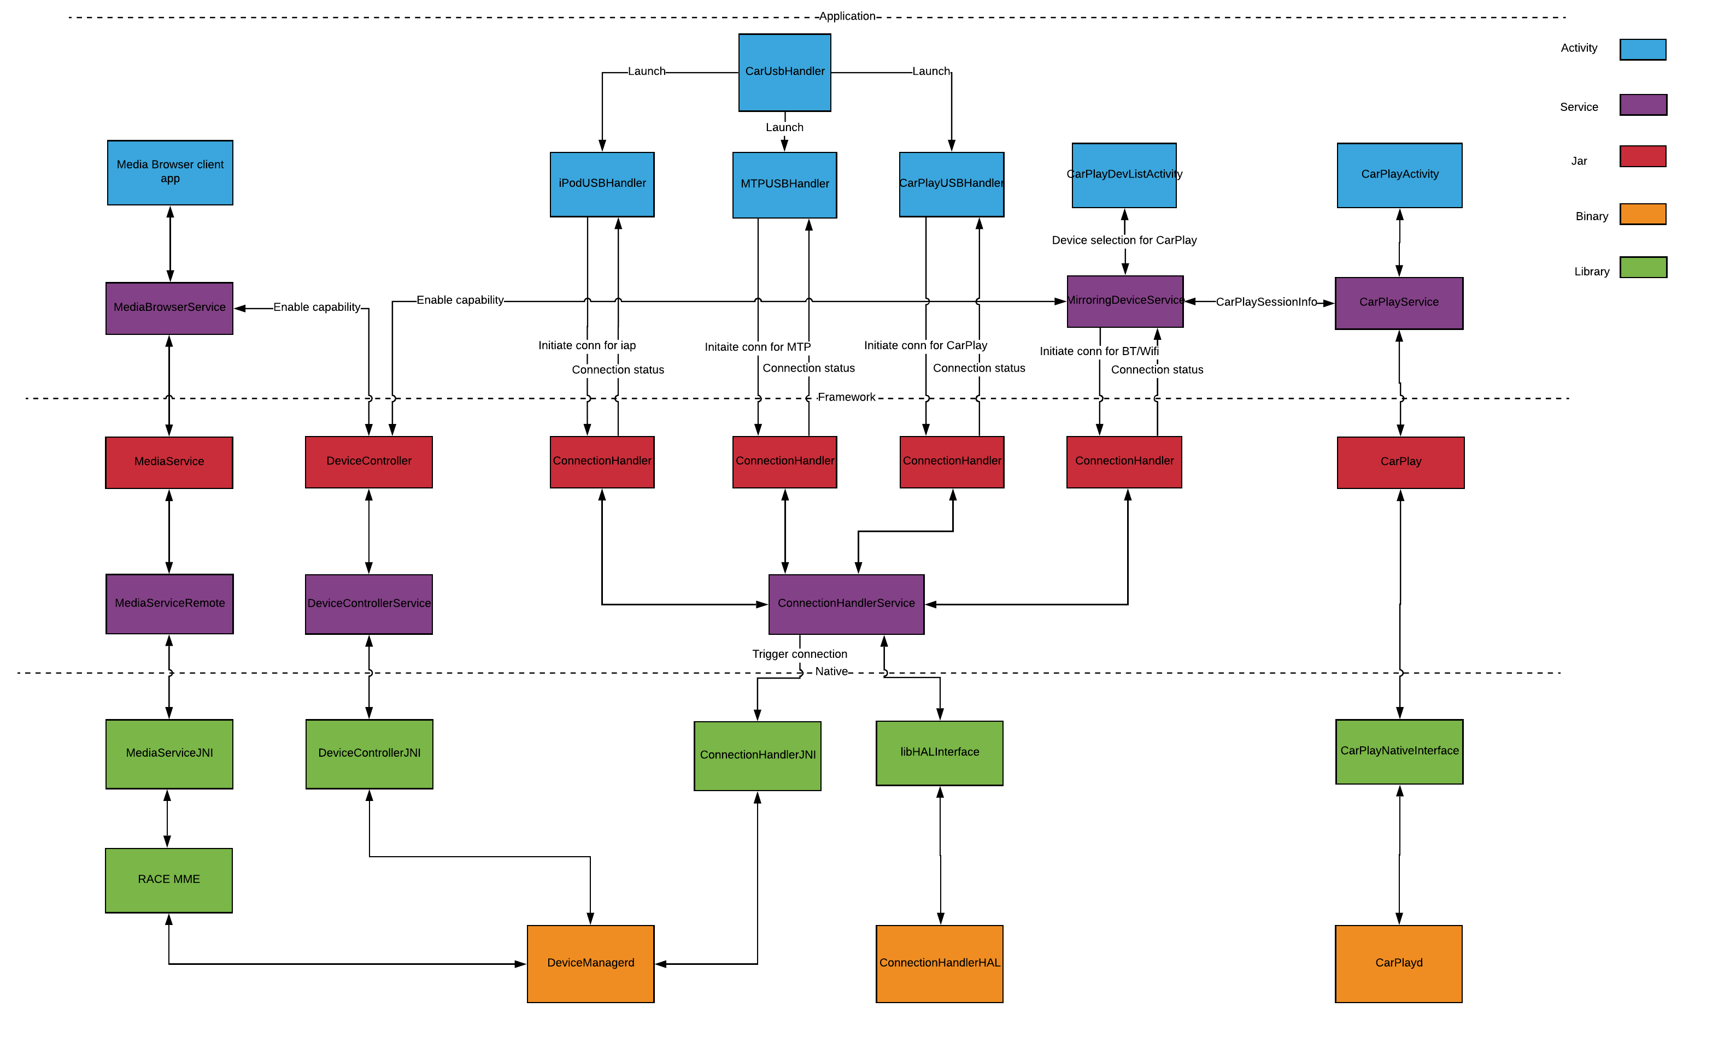

Component Design

CarUsbHandler
CarUsbHandler will be used without any change to avoid any compatibility issues later when this module is converted to service approach in Android P. Each device handling will be handled in separate activity so that each feature is independent of each other. Eg. iPod activity should not depend on CarPlay and vice versa. Car media application will be duplicated for iPod and MTP playback. But as there are cases where the actual application should not start automatically, like requirement 8 above, so any device related activity should be handled in a smaller, GUI less activity.

ConnectionHandler
ConnectionHandler will be used by handler application to initiate logical connection with specified device. Once application detects device connection in case of Usb device or device availability in case of Bluetooth device it will use connection handler to initiate connection with that device for specific protocol.

ConnectionHandlerHAL
- Hardware specific preveledged native service started from init.rc.
- Device specific operations like roleswitch, network activations are handled here.

iPodUSBHandler
- This will be no GUI activity on the lines of CarUsbHandler.
- It will have device_filter.xml file with all iPod/iPad/iPhone model vendor/product id pairs. So that it is triggered for all Apple device connections from CarUsbHandler.
- It will initiate connection with iPod in device mode.

MTPUSBHandler
- This will be no GUI activity on the lines of CarUsbHandler.
- It will have device_filter.xml file with all MTP model vendor/product id pairs, protocol, subprotocols so that it is triggered for all MTP device connections from CarUsbHandler.
- It will initiate connection with device to operate for MTP mode.

CarPlayUSBHandler
- This will be no GUI activity on the lines of CarUsbHandler.
- It will have device_filter.xml file with all the iPhone 5 and onwards vendor/product id pairs. So that it is triggered for all iPhone connections from CarUsbHandler.
- First check if CarPlay is supported on this device. If not then it means restriction is enabled, so pass it on to iPodUSBHandler to start it as iPod.
- Else initaiteConnection in UsbHost mode (Roleswitch mode). USB roleswitch will be triggered here with CarPlay mode.

devicemanager
- This is the RACE device manager service.
- Platform independent core device manager module.

DeviceController
- Should monitor for device control events.
- Must Provide java interface for application to perform device control operations like enabling/disabling perticular capabilities on specific transport.
- Will be delivered as java archive (.jar).

RACE-MME
- This is the RACE multimedia engine.
- Will handle media playback, metadata browsing.

MediaService
- This is the RACE 2.0 java library.
- Will provide high level java interface to application for media playback, metadata browsing.
- Will provide callbacks for media device connection status, playback state, track updates.

MediaBrowserClient App
- This is the client HMI App which binds to MediaBrowserService.

CarPlayService
- This will be pure CarPlay app which has service component and starts at device bootup.
- Will listen for ControlClient events and maintains list of ControlClients connected, state of ControlClient, and handles resource management like app focus, audio focus, screen focus etc.
- Activities will bind with it to start/stop CarPlay session with specific Control client.

MirroringDeviceService
- This will be a service which starts after bootup.
- Detects any USB CarPlay device detection from device controller service.
- Will use ConnectionHandler to initaiate connection for BT/WIFI devices in CarPlay Mode.
- Talks to CarPlay app service to get CarPlay and session related parameters.
- This service will control if the session should start automatically when connected/detected. If there is a session already running, then it should not start a new one.
- Handles the last known and running device in BT or USB mode. Once a first time USB CP is connected, it will be started from this service by starting CarPlay App.
- If a new CP device comes up and wireless CP is already running then it will not start CarPlay app.
- OOBBT pairing will also be handled by this service.

DeviceListActivity
- This is a demo application to show all the CarPlay devices including BT and USB. Ideally this should be part of settings menu.
- This uses CarPlayDeviceService and CarPlayService to get a list of all CarPlay devices and ControlClients,
- It will start CarPlay session on User action.
- User should be able to select different device to start CarPlay session.
- This App can be skipped for USB CarPlay.

MirroringControl
- This service will provide the Java interface to the application for Mirroring control operations. This is a service so that all the device interaction are serialized using this service.
- This may not be require to be Java service as the underlying device manager is already a native service.
- Will provides features like communication updates, location data, vehicle data in case of iPod device.

Design Rationale/ decisions and tradeoffs

Using MediaBrowserService
MediaBrowserService is the standard way of handling all media devices in Android. This is a media agnostic interface which can handle 3rd party application as well.

Modifying CarUsbHandler vs no change
CarUsbHandler can be overridden from Android config.xml with our own module. One approach is to modify CarUsbHandler to add features of USB roleswitch, adding device type of CarPlay, iPod in its database, device filtering based on port ID (OTG-Port in case of CarPlay devices) etc. This will streamline USB handling in a single module.
Disadvantage is that this will mean relying on the CarUsbHandler module and keeping it updated with future updates. There was a roadmap item of converting this module as a service which will mean that we will have to redo this module in Android P.
One part of the Android architecture which is fixed is that a specific application with USB id will be started by this module so we have finalized on the current approach.

Same MediaBrowserService for MTP and iPod vs separate
MediaBrowserService for MTP and iPod will be more or less same as both of them will be using MediaService API for implementation but it is better to keep it separate as only one MediaBrowserService can be started in one package and also we should keep it separate in case customer is only interested in iPod or MTP.

- Design

4.1 Control Flow

CarPlay USB connection
Initiate connection to iPhone with CarPlay Mode.
If connection is success launch CarPlay App.
If connection is failure may be because of CarPlay is disabled from iPhone side, then diapatch the USB_ATTACHED intent to IPodHandlerApp to activate in IAP mode.

MTP connection
Initiate connection to iPhone with MTP Mode.
If connection is success launch MTP Media App.

iPod connection
Initiate connection to iPhone with IAP Mode.
If connection is success launch IAP Media App.

Following sequence diagram shows the control sequence for connection/disconnection case.

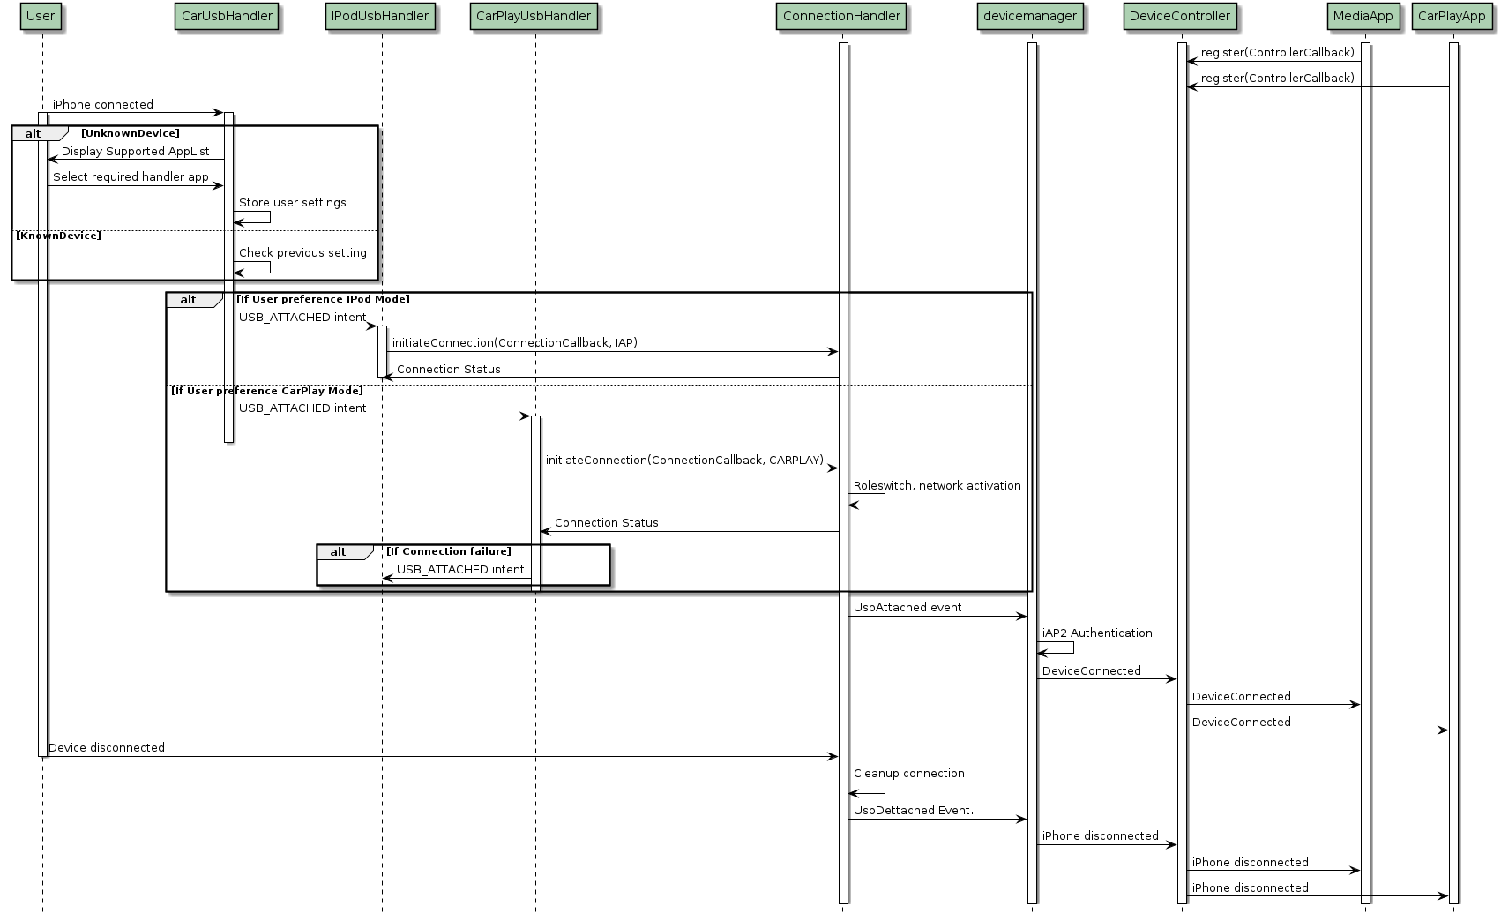

6. Modules Design
- Low Level Design
7.1 Object Design
What are structure, what is relation between objects, where are it stored
7.2 Pseduocode for components
Pseudo code is not an actual programming language. It uses short phrases to write code for programs before you actually create it in a specific language. It is to ensure that programmers understand a software project's requirements and align code accordingly.
<Flow of code >
7.3 Implementation and changes
Changes in file and implementation detail
- Interfaces
Chm file and any other interfaces
- Human Interface Design
  - Overview of Interface
Describe the functionality of the system from the user’s perspective. Explain how the user will be able to use the system to complete all the expected features and the feedback information that will be displayed by the user.
  - Screen Images
Display screen shots showing the interface from the user’s perspective.
  - Screen Objects and Actions
Discussion of screen objects and actions associated with those objects

- Requirements Matrix
Provide a cross reference that traces components and data structures to the requirements in your SRS document.
Use a tabular format to show which system components satisfy each of the functional requirements from the SRS. Refer to the Functional requirements by the numbers/ codes (Tags) that is given in the SRS.
- Appendices
To provide supporting or reference details that could aid in the understanding of the Design document.
List of reference readings:
- IEEE Std 1016-1998
- IEEE Recommended Practice for Software Design Descriptions.

