**Make test cases to cover the row named “numbers of items” (4 test cases)**

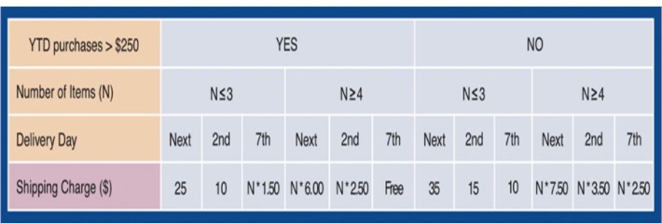

**Test Case 1**

Check if the right shipping charge is calculated when the number of chosen items are equal to 3 with total costs > 250

1. Choose 3 items you want to buy, which total costs are >250
2. Choose delivery day - Next

Expected result: The calculated delivery charge should be 25$.

Suite: purchase items

Type: positive

**Test Case 2**

Check if the right shipping charge is calculated when the number of chosen items are equal to 4 with total costs > 250

1. Choose 4 items you want to buy which total costs are >250
2. Choose delivery day – 7th

Expected result: The delivery should be FREE of charge (equal to 0)

Suite: purchase items

Type: negative

**Test Case 3**

Check if the right shipping charge is calculated when the number of chosen items are equal to 3 with total costs < 250

1. Choose 3 items you want to buy which total costs are < 250
2. Choose delivery day – 7th

Expected result: The calculated delivery charge should be 10$.

Suite: purchase items

Type: negative

**Test Case 4**

Check if the right shipping charge is calculated when the number of chosen items are equal to 4 with total costs < 250

1. Choose 4 items you want to buy which total costs are < 250
2. Choose delivery day – 2th

Expected result: The calculated delivery charge should be 4*3.50$, which in total is 14$

Suite: purchase items