Members: Daniil Blagoev, Jakub Jelínek, Rositsa Nikolova, Rens van den Elzen

11/5/2022

Process Report

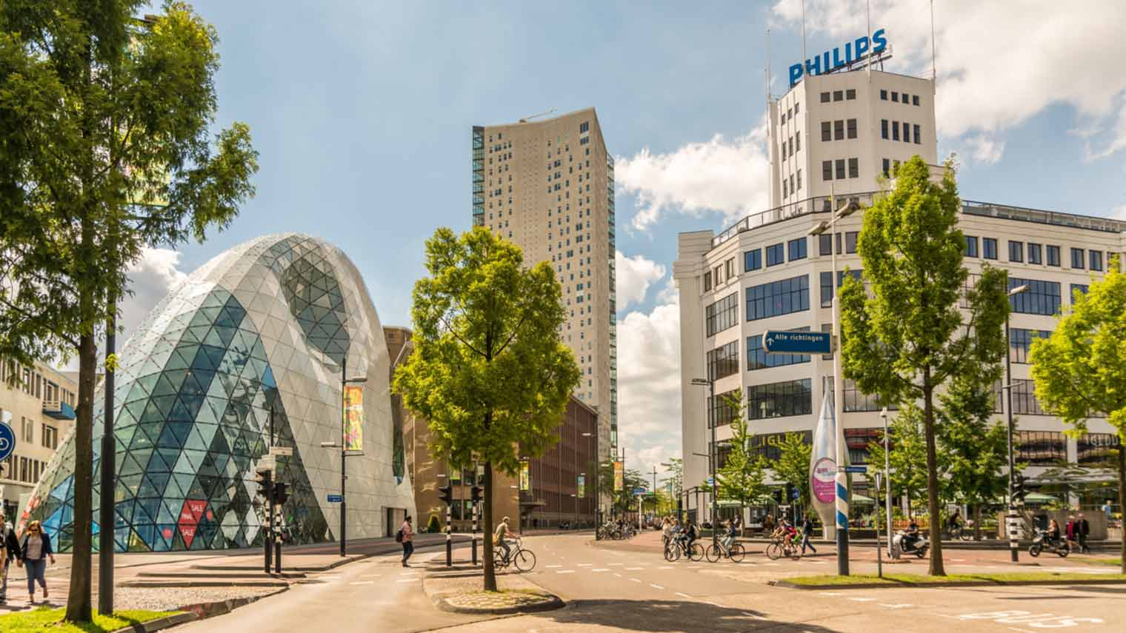

Location: Eindhoven

Tutor: Michiel Koehorst

Location: Eindhoven

Note: i1, i2, i3 and i4 are mentioned across this document- they stand for iteration 1, iteration 2, iteration 3 and iteration 4 respectively.

Work division

Work division is one of the most important aspects of making a project idea and plan come into fruition. Assigning tasks in such a way that group members don’t feel like the workload is unfair and uneven is a big part of it. The tool which helped us with this was Jira. Here is a small snippet of what that looked like:

We did not have a person who directly handed out tasks to whoever they wanted, instead, everyone could choose what they would like to do most of the time.

## Personal reflection

#### Daniil

(i1) In my personal opinion, the project has been going pretty well. Sometimes it felt like there were mountains of work to be done but we managed to get through those points of struggle. The teamwork was on point, everyone in the team was open to new ideas and I feel like our coordination was spot on. Working with Rens, Jakub and Rositsa was not only a productive, but a fun experience as well. At times it seemed like we were struggling to keep up with the pace of the program, because of having to work on 2 projects at once, but I feel like we covered what we learned in class the past weeks well. Everyone put in a lot of effort, and I am proud of my teammates and what we managed to create for the time we had.

(i2) Work has been going according to plan, no complaints to be made. The process-peer reviews we made were pretty much on the same page, which is a good sign, it shows that we are all aware of what is happening and how things are going.

(i3) Iteration 3 turned out very well. We managed to finish all of the customer’s requests once again. I am very happy with how it turned out and I very much appreciate the effort my teammates are putting in, especially Rositsa for the automated schedule. The finish line is close and I am fairly certain that our final product will not disappoint.

(i4) The fourth and final iteration was a success in my eyes, as were the rest of them. Some finishing touches to the product were done and the final result is decent for first year students I’d say. There were some last-minute requirements which came as a surprise to us but we managed to implement the important ones on time.

#### Rositsa

(i1) In my point of view this phase of the project was a challenge. All of us did not have prior experience with developing a software system for a client in so short period of time but I think, we managed to do well and covered all the basic requirements. The most important part of such projects is the communication – with the client and between the team members. In my opinion, we showed very good level of communication skills and understanding of the requirements. We followed strictly the guidance of our tutor and implemented the feedback after every meeting. Due to our weekly meetings we managed to further develop our hard and soft skills. I believe, our team is very united, and we decide everything together. Everyone had the opportunity to shine with his best qualities but also to step out of his conform zone and learn a lot. There was a room for discussion, everyone's ideas were considered. We managed to deal with huge amounts of work for short period of time and I am proud of that. Something that can be improved is splitting the time for the tasks better – more time for developing.

(i2) After successfully delivering a working software solution with all the requirements that we promised for iteration 1, for iteration 2 we had to add some additional functionalities and create new ones from the begging. The workload was big because the new requirements were a lot and more advanced. We choose a nice approach because we split the tasks equally and it was possible for everyone to work quite separately on it without depending on the others. We went the extra mile because we implemented features which were quite advanced, fully working and we met the deadline. We are becoming better with planning, and we also realized how important the good design of the software is and how easily can be extended and changed later if needed.

(i3) I think for this iteration we had more requirements than the other iterations which was a bit challenging for us. We split the tasks considering everyone's strong sides and preferences which was a nice approach because everyone enjoyed doing his part. We also decided to have a second meeting with the client to clarify certain details regarding scanning of products and automated scheduling which were not fully clear after the first meeting. This was extremely helpful for us because we made sure that we are on the same page with the client and can deliver exactly what she expected from us. Being aligned with our teammates was very important for this stage because what someone has implemented directly affected others code and logic (me and Jakub). In my opinion, we did very well with this part, and everything went smoothly. I think not only our skills and hard work helped us deliver what we promised but also the level of our teamwork and how we solve everything together.

(i4) For the last iteration we had some new requirements that we did not expect but we managed to finish the new functionalities on time. Also, we had to make some changes to the already implemented features, update all documents, redo the UI in the desktop application and 'deploy' the app which was quite a lot of work. I believe at this point we have very good communication and organization in our team, so we managed to finish everything. Everyone was proactive and did his part, so I am proud of my teammates, and I believe that client will be happy with the final product.

#### Jakub

(i1) From my personal view we have done lot of work. This project was not just about finishing or creating software solution for client, but also about team collaboration, problem solving and time management. I must confess that it was not easy 5 weeks, however it had strengthened our mind and showed us how the real-life projects look like. This whole project was so far very contributively for me, it has really widened my tunnel view in project management area which I am grateful for. It is very good experience, and I honestly could not wish for better team.

(i2). With the passing time and new features that needed to be implemented, this iteration was pretty hard. We have done a lot of work, and I can say that it could have been much harder if we did not keen on having clean code. Since we tried to keep the code simple and refactored, implementation was manageable. Thanks to process peer review, our team discussed things that would not normally be told, everyone took something from it, and I feel that some things have changed.

(i3) With iteration 3, we came across the hardest challenges. From implementing the automated schedule to implementing barcode and scanning. I would say this iteration taught me the most and specially I learned a lot of new stuff, that I can further implement. Our teamwork was good, immediately after the first meeting, our team divided the tasks so there would be no confusion, meaning, who does what and potential time waste. We have finished and implemented all the requirements that our client gave us and therefore I am proud of our work. Working in this team brings a lot of experience, even though our cultural diversity triangle is not that distinct.

(i4). Last iteration was the most challenging one. Time planning and finishing up the project was hard and time consuming. We also got few new functional requirements that needed to be done, which we did not expect. However, everything has been finished. Our teamwork and effort stayed on high level I would say. Everyone was quite active and what was promised was finished/done.

#### Rens

(i1) The development of the project went fairly well in my opinion, teamwork went pretty fluent, and the work was divided equally. I did at times feel like I was fixated on a specific part of the code to solve an error only to later find out that the problem was somewhere else entirely. On other times I felt like I saved the day when git started acting up. All in all a job well done.

(i2) work got divided fairly, we all just picked what we wanted to work on. If anybody was struggling with something someone else assisted with it. I remember that we were struggling with a specific issue for weeks, then someone said something that gave me an idea on how to solve it. That idea didn't work but it led me to finding the solution to that problem. It was also nice to see that we all thought the same of each other performance during the peer process review.

(i3) the clients request we're successfully implemented, process went swimmingly. Not a lot to complain about in my case. But I did feel a bit overwhelmed with other projects that needed to be done. But still all the work went by just fine.

(i4) this iteration was just a few minor changes. Not sure if there is much to say about it. The only real problem was thinking about having enough time add a certain feature to implement. We decided that we didn't have enough time for it. Other than that, we added the minor changes that have been requested that we knew we had enough time for.

## Reflection about applying Waterfall

#### Strengths

The strengths of the Waterfall method are in its definitive planning and outlining of processes that need to be done in order to complete the project. Pretty much everything is planned from beginning to end in it. It provides a clear plan and sequence of actions.

#### Weaknesses

The main weakness of the Waterfall method is the lack of flexibility in the development process. Since everything is planned beforehand, it may be problematic if an external event calls for a change of course during development. Another problem is that sometimes clients cannot clearly turn their needs into functional requirements, and it gets left up to the team to kind of guess exactly what needs to be done.

## Reflection about applying Agile

#### Strengths

The strengths of the Agile method are that it is quite a bit more flexible than the Waterfall, we have something to show the customer more often and there is more communication between the team and the customer.

#### Weaknesses

The weaknesses of the Agile method are that it is harder to predict the future of the application, since planning is done for shorter periods of time and the updating of the documentation takes up a decent chunk of time from each iteration.