Members: Daniil Blagoev, Jakub Jelínek, Rositsa nikolova, Rens van den Elzen

2/16/2022

URS Document



Tutor: Michiel Koehorst

Location: Eindhoven

Contents

Agreement with client 1

Functional requirements 1

App 1

Use cases 2

Wireframes 5

Administrator 5

Manager 7

Worker 8

## Agreement with client

We are going to deliver intermediate version of the system in week 6. We agreed for the first six weeks to focus on the employee management part of the application because this is the main priority for the company. We are also going to show the URS document and double check if all requirements are met also if there are any changes to be done before the implementation. During the process, in week 5 we are going to schedule a short meeting to show what we have done so far and if the client is happy with the user interface and functionalities. In week 6 we are adding the final touch and presenting the intermediate version.

## Functional requirements

### App

**Admin**

* AFR-01: Admins should be able to create an employee
* AFR-02: Admins should be able to deactivate an employee
  + By deactivating an employee due to an employee terminating their contract for any reason, the employee’s data is not removed from the database, but employee cannot log in into the system
* AFR-03: Admins should be able to delete an employee
  + Employee will be deleted 2 years after their deactivation and the employee’s data will be removed from the database
* AFR-04: Admins should be able to update an employee's information
* The email, password, contract type, wage and position are updatable
* AFR-05: Admins should be able to see statistics
  + The statistics will only be about employees for the first release
  + Statistics: average salary, number of employees, employee retention rate
* AFR-06: Admins should be able to see all the shift schedules
* AFR-07: Admins should be able to assign an employee to a shift
* AFR-08: Admins should be able to remove employees from a shift
* AFR-09: Admins should be able to see an overview of all employees
* AFR-10: Admin should be able to search for an employee

**Manager**

* MFR-01: Managers should be able to see all statistics
  + The statistics will only be about employees for the first release
  + Same statistics as admin
* MFR-02: Managers should be able to see all the shift schedules
* MFR-03: Managers should be able to see an overview of all employees
* MFR-04: Manager should be able to search for an employee

**Employee**

* EFR-01: Employees should be able to see their own shift schedule

## Use cases

Use case diagram

**UC-01:**

**Use case: Create an employee**

**Actor: Admin**

**Main Success Scenario:**

1. Admin goes to create a new employee
2. System requests for the required fields to be filled in
3. Admin fills in the information fields and confirms
4. System confirms the employee has been added successfully

**Extensions:**

3a: There are empty information fields

.1: System displays an empty information field error message

.2: Return to MSS step 2

4a: The employee already exists

.1: System displays an error message stating that an employee with such information already exists

.2: Return to MSS step 2

3b: Some of the filled information is not valid

.1: System displays an error message stating that some of the filled information is not valid

.2: Return to MSS step 2

**UC-02:**

**Use case: Deactivate an employee**

**Actor: Admin**

**Main Success Scenario:**

1. Admin goes to the list of employees
2. System shows the list of employees
3. Admin selects an employee and confirms
4. System marks the employee as inactive, and they can no longer login into the system

**Extensions:**

3a: An employee is not selected

.1: System displays an error message stating an employee was not selected

.2: Return to MSS step 2

**UC-03:**

**Use case: Delete employee**

**Actor: Admin**

**Main Success Scenario:**

1. Admin goes to see the list employees
2. System shows the list of employees
3. Admin selects an employee to be delete
4. System deletes the selected employee and removes their data from the database

**Extensions:**

3a: An employee is not selected

.1: System displays an error message stating an employee was not selected

.2: Return to MSS step 2

**UC-04:**

**Use case: Assign an employee to a shift**

**Actor: Admin**

**Main Success Scenario:**

1. Admin goes to assign an employee to a shift
2. System requests a day to be selected
3. Admin selects a day
4. System requests the morning, mid-day or evening shift to be selected
5. Admin selects one of the three shifts
6. System requests the user to select an employee to be assigned to the selected shift
7. Admin selects the employee they want
8. System confirms the employee has successfully been assigned to the shift

**Extensions:**

5a: A shift is not selected

.1: System displays an error message

.2: Return to MSS step 4

7a: An employee is not selected

.1: System displays an error message

.2: Return to MSS step 6

8a: The employee already has 2 shifts for the day

.1: System displays an error message

.2: Return to MSS step 6

5b: There are 10 employees assigned to the selected shift

.1: System displays an error message

.2: Return to MSS step 4

**UC-05:**

**Use case: Remove an employee from a shift**

**Actor: Admin**

**Main Success Scenario:**

1. Admin goes to remove an employee from a shift
2. System requests a day to be selected
3. Admin selects a day
4. System requests a shift to be selected
5. Admin selects a shift
6. System shows the assigned employees in the selected shift
7. Admin selects an employee
8. System removes the selected employee from the shift

**Extensions:**

5a: A shift is not selected

.1: System displays an error message

.2: Return to MSS step 4

7a: An employee is not selected

.1: System displays an error message

.2: Return to MSS step 6

**UC-06:**

**Use case: Update information for employee**

**Actor: Admin**

**Main Success Scenario:**

1. Admin goes to update information about employee
2. System shows the fields that can be edited
3. Admin edits the information about employee
4. System confirms the employee's information has been updated successfully

**Extensions:**

3a: There are empty information fields

.1: System displays an empty information field error message

.2: Return to MSS step 2

3b: Some of the filled information is not valid

.1: System displays an error message stating that some of the filled information is not valid

.2: Return to MSS step 2

**UC-07:**

**Use case: View statistics of the shop**

**Actor: Admin/Manager**

**Main Success Scenario:**

1. Admin/Manager goes to see the statistics
2. System shows the statistics

**UC-08:**

**Use case: Displaying schedule**

**Actor: Admin/Manager**

**Main Success Scenario:**

1. Admin/Manager goes to see the schedule
2. System shows the schedule for all employees

**UC-09:**

**Use case: Displaying an overview of all employees**

**Actor: Admin/Manager**

**Main Success Scenario:**

1. Admin/Manager goes to see an overview of all employees
2. System shows the overview

**UC-10:**

**Use case: Searching for employee by name**

**Actor: Admin/Manager**

**Main Success Scenario:**

1. Admin/Manager enters an employee’s name in the search bar
2. System displays information about employee(s) with a matching name

**Extensions:**

1a: Employee is not found

.1: System displays a massage stating there is no such employee

.2: Return to MSS step 1

**UC-11:**

**Use case: Displaying schedule for employee**

**Actor: Employee**

**Main Success Scenario:**

1. Employee goes to see their schedule
2. System shows their own schedule

## Wireframes

#### Log In

* + - Graphical user interface

      Description automatically generatedUser Authentication via email and password

### Administrator

#### Administrator – main page

* + - After logging in as administrator, this page will show up
    - Administrators have the options to:
      * Click on one of the three buttons on the left side of the page (redirects them to the selected page)
      * See and filter a list of all employees (filter by nationality, type of contract)

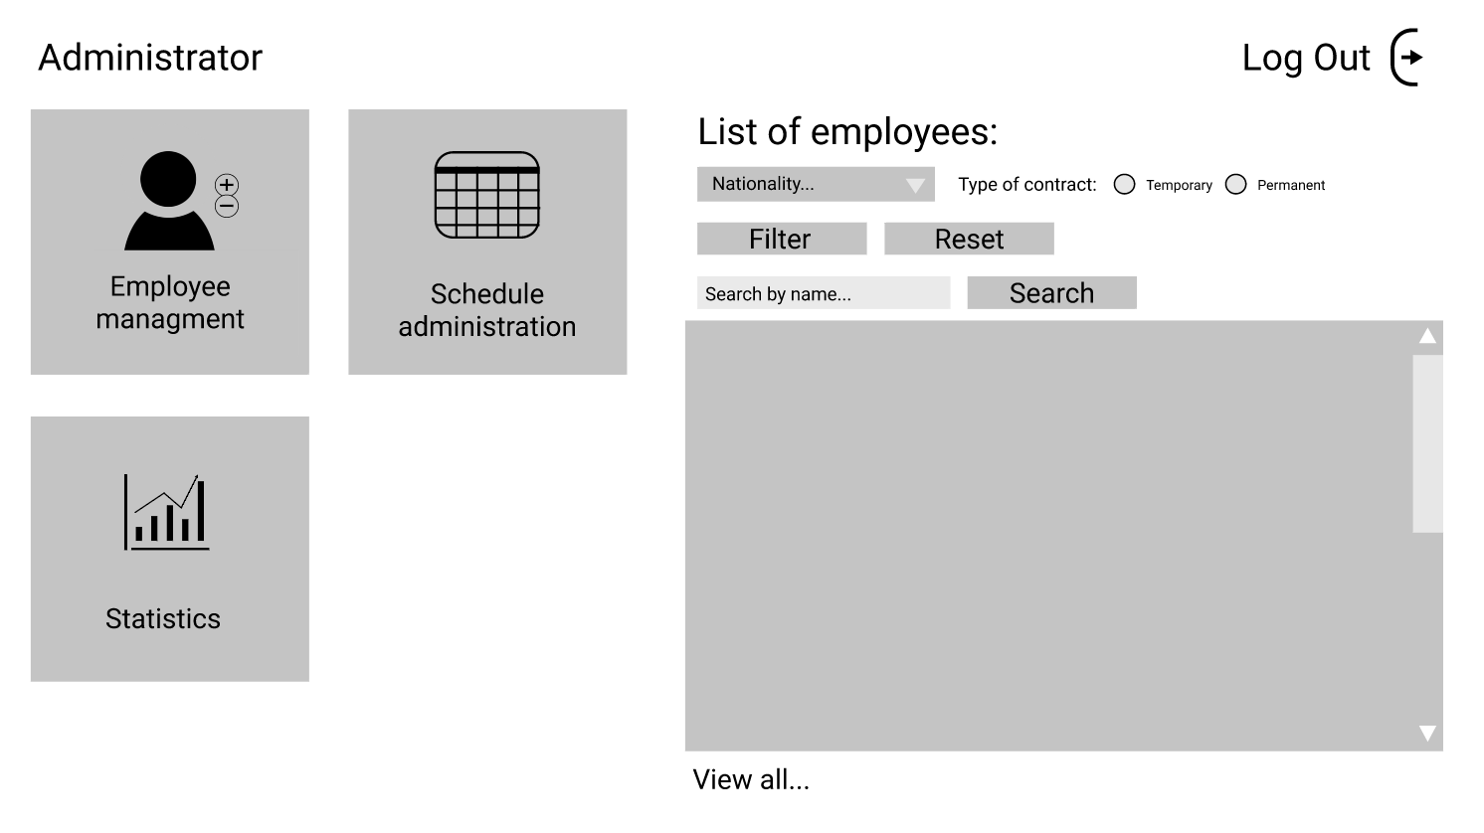

#### Administrator – sub pages

##### Employee management

* + - Administrators can Add, Update (redirects after pressing corresponding button) and Remove employees (by selecting employee in the list and pressing button)

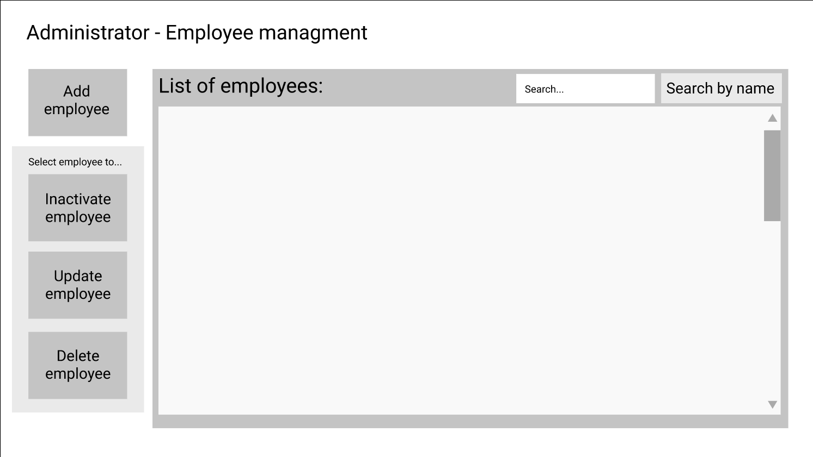

|  |  |
| --- | --- |
|  |  |

##### Administrator - schedule

* + - Administrators can assign to or remove employees from shifts

##### Administrator – Statistics

* + - Administrator can see graphs with statistics

### Manager

#### Manager – main page

* + - The managers’ main page is basically the same as the administrators’, but managers have no access to the Employee management button

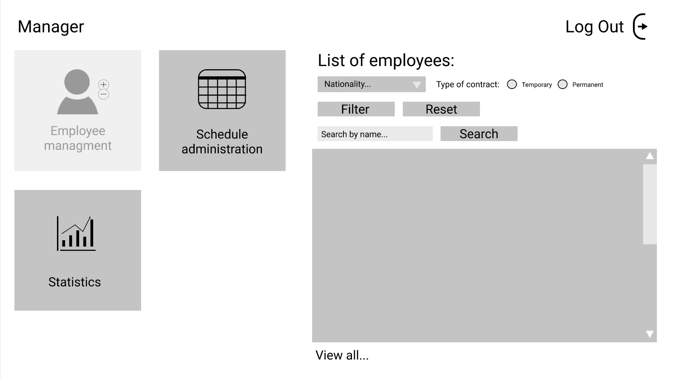

#### Manager – Schedule

* + - Managers can only see the schedule, but they can’t edit it

#### Manager – Statistics

* + - Managers can see the same statistics as the administrators

### Worker

#### Worker – Main page

* + - Workers can see their own schedule and re-shelf requests

