Members: Daniil Blagoev, Jakub Jelínek, Rositsa nikolova, Rens van den Elzen

2/16/2022

URS Document



Tutor: Michiel Koehorst

Location: Eindhoven

Contents

Agreement with client 1

Functional requirements 1

App 1

Use cases 2

Wireframes 5

Administrator 5

Manager 7

Worker 8

Note: i1, i2, i3 and i4 are mentioned across this document- they stand for iteration 1, iteration 2, iteration 3 and iteration 4 respectively

## Agreement with client

We are going to deliver intermediate version of the system in week 6. We agreed for the first six weeks to focus on the employee management part of the application because this is the main priority for the company. We are also going to show the URS document and double check if all requirements are met also if there are any changes to be done before the implementation. During the process, in week 5 we are going to schedule a short meeting to show what we have done so far and if the client is happy with the user interface and functionalities. In week 6 we are adding the final touch and presenting the intermediate version.

(i1) For the second release of the system, we are going to focus on companies' second priority – managing products. For this goal we will implement full functionalities for managing products. The next important step is making possible sending requests for products from the sales to the warehouse department. The requests can be fully approved, partially approved or rejected. We are also going to create a website where only 'workers' can login and see their own schedule. In week 9 we are going the present the software solution to the client.

(i2) For this iteration we are going to add some additional features to product management like search function by category, brand or product name and barcode with numbers for every product. For the website, the employees should receive and automatic e-mail with their credentials when their accounts are created by the admin. With the first login they should be able to change their passwords. They can also request a leave request up to 2 days per month from the website, after admin approves, the changes will be reflected in the schedule. The client wants some changes in the schedule as well like- the employees to be able to see the past months. We agreed that the functionality for admin to add custom category for the products is important, so this is also on the list. We are also going to improve the user interface for the workers in the desktop application and add some other minor changes. In week 12 we are presenting what we have done so far.

(i3) In this phase we agreed that the task with the highest priority is the automated scheduling. Along with that on the website the employees should be able to add preferences for which Week Days they want to work, and this should be taken into consideration when creating the schedule. We also discussed some minor changes in the already implemented functionalities like adding link for the website in the email sent to employees when their accounts are created, removing the employee form available employees for the day when he has requested a leave and redoing the user interface in the desktop application. Another especially important feature for the client is using barcodes for the products but we agreed that we will research the possibilities and we will a second meeting to discuss only this feature on Monday, 23rd of May. On the meeting we agreed that we are going to use barcodes and scan them from the screen. The client also wants a price for the products to be added and after scanning several products a total sum to be shown.

(i4) The client was quite happy with the progress we have made in iteration 3, so for iteration we are focusing more on finishing in the best possible way the existing functionalities rather than implementing new ones. First, we will modify the preferred shifts on the website that employees can choose Saturday and Sunday as well. Secondly, we will make sure that leave request of employees are requested in the automated schedule. Next step is making scanning printed barcodes form paper possible and reducing the quantity of the scanned products from the quantity in the sales department. We are going the improve the UI in both desktop application and website. The client wants announcements created by the manager to be shown on the home page on the website. Also, we when partially accepting or rejecting a request for a product the warehouse employees should be able to add a message for the sales employees. Last but not the least, for the automated schedule it should be possible to be deleted and generated again.

## Functional requirements

### App

**Admin**

* AFR-01: Admins should be able to create an employee
  + i2: After creating employee, system sends email to employee with credentials and link to website
* AFR-02: Admins should be able to deactivate an employee
  + By deactivating an employee due to an employee terminating their contract for any reason, the employee’s data is not removed from the database, but employee cannot log in into the system
* AFR-03: Admins should be able to delete an employee
  + Employee will be deleted 2 years after their deactivation and the employee’s data will be removed from the database
* AFR-04: Admins should be able to update an employee's information
* The email, password, contract type, wage and position are updatable
* AFR-05: Admins should be able to see statistics
  + The statistics about employees and product management
  + Statistics:
    - Employees: average salary, number of employees, employee nationalities, contract types
  + AFR-05.i1: Product management: number of all products, how many requests for re-shelf accepted and rejected, see all types of products
  + AFR-05.i2: Product management: distribution and requests per category
* AFR-06: Admins should be able to see all the shift schedules
* AFR-07: Admins should be able to assign an employee to a shift
  + i3: Admin will not see employees whose *leave request* got accepted
* AFR-08: Admins should be able to remove employees from a shift
* AFR-09: Admins should be able to see an overview of all employees
* AFR-10: Admin should be able to search for an employee
* AFR-11: Admin should be able to log in
* AFR-12.i1: Admin should be able to see list of all products
* AFR-13.i1: Admin should be able to manage products in warehouse
  + Add, Edit and Remove any product
  + i2: Admin can add a barcode to the product when he is adding/editing it
* AFR-14.i2: Admin can see all leave requests
* AFR-15.i2: Admin can accept or reject leave request from employee
* AFR-16.i2: Admin can search for a product by name/category/manufacturer
* AFR-17.i3: Admin can generate automated shift schedule
  + Schedule will be created for a week
* AFR-18.i3: Admin can fire employees
  + Email with reason is sent to inform the employee, that he/she is fired

**Manager**

* MFR-01: Managers should be able to see all statistics
  + Same statistics as admin
  + MFR-01.i1: Plus product statistics like admin
  + MFR-01.i2: Plus new features in product statistics like admin
* MFR-02: Managers should be able to see all the shift schedules
* MFR-03: Managers should be able to see an overview of all employees
* MFR-04: Manager should be able to search for an employee
* MFR-05: Manager should be able to log in
* MFR-06.i1: Manager should see list of all products
* MFR-07.i4: Manager can manage announcements
  + MFR-07.i4-01: Manager can create announcement
  + MFR-07.i4-02: Manager can view announcements
  + MFR-07.i4-03: Manager can edit announcements
  + MFR-07.i4-04: Manager can delete announcements

**Employee**

* EFR-01: Employees should be able to see their own shift schedule
* EFR-02: Employee should be able to log in
* EFRW-03.i1: Employee Warehouse
  + EFRW-W01.i1: Should see all requests from Sales Employee
    - Has three weeks to finish the request
  + EFRW-W02.i1: Should be able to **Accept** request
    - When amount of requested products is lower than amount in Warehouse
  + EFRW-W03.i1: Should be able to **Partially Accept** request
    - When amount of requested products is higher than amount of products in Warehouse
  + EFRW-W04.i1: Should be able to **Reject** request
    - When amount of requested products in Warehouse is 0
* EFRS-03.i1: Employee Sales
  + EFRS-S01.i1: Should be able to send re-shelf request to Warehouse Employee
    - Max. number of requested products is 10
  + EFRS-S02.i1: Should be able to see status(Accepted, Partially Accepted, Rejected) of product request
  + EFRS-S03.i1: Should see list of all products in the shop
* EFR-04.i2: Employee should be able to see all his *leave requests* (whether approved/rejected)
* EFR-05.i3: Employee should be able to see all his *preferred shifts* that they have selected (whether approved/rejected)
* EFRS-06.i3: Sales employee can use a barcode scanner
  + When product is scanned, its information should be shown
  + Product's price is also shown
  + (i4) When products scanned, quantity of items is counted and later possibly reduced by using “**Sale** button"

### Website

**Admin**

**Manager**

**Employee**

* WEFR-01.i1: Employee should be able to log in
* WEFR-02.i1: Employee should be able to see their own shift schedule
* WEFR-03.i2: Employee can request for a “Leave request”
* WEFR-04.i3: Employee can request for a “Preferred shift”
  + What day he/she wants to work
* WEFR-05.i4: Employee can see all announcements

## Use cases

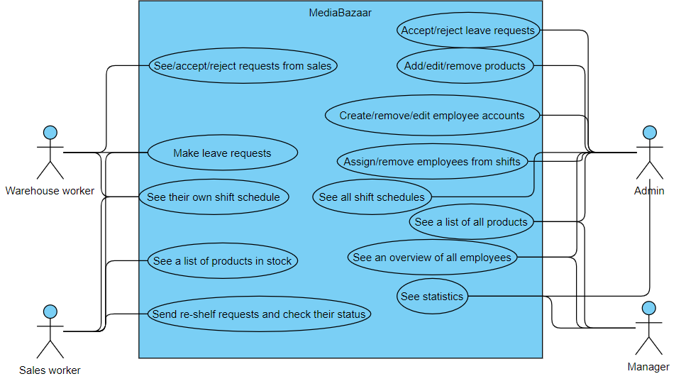

Use case diagram

**UC-01 – AFR-01:**

**Use case: Create an employee**

**Actor: Admin**

**Main Success Scenario:**

1. Admin goes to create a new employee
2. System requests for the required fields to be filled in
3. Admin fills in the information fields and confirms
4. System confirms the employee has been added successfully
5. System sends an email containing the credentials to the new employee

**Extensions:**

3a: There are empty information fields

.1: System displays an empty information field error message

.2: Return to MSS step 2

4a: The employee already exists

.1: System displays an error message stating that an employee with such information already exists

.2: Return to MSS step 2

3b: Some of the filled information is not valid

.1: System displays an error message stating that some of the filled information is not valid

.2: Return to MSS step 2

**UC-02 – AFR-02:**

**Use case: Deactivate an employee**

**Actor: Admin**

**Main Success Scenario:**

1. Admin goes to the list of employees
2. System shows the list of employees
3. Admin selects an employee and confirms
4. System marks the employee as inactive, and they can no longer login into the system

**Extensions:**

3a: An employee is not selected

.1: System displays an error message stating an employee was not selected

.2: Return to MSS step 2

**UC-03 – AFR-03:**

**Use case: Delete employee**

**Actor: Admin**

**Main Success Scenario:**

1. Admin goes to see the list employees
2. System shows the list of employees
3. Admin selects an employee to be delete
4. System deletes the selected employee and removes their data from the database

**Extensions:**

3a: An employee is not selected

.1: System displays an error message stating an employee was not selected

.2: Return to MSS step 2

**UC-04 – AFR-07:**

**Use case: Assign a worker to a shift**

**Actor: Admin**

**Main Success Scenario:**

1. Admin goes to assign a worker to a shift
2. System requests a day to be selected
3. Admin selects a day
4. System requests the morning, mid-day or evening shift to be selected
5. Admin selects one of the three shifts
6. System requests the user to select a worker to be assigned to the selected shift
7. Admin selects the worker they want
8. System confirms the worker has successfully been assigned to the shift

**Extensions:**

5a: A shift is not selected

.1: System displays an error message

.2: Return to MSS step 4

7a: A worker is not selected

.1: System displays an error message

.2: Return to MSS step 6

8a: The worker already has 2 shifts for the day

.1: System displays an error message

.2: Return to MSS step 6

5b: There are 10 workers assigned to the selected shift

.1: System displays an error message

.2: Return to MSS step 4

**UC-05 – AFR-08:**

**Use case: Remove a worker from a shift**

**Actor: Admin**

**Main Success Scenario:**

1. Admin goes to remove a worker from a shift
2. System requests a day to be selected
3. Admin selects a day
4. System requests a shift to be selected
5. Admin selects a shift
6. System shows the assigned workers in the selected shift
7. Admin selects a worker
8. System removes the selected worker from the shift

**Extensions:**

5a: A shift is not selected

.1: System displays an error message

.2: Return to MSS step 4

7a: A worker is not selected

.1: System displays an error message

.2: Return to MSS step 6

**UC-06 – AFR-04:**

**Use case: Update information for employee**

**Actor: Admin**

**Main Success Scenario:**

1. Admin goes to update information about employee
2. System shows the fields that can be edited
3. Admin edits the information about employee
4. System confirms the employee's information has been updated successfully

**Extensions:**

3a: There are empty information fields

.1: System displays an empty information field error message

.2: Return to MSS step 2

3b: Some of the filled information is not valid

.1: System displays an error message stating that some of the filled information is not valid

.2: Return to MSS step 2

**UC-07 – AFR-05/MFR-01 + MFR-01.i1:**

**Use case: View statistics of the shop**

**Actor: Admin/Manager**

**Main Success Scenario:**

1. Admin/Manager goes to see the statistics
2. System shows the statistics

**UC-08 – AFR-06/MFR-02:**

**Use case: Displaying schedule**

**Actor: Admin/Manager**

**Main Success Scenario:**

1. Admin/Manager goes to see the schedule
2. System shows the schedule for all employees

**UC-09 – AFR-09/MFR-03:**

**Use case: Displaying an overview of all employees**

**Actor: Admin/Manager**

**Main Success Scenario:**

1. Admin/Manager goes to see an overview of all employees
2. System shows the overview

**UC-10 – AFR-10/MFR-04:**

**Use case: Searching for employee by name**

**Actor: Admin/Manager**

**Main Success Scenario:**

1. Admin/Manager enters an employee’s name in the search bar
2. System displays information about employee(s) with a matching name

**Extensions:**

1a: Employee is not found

.1: System displays a massage stating there is no such employee

.2: Return to MSS step 1

**UC-11 – EFR-01:**

**Use case: Displaying schedule for worker**

**Actor: Worker**

**Main Success Scenario:**

1. Employee goes to see their schedule
2. System shows their own schedule

**UC-12 – EFR-02/MFR-05/AFR-11:**

**Use case: Logging into the app**

**Actor: Worker, Manager, Admin**

**Main Success Scenario:**

1. Actor opens the app
2. System shows the log in screen
3. Actor enters their credentials
4. System shows the view according to the entered credentials

**Extensions:**

3a: Invalid credentials

.1: System displays a message stating there is no such account

.2: Return to MSS step 3

3b: Empty credentials field

.1: System displays a message stating there is an empty field

.2: Return to MSS step 3

**UC-13 –AFR-12.i1/MFR-06.i1:**

**Use case: Product overview**

**Actor: Manager, Admin**

**Main Success Scenario:**

1. Admin/manager goes to see the list of all products in the store/warehouse
2. System shows the list of all products in the store

**UC-14 –AFR-13.i1:**

**Use case: Adding a new product**

**Actor: Admin**

**Main Success Scenario:**

1. Admin goes to add a new product
2. System requests for the required fields to be filled in
3. Admin fills in the information fields, (i2)adds a barcode and confirms
4. System confirms the product has been added successfully

**Extensions:**

3a: There are empty information fields

.1: System displays an empty information field error message

.2: Return to MSS step 2

4a: The product already exists

.1: System displays an error message stating that a product with such information already exists

.2: Return to MSS step 2

3b: Some of the filled information is not valid

.1: System displays an error message stating that some of the filled information is not valid

.2: Return to MSS step 2

**UC-15 – AFR-13.i1:**

**Use case: Remove product**

**Actor: Admin**

**Main Success Scenario:**

1. Admin goes to see the list of products
2. System shows the list of products
3. Admin selects a product to be removed
4. System removes the selected product

**Extensions:**

3a: A product is not selected

.1: System displays an error message stating a product was not selected

.2: Return to MSS step 2

**UC-16 – AFR-13.i1:**

**Use case: Update information for product**

**Actor: Admin**

**Main Success Scenario:**

1. Admin goes to update information about product
2. System shows the editable fields with product information
3. Admin edits the information about the product
4. System confirms the product’s information has been updated successfully

**Extensions:**

3a: There are empty information fields

.1: System displays an empty information field error message

.2: Return to MSS step 2

3b: Some of the filled information is not valid

.1: System displays an error message stating that some of the filled information is not valid

.2: Return to MSS step 2

**UC-17 – AFR-14.i2:**

**Use case: Admin can see all leave requests**

**Actor: Admin**

**Main Success Scenario:**

1. The admin goes to see the leave requests
2. System shows the leave requests

**UC-18 – AFR-15.i2:**

**Use case: Admin can accept or reject leave requests from employees**

**Actor: Admin**

**Main Success Scenario:**

1. The admin goes to see the leave requests
2. System shows the leave requests
3. Admin selects a leave request to accept/reject and confirms
4. System accepts/rejects the selected request

**Extensions:**

3a: No leave request selected

.1: System displays a message that no leave request has been selected

.2: Return to MSS step 2

**UC-19 – AFR-16.i2:**

**Use case: Admin can search for a product by name/category/manufacturer**

**Actor: Admin**

**Main Success Scenario:**

1. Admin goes to search for a product
2. System shows the products which comply with the search criteria

**UC-19 – EFRW-W01:**

**Use case: Checking product requests**

**Actor: Warehouse employee**

**Main Success Scenario:**

1. The warehouse employee goes to see the product requests from the sales employees
2. System shows the product requests

**UC-20 – EFRW-W02.i1/EFRW-W03.i1:**

**Use case: Accepting a product request**

**Actor: Warehouse employee**

**Main Success Scenario:**

1. The warehouse employee goes to see the product requests from the sales employees
2. System shows the product requests from the sales employees
3. The warehouse employee selects a request and accepts it
4. The system shows confirmation the request was accepted successfully

**Extensions:**

3a: No product request selected

.1: System displays an error message stating a request wasn’t selected

.2: Return to MSS step 2

3b: Not enough products in the warehouse to fully accept request

.1: System displays an error message stating that the request cannot be fully accepted

.2: System partially accepts the request and displays a message stating the request has been **partially accepted**

* + - **Partially accepted** explanation: number of products needed for Sales department is higher than number of products in the Warehouse department -> system takes all products from Warehouse and partially fulfils the request, with remainder

3c: No products in the warehouse for the request

.1: System displays an error message stating that the request cannot be accepted due to having no products left in the warehouse

.2: Return to MSS step 2

**UC-21 – EFRW-W04.i1:**

**Use case: Rejecting a product request**

**Actor: Warehouse employee**

**Main Success Scenario:**

1. The warehouse employee goes to see the product requests from the sales employees
2. System shows the product requests from the sales employees
3. The warehouse employee selects a request and rejects it
4. System shows confirmation the request was declined successfully

**Extensions:**

3a: No product request selected

.1: System displays an error message stating a request wasn’t selected

.2: Return to MSS step 2

**UC-22 – EFRS-S01.i1:**

**Use case: Making a re-shelf request**

**Actor: Sales employee**

**Main Success Scenario:**

1. The sales employee goes to see the list of products
2. System shows the list of products
3. The sales employee selects a product from the list
4. The sales employee types the amount needed and confirms
5. System shows confirmation the request was made successfully

**Extensions:**

3a: No product selected

.1: System displays an error message stating a product wasn’t selected

.2: Return to MSS step 2

4a: Requesting more than 10 of a product

.1: System displays an error message stating that you cannot request more than 10 of a product per request.

.2: Return to MSS step 2

**UC-23 – EFRS-S02.i1:**

**Use case: Checking request status**

**Actor: Sales employee**

**Main Success Scenario:**

1. The sales employee goes to see the status of requests
2. System shows a list of requests and their status

**UC-24 – EFRS-S03.i1:**

**Use case: Checking all products in the store**

**Actor: Sales employee**

**Main Success Scenario:**

1. The sales employee goes to see the list of products in the store
2. System shows a list of products in the store

**UC-25 – WFR-01.i1:**

**Use case: Logging into the website**

**Actor: Workers**

**Main Success Scenario:**

1. Worker opens the website
2. System shows the log in screen
3. Worker enters their credentials
4. System shows the home page

**Extensions:**

3a: Invalid credentials

.1: System displays a message stating there is no such account

.2: Return to MSS step 3

3b: Empty credentials field

.1: System displays a message stating there is an empty field

.2: Return to MSS step 3

**UC-26 – WFR-02.i1:**

**Use case: Checking own schedule**

**Actor: Workers**

**Main Success Scenario:**

1. Worker logs into the website
2. System shows the home screen
3. Worker goes to check their own schedule
4. System shows the schedule for the logged in worker

**UC-27 – WFR-03.i2:**

**Use case: Employee can request for a “Leave request”**

**Actor: Workers**

**Main Success Scenario:**

1. Worker logs into the website
2. System shows the home screen
3. Worker goes to request for a leave
4. System shows all future dates
5. Worker selects the date they want and confirms
6. System creates the leave request and sends it to the admin for review

**Extensions:**

5a: No date selected

.1: System displays a message stating there is no date selected

.2: Return to MSS step 4

5b: Worker has already reached the maximum leaves allowed

.1: System displays a message stating the worker has no leaves remaining

.2: Return to MSS step 2

**UC-28 – AFR-17.i3:**

**Use case: Admin can generate automated shift schedule**

**Actor: Admin**

**Main Success Scenario:**

1. Admin goes to the schedule administration
2. System shows the schedule administration
3. Admin confirms they want to auto generate the schedule for next week
4. System auto generates the schedule for next week

**UC-29 – AFR-18.i3:**

**Use case: Admin can fire an employee**

**Actor: Admin**

**Main Success Scenario:**

1. Admin goes to the employee administration
2. System shows the list of employees
3. Admin selects an employee
4. Admin fires the employee
5. System confirms the employee was fired

3a: An employee was not selected

.1: System displays a message stating an employee was not selected

.2: Return to MSS step 2

3b: The selected employee has an upcoming shift

.1: System displays a message stating the employee has an upcoming shift

.2: Return to MSS step 2

**UC-30 - WEFR-04.i3:**

**Use case: Employee can request for a “Preferred shift”**

**Actor: Employee**

**Main Success Scenario:**

1. Employee goes to request for a preferred shift
2. System shows a calendar
3. Employee selects which day they would prefer to work on in the calendar
4. System displays that the preference has been set

3a: The selected date has already passed

.1: System displays a message stating the selected date has already passed

.2: Return to MSS step 2

**UC-31 - EFRS-06.i3:**

**Use case: Sales employee can use a barcode scanner**

**Actor: Employee**

**Main Success Scenario:**

1. Employee goes to the scanning screen
2. System shows the list of items in the sales department
3. Employee selects an item
4. System shows a picture of the selected item’s barcode
5. Employee scans the picture of the barcode with a barcode scanner
6. System shows the scanned item’s information
7. (i4) System reduces the scanned item’s quantity in the sales department

**UC-32 - MFR-07.i4-01:**

**Use case: Manager can create announcements**

**Actor: Manager**

**Main Success Scenario:**

1. Manager goes to the announcements management screen
2. System shows the announcements management screen
3. Manager fills the required fields for creating an announcement
4. System shows a message the announcement has been created successfully

**Extensions:**

2a: Manager left a field empty

.1: System displays a message stating that a required field has been left empty

.2: Return to MSS step 2

**UC-33 - MFR-07.i4-02:**

**Use case: Manager can view announcements**

**Actor: Manager**

**Main Success Scenario:**

1. Manager goes to the announcements management screen
2. System shows the announcements management screen

**UC-34 - MFR-07.i4-03:**

**Use case: Manager can edit announcements**

**Actor: Manager**

**Main Success Scenario:**

1. Manager goes to the announcements management screen
2. System shows the announcements management screen
3. Manager selects an announcement
4. Manager fills the fields for editing an announcement
5. System shows a message the announcement has been edited successfully

**Extensions:**

4a: Manager left a field empty

.1: System displays a message stating that a required field has been left empty

.2: Return to MSS step 2

3a: Manager did not select an announcement

.1: System displays a message stating that an announcement must be selected

.2: Return to MSS step 2

**UC-35 - MFR-07.i4-04:**

**Use case: Manager can delete announcements**

**Actor: Manager**

**Main Success Scenario:**

1. Manager goes to the announcements management screen
2. System shows the announcements management screen
3. Manager selects an announcement
4. Manager deletes the selected announcement
5. System shows a message the announcement has been deleted successfully

**Extensions:**

3a: Manager did not select an announcement

.1: System displays a message stating that an announcement must be selected

.2: Return to MSS step 2

## Wireframes

#### Log In

* + - 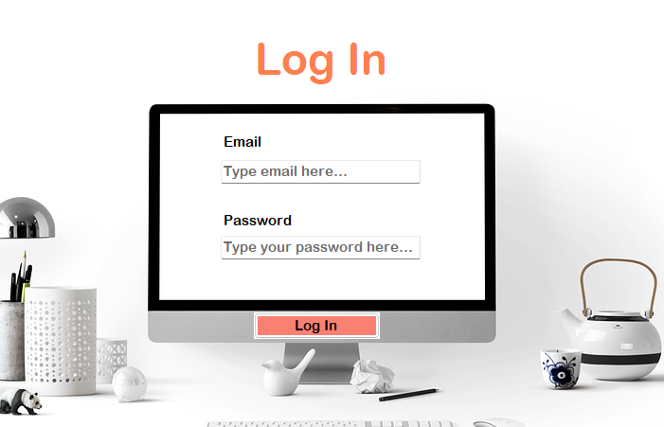User Authentication via email and password

### Administrator

#### Administrator – main page

* + - After logging in as administrator, this page will show up
    - Administrators have the options to:
      * Click on one of the three buttons on the left side of the page (redirects them to the selected page)
      * See and filter a list of all employees (filter by nationality, type of contract)

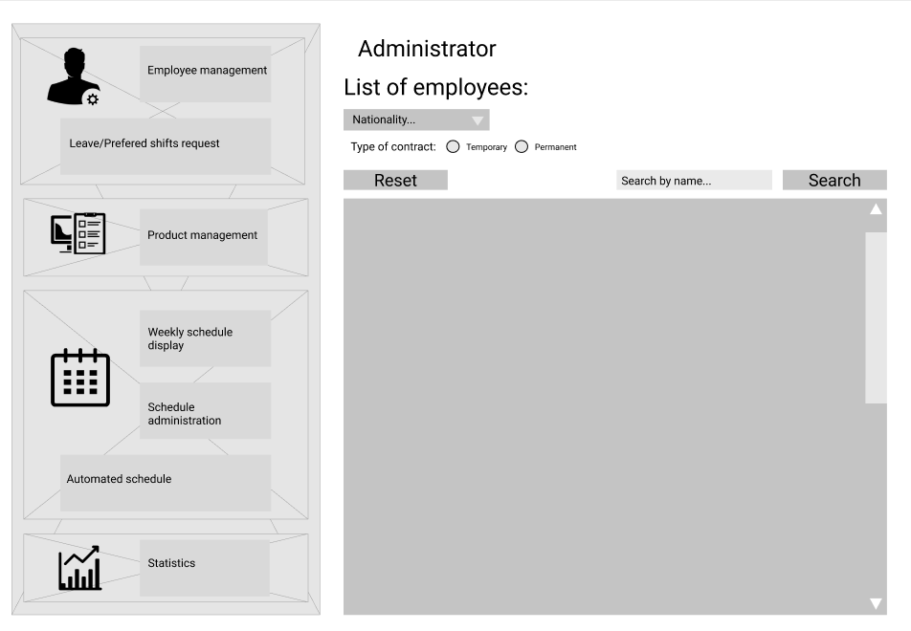

#### Administrator – sub pages

##### Employee management

* + - Administrators can Add, Update (redirects after pressing corresponding button) and Remove employees (by selecting employee in the list and pressing button)

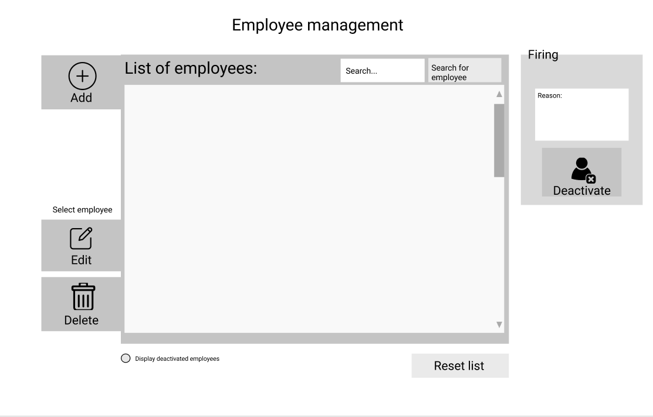

|  |  |
| --- | --- |
|  |  |

##### Administrator – product management

* 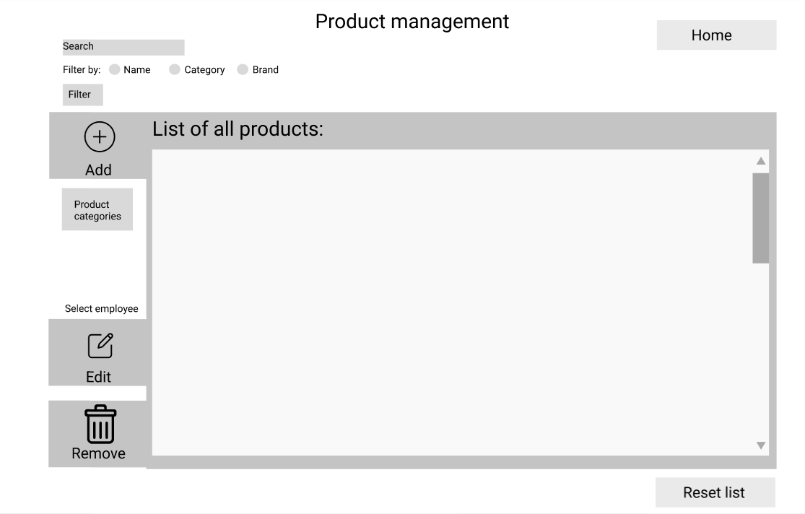Chart

  Description automatically generated with medium confidenceAdministrator can add, edit and remove product
* Administrator sees all products on-site and in warehouse

##### Administrator - schedule

* + - Administrators can assign or remove employees from/to shifts
    - With weekly schedule, administrator can see every shift

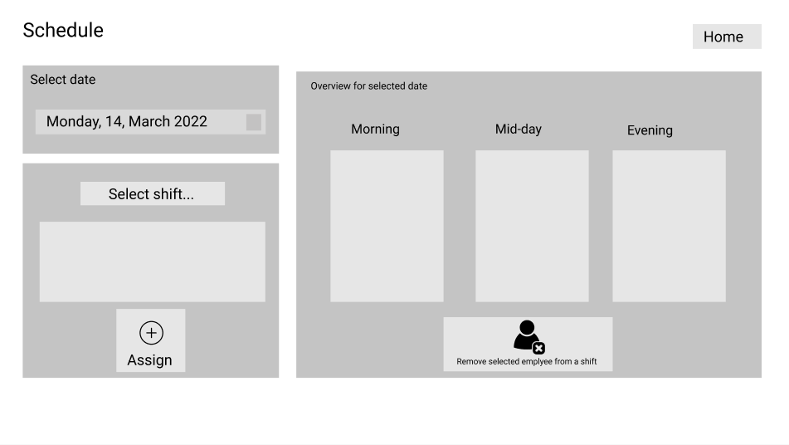

##### Administrator – Statistics

* + - Administrator can see graphs with statistics

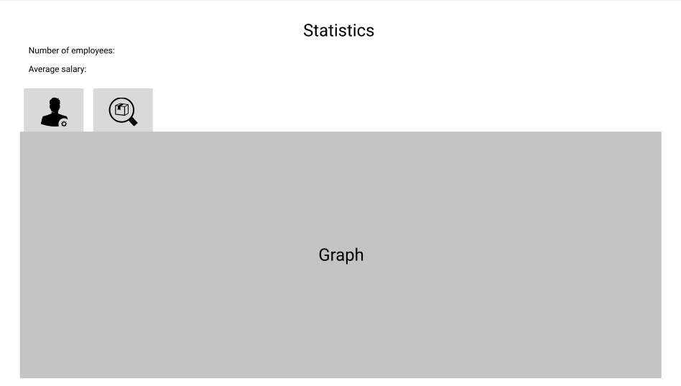

### Manager

#### Manager – main page

* + - 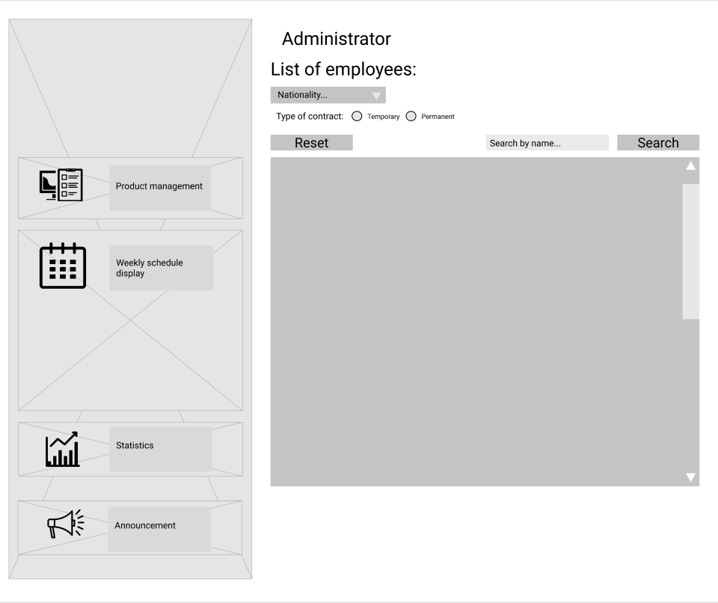The managers’ main page is basically the same as the administrators’, but managers have no access to the Employee management button

#### Manager – Schedule

* + - Managers can only see the schedule, but they can’t edit it

#### Manager – Statistics

* + - Managers can see the same statistics as the administrators



### Worker

#### Worker – Main page

* + - Workers can see their own schedule and re-shelf requests

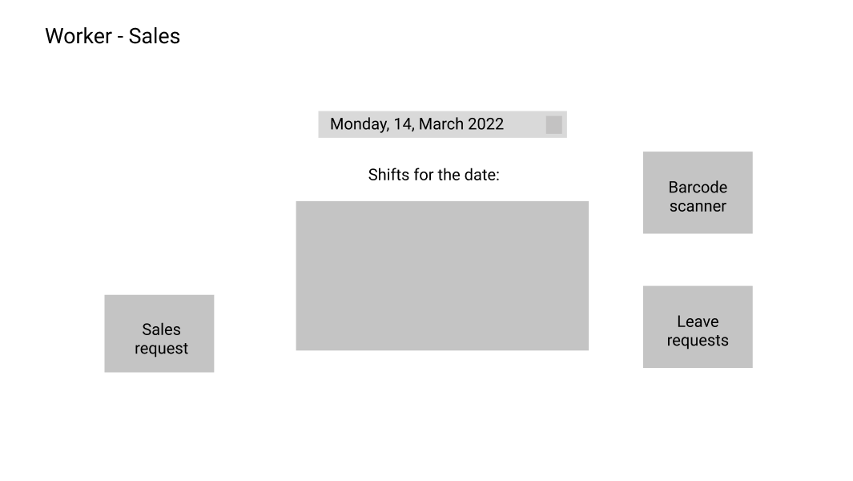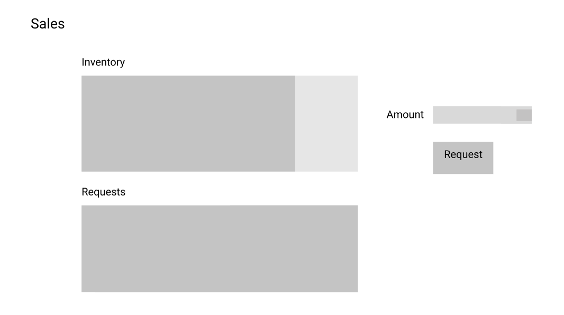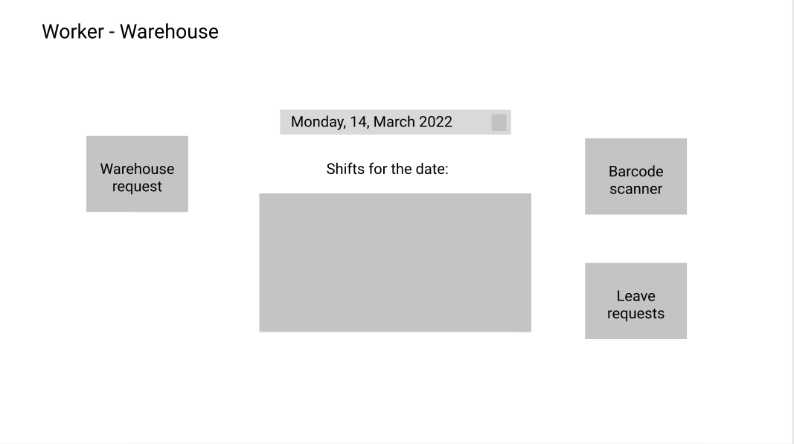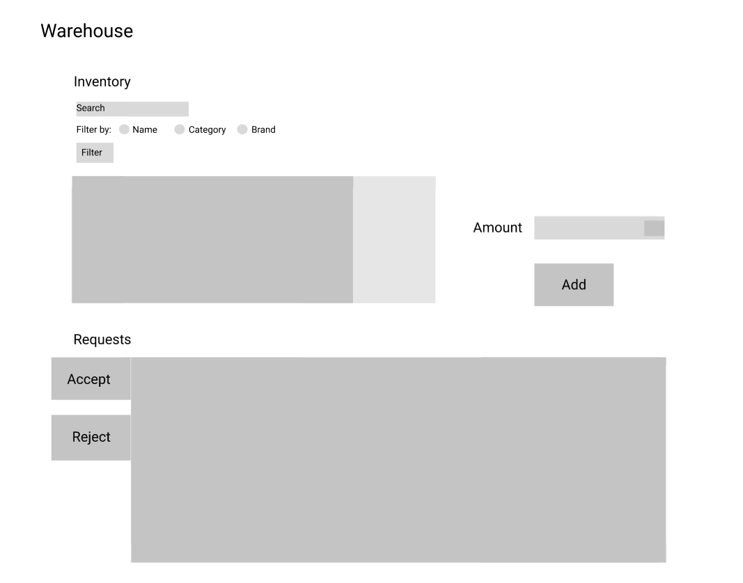

# Website

