|  |
| --- |
| colored transparent rectanglecolored transparent rectangle  My Spot  Restaurant  Reviews  Web App |

|  |
| --- |
| Name: Rositsa Nikolova  Student number: 4693582 |

|  |  |
| --- | --- |
|  |  |

WAD & OOD

Personal project

Ideation document



Contents

Git repository1

Description2

Site map3

Wireframes4

|  |
| --- |
| Git repository |

|  |
| --- |
|  |

GIT:

https://git.fhict.nl/I497286/restaurant_reviews_rositsa_wad.git

|  |
| --- |
| Description |

The idea of the web application is to be a restaurant reviews website that operates mainly with user-generated content. The main page will display a list of restaurants with a wide variety of characteristics such as: cuisine, atmosphere type – romantic, work-friendly, luxury, etc., price range, level of service, does it have a parking and so on. The restaurants list will also support different filters. The main purpose of the application is to provide detailed and diverse information about the restaurants. In that way the users will be able to see everything that they need to know in order to make the best choice for the place which they want to visit. After registering and logging in the user will be able to add a review only about the restaurants that are already in the database. The logged user will have a profile page where they can see and edit their reviews. The user will also have a ‘my spots’ list where they can view the ‘visited’ restaurants and ‘to be visited’ restaurants (if added to their wish list). The users will also be able to edit their profile details. Probably later in the development of the application a form can be implemented for inviting the restaurant owners to register their restaurant in order to be shown on the website, get reviews, gain more popularity and attract clients.

The application is inspired by the fact that due to the Covid pandemic the industry has experienced great difficulties. Furthermore, visiting a restaurant is not only about eating but a whole experience in itself. It also encourages people to socialize and have fun together. Additionally, it is inspired by personal experience because I am someone who loves to travel and visit new places and I am having hard times choosing the right place to sit in and have a nice dinner because I often cannot find accurate and detailed information.

|  |
| --- |
| Site map |

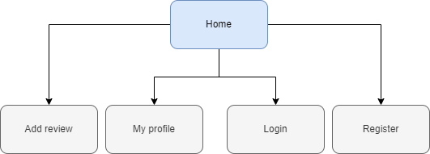

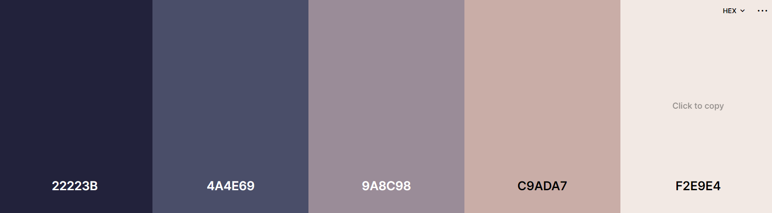

Color palette

|  |  |  |
| --- | --- | --- |
| Wireframes |  |  |

