URS Document

DuelSys inc.

Synthesis Assignment

Rositsa Nikolova

Contents

Agreements with client.............................................................................................

Functional requirements............................................................................................

Desktop Application.......................................................................................

Website............................................................................................................

Use cases....................................................................................................................

Wireframes.................................................................................................................

Desktop Application........................................................................................

Website............................................................................................................

Agreements with client

A software solution for managing sports tournaments will be developed for the company DuelSys Inc. It will include a desktop application for the staff (sports associations) where they can manage tournaments, generate games and add results. The second part will be an ASP .NET website where players can register for a tournament and see detailed information about all tournaments with ranking, games and participants. Any interested party should be able to see the information about the tournaments. The system will support one type of sport – badminton but different tournament systems: round- robin and double round-robin. Together with the applications, a database running on Hera server, Unit tests and Documentation including Project plan, URS document, Test plan, Test report and UML diagram will be delivered. We agreed to have weekly meetings on Wednesday when we can discuss the current progress. Everything will be uploaded to FHICT GitLab repository together with the source code. The project plan and URS should be approved by the mentor – Hanane Ezzikouri in week 13. All deliverables should be submitted in week 16 before 5:00pm on Friday 10th of June 2022.

Non-functional requirements:

**NFR-01:** The code base should be maintainable and extendable

**NFR-02:** Bug free system

**NFR-03:** Secure software

Functional requirements:

**Desktop application – Staff**

*SFR – Staff functional requirement

**SFR-01:** Staff must be able to log in

**SFR-02:** Staff must be able to add a tournament

* Staff should be able to choose from two types of tournament systems: round-robin and double round-robin

**SFR-03:** Staff must be able to edit a tournament

**SFR-04:** Staff must be able to delete a tournament

* If it is with status open or cancelled

**SFR-05:** Staff must be able to see an overview of the tournaments

**SFR-06:** Staff must be able to generate tournament's schedule

**SFR-07:** Staff must be able to register the results of the games in a tournament

* Based on the sport type

**Website – Players**

*PFR – Player functional requirement

**PFR-01:** A player must be able to log in

**PFR-02:** A player must be able to create a profile

**PFR-03:** A player must be able to register for a chosen tournament

**PFR-04:** A player must be able to view detailed information about any tournament – general information and games between players with results

**PFR-05:** A player must be able to see information related to participation in the tournaments: ranking, matches played against opponents and his personal information – Players Profile

**PFR-06:** A player must be able to edit his personal information – email, password, first name and last name

**Website – Any Interested Party**

*GFR – General functional requirement

**GFR-01:** Any interested party should be able to see information about any given tournament – general information and games between players with results

Use cases

**UC-01 – SFR-01:**

**Use case: Staff logs in into the desktop application**

**Actor: Staff**

**Main Success Scenario:**

1. Staff opens the app
2. System shows login form
3. Staff enters their credentials – email and password and confirms
4. System shows home page

**Extensions:**

3a: Credentials are invalid

.1: System displays an error message stating that there is no registered user with such credentials

.2: Return to MSS step 2

3b: Email is not entered

.1: System displays an error message stating that email field is empty

.2: Return to MSS step 2

3c: Password is not entered

.1: System displays an error message stating that password field is empty

.2: Return to MSS step 2

3d: Email and password are not entered

.1: System displays an error message stating that email and password fields are empty

.2: Return to MSS step 2

3e: Credentials are player's credentials

.1: System displays an error message stating that the user is a player, and they can log in on the website

.2: Return to MSS step 2

**UC-02 – SFR-02:**

**Use case: Staff creates a tournament**

**Actor: Staff**

**Main Success Scenario:**

1. Staff goes to Manage tournaments tab
2. System displays tournaments with status open or cancelled
3. Staff presses Create a tournament button
4. System shows the required fields to be filled in
5. Staff enters the information and confirms
6. System shows a message that the tournament is created successfully

**Extensions:**

5a: There are empty information fields

.1: System displays an error message stating which field is empty

.2: Return to MSS step 4

5b: The input is invalid

.1: System displays an error message stating which field has invalid input

.2: Return to MSS step 4

**UC-03 – SFR-03:**

**Use case: Staff edits a tournament**

**Actor: Staff**

**Main Success Scenario:**

1. Staff goes to Manage tournaments tab
2. Staff selects tournament to be edited
3. Staff presses Edit tournament button
4. Edit tournament form is shown with the fields to be edited
5. Staff edits the information and confirms
6. System shows a message that the tournament's information is edited successfully

**Extensions:**

2a: A tournament is not selected

.1: System displays an error message stating there is no tournament selected

.2: Return to MSS step 2

5a: There are empty information fields

.1: System displays an error message stating which field is empty

.2: Return to MSS step 4

5b: The input is invalid

.1: System displays an error message stating which field has invalid input

.2: Return to MSS step 4

**UC-04 – SFR-04:**

**Use case: Staff deletes a tournament**

**Actor: Staff**

**Main Success Scenario:**

1. Staff goes to Manage Tournament tab
2. Staff selects a tournament to be deleted
3. Staff presses Delete tournament button
4. System shows a message that the tournament is deleted successfully

2a: A tournament is not selected

.1: System displays an error message stating there is no tournament selected

.2: Return to MSS step 2

**UC-05 – SFR-05:**

**Use case: Staff sees an overview of the tournaments**

**Actor: Staff**

**Main Success Scenario:**

1. Staff goes to home page
2. System displays a table with the tournaments

**UC-06 – SFR-06:**

**Use case: Staff generates a tournament's schedule**

**Actor: Staff**

**Main Success Scenario:**

1. Staff goes to Generate Games tab
2. System shows a list of tournaments with status pending
3. Staff selects a tournament to generate a schedule (matches between players) and presses the button Generate schedule
4. System shows a message that the tournament's schedule is generated successfully
5. System displays the generated games

2a: A tournament is not selected

.1: System displays an error message stating a tournament was not selected

.2: Return to MSS step 2

**UC-07 – SFR-07:**

**Use case: Staff enters results for the matches in a tournament**

**Actor: Staff**

**Main Success Scenario:**

1. Staff goes to Enter results tab
2. System displays tournaments with status ongoing
3. Staff selects a tournament to add the results for
4. Systems shows tournament's matches
5. Staff enters the results and presses Add results button
6. System shows a message that all results are entered successfully

5a: A tournament is not selected

.1: System displays an error message stating that there is no tournament selected

.2: Return to MSS step 4

5b: There are empty fields

.1: System displays an error message saying that the results cannot be zero with the id of for the game

.2: Return to MSS step 4

5c: The added result does not correspond to the sport type rules

.1: System displays an error message with the id of the game and what is the mistake in the results

.2: Return to MSS step 4

**UC-08 – SFR-01:**

**Use case: A player logs in into the desktop application**

**Actor: Player**

**Main Success Scenario:**

1. Player opens the website
2. System shows home page
3. Player clicks on login button
4. System shows fields to be filled – email and password
5. Player enters his credentials and confirms
6. Website redirects to home page

**Extensions:**

5a: Credentials are invalid

.1: System displays an error message stating that there is no registered user with such credentials

.2: Return to MSS step 4

5b: Email is not entered

.1: System displays an error message stating that email field is required

.2: Return to MSS step 4

5c: Password is not entered

.1: System displays an error message stating that password field is required

.2: Return to MSS step 4

5d: Email and password are not entered

.1: System displays an error message stating that email and password fields are required

.2: Return to MSS step 4

5e: Credentials are staff's credentials

.1: System displays an error message stating that the user is a staff, and they can log into the desktop application

.2: Return to MSS step 4

**UC-09 – SFR-02:**

**Use case: A player creates account on the website**

**Actor: Player**

**Main Success Scenario:**

1. A player goes to Create Account page
2. System shows fields to be filled – email and password, first name, last name
3. A player enters the required information and confirms
4. Website redirects to Login page

**Extensions:**

4a: There are empty fields

.1: System displays an empty information field error message

.2: Return to MSS step 2

4b: User with these credentials already exists

.1: System displays an error message stating that there is already registered player with this email

.2: Return to MSS step 2

**UC-10 – SFR-03:**

**Use case: A player registers for a tournament**

**Actor: Player**

**Main Success Scenario:**

1. A player goes to Available tournaments page
2. System shows list of available tournaments
3. A player clicks register button for one of the tournaments
4. System redirects player to Sign Up for a tournament page
5. Player clicks Sign up button
6. System shows message stating that player is registered successfully for this tournament

**Extensions:**

3a: The player is not logged in

.1: System displays login page

.2: Return to MSS step 4

5a: The player is already registered

.1: System displays an error message stating that the player is already registered for this tournament

.2: Return to MSS step 4

**UC-11 – SFR-04:**

**Use case: A player sees detailed information about chosen tournament**

**Actor: Player**

**Main Success Scenario:**

1. A player goes to home page
2. System displays a list of the tournaments
3. Player clicks on a tournament
4. The website redirects to a page with detailed information about the selected tournament

**UC-12– SFR-05:**

**Use case: A player sees information about his participations in the tournaments and personal information**

**Actor: Player**

**Main Success Scenario:**

1. A player goes to My profile
2. System shows information about tournaments he participated in and matches with results

**UC-13– SFR-06:**

**Use case: A player edits his personal information**

**Actor: Player**

**Main Success Scenario:**

1. A player goes to Edit my profile
2. System shows fields to be edited
3. A player edits his information and confirms
4. System shows message stating profile's information is edited successfully

3a: There are empty fields

.1: System displays a message stating all fields are required

.2: Return to MSS step 2

3b: User with this email already exists

.1: System displays an error message stating that there is already registered player with this email

.2: Return to MSS step 2

3c: The Input is invalid

.1: System displays an error message stating that the input is invalid

.2: Return to MSS step 2

**UC-13 – GFR-01:**

**Use case: Any interested party sees information about chosen tournament**

**Actor: Player**

**Main Success Scenario:**

1. A user goes to home page
2. System displays a list of the tournaments
3. A user clicks on a tournament
4. The website redirects to a page with detailed information about the selected tournament

Wireframes

Desktop Application:

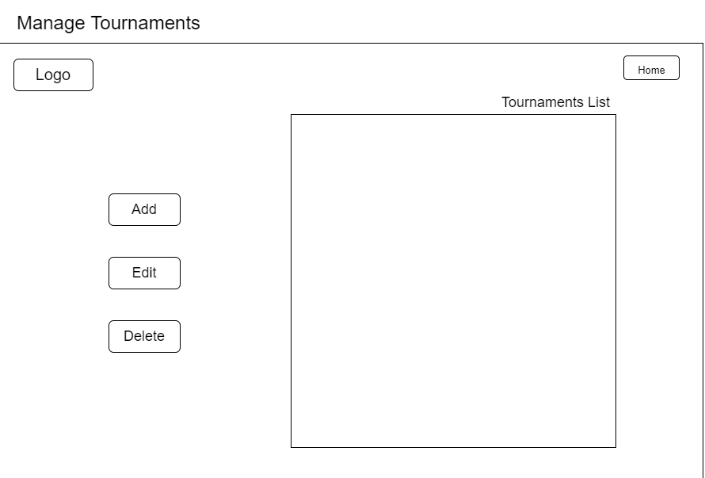

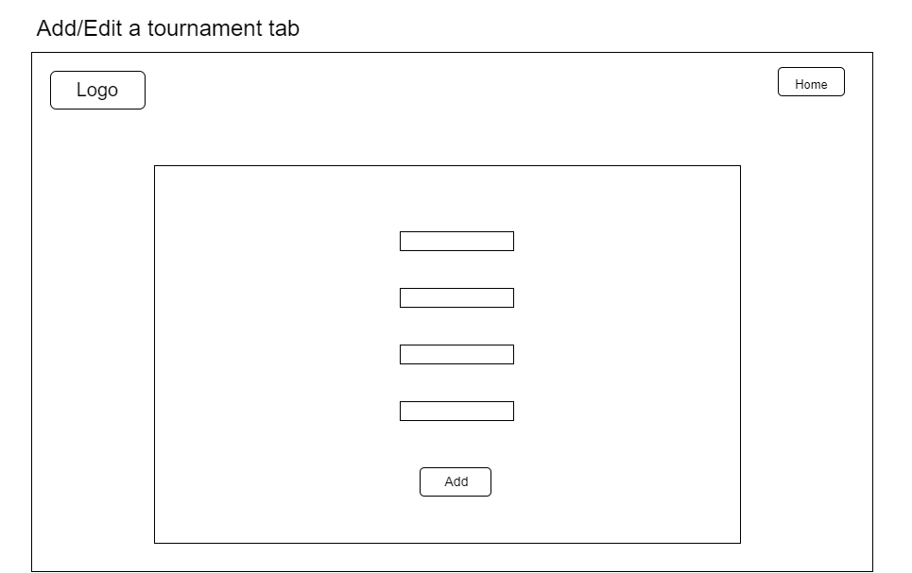

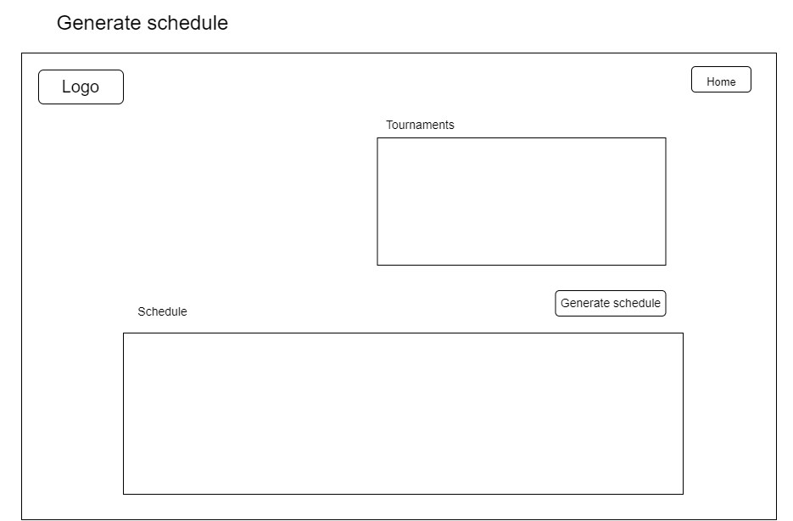

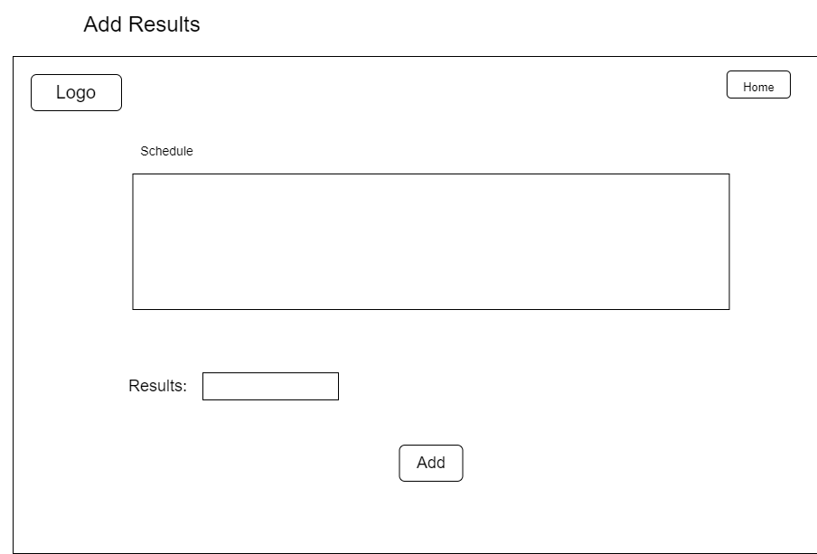

Website

