**Macrobenthic Invertebrate Distribution & Abundance in the Thames Estuary**

**Introduction**

This study aims to give a broad overview of the relationship between macrobenthic taxa distributions sampled from sites within the Thames Estuary & examines the changes in patterns of abundance. Well-documented research highlights the loss of estuarine habitats due to intense anthropogenic disturbances. This includes the direct alteration of natural riverbanks, chronic anoxia from industrial/sewage pollution & unprecedented drought conditions leading to significant salt water intrusions into brackish and freshwater areas [1,2]. Unfortunately, there is no comprehensive information on invertebrates before the Thames Estuary was heavily impacted by the industrial revolution & data on macrobenthic abundance during the most polluted years are limited with monitoring efforts heavily focussed on water quality and fish stock assessments [2,3].

However, the taxonomic composition of benthic macroinvertebrate communities in estuaries serve as effective indicators of environmental quality. Here, I focus on 3 ‘major’ macrobenthic taxa; annelids, crustaceans & molluscs. Studies have shown annelids to be the least sensitive to human-induced disturbances as their abundance and species richness tends to increase compared to the more sensitive crustaceans & molluscs. Benthic macroinvertebrates are vital for the regulation of estuarine ecosystems & food webs. For example, through feeding & burrowing (bioturbation) they play an active role in nutrient cycling & are primary food sources for many estuarine fish [3,4]. Therefore, the Thames Estuary is considered as an ideal stie to study changes in abundance where the potential for recovery & establishment of benthic community structures since its most polluted days needs to be discussed given their ecological importance.

**Methods**

Project can be installed by downloading the Jupyter notebook file from the GitHub repository: <https://github.com/Rosie-Ann-Rickward/SWBio_2024> I use the marine benthic invertebrate dataset collected by the Environmental Agency: <https://environment.data.gov.uk/ecology/explorer/downloads/TC_BENT_OPEN_DATA_TAXA.zip> combined with the Biosys Taxon Info sheet: <https://environment.data.gov.uk/ecology/explorer/downloads/OPEN_DATA_TAXON_INFO.zip> I use Geofabrik: <https://download.geofssabrik.de/europe/united-kingdom/england-latest-free.shp.zip/gis_osm_water_a_free_1.shp> to extract the Thames shape file.

Aims:

1. Calculate mean abundance across 1980-2000 & 2001-2024 to investigate % change.
2. Overlay taxa distribution onto the Thames Estuary shapefile (note: for all years).
3. Use hierarchical clustering dendrograms to visualise how different sites are clustered based on their similarity in taxa abundance across different years (code provided on the notebook for a supplementary csv. table of identified clusters to ease analysis).
4. Use ANOVAs to see if abundance varies over years across clusters (C) and proceeded with post-hoc testing to explore which clusters differ significantly from each other.

**Results**

**1)** From 1980-2000 to 2001-2024 the abundance of all 3 taxa declined. Annelids experienced the greatest decline with a 91% reduction (13340319 to 1185831) followed by crustaceans with a 69% decline (533598-165175). Molluscs showed the smallest percentage decrease of 49% although abundance was nearly halved (322279-165765).

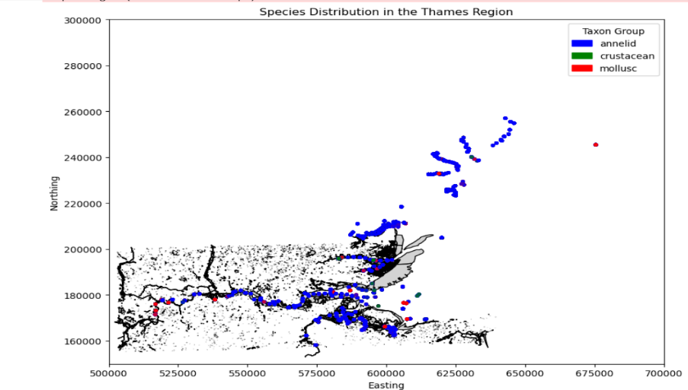**2)**

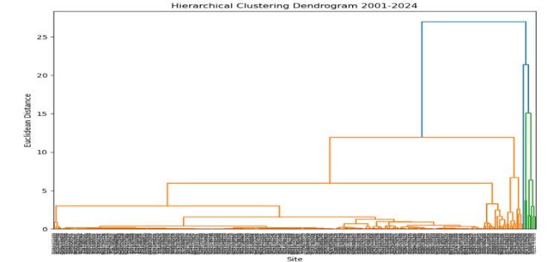

**3)** Across the 2 periods, C1 contains the largest number of sites based on their similarity in taxa abundance. C2,3 & 4 have fewer locations suggesting they represent distinct/less common groupings perhaps due to environmental conditions that differentiate them from the broader spread in C1. Whilst the recent data set introduces 7 new sites, no differences in cluster assignments were found for shared entries.

**4)** ANOVA analysis revealed a significant effect of cluster on crustacean (F3,289= 394.48, P<0.001), annelid (F3,289=226.08, P<0.001) and mollusc abundance(F3,389=892.58, P<0.001).

Tukey HSD Post-Hoc results demonstrates abundances vary across clusters. To briefly summarise, for crustaceans, C3 showed significantly higher abundance, & no significant differences are found between C1,2 & 4. For annelids, differences exist between most cluster pairs except C1 & 4. For molluscs, C4 shows significantly higher abundance versus other clusters with smaller but significant differences observed between C1,2 & 3.

**Summary/Conclusions**

In the absence of a meaningful baseline and ecological parameters, the findings I present, I hope, can be built upon in future research to continue assessments of the current ecological status of the Thames Estuary. I have shown, abundance & percentage decreases in the macrobenthic taxa and provided a visual aid demonstrating where sites clustered together are similar in terms of their taxa abundance across years. The significant differences & patterns of abundances across clusters suggest distinct ecological influences shaping the grouping distributions of these taxa. Future research must therefore consider, environmental & biological drivers of biodiversity or patterns of stress to provide insights into how sites are grouped & abundances are affected.

**References**

1. **Attrill MJ, Bilton DT, Rowden AA, Rundle SD, Thomas RM. The impact of encroachment and bankside development on the habitat complexity and supralittoral invertebrate communities of the Thames Estuary foreshore. Aquatic Conservation: Marine and Freshwater Ecosystems. 1999 Mar;9(2):237-47.**
2. **Ferrero TJ, Debenham NJ, Lambshead PJ. The nematodes of the Thames estuary: Assemblage structure and biodiversity, with a test of Attrill's linear model. Estuarine, Coastal and Shelf Science. 2008 Sep 10;79(3):409-18.**
3. **Attrill M. The benthic macroinvertebrate communities of the Thames estuary. InA Rehabilitated Estuarine Ecosystem: the environment and ecology of the Thames Estuary 1998 (pp. 85-113). Boston, MA: Springer US.**
4. **Wildsmith MD, Rose TH, Potter IC, Warwick RM, Clarke KR. Benthic macroinvertebrates as indicators of environmental deterioration in a large microtidal estuary. Marine Pollution Bulletin. 2011 Mar 1;62(3):525-38.**