

COS700 Research Report
Application of NLP Techniques for Automated Analysis of 5G Network Logs.

Student number: u26621895
Name: Palesa Rose Tladi

Supervisor:
Mr. SM (Sheunesu) Makura

October 2026

Table of Contents
List of figures 4
List of Tables 4
Title 5
Abstract 5
Keywords: 5
Chapter One: Introduction 7
1.1 Introduction 7
1.2 Problem Statement 8
1.3 Research Questions 9
1.4 Motivation 9
1.5 Aims and Limitations 10
1.6 Methodology overview 10
1.7 Dissertation structure 11
1.8 Conclusion 12
Chapter 2: Literature Review and Conceptual Foundation 13
2.1 Introduction 13
2.2 5G network architecture and log sources 13
2.3 Characteristics and challenges of 5G logs 14
2.4 Log anomaly detection 15
2.5 Log preprocessing and representation 16
2.6 Lexical representations 16
2.7 Static semantic representations 17
2.8 Hybrid representation and fusion strategies 17
2.9 Contextual and sequence-aware models 18
2.10 Classifiers and decision thresholds 18
2.11 Research gap and conceptual model 19
2.12 Conclusion 19
Chapter 3: Research Methodology 20
3.1 Introduction 20
3.2 Research design 20
3.3 Dataset and label definition 22
3.4 Unit of analysis and sequence construction 23
3.5 Data preparation 23
3.6 Training, validation, and test split 24
3.7 Feature representations 24
3.8 Classification and contextual models 26
3.9 Experimental matrix 27
3.10 Evaluation metrics 28
3.11 Conclusion 28
Chapter 4: Prototype Design and Implementation 29
4.1 Introduction 29
4.2 Requirements and use cases 29
4.3 Prototype architecture 29
4.4 Processing pipeline 30
4.5 Interface and outputs 31
4.6 Implementation environment 36
4.7 Conclusion 37
Chapter 5: Results and Discussion 38
5.1 Introduction 38
5.2 Results of the Experiments 38
5.2.1 Log-entry experiments 38
5.2.2 Session experiments 39
5.3 Error Analysis 39
5.4 Analysis and Interpretation of Results 42
5.5 Why TF-IDF Performed Strongly 42
5.6 What Each Representation Preserved or Lost 42
5.7 Evaluation of Hybridisation Strategies 43
5.8 Critical Evaluation of the Prototype 43
5.9 Conclusion 44
Chapter 6: Conclusion and Future Work 45
6.1 Introduction 45
6.2 Problem Statement and Research Questions Revisited 45
6.3 Contributions of the Research 46
6.4 Limitations of the Study and Future work 46
6.5 Conclusion 47
References 48

List of figures

Figure 1: Overview of the two research categories 11
Figure 2: Dissertation structure 12
Figure 3: “3GPP 5GS service-based architecture” Reproduced from [15], figure 9. 14
Figure 4: Experimental pipeline and separation of prediction units 21
Figure 5: Distinct implementations of weighting, concatenation and decision fusion 26
Figure 6: Prototype components and local artifact flow 30
Figure 7: Seven-stage interface workflow 31
Figure 8: Raw message, cleaned text and token inspection 31
Figure 9: Dataset context after upload 32
Figure 10: Model configuration controls 32
Figure 11: Completed training and saved experiments 33
Figure 12: Held-out session evaluation in the prototype 33
Figure 13: Comparison of configurations within a selected prototype run 34
Figure 14: Manual message prediction 34
Figure 15: Manual message prediction 35
Figure 16: Dashboard evaluation and complete-dataset prediction counts 35
Figure 17: Record-level prediction explanations 36
Figure 18: Selected confusion matrix comparison from the prototype 41

List of Tables

Table 1: Dataset fields and analytical roles 23
Table 2: Fixed partitions by prediction unit 25
Table 3: Twenty-configuration experiment matrix 28
Table 4: Threshold-specific binary evaluation measures 29
Table 5: Declared prototype implementation environment 37
Table 6: Prototype log-entry results 39
Table 7: Prototype session results 40
Table 8: Error counts for all 20 prototype models 41
Table 9: Information retained and compressed by the implemented representations 44

Title
Application of NLP Techniques for Automated Analysis of 5G Network Logs.

Abstract
Modern 5G networks generate large volumes of semi-structured log data that are difficult to analyse manually due to their scale and complexity. These logs contain critical information for system monitoring, fault diagnosis, and security anomaly detection, making automated analysis essential for reliable network operations. This study investigated Natural Language Processing (NLP) techniques for automated anomaly detection in 5G network logs. A quantitative approach was used with a synthetic dataset of 50,000 5G network log records, produced by a Python generator. The generator assigned normal or abnormal labels to predefined scenarios and rendered messages from fixed templates. Twenty experimental configurations were evaluated across two categories. Category 1 analysed log entries using Term Frequency-Inverse Document Frequency (TF-IDF), Word2Vec, TF-IDF-weighted Word2Vec, feature concatenation and decision fusion with Logistic Regression and Random Forest. Category 2 analysed log sessions using TF-IDF, a LogBERT-style representation, TF-IDF-weighted LogBERT, feature concatenation and decision fusion with Logistic Regression and Random Forest. Results were evaluated using accuracy, precision, recall, F1-score, false-positive rate and confusion matrices. Category 1 achieved its best F1-score of 99.52% using TF-IDF with Logistic Regression, while Category 2 achieved its best F1-score of 99.84% and accuracy of 99.92% using both TF-IDF with Random Forest and TF-IDF–LogBERT-style concatenation with Random Forest. A Flask-based prototype was developed to support preprocessing, model training, evaluation, comparison, manual analysis and explainable predictions. The findings showed that TF-IDF-based representations performed well on the dataset.

Keywords:
NLP, ML, 5G network logs, anomaly detection, TF-IDF, word embeddings, LogBERT, Session-Level Analysis, Random Forest, Logistic regression.

“DECLARATION OF ORIGINALITY
UNIVERSITY OF PRETORIA
The Department of Computer Science places great emphasis upon integrity and ethical conduct in the preparation of all written work submitted for academic evaluation.
While academic staff teach you about referencing techniques and how to avoid plagiarism, you too have a responsibility in this regard. If you are at any stage uncertain as to what is required, you should speak to your lecturer before any written work is submitted.
You are guilty of plagiarism if you copy something from another author’s work (eg a book, an article or a website) without acknowledging the source and pass it off as your own. In effect you are stealing something that belongs to someone else. This is not only the case when you copy work word-for-word (verbatim), but also when you submit someone else’s work in a slightly altered form (paraphrase) or use a line of argument without acknowledging it. You are not allowed to use work previously produced by another student. You are also not allowed to let anybody copy your work with the intention of passing it off as his/her work.
Students who commit plagiarism will not be given any credit for plagiarised work. The matter may also be referred to the Disciplinary Committee (Students) for a ruling. Plagiarism is regarded as a serious contravention of the University’s rules and can lead to expulsion from the University.
The declaration which follows must accompany all written work submitted while you are a student of the Department of Computer Science No written work will be accepted unless the declaration has been completed and attached.
Full names of student: Palesa Rose Tladi
Student number: u26621895
Topic of work: Application of NLP Techniques for Automated Analysis of 5G Network Logs.
Declaration
- I understand what plagiarism is and am aware of the University’s policy in this regard.
- I declare that this …Research Report…… (eg essay, report, project, assignment, dissertation, thesis, etc) is my own original work. Where other people’s work has been used (either from a printed source, Internet or any other source), this has been properly acknowledged and referenced in accordance with departmental requirements.
- I have not used work previously produced by another student or any other person to hand in as my own.
- I have not allowed, and will not allow, anyone to copy my work with the intention of passing it off as his or her own work.
SIGNATURE .....Palesa Tladi.........”

Chapter One: Introduction

1.1 Introduction
Information Technology (IT) is the field concerned with the development and use of computer systems, software, communication networks, and digital technologies for the storage, processing, transmission, and management of data. IT forms the backbone of modern society, enabling industries ranging from healthcare and finance to telecommunications and education to operate efficiently. It supports critical functions such as data analytics, automation, decision-making, and communication, while driving economic growth and digital transformation across sectors [1].
Mobile communication networks represent one of IT's most transformative domains. Since the emergence of the first generation (1G) system in 1981, new generations of wireless networks have appeared approximately every decade [2]. 2G networks introduced digital voice and basic data services, while 3G enabled mobile broadband and multimedia communications. 4G LTE-Advanced systems subsequently delivered peak downlink data rates of 100 Mbps for vehicular mobility and 1 Gbps for pedestrian use [2]. 5G represents a paradigm shift beyond its predecessors, delivering ultra-high capacity, ultra-low latency, and support for three distinct service classes: “Ultra-Reliable Low Latency Communications (URLLC), Massive Machine-Type Communications (mMTC), and Enhanced Mobile Broadband (eMBB)” [1] .
The operation of 5G networks generates vast amounts of network logs that record signalling events, protocol exchanges, network function interactions, traffic patterns, and resource utilisation information [1] . These logs are critical for network monitoring, troubleshooting, anomaly detection, security analysis, and performance optimisation [3]. However, the volume, heterogeneity, and largely unstructured nature of logs in large-scale distributed systems make manual analysis impractical [4]. Traditional rule-based log analysis methods struggle with the complexity of logs generated by 5G networks [5], while virtualised network functions introduce extra security and monitoring challenges [6].
Within artificial intelligence, NLP allows computers to analyse, comprehend, and produce human language [7]. NLP techniques such as tokenisation, feature extraction, word embeddings, text classification, clustering, and deep learning models including Word2Vec, Long Short-Term Memory (LSTM) networks, BERT, and transformer architectures demonstrated capabilities in analysing unstructured textual information [8], [3] . In log analysis, NLP techniques can transform log messages into meaningful representations, automatically identify patterns, classify events, detect anomalies, and extract actionable insights from large volumes of network logs [3], [9]. The application of NLP techniques presents a promising approach for automating the analysis of 5G network logs and enhancing intelligent network management.
Recent log-anomaly research shows that representation and preprocessing are not merely implementation details, they determine which lexical, semantic, temporal and numerical signals remain available to the downstream detector [10], [11]. This supports the present study's comparison of sparse lexical features, static embeddings and contextual session representations.
The remainder of this chapter is structured as follows. Section 1.2 presents the problem statement, Section 1.3 elaborates on the research questions, and Section 1.4 explains the motivation. Section 1.5 defines the aims and limitations, Section 1.6 outlines the methodology, and Section 1.7 presents the dissertation structure. Section 1.8 concludes the chapter.

1.2 Problem Statement
The increasing complexity of 5G networks produces large volumes of heterogeneous log data that are difficult to analyse manually for anomaly detection and security monitoring [1] . Existing log-analysis approaches address this problem by transforming log messages into numerical representations, identifying recurring anomalous patterns and classifying events using lexical, embedding-based and sequence-based models [3] , [9] , [12]. TF-IDF preserves exact terms and local phrases, Word2Vec represents token co-occurrence through learned vectors, and contextual models represent relationships between ordered log events. These approaches have demonstrated the feasibility of applying NLP and machine-learning techniques to automated log analysis, but they preserve different types of information and have different limitations [5] , [9] .
What remains uncertain is whether combining these representations improves anomaly detection under the same experimental conditions. In particular, it is unclear whether TF-IDF, Word2Vec and a LogBERT-style representation provide complementary evidence, or whether the performance of a combined representation depends on the classifier and the prediction unit. A more complex representation may also produce strong results because of stable templates, repeated wording or label-associated features in the dataset rather than because it captures information that generalises to unfamiliar operational logs. Previous studies therefore recommend comparing representations across classifiers, preprocessing choices and evaluation conditions instead of assuming that hybrid or contextual methods will always outperform simpler lexical approaches [13], [11] .
Comparing log-entry-level and session-level detection is necessary because the two prediction units expose different evidence. Log-entry-level detection classifies each message independently, whereas session-level detection represents and classifies an ordered group of related messages. A single message may contain a direct lexical indicator of an anomaly, while a session may provide additional information through the order and combination of its events. The two units can therefore produce different error patterns, and their results should not be treated as interchangeable.
This study addresses the uncertainty through two controlled experiments. The first evaluates individual log entries using TF-IDF, Word2Vec and their hybrid representations, while the second evaluates ordered sessions using TF-IDF and a project-specific LogBERT-style representation together with their hybrid forms. Within each experiment, five representation strategies are paired with Logistic Regression and Random Forest, producing ten configurations per prediction unit. The models are trained and evaluated using fixed training, validation and test partitions. Standalone representations provide reference points for evaluating TF-IDF-weighted features, feature concatenation and probability-level fusion. This design determines whether hybrid representations improve accuracy, recall, F1-score or false-positive rate within the supplied corpus, while recognising that the experiments cannot by themselves establish generalisation to real networks or completely unseen templates.

1.3 Research Questions
The research problem is further addressed through the following research questions

1.3.1 What challenges did 5G network logs present for automated anomaly detection using NLP techniques?
This question concerned the volume, heterogeneity and largely unstructured nature of network logs described in the proposal. The literature review and data preparation informed the discussion of these challenges and their implications for the study.

1.3.2 How could TF-IDF, Word2Vec and a LogBERT-style representation be applied to represent 5G network logs at log-entry and session levels?
This question examined the representation of lexical and semantic information in Category 1, and lexical and contextual information in Category 2. The implementation distinguished individual messages from ordered event sequences rather than treating the two units of analysis as interchangeable.

1.3.3 How did Logistic Regression and Random Forest perform with the selected representations in each research category?
This question was addressed by evaluating the two classifiers with each representation strategy on held-out data. Performance was compared within each category using the selected evaluation metrics.

1.3.4 To what extent is it feasible to develop a hybrid NLP-based anomaly detection model that improves classification accuracy and overall performance in 5G network log analysis?
This question explored the feasibility of developing a hybrid NLP-based model that combines multiple feature representation techniques to enhance anomaly detection performance. It aimed to determine whether integrating lexical and semantic features can improve classification accuracy and robustness in 5G network log analysis.

1.4 Motivation
This study was motivated by the increasing complexity of 5G networks and the large volumes of heterogeneous logs that make manual anomaly detection difficult [1] . NLP can transform these logs into machine-readable representations, but it remains uncertain whether lexical, semantic and contextual representations provide complementary information or whether their performance depends on the classifier and prediction unit [9], [13], [11] .

1.5 Aims and Limitations
The aim of this study was to investigate the application of NLP techniques for automated anomaly detection in 5G network logs. The objectives were to prepare the log data, implement the selected representations and compare their performance across two research categories. The first category examined individual log entries using TF-IDF and Word2Vec, while the second examined sessions using TF-IDF and a LogBERT-style model. Each category compared standalone representations with hybrid strategies using Logistic Regression and Random Forest. Performance was evaluated using accuracy, precision, recall, F1-score and false-positive rate to determine whether combining lexical information with semantic or contextual information improved anomaly detection.
The research was limited to a single synthetic 5G network log dataset, which may not fully represent the diversity and complexity of real-world network environments. The supervised classification approach depended on the quality and availability of labelled data, and the evaluation was restricted to Logistic Regression and Random Forest. The LogBERT-style model was a project-specific implementation, which limited the extent to which its findings could be generalised to other contextual models. Furthermore, log-entry and session-level results represented different prediction units and therefore required separate interpretation. The study did not evaluate the methods in a live 5G network, so their operational performance and generalisability remained unverified.

1.6 Methodology overview
A structured experimental approach was adopted to evaluate the effectiveness of NLP techniques for anomaly detection in 5G network logs. The investigation combined a literature study, prototype implementation, experimentation and critical evaluation. The literature study informed the choice of representations and the interpretation of their limitations. The prototype supported the practical application and comparison of the selected techniques.
At log-entry level, each cleaned message was represented and classified individually. At session level, the messages sharing a session identifier were ordered by timestamp and classified as one unit with a common label. TF-IDF used the joined session text, while the contextual encoder used the ordered template identifiers. Training, validation and test partitions were kept separate by scenario and session. Representations and classifiers were fitted on training data, validation data supported threshold and fusion-weight selection, and the held-out test partition supported final comparison.

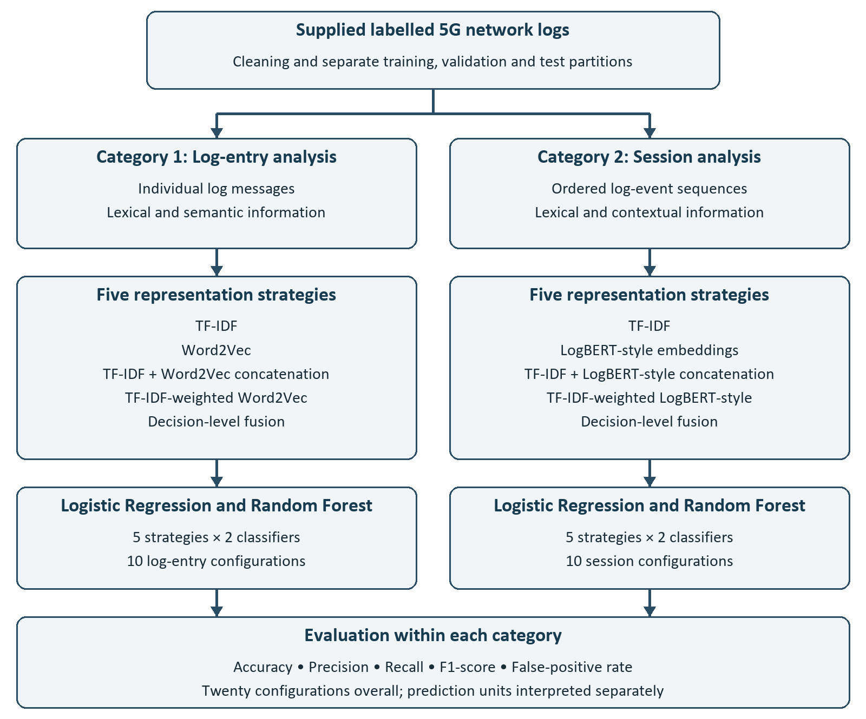
Figure 1: Overview of the two research categories
Figure 1 shows how the same generated corpus supports two separate experiments. The left branch represents individual entries using TF-IDF or Word2Vec; the right branch represents sessions using TF-IDF or the custom contextual encoder. Within each branch, two standalone representations and three hybrid constructions are paired with LR and RF, giving ten configurations per category. Evaluation at the bottom of the figure is performed within each prediction unit, so a session score is not treated as directly interchangeable with an entry score.

1.7 Dissertation structure
The dissertation is organised into six chapters. Chapter 1 introduces the research problem, motivation, research questions, aims, limitations and methodological approach. The remaining chapters are organised as follows:
Chapter 2: Literature Review and Conceptual Foundation reviews the literature on 5G network logs, natural language processing representations, anomaly detection, hybrid representation strategies and the conceptual foundations of the study.
Chapter 3: Research Methodology describes the research design, dataset, preprocessing procedures, experimental categories, text representations, classifiers and evaluation methods used in the investigation.
Chapter 4: Prototype Design and Implementation presents the design and implementation of the prototype developed to support the automated analysis and classification of 5G network logs.
Chapter 5: Experimental Results presents and analyses the results of the log-entry-level and session-level experiments. It compares the performance of the different representation strategies and classifiers, examines their prediction errors, and discusses the findings in relation to the research questions and limitations of the experimental dataset.
Chapter 6: Conclusion and Future Work summarises the main findings and contributions of the study, revisits the research questions, discusses the limitations of the research and identifies opportunities for future investigation.
Figure 2 illustrates the structure of the dissertation and the progression of the research. The study moves from the research problem and theoretical foundation to the methodology and prototype implementation. The experimental results are then presented and analysed before the dissertation concludes with the main findings, limitations and recommendations for future work.
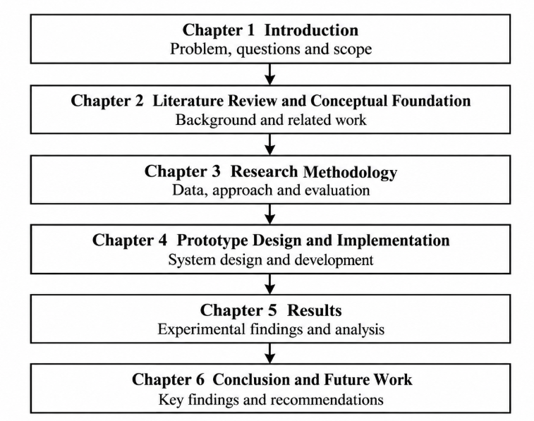
Figure 2: Dissertation structure

1.8 Conclusion
This chapter defined the research problem, four questions and two prediction units. The study compares standalone and hybrid representations within a controlled synthetic setting and distinguishes technical feasibility from measured improvement. Chapter 2 develops the literature and conceptual rationale for that comparison.

Chapter 2: Literature Review and Conceptual Foundation

2.1 Introduction
The growing complexity of 5G networks has increased the volume of network logs generated during normal operations. These logs contain valuable information for anomaly detection, fault diagnosis, and security monitoring. Consequently, researchers have explored the use of NLP and ML techniques to automate log analysis.
The remainder of this chapter is structured as follows. Section 2.2 presents the 5G network architecture and log sources, Section 2.3 considers log characteristics and challenges, and Section 2.4 introduces anomaly detection. Sections 2.5–2.9 examine preprocessing, lexical features, static embeddings, hybrid strategies and contextual models. Section 2.10 considers classifiers and thresholds, Section 2.11 connects the research gap to the experiments, and Section 2.12 concludes the chapter.

2.2 5G network architecture and log sources
The fifth generation of mobile communication networks represents a major advancement in wireless communications, supporting ultra-low latency, high data rates, enhanced reliability, and connectivity for diverse applications, autonomous systems, and smart industries [2]. Unlike previous generations, 5G is a heterogeneous “network of networks” integrating multiple radio access technologies and network functions to meet increasing traffic and service demands. It enables data rates of several gigabits per second and millisecond-level end-to-end latency [2]. Its architecture supports three key service categories: URLLC, mMTC, and eMBB, each with distinct performance requirements [2].
The 5G Core (5GC) uses virtualized Network Functions (NFs) within a Service-Based Architecture (SBA), supporting interactions between components such as the AMF, SMF, UPF, UDM, and NWDAF, which generate operational records and event logs [1] . These logs capture signalling procedures, resource utilization, network performance, user activities, and fault events, supporting network monitoring and management [1] . Network slicing further enables a single physical network to be divided into multiple logical networks, each optimized for specific Quality of Service (QoS) requirements [14]. Together, this architectural complexity and the growing number of connected devices contribute to the large volume and diversity of operational logs generated by 5G systems.
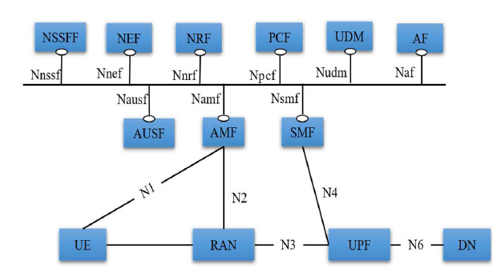
Figure 3: “3GPP 5GS service-based architecture” Reproduced from [15], figure 9.

Figure 3 distinguishes service-based control-plane functions from the user-data path. AMF manages access and mobility, SMF manages sessions and controls UPF through N4, while UPF connects the access and data networks through N3 and N6. Supporting functions provide services such as authentication, subscriber data, policy, discovery and exposure. This simplified non-roaming view provides architectural context rather than representing an implemented test network [15].
The NWDAF, proposed by 3GPP and implemented by [1] in an open-source 5G core, centrally collects and analyses network function data. Its case study shows that functions such as the Binding Support Function (BSF) generate structured, periodic control messages that can reveal network status and support proactive management.
Although this architecture describes operational 5G systems, the experimental corpus contains generated text labelled with AMF, AUSF, NRF, NSSF, PCF, SCP, SMF, UDM and UPF names, alongside UE and gNB records. It represents selected registration, authentication, session, mobility, policy and health scenarios through templates. It does not capture deployed-core traffic, execute network functions, or measure actual network slicing, latency or NWDAF behaviour. Therefore, the architecture provides domain context rather than evidence that the experiment reproduces a complete 5G deployment.

2.3 Characteristics and challenges of 5G logs
The exponential growth of data makes traditional log inspection methods insufficient. As [5] note, manual and rule-based approaches struggle to process the large volumes of diverse log data generated in 5G environments. Even a single user equipment registration process can produce numerous records documenting device activities and interactions with network components. Anomalies caused by network disruptions, security breaches or misconfigurations must therefore be detected within high-volume, unstructured log streams. Automated analysis has consequently become essential for maintaining network reliability and security.
5G log analysis presents challenges arising from the scale, complexity and dynamic nature of these networks. [3] identify key difficulties, including heterogeneous log structures, interleaved events from concurrent processes, and the need to combine messages, parameter values and timestamps to accurately identify anomalies.
One major challenge is the volume of data generated by interconnected network functions, devices and services. [1] explain that the scale and speed of log generation make manual analysis impractical, necessitating automated approaches that can process large datasets efficiently while maintaining acceptable computational costs.
The dynamic nature of 5G networks also creates difficulties. Changing configurations, services and operational behaviours introduce new vocabularies and event patterns. [4] highlights that out-of-vocabulary (OOV) token rates can increase when models are applied across different datasets or environments. Similarly, [9] note that large-scale systems generate numerous distinct event types, increasing computational complexity and limiting generalisability. Although embedding-based and hybrid approaches improve robustness to vocabulary changes, performance can still decline in previously unseen environments [4] .
Recent studies further connect representation quality with vocabulary changes. Wu, Li and Khomh found that representation techniques differ in handling data shifts and OOV effects, while Khan et al. showed that template distinguishability can be more important than parsing accuracy alone [13], [11] . These findings inform the present study's audits of repeated strings, template overlap and unseen tokens.
These challenges motivate several design choices. Variable identifiers are normalised to limit vocabulary growth, while severity, negation and technical terms are retained. Separate entry and session experiments examine prediction units, while vocabulary coverage and template-overlap audits assess repeated and unfamiliar inputs. However, the 50,000-record corpus and short generated sessions do not constitute throughput, concept-drift or long-procedure benchmarks; these operational challenges remain outside the evaluation.

2.4 Log anomaly detection
The complexity of modern 5G networks creates additional security challenges for anomaly detection. [16] explain that their software-defined and virtualised nature increases exposure to vulnerabilities and malicious activities. Their analysis of srsRAN logs showed that subtle deviations in protocol-level exchanges could reveal potential vulnerabilities under fuzzing conditions. However, [17] highlight that machine-learning-based security solutions must adapt to evolving attacks, as models trained on historical data may fail to detect emerging threats. Anomaly detection systems must therefore recognise both known and previously unseen abnormal patterns.
Supervised machine learning offers potential for addressing these challenges, but its effectiveness depends on the availability of accurately labelled training data.[18] demonstrated its potential by evaluating Multilayer Perceptron, Decision Tree and Support Vector Machine classifiers on real-world O-RAN Key Performance Indicator datasets, achieving a peak accuracy of 99.95%. However, their study focuses on structured KPI data rather than unstructured network logs and does not explore NLP-based representations. This highlights the need to investigate NLP techniques for the automated detection of anomalies in textual 5G network logs.

2.5 Log preprocessing and representation
5G network logs are semi-structured textual records that capture system states, events and control-plane signalling across network functions [3] . Their volume, velocity and unstructured nature create representation challenges, as raw text must be converted into numerical features before machine learning models can process it [9] . NLP provides techniques for extracting meaningful information from these logs and supporting automated anomaly detection. This approach is supported by [3], whose DeepLog framework demonstrated that log events follow grammar-like sequential patterns that can be modelled using NLP techniques.
However, 5G logs contain diverse information, including timestamps, identifiers, variable parameters, protocol messages and free-text descriptions that vary across components and vendors [9] . They must therefore be cleaned, parsed and transformed into suitable representations before analysis. Although log parsing can expose stable event structures, incorrectly separating fixed and variable content may remove useful information. KELog addresses this through a keyword library, information-fusion layer and auxiliary masked-key task to preserve keyword information [19] . This provides a comparison for the present preprocessing approach, which retains selected terms while replacing numeric values with a common placeholder.
Preprocessing also influences the information available to each representation method. In this study, cleaning affects the features retained by TF-IDF, while tokenisation determines the contexts used by Word2Vec. Replacing identifiers and numbers reduces sparsity but removes original identities and magnitudes, while averaging word vectors removes token order. The contextual branch uses generator-supplied template identifiers rather than parser-generated templates, providing event-key sequences without the full log text. Session construction further determines which events are grouped and their order. These differences must therefore be considered when interpreting the results, as performance reflects both preprocessing choices and representation techniques.

2.6 Lexical representations
Early NLP-based log analysis relied on frequency-based representations such as Bag-of-Words (BoW), which represents log entries using term or event frequencies [9] . TF-IDF builds on this approach by assigning higher weights to rare, informative terms while reducing the influence of frequently occurring terms [9] . Techniques such as LogClass and LogCluster have used TF-IDF and related weighting methods to convert log sequences into features for machine-learning classification and anomaly detection [9].
Several studies demonstrate the effectiveness of TF-IDF in log analysis. [9] incorporated TF-IDF into the LogEvent2vec framework, using the resulting vectors as inputs to supervised models such as Random Forest and Neural Networks. These applications demonstrate its computational efficiency and practical value. However, TF-IDF relies on term-frequency statistics and therefore cannot capture semantic relationships or contextual dependencies between log events.
The underlying weighting principle is that informative terms should receive greater influence than terms occurring frequently across a collection [20]. Furthermore, Wang and Manning showed that incorporating word bigrams can improve classification performance in suitable short-text tasks, supporting their use for capturing recurring multiword expressions in log data [21].

2.7 Static semantic representations
To address TF-IDF's limitations, researchers introduced word embeddings, which represent words and events as vectors in a continuous space, allowing semantically similar terms to be positioned closer together. Word2Vec, proposed by [22] demonstrated that neural language models can learn semantic relationships from large text corpora and outperform traditional N-gram approaches. In log analysis, Word2Vec captures relationships between events that frequency-based methods may overlook, while Template2Vec and LogAnomaly use embeddings to extract semantic information from log templates for anomaly detection [9].
However, Word2Vec has limitations. Although it learns semantic and syntactic relationships from local context, ordinary word representations are relatively insensitive to word order and may not adequately represent multiword phrases [23]. This is particularly relevant when averaged token vectors are used to represent entire log entries.
In this study, Word2Vec was trained from scratch on cleaned training logs using 100-dimensional skip-gram vectors over ten epochs, rather than a general-language pretrained model. Each entry was represented by averaging its available token vectors, with unknown tokens omitted and all-unknown entries assigned zero vectors before scaling. Consequently, its results evaluate a small, domain-specific co-occurrence representation rather than general semantic understanding or robustness to unseen network terminology.

2.8 Hybrid representation and fusion strategies
Hybrid representations combine frequency-based and semantic approaches to capture both informative log terms and contextual relationships. [4] identifies hybrid embeddings, which integrate semantic word vectors with TF-IDF weighting, as an emerging direction in log anomaly detection. Supporting this approach, [9] demonstrates through LogEvent2vec that applying TF-IDF weighting to Word2Vec-generated event vectors can produce effective log sequence representations, particularly when combined with Random Forest classifiers. These findings suggest that hybrid methods can balance semantic information and discriminative feature weighting.
In this study, the hybrid representation combines TF-IDF scores with word embeddings, weighting embedding vectors according to the importance of terms within the corpus. This approach addresses limitations associated with relying exclusively on frequency-based or semantic representations [4] , [9] . However, its effectiveness is not guaranteed across all datasets and models. Wu, Li and Khomh found that feature aggregation and representation performance vary depending on the dataset and downstream model. Similarly, Yaker et al. demonstrated that combining TF-IDF with sentence-transformer representations improved unsupervised detection in a private 5G core setting, where statistical attack signatures and semantic context provided complementary information [11], [24].

2.9 Contextual and sequence-aware models
Contextual language models improve on static embeddings by considering surrounding words. BERT, introduced by [8], uses bidirectional context to capture relationships between preceding and succeeding words. In comparing TF-IDF, Word2Vec and BERT, [25] found that BERT achieved higher classification performance, although contextual representations require greater computational resources.
LogBERT applies contextual learning to log anomaly detection through masked log-message prediction and hypersphere-volume minimisation, identifying sequences that deviate from normal behaviour [12]. Similarly, Janus uses separate attention masks to capture procedural order and critical field-level consistency in cellular networks [26]. These approaches demonstrate the value of contextual information in log analysis.
This study adopts masked event-key prediction and a normal-session compactness objective inspired by LogBERT. Its two-layer Transformer extracts 64-dimensional features for classification using Logistic Regression (LR) or Random Forest (RF). However, it does not use pretrained BERT or reproduce the published LogBERT system. Instead, it processes generated template keys in five-to-seven-event sessions. Its results therefore evaluate the implemented approach, not the original LogBERT model.
Representation performance also varies across classifiers and applications. [25] found that TF-IDF, Word2Vec and BERT produced different results across classifier combinations, supporting comparative evaluation. Additionally, [27] introduced the Transformer architecture, which uses self-attention mechanisms to model relationships between tokens in a sequence. This enables the model to capture contextual dependencies without relying on recurrent processing.

2.10 Classifiers and decision thresholds
Machine learning (ML) is widely used for automated log anomaly detection, classifying normal and abnormal network behaviour using extracted features [9]. Its effectiveness depends on both the classification algorithm and the quality of the feature representations, making the comparison of NLP-based representations important for anomaly detection.
Logistic Regression (LR) and Random Forest (RF) are commonly used supervised classifiers. LR provides an interpretable probabilistic baseline, while RF captures complex, non-linear relationships and handles high-dimensional feature spaces [9]. RF also demonstrates robustness to noisy and incomplete data, making it suitable for network environments [28]. Its effectiveness in detecting denial-of-service, malware and intrusion attacks in 5G traffic further supports its application to security-related anomaly detection [28]. Similarly, [17] report strong performance from LR and RF in intrusion detection, supporting their selection as the primary classifiers in this study. Their suitability for NLP-based 5G log analysis is further demonstrated by [16], who applied NLP vectorisation and machine-learning classifiers to srsRAN 5G platform logs. Both LR and RF achieved high classification accuracy, with RF generally delivering the strongest results.

2.11 Research gap and conceptual model
Recent studies demonstrate NLP applications in 5G environments. [16] applied NLP-based text vectorisation and machine-learning classifiers to fuzzing-generated srsRAN runtime logs to detect potential vulnerabilities, while [5] applied Bag-of-Words and machine learning to 5G registration logs, noting limitations in capturing semantic information. Beyond log analysis [29] introduced SPEC5G, an NLP dataset for 5G specifications, while [7] identified text classification, masked language modelling and TF-IDF as useful for automated 5G security assessment.
However, representation effectiveness varies. Preprocessing, grouping and evaluation design influence detection performance, and simpler methods can remain competitive [10] . Similarly, [4] found differences in the performance of template-based, semantic and hybrid representations. This supports comparing TF-IDF, Word2Vec and TF-IDF-weighted embeddings rather than assuming hybrid methods are superior.
Limited research has systematically compared these representations for 5G log anomaly detection using both Logistic Regression and Random Forest. This study addresses this gap while also considering explainability. [30] highlight that anomaly detection often prioritises accuracy over evidential integrity and interpretability. Their DFR-BUST framework emphasises structured analysis and meaningful explanations of abnormal behaviour.
The study investigates whether lexical and embedding features complement one another through twenty configurations presented in Table 3. Research Question 1 examines preprocessing and data quality; Question 2 compares entry and session representations; Question 3 evaluates Logistic Regression and Random Forest; and Question 4 assesses hybrid representations against their standalone components. The evaluation uses generated data and does not claim universal representation superiority, real-network generalisation or replication of published LogBERT.

2.12 Conclusion
The literature establishes that lexical, embedding and sequence representations can support log anomaly detection, but their relative value depends on preprocessing, input information, classifiers and evaluation conditions. This motivates a controlled comparison in which hybrid gains are measured against standalone components and findings are bounded by the dataset. The next chapter translates that rationale into explicit prediction units, fixed partitions, model configurations and evaluation rules.

Chapter 3: Research Methodology

3.1 Introduction
The study evaluated how lexical, static semantic and contextual representations affected supervised anomaly detection in 5G network logs. The completed investigation comprised two controlled comparisons: ten configurations operating on individual log entries and ten configurations operating on sessions. Each comparison paired five representation strategies with Logistic Regression (LR) and Random Forest (RF). The completed experiments used 50,000 synthetic textual logs produced by a python log generator. Feature concatenation and decision fusion supplemented the original representations, and a custom LogBERT-style session encoder extended the comparison.
The remainder of this chapter is structured as follows. Section 3.2 defines the research comparison design, Sections 3.3–3.6 explain dataset generation, prediction units, preprocessing and partitioning. Sections 3.7–3.9 describe representations, models and experimental configurations. Section 3.10 defines evaluation and selection procedures, and Section 3.11 concludes the chapter.

3.2 Research design
A quantitative, supervised comparative design was used to evaluate NLP representations for binary anomaly detection. A synthetic dataset containing 50,000 5G network log records was generated locally using the Python script 5g_log_dataset_generator.py with the default generation seed 7002026. Normal records were assigned to class 0 and abnormal records to class 1. The records were grouped into 8,326 sessions. Log-entry experiments used 35,000 training, 7,500 validation and 7,500 test entries, while session experiments used 5,834 training, 1,246 validation and 1,246 test sessions. The supplied partitions were retained, and the prototype used random seed 42 for partitioning and model training.
The study used two experimental categories: individual log-entry analysis and session-level analysis. Within each category, all configurations used the same observations, partitions, labels, random seed and evaluation rules. Representation-specific preprocessing was then applied to create the model inputs. Five representation strategies were evaluated: TF-IDF, an embedding representation, feature concatenation, weighted embeddings and decision fusion. TF-IDF used unigrams and bigrams with a minimum document frequency of two. Word2Vec was used for individual log entries with 100-dimensional vectors and ten training epochs. For sessions, a custom LogBERT-style Transformer used ordered template keys, a 64-dimensional output and a maximum sequence length of seven events. Feature concatenation combined scaled lexical and embedding features, while weighted embeddings applied inverse-document-frequency weights before pooling. Decision fusion combined the probability outputs of the corresponding standalone models.
Each representation was paired with Logistic Regression and Random Forest, producing ten configurations per category and twenty configurations overall. Random Forest used 300 trees in the recorded research runs. Models were compared within their category because an individual log entry and an ordered session are different prediction units. Session TF-IDF models received joined session message text, whereas LogBERT-style models received ordered template-key sequences.
Representations and classifiers were fitted using the training partition. Feature transformations were fitted on training data only. Classification thresholds and decision-fusion weights were selected using validation data, and the held-out test partition was used only for final evaluation. Accuracy, precision, recall, F1-score and false-positive rate were calculated from the test predictions, with F1-score used as the primary descriptive comparison measure. This design enabled each hybrid strategy to be compared with its corresponding standalone representations under consistent conditions.
Only one training seed was recorded, and the two session representation families used different input forms. The experiments therefore do not establish statistical significance, universal representation superiority or generalisation to unseen operational logs. They provide a controlled comparison of the implemented prototype configurations on the supplied dataset.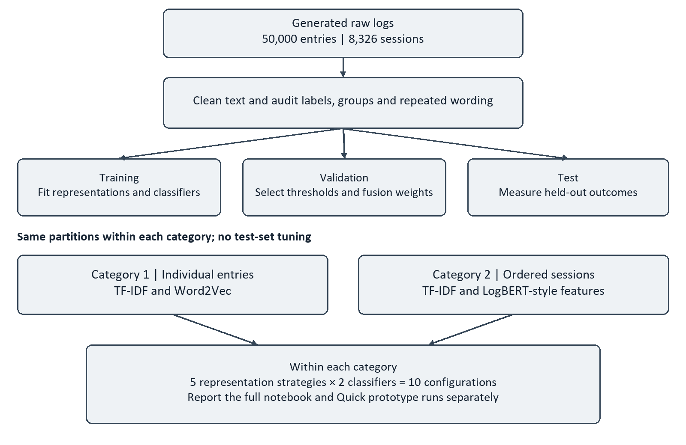
Figure 4: Experimental pipeline and separation of prediction units
Figure 4 traces the prototype experiment from uploaded records through cleaning and auditing to the fixed partitions. The training branch fits representations and classifiers, the validation branch selects thresholds and fusion coefficients, and the test branch measures the resulting decisions. The lower branches separate individual entries from ordered sessions and apply the same five-by-two comparison structure within each. All configurations in one category use the same partition; scores from the two prediction units are interpreted separately.

3.3 Dataset and label definition
The study dataset contained 50,000 generated records, comprising 37,500 normal records and 12,500 abnormal records. The raw CSV contained ten fields: timestamp, network_function, severity, log_text, label, anomaly_type, scenario_id, session_id, template_id and split. The prototype accepts raw messages or supplied clean_text. data.py preserves the uploaded fields and adds internal modelling and audit fields, including _text, _target, _session, _template, _timestamp and _split.
The study used a locally generated synthetic corpus. The dataset construction described eighteen predefined event categories: eight normal procedures and ten abnormal scenarios. Each category supplied four message patterns and four detail endings, giving 16 template combinations per category and 288 template identifiers overall. Scenario plans fixed the class and partition quotas before messages were rendered. Each plan generated a five-to-seven-record session with shared identifiers and ordered timestamps. A record's binary label was inherited from its scenario category; labels were not assigned by expert annotation of observed incidents. The prototype imports this corpus and does not generate it during upload or training.
Table 1 separates modelling inputs from supervisory and audit metadata. data.py uses supplied clean_text when present; otherwise it cleans the selected message field into _text. Binary labels are mapped to _target. The contextual branch uses template_id within groups defined by session_id, with timestamp supplying order. scenario_id and split protect partition boundaries, while anomaly_type supports descriptive auditing. Severity and network-function wording may also occur in log_text and survive cleaning, so excluding their separate columns does not exclude those signals from text classification.
Table 1: Dataset fields and analytical roles
Fields | Role
log_text; clean_text; _text | Original message and normalised modelling input
label; target; _target | Ground truth; normal = 0 and abnormal = 1
timestamp | Event ordering and audit context
session_id; scenario_id | Grouping and partition-integrity checks
template_id | Ordered event key for the contextual session encoder
network_function; severity | Retained metadata; corresponding wording also occurs in messages
anomaly_type | Known scenario category for descriptive analysis
split | Fixed train, validation or test assignment

The generator assigned severity from class-specific quotas: normal records included 27,000 INFO, 6,000 DEBUG, 4,000 NOTICE and 500 WARNING messages; abnormal records included 500 INFO, 4,500 WARNING, 6,500 ERROR and 1,000 CRITICAL messages. Severity was therefore strongly label-associated, although 1,000 exceptions prevented it from being a perfect rule. Label-specific success and failure wording also remained. Training and test shared template families, so generalisation to wholly unseen templates was not established.

3.4 Unit of analysis and sequence construction

Category 1 used a single cleaned log message as one sample. Only _text was passed to its text representations; _target supplied the outcome. Scenario IDs, session IDs, template IDs, the split field and anomaly categories were retained for grouping and auditing rather than appended as predictive text.
Category 2 grouped records by session_id and sorted their events by timestamp. A session was required to belong to one partition and one label. Its lexical input joined cleaned messages with an [EVENT] separator. Its contextual input comprised the ordered template_id sequence. This produced 8,326 sessions, with lengths of five to seven events and a mean of approximately 6.01 events. There were 5,834 training sessions, 1,246 validation sessions and 1,246 test sessions.
The session representations received different evidence: TF-IDF used joined message text, while the Transformer used ordered template keys. The keys were generated metadata rather than parser outputs. Short sessions did not establish performance on long-range procedural dependencies [12], [26].
Mixed-label or cross-partition training sessions raise an error. The encoder prepends [DIST], uses [PAD] for padding, maps unseen keys to [UNK] and truncates beyond the maximum training length. Missing genuine session/template identifiers disable session training. Invalid timestamps are audited and sort to the end. These fallbacks do not establish reliable detection of incomplete operational procedures.

3.5 Data preparation

data.py first checks the required columns and removes only exact duplicate source rows. It retains original row identities and rejects blank messages, invalid binary labels and identical raw messages with contradictory labels. If clean_text is supplied, it is retained as _text without applying the cleaner again. Otherwise, leading timestamps are removed and text is lowercased. Ordered replacement rules normalise SUPI, GUTI, session, gNB, cell, network-function-instance, policy, security-context, UE-group and slice identifiers to named placeholders before address and numeric replacement.
The address rule matches dotted addresses beginning with 10, 172 or 192, with an optional port; it is a pattern replacement rather than validation of private-address ranges. Remaining standalone integer and decimal values become num_value. Other punctuation is replaced by spaces, hyphens become underscores and repeated whitespace is collapsed. Empty cleaned messages raise an error. Labels are mapped to normal = 0 and abnormal = 1. Timestamps are parsed with invalid values recorded as missing, and events are stably ordered within sessions. Word2Vec tokenisation splits on whitespace, whereas TF-IDF constructs word unigrams and bigrams.
Severity words, technical terms, operational verbs and negation were retained. Stop-word removal and stemming were not applied. These choices preserved words such as error and failure, together with expressions of successful operation. However, normalising numbers also removed exact numeric magnitudes, so a representation could not recover a latency or utilisation threshold that had already been replaced by num_value. [19]

3.6 Training, validation, and test split

Table 2 reports 35,000/7,500/7,500 entries and 5,834/1,246/1,246 sessions. Variable session lengths explain the different counts. Supplied partitions are used by default; custom splitting keeps connected scenario/session groups together and approximates requested proportions. Group isolation does not remove shared templates or cleaned wording.
Table 2: Fixed partitions by prediction unit
Partition | Logs | Normal | Abnormal | Sessions | Normal | Abnormal
Train | 35,000 | 26,250 | 8,750 | 5,834 | 4,374 | 1,460
Validation | 7,500 | 5,625 | 1,875 | 1,246 | 936 | 310
Test | 7,500 | 5,625 | 1,875 | 1,246 | 936 | 310

3.7 Feature representations

TF-IDF used word unigrams and bigrams, a minimum document frequency of two and sublinear term-frequency scaling. The maximum vocabulary was 20,000 features for individual entries and 25,000 for sessions. The fitted vocabulary and inverse-document-frequency values were learned from the training partition and reused for validation and testing. Character n-grams were not included in the completed matrix.
For a term t occurring c times in document d, the sublinear term-frequency component is 1 + ln(c) when c is positive. Smoothed inverse document frequency is idf(t) = ln((1 + N)/(1 + df(t))) + 1, where N is the number of training documents and df(t) counts training documents containing t. The resulting TF-IDF vector uses L2 normalisation. These settings preserve exact words and short phrases while reducing the relative influence of repeated terms [20] , [21].
Word2Vec used 100-dimensional skip-gram vectors, a context window of five, minimum count two, one worker and seed 42. The prototype trains for five epochs in Quick or ten in Research. An entry is the arithmetic mean of its in-vocabulary token vectors; an entry with no usable vectors receives a zero vector before scaling. A StandardScaler is fitted to training representations and reused for the other partitions. Averaging does not retain the original order of tokens [23] .
The method labelled TF-IDF-weighted Word2Vec was implemented as an IDF-weighted average over token occurrences. Each usable occurrence contributed its word vector with the corresponding training-corpus IDF weight. Repeated occurrences contributed repeatedly. The implementation therefore did not multiply each vector by the complete sublinear, L2-normalised document TF-IDF value. This precise distinction was retained when interpreting the hybrid method.
Feature concatenation joined the sparse TF-IDF vector to the scaled embedding vector, preserving both feature blocks as separate coordinates. Decision fusion instead combined independently fitted classifiers: p_fused = alpha × p_TFIDF + (1 − alpha) × p_embedding. The lexical coefficient alpha and the final classification threshold were selected on validation data.
The session embedding used the hidden state at a leading [DIST] token from the custom Transformer. The weighted session variant averaged contextual event vectors using training-fitted IDF values for template keys. These vectors were scaled using training statistics. The weighted variant, concatenated variant and decision-fusion variant were distinct constructions, and none was treated as interchangeable with another hybrid.
With V lexical features, TF-IDF produces V coordinates, Word2Vec produces 100, and entry concatenation produces V + 100. Session vectors contain 64 coordinates, giving V + 64 after concatenation. Seven event keys plus [DIST] produce an 8-by-64 hidden array for this corpus. engine.py stores fitted dimensions in feature_info. Fusion combines two probabilities rather than feature coordinates.
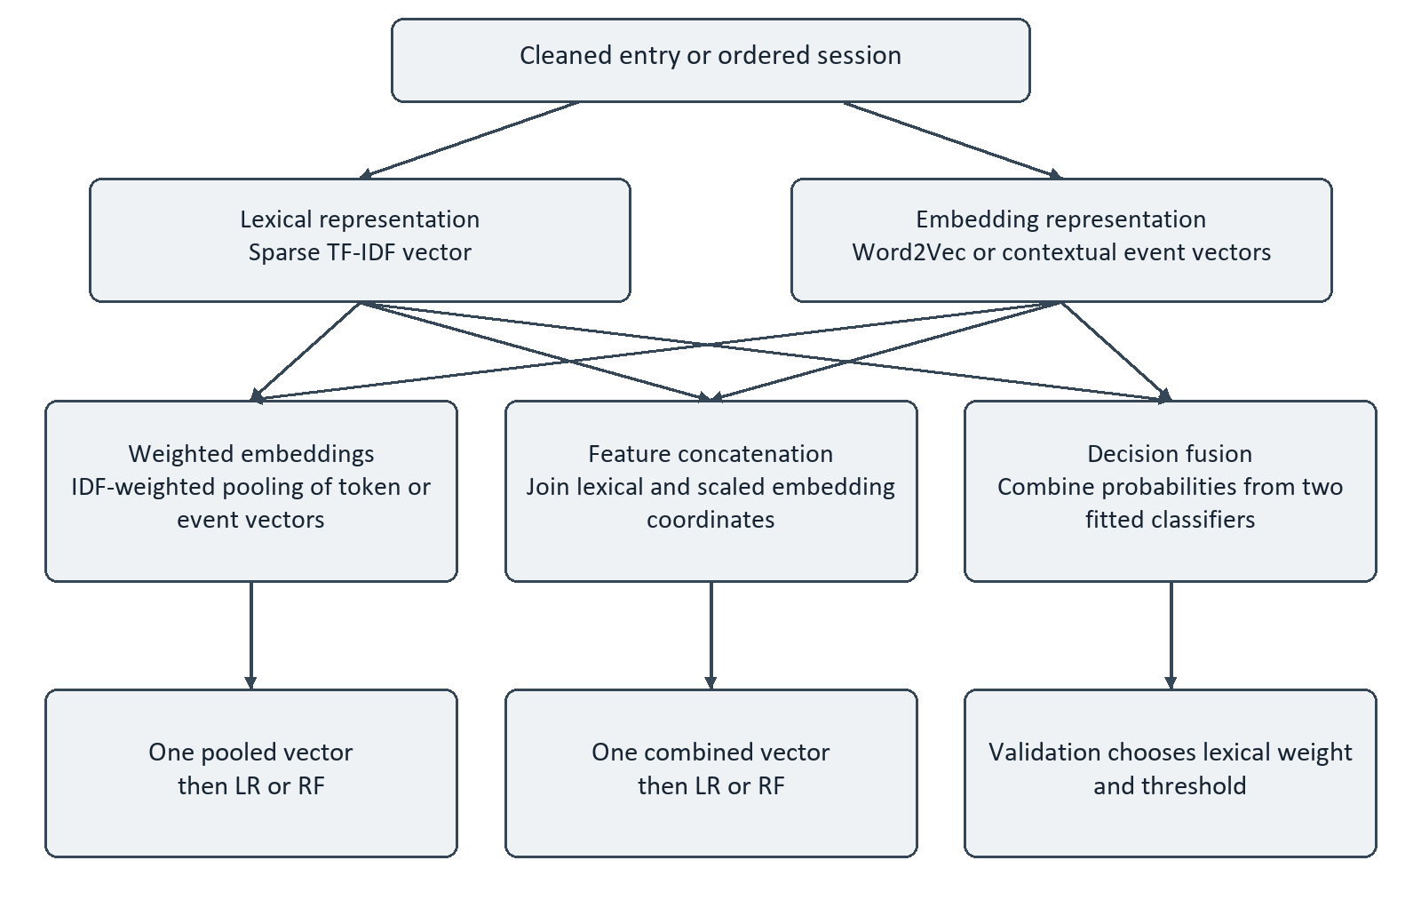
Figure 5: Distinct implementations of weighting, concatenation and decision fusion
Figure 5 distinguishes three constructions often grouped under the word hybrid. Weighted pooling combines token or event vectors into a single fixed-size embedding, using IDF to change their contribution; it does not preserve the original sparse lexical coordinates. Concatenation keeps lexical and embedding blocks as separate input coordinates for one classifier. Decision fusion fits two classifiers independently and combines their probabilities, with the lexical coefficient and threshold chosen on validation data. These paths preserve different information and must be evaluated separately.

3.8 Classification and contextual models

LR used the liblinear solver, balanced class weights, a maximum of 2,000 iterations and seed 42. RF used balanced_subsample class weights, parallel tree fitting and the same seed. app.py sets 120 RF trees in the Quick profile and 300 in the Research profile. The settings support comparison between a linear classifier and a tree ensemble.
The custom LogBERT-style encoder used 64-dimensional token and position embeddings, two Transformer layers, four attention heads, a 256-unit feed-forward layer, GELU activation and dropout of 0.10. It predicted masked log keys and applied a compactness penalty to the [DIST] representation of normal sessions. The loss combined masked-key cross-entropy with 0.10 times the compactness loss.
The implementation is conceptually related to LogBERT because it learns from masked event keys and normal-session structure, but it is not a reproduction of the published LogBERT architecture. LogBERT uses masked log-message prediction together with hypersphere-volume minimisation, whereas the present encoder used the project-specific masked-key and compactness objectives described above [12] .
Training masked approximately 30% of event positions. AdamW used a learning rate of 0.001 and weight decay of 0.0001; gradient norms were clipped to 1.0. Batch size was 256. Quick allowed five encoder epochs and Research allowed twelve, with early-stopping patience three. The checkpoint with the lowest normal-validation loss was retained. Special tokens handled padding, the sequence summary, masking and unknown keys. Sequence length was bounded by the maximum training-session length.
The compactness centre is the mean initial [DIST] representation of normal training sessions and remains fixed. Training updates embeddings, Transformer layers, normalisation and the masked-key head. After checkpoint selection, the encoder runs in evaluation mode. LR and RF receive extracted hidden features, rather than masked-key logits, and fit on both normal and abnormal training labels.

3.9 Experimental matrix
Each category contained the same five representation families crossed with two classifiers. The six configurations corresponding to the proposal's TF-IDF, embeddings and weighted embeddings formed the original core. Concatenation and decision fusion expanded the individual-entry comparison, while the session category extended the scope to contextual features. Experiment numbers were local to each category.
Table 3: Twenty-configuration experiment matrix
IDs | Representation | Log-entry input | Session input
1 / 2 | TF-IDF | Cleaned entry | Joined session messages
3 / 4 | Embedding | Mean Word2Vec | LogBERT-style [DIST] vector
5 / 6 | Concatenation | TF-IDF + scaled Word2Vec | TF-IDF + scaled contextual vector
7 / 8 | Weighted embedding | IDF-weighted token vectors | IDF-weighted contextual event vectors
9 / 10 | Decision fusion | Lexical + Word2Vec probabilities | Lexical + contextual probabilities
Odd IDs used LR and even IDs used RF in each category.
Table 3 defines lexical and embedding baselines in IDs 1–4, concatenation in 5–6, weighting in 7–8 and fusion in 9–10. Odd IDs use LR and even IDs use RF; numbering restarts in each category. Every hybrid is compared with both components using the same classifier.

3.10 Evaluation metrics

Table 4 summarises the evaluation measures used to assess the models’ classification performance at the selected decision threshold. It provides each measure’s calculation and interpretation, showing how accurately the models identify abnormal and normal records.
Table 4: Threshold-specific binary evaluation measures
Measure | Calculation | Interpretation
Accuracy | $$\frac{TP + TN}{TP + TN + FP + FN}$$ | Fraction of all correct decisions
Precision | $$\frac{TP}{TP + FP}$$ | Fraction of alarms that were abnormal
Recall | $$\frac{TP}{TP + FN}$$ | Fraction of abnormal units detected
F1 | $$\frac{2 × precision × recall}{precision + recall}$$ | Balance of precision and recall
False-positive rate | $$\frac{FP}{FP + TN}$$ | Fraction of normal units flagged

3.11 Conclusion

The completed method produced twenty comparisons across two prediction units, with fixed group partitions, training-fitted representations and validation-selected decisions. It also identified the dataset regularities and evidence limits that governed interpretation. Chapter 4 described how this experimental process was implemented in the local prototype.

Chapter 4: Prototype Design and Implementation

4.1 Introduction

The prototype translated the experiment pipeline into a local application for inspecting logs, training models, evaluating held-out predictions and analysing new inputs. Python and Flask implemented the backend, while HTML, CSS and JavaScript provided the interface. The design linked dataset preparation, model selection and explanatory outputs within one workflow. The prototype is referred to as 5G Network Log Analysis, consistent with its displayed interface title.
The remainder of this chapter is structured as follows. Sections 4.2 and 4.3 describe requirements and architecture, Section 4.4 follows the processing pipeline, and Section 4.5 explains the interfaces and their evidence. Section 4.6 records the implementation environment and Section 4.7 concludes the chapter.

4.2 Requirements and use cases

The application required a CSV upload before data-dependent views became available. It supported inspection of raw messages, cleaned messages and tokens; training of one configuration or all configurations in a category; comparison of measured results; individual and batch prediction; and export of evaluation records. Training required binary labels. Session experiments additionally required genuine session_id and template_id fields.

4.3 Prototype architecture

Figure 6 shows the data flow through 5G Network Log Analysis. Browser uploads and selections reach app.py, which coordinates requests, background jobs and run state. data.py validates and prepares the records before engine.py fits TF-IDF, Word2Vec or the session encoder and then LR or RF. The default local instance_v2 directory stores dataset copies, model bundles, run metadata and prediction CSVs. During inference, the fitted vocabulary, IDF values, embeddings, scalers and decision rule are reused without fitting to new inputs.

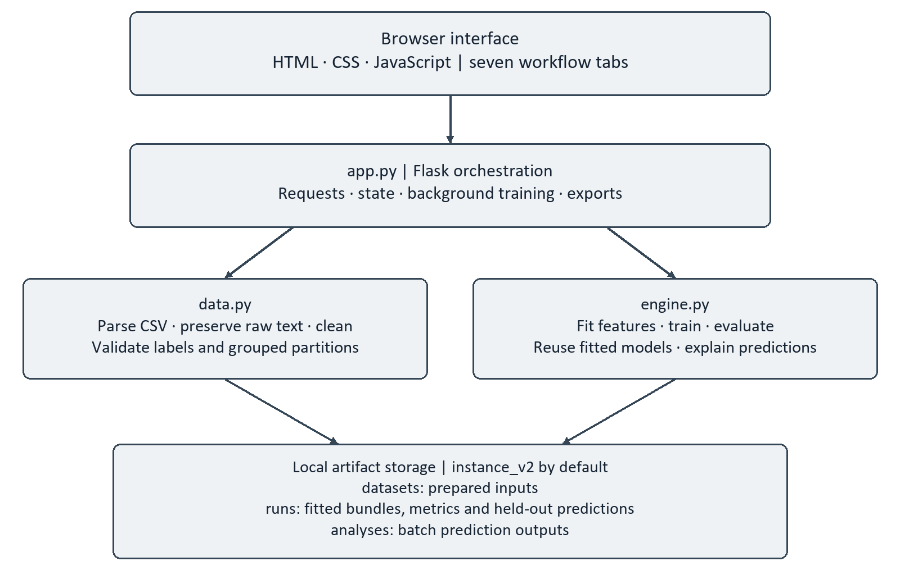
Figure 6: Prototype components and local artifact flow

4.4 Processing pipeline

Figure 7 follows the seven interface stages: upload and inspect text, review dataset context, train models, inspect held-out evaluation, compare configurations, predict manual inputs and inspect the dashboard. The direction of the arrows describes a typical workflow. The evaluation view measures the fixed test partition, while manual inputs and full-dataset dashboard predictions are applications of a fitted model. They must not be counted as additional held-out experiments.

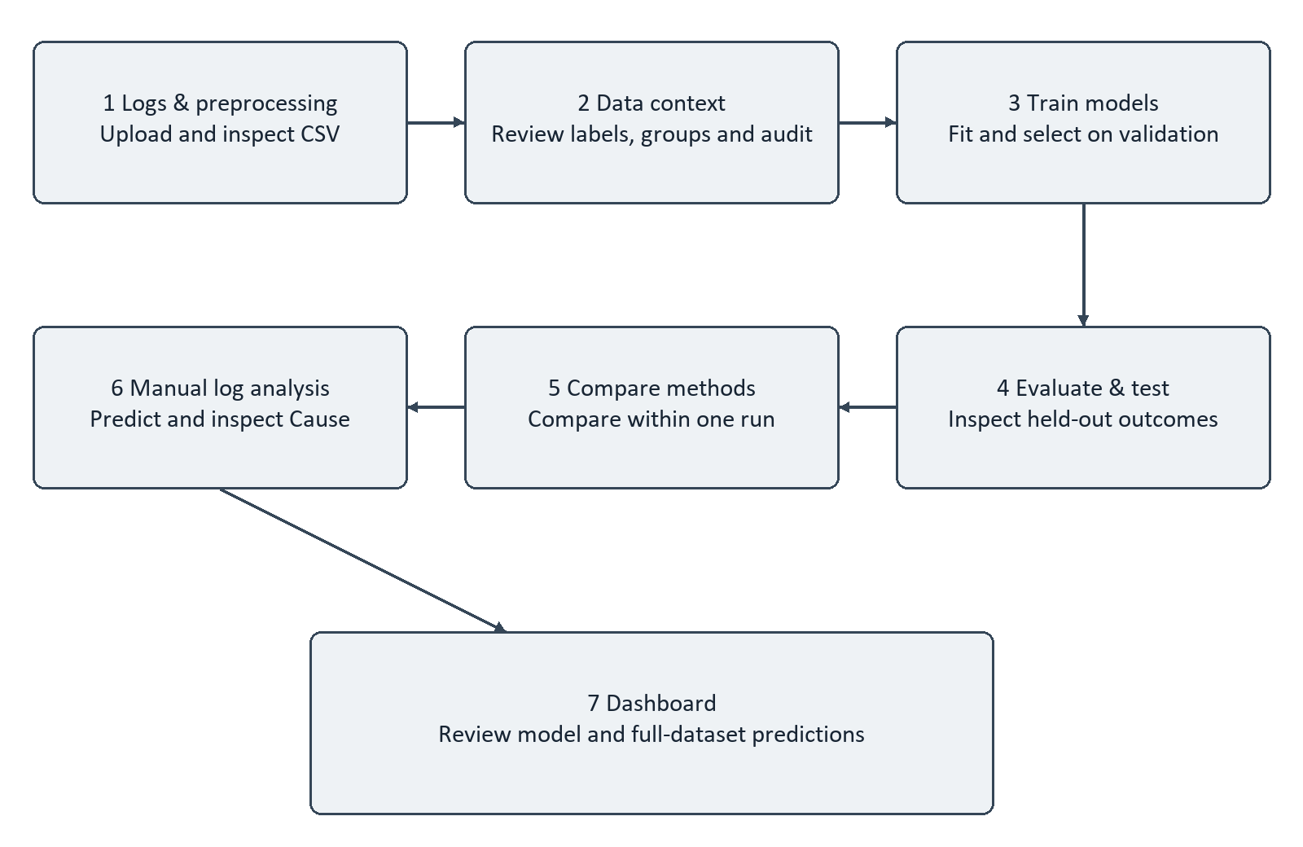
Figure 7: Seven-stage interface workflow

4.5 Interface and outputs

Figure 8 shows the Logs & preprocessing inspector with the original message, cleaned text and extracted tokens. The displayed identifier and numerical replacements make the information loss visible, while retained network-function, severity and event words show which evidence remains available for modelling.
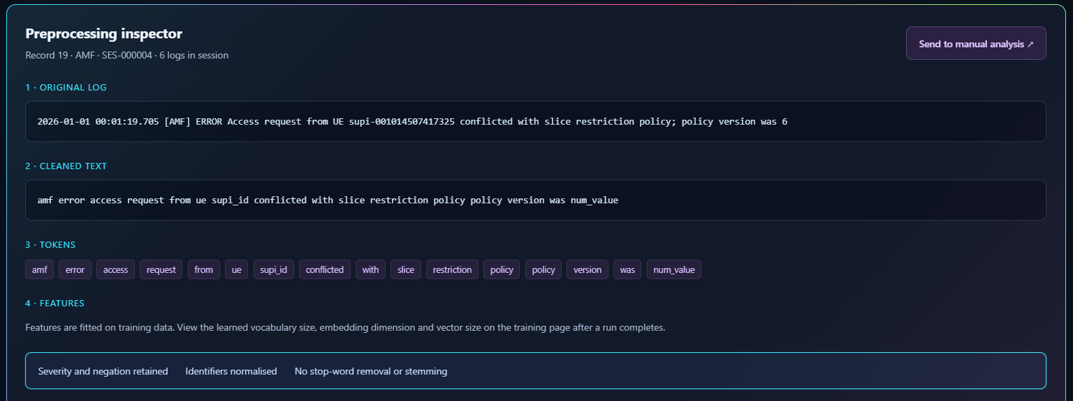
Figure 8: Raw message, cleaned text and token inspection
This inspection step is important because parsing and cleaning determine which evidence reaches the detector. Recent studies recommend treating preprocessing as part of the anomaly-detection experiment: parsing may reduce noise, but over-abstraction can make normal and abnormal events indistinguishable [13] , and keyword-focused representations may preserve useful signals that generic parsing removes [19] .
Figure 9 shows the Data context view after a successful upload: the interface reports 50,000 records, 37,500 normal labels and 12,500 abnormal labels. These are ground-truth dataset counts, not predicted class totals. The accompanying audit and partition information allow the user to check the input before training.
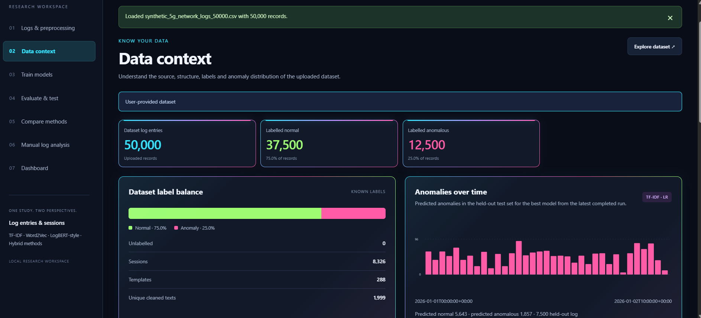
Figure 9: Dataset context after upload
Figures 10 and 11 show configuration selection and a completed training status respectively. The controls identify the prediction unit, representation, classifier, partition policy and profile. The saved-run status indicates completion of the displayed execution.
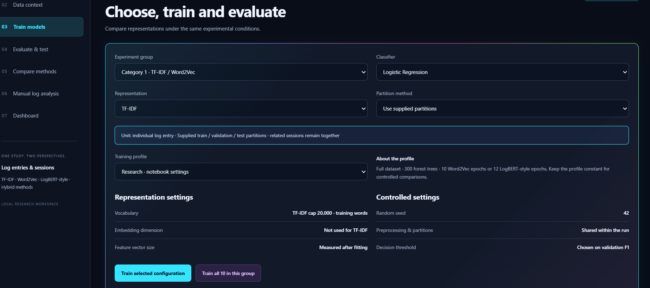
Figure 10: Model configuration controls

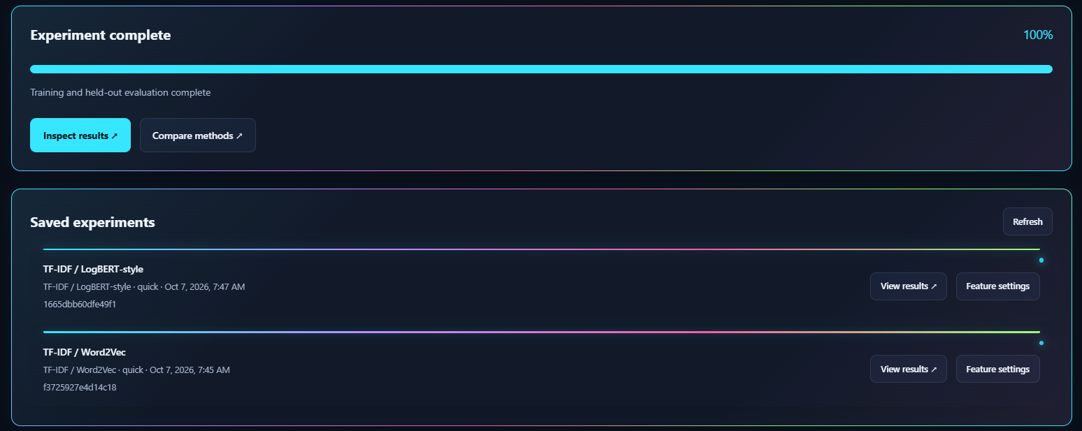
Figure 11: Completed training and saved experiments
Figure 12 shows a prototype session TF-IDF–RF evaluation on 1,246 held-out sessions: 936 TN, 0 FP, 1 FN and 309 TP. These counts yield accuracy 0.9992, precision 1.0000, recall 0.9968 and F1 0.9984. The interface also exposes outcome filters and the selected threshold.
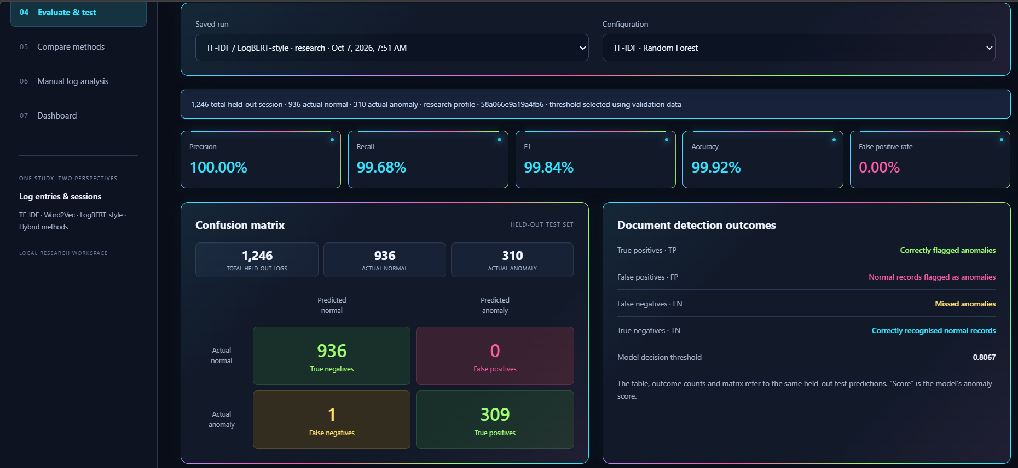
Figure 12: Held-out session evaluation in the prototype
Figure 13 shows the current Compare methods view for the session category. Each row identifies its representation and classifier, allowing metrics to be compared within one prediction unit. TF-IDF–RF and concatenation–RF share the strongest displayed accuracy and F1, while fusion–RF has the highest recall. The accompanying false-positive rates show why recall alone is insufficient for model comparison.

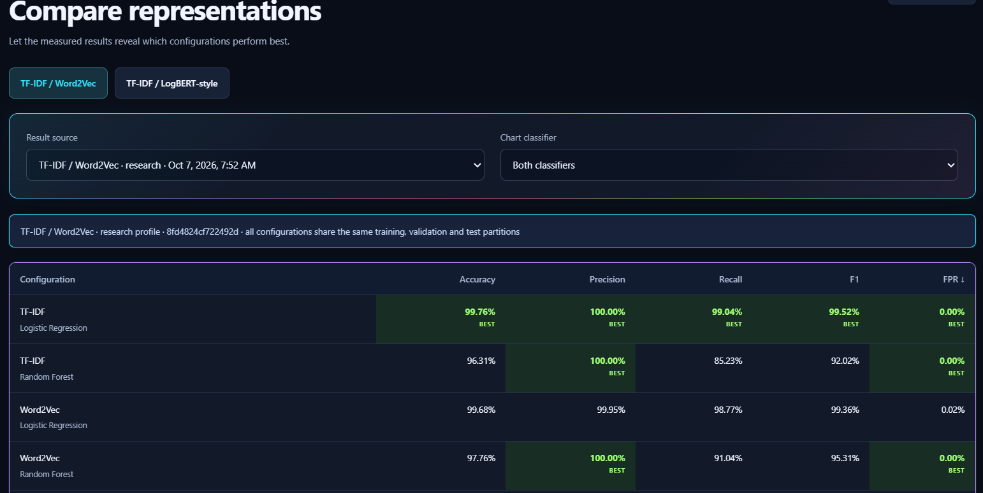
Figure 13: Comparison of configurations within a selected prototype run
Figure 14 and 15 shows a manually entered message and the resulting anomaly prediction. The input is unlabelled, so its displayed score and explanation demonstrate inference rather than measured detection accuracy. The prediction is made by the retained model and threshold; it is not a new training observation.

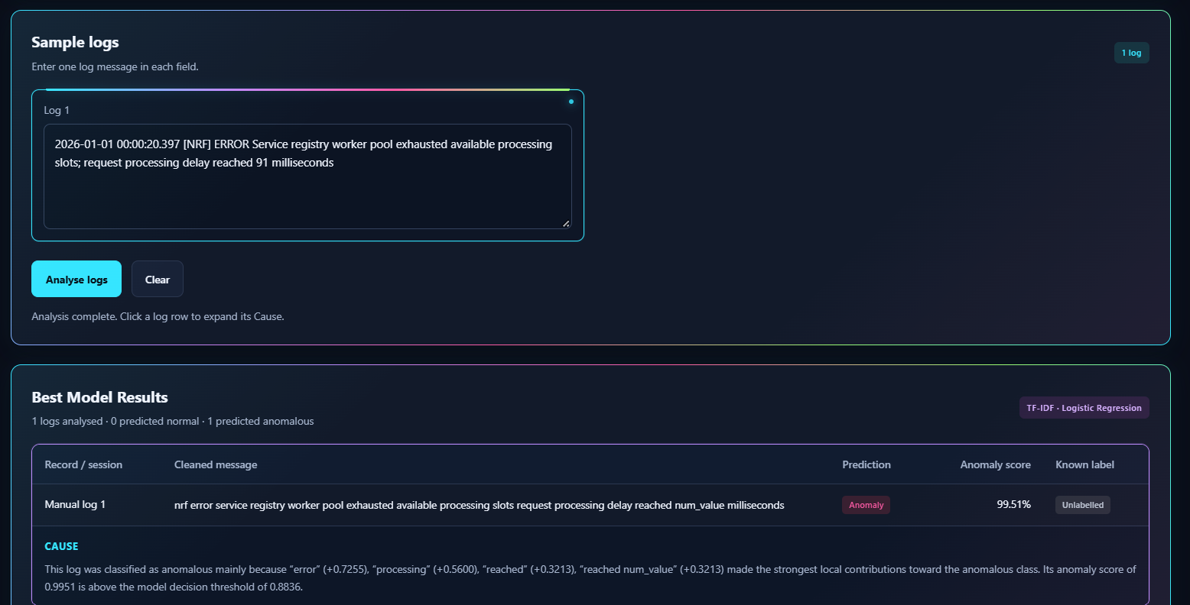
Figure 14: Manual message prediction

Figure 15: Manual message prediction
Figure 16 shows the dashboard's held-out metrics alongside counts from analysis of the complete uploaded dataset. The displayed 37,518 normal and 12,482 abnormal predictions sum to 50,000 and differ from the supplied ground-truth class totals. Because full-dataset inference includes training and validation records, those totals do not constitute an independent test result.

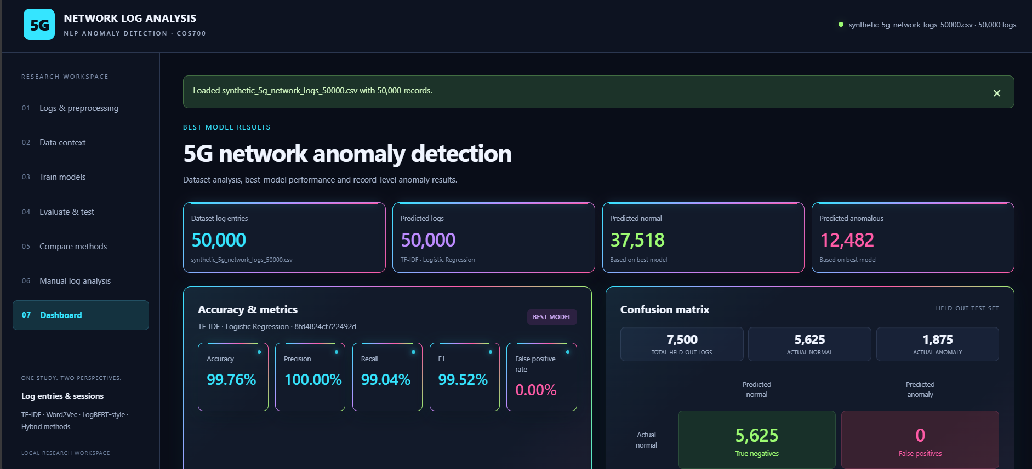
Figure 16: Dashboard evaluation and complete-dataset prediction counts
Figure 17 shows expanded prediction explanations and model outputs for individual records. The term Prediction explanation is used here because these are model attributions; the captured prototype still displays the older label Cause. For TF-IDF with LR, each feature contribution is its TF-IDF value multiplied by the corresponding coefficient, contributing to the linear decision score rather than directly to probability. Other entry models use the change in predicted probability after removing a token, and session models use event-removal sensitivity. These local comparisons can identify influential inputs, but cannot establish a network fault's cause or a causal relationship.

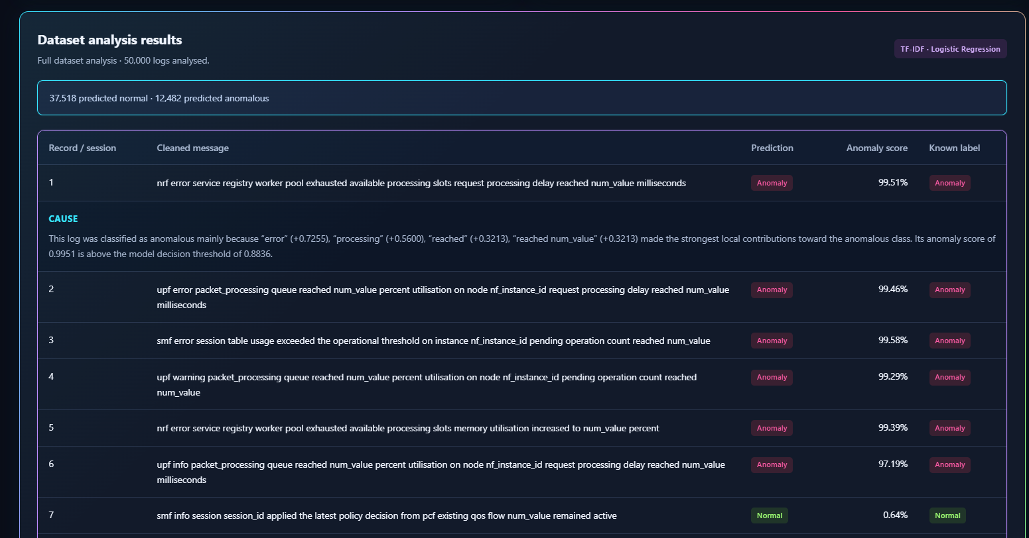
Figure 17: Record-level prediction explanations

4.6 Implementation environment

Table 5 records the prototype's declared environment. requirements.txt pins the main packages, and the Windows launcher installs CPU PyTorch and serves the application on local port 5073. These are deployment specifications; the comparison screenshots do not identify the exact installed versions, CPU model, RAM or execution device. A complete run manifest is required to reproduce numerical details.
Table 5: Declared prototype implementation environment
Component | Retained specification | Evidence boundary
Python | Launcher recommends Python 3.12 | Exact interpreter version of comparison run not recorded
Web server | Flask 3.1.3; waitress 3.0.2 | Pinned requirements
Numerical libraries | NumPy 2.3.5; pandas 3.0.1; SciPy 1.18.1 | Pinned requirements
ML and persistence | scikit-learn 1.9.1; Gensim 4.4.0; joblib 1.6.0 | Pinned requirements
Contextual encoder | PyTorch 2.14.0 CPU package | Declared launcher installation target
Local platform | Windows; local port 5073 | PowerShell launcher
Hardware and run device | CPU model, RAM and exact device not recorded | No hardware manifest accompanies the comparison views

4.7 Conclusion
5G Network Log Analysis connects preparation, representation fitting, supervised classification, evaluation and local explanations. The screenshots support specific workflow functions, while the documented Quick tests provide separate functional evidence. Complete reproducibility requires retained model outputs and an environment manifest. Prediction explanations remain model attributions rather than causal diagnoses.

Chapter 5: Results and Discussion

5.1 Introduction
This chapter presents the prototype's results for individual log entries and ordered sessions. It examines the performance of all 20 configurations, analyses classification errors, compares the leading models and discusses how different representations influenced anomaly detection.
The remainder of this chapter is structured as follows. Section 5.2 presents the experimental results, and Section 5.3 analyses errors across the 20 prototype configurations. Section 5.4 interprets the results, Section 5.5 explains the strong performance of TF-IDF, and Section 5.6 discusses the information preserved or lost by each representation. Section 5.7 evaluates the hybridisation strategies, Section 5.8 critically evaluates the prototype, and Section 5.9 concludes the chapter.

5.2 Results of the Experiments

5.2.1 Log-entry experiments
Table 6 shows that the entry-level results were driven mainly by missed abnormal records rather than false alarms. All four Random Forest entry configurations had a false-positive rate of 0.00%, but their false-negative counts ranged from 168 to 293. Logistic Regression retained substantially more abnormal entries, although the Word2Vec and concatenation variants each introduced one false positive. The decision-fusion result matched the Word2Vec result because the selected fusion weight placed no weight on the TF-IDF probability stream in this run.

Table 6: Prototype log-entry results
Representation | Classifier | Accuracy | Precision | Recall | F1 / FPR
TF-IDF | LR | 99.76% | 100.00% | 99.04% | 99.52% / 0.00%
TF-IDF | RF | 96.31% | 100.00% | 85.23% | 92.02% / 0.00%
Word2Vec | LR | 99.68% | 99.95% | 98.77% | 99.36% / 0.02%
Word2Vec | RF | 97.76% | 100.00% | 91.04% | 95.31% / 0.00%
TF-IDF + Word2Vec concat. | LR | 99.63% | 99.95% | 98.56% | 99.25% / 0.02%
TF-IDF + Word2Vec concat. | RF | 96.09% | 100.00% | 84.37% | 91.52% / 0.00%
TF-IDF-weighted Word2Vec | LR | 99.27% | 100.00% | 97.07% | 98.51% / 0.00%
TF-IDF-weighted Word2Vec | RF | 96.72% | 100.00% | 86.88% | 92.98% / 0.00%
Decision fusion: TF-IDF + Word2Vec | LR | 99.68% | 99.95% | 98.77% | 99.36% / 0.02%
Decision fusion: TF-IDF + Word2Vec | RF | 97.76% | 100.00% | 91.04% | 95.31% / 0.00%
Note: Values are percentages. LR = Logistic Regression; RF = Random Forest; F1 is the primary comparison measure; FPR is the false-positive rate.

5.2.2 Session experiments
Table 7 shows that the session experiment used 1,246 held-out sessions, consisting of 936 normal and 310 abnormal sessions. TF-IDF with Random Forest achieved the strongest session-level result, with accuracy 99.92%, precision 100.00%, recall 99.68% and F1 99.84% (accuracy = 0.999197; F1 = 0.998384). TF-IDF with LogBERT-style concatenation and Random Forest produced the same displayed test metrics and the same confusion counts. The session TF-IDF Logistic Regression baseline achieved F1 99.51%, whereas the standalone LogBERT-style representations produced substantially lower F1 scores.

Table 7: Prototype session results
Representation | Classifier | Accuracy | Precision | Recall | F1 / FPR
TF-IDF | LR | 99.76% | 100.00% | 99.03% | 99.51% / 0.00%
TF-IDF | RF | 99.92% | 100.00% | 99.68% | 99.84% / 0.00%
LogBERT-style | LR | 72.95% | 47.55% | 84.52% | 60.86% / 30.88%
LogBERT-style | RF | 86.92% | 68.15% | 89.03% | 77.20% / 13.78%
TF-IDF + LogBERT concat. | LR | 99.28% | 100.00% | 97.10% | 98.53% / 0.00%
TF-IDF + LogBERT concat. | RF | 99.92% | 100.00% | 99.68% | 99.84% / 0.00%
TF-IDF-weighted LogBERT | LR | 61.88% | 39.24% | 97.10% | 55.90% / 49.79%
TF-IDF-weighted LogBERT | RF | 92.70% | 78.15% | 98.06% | 86.98% / 9.08%
Decision fusion: TF-IDF + LogBERT | LR | 99.36% | 97.78% | 99.68% | 98.72% / 0.75%
Decision fusion: TF-IDF + LogBERT | RF | 99.76% | 99.04% | 100.00% | 99.52% / 0.32%
Note: Values are percentages. LR = Logistic Regression; RF = Random Forest; F1 is the primary comparison measure; FPR is the false-positive rate.

5.3 Error Analysis
Error analysis was conducted from the stored confusion-matrix counts rather than from rounded percentages. For entries, the test partition contained 5,625 normal and 1,875 abnormal records. For sessions, it contained 936 normal and 310 abnormal sessions. A false positive represents a normal unit incorrectly raised as abnormal, while a false negative represents an abnormal unit that was missed. The complete error counts for all 20 models are shown in 8.
Table 8: Error counts for all 20 prototype models
Unit | Representation | Clf. | TN | FP | FN | TP | F1
Entry | TF-IDF | LR | 5625 | 0 | 18 | 1857 | 99.52%
Entry | TF-IDF | RF | 5625 | 0 | 277 | 1598 | 92.02%
Entry | Word2Vec | LR | 5624 | 1 | 23 | 1852 | 99.36%
Entry | Word2Vec | RF | 5625 | 0 | 168 | 1707 | 95.31%
Entry | TF-IDF + Word2Vec concat. | LR | 5624 | 1 | 27 | 1848 | 99.25%
Entry | TF-IDF + Word2Vec concat. | RF | 5625 | 0 | 293 | 1582 | 91.52%
Entry | TF-IDF-weighted Word2Vec | LR | 5625 | 0 | 55 | 1820 | 98.51%
Entry | TF-IDF-weighted Word2Vec | RF | 5625 | 0 | 246 | 1629 | 92.98%
Entry | Decision fusion: TF-IDF + Word2Vec | LR | 5624 | 1 | 23 | 1852 | 99.36%
Entry | Decision fusion: TF-IDF + Word2Vec | RF | 5625 | 0 | 168 | 1707 | 95.31%
Session | TF-IDF | LR | 936 | 0 | 3 | 307 | 99.51%
Session | TF-IDF | RF | 936 | 0 | 1 | 309 | 99.84%
Session | LogBERT-style | LR | 647 | 289 | 48 | 262 | 60.86%
Session | LogBERT-style | RF | 807 | 129 | 34 | 276 | 77.20%
Session | TF-IDF + LogBERT concat. | LR | 936 | 0 | 9 | 301 | 98.53%
Session | TF-IDF + LogBERT concat. | RF | 936 | 0 | 1 | 309 | 99.84%
Session | TF-IDF-weighted LogBERT | LR | 470 | 466 | 9 | 301 | 55.90%
Session | TF-IDF-weighted LogBERT | RF | 851 | 85 | 6 | 304 | 86.98%
Session | Decision fusion: TF-IDF + LogBERT | LR | 929 | 7 | 1 | 309 | 98.72%
Session | Decision fusion: TF-IDF + LogBERT | RF | 933 | 3 | 0 | 310 | 99.52%

The entry models made between 18 and 293 false-negative errors. TF-IDF with Logistic Regression made the fewest entry errors overall: 18 false negatives and no false positives. Word2Vec with Logistic Regression and entry decision fusion each made one false-positive error and 23 false-negative errors. The entry Random Forest models were conservative: they raised no false alarms but missed more abnormal entries, with concatenation producing the largest false-negative count.
The session models showed a wider range of error behaviour. The two best session models each made one false-negative error and no false-positive errors. The standalone contextual models produced many false positives and false negatives, especially contextual Logistic Regression with 289 false positives and 48 false negatives. Weighted contextual Logistic Regression produced 466 false positives, illustrating that the higher recall of a model can be accompanied by an unacceptable alert burden. Decision fusion with Random Forest detected all 310 abnormal sessions, but it produced three false positives.

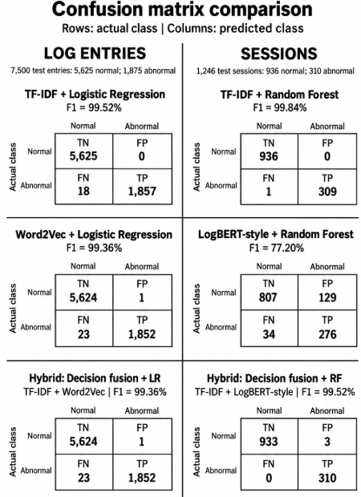
Figure 18: Selected confusion matrix comparison from the prototype
Figure 18 shows that the selected matrices reinforce the distinction between high recall and balanced detection. The session decision-fusion Random Forest model detected every abnormal session, but its three false positives reduced precision and F1 to 99.52%. The contextual Random Forest model made 129 false-positive and 34 false-negative errors. Thus, recall alone does not identify the most suitable detector; the operational cost of false alerts and missed anomalies must be considered together.

5.4 Analysis and Interpretation of Results
The experiments provide different answers at the two prediction units. At log-entry level, TF-IDF with Logistic Regression was the strongest configuration. At session level, TF-IDF with Random Forest and TF-IDF plus LogBERT-style concatenation with Random Forest tied for the strongest F1. This change in the leading classifier does not mean that Random Forest is universally better for sessions. Session aggregation changes the input unit, the number of observations and the evidence available to a classifier, so the comparison is specific to the supplied corpus and the fixed partitions.
The high scores should also be interpreted in light of the dataset audit. The corpus contained repeated cleaned messages, label-pure templates and substantial overlap of cleaned strings and template identifiers between training and test partitions. These properties make lexical recognition highly effective, but they limit the evidence for generalisation to unseen templates or operational logs. The results therefore establish comparative performance within the prototype evaluation, rather than a guarantee of performance on a different network or on a template-disjoint test set [13] , [23] .

5.5 Why TF-IDF Performed Strongly
TF-IDF performed strongly because the prototype logs contained informative lexical signals that remained visible after cleaning. The representation retains exact words and adjacent bigrams, allowing the classifier to use terms associated with message type, severity, network function and anomaly wording. In a corpus with repeated templates and label-pure wording, these features provide a direct separation between normal and abnormal records. Logistic Regression can assign a stable weight to each feature, while Random Forest can partition the resulting feature space through threshold rules.
The strong TF-IDF scores should not be interpreted as evidence that lexical features are always sufficient. They indicate that the available corpus made lexical evidence highly predictive. The lack of a severity and wording ablation means that the contribution of each signal cannot be isolated, and the shared strings between training and test reduce the strength of claims about unseen-template detection. TF-IDF was therefore the most effective representation in this experiment, while its generalisation must be tested separately.

5.6 What Each Representation Preserved or Lost
TF-IDF preserved exact terms and local two-word phrases, but it did not represent long-range event order. Mean Word2Vec preserved token co-occurrence information in a dense vector, but averaging removed word order and could dilute uncommon anomaly indicators. TF-IDF-weighted Word2Vec increased the influence of rarer tokens, but the pooled vector still compressed different tokens into one representation. The LogBERT-style encoder represented ordered template-key context within a short session, but it did not receive the full raw numeric content of each message and its contextual features were less effective than TF-IDF on this dataset.
Concatenation preserved separate lexical and embedding coordinates, allowing the classifier to access both feature spaces. However, adding dimensions did not guarantee complementary evidence: the entry and session concatenation models did not consistently exceed the stronger standalone TF-IDF model. Decision fusion preserved two probability streams rather than the original feature detail. It improved the recall of the session detector in one configuration, but it also introduced false positives. These outcomes show that a representation can preserve more types of information without improving the final classification measure [20], [11] . Table 9 shows what each representation preserves and loses.
Table 9: Information retained and compressed by the implemented representations
Representation | Retained information | Principal limitation
Word TF-IDF | Exact words and adjacent bigrams | No long-range event ordering
Mean Word2Vec | Average token co-occurrence features | Order lost; uncommon signals may be diluted
Weighted embeddings | IDF-emphasised pooled features | Pooling still compresses distinct tokens or events
LogBERT-style | Ordered template-key context | No raw numeric fields; short generated sessions
Concatenation | Separate lexical and embedding coordinates | Extra features do not guarantee complementary evidence
Decision fusion | Two probability streams | Feature detail is absent at the fusion stage

5.7 Evaluation of Hybridisation Strategies
The hybrid strategies were implemented in three forms: feature concatenation, IDF-weighted embeddings and decision fusion. Their effects depended on the prediction unit and classifier. At entry level, concatenation reduced F1 relative to both strong Logistic Regression baselines, while weighted Word2Vec reduced F1 further. For Random Forest, weighted Word2Vec improved over TF-IDF alone but remained below the standalone Word2Vec result. Decision fusion reproduced the embedding result in both entry-level classifiers because the learned fusion endpoint selected the embedding probability stream.
At session level, concatenation improved the standalone LogBERT-style representations, especially with Random Forest, but the resulting score tied the TF-IDF Random Forest baseline rather than exceeding it. Weighted contextual representations increased recall but introduced many false positives, particularly with Logistic Regression. Decision fusion with Random Forest achieved complete abnormal-session recall, but its three false positives lowered F1. The hybrid results therefore demonstrate that combining representations is feasible, but they do not show a consistent benefit over the strongest standalone component.

5.8 Critical Evaluation of the Prototype
The prototype provides a reproducible comparison structure: the same labelled observations, partitions, seed and evaluation rules were used within each experimental category, and thresholds were selected on validation data before the held-out test metrics were calculated. The application also stores model outputs and confusion counts, which allowed the displayed percentages to be reconciled with the underlying errors. This supports a transparent comparison of the 20 configurations.
The evaluation remains bounded by the corpus and the recorded run. The dataset is synthetic, repeated wording is common, and the test partition is not fully template-disjoint. Only one seed is represented in the reported results, so uncertainty across repeated training runs was not estimated. The contextual model is a LogBERT-style prototype rather than a full operational pre-trained system, and the masked-event training objective is different from the downstream anomaly-classification objective. Finally, the available results do not isolate the effects of severity, network-function wording, repeated templates or other label-correlated fields. These limitations restrict the claims to comparative behaviour within this prototype.

5.9 Conclusion
The prototype produced strong lexical results for both prediction units. TF-IDF with Logistic Regression was the log-entry leader with F1 0.995177, while TF-IDF with Random Forest was the session leader with accuracy 0.999197 and F1 0.998384; the TF-IDF plus LogBERT-style concatenation Random Forest configuration tied the session leader. The error analysis showed that the highest recall was not always the best balanced outcome, because false positives reduced precision and F1 for several contextual and fusion models. Overall, the results support TF-IDF as the most effective representation for this controlled corpus, while the hybrid and contextual experiments provide useful evidence about the information each representation preserves and the errors it introduces. The findings motivate the future evaluation of diverse real logs, template-disjoint test sets, repeated experiments with uncertainty estimates and ablation studies of label-correlated signals.

Chapter 6: Conclusion and Future Work

6.1 Introduction
This chapter revisits the problem addressed by the study and the four research questions. It summarises what was established through the prototype experiments, identifies the limits of the findings and presents the future work required to evaluate the approach more reliably.
The remainder of this chapter is structured as follows. Section 6.2 revisits the problem statement and research questions, Section 6.3 discusses the contributions of the research, and Section 6.4 presents the limitations of the study and future work, while Section 6.5 concludes the chapter.

6.2 Problem Statement and Research Questions Revisited
5G networks generate large volumes of heterogeneous logs that are difficult to analyse manually. Existing log-analysis approaches address this challenge by transforming messages into numerical representations and applying machine-learning or sequence-based models to detect anomalous patterns [3], [9] , [12] . TF-IDF preserves exact terms and local phrases, Word2Vec represents token co-occurrence, and contextual representations model relationships between ordered events.
The problem addressed by this study was that it remained uncertain whether these representations provide complementary information when combined. It was also uncertain whether their performance depends on the classifier and the prediction unit. Individual log entries and ordered sessions expose different evidence, so results from the two units cannot be directly treated as interchangeable. The study addressed this uncertainty through two controlled experiments. Each experiment compared five representation strategies with Logistic Regression and Random Forest using fixed training, validation and test partitions.
The first research question examined the challenges of analysing 5G network logs using NLP techniques. These included the large volume of logs, differences in formats across network functions, interleaved events from concurrent processes, variable identifiers and changing terminology. These characteristics make it difficult to identify meaningful patterns and require effective preprocessing, event ordering and feature representation. Although identifier and numerical-value normalisation addressed some of these challenges, repeated templates and label-associated wording in the synthetic dataset limited its representation of the variability found in real-world 5G logs [3], [13], [10] .
The second research question concerned the application of TF-IDF, Word2Vec and a LogBERT-style representation. The prototype implemented TF-IDF and Word2Vec for individual entries, and TF-IDF and a project-specific LogBERT-style Transformer for sessions. TF-IDF used joined session text, while the contextual model used ordered template identifiers. The representations therefore preserved different information: TF-IDF retained exact words and phrases, Word2Vec pooled token information, and the contextual model retained the order of available event keys [12], [23], [20] .
The third research question concerned the performance of Logistic Regression and Random Forest. TF-IDF with Logistic Regression produced the strongest log-entry result, with an accuracy of 99.76% and an F1-score of 99.52%. At session level, TF-IDF with Random Forest and TF-IDF–LogBERT-style concatenation with Random Forest shared an accuracy of 99.92% and an F1-score of 99.84%. The results show that classifier performance depended on the prediction unit and representation. They do not establish that one classifier is universally preferable.
The fourth research question investigated whether hybrid representations improved anomaly detection performance. The experimental results showed that hybrid representations did not improve overall classification performance compared with the strongest standalone representations. Although the prototype successfully implemented weighted embeddings, feature concatenation and decision fusion, none of the hybrid configurations consistently outperformed the best standalone configuration. For example, Session Fusion with Random Forest achieved 100.00% recall, compared with 99.04% for the strongest standalone configuration (TF-IDF with Logistic Regression). However, this increase in recall came at the cost of a higher false-positive rate of 0.32%, compared with 0.00% for the standalone configuration, while both achieved an F1-score of 99.52%. Therefore, the findings demonstrate that hybridisation was successfully implemented but did not provide an overall classification performance improvement. The additional complexity of combining representations did not translate into better overall results.

6.3 Contributions of the Research
This research contributed a prototype for comparing NLP-based representations for automated anomaly detection in 5G network logs. It evaluated TF-IDF, Word2Vec, a LogBERT-style representation and three hybridisation strategies using Logistic Regression and Random Forest at both log-entry and session level. The results showed that TF-IDF performed strongly on the supplied corpus, while the error analysis demonstrated how different representations affected false positives and false negatives. The prototype also provides a structured basis for evaluating representation strategies within a consistent experimental framework.

6.4 Limitations of the Study and Future work
The findings of this study should be interpreted in relation to several limitations of the dataset, experimental design and implemented models. These limitations identify areas where further investigation is required to establish the reliability and generalisability of the results.
The study used a controlled synthetic 5G network log dataset containing repeated wording, label-pure templates and overlap between training and test representations. These characteristics may have made the classification task easier and resulted in overly optimistic performance estimates, limiting the external validity of the findings. Consequently, the results do not establish how well the evaluated approaches would generalise to real-world logs or completely unseen templates. Future work should prioritise evaluation using diverse real 5G network logs covering different network functions, vendors, message formats, anomaly types and operational conditions. Template-disjoint test sets should be used to ensure that test messages and event templates are not repeated in the training data. Temporal and cross-system holdouts should also be considered to evaluate performance on future or unfamiliar events. These approaches would provide stronger evidence of generalisation than the shared-template setting used in this study [13], [10] .
Only one recorded training seed was evaluated, which prevented the study from estimating variation across repeated experiments. Therefore, it remains uncertain whether small performance differences between representations and classifiers would remain consistent under different training conditions. Future experiments should use several predefined random seeds and report uncertainty estimates, such as confidence intervals or variation across repeated runs. This would help establish whether the observed performance differences are stable or influenced by random initialisation and fixed training conditions.
The study did not include ablation experiments to isolate the influence of severity, network-function wording, repeated anomaly terms and other potentially label-correlated signals. As a result, it remains uncertain whether the high lexical performance reflects meaningful log patterns or signals that make the synthetic classification task easier. Future work should conduct ablation experiments by removing or controlling these features and metadata. Additional experiments should compare the current numerical-value normalisation approach with alternatives that retain selected numeric information. These comparisons would help determine the contribution of individual log features to anomaly detection performance.
The contextual model was implemented as a project-specific LogBERT-style prototype rather than a full operational pre-trained system. Therefore, its results do not establish the performance of the published LogBERT approach or other advanced contextual models. Further contextual-model development should investigate longer sessions, matched textual and event-key inputs, field-aware attention and controlled event-order information. These models should be evaluated against the TF-IDF baseline using the same dataset and evaluation conditions to ensure a fair comparison.
Finally, the prototype's prediction explanations provide local model attributions but do not establish causality or explain the actual cause of a network fault. This limits their ability to support detailed operational diagnosis. Future work should investigate more advanced explainability methods and evaluate them in terms of fidelity, stability and usefulness to network analysts. To improve reproducibility, future evaluations should also retain the dataset identifier, code version, model configuration, decision thresholds, prediction probabilities, software versions and hardware information. This would allow the experimental setup and reported metrics to be more consistently verified and reproduced.

6.5 Conclusion
This study demonstrated that NLP representations can support automated binary anomaly detection in generated 5G network logs through a local prototype. TF-IDF with Logistic Regression achieved the strongest log-entry result, while TF-IDF with Random Forest and TF-IDF–LogBERT-style concatenation with Random Forest shared the strongest session result. However, hybrid representations did not improve overall classification performance or consistently outperform the strongest standalone representations. These findings are limited to the synthetic dataset and prototype implementations. Real-log evaluation and further experiments are required before applying these findings to operational 5G networks.

References

[1] A. Chouman, D. M. Manias, A. Shami, C. International Wireless, and C. Mobile, "Towards Supporting Intelligence in 5G/6G Core Networks: NWDAF Implementation and Initial Analysis," in 2022 International Wireless Communications and Mobile Computing (IWCMC), 2022, pp. 324–329.
[2] R. Chávez-Santiago et al., "5G: The Convergence of Wireless Communications," Wireless Personal Communications, vol. 83, no. 3, pp. 1617–1642, 2015/08/01 2015, doi: 10.1007/s11277-015-2467-2.
[3] M. Du, F. Li, G. Zheng, and V. Srikumar, "DeepLog Anomaly Detection and Diagnosis from System Logs through Deep Learning," in Proceedings of the 2017 ACM SIGSAC Conference on Computer and Communications Security, 2017, p. 1285.
[4] M. Alzahrani, "Investigating the Impact of Log-Sequence Embeddings on Anomaly Detection: A Systematic Study," Information, vol. 17, no. 3, p. 228, 2026, doi: 10.3390/info17030228.
[5] P. Á, E. Kail, S. Laczi, and A. Bánáti, "Neural Network-Based Log Analysis Methods for 5G Network," in 2023 IEEE 21st Jubilee International Symposium on Intelligent Systems and Informatics (SISY), 21–23 Sept. 2023 2023, pp. 000589–000594, doi: 10.1109/SISY60376.2023.10417905.
[6] L. Fernandez Maimo, A. L. Perales Gomez, F. J. Garcia Clemente, M. Gil Perez, and G. Martinez Perez, "A Self-Adaptive Deep Learning-Based System for Anomaly Detection in 5G Networks," IEEE Access, vol. 6, 2018, doi: 10.1109/ACCESS.2018.2803446.
[7] H. T. Nguyen, N. Q. Nguyen, N. K. Dao, and T. Q. Bao, "When 5G Security Meets Natural Language Processing: Challenges and Future Pathways," in 2024 IEEE Conference on Antenna Measurements and Applications (CAMA), 9–11 Oct. 2024 2024, pp. 1–6, doi: 10.1109/CAMA62287.2024.10986050.
[8] J. Devlin, M.-W. Chang, K. Lee, and K. Toutanova. (2018). BERT: Pre-training of Deep Bidirectional Transformers for Language Understanding. Available: http://arxiv.org/abs/1810.04805
[9] J. Wang et al., "LogEvent2vec: LogEvent-to-Vector Based Anomaly Detection for Large-Scale Logs in Internet of Things," Sensors (Basel, Switzerland), vol. 20, no. 9, 2020, doi: 10.3390/s20092451.
[10] M. Landauer, S. Onder, F. Skopik, and M. Wurzenberger, "Deep learning for anomaly detection in log data: A survey," Machine Learning with Applications, vol. 12, p. 100470, 06/01 2023, doi: 10.1016/j.mlwa.2023.100470.
[11] X. Wu, H. Li, and F. Khomh, "On the effectiveness of log representation for log-based anomaly detection," Empirical Software Engineering : An International Journal, vol. 28, no. 6, 2023, doi: 10.1007/s10664-023-10364-1.
[12] H. Guo, S. Yuan, X. Wu, and N. International Joint Conference on Neural, "LogBERT: Log Anomaly Detection via BERT," in 2021 International Joint Conference on Neural Networks (IJCNN), 2021, pp. 1–8.
[13] Z. A. Khan, D. Shin, D. Bianculli, and L. C. Briand, "Impact of log parsing on deep learning-based anomaly detection," Empirical Software Engineering : An International Journal, vol. 29, no. 6, 2024, doi: 10.1007/s10664-024-10533-w.
[14] Z. Haijun, L. Na, C. Xiaoli, L. Keping, A.-H. Aghvami, and V. C. M. Leung, "Network Slicing Based 5G and Future Mobile Networks: Mobility, Resource Management, and Challenges," IEEE Communications Magazine, vol. 55, no. 8, 2017, doi: 10.1109/MCOM.2017.1600940.
[15] F. Erunkulu, M. Adamu Zungeru, C. Lebekwe, M. Mosalaosi, and J. Chuma, "5G Mobile Communication Applications: A Survey and Comparison of Use Cases," IEEE Access, vol. 9, pp. 97251–97295, 06/28 2021, doi: 10.1109/ACCESS.2021.3093213.
[16] Z. Wang and Y. Wang, "NLP-based Cross-Layer 5G Vulnerabilities Detection via Fuzzing Generated Run-Time Profiling," in 2023 IEEE 12th International Conference on Cloud Networking (CloudNet), 1–3 Nov. 2023 2023, pp. 194–202, doi: 10.1109/CloudNet59005.2023.10490042.
[17] M. Sannigrahi and R. Thandeeswaran, "Predictive Analysis of Network-Based Attacks by Hybrid Machine Learning Algorithms Utilizing Bayesian Optimization, Logistic Regression, and Random Forest Algorithm," IEEE Access, vol. 12, pp. 142721–142732, 2024, doi: 10.1109/ACCESS.2024.3464866.
[18] P. V. A. Alves et al., "Machine Learning Applied to Anomaly Detection on 5G O-RAN Architecture," Procedia Computer Science, vol. 222, pp. 81–93, 2023, doi: 10.1016/j.procs.2023.08.146.
[19] Y. Song, Z. Yan, Y. Qin, Y. Xie, X. Ye, and Y. Ouyang, "Network anomaly detection based on keyword embedding log," ITU Journal on Future and Evolving Technologies, vol. 3, pp. 235–242, 09/22 2022, doi: 10.52953/ICXQ5497.
[20] G. Salton and C. Buckley, "Term-weighting approaches in automatic text retrieval," Information Processing and Management, vol. 24, no. 5, pp. 513–523, 1988, doi: 10.1016/0306-4573(88)90021-0.
[21] S. Wang and C. Manning, "Baselines and bigrams : simple, good sentiment and topic classification," (in English), Annual meeting of the Association for Computational linguistics and ... Conference of the European Chapter of the Association for Computational Linguistics : proceedings of the conference, 2012.
[22] T. Mikolov, K. Chen, G. Corrado, and J. Dean. (2013). Efficient Estimation of Word Representations in Vector Space. Available: http://arxiv.org/abs/1301.3781
[23] T. Mikolov, I. Sutskever, K. Chen, G. Corrado, and J. Dean. (2013). Distributed Representations of Words and Phrases and their Compositionality. Available: https://arxiv.org/abs/1310.4546
[24] K. Yaker, B. A. Salem, D. Appadoo, N. Aitsaadi, and V. Raynal, "Unsupervised CoAP-based anomaly detection in private 5G core network for Industrial-IoT," Computer Communications, vol. 257, 2026, doi: 10.1016/j.comcom.2026.108634.
[25] A. A. Tawil, L. Almazaydeh, D. Qawasmeh, B. Qawasmeh, M. Alshinwan, and K. Elleithy, "Comparative Analysis of Machine Learning Algorithms for Email Phishing Detection Using TF-IDF, Word2Vec, and BERT," Computers, Materials & Continua, vol. 81, no. 2, pp. 3395–3412, 2024, doi: 10.32604/cmc.2024.057279.
[26] U. Kulkarni and S. Fahmy, "Janus: A Dual-Mask Attention Transformer for Log-based Anomaly Detection in Cellular Networks," ACM SIGMETRICS Performance Evaluation Review, vol. 54, no. 1, pp. 141–143, 2026, doi: 10.1145/3820171.3806900.
[27] A. Vaswani et al. (2017). Attention Is All You Need. Available: https://arxiv.org/abs/1706.03762
[28] G. S. Chavhan et al., "Machine Learning For 5G Security Using Random Forest," in 2023 International Conference on Advances in Computation, Communication and Information Technology (ICAICCIT), 2023, pp. 544–549.
[29] I. Karim, K. S. Mubasshir, M. M. Rahman, and E. Bertino. (2023). SPEC5G: A Dataset for 5G Cellular Network Protocol Analysis. Available: http://arxiv.org/abs/2301.09201
[30] G. Shoderu, O. B. Stacey, M. Sheunesu, and M. Abiodun, "Digital Forensic Readiness to Mitigate Insider Threats in the SaaS Cloud Environment," The Indonesian Journal of Computer Science, vol. 14, no. 6, 2025, doi: 10.33022/ijcs.v14i6.5059.

