SHIELD
Signed Hash Infrastructure for Evidence-Linked Digital Content
Scenario 10: Media Provenance & Deepfake Defense
Cryptographic Systems Design Report
Rosie Domenech | github.com/RosieDomenech
2025

1. System Overview

1.1 Problem Statement
The proliferation of AI-generated synthetic media — commonly called "deepfakes" — presents an existential threat to the epistemic integrity of digital journalism. Modern generative models can convincingly fabricate facial expressions, voices, and entire scenes, making it impossible for a human observer to distinguish authentic footage from fabricated content by inspection alone.
News organizations require a cryptographically verifiable chain of custody, established at the precise moment of capture, that travels with the media asset through its entire lifecycle: from the journalist's camera to the publisher's server to the end consumer's browser. SHIELD addresses this problem by combining device-level hardware-backed digital signatures, a hierarchical Public Key Infrastructure (PKI), a C2PA-compatible content manifest, and a trusted timestamping service to produce a tamper-evident, publicly verifiable provenance record for every piece of digital media captured by participating organizations.

1.2 System Architecture
The SHIELD system consists of five principal components working in concert to establish and maintain a cryptographically verifiable media provenance chain:

Component | Role
Capture Device | Generates content hash and device-level signature using Secure Enclave (Apple SEP / Android StrongBox)
Org Signing Server | Co-signs the manifest with the organization's intermediate CA key over mTLS 1.3
PKI / CA Infrastructure | Issues, revokes, and verifies the certificate chain for all participants; logs to Certificate Transparency
Trusted Timestamp Authority (TSA) | Provides an RFC 3161-compliant timestamp token binding the content hash to an authoritative clock
Content Delivery Layer | Stores the media file and its attached C2PA manifest; treated as an untrusted medium
Verification Endpoint | Public API consumed by browsers, fact-checkers, or QR code scanners; performs full chain validation in real time

Figure 1 illustrates the C2PA manifest assembly pipeline — from raw media through the chain of cryptographic operations to the final verifiable asset package:

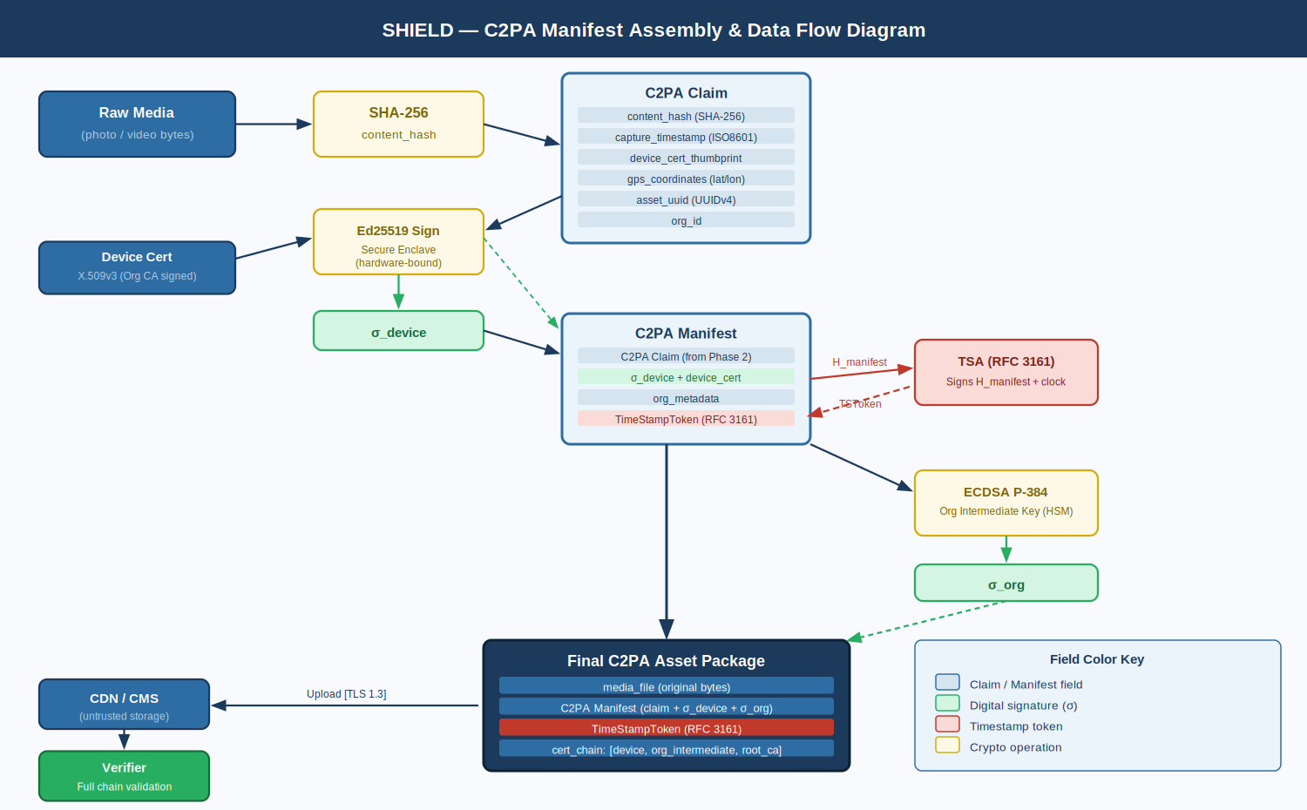
Figure 1: C2PA Manifest Assembly & Data Flow — raw media through SHA-256, Ed25519 device signing, RFC 3161 timestamping, ECDSA P-384 org co-signing, and final package assembly

1.3 Security Goals
- Confidentiality: Unpublished media protected in transit via TLS 1.3 with Perfect Forward Secrecy
- Integrity: Any modification to media content is cryptographically detectable via signed hashes
- Authenticity: Every asset is bound to a specific capture device and organizational identity via PKI
- Non-repudiation: Hardware-bound device keys and organizational HSM keys cannot be credibly disavowed
- Public Verifiability: Any consumer can independently verify provenance without special access or credentials
- Availability: Revocation infrastructure (OCSP) operates independently; CT logs are append-only and redundant

2. Trust Assumptions
A well-scoped trust model explicitly defines what the system relies upon and where its guarantees end. The following assumptions are foundational to SHIELD's security properties:

2.1 Trusted Components
- The Root CA and Organizational Intermediate CAs are operated honestly; private keys are held in FIPS 140-2 Level 3 HSMs.
- The Secure Enclave on capture devices correctly isolates private key material. Physical tampering that bypasses the Secure Enclave is assumed to be detectable via attestation.
- The RFC 3161 Timestamp Authority is an independent third party (e.g., DigiCert) with an accurate, unforgeable clock.
- TLS 1.3 correctly provides its stated security properties when properly configured.

2.2 Untrusted Components
- The network is treated as fully hostile. All communications assume an adversary capable of passive interception and active modification.
- The CDN and CMS storage layer is treated as an untrusted storage medium. Integrity is verified cryptographically on read, never assumed from storage guarantees.
- End-consumer devices. The verification protocol is stateless and requires no trust in the verifier's device.
- Intermediaries between the camera and signing server — all relay points are explicitly distrusted.

2.3 Out-of-Scope Threats
- Physical coercion of a journalist to fabricate a scene before capture initiates.
- Compromise of the Root CA private key (a systemic assumption shared by all PKI systems; mitigated by air-gapping and hardware protection).
- Legal compulsion to sign fabricated content (a governance/policy problem, not a cryptographic one).

3. Threat Model

3.1 Adversary Profile
The primary adversary is a sophisticated, motivated attacker — such as a state-sponsored disinformation actor — with resources to conduct cryptanalytic attacks, operate infrastructure to intercept network traffic, and potentially compromise individual journalist devices. Secondary adversaries include opportunistic tamperers who modify media in transit, and insider threats at the news organization itself.

3.2 Attack Vectors and Mitigations

3.2.1 Data Eavesdropping (Passive Interception)
Attack: An attacker positioned on the network intercepts raw media in transit between the device and the org signing server, accessing unpublished footage.
Mitigation: All communications use TLS 1.3 with certificate pinning. The device only connects to a server whose certificate chains to the pinned intermediate CA. Passive eavesdropping yields only ciphertext encrypted under ephemeral X25519 session keys — computationally infeasible to decrypt without the ephemeral private key, which is discarded after session close (Perfect Forward Secrecy).

3.2.2 Data Modification / Tampering
Attack: An attacker modifies a media file at rest on the CDN, replacing frames with deepfake content, and attempts to update the stored manifest to match.
Mitigation: The C2PA manifest contains a SHA-256 hash of the original media bytes, signed by the device's hardware-bound private key. Modification produces a hash mismatch. Forging the manifest requires breaking Ed25519, which is computationally infeasible. The org co-signature provides a second, independent layer of protection.

3.2.3 Originator Spoofing
Attack: An attacker constructs a fake manifest claiming capture by a legitimate journalist, using a self-signed certificate.
Mitigation: Device certificates are issued by the organization's intermediate CA, which chains to the Root CA. Verification performs complete chain-of-trust validation. A self-signed certificate fails at the root anchor. Certificate Transparency (RFC 9162) makes fraudulent issuance publicly detectable.

3.2.4 Replay Attacks
Attack: A valid, signed media package from a past event is republished in a new context, attempting to misrepresent its temporal or geographic origin.
Mitigation: The RFC 3161 trusted timestamp embeds an authoritative, third-party-attested time in the manifest. A verifier confirms that the timestamp matches the claimed context. GPS coordinates further anchor provenance. Temporal mismatch between the embedded timestamp and claimed publication date is a detectable integrity failure.

3.2.5 Relay Attacks
Attack: An attacker intercepts a signing request and relays it through a different connection, injecting context into the manifest.
Mitigation: The device signature is computed locally within the Secure Enclave before any network communication. The org server receives the pre-signed payload over a mutual TLS connection. mTLS requires both parties to authenticate with valid certificates — a relay that cannot present a valid device certificate is rejected at the TLS handshake.

3.2.6 Meet-in-the-Middle Attack
Attack: Against the SHA-256 hash function, an attacker attempts to find two different media files with the same hash to allow a fabricated file to pass hash verification.
Mitigation: SHA-256 provides 2^128-bit collision resistance. Additionally, the hash is cryptographically bound to the Ed25519 signature — a hash collision is useless without simultaneously forging the signature, a separate and independent hardness assumption. The two independent security properties compound the effective attack complexity.

3.2.7 Man-in-the-Middle (MitM) Attack
Attack: An attacker interposes between the device and signing server, presenting a fraudulent TLS certificate to the device, decrypting and re-encrypting traffic bidirectionally.
Mitigation: The capture application implements TLS certificate pinning. The device's trust store contains only the organization's intermediate CA certificate. Any certificate not chaining to the pinned CA is immediately rejected. The attacker cannot forge a satisfying certificate without the intermediate CA's HSM-protected private key. The device signature is also computed before transmission, so MitM transport decryption cannot alter already-signed content.

3.2.8 Deepfake Substitution Post-Capture
Attack: An attacker strips the manifest from a legitimate file and re-attaches it to a deepfake, or generates a deepfake that produces a SHA-256 collision with the original.
Mitigation: Re-attaching the manifest to a different file produces a hash mismatch detectable at verification. True SHA-256 collision attacks require 2^128 operations — computationally infeasible. SHIELD also aligns with C2PA's assertion model, where editing tools append modification assertions; the absence of a capture-origin assertion in a modified file is itself a verifiable negative signal.

3.2.9 Key Revocation Failures (Compromise / Insider Threat)
Attack: A journalist's device is stolen; the attacker uses the device key to sign fabricated content.
Mitigation: The verification endpoint checks device certificate revocation status via OCSP in real time. Revoked certificates cause verification failure immediately, even for cryptographically valid signatures. Revocation can be executed within minutes of incident detection.

4. Step-by-Step Protocol Workflow
Figure 2 shows the complete end-to-end message flow across all five phases of the SHIELD protocol, from initial device enrollment to consumer-facing verification:

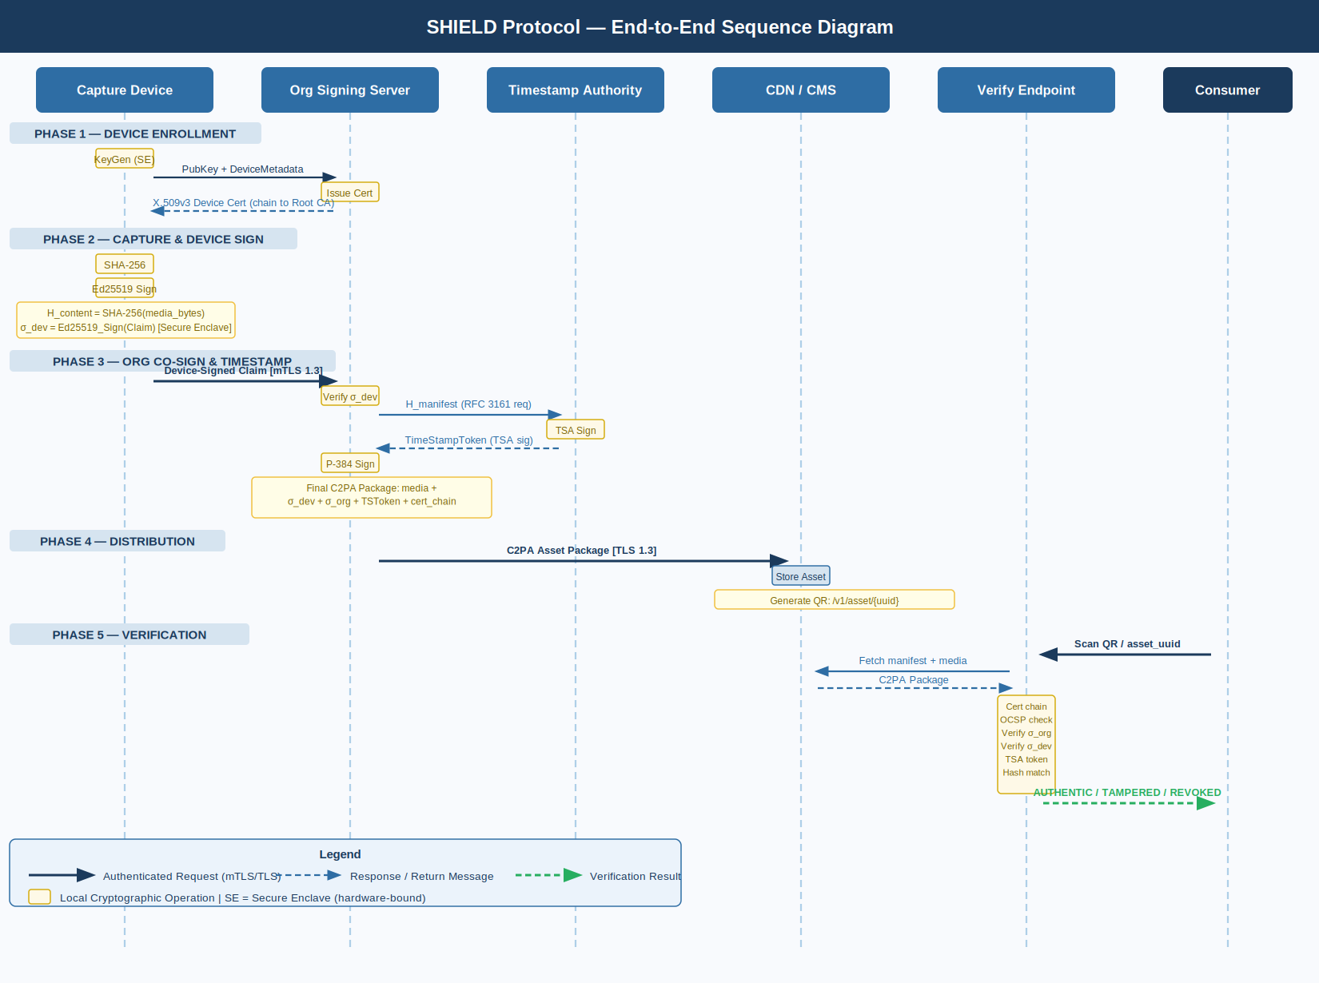
Figure 2: SHIELD End-to-End Sequence Diagram — five-phase message flow across Capture Device, Org Signing Server, TSA, CDN, Verification Endpoint, and Consumer

Phase 1: Device Enrollment (One-Time)
1. Device generates Ed25519 key pair inside Secure Enclave.
Private key: non-exportable, hardware-bound.
Public key: exported for certification.

2. Public key + device metadata sent to Org CA via authenticated enrollment portal.

3. Org CA issues X.509v3 device certificate signed by Org Intermediate CA.
Certificate fields: Subject (device ID + journalist ID),
Validity (1 year), Key Usage (digitalSignature),
EKU (id-kp-contentSigning), OCSP URL, CRL DP.

4. Certificate installed on device. Private key remains in Secure Enclave.

Phase 2: Content Capture and Device Signing
1. Journalist captures media via SHIELD-integrated camera app.

2. App computes: H_content = SHA-256(raw_media_bytes)

3. App assembles C2PA Claim:
{
"content_hash": H_content,
"hash_algorithm": "SHA-256",
"capture_timestamp_local": ISO8601_datetime,
"device_cert_thumbprint": SHA-256(device_cert),
"gps_coordinates": { "lat": ..., "lon": ... },
"org_id": "ORG-SHIELD-001",
"asset_uuid": UUIDv4()
}

4. Secure Enclave signs Claim:
σ_device = Ed25519_Sign(device_private_key, SHA-256(Claim_bytes))

5. Package: Claim + σ_device + device_cert → "Device-Signed Claim"

Phase 3: Organizational Co-Signing and Timestamping
6. Device transmits Device-Signed Claim to Org Signing Server over mTLS 1.3.
Server validates: device cert chain → Root CA.
Server verifies: σ_device over Claim.

7. Server constructs C2PA Manifest:
Manifest = { Device-Signed Claim + org_metadata + publication_intent }

8. Server submits H_manifest = SHA-256(Manifest) to RFC 3161 TSA.
TSA returns: TimeStampToken = TSA_Sign(H_manifest + TSA_timestamp)

9. Server computes org co-signature:
σ_org = ECDSA_P384_Sign(org_intermediate_key,
SHA-256(Manifest_bytes || TimeStampToken))

10. Final C2PA Asset Package:
{
"media_file": <original_bytes>,
"manifest": {
"claim": { ...fields... },
"device_sig": σ_device,
"device_cert": <PEM>,
"org_sig": σ_org,
"org_cert_chain": [org_intermediate, root_ca],
"timestamp_token": TimeStampToken
}
}

Phase 4: Distribution
11. Asset Package uploaded to CDN/CMS.
Media + manifest stored as linked pair (XMP sidecar per C2PA spec).

12. Verification QR code generated:
QR → https://verify.shield.org/v1/asset/{asset_uuid}
QR may also encode H_manifest for offline partial verification.

Phase 5: End-Consumer Verification
13. Consumer scans QR code or activates browser extension.

14. Verification Endpoint executes:
a. Retrieve manifest by asset_uuid.
b. Validate org cert chain → Root CA.
c. Check org cert OCSP status (not revoked).
d. Verify σ_org over (Manifest || TimeStampToken).
e. Validate device cert chain → Org CA → Root CA.
f. Check device cert OCSP status (not revoked).
g. Verify σ_device over Claim.
h. Verify TimeStampToken via TSA public key.
i. Recompute SHA-256(media_bytes); compare to H_content in Claim.

15. Result returned to consumer:
✅ AUTHENTIC — captured by [device_id] at [timestamp], signed by [org]
❌ TAMPERED — content hash mismatch detected
❌ REVOKED — signing certificate revoked on [date]
❌ INVALID — signature chain broken

4.6 Protocol Sequence Diagram
Figure 2 shows the full message sequence across all five phases, from device enrollment through end-consumer verification. Solid arrows indicate requests; dashed arrows indicate responses. All transport channels use TLS 1.3 with mutual authentication.


Figure 2: SHIELD End-to-End Protocol Sequence Diagram

5. Cryptographic Justification

5.1 Ed25519 for Device Signatures
Ed25519 (Edwards-curve Digital Signature Algorithm over Curve25519) is selected for device-level signing for three reasons. First, it produces compact 64-byte signatures with fast constant-time operations — critical for low-latency capture workflows on mobile devices. Second, its security is grounded in the hardness of the discrete logarithm problem over a twisted Edwards curve, providing approximately 128-bit security. Third, and critically, Ed25519 is natively supported by both the Apple Secure Enclave and Android StrongBox Keymaster, enabling hardware-bound keys that are never exposed to application-layer code.
Unlike RSA-2048 (borderline 112-bit security) or ECDSA P-256 (vulnerable to catastrophic failure on nonce reuse), Ed25519 is deterministic — it derives the signing nonce from the message and private key via a hash function, making it immune to nonce reuse vulnerabilities regardless of the quality of the device's random number generator.

5.2 ECDSA P-384 for Organizational Signatures
The organizational intermediate CA key uses ECDSA with NIST P-384, providing 192-bit security. The deliberate step up from Ed25519's 128-bit security reflects the fact that the org key is a higher-value, longer-lived credential that signs many assets and is therefore a more attractive target. P-384 is FIPS 186-5 compliant, satisfying federal contracting requirements. The key is held in a FIPS 140-2 Level 3 validated HSM, ensuring it cannot be extracted even with direct physical access to the hardware.

5.3 SHA-256 Content Hashing
SHA-256 is selected for all content hashing. Its 256-bit output provides 128-bit collision resistance under the birthday bound, requiring approximately 2^128 hash evaluations for a collision — a figure exceeding the estimated computational budget of any nation-state actor using classical hardware over any practical time horizon. SHA-256 is hardware-accelerated on all modern mobile SoCs (ARMv8 SHA extensions), adding negligible latency to the capture flow.
A forward upgrade path to SHA-3-256 is explicitly noted in the system design. SHA-3's Keccak sponge construction provides algorithmic diversity: any undiscovered structural weakness in SHA-2's Merkle-Damgard design would not apply to SHA-3, ensuring the system's hash security does not depend on a single design lineage.

5.4 RFC 3161 Trusted Timestamps
A system relying on the device's local clock is vulnerable to clock manipulation attacks: a device with a compromised OS can backdate or forward-date content. RFC 3161 trusted timestamps solve this by delegating timekeeping to a mutually trusted third party (the TSA), whose signature cryptographically attests that a specific hash existed at a specific time per the TSA's authoritative clock. The TimeStampToken is a signed CMS object whose validity depends entirely on the TSA's key — not the device or org clocks. This eliminates the temporal component of replay attacks.

5.5 X.509 PKI and Certificate Transparency
The hierarchical PKI (Root CA -> Org Intermediate CA -> Device Certificate) establishes a globally auditable chain of trust. Certificate Transparency (RFC 9162) requires all issued certificates to be logged in public append-only logs. This prevents a compromised CA from issuing fraudulent certificates undetected: any certificate appearing in a verification chain that is absent from CT logs is treated as invalid. This closes the attack surface of CA-level compromise as an undetectable vector.

5.6 TLS 1.3 Transport Security
All inter-component communication uses TLS 1.3 with X25519 key exchange, providing Perfect Forward Secrecy (PFS). PFS ensures that long-term key compromise does not retroactively expose past session traffic — directly defeating harvest-now-decrypt-later attacks. The combination of TLS 1.3's efficient handshake and mTLS mutual authentication prevents both passive eavesdropping and active relay and MitM attacks at the transport layer.

5.7 C2PA Standard Alignment
SHIELD aligns with the Coalition for Content Authenticity and Provenance (C2PA) technical specification v2.0, co-developed by Adobe, Microsoft, BBC, Intel, and others. C2PA defines a standardized manifest format, assertion vocabulary, and verification algorithm already integrated into Adobe Photoshop, Microsoft Designer, and major browser extensions. This alignment ensures SHIELD-signed assets are verifiable by third-party tools, maximizing public verifiability and interoperability without requiring consumers to trust any single organization's verification infrastructure.

6. Attack Mitigations Summary

Attack Vector | Mitigation Mechanism | Cryptographic Primitive
Eavesdropping | TLS 1.3 with Perfect Forward Secrecy | X25519 + AES-256-GCM
Data Modification | Signed content hash in C2PA manifest | SHA-256 + Ed25519
Originator Spoofing | Certificate chain validation + CT logs | X.509 PKI + RFC 9162
Replay Attack | RFC 3161 authoritative timestamp token | TSA RSA-2048 signature
Relay Attack | Mutual TLS + pre-computed device signature | mTLS + Ed25519
Meet-in-the-Middle | SHA-256 (2^128 collision resistance) | SHA-256
Man-in-the-Middle | Certificate pinning + mutual TLS | X.509 cert pinning
Deepfake Substitution | Hash-to-file binding via nested signatures | SHA-256 + ECDSA P-384
Key Compromise | OCSP real-time revocation checking | OCSP / CRL
Insider Forgery | Immutable CT logs; HSM-bound org keys | RFC 9162 + HSM

References
NIST FIPS 186-5. Digital Signature Standard (DSS). National Institute of Standards and Technology, 2023.
Bernstein, D.J. et al. High-speed high-security signatures. CHES 2011. (Ed25519 specification)
Adams, C. et al. Internet X.509 Public Key Infrastructure — Time-Stamp Protocol (TSP). RFC 3161, IETF, 2001.
Laurie, B. et al. Certificate Transparency. RFC 9162, IETF, 2021.
C2PA Technical Specification v2.0. Coalition for Content Authenticity and Provenance, 2023. https://c2pa.org/specifications/
NIST SP 800-131A Rev. 2. Transitioning the Use of Cryptographic Algorithms and Key Lengths. NIST, 2019.
Cooper, D. et al. Internet X.509 PKI Certificate and Certificate Revocation List (CRL) Profile. RFC 5280, IETF, 2008.
Rescorla, E. The Transport Layer Security (TLS) Protocol Version 1.3. RFC 8446, IETF, 2018.
NIST FIPS 180-4. Secure Hash Standard (SHS). National Institute of Standards and Technology, 2015.
National Institute of Standards and Technology. NIST FIPS 202: SHA-3 Standard. 2015.

Report prepared for academic and portfolio purposes. System design by Rosie Domenech.

