Assembly Programming Report

Project1

Professor | 심동규 교수님
Department | Computer engineering
Student ID | 2013722058
Name | 김현지
Class | 월5, 수67
Date | 2015. 11. 22

- Introduction
- This program performs sorting 500 strings which composed of 4 characters by alphabet order. Strings are stored by small order from address 0x60000000. After sorting 500 strings, then find same string with given search_data. Finding same strings, add the string’s length into r0. Using this program, can make another sorting or search program which composed of anything including string, integers.
It was supposed to do Coding in 10/22 and Debugging from that date to 10/28. I did all coding and debugging, but I made bubble sort and bubble search program. So, for the good performance, I made a code from 11/16 to 11/21, and debugging 11/22.

- Project Specification
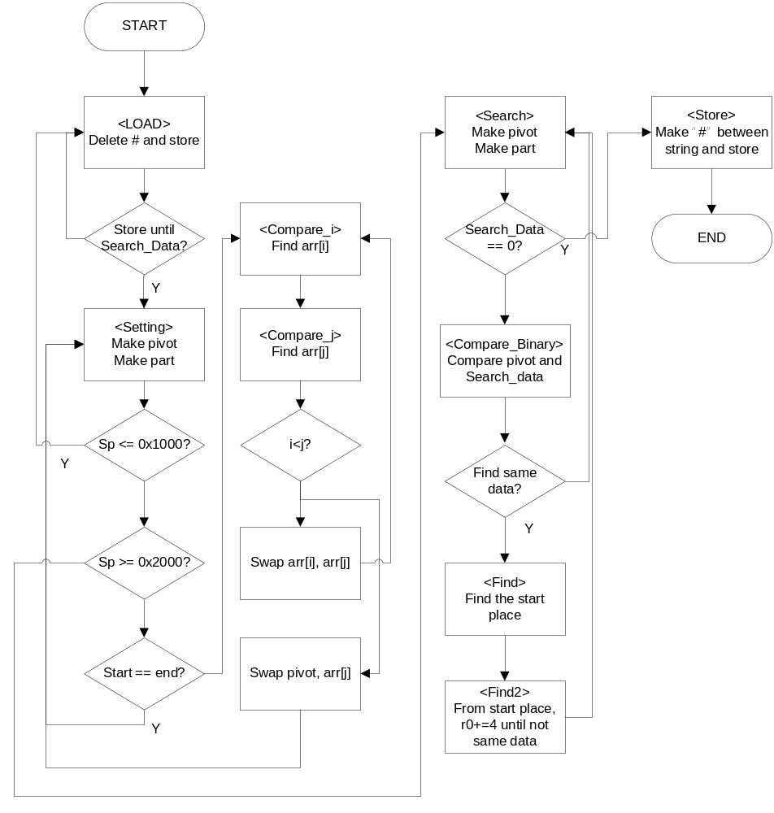
- Algorithm
- Sorting
- Load
: Using “LDR” is very good way in performance. For using “LDR” instruction, delete “#” from strings. Because all strings are have 4-length which is proper using LDR. So, I removed “#” and stored in another address (0x50000000). This requires many memory accesses, so it can be low performance if using LDR and STR for loading original strings and storing removed strings. Because doing LDR and STR in every code, then it makes memory access by 1000 times. So, I used “STMEA” and “LDMFA”. As a result, it can be decreased more than 500 times in memory access. After storing all strings, store start point (address) and end point (address) in sp.
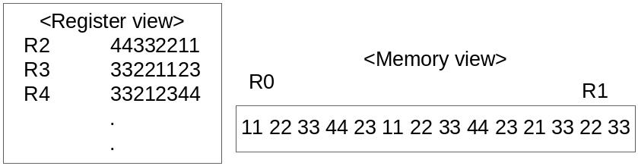
Deleting “#” is like following. Like above picture, in register view, look at the r3, #’s ascii code is 23. So, r3 must be not 33221123, but 44332211. So, shift r3 to right 2 hexa and add the first 2 hexa “44”. So, I can solved in r3, LSR#8 + r4, LSL#24. Like this, go every string’s shift and addition.

- Setting
: Pop 2 points in stack for make part which will be sorted. And make r0 to start point, and r1 to end point. So, in this branch, decide part to sorting, and make pivot and swap with the first string.
If the r0 and r1 is same, in other words, start point and end point is same, pop another 2 points in stack. And if r0 is bigger than r1, change r0 and r1, and sort. If the part set is done, pivot is the middle value in the part. If the pivot pointer has not the first character, for an example, not “m” in “mess”, do LSL#30 and LSR#30. When doing this, if the value is 2, it means not first character, so, subtract pointer #2. And then, load pivot and shift left-right. Because the program is in a little-endian form. After pivot setting, do i, j setting. i is the low position and j is high position.
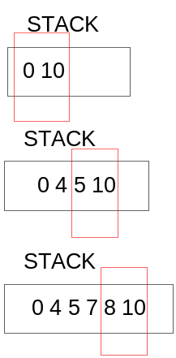
If the stack is popped and pushed, it will be changed like this picture. it means, searched part will be popped and the detailed part, will-searching part will be pushed.

- Compare_i
: This branch’s goal is find the value which is larger than pivot’s value for changing the result of Compare_j. From the next address of pivot, load that value and shift left-right. And then compare with shifted pivot value. If I’s value is smaller than pivot’s value, loop this Compare_i branch for finding value until end address. If I’s value is larger than pivot’s value or I’s address is larger than end address, go to Compare_j.

- Compare_j
: This branch’s goal is find the value which is smaller than pivot’s value. From the end address, load that value and shift left-right. And then compare with pivot value. If can’t find, loop again, and find, compare I’s address and j’s address. If I’s address is smaller, it was find successfully, so make swap and go again to Compare_i for more finding. If not smaller, swap pivot and j’s value, and then store in stack the part of {start ~ j}, {after j ~ end}. For make more comparing in two parts.

- Search
- Setting
: After sorting is finished, it must be sp pointer is less than 0x1000. Because there are nothing in sp, so, if sp is less than 0x1000 it means Sorting is finished. So, in Setting branch, if sp is less than 0x1000, setting about search. Load r0 to Search_data’s first address and r1 is end address, r10 is new stack pointer which has 0x2000, and sp has 0x2500. After this, go Load for deleting “#” from the Search_data. After Load, it goes back again in Setting, and compare sp and 0x2000. If sp is not less than 0x2000, it means Search. So, load r4, 0x2000 and sp, 0x1000 and r0 is 0 (for storing finding string’s length). And make r4 to r4-4.

- Search
: This branch makes Search_data. so, from the r4+4, load that value into r8. And shift r8 left-right. And then store into sp, start point and end point again. And go Compare_Binary. If the r8’s value is 0, it means there is no search_data anymore. So, search is ended. Then go to Store for storing with “#”.

- Compare_Binary
: This branch makes pivot and Compare. Pop 2 points in stack, if the start and end point is different, make pivot with same way in Sorting’s pivot. And then, compare with pivot’s value and search data’s value. If pivot’s value is larger, it means that I should search left part of pivot. If pivot’s value is smaller, it means that I should search right part of pivot. So, in these cases, store in stack the left or right part’s start and end point. If values are same, for finding the first same value’s start point, go Find branch. If even there are no same values, then start and end point will be same someday, so it will go again into Search branch.

- Find
: This branch finds the first value which has same value. So, go before string and compare, and if not same, it means there are no same values in the backward parts, go Find2.

- Find2
: This branch finds the last value which has same value. So, go after string and compare, if same, add #4 into r0 and if not same, it means there are no same values in the forward parts then finish the Search_data. so go to Search for search another data.

- Store
: As same as load, load into 0x50000000, and add “#” and store in 0x60000000. For adding “#” using shifter and the point is loading into 4 registers, but after adding #, storing from 5 registers.

- Performance & result
- Sorting result
: Before sorting, original data
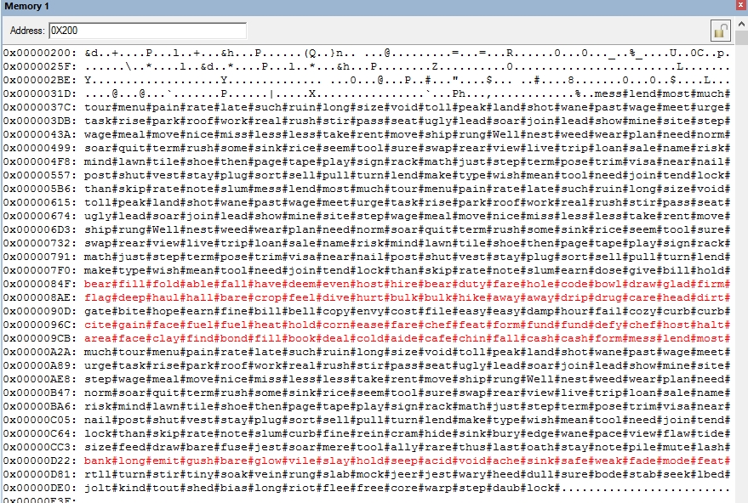

: Before sorting, delete #
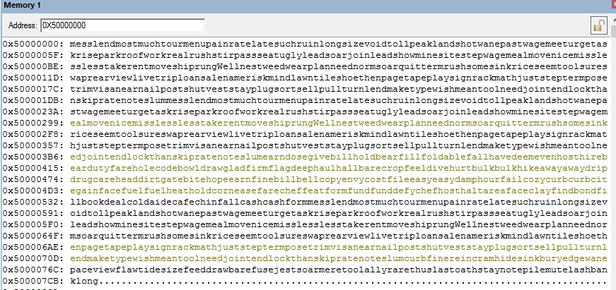

: make first pivot and swap with first data (pivot : hold)
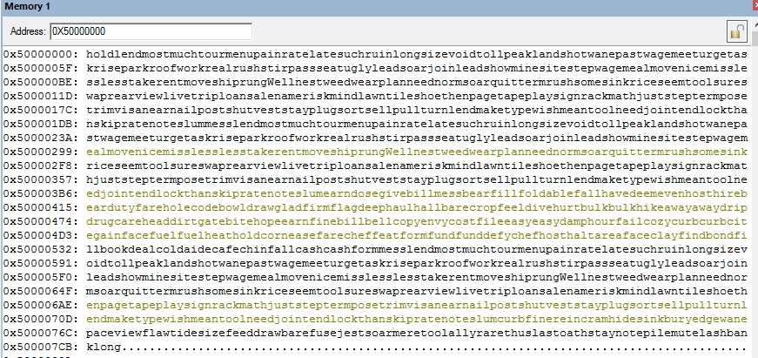

: After sorting.
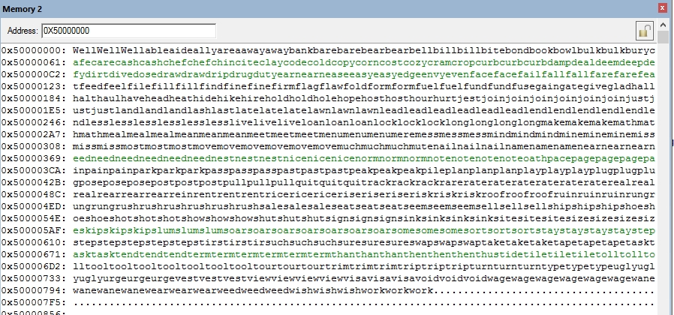

: Store in 0x60000000 with #
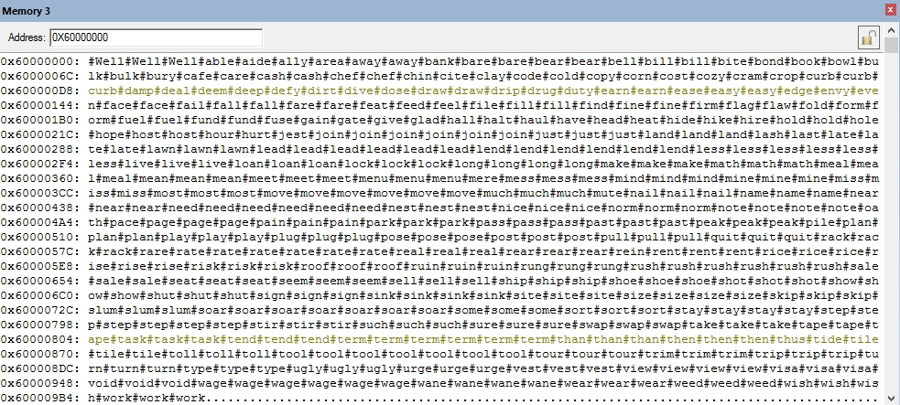

- Search result
: Search_data deleting “#”
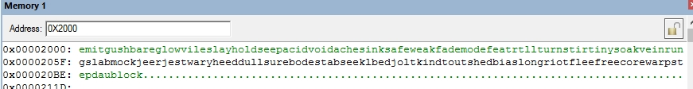

1 | 2 | 3 | 4 | 6
Feat, jest | Bare, hold | Void, turn, stir, rung, sure, lock | Sink, long | Step
: finding string – 35. 35 x 4 = 152 = 0x98

: After Search, r0’s state.
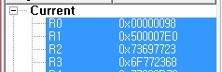

R0 : 0x98

- Performance
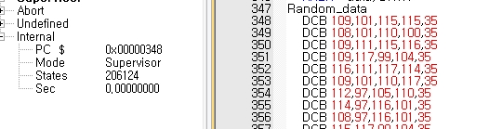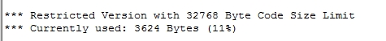
: Performance = 3624 x 206124 x 206124 = 153973262634624

- Conclusion
: Actually I made a code in bubble, shell, insert. But they had bad states. In bubble, State was almost 8,700,000, and in shell, it was almost 5,800,000. So, I had to make a code in quick sort strategy, despite there are no time for me. Fortunately, I can make a code for two days, and same as my expecting, quick sort’s state was so good. Surely, there are quick sort’s effort is so big, but I modify my code in many parts.
The first was deleting #. When I used bubble sort, I did a load into memory by one byte, and shift it and compare to that. But when I deleting #, it can use “LDR” at once, so LDRB 4 -> LDR 1. It brings the code decreasing memory access. The second thing was Branch. I prefer the good-reading code than performance before assembly class, so I used so many Branch and loop. Because just it looks good and it is better to understand. But, in shell, and quick, I can decrease the loop branch after many considerations, and it makes the better quality of performance. And eventually it looks good to understand in some part. The third thing was coding after scratch. When first, I did a coding without any thinking of problem, but there are limited registers and I should use this in formally for not lacking registers.
After finished coding, I felt the “STM~” is so good way in performance but, it’s order is randomly input. So, I had to write one by one. And when sorting the strings, I give the part into start ~ before pivot, after pivot~ end, and this results in the last one more changing. So, it sorted not successfully. So I modify my code start~pivot, after pivot~end. Because my pivot address means the first string, start~ before pivot means pivot’s 2 more back address point.

