# Measures of Average

An average is a single value which we use to summarise a set of data. It can be helpful to think of an average as a typical, representative or expected value. Averages are sometimes called summary statistics or measures of central tendency.

## Types of measures of average

There are three well-known ways to calculate the average of a data set and depending on the type of data we may prefer to use one method over another.

* The Mean
* The Mode
* The Median

**The Mean**

The mean is calculated by adding together the total sum of all the data and dividing by the number of data values you have, which we call the count. It can be remembered as

$$\frac{Total}{Count}$$

In mathematical notation we write this as

$$\frac{Σx}{n}$$

The mean gives a value for if the data were evenly distributed.

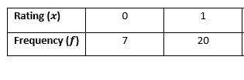**The Mean of a Frequency Table**  
The mean for a frequency table can be calculated as

$$\frac{Σ(x*f)}{n}$$

Where $f$ is the frequency for each data value $x$.

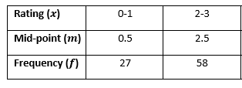**The Mean of a Group Frequency Table**  
For a group frequency table, the mean is calculated as

$$\frac{Σ(m*f)}{n}$$

Where $m$ is the mid-point of each interval value $x$.

**The Mode**

The mode is the data value which occurs most often.

The mode is the only measure of average that may take qualitative data e.g. the colours of 5 cars owned by Sheffield households are given as

$$white, red, black, red, silver.$$

We can calculate the mode as the colour $red,$ which has the highest frequency of 2.

There are a few cases which can arises when finding the mode:

* **No Mode**. No value occurs most often i.e. every value of $x$ occurs with the same frequency, this may be only once or multiple times.
* **Single Mode**. A single value that occurs more often than every other value.
* **Bi-modal.** There are two modes i.e. there are two values which occur the same amount but more often than any other value.
* **Multi-Modal.** There are multiple modes i.e. there are more than two values which occur equally as often but more than other values.

**The Mode of a Frequency Table**

This mode of a frequency table is very straightforward just read off the $x$ value which has the highest frequency.

|  |  |  |  |  |  |  |
| --- | --- | --- | --- | --- | --- | --- |
| **Rating($x$)** | 0 | 1 | 2 | 3 | 4 | 5 |
| **Frequency ($f$)** | 7 | 20 | 25 | 33 | 10 | 5 |

Highest Frequency

**The Median**

Another way to find an average value is to find the number in the middle of the data when they are arranged in ascending order. This is known as the median.

For example, with the following ordered list of numbers we can highlight the middle value

$$4, 6, 6, 8, 9$$

The number in the middle is 6 so 6 is the median.

In general, when the data is arranged in order the median is the value in the position

$$\frac{n+1}{2}$$

**The Median of a Frequency Table**

To find the median we must first add a new row named Cumulative Frequency, denoted $F$, and in each entry of this row we sum all of the frequency values which came before it e.g. the cumulative frequency for the first three entries, $F_{1}, F_{2}$ and $F_{3 , }$ are given as

$$F_{1} = f_{1}= 7,$$

$$F_{2} = f_{1}+ f_{2}= 7 + 20=27,$$

$$F_{3} = f_{1}+ f_{2} + f_{3}= 7 + 20 + 25=52.$$

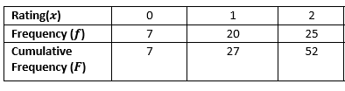

Values with position   
7, 8, 9, … , 25, 26, 27

Then we find the position of the middle value and use our cumulative frequency to find out which $x$ this refers to.