USECASE

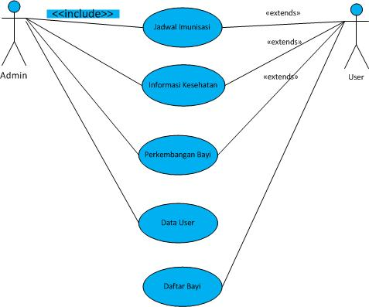

ACTIVITY DIAGRAM (USER)

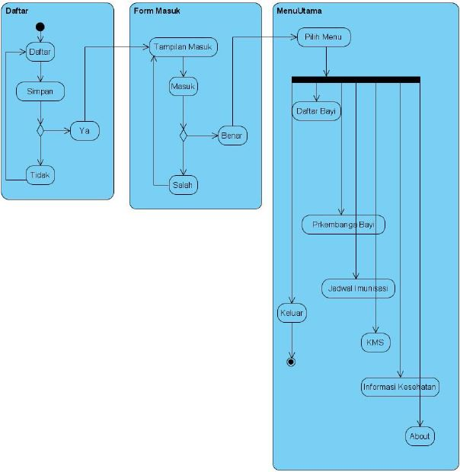

CLASS DIAGRAM (USER)

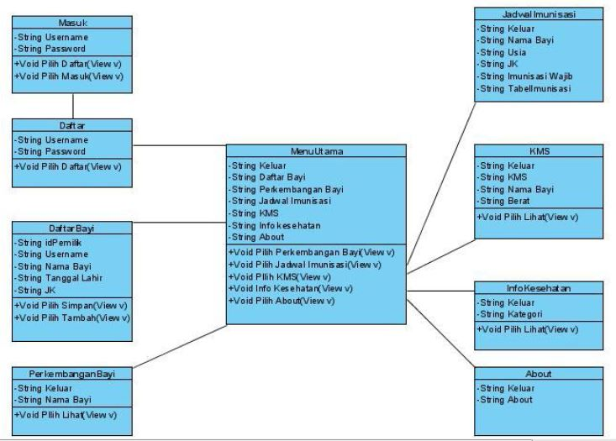

SEQUNCE DIAGRAM (USER)

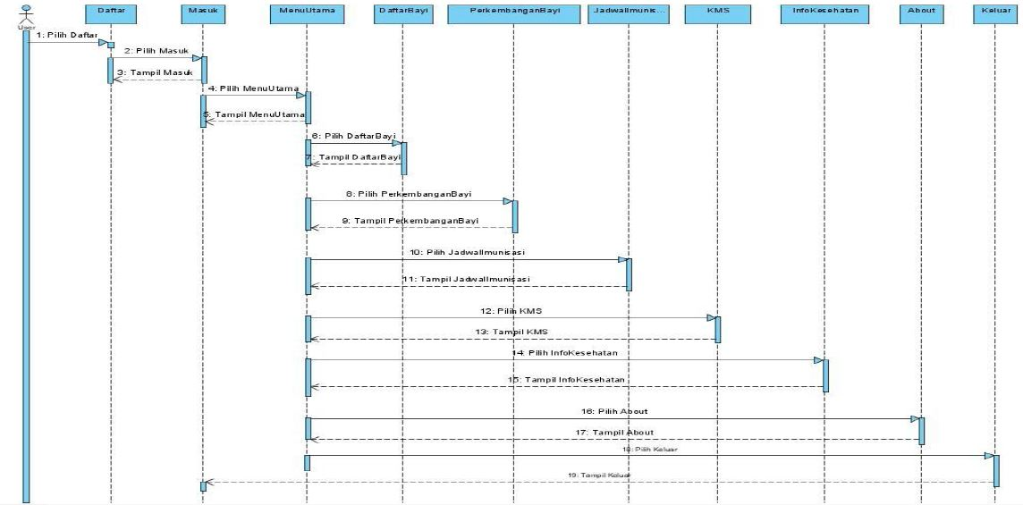

ACTIVITY DIAGRAM (ADMIN)

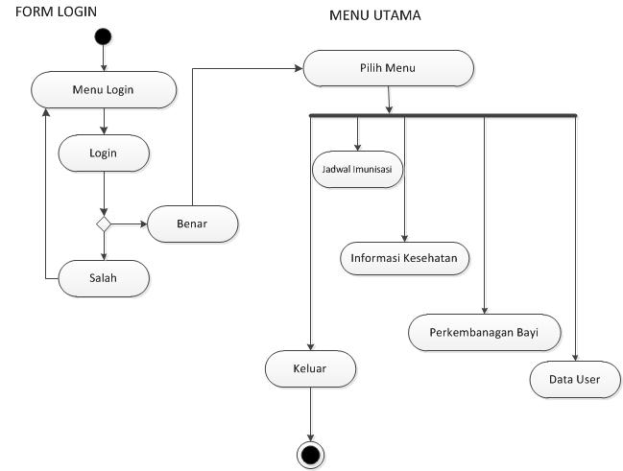

CLASS DIAGRAM (ADMIN)

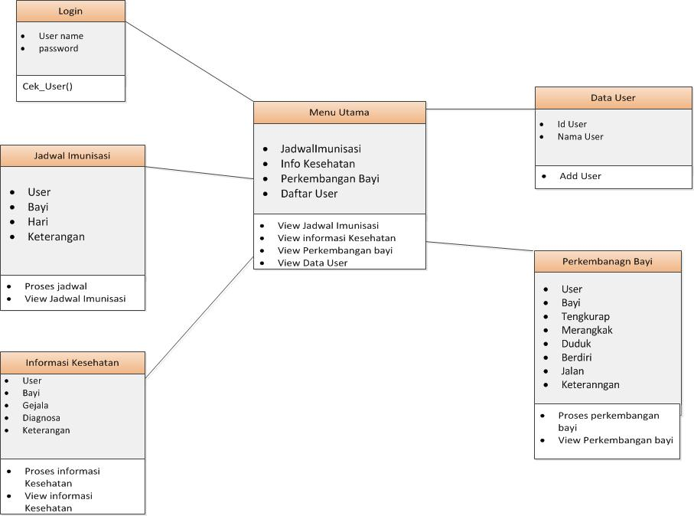

SEQUNCE DIAGRAM (ADMIN)

