**Hash Code 2018**

**Self-Driving Car**

* Example of the input file:

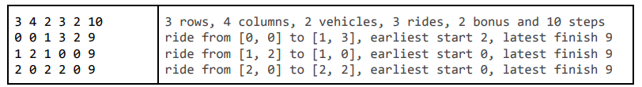

* This input file represents the following:

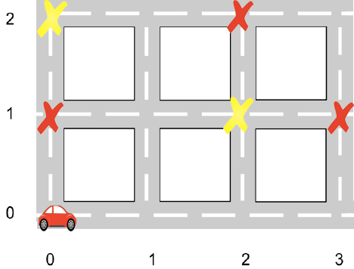

It’s 2 cars in the cell (0, 0) and they need to complete these rides:

(0, 0) – (1,3), (1,2) – (1,0), (2,0) – (2,2).

* To find the score of my result I am going to use the following resource: https://nikosk93.github.io/hashcode2018_grader/