Abstract
The growing globalization of food supply chains, combined with the increasing prevalence of dietary restrictions caused by diseases, religious beliefs, and lifestyles of people, has made food purchasing a difficult and potentially dangerous task for a significant part of the population. Modern technological solutions, primarily based on barcode scanning, have significant limitations, including incomplete database coverage and the inability to process complex, user-defined dietary recommendations. This project addresses this research gap by designing, developing, and evaluating a prototype web application that provides a single platform for verifying dietary compliance. The proposed system directly analyses uploaded images of product ingredient lists using a reliable pipeline that combines a text recognition engine for text extraction, a mechanism for text correction and ingredient identification, as well as a rule-based analysis module to verify compliance with a fully customizable user profile. The main goal is to develop a reliable, database-independent solution to enhance food safety and inclusivity. The project goes through a structured development lifecycle, culminating in the creation of a minimum viable product (MVP) and a continuous phase of iterative improvements aimed at optimizing accuracy and speed. Upon completion of this study, a functional web application will be developed that will allow users with diverse dietary needs to make safe and informed food choices with greater confidence and ease.

Acknowledgments
I would like to express my sincere gratitude to my supervisor, Prof. Chen MA, for his invaluable guidance, continuous support, and constructive feedback throughout the development of this project. His expertise and insightful suggestions have been instrumental in shaping the direction and quality of my Final Year Project.
I am also deeply thankful to my classmates and friends who generously dedicated their time to provide feedback, share their thoughts, and offer valuable ideas on how to develop and improve the application. Their honest opinions and suggestions played a significant role in refining the features and user experience of the app.
Last but not least, I would like to extend my heartfelt appreciation to my family for their unwavering love, encouragement, and support in all my beginnings and endeavors. Their constant belief in me has been a source of strength and motivation during the challenging journey of completing this project.

Table of Contents
Abstract 2
1. Introduction 10
1.1 Background Information 10
1.2 Problem Statement and Research Gap 10
1.3 Aims and Objectives 12
1.4 Scope and Deliverables 12
1.4.1 Project Scope 12
1.4.2 Deliverables 13
2. Literature Review 15
2.1 Barcode Scanning Method 15
2.2 Applicability of the Barcode Scanning Method to the Project 15
2.3 OCR Scanning Method 16
2.3.1 Traditional OCR Approaches 17
2.3.2 Convolutional Neural Network (CNN) Based OCR 17
2.3.3 Convolutional Recurrent Neural Network (CRNN) Architecture 17
2.3.4 EasyOCR Implementation 18
2.3.5 Transformer-Based OCR Models 19
2.3.6 Multimodal Large Language Models for OCR 19
2.4 Applicability of the OCR to the Project 20
3. System Design 23
3.1 System Architecture Overview 23
3.2 Component Flows 24
3.3 System Components 25
3.4 Testing Strategy 26
3.5 Summary 27
4. Methodology and Implementation 28
4.1.1 Component Interaction Flow 28
4.2 Database Design 29
4.2.1 Data Model Overview 29
4.2.2 Schema Design Decisions 31
4.3 Algorithm Implementation 31
4.3.1 OCR Text Extraction 31
4.3.2 Barcode Scanning and Product Lookup 32
4.3.3 Lightweight Ingredient Extraction/Correction Using SymSpell 32
4.3.4 LLM-Based Ingredient Extraction/Correction 33
4.3.5 Rule-Based Dietary Analysis 34
4.3.6 LLM-Based Dietary Analysis 34
4.4 Testing Methodology 36
4.4.1 Test Architecture 36
4.4.2 Unit Test Design 37
4.4.3 Integration Test Design 37
4.4.4 Accuracy Target and Evaluation 38
4.4.5 Test Fixtures and Environment 39
4.5 Problems Encountered and Solutions 39
4.5.1 OCR Quality Inconsistency 39
4.5.2 LLM Extraction Latency 40
4.5.3 Open Food Facts API Coverage and Data Quality 40
4.6 Technology Stack Overview 41
4.7 Summary 42
5. Preliminary Results and Future Improvement 43
5.1 Preliminary testing results 43
5.1.1 Rule-based dietary analysis 43
5.1.2 Unit testing 43
5.1.3 Integration Testing 44
5.2 Parts of the system to be improved 45
5.2.1 Rule-Based Analysis Dictionary Expansion. 45
5.2.2 SymSpell and LLM Prompt Optimisation. 45
5.2.3 Frontend User Interface Refinements. 45
Appendix 46
1. Plan and Schedule for Implementation and Testing 46
2. Monthly Logs 48
References 51

Summary of Revisions and Additions since Interim Report 1

What have been made to address supervisor’s feedback
Feedback received on the previous interim report was carefully reviewed and incorporated into this document. The primary guidance focused on enhancing the overall structure and providing more substantial evidence of progress.
To address the feedback on structure, the report has been comprehensively reorganized. The flow of information has been improved for better logical progression, with clearer sectional divisions and more consistent formatting throughout. A dedicated summary of completed work was also added to provide a concise overview of developments.
Regarding the request for more preliminary results, findings from the recent development and testing phases have been integrated into the relevant sections. This includes performance evaluations of key system components and metrics from the current quality assurance activities. These additions offer tangible evidence of the project's technical advancement and current state of verification.

What addition have been made overall
This section outlines the development and enhancements implemented between November 2025 and the beginning of February 2026. The work followed a structured four-phase plan, culminating in a system currently undergoing final quality assurance.
Phase 1: Front-End Development & Enhancement (Nov – Dec 2025)
The user interface was expanded and refined. Key additions include enhanced, reusable UI components, a real-time upload progress indicator, robust error handling mechanisms, and dedicated views for scan results. Interactive features for user profile management, ingredient scan uploads, and historical scan access were fully integrated.
Phase 2: Core Algorithm Improvement (Dec 2025 – Jan 2026)
The Optical Character Recognition (OCR) module was successfully migrated to EasyOCR, and its performance was systematically evaluated. The spell correction component was enhanced by integrating a more advanced hybrid machine-learning model. Furthermore, the text parsing and ingredient extraction pipeline was upgraded through the training and integration of a Naive Bayes classifier. This phase also delivered a feature for flexible, context-aware rule definition to improve ingredient filtering. Additionally, barcode scanning feature was added.
Phase 3: User System Finalization (Jan 2026)
The backend user system was finalized. Enhancements were made to user registration, authentication, and session management for improved security and reliability. The dietary profile system was extended to support a wider array of dietary restrictions and allow for more granular user customization.
Phase 4: Testing and Quality Assurance (Jan – Feb 2026) – In Progress
A comprehensive testing regimen is currently underway. Unit tests have been implemented, achieving approximately 90% statement coverage. Integration tests for core system workflows are also complete. The present focus is on sourcing and utilising diverse testing datasets—comprising both real and synthetic ingredient label images—to execute these integration tests. This final phase aims to validate overall system accuracy, robustness, correct warning generation, and the handling of edge cases.

All planned development work for Phases 1 through 3 is complete. The project is now in the final verification stage, with testing and QA activities ongoing as scheduled.

Introduction

Background Information
In the significantly globalized modern world, the population has become more health-conscious and quite selective about the food they consume (Müller-Pérez et al., 2025). The reason why humanity has started to care more about what they consume may stem from different reasons, including personal lifestyle choices (e.g., vegetarianism), medical requirements (e.g., lactose intolerance, severe allergies), or religious beliefs (Shepherd & Raats, 2006). Due to their selectiveness, grocery shopping presents a considerable challenge for these individuals. Manually scanning a long list of ingredients filled with chemical terms is a time-consuming, frustrating, and often error-prone process, as it is easy to overlook or misinterpret ingredients (Food Allergy Research & Education [FARE], 2020). A single oversight can lead to severe health consequences for those with allergies or a breach of religious principles for others (Chouraqui et al., 2021). Thanks to advances in the fields of Computer Vision and Deep Learning, it has become possible to solve the problem via applications,canser is able to scan a product and obtain a comprehensive analysis, including a detailed breakdown of the ingredient list, identification of potential allergens, assessment of compliance with specific dietary restrictions, and personalized recommendations based user's user’s defined preferences (Nossair & El Housni, 2024). Collectively, these innovations offer a promising foundation for enhancing the safety, convenience, and inclusivity of food selection in a complex global marketplace.

Problem Statement and Research Gap
Current solutions typically have several limitations. Some existing solutions available in App Marketplaces rely on barcode scanning to query product databases. Others focus on specific dietary needs in isolation, such as checking only for allergens or only for Halal compliance. Furthermore, many existing applications lack personalization, offering only a narrow set of dietary profiles without allowing users to add custom restrictions (Ahmed et al., 2018). To sum up, the central issue is the absence of a unified, reliable, and highly personalized technological solution for verifying food compliance across various dietary restrictions. Current applications address this need with an incomplete approach, creating user friction.
The research gap can be expressed on three levels:
Technical Limitation of Barcode-Centric Systems: As identified by Leba et al. (2024), dependency on centralized databases renders barcode-scanning applications ineffective for a portion of the global food market, including local and non-popular products, thus creating a reliability gap (van der Avoort et al., 2021).
Functional Fragmentation: The Google Play and App Store markets are pervaded by single-purpose applications. Currently, individuals with both allergies and religious dietary restrictions often cannot verify all their requirements within a single application; instead, they are compelled to use multiple separate apps to address each need. This represents a significant usability and functionality gap.
Lack of Adaptive Personalization: Most applications offer a static set of filters (e.g., vegetarian, gluten-free). They fail to accommodate complex, user-defined combinations or lesser-known restrictions, such as avoiding specific food additives like cochineal extract (E120) for vegetarians or checking for the absence of alcohol-based additives (Khamesian et al., 2025). This indicates a critical personalization gap.

Aims and Objectives
The primary purpose of this Final Year Project is to design, develop, and evaluate a prototype web application that provides a unified platform for dietary compliance checking by directly analyzing uploaded images of product ingredient lists. Moreover, one of the essential objectives is to make the app customizable according to users' needs.
The following are the objectives to achieve this aim:
To design and develop a responsive web application front-end with an intuitive UI that allows users to create personalized dietary profiles and upload product images.
To implement a robust backend system integrating an OCR engine for text extraction and a barcode scanning module as a supplemental data source.
To develop a mechanism to correct OCR text and leverage a Large Language Model (LLM) for contextual, rule-based compliance analysis against user-defined restrictions.
To conduct testing to evaluate the system's end-to-end accuracy, speed, and usability.

Scope and Deliverables

Project Scope
Included in project scope:
• Processing of English-language ingredient lists
• Recognition of common allergens (peanuts, gluten, dairy, etc.)
• User customization of dietary profiles, e.g., adding specific allergens
• Halal compliance checking based on common non-Halal ingredients
• Manual correction of OCR results by the user
Out of scope:
• Recognition of non-English ingredient lists (v1.0)
• Nutritional information analysis (calories, macros, etc.)
• Recipe analysis or meal planning
• Expiry date tracking or inventory management
• Recognition of handwritten ingredient lists
• Native mobile version of an app
Assumptions:
• Users have smartphones with functioning cameras
• Product packaging has legible ingredient text
• Lighting conditions will be sufficient for text recognition in most cases
Constraints:
• Limited to common Western dietary restrictions in the initial version
• Dependent on the quality of device cameras and OCR capabilities

Deliverables
Expected Results:
OCR accuracy of ≥90% on clear images of standard packaging
Dietary compliance detection accuracy of ≥95% for common restrictions
Average processing time of <12 seconds per scan
Positive user feedback on UI
Deliverables:
A functioning web application, where users can scan the ingredients/barcodes and receive the result against their dietary requirements.

Literature Review
This section provides an overview of current solutions and methodologies that are used to address dietary restriction management, highlighting their functionalities, limitations, and areas for future improvement.

Barcode Scanning Method
Barcode-scanning approaches have been widely adopted in applications for allergen identification due to their ease of use and quick product lookup capabilities. Leba et al. (2024) developed the Allertify Android app that integrates barcode scanning with image recognition for food allergen detection. While effective in utilizing product databases for rapid information retrieval, their study highlights significant limitations inherent to barcode-dependent systems (Baker et al., 2025). Notably, the reliance on centralized databases results in substantial coverage gaps, particularly for local, niche, or newly introduced products that have not yet been catalogued. Moreover, only a few barcodes are available in the database due to confidentiality concerns. This creates a reliability issue and potentially compromises user trust if certain products cannot be identified or their allergen information verified. Furthermore, barcode scanning alone lacks the capability to address complex multi-dietary profiles or allow for custom user-defined restrictions, restricting functional flexibility. These limitations reflect critical drawbacks in current commercial barcode-scanning tools and emphasize the need for more comprehensive, database-independent methods for dietary compliance verification.

Applicability of the Barcode Scanning Method to the Project
Despite the noted limitations, the barcode scanning method remains appealing in practical applications due to its simplicity and ease of use. Barcodes provide a fast and convenient way for users to retrieve product information with a single scan, minimizing manual effort during grocery shopping or allergen identification. However, the effectiveness of barcode scanning ultimately depends on the completeness and accuracy of the underlying product databases, and it may be less optimal for handling niche, new, or unlisted products, as well as for supporting complex or customized dietary profiles. Consequently, while barcode scanning offers an efficient first step for ingredient verification, it is best complemented by other techniques to achieve comprehensive dietary compliance checking.

OCR Scanning Method
Optical Character Recognition (OCR) is a technology that enables the conversion of printed, handwritten, or typewritten text from images or scanned documents into machine-encoded, editable, and searchable digital text. This automated process operates by first analyzing an image to detect regions of interest containing text, then segmenting that text into lines, words, and individual characters, and finally recognizing those characters using a variety of pattern recognition and machine learning techniques. Modern OCR solutions can process a wide range of formats—including labels, receipts, and photographed documents—and significantly reduce the need for manual data entry, speed up information retrieval, and facilitate downstream text analysis (IBM, 2024).
Over the years, OCR has evolved from basic template and pattern-matching approaches to sophisticated deep learning architectures capable of extracting text from diverse images with high accuracy. This section examines the main types of OCR systems and their underlying algorithms, with particular emphasis on implementations relevant to ingredient scanning applications.

Traditional OCR Approaches
Traditional OCR systems heavily relied on template matching and pattern recognition, where character recognition was performed by comparing extracted features with predefined templates. These methods involved pixel-wise or feature-based comparisons using normalized cross-correlation to identify characters. However, traditional approaches exhibited significant limitations when confronted with varying font styles, complex backgrounds, or distorted text (Fujisawa, 2008). Thus, it became necessary to develop machine learning-based solutions to achieve higher accuracy.​

Convolutional Neural Network (CNN) Based OCR
Convolutional neural networks have become the cornerstone of modern text recognition systems due to their exceptional ability to automatically extract spatial features from images (Yamashita et al., 2018). CNN processes images using multiple convolutional layers that identify elements such as edges, curves, and textures, which are the main components of symbols. These elements are gradually improved by combining layers that reduce the selection of feature maps, which reduces computational complexity while preserving important information. The hierarchical nature of CNNs allows them to capture both low-level elements, such as edges and corners, and high-level semantic representations such as full character shapes, making them significantly more reliable than traditional methods when working with different fonts and variations in image quality.

Convolutional Recurrent Neural Network (CRNN) Architecture
The CRNN architecture combines CNNs and Recurrent Neural Networks (RNNs) to address the sequential nature of text recognition tasks. In this hybrid approach, CNNs serve as feature extractors that process input images and generate feature maps, which are then reshaped into sequences and fed into RNN layers, typically implemented using Long Short-Term Memory (LSTM) networks (Guo, Tu, Li, & Lei, 2016). The LSTM layers model sequential dependencies between characters by processing the feature sequence in both forward and backward directions, enabling the network to understand contextual relationships that improve recognition accuracy, especially for cursive handwriting or ambiguous characters. A critical component of the CRNN architecture is the Connectionist Temporal Classification (CTC) layer, which handles alignment between input sequences and output labels without requiring explicit character segmentation.
However, CRNNs, while robust for most printed and handwritten text, may encounter difficulties with very long text sequences, heavy document noise, or overlapping characters.

EasyOCR Implementation
EasyOCR is a Python-based deep learning OCR library that implements a two-stage pipeline consisting of text detection followed by text recognition. The detection stage employs CRAFT (Character-Region Awareness For Text), a CNN-based detector that excels at identifying individual character regions and linking them into words, making it particularly effective for scene text with arbitrary layouts (Salehudin et al., 2023). For text recognition, EasyOCR utilizes a CRNN architecture with a ResNet backbone for feature extraction, followed by two LSTM layers for sequence modeling. The ResNet backbone extracts deep feature sequences from detected text regions, which are then processed by LSTM layers to capture contextual information across the character sequence.
Moreover, EasyOCR supports a wide range of languages and various writing scripts, including Latin, Chinese, Arabic, Devanagari, and Cyrillic, with pre-trained models available for immediate deployment, making it a robust and versatile solution for processing product packaging in a globalized market.

Transformer-Based OCR Models
Transformer-based OCR models represent a paradigm shift from traditional CNN-RNN architectures by leveraging self-attention mechanisms to capture global relationships within images and text sequences. Exemplifying this paradigm, Li et al. (2021) introduced TrOCR, which utilizes a vision transformer for image encoding and a text transformer for decoding. This architecture establishes a fully end-to-end recognition system, eliminating the dependency on convolutional or recurrent layers. The encoder processes input images by dividing them into patches, which are then flattened and embedded with positional information before being processed through multi-head self-attention blocks to generate image embeddings that capture spatial relationships across the entire image. These embeddings are subsequently passed to the decoder, which utilizes autoregressive generation with attention mechanisms to produce the output text sequence. Vision Transformers in OCR applications demonstrate superior performance on complex multilingual text and scene text recognition benchmarks, exhibiting enhanced robustness to low-light conditions, skewed text, and noisy backgrounds, although they require substantial computational resources and large, diverse training datasets for optimal performance.​

Multimodal Large Language Models for OCR
Recent advances in artificial intelligence have led to the development of multimodal large language models (LLMs) that combine visual perception and language comprehension capabilities, allowing them to perform text recognition as part of broader document comprehension tasks (Sinha & Rekha, 2025). GPT-4 Vision (GPT-4V) includes a visual encoder with pre-trained components for visual perception that matches encoded visual elements with representations of a language model to process complex visual data along with natural language. The architecture uses convolutional neural networks to extract features, object detection modules for localization, and integrates text recognition technologies to extract text from images. The GPT-4V demonstrates reliable text recognition capabilities in scenes, accurately reading both handwritten and printed text in various scenarios, and can perform table structure recognition, chart interpretation, and provide visual answers to document-oriented questions. However, estimates show that GPT-4V faces challenges related to multilingual text, handwritten mathematical expressions, and blurred or distorted images, and it does not always outperform specialized modern text recognition models by standard metrics. Claude, developed by Anthropic, similarly offers visualization capabilities through its API, using multimodal architectures that combine image understanding with natural language processing to extract text from images, interpret document structures, and perform contextual analysis. These multimodal LLMs represent a shift from traditional text recognition systems not only to reading text, but also to understanding its context, semantics, and relationships within documents.

Applicability of the OCR to the Project
Compared to barcode scanning methods, OCR-based ingredient extraction offers key advantages. Barcode scanning relies on product lookup in centralized or proprietary databases, which can result in gaps and missing data for new, niche, or local products—a limitation especially problematic given the confidential nature of many database entries and the lack of coverage for recently introduced items (Baker et al., 2025). OCR-based scanning, by directly interpreting text on product packaging, is inherently database-independent. This allows the system to process ingredient lists for any product, including those not found in existing databases, and better supports complex or personalized dietary profiles.
A comprehensive review of OCR methodologies demonstrates that deep learning-based approaches, particularly Convolutional Recurrent Neural Network (CRNN) architectures, provide significant improvements over traditional template-matching techniques for ingredient recognition tasks. For this ingredient scanner project, EasyOCR is selected as the primary OCR engine due to its integration of CRNN with CRAFT text detection. This architecture excels at extracting scene text in various layouts and languages, while ensuring high recognition accuracy and reliable performance across visually diverse packaging.
Many alternatives were considered, including traditional methods and transformer-based or large language model (LLM) powered solutions. As demonstrated by recent benchmarks, EasyOCR stands out among open-source options by offering a strong balance of speed, accuracy, and cost efficiency. While more recent LLM-powered APIs such as GPT-4o and Gemini achieve marginally higher accuracy, they require substantial computational resources and incur higher costs or dependency on external cloud services. EasyOCR, on the other hand, operates efficiently on local devices, maintains low latency, and provides performance comparable to leading commercial APIs, making it the most suitable choice for a mobile ingredient scanner application (Ueno, 2024).
Figure 1 below, reproduced from Roboflow benchmark data, illustrates that EasyOCR performs competitively with advanced OCR models, achieving strong average accuracy while being significantly more accessible for integration and deployment.
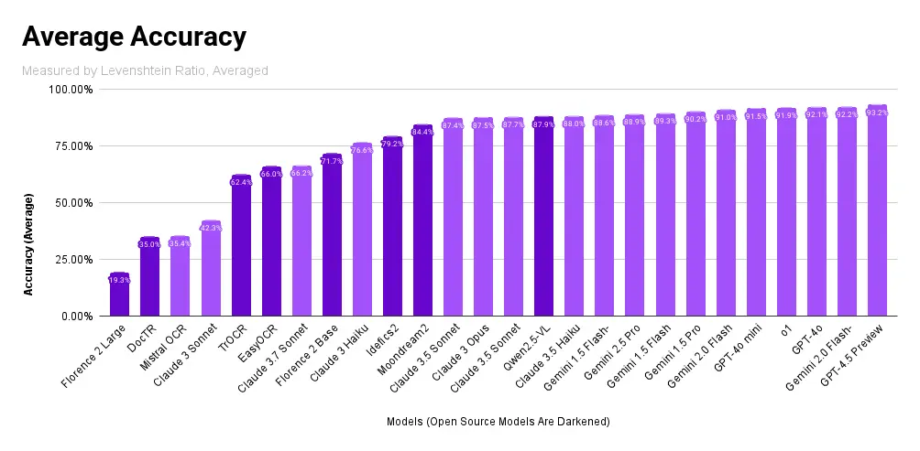
Figure 1. Average accuracy of common OCR solutions
​
Furthermore, a review of several competitive apps revealed that they seldom disclose what OCR technologies are used internally, and most do not provide users with an option to correct detected text from images manually. In contrast, this project will provide users with the ability to edit or correct OCR results directly, addressing a common pain point and further enhancing reliability and user empowerment. However, solutions based on popular OCR engines like PyTesseract face significant limitations. These systems are predominantly rule-based and rely on predefined ingredient lists, which constrain their flexibility. They struggle to adapt to variations in terminology, multilingual labels, and diverse packaging layouts. This inflexibility, combined with a high susceptibility to OCR errors, requires extensive post-processing and makes them inadequate for complex, real-world applications (Assiri et al., 2025). After careful research and practical evaluation, EasyOCR appears to be the best fit for our application due to its balance of accuracy, usability, and efficient local operation.

System Design

System Architecture Overview
The Smart Food Scanner is designed around a modular, three‑tier architecture comprising (1) a user‑facing interface, (2) an application logic server, and (3) a data management layer. The system supports two primary input channels: image‑based OCR scanning and barcode scanning and routes both through a unified analysis pipeline that evaluates ingredients against the user’s dietary profile.
User Interface Layer: A responsive web application allows users to capture or upload food‑label images, scan barcodes, view scan results, manage dietary profiles, and review scan history. It provides real‑time feedback and integrates user‑account management.
Application Logic Layer: The backend handles authentication, image processing, scan‑record management, and dietary analysis. It orchestrates the processing pipeline, including OCR extraction, text correction, ingredient classification, and compliance evaluation.
Data Layer: A relational database stores user accounts, scan history, and dietary profiles, while separate image storage retains scanned photos for later retrieval and historical analysis.
Figure 2 presents the System Design Diagram for the Smart Food Scanner, illustrating how these layers interact with the core services.
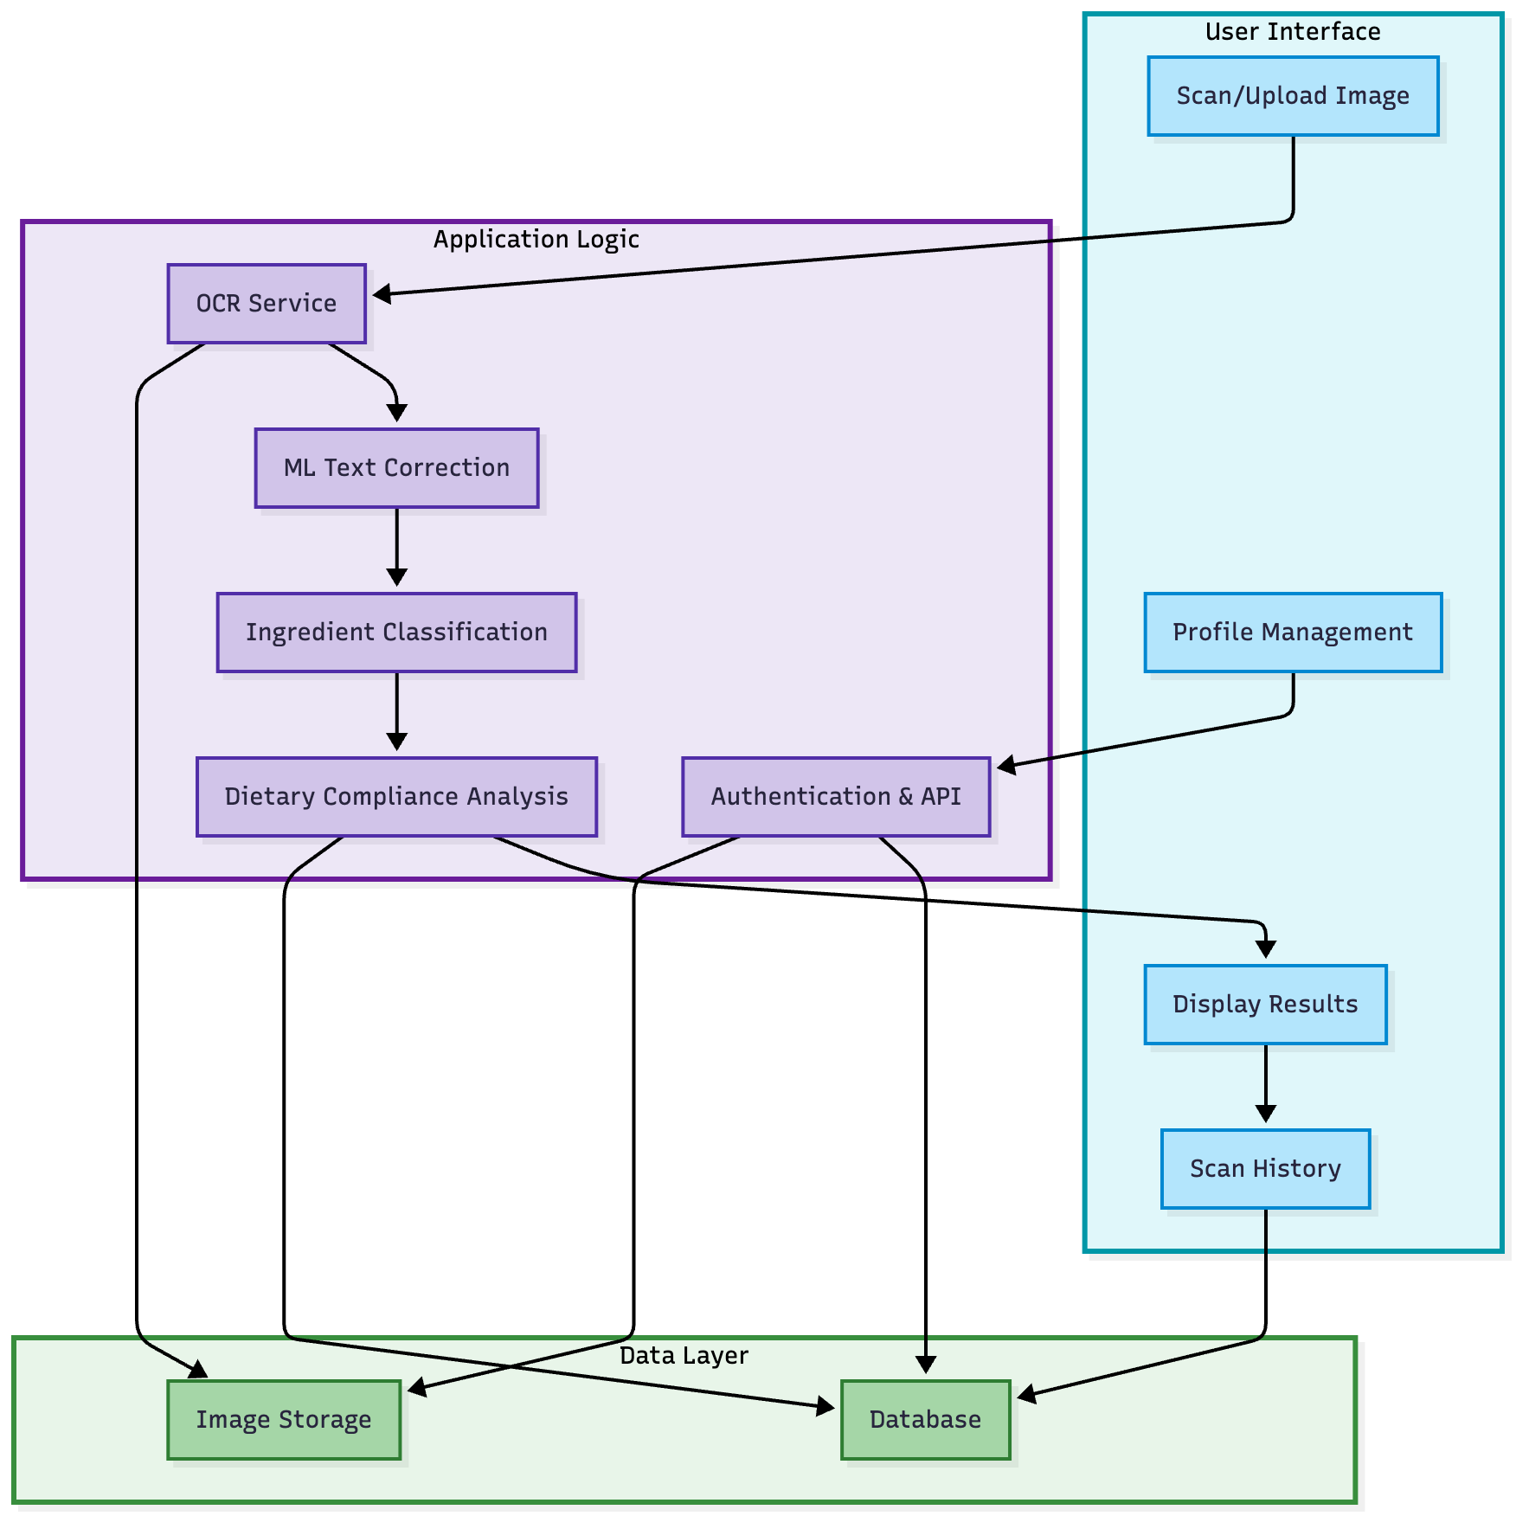
Figure 2. System Design Diagram of the app

Component Flows
Scan Processing Flow:
- The user captures or uploads an ingredient label photo.
- The image is sent to the backend for processing.
- OCR extracts raw text from the image.
- SymSpell applies dictionary-based spell correction
- Rule-based filter removes non-ingredients
- Dietary compliance analysis checks the ingredient list against the nutritional restrictions, returning status and warnings.
- Results are sent back to the user interface and stored in the database for history and analytics.

System Components
User Interface: Enables all primary actions—scanning, viewing results, managing profiles, and history access.
OCR Service: Uses EasyOCR for extracting text from images, supporting multiple image formats. OCR failures and uncommon image formats are handled with user feedback and error messages.
Text correction and filtering: Corrects common OCR errors and removes non-ingredient text (addresses, instructions, URLs, etc.) so only relevant ingredient content is kept for downstream analysis.
Dietary Analysis: Matches the identified ingredient against the user's stored dietary profile, utilizing either rule-based or AI-driven (LLM/API) analysis for compliance evaluation. The system can fall back to dictionary matching in the event of service unavailability.
Data Management: Handles secure storage and retrieval of user data, scan history, and images, supporting account management and long-term analytics.

Testing Strategy
The testing strategy for SmartFoodScanner combines unit, integration, and performance testing, with a separate focus on OCR accuracy. Core logic is covered by unit tests; integration and system tests check end-to-end flows and API behaviour.
Test architecture: Tests are organised in three tiers: unit tests (core logic in isolation), integration tests (pipeline and API), and performance tests (response times and resource use). Unit tests target the rule-based analysis engine, LLM analysis, ingredient extraction (tokenization, spell correction, filtering), OCR, barcode lookup, validation, and classification.
Unit test design: Core logic components are covered by unit tests. The ingredient extraction pipeline (tokenization, stemming, spell correction, non-ingredient filtering) and dietary analysis logic are tested in isolation. Rule-based tests cover all dietary restrictions with positive and negative cases; barcode tests cover Open Food Facts parsing, ingredient/allergen extraction, and error handling.
Integration test design: Integration tests validate the full flow from image upload or barcode scan to analysis. They use mocked LLM, and Open Food Facts dependencies. API tests cover auth, dietary profiles, OCR/barcode scan submission, and history; database tests check that scan records and user–profile–scan relationships are stored correctly.
OCR accuracy testing: OCR accuracy is tested separately, aiming for 90% accuracy. A varied set of food labels (different fonts, lighting, backgrounds, orientations) is used; extracted text is compared to ground truth to compute character error rate (CER) and word error rate (WER).
Accuracy target and evaluation: Dietary compliance detection aims for at least 95% accuracy, evaluated on a synthetic dataset of 100+ cases across all restrictions. Per-category metrics and warning quality are also assessed.

Summary
The Smart Food Scanner provides a modular, scalable solution for ingredient label analysis and dietary compliance. Its architecture decouples user interaction, processing logic, and long-term data management for maintainability and extensibility. The incremental integration of robust OCR, OCR text correction and non-ingredients filtering, and LLM-powered dietary analysis aims to increase reliability, adaptability, and user confidence continuously.

Methodology and Implementation
This chapter presents the technical implementation of the Smart Food Scanner application, detailing the system architecture, database design, algorithm implementations, and testing methodology. The chapter concludes with a discussion of problems encountered during development and the solutions applied.

Component Interaction Flow
The system supports two primary input methods: image‑based OCR scanning and barcode scanning.
Image‑based OCR flow: When a user uploads a food‑label image, the request is first validated by the FastAPI server (checking file type and size). The image is then passed to the OCR service, which extracts text using EasyOCR. The extracted text is forwarded to the ingredient extraction service, which can use either a SymSpell‑based spell checker or an LLM‑based extractor, depending on configuration.
Barcode‑based flow: When a user scans a barcode, the system queries the Open Food Facts API to retrieve structured product data, including the product name, brand, ingredients list, declared allergens, and potential traces. This route bypasses OCR and ingredient extraction, as the ingredients are already available in structured form.
In both cases, once ingredients are obtained, they are sent to the analysis service, which evaluates them against the user’s dietary profile. The system first attempts LLM‑based analysis for richer interpretation, falling back to rule‑based analysis if the LLM service is unavailable. Finally, the scan results are persisted to the database and returned to the client through the User Interface Layer. Figure 3 shows the application screen where the user selects their desired scanning method.

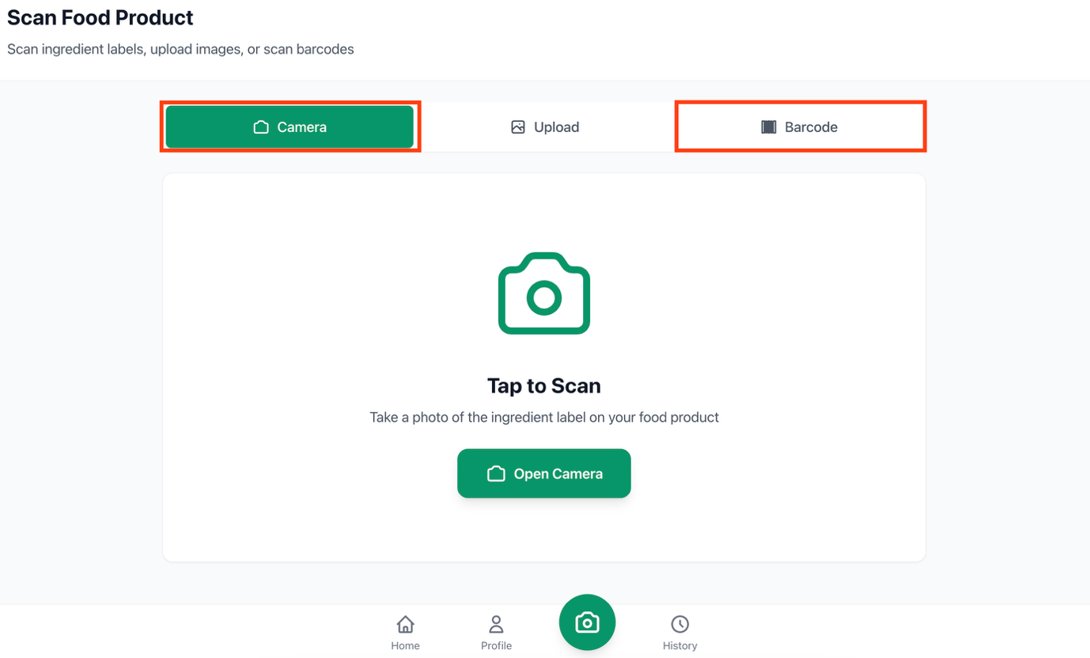
Figure 3 Choice between OCR and Barcode scanning methods in the app

Database Design

Data Model Overview
The database schema consists of four primary entities: Users, Dietary Profiles, Scans, and Refresh Tokens.
The Users table stores authentication credentials including email, username, hashed password, and optional full name. Each user has a one-to-one relationship with a Dietary Profile, which contains boolean flags for common dietary restrictions such as halal, gluten-free, vegetarian, vegan, nut-free, and dairy-free.
The Dietary Profile also stores custom allergens and restrictions as JSON arrays, along with a preference flag for enabling LLM-based ingredient extraction.
The Scans table maintains a history of all food label scans performed by each user, storing the original image path or barcode, raw OCR text or ingredients text from the database lookup, extracted ingredients, safety determination, warnings, and detailed analysis results.
The Refresh Tokens table supports secure token-based authentication by tracking token hashes, creation times, expiration times, and revocation status. The below demonstrates the Entity Relationship diagram.
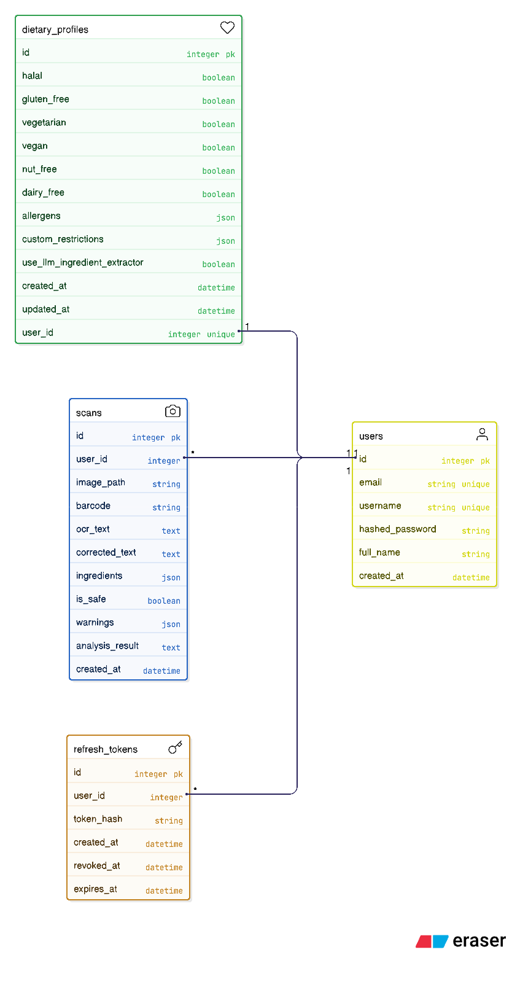
Figure 4. System Design Diagram of the app

Schema Design Decisions
The decision to store allergens and custom restrictions as JSON arrays rather than separate normalised tables was made to simplify queries and reduce join operations during the time-critical analysis phase. This denormalised approach allows the dietary profile to be retrieved in a single query without complex joins. The ingredients and warnings fields in the Scans table similarly use JSON storage to accommodate variable-length lists without requiring separate junction tables. The Scans table accommodates both OCR-based and barcode-based scans by having nullable fields for image_path and barcode, where one or the other is populated depending on the scan method.

Algorithm Implementation

OCR Text Extraction
The OCR service utilises EasyOCR, an open-source optical character recognition library that supports multiple languages and provides confidence scores for each detected text region. When an image is received, it is first converted to RGB format if necessary, with special handling for HEIF/HEIC formats commonly produced by iPhone cameras. The image is then converted to a NumPy array and processed by the EasyOCR reader, which returns a list of detected text regions along with their bounding boxes and confidence scores.
To improve extraction quality, the system implements confidence-based filtering with a configurable threshold defaulting to 0.3. Text detections with confidence scores below this threshold are discarded to reduce noise from unreliable readings. The remaining text lines are concatenated to form the complete OCR output. The OCR reader is initialised as a singleton to avoid the performance overhead of loading the neural network models on each request, with automatic fallback from GPU to CPU mode if GPU resources are unavailable.

Barcode Scanning and Product Lookup
As an alternative to OCR-based scanning, the system provides barcode scanning functionality that retrieves product information from the Open Food Facts database. Open Food Facts is a collaborative, open-source database containing information on food products from around the world, including ingredient lists, nutritional information, allergens, and packaging details.
When a barcode is scanned, the system first validates the barcode format, ensuring it contains only numeric digits. The validated barcode is then sent to the Open Food Facts API, which returns comprehensive product information if the product exists in the database. The API response includes the product name, brand, ingredients text, declared allergens, and trace warnings indicating potential cross-contamination risks.
The ingredients text retrieved from the database is parsed to extract individual ingredients. The parsing algorithm handles the hierarchical structure common in ingredient lists, where parentheses indicate sub-ingredients or additional details. The parser tracks parenthesis depth to correctly split on commas only at the top level, preventing incorrect separation of compound ingredients. Percentages and numeric values are removed during cleaning, as these typically indicate proportions rather than ingredient names.

Lightweight Ingredient Extraction/Correction Using SymSpell
As an alternative to the computationally intensive neural network approach, the system provides a lightweight extraction method based on the SymSpell algorithm. SymSpell is a symmetric delete spelling correction algorithm that offers significantly faster lookup times compared to traditional edit-distance algorithms. The implementation maintains a custom dictionary populated with over 800 food-specific terms, including common ingredients, E-number additives, and their associated names.
The SymSpell extractor operates by first splitting the OCR text on common delimiters such as commas and semicolons. Each segment is then processed through the spell checker, which attempts to match the text against the food dictionary using edit distance calculations. For compound terms, the algorithm employs word segmentation to handle cases where spaces may have been omitted or incorrectly inserted during OCR. The system applies a 15% error rate threshold to prevent over-correction of heavily corrupted text. E-number patterns are detected using regular expressions and normalised to a standard format. This approach provides near-instantaneous processing times while maintaining reasonable accuracy for well-formed ingredient lists.

LLM-Based Ingredient Extraction/Correction
For users who require higher extraction accuracy, particularly with complex or poorly formatted labels, the system offers LLM-based extraction. This approach constructs a prompt that instructs the language model to extract individual ingredients from the OCR text, handling variations in formatting, abbreviations, and OCR errors. The LLM response is parsed as JSON to obtain a structured list of ingredients. While this method produces superior results for challenging inputs, it introduces latency due to API calls and consumes API quota, making it optional based on user preference.

Rule-Based Dietary Analysis
The rule-based analysis system maintains a database of known allergens and restricted ingredients organised by dietary category. For halal compliance, the database includes pork, gelatin, lard, and bacon. For gluten-free verification, it contains wheat, barley, rye, oats, and gluten. Vegetarian and vegan restrictions include various animal-derived ingredients, while nut and dairy allergen lists cover common variants of these food groups.
The analysis algorithm iterates through the user's enabled dietary restrictions and checks each extracted ingredient against the corresponding allergen list using case-insensitive substring matching. The algorithm also supports custom allergens specified by the user, which are checked in addition to the predefined categories. The final result includes a boolean safety determination, a list of specific warnings, and a human-readable summary of the analysis.

LLM-Based Dietary Analysis
For more comprehensive analysis that considers hidden ingredients, derivatives, and contextual factors, the system supports LLM-based analysis. The algorithm constructs a detailed prompt that provides the language model with the user's dietary restrictions and the list of extracted ingredients. The prompt instructs the model to consider factors such as hidden ingredients and derivatives, cross-contamination risks, and ambiguous ingredient names that may have multiple interpretations. If the LLM service is unavailable or returns an invalid response, the system automatically falls back to rule-based analysis to ensure continuous operation. The figure below presents an example of the dietary analysis result generated by the LLM module within the application.

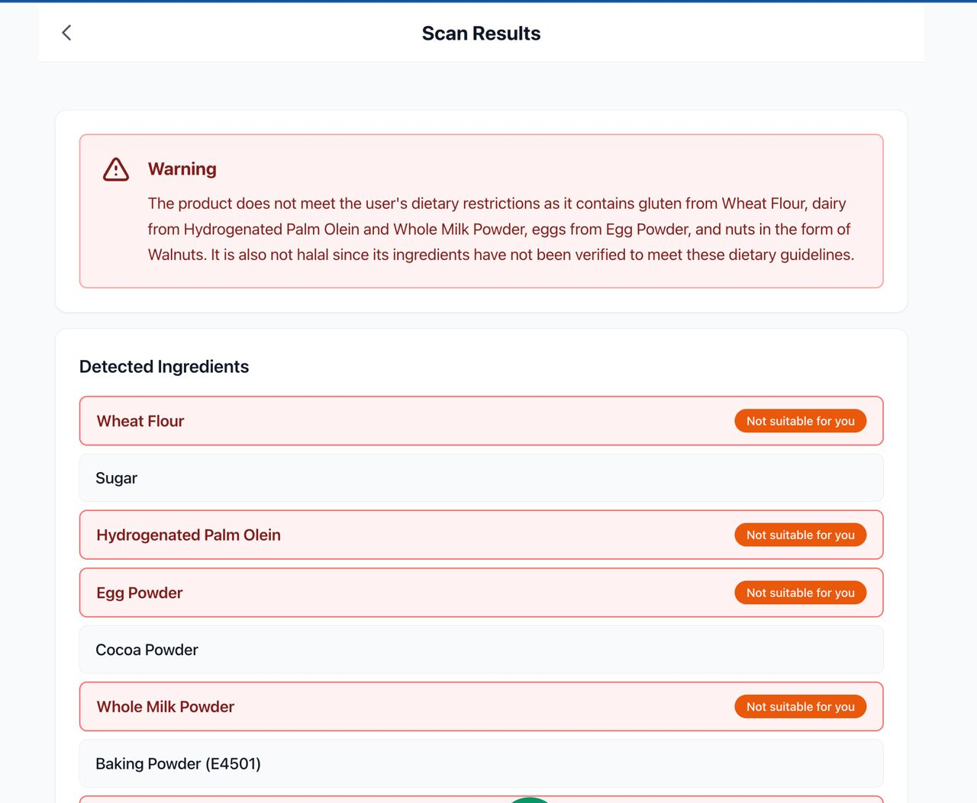
Figure 5 Scan Results Example

To support multiple LLM providers, the system implements a unified service architecture based on the abstract factory pattern. A base provider class defines the common interface for all LLM interactions, including methods for checking availability, making API calls, and parsing responses. Concrete implementations exist for six providers: Groq, Google Gemini, OpenAI, Anthropic, Ollama, and LM Studio. Each provider implementation handles the specific API requirements and authentication mechanisms of its respective service. The Figure 6 shows the class hierarchy and relationships between the base provider class and its concrete implementations in this architecture.
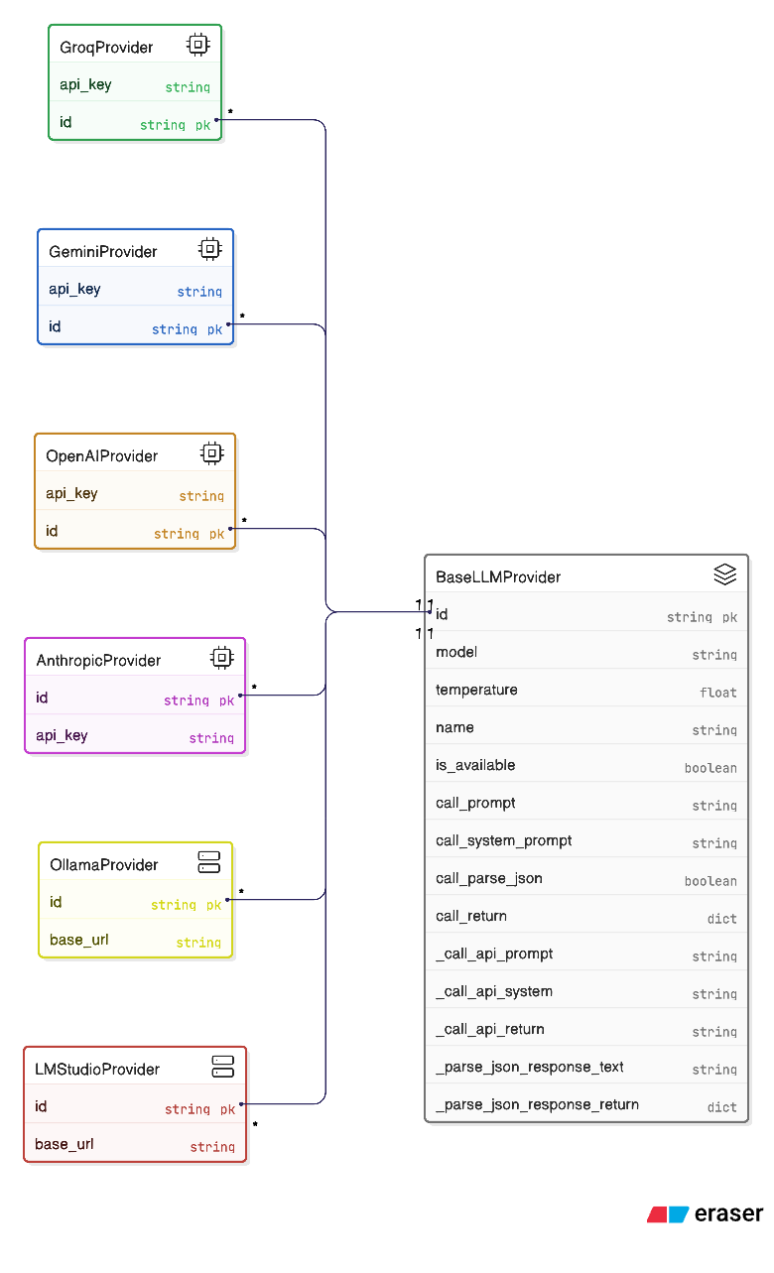
Figure 6. LLM Provider Inheritance Hierarchy

Testing Methodology

Test Architecture
The testing strategy employs a three-tiered approach comprising unit tests, integration tests, and performance tests. Unit tests verify the correctness of individual components in isolation, including the rule-based analysis engine, LLM analysis integration, ingredient extraction services, OCR processing, barcode lookup service, input validation, and ingredient classification. Integration tests validate the interaction between components, focusing on end-to-end pipeline flows for both OCR and barcode scanning, API endpoint functionality, and database operations. Performance tests measure response times, throughput, and resource utilisation under various load conditions.

Unit Test Design
Unit tests for the rule-based dietary analysis cover all supported dietary restrictions with both positive and negative test cases. For each restriction type, tests verify that safe ingredients correctly produce a positive safety determination, while restricted ingredients correctly trigger warnings and negative safety determinations. Test cases include verification of common variants such as different nut types for nut allergies, various gluten-containing grains for gluten-free requirements, and multiple animal-derived ingredients for vegan compliance. The tests also verify correct handling of custom allergens specified by users and proper generation of warning messages that identify the specific problematic ingredient.
Unit tests for the barcode service verify correct parsing of Open Food Facts API responses, proper extraction of ingredients from the ingredients text field, correct formatting of allergen and trace information, and appropriate error handling when products are not found in the database.

Integration Test Design
Integration tests validate the complete processing pipeline from image upload or barcode scan through to final analysis results. The pipeline flow tests simulate realistic usage scenarios by providing OCR output text or barcode values, extracting ingredients, creating dietary profiles with specific restrictions, and verifying that the analysis correctly identifies compliance violations. These tests use mocking to isolate the integration under test from external dependencies such as the LLM services, and the Open Food Facts API, allowing for deterministic test execution.
API endpoint tests verify the correct behaviour of all REST endpoints, including authentication flows, dietary profile management, OCR scan submission, barcode scan submission, and history retrieval. These tests use the FastAPI TestClient to simulate HTTP requests and validate response status codes, content types, and payload structures. Database integration tests verify that scan records are correctly persisted for both scan types and that relationships between users, profiles, and scans are properly maintained.

Accuracy Target and Evaluation
The system targets a dietary compliance detection accuracy of 95% or higher. This target is evaluated using a test dataset containing over 100 test cases. Each test case specifies an ingredient list, a dietary profile configuration, and the expected safety determination. The evaluation calculates accuracy as the proportion of test cases where the predicted safety matches the expected safety.
Additional accuracy metrics are calculated for each dietary restriction category separately, allowing identification of specific areas that may require improvement. The evaluation also considers warning generation quality, verifying that when products are marked unsafe, the warnings correctly identify the ingredients responsible for the violation.

Test Fixtures and Environment
The testing framework uses pytest with custom fixtures for database sessions, test users, dietary profiles, and mock services. Database tests use an in-memory SQLite database to ensure test isolation and avoid side effects on production data. User fixtures create test accounts with hashed passwords, while dietary profile fixtures provide pre-configured profiles for common restriction combinations such as halal-only, vegan, and multiple-restriction scenarios.
Mock fixtures replace external services during testing, including a mock OCR reader that returns predetermined text results, mock LLM services that return controlled responses, and mock HTTP responses for the Open Food Facts API. This mocking strategy enables comprehensive testing of all code paths, including error handling for unavailable services and fallback behaviour.

Problems Encountered and Solutions

OCR Quality Inconsistency
The initial implementation used pytesseract for optical character recognition, which produced inconsistent results when processing food labels. Common issues included poor performance on curved text found on cylindrical packaging, sensitivity to lighting conditions, difficulty reading small font sizes, and confusion with multilingual ingredient lists. These problems resulted in high character error rates that propagated through the extraction and analysis pipeline.
The solution involved migrating to EasyOCR, which demonstrated superior performance on diverse text styles and layouts. Additionally, confidence-based filtering was implemented to reject low-quality detections, with a threshold of 0.3 providing an effective balance between recall and precision. Support for HEIF/HEIC image formats was added to accommodate images captured on Apple devices, which use these formats by default.

LLM Extraction Latency
During development, it became apparent that LLM-based ingredient extraction, while producing high-quality results, introduced significant latency. This was primarily due to API round-trip times and variability in LLM server performance, with response times ranging from several seconds to dozens of seconds depending on the provider and network conditions. Such latency proved unacceptable for an application where users expect near-instantaneous feedback when scanning products in a retail environment.
The solution implemented a tiered extraction approach. The SymSpell-based extractor was developed as a lightweight alternative that provides near-instantaneous processing using a pre-loaded food ingredient dictionary. This method handles straightforward ingredient lists effectively while avoiding API calls entirely. Users can enable LLM-based extraction through their profile settings when they require higher accuracy for complex labels, accepting the latency trade-off for improved results. The SymSpell-based extractor serves as the default option, providing a balance between accuracy and speed by running inference locally without external API dependencies.

Open Food Facts API Coverage and Data Quality
When implementing barcode scanning, it was discovered that the Open Food Facts database, while extensive, does not contain all products and sometimes has incomplete or missing ingredient information. Products from certain regions or smaller manufacturers may not be present in the database, and even when products are found, the ingredients text may be in a language other than English or formatted inconsistently.
The solution involved implementing robust error handling that provides clear feedback to users when products are not found or lack ingredient information. The system preferentially retrieves English-language fields when available, falling back to the default language fields when English versions are not present. For products with incomplete data, users are informed that the barcode lookup was unsuccessful and are directed to use the OCR scanning method as an alternative.

Technology Stack Overview
The client layer is built using Vue.js 3 as the Progressive Web Application framework, with Tailwind CSS for responsive styling, Pinia for state management, and Vue Router for navigation. The backend employs FastAPI as the REST API framework, SQLAlchemy as the Object-Relational Mapper, Pydantic for data validation, and python-jose for JWT token handling.
The core components of the system include EasyOCR for text extraction, SymSpell for lightweight spell correction, and a rule-based filter for non-ingredient detection. The spell correction and filtering modules are complemented by an LLM-based alternative for enhanced accuracy. Furthermore, the barcode scanning functionality is integrated with the Open Food Facts API for product information retrieval.
The data layer uses PostgreSQL as the primary database, hosted on Supabase for cloud deployment, with SQLite used for testing purposes. The testing stack comprises pytest as the test framework, unittest.mock for mocking dependencies, and the FastAPI TestClient for API testing.

Summary
This chapter has presented the technical implementation of the Smart Food Scanner, covering the system architecture, database design, algorithm implementations, and testing methodology. The multi-layered architecture separates concerns between presentation, business logic, and data persistence, while the dual input method approach supports both OCR-based image scanning and barcode-based product lookup. The hybrid AI approach combines deterministic rule-based analysis with probabilistic LLM-based analysis, and the tiered extraction strategy offers choices between SymSpell, rule-based, and LLM-based extraction methods. The problems encountered during development and their solutions demonstrate practical engineering decisions necessary for deploying AI-powered applications in real-world environments.

Preliminary Results and Future Improvement

Preliminary testing results

Rule-based dietary analysis
Initial testing of the Smart Food Scanner system produced encouraging results across the core functionality areas. The rule-based dietary analysis demonstrated correct identification of dietary violations for all supported restriction categories including halal, gluten-free, vegetarian, vegan, nut-free, and dairy-free profiles.

Unit testing
As shown in Figure 7, the core logic of the application was successfully covered by unit tests, achieving close to 100% test coverage across all components.
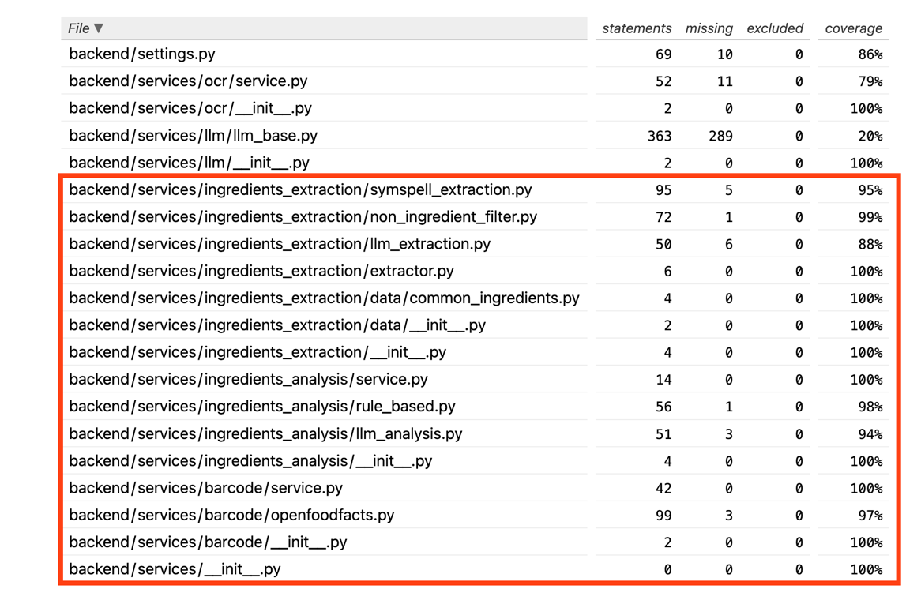
Figure 7. Unit tests results

Integration Testing
As part of integration testing, full pipeline performance tests are run to evaluate end-to-end speed and to compare the two ingredient extraction modes: rule-based SymSpell extraction and LLM-based extraction. These tests use real services (no mocking): OCR (EasyOCR), extraction (SymSpell or LLM), and dietary analysis.
The comparison test runs the complete pipeline (image → OCR → extraction → analysis) mutliple times for each mode. For each iteration, wall-clock time is recorded. In the Figure 8 a box plot visualisation is demonstrates the distribution of per-iteration times, including mean and whiskers (min–max) for both SymSpell and LLM methods.
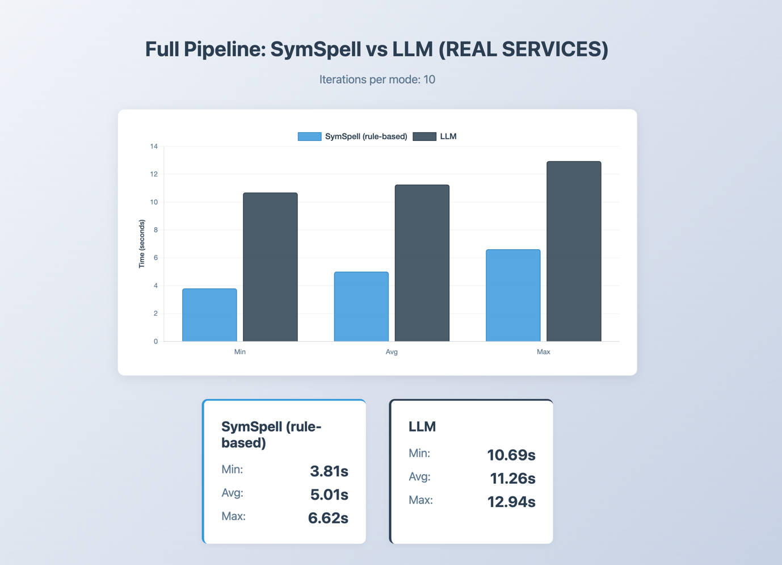
Figure 8 SymSpell vs LLM methods performance
The LLM-based pipeline demonstrates a mean latency of approximately 11 seconds, slightly exceeding the 10-second performance target, whereas the rule-based SymSpell method consistently remains below this threshold at around 5 seconds.

Parts of the system to be improved

Rule-Based Analysis Dictionary Expansion.
The current ALLERGENS dictionary contains a limited number of terms per category. To achieve the target accuracy of 80% for rule-based dietary compliance detection, additional ingredient terms, synonyms, and variants must be added to each allergen category.

SymSpell and LLM Prompt Optimisation.
Following the completion of full system integration testing and comprehensive time and accuracy evaluation, the SymSpell dictionary and LLM prompts will be refined to improve extraction and analysis quality. The SymSpell dictionary may be expanded with additional food-specific terms identified during testing, while LLM prompts may be adjusted to produce more consistent and accurate results based on observed failure cases.

Frontend User Interface Refinements.
The current frontend implementation contains minor visual inconsistencies that affect the overall polish of the application. These include UI elements such as buttons and text labels that are not consistently centred or aligned within their containers, and loading indicators that could be more visually refined. Future iterations will address these layout discrepancies to ensure consistent alignment and spacing throughout the interface. Additionally, popup notification messages will be implemented to provide clearer feedback to users during operations such as scan completion, error states, and successful profile updates, enhancing overall interactivity and user experience.

Appendix
- Plan and Schedule for Implementation and Testing
The preliminary 26-week Gantt chart outlines a sequential and modular approach, with each major project task building on the outcomes of prior work. As of November 2025, development has progressed to a Minimum Viable Product (MVP) stage, featuring a core backend, a user interface allowing users to scan ingredients, and a basic text correction module.
Completed Work:
September 1 – September 12, 2025: Research and Planning
— Completed background literature review, technology selection, system architecture, and requirements analysis.
September 15 – November 7, 2025: Backend and MVP Development
— Designed and implemented backend infrastructure, including API endpoints, database schemas, and core image processing modules.
— Developed an MVP including initial OCR integration and a simple statistical text correction model.
Planned Work:
November 10, 2025 – December 5, 2025: Front-End Development & Enhancement
— Expand the user interface with enhanced UI components, real-time upload progress, error handling, and result display views.
— Integrate interactive features for profile management, ingredient scan uploads, and access to scan history.
December 8, 2025 – January 9, 2026: Core Algorithm Improvement
— Migrate the OCR module to EasyOCR and conduct a systematic evaluation of its accuracy and speed.
— Enhance the spell correction component by integrating an LLM.
— Upgrade text parsing and ingredient extraction methods by training and integrating the Naive Bayes classifier.
— Implement features for flexible rule definition and context-aware ingredient filtering.
January 12, 2026 – January 23, 2026: User System Finalization
— Enhance user registration, authentication, and session management.
— Extend dietary profile customization and support for more restriction types.
January 26, 2026 – February 6, 2026: Testing and Quality Assurance (QA)
— Carry out comprehensive unit and integration testing using 100+ real and synthetic ingredient label images.
— Evaluate system accuracy, robustness, and correct warning generation.
— Validate error handling and edge cases.
February 9, 2026 – February 20, 2026: Debugging and Iterative Refinement
— Address all issues detected during testing and user trials.
— Refine UI/UX in response to user feedback from acceptance testing.
February 23, 2026 – March 18, 2026: Finalization, Documentation, and Submission
— Prepare final project documentation, presentations, and the comprehensive project report.
— Compile final evaluation metrics, results analysis, and user feedback.
— Submit the complete source code, final report, and all project deliverables by the March 18, 2026, deadline.
- Monthly Logs
Month | Content
October, 2025 | - Conducted problem definition and a comprehensive analysis of the project scope.  - Performed a review of existing applications to identify their respective strengths and limitations.  - Researched and evaluated potential methodologies, including barcode scanning, Optical Character Recognition (OCR), and machine learning models for textual error correction.  - Selected an appropriate technology stack and suite of libraries for application development.  - Requested the necessary hardware from the Computer Science department.  - Commenced the implementation of the Minimum Viable Product (MVP).
November, 2025 | - Designed a foundational machine learning model for the correction of misspelled words.  - Completed the implementation of the MVP and successfully demonstrated it to the project supervisor, Professor Chen Ma.  - Discussed potential avenues for application enhancement, focusing on improvements to processing speed and data accuracy.  - Initiated and am currently working on application improvements, specifically through the integration of the EasyOCR engine and the development of a more advanced spelling correction model.
December, 2025 | - After thorough research managed to improve ingredients detection by integrating an ML model from Hugging Face.  - Fine-tune UI for mobile version.
January, 2026 | - Integrated LLM for ingredients analysis  - Added SymSpell for dictionary-based spell correction instead of ML model  - Implement rule-based non-ingredients filtering  - Prototyped and implemented the Profile page in the frontend, allowing users to add their custom dietary restrictions.  - Added barcode scanning option  - Researched and cleaned ~100 images for testing and system performance evaluation
February, 2026 | - Implemented unit tests, covering 80-100% of important services like OCR text extraction and ingredients extraction/correction  - Started implementing integration testing for performance and accuracy evaluation

References
Ahmed, S., Elahi, M., & Ricci, F. (2018). A conversational recommender system for personalized food suggestions. Information Systems, 72, 95–109. https://doi.org/10.1016/j.is.2017.10.003
Baker, E., Foubister, C., Shucksmith, J., Akhter, N., Battista, K., Buxton, D., Fairbrother, H., Hind, D., Hock, E., Jones, G., Limb, E., Machaczek, K. K., McGowan, L., Parretti, H. M., Quirk, H., Sherar, L. B., Wilkinson, S., Zizzo, G., & Relton, C. (2025). The impact of the Change4Life Food Scanner on children's diets and parental psychological outcomes: A randomised pilot and feasibility study. BMC Public Health, 25(1), Article 340. https://doi.org/10.1186/s12889-025-23400-0
Chouraqui, J.-P., Turck, D., Briend, A., Darmaun, D., Bocquet, A., Feillet, F., Frelut, M.-L., Girardet, J.-P., Guimber, D., Hankard, R., Lapillonne, A., Peretti, N., Roze, J.-C., Siméoni, U., Dupont, C., & the Committee on Nutrition of the French Society of Pediatrics. (2021). Religious dietary rules and their potential nutritional and health consequences. International Journal of Epidemiology, 50(1), 12–26. https://doi.org/10.1093/ije/dyaa182
Food Allergy Research & Education. (2020). The food allergy consumer journey. https://www.foodallergy.org/sites/default/files/2020-07/FARE-Food-Allergy-Consumer-Journey-Study-July2020.pdf
Fujisawa, H. (2008). Forty years of research in character and document recognition—An industrial perspective. Pattern Recognition, 41(8), 2435–2446. https://doi.org/10.1016/j.patcog.2008.03.015
Guo, Q., Tu, D., Li, G., & Lei, J. (2016). Memory Matters: Convolutional Recurrent Neural Network for Scene Text Recognition. arXiv:1601.01100. https://doi.org/10.48550/arXiv.1601.01100
Salehudin, M. A. M., Basah, S. N., Yazid, H., Basaruddin, K. S., Safar, M. J. A., Som, M. H. M., & Sidek, K. A. (2023). Analysis of Optical Character Recognition using EasyOCR under Image Degradation. Journal of Physics: Conference Series, 2641(1), 012001. https://doi.org/10.1088/1742-6596/2641/1/012001
Li, C., Zhang, C., Cai, Z., & Wang, C. (2021). TrOCR: Transformer-based optical character recognition. arXiv:2109.10282. https://doi.org/10.48550/arXiv.2109.10282
Assiri, F. Y., Almulhim, M. F., Aldayel, T. S., Alabdulqader, N. A., Almashouq, M. K., & Alrubaish, A. M. (2025). Extract Nutritional Information from Bilingual Food Labels Using OCR and Machine Learning. Frontiers in Nutrition. https://www.ncbi.nlm.nih.gov/pmc/articles/PMC10658186/
IBM. (2024, April 18). What Is Optical Character Recognition (OCR)? Retrieved from https://www.ibm.com/think/topics/optical-character-recognition
Leo Ueno. (March 16, 2024). Best OCR Models for Text Recognition in Images. Roboflow Blog: https://blog.roboflow.com/best-ocr-models-text-recognition/
Khamesian, S., Arefeen, A., Carpenter, M., & Ghasemzadeh, H. (2025). NutriGen: Personalized meal plan generator leveraging large language models to enhance dietary and nutritional adherence. https://arxiv.org/abs/2502.20601
Leba, E., Faigao, J. A., Magante, M. V., Tamba, V. J. Y., & Bingcang, I. N. E. (2024). Allertify: Android-based mobile application for food allergens identification using barcode scanning and image recognition. Proceedings of the 11th International Scholars Conference. https://doi.org/10.35974/isc.v11i5.3669
Müller-Pérez, J., Acevedo-Duque, A., García-Salirrosas, E. E., Escobar-Farfán, M., Esponda-Pérez, J. A., Cachicatari-Vargas, E., Álvarez-Becerra, R., & Alcina De Fortoul, S. (2025). Factors influencing healthy product consumer behavior: An integrated model of purchase intention. Frontiers in Public Health, 13, Article 1576427. https://doi.org/10.3389/fpubh.2025.1576427
Nossair, A., & El Housni, H. (2024). Eating smart: Advancing health informatics with the Grounding DINO-based dietary assistant app. https://arxiv.org/abs/2406.00848
Shepherd, R., & Raats, M. M. (Eds.). (2006). The psychology of food choice. CABI Publishing.
Sinha, R., & Rekha, B. S. (2025). Digitization of Document and Information Extraction using OCR and Large Language Models. arXiv:2506.11156. https://arxiv.org/abs/2506.11156
van der Avoort, C. M., van Lee, L., van Loon, M. R., van Loo, E. J., & Feskens, E. J. (2021). Food identification by barcode scanning in the Netherlands: A quality assessment of labelled food product databases underlying popular nutrition applications. Public Health Nutrition, 24(12), 4000–4007. https://doi.org/10.1017/S1368980021002000
Yamashita, R., Nishio, M., Do, R. K., & Togashi, K. (2018). Convolutional neural networks: An overview and application in radiology. Insights into Imaging, 9(4), 611–629. https://doi.org/10.1007/s13244-018-0639-9

