BDA400 Assignment 5 - Technical Analysis
using R, Development Phase

Student Name | Rosalie Nayal
Student ID Number | 664211817
Course | BDA400 - Data Science Tools and Techniques
Diploma Program | Data Analytics with Capstone (Online)

GitHub Repository Link
https://github.com/Ross41313/TechnicalAnalysis

Introduction
This report documents the implementation and testing of nine technical analysis functions in R: Simple Moving Average (SMA), Exponential Moving Average (EMA), Moving Average Convergence Divergence (MACD), Standard Deviation, Linear Regression, Relative Strength Index (RSI), Stochastic RSI, Crossover, and Crossunder.

Each implementation follows the function templates and pseudocode provided in the Assignment 5 instructions and uses standard/core R functions without technical-indicator libraries. Each section includes a brief explanation of the implementation, instructions for running the code, the RStudio test result, and a short interpretation of the result.

Simple Moving Average (SMA)
Brief Explanation
The sma() function calculates the Simple Moving Average of numeric data over a specified period. It processes each consecutive window of data, calculates the sum of the values, and divides the sum by the period to produce the moving-average values.

How to Run
Open sma.R in RStudio and click Source to load the function. In the Console, enter:

data <- c(10, 12, 15, 20, 18, 22, 25, 24, 21)
sma_result <- sma(data, period = 3)
print(sma_result)

Test Result
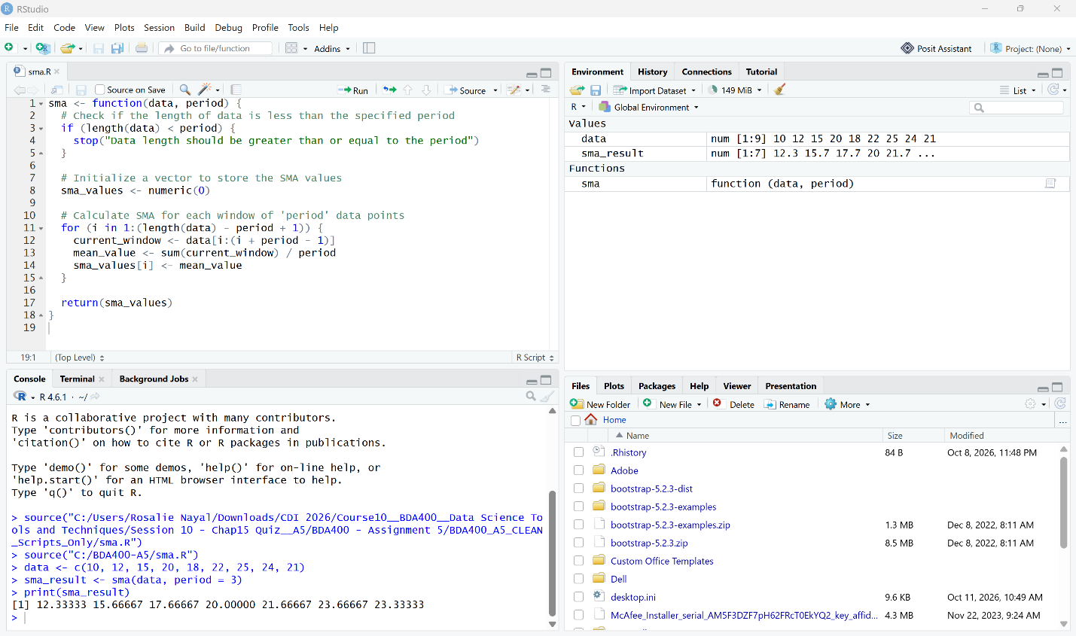

Interpretation
The function successfully calculated the 3-period moving averages for the sample data. Each result represents the average of three consecutive data points.

Exponential Moving Average (EMA)
Brief Explanation
The ema() function calculates the Exponential Moving Average of numeric data over a specified period. It gives greater weight to more recent values by using a multiplier of 2 / (period + 1) and calculates each new EMA value using the previous EMA value. This follows the EMA method provided in the assignment.

How to Run
Open ema.R in RStudio and click Source to load the function. In the Console, enter:

data <- c(10, 12, 15, 20, 18, 22, 25, 24, 21)
ema_result <- ema(data, period = 3)
print(ema_result)

Test Result
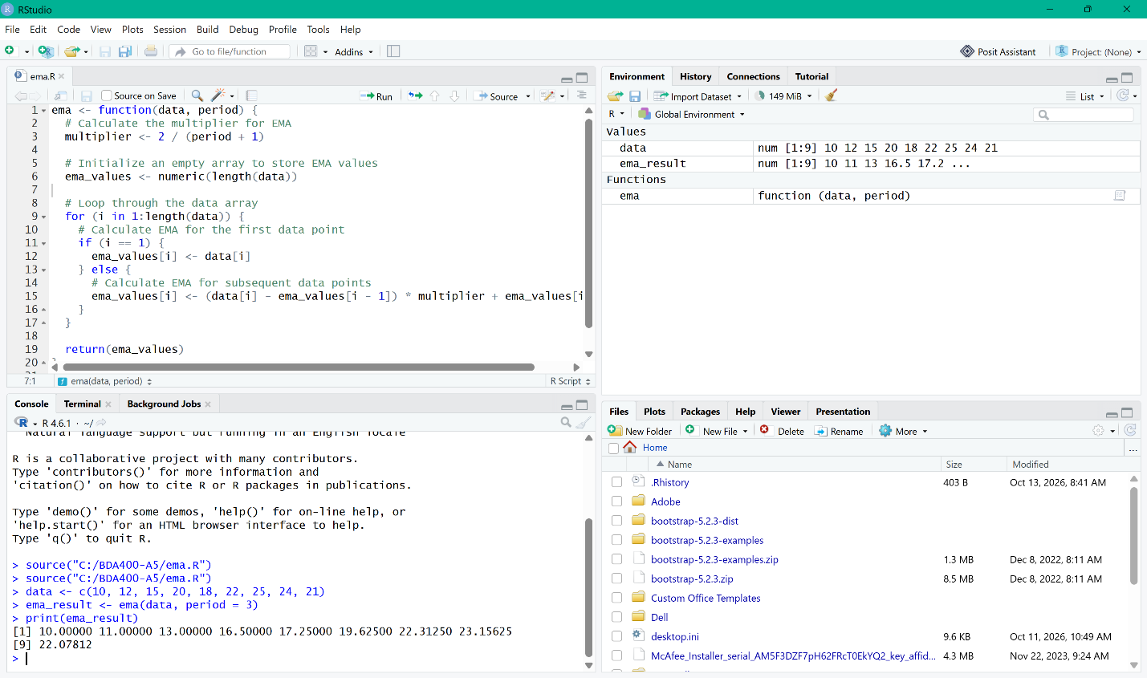

Interpretation
The EMA function successfully calculated the 3-period exponential moving averages for the sample data. The results begin with the first data value and then adjust each subsequent value using the EMA multiplier, giving more weight to recent observations.

Moving Average Convergence Divergence (MACD)
Brief Explanation
The macd() function calculates the Moving Average Convergence Divergence using a short-term EMA and a long-term EMA. It subtracts the long-term EMA from the short-term EMA to create the MACD line, then calculates a signal line using another EMA and a histogram from the difference between the MACD line and signal line.

How to Run
Open ema.R in RStudio and click Source first because macd() uses the ema() function. Then open macd.R and click Source. In the Console, enter:

data <- c(100, 105, 110, 115, 120, 125, 130)
macd_result <- macd(data, short_period = 3, long_period = 5, signal_period = 2)
print(macd_result)

Test Result
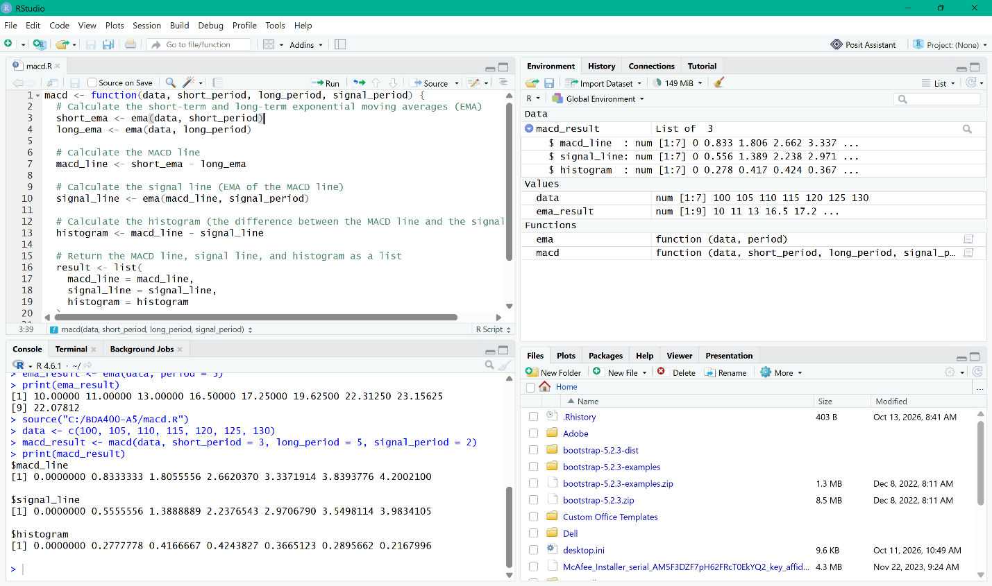

Interpretation
The MACD function successfully calculated the MACD line, signal line, and histogram for the sample data. The positive MACD values indicate that the short-term EMA is above the long-term EMA, showing upward momentum in the sample series.

Standard Deviation (stdev)
Brief Explanation
The stdev() function calculates the standard deviation of a numeric dataset by first finding the mean, then calculating the differences between each data point and the mean. These differences are squared, averaged to obtain the variance, and the square root of the variance is returned as the standard deviation. The assignment uses the population standard deviation formula, dividing by the total number of data points.

How to Run
Open stdev.R in RStudio and click Source to load the function. In the Console, enter:

data <- c(10, 12, 15, 20, 18, 22, 25, 24, 21)
stdev_result <- stdev(data)
print(stdev_result)

Test Result
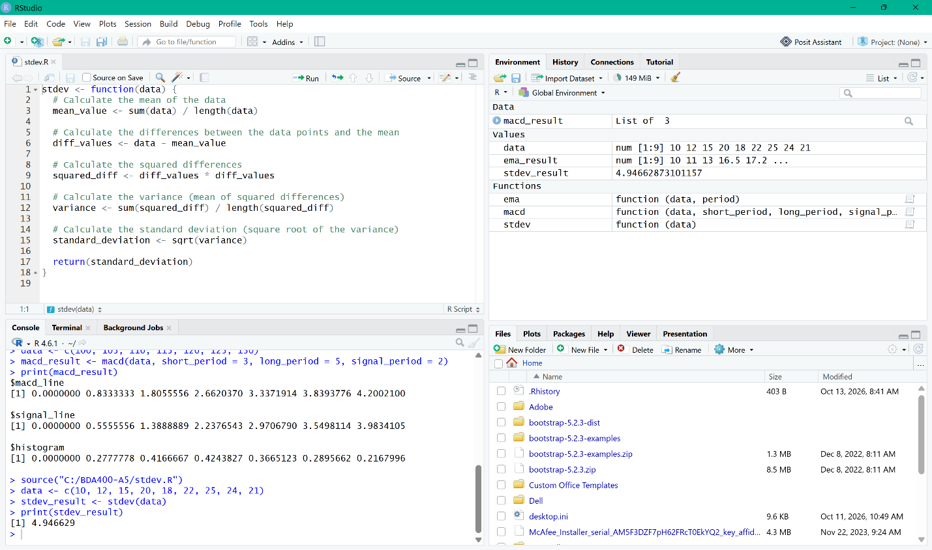

Interpretation
The function successfully calculated a standard deviation of approximately 4.946629 for the sample data. This result represents the amount of variation in the values around their mean using the population standard deviation method.

Linear Regression (linreg)
Brief Explanation
The linreg() function performs a simple linear regression on a selected portion of the input data. It calculates the slope and intercept of the regression line and then uses them to generate predicted values. The function also checks that the regression length and offset are valid before performing the calculation.

How to Run
Open linreg.R in RStudio and click Source to load the function. In the Console, enter:

regressionSource <- c(2, 4, 6, 8, 10)
linreg_result <- linreg(regressionSource, regressionLength = 5, regressionOffset = 0)
print(linreg_result)

Test Result
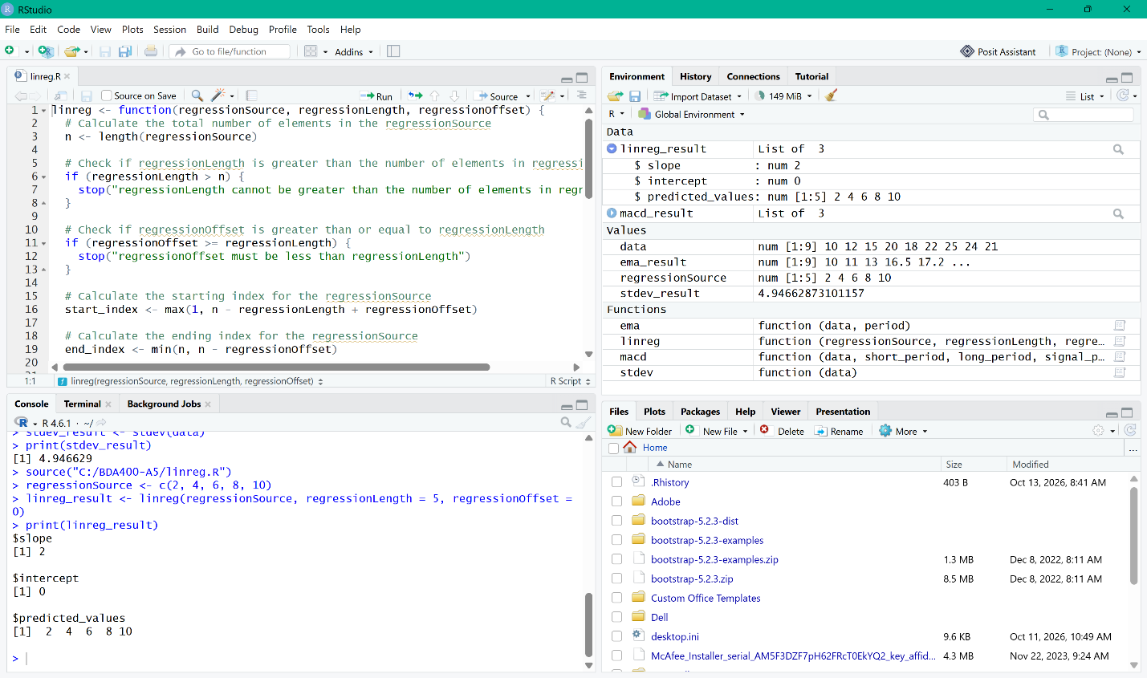

Interpretation
The function successfully calculated a slope of 2 and an intercept of 0. The predicted values 2, 4, 6, 8, and 10 match the input sequence, confirming that the regression line correctly represents this simple linear relationship.

Relative Strength Index (RSI)
Brief Explanation
The rsi() function calculates the Relative Strength Index by measuring gains and losses between consecutive data points. It calculates the initial average gain and loss and then applies Wilder’s smoothing method to generate RSI values ranging from 0 to 100.

How to Run
Open rsi.R in RStudio and click Source to load the function. In the Console, enter:

data <- c(45, 50, 48, 55, 52, 49, 58, 60, 65, 62)
rsi_result <- rsi(data, period = 5)
print(rsi_result)

Test Result
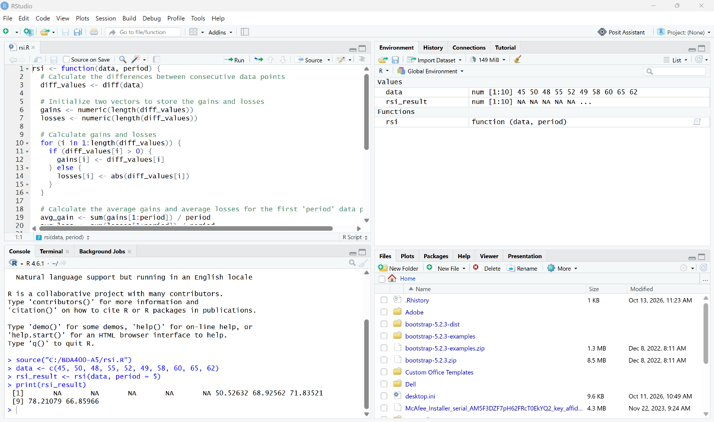

Interpretation
The RSI function successfully calculated RSI values for the sample data after the initial five-period calculation window. The later RSI values rise above 70 at several points, indicating stronger upward price momentum in the sample series.

Stochastic RSI (StochRSI)
Brief Explanation
The stoch_rsi() function calculates the Stochastic RSI by first generating RSI values using the rsi() function. The RSI values are then normalized between their minimum and maximum values, and the resulting values are smoothed using the sma() function to calculate the %K and %D lines.

How to Run
Before running stoch_rsi(), open and Source both rsi.R and sma.R, because the StochRSI function depends on both rsi() and sma(). Then open stoch_rsi.R and click Source. In the Console, enter:

data <- c(45, 50, 48, 55, 52, 49, 58, 60, 65, 62)
stoch_rsi_result <- stoch_rsi(data, period = 5, k_period = 3, d_period = 3)
print(stoch_rsi_result)

Note
The assignment’s hypothetical StochRSI example uses 10 data points with an RSI period of 14. This does not provide enough observations for this implementation to generate usable RSI/StochRSI values. For live verification, the same sample data was tested with an RSI period of 5 while keeping the assignment’s StochRSI calculation logic unchanged.

Test Result
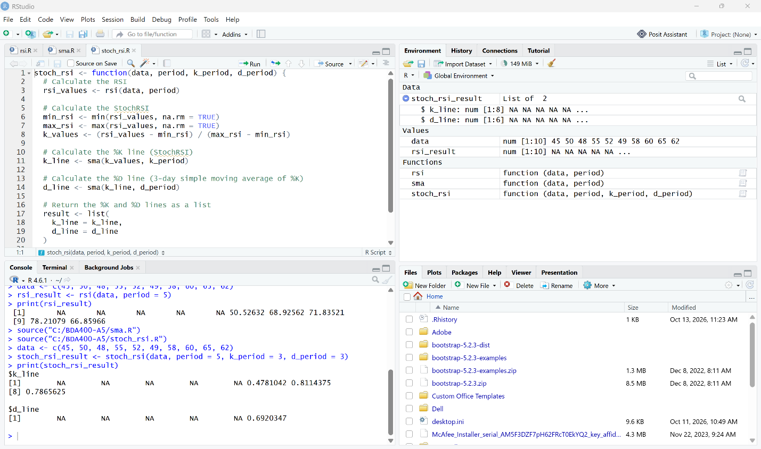

Interpretation
The function successfully produced %K and %D Stochastic RSI values after the required initial calculation period. The numeric values fall between 0 and 1, which is the expected range for Stochastic RSI.

Crossover
Brief Explanation
The crossover() function compares two arrays to detect when the first array crosses above or below the second. It returns "Up" when arr1 crosses from below to above arr2, "Down" when it crosses from above to below, and "None" when no crossover occurs.

How to Run
Open crossover.R in RStudio and click Source to load the function. In the Console, enter:

arr1 <- c(10, 12, 15, 20, 18, 22, 25, 24, 21)
arr2 <- c(18, 20, 22, 18, 15, 12, 10, 11, 13)

crossover_signals <- crossover(arr1, arr2)
print(crossover_signals)

Test Result
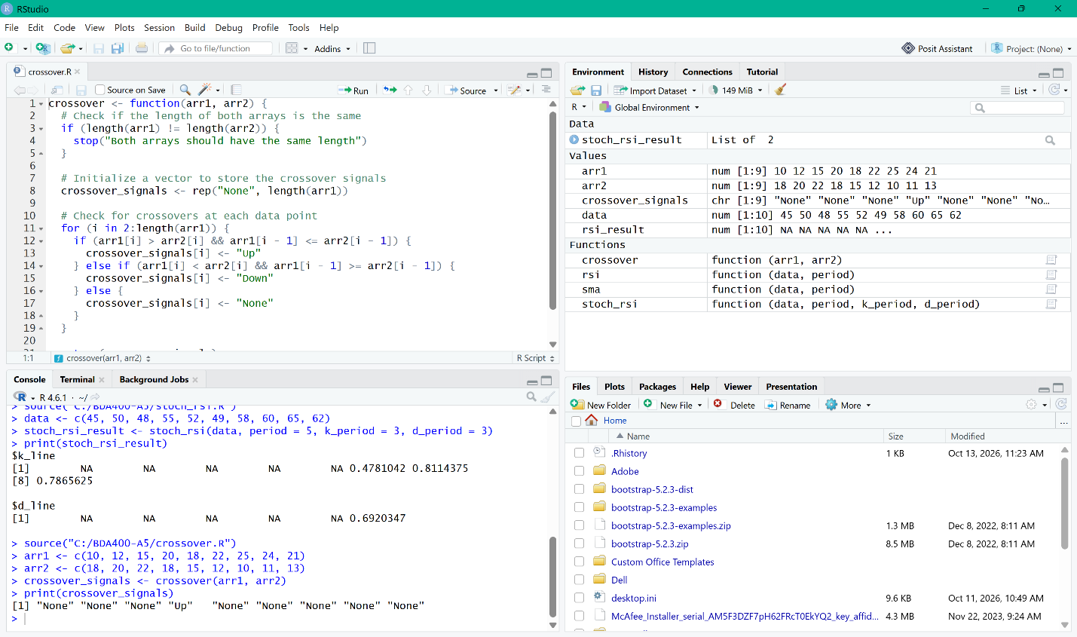

Interpretation
The function detected one upward crossover at the fourth data point and returned "None" for all other positions. This confirms that the function correctly identifies when arr1 crosses above arr2.

Crossunder
Brief Explanation
The crossunder() function compares two arrays and identifies when the first array crosses from above or equal to the second array to below it. It returns "True" when a crossunder occurs, "False" when no crossunder occurs, and "None" for the first value because there is no previous data point for comparison.

How to Run
Open crossunder.R in RStudio and click Source to load the function. In the Console, enter:

arr1 <- c(10, 12, 15, 20, 18, 22, 25, 24, 21)
arr2 <- c(18, 20, 22, 18, 15, 12, 10, 11, 13)

crossunder_signals <- crossunder(arr1, arr2)
print(crossunder_signals)

Test Result
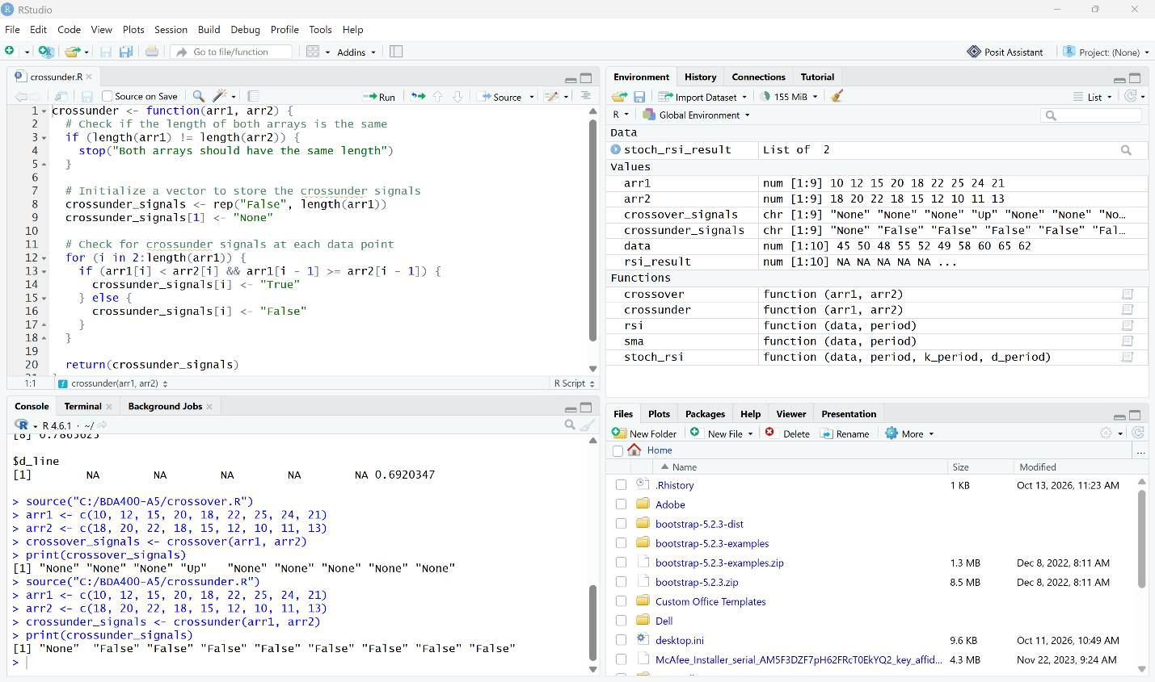

Interpretation
The function returned "None" for the first data point and "False" for all remaining values. This indicates that no crossunder event occurred in the sample data.

Conclusion
All nine required technical analysis functions were implemented and tested successfully in RStudio. The functions produced the expected results during live testing and followed the required function names, templates, and pseudocode provided in the Assignment 5 instructions.

