BDA400 Assignment 2 - Technical Analysis
using R, Preliminary Stage

Student Name | Rosalie Nayal
Student ID Number | 664211817
Course | BDA400 - Data Science Tools and Techniques
Diploma Program | Data Analytics with Capstone (Online)

Overview
This assignment is the preliminary stage of a three-stage technical analysis project. The work establishes the GitHub repository and local R environment, defines a small stock portfolio, loads market data, calculates the required basic statistics, and displays the data and visualizations. The prepared implementation uses a simple R script and the quantmod and TTR packages.

Step 1 - Setting up a GitHub Account and Repository

GitHub Account Setup
This GitHub account was originally created during BDA400 Assignment 1. Assignment 1 did not require screenshots documenting the account-creation process, so no step-by-step signup screenshots were taken at that time. The available screenshot shows the GitHub welcome/dashboard page after the account had been created in assignment 1. The same account is being reused for Assignment 2.

Existing GitHub account created during Assignment 1, shown on the GitHub welcome/dashboard page.
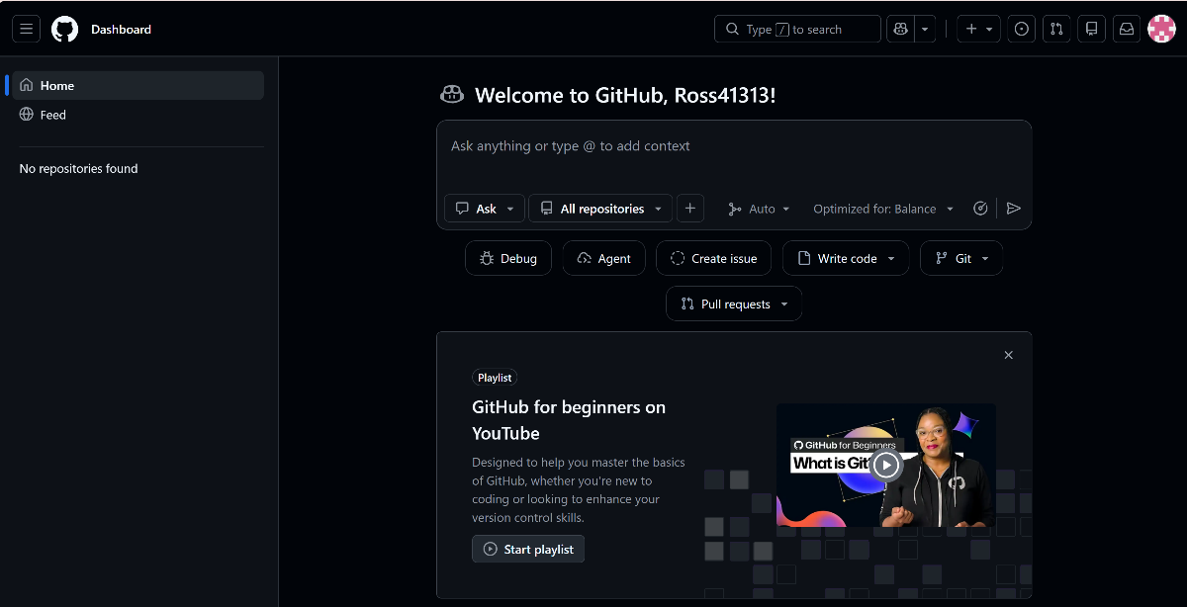

A GitHub repository named TechnicalAnalysis was created for the course project. An Assignment2 subfolder will be used so the assignment files remain separate and can be preserved for the later stages of the same technical analysis project. The subfolder creation will be done in Step 4 when the portfolio.txt file is created in the GitHub repository.

Creation of GitHub repository named TechnicalAnalysis

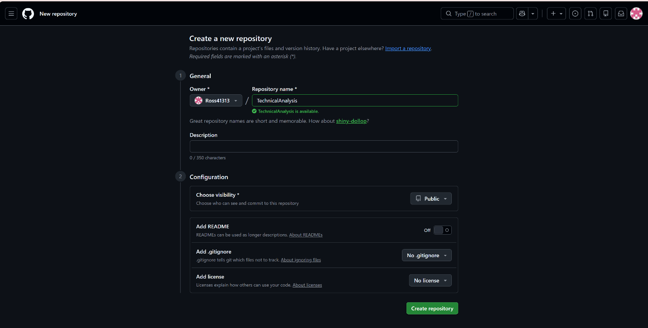

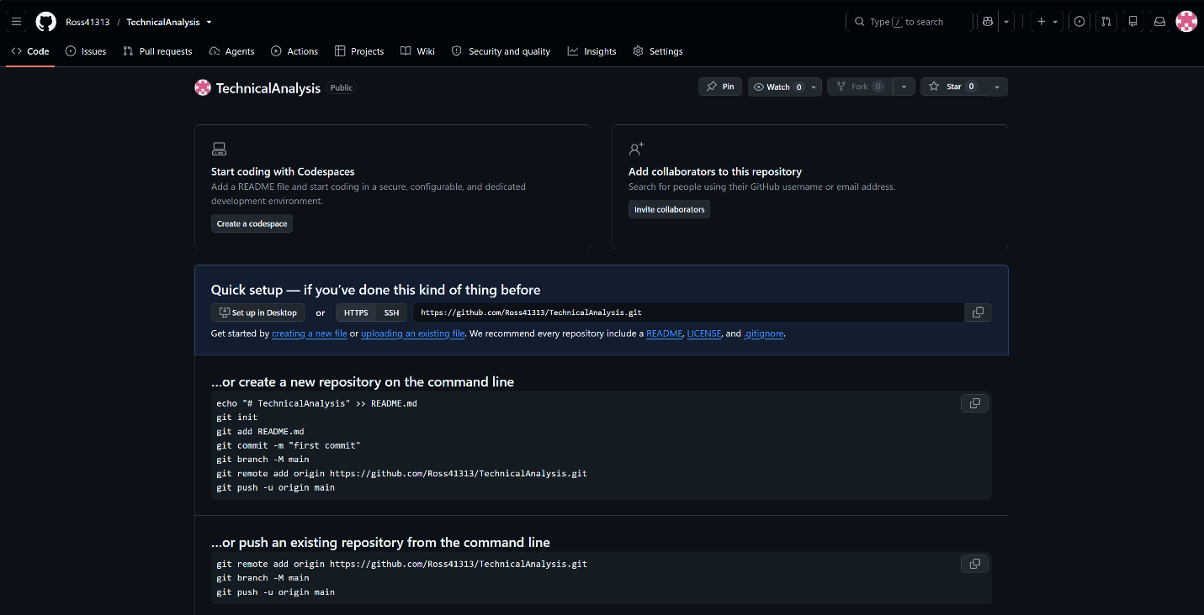

Step 2 - Installing and Configuring R and RStudio
I downloaded R for Windows from the CRAN website at https://cran.rstudio.com/. I selected the Windows installation option, downloaded R 4.6.1 for Windows (64-bit), and completed the installation using the default settings.

R for Windows Installation Process

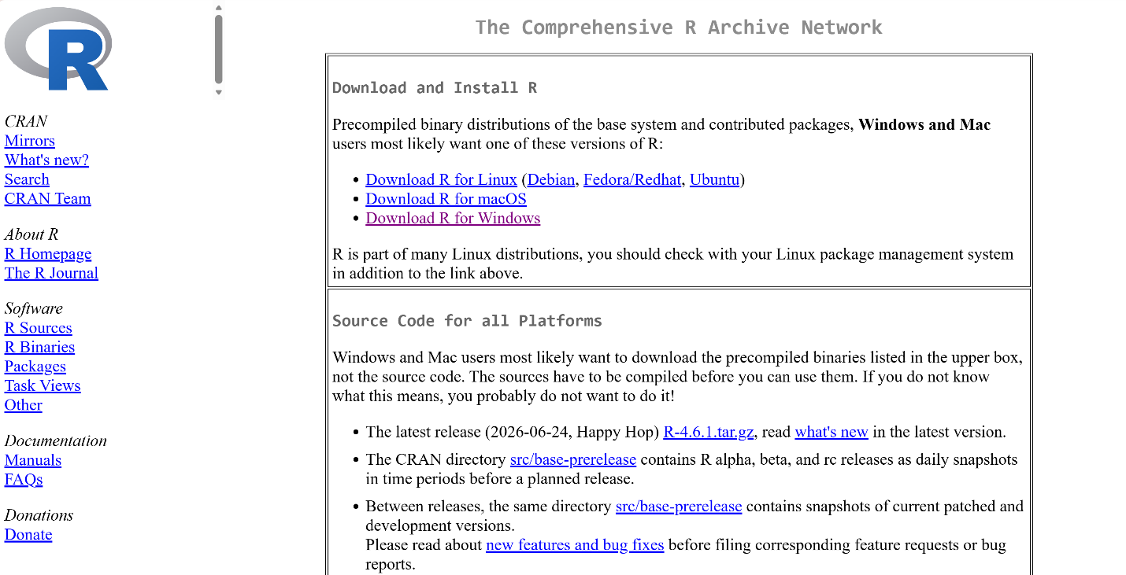

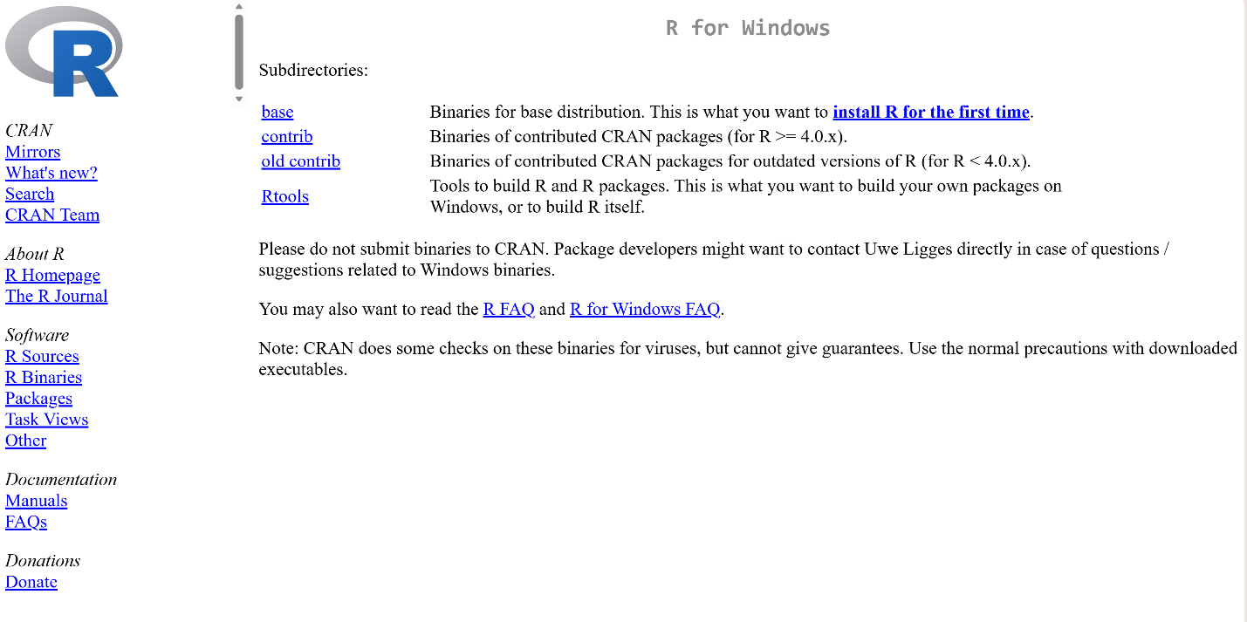

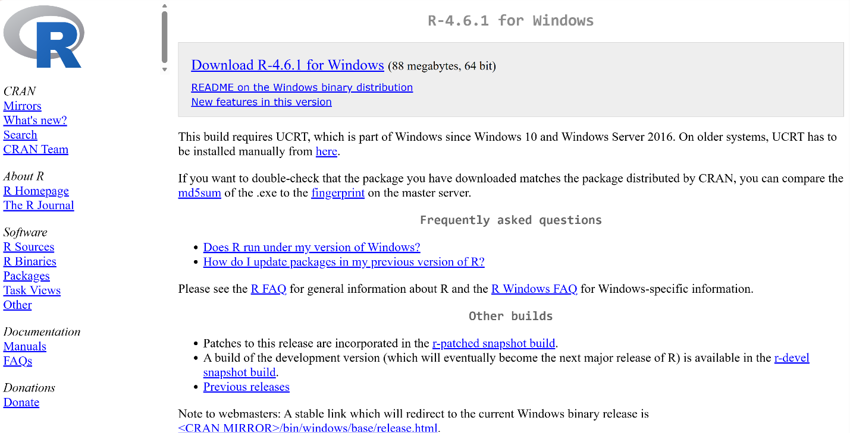

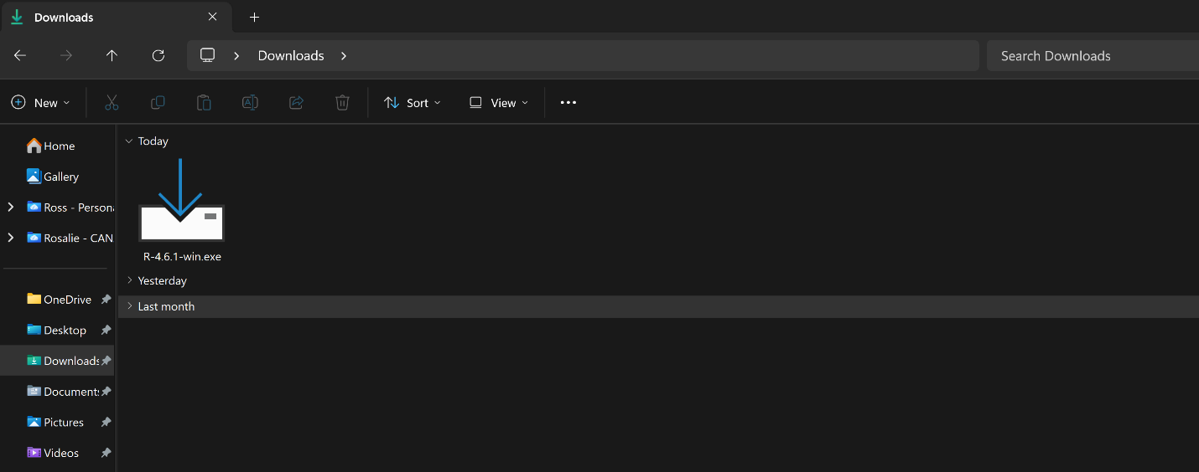

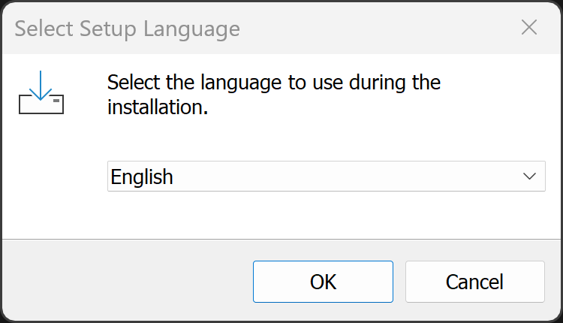

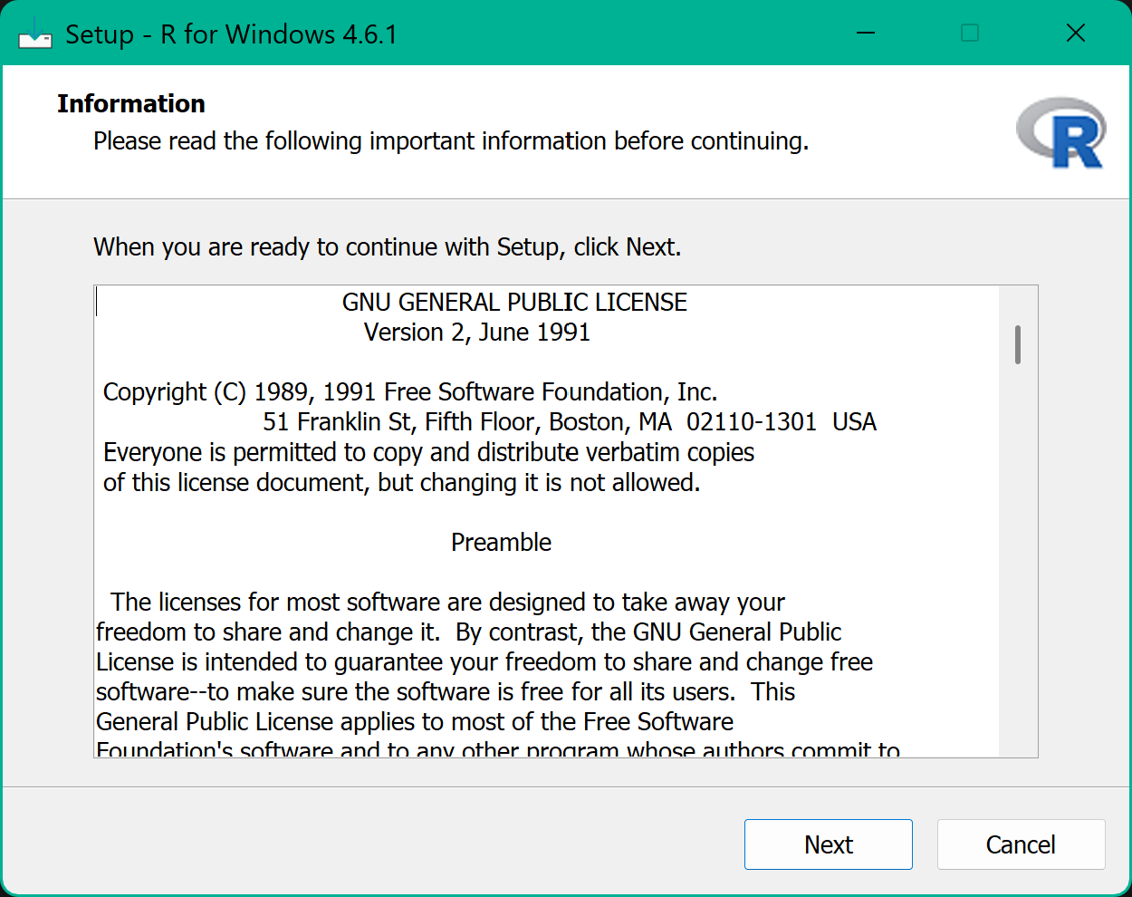

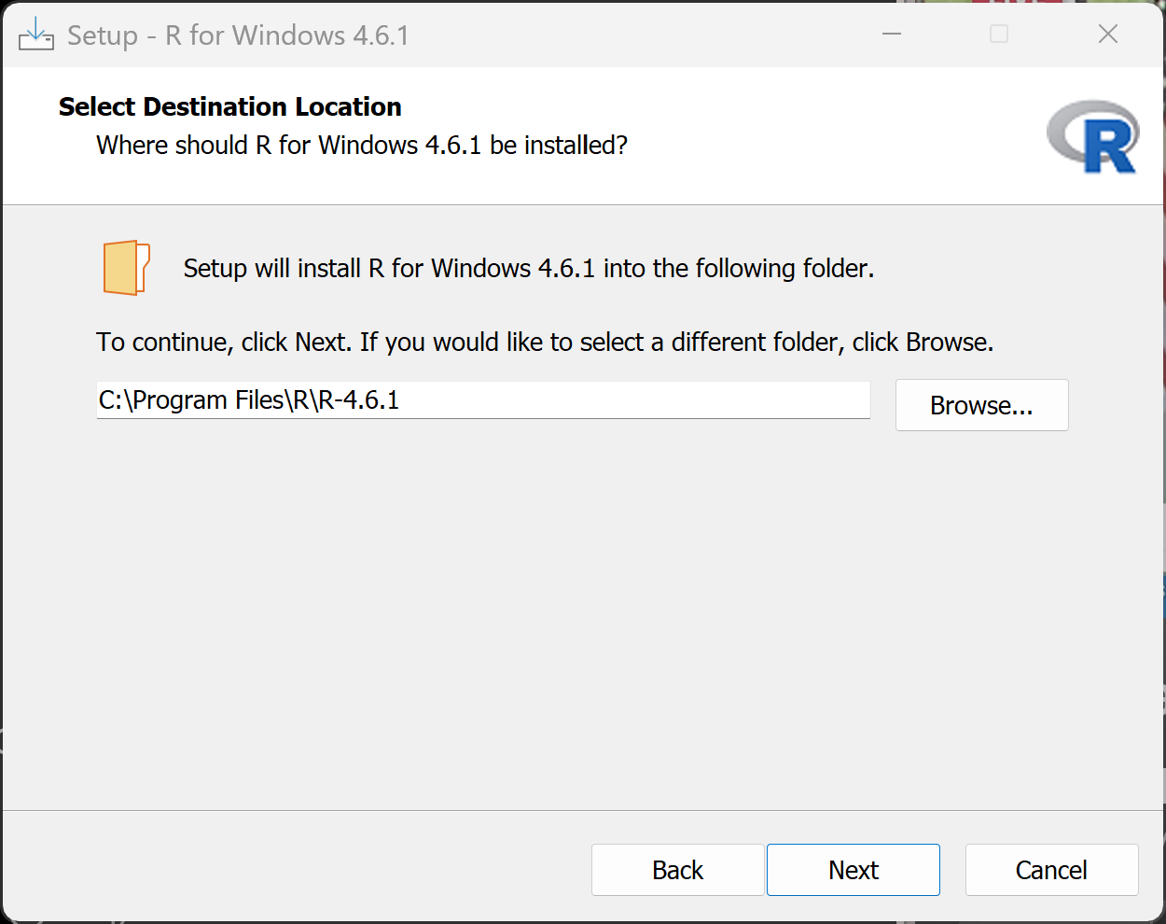

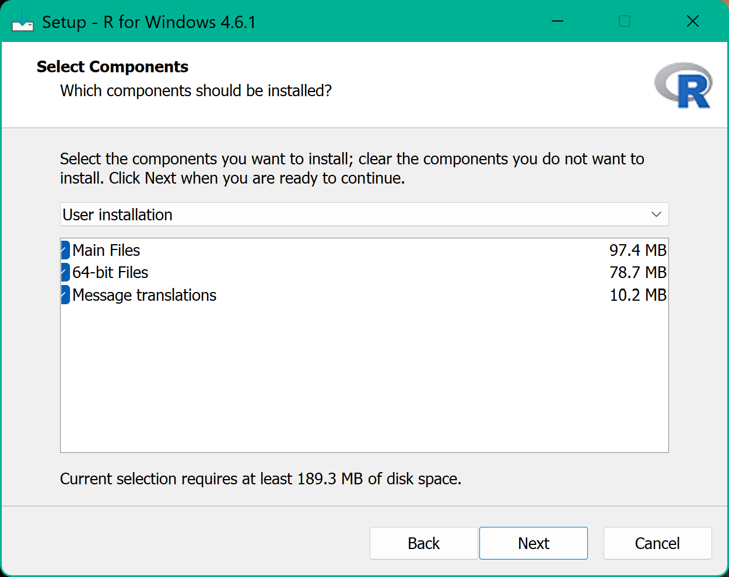

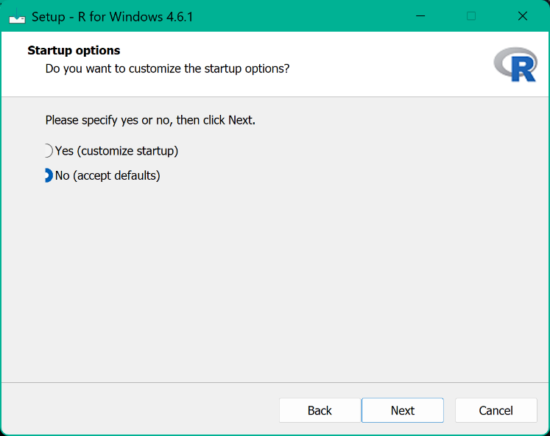

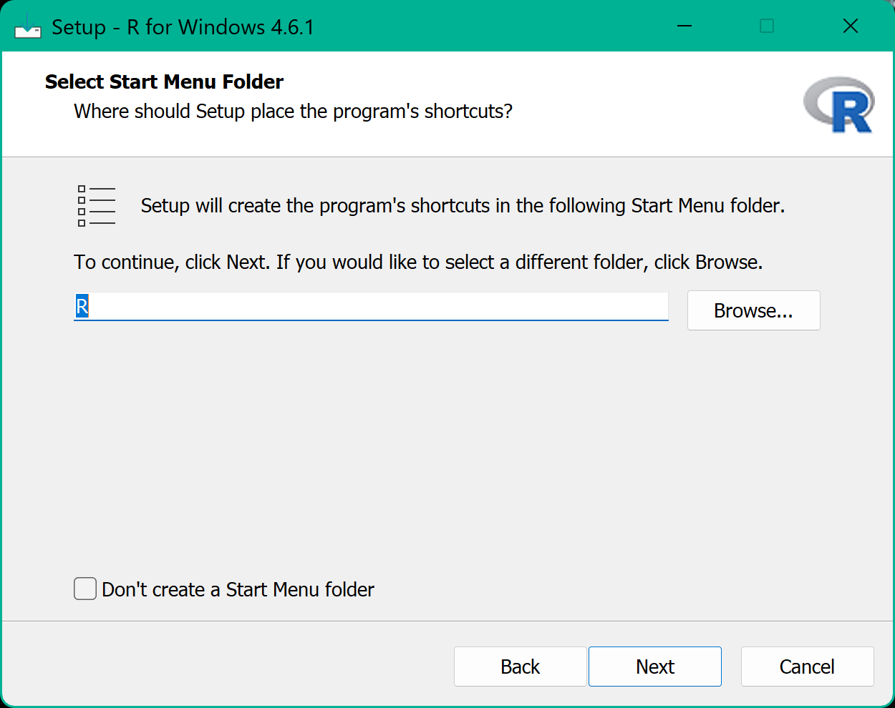

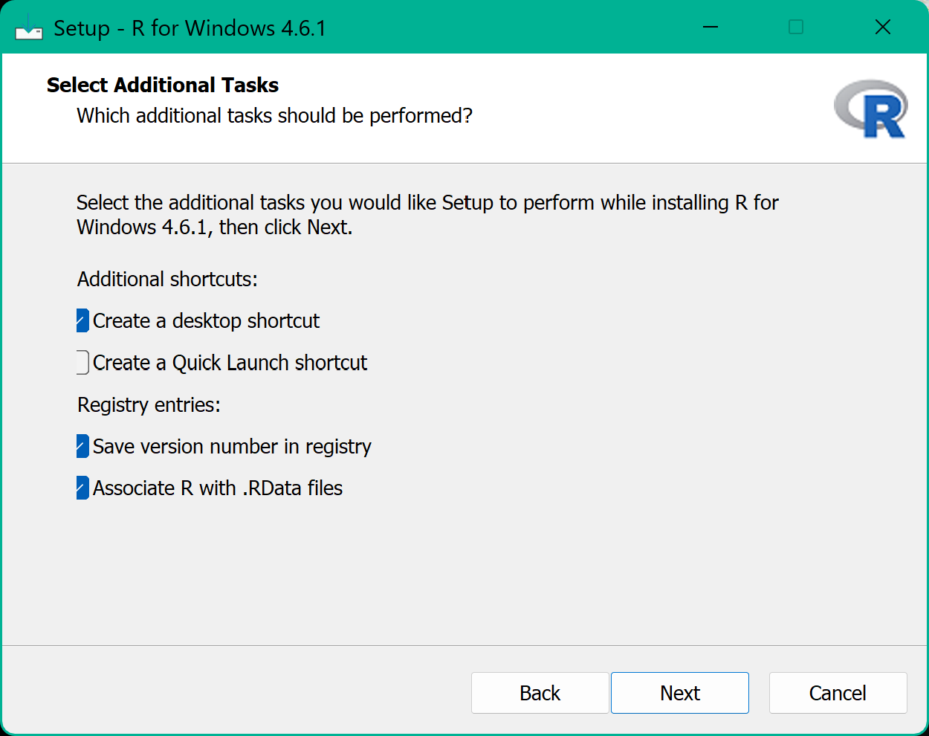

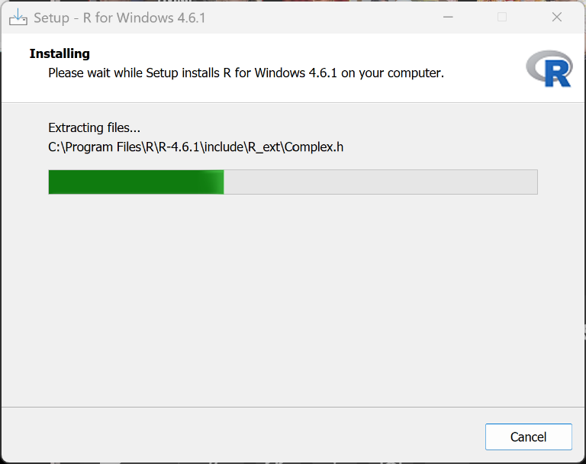

R installation completed successfully
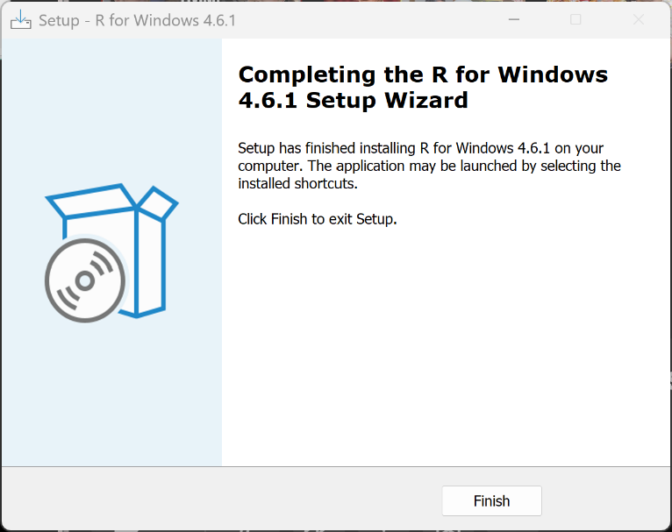
The assignment instructions required RStudio to be installed but did not provide a direct download link for RStudio Desktop. I searched for the official RStudio website and downloaded RStudio Desktop for Windows from the official Posit website at https://posit.co/download/rstudio-desktop/. I then followed the installation steps to complete the setup.

RStudio Desktop Installation Process

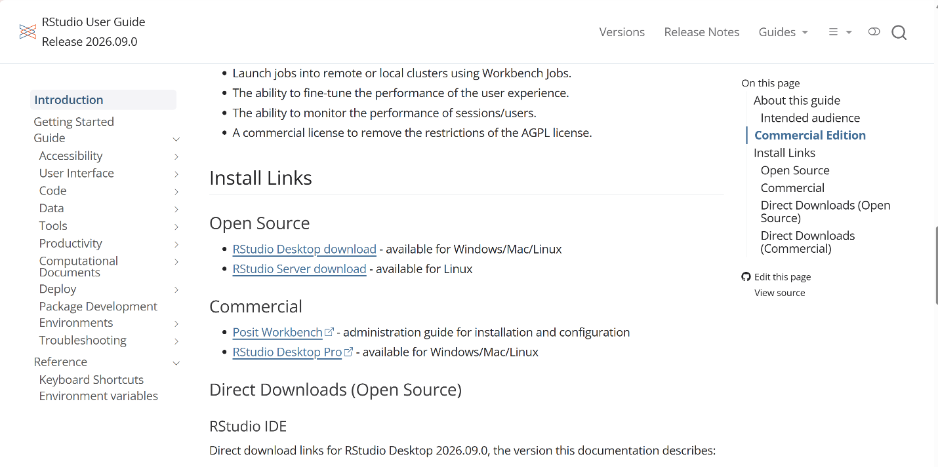

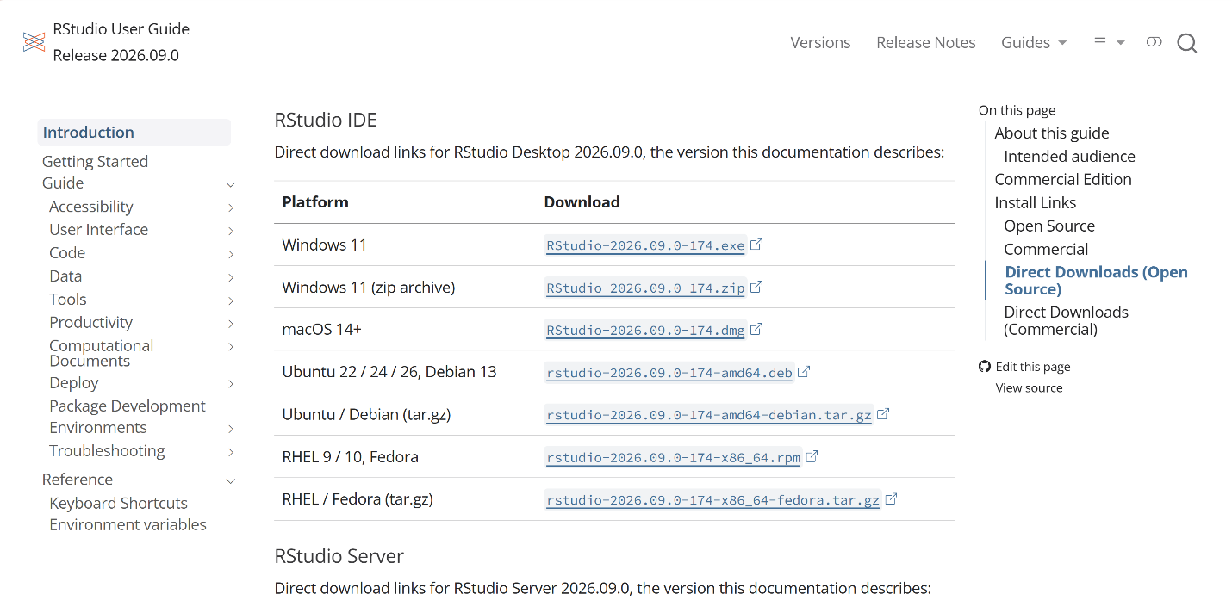

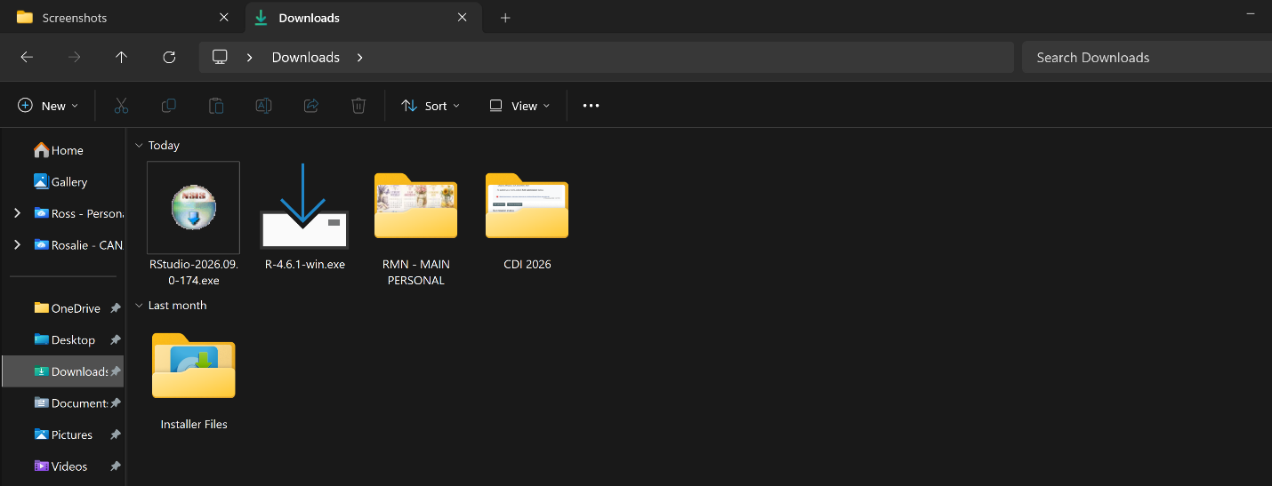

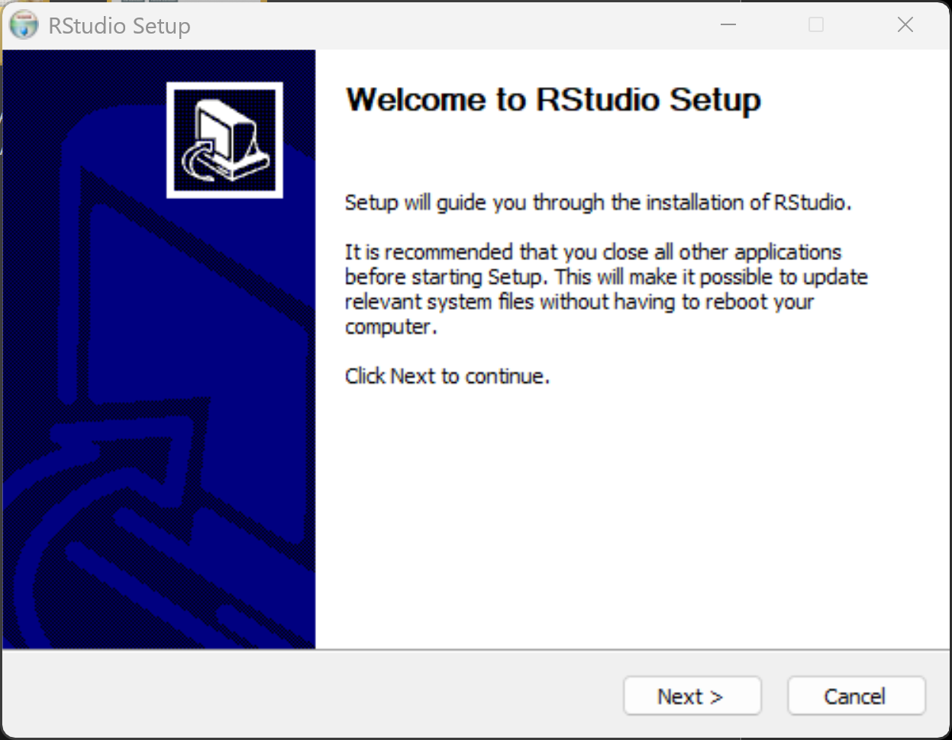

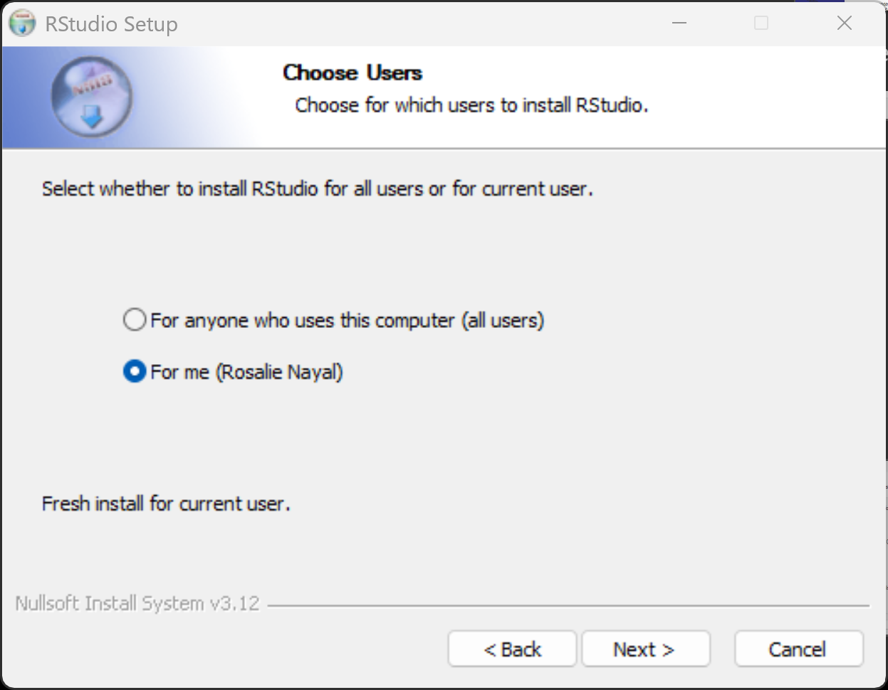

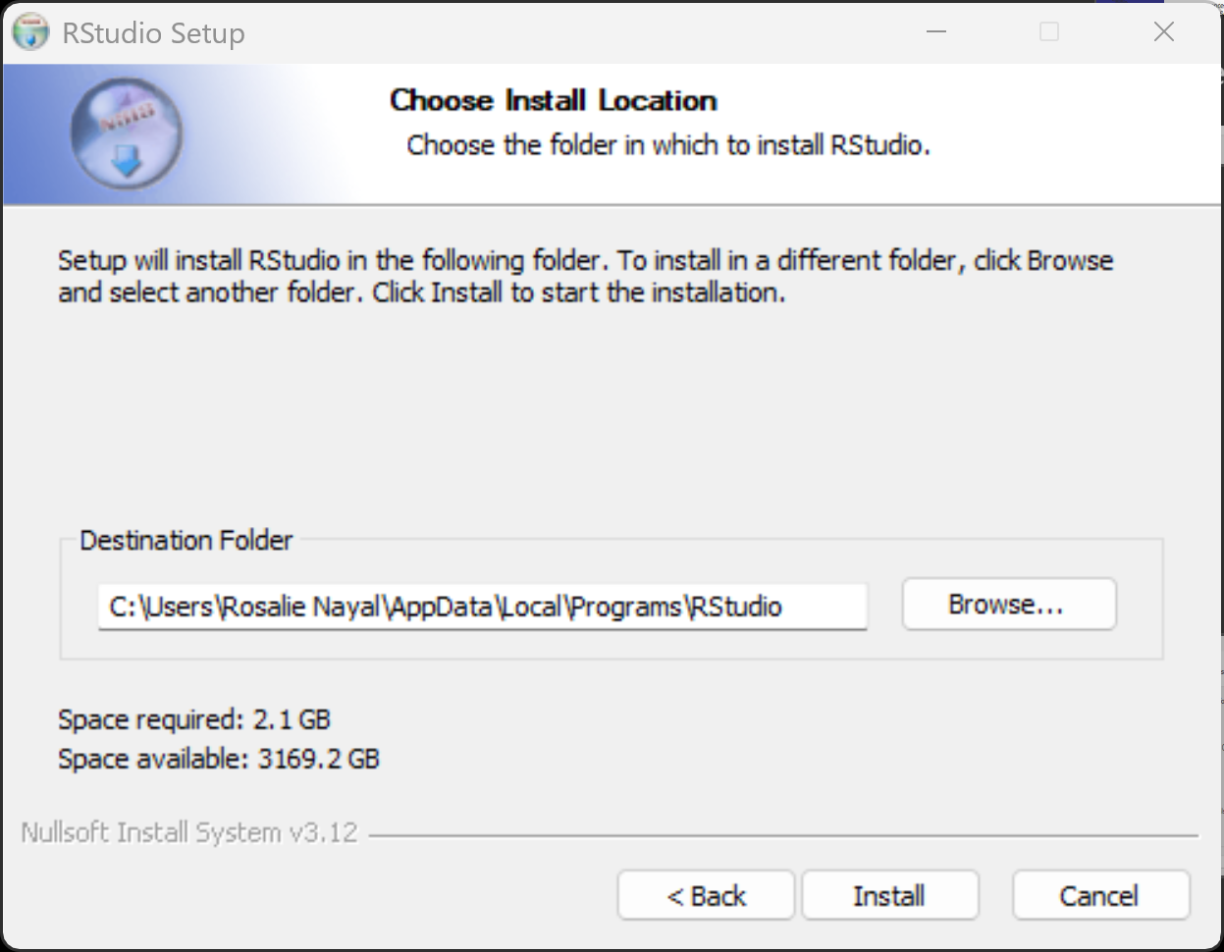

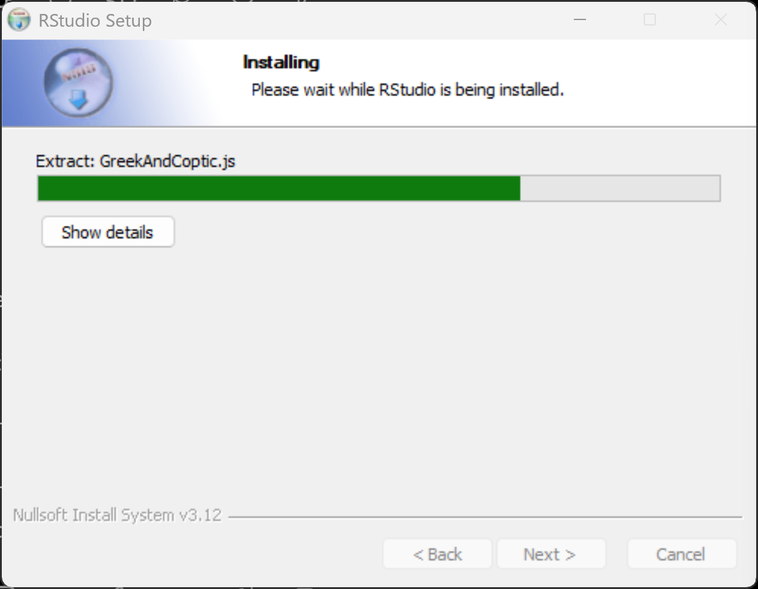

RStudio Installation completed successfully
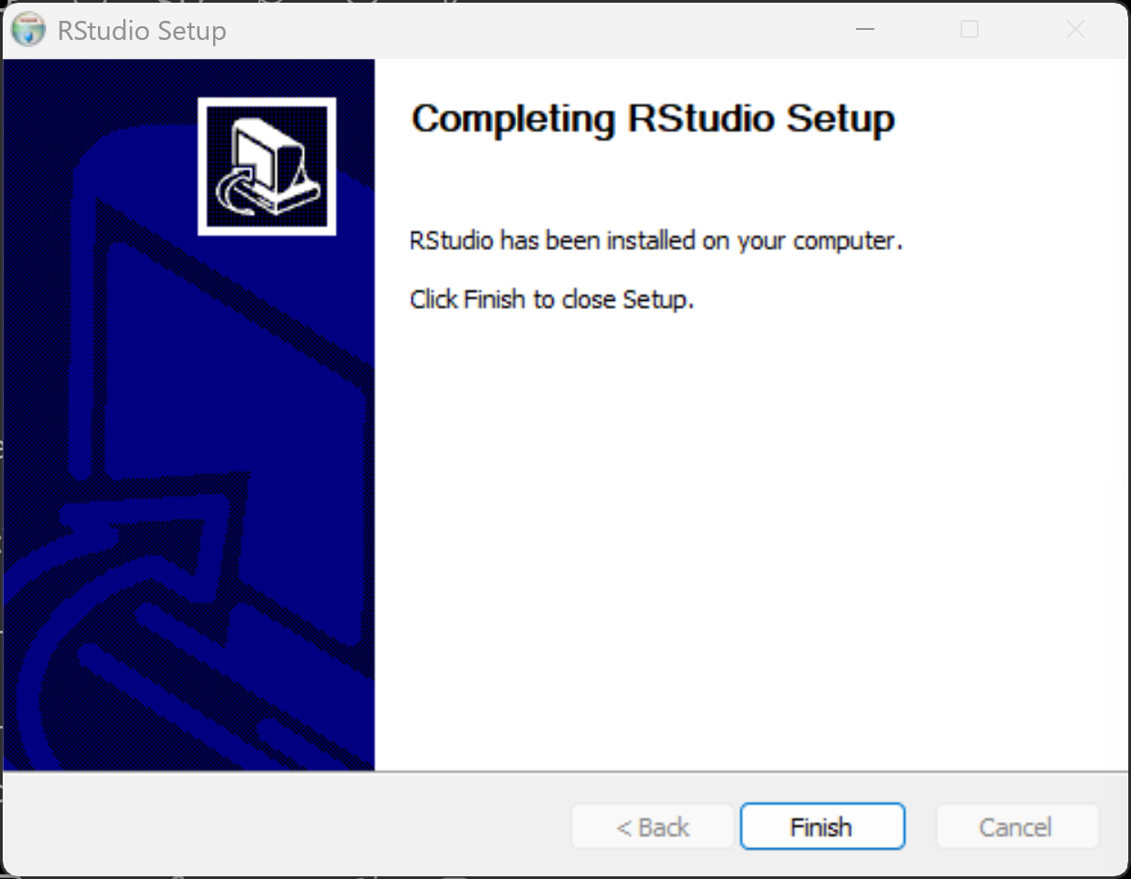

Verification of R Installation: R 4.6.1 opened successfully on Windows, confirming that the R installation was completed correctly.
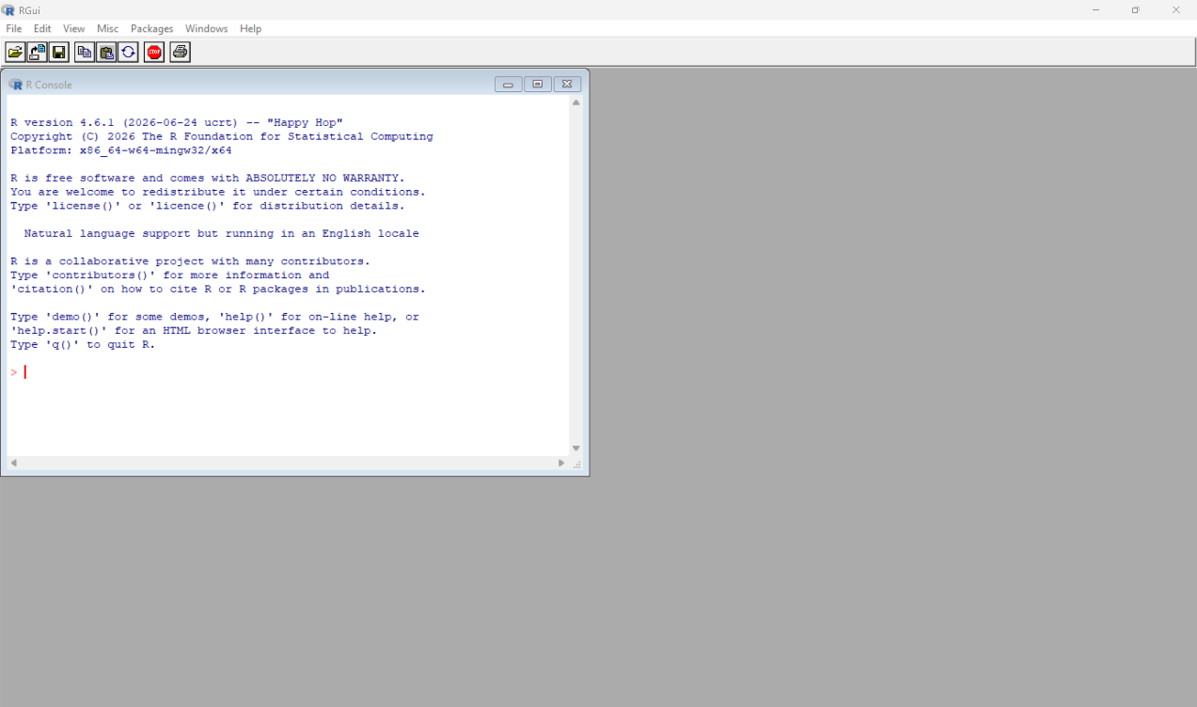

Verification of RStudio Installation: RStudio opened successfully and detected R version 4.6.1, confirming that R and RStudio were installed and configured correctly.
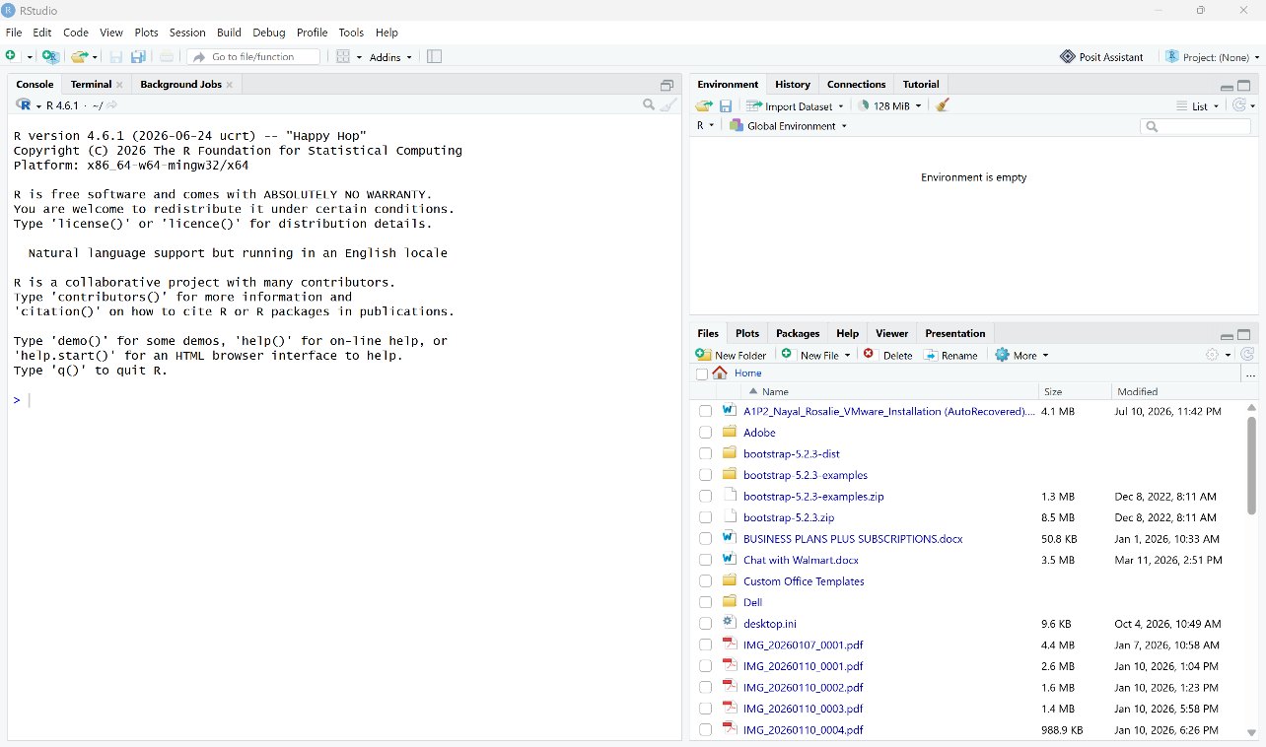

Step 3 - Downloading and Installing R Packages for Technical Analysis
Package Installation: The assignment specifies technical-analysis packages such as quantmod and TTR. I used the RStudio Console to install quantmod. During the installation, R also installed several required dependencies, including TTR, zoo, curl, and jsonlite.

Package Installation and Troubleshooting: During installation, the xts dependency initially failed to download because of an SSL connection error. I consulted ChatGPT to help interpret the error message and identify the appropriate troubleshooting steps. I then installed xts separately and used library(quantmod) and library(TTR) to verify that the required packages loaded successfully without errors.

Commands used:
install.packages("quantmod")
install.packages("xts")
library(quantmod)
library(TTR)

Screenshots of the Installation Process

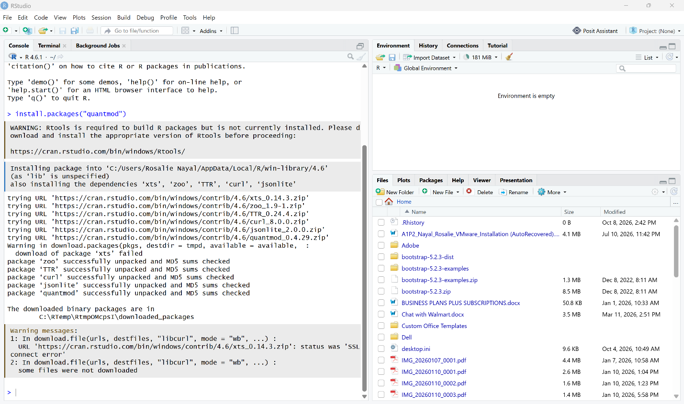

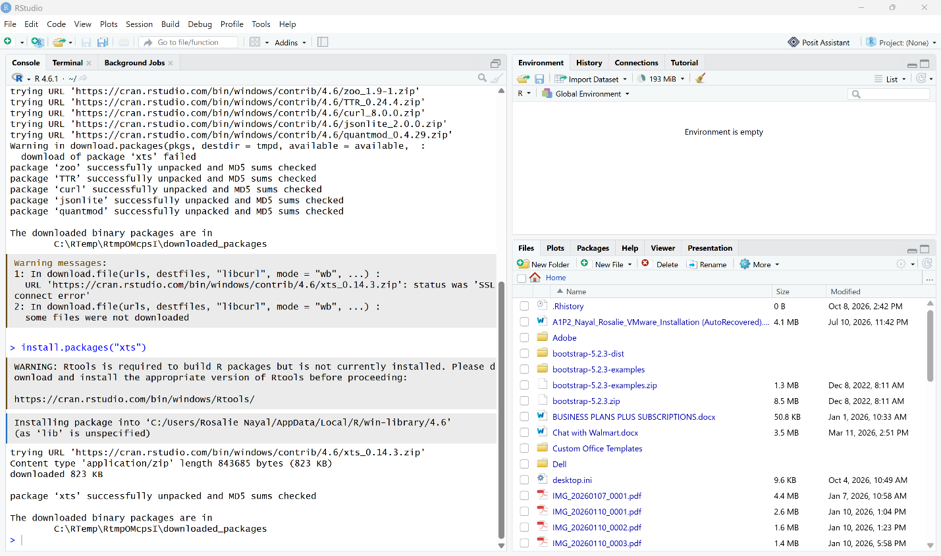

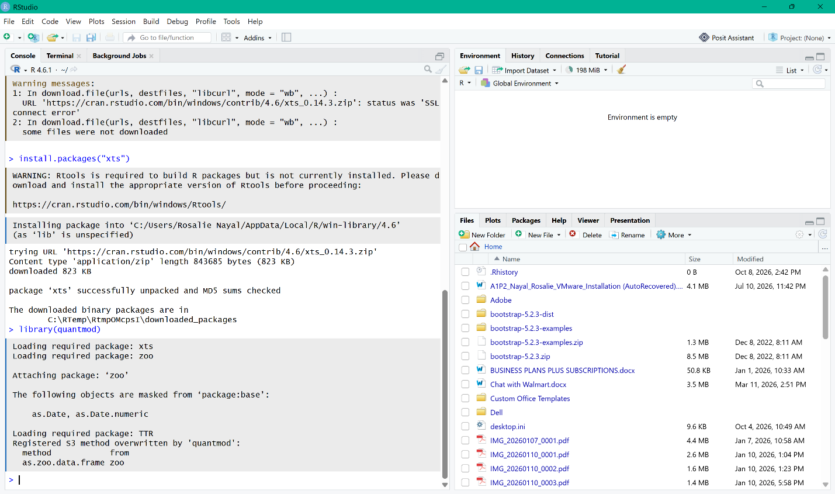

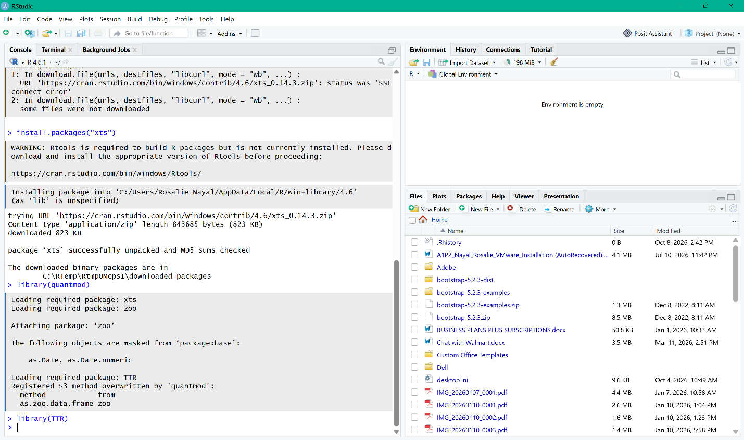

Step 4 - Project Configuration and Initialization
I created the Assignment2 subfolder inside the TechnicalAnalysis GitHub repository to organize the files for this assignment. For the project configuration, I created a text file named portfolio.txt to represent my stock portfolio. The file contains one stock symbol per line. I used six stock symbols from different companies to provide a small but varied portfolio for the technical analysis process.

Six stock symbols are:
AAPL
MSFT
AMZN
GOOGL
JPM
WMT

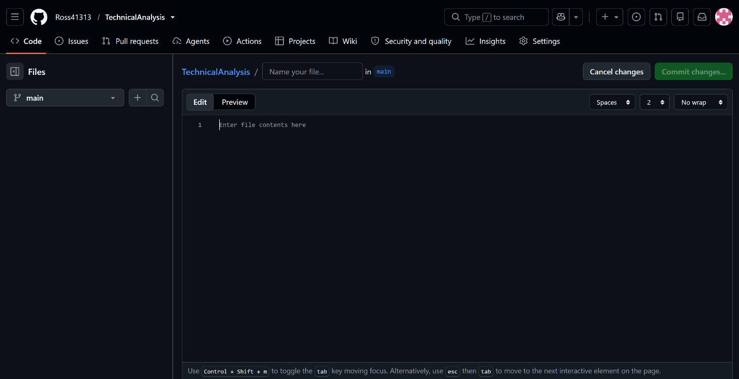

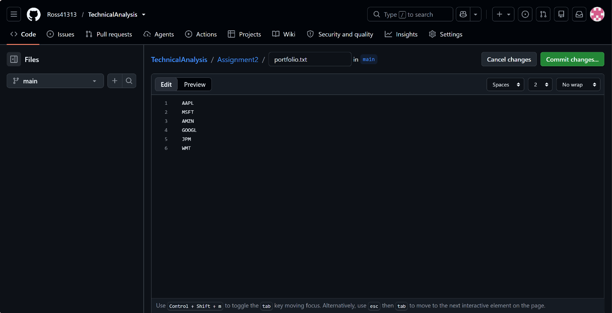

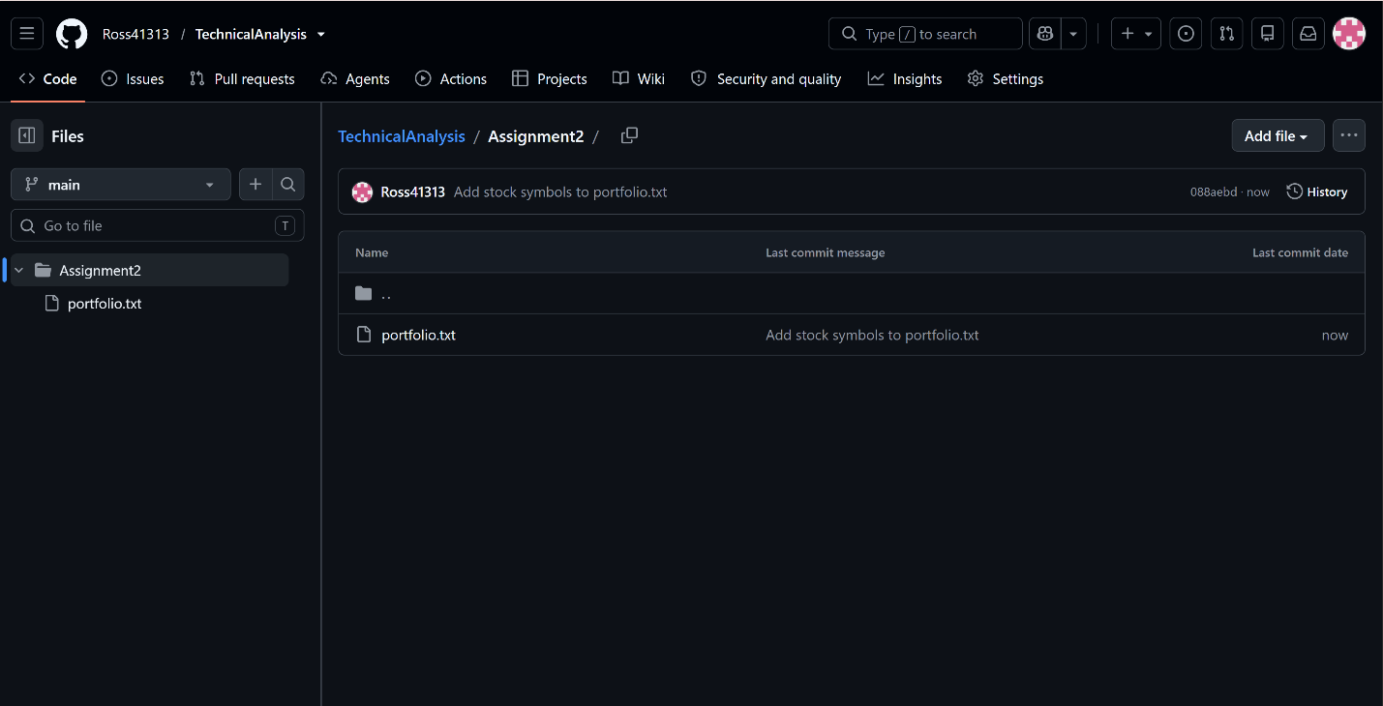

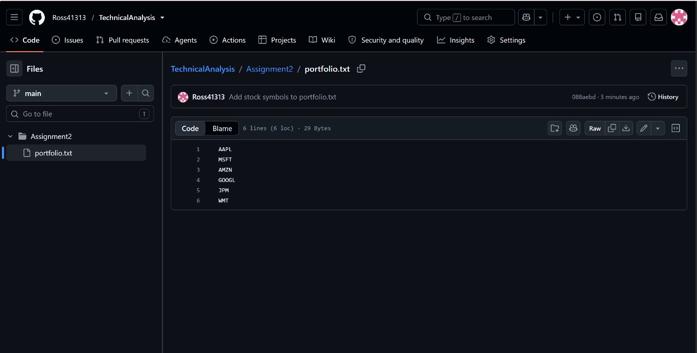

Step 5 – Writing a Function to Import and Load Stock Data
I opened the RosalieNayal_BDA400_A02.R script in RStudio and set the working directory to C:\BDA400-A2, where the R script and portfolio.txt files were stored together. I then selected and ran the required package commands and the complete load_stock_data() function. After the function was successfully loaded into the RStudio Environment, I ran stocks <- load_stock_data("portfolio.txt") to read the six stock symbols from the portfolio file and download their market data using the quantmod package. The resulting stocks object contained a list of six separate data frames—AAPL, MSFT, AMZN, GOOGL, JPM, and WMT. Each data frame contained the Date, Open, High, Low, Close, Volume, and Adjusted values for the individual stock.

RStudio Opened
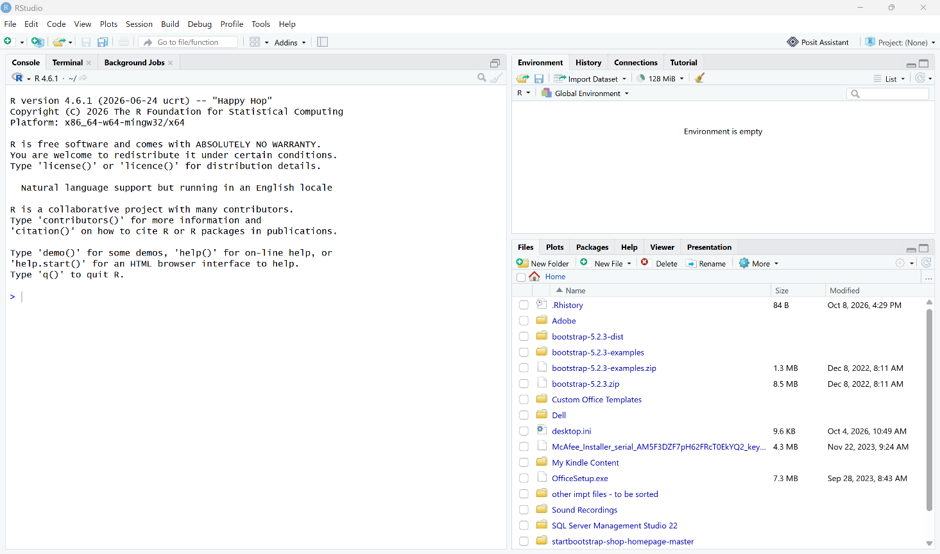

R script Opened in RStudio
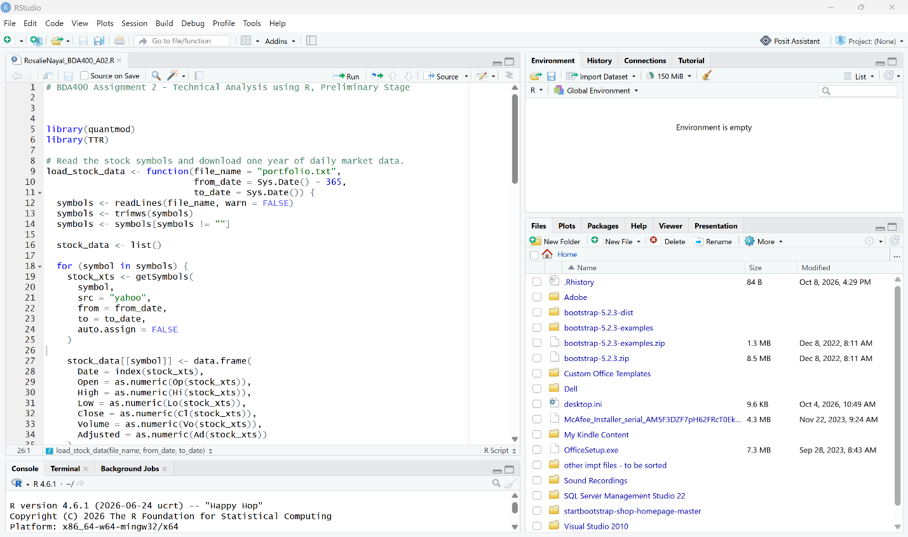

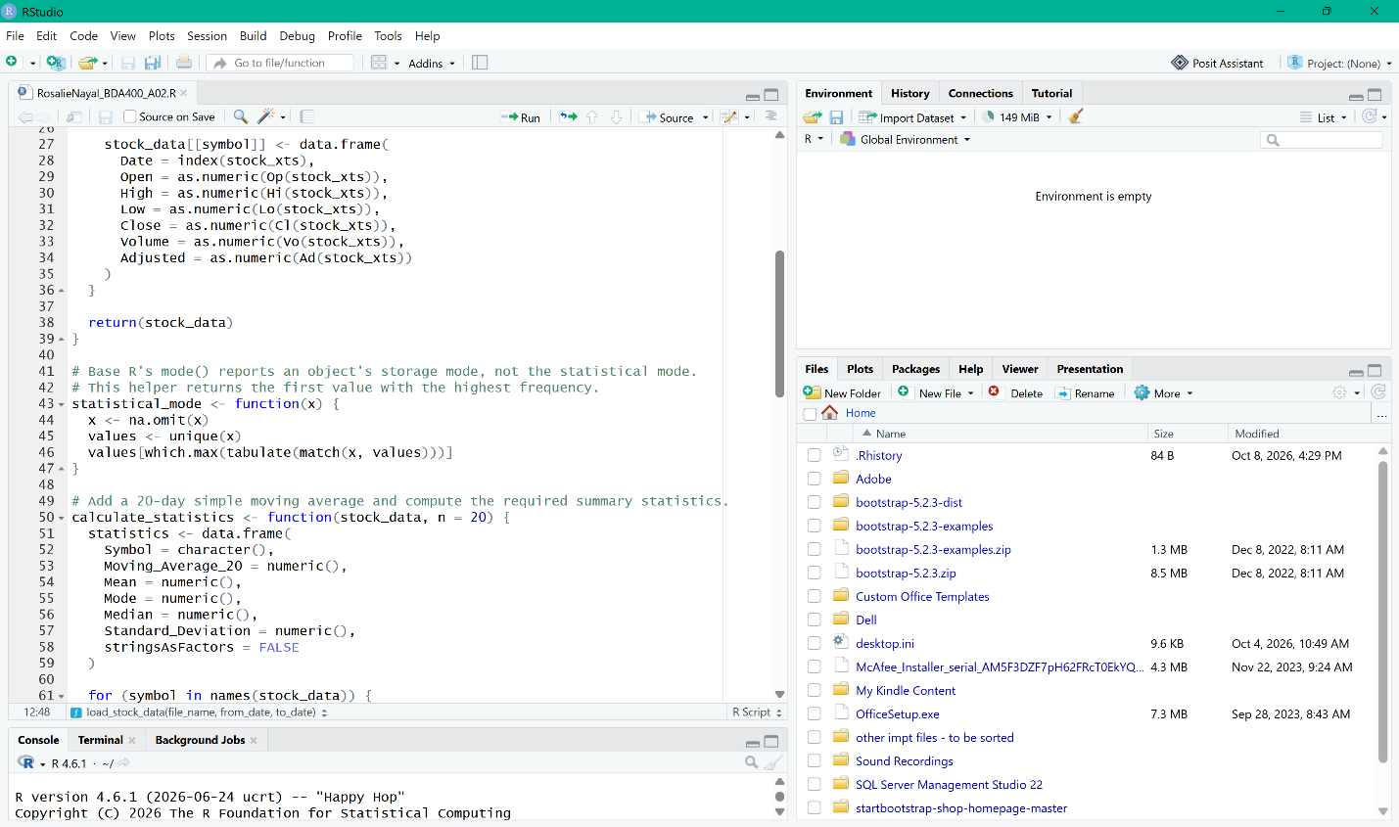

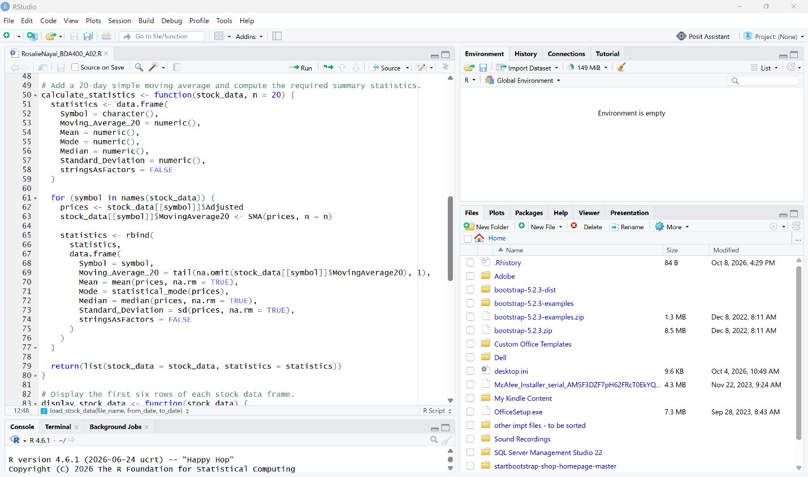

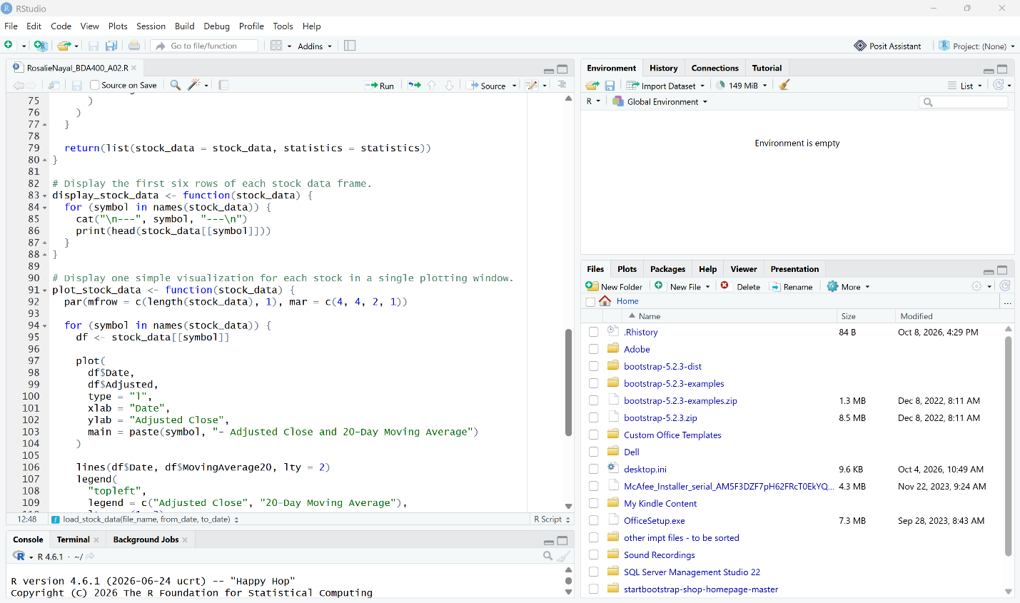

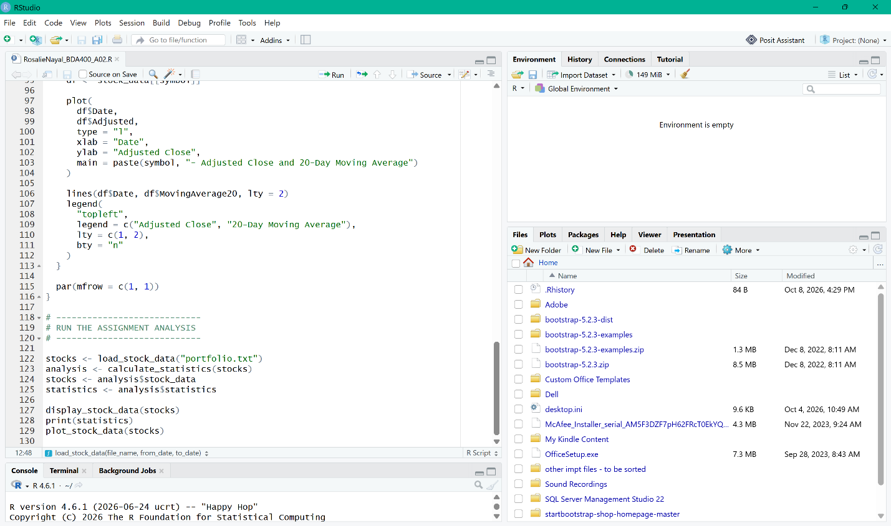

Working Directory Set to C:\BDA400-A2
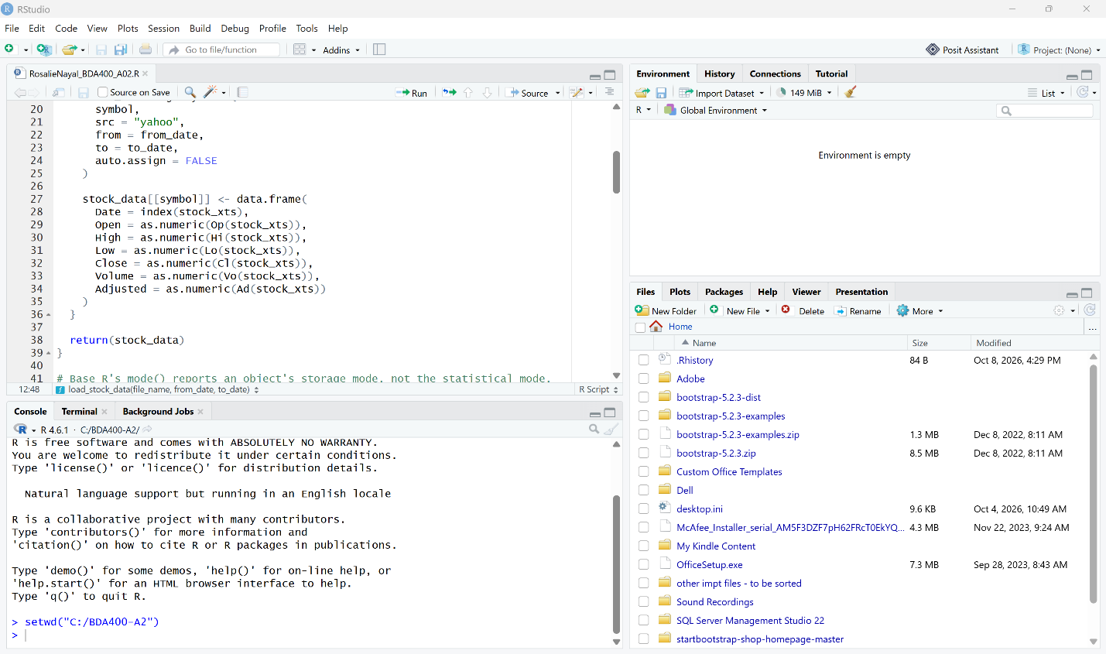

Lines 5–39 Highlighted (quantmod, TTR, and load_stock_data())
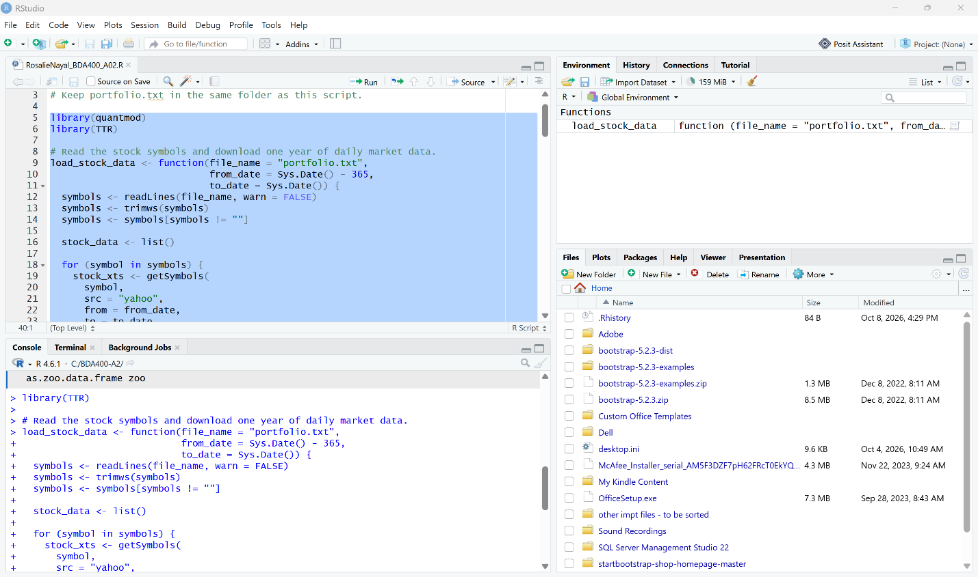

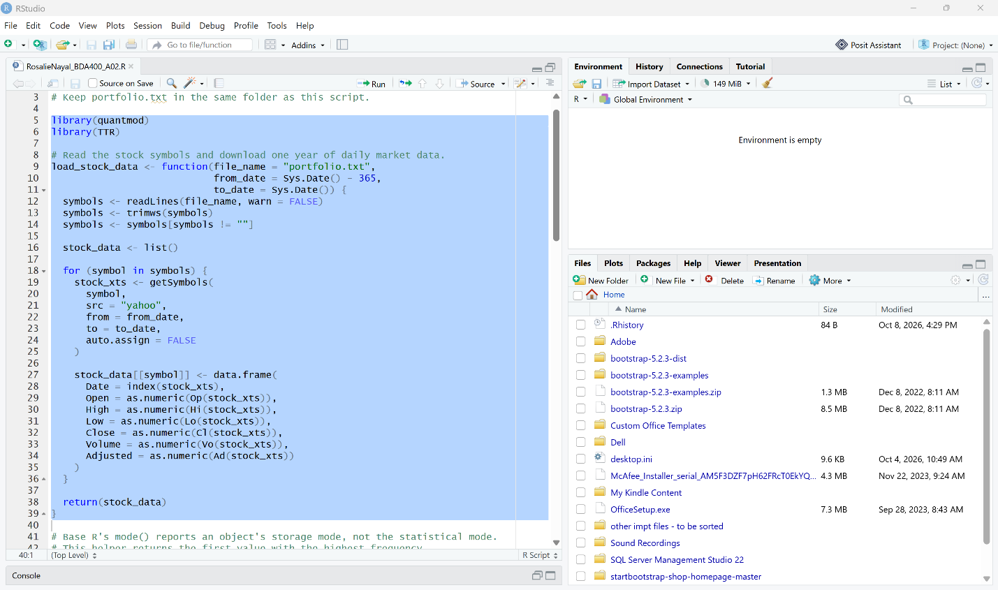

Selected code run successfully; load_stock_data appears under Functions.
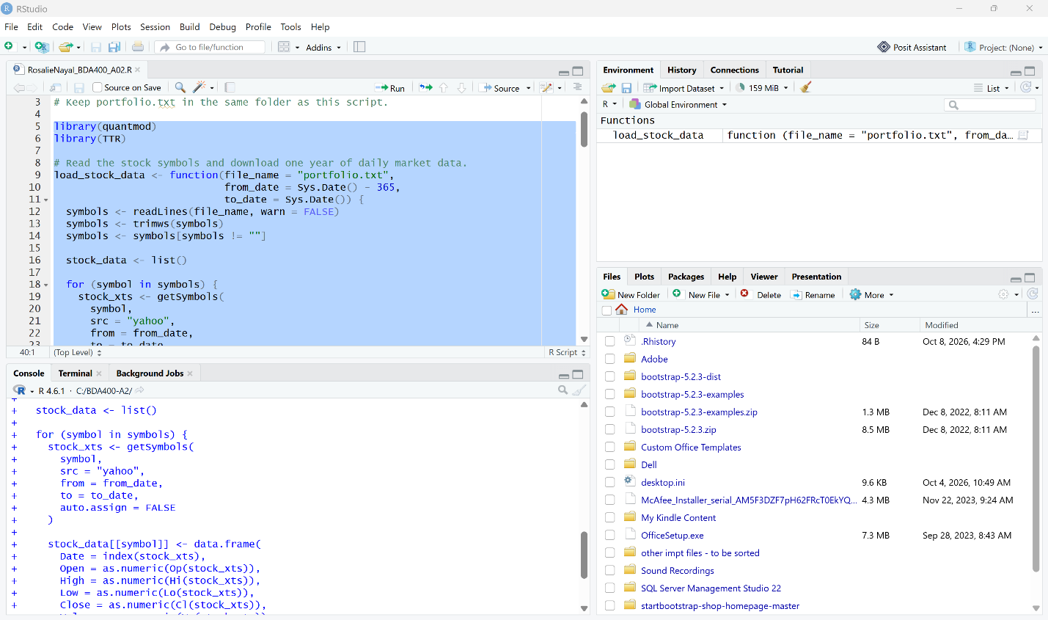

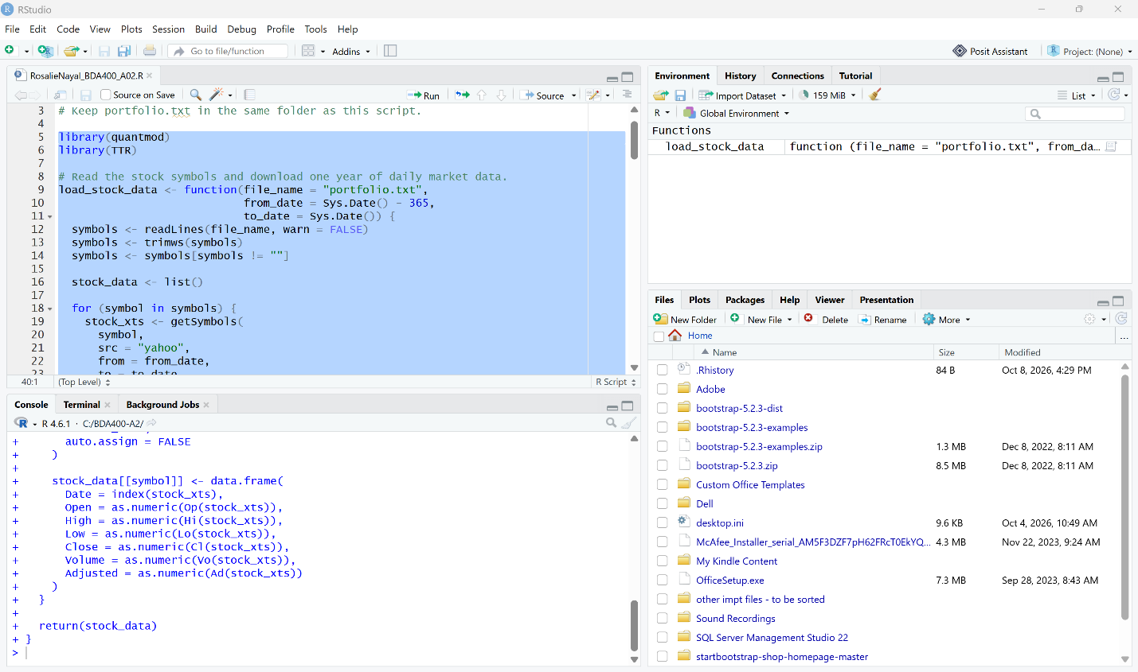

stocks <- load_stock_data("portfolio.txt") executed; Environment shows stocks — List of 6.
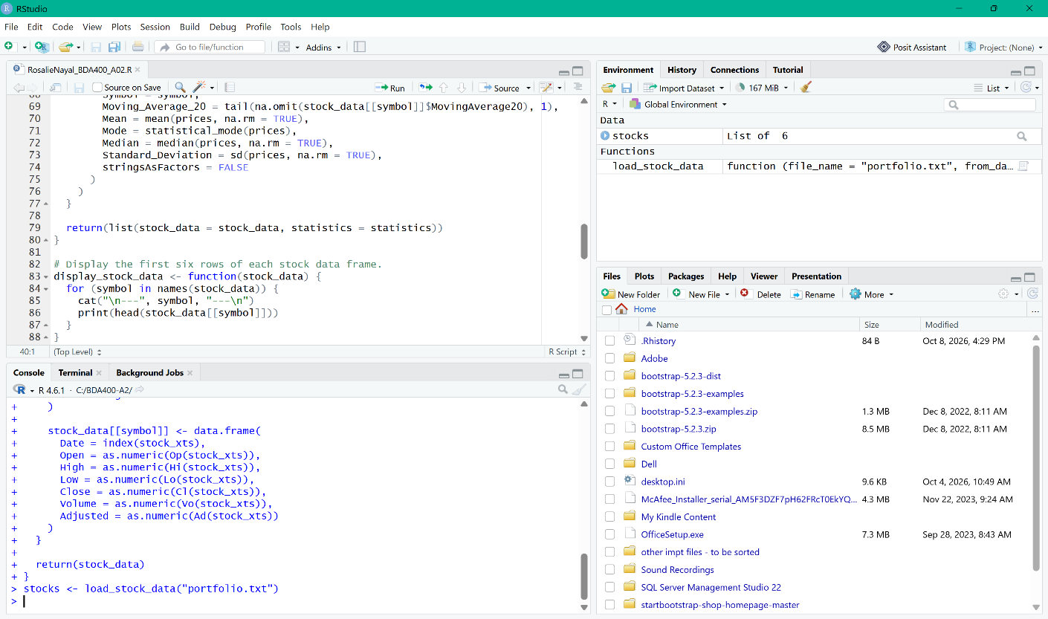

Expanded stocks object showing the six separate stock data frames and their variables.
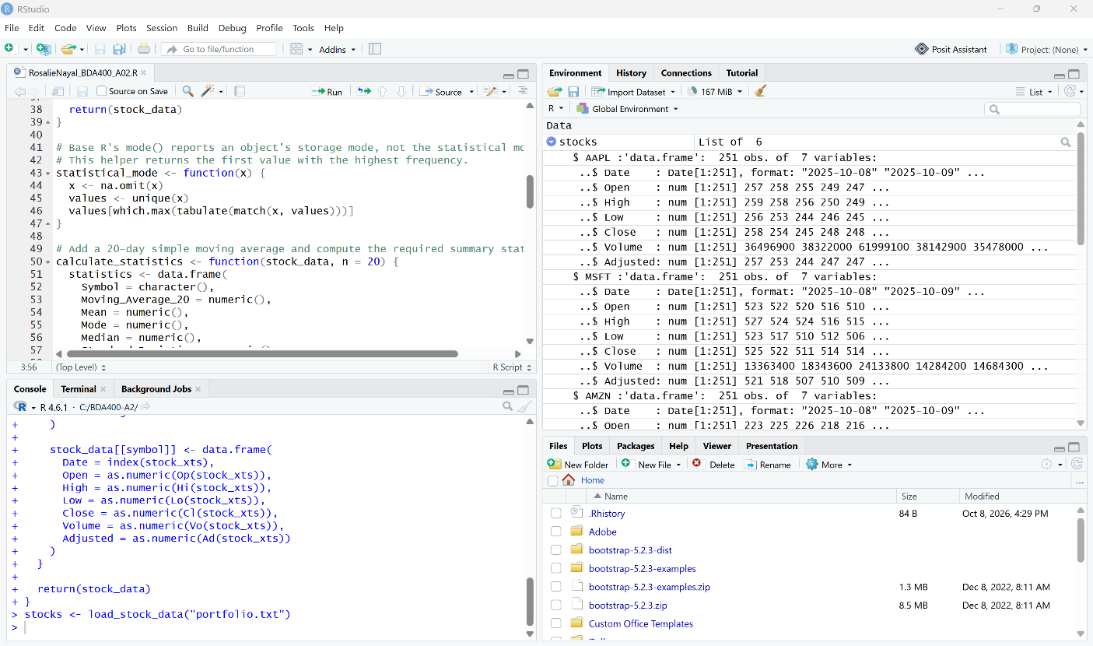

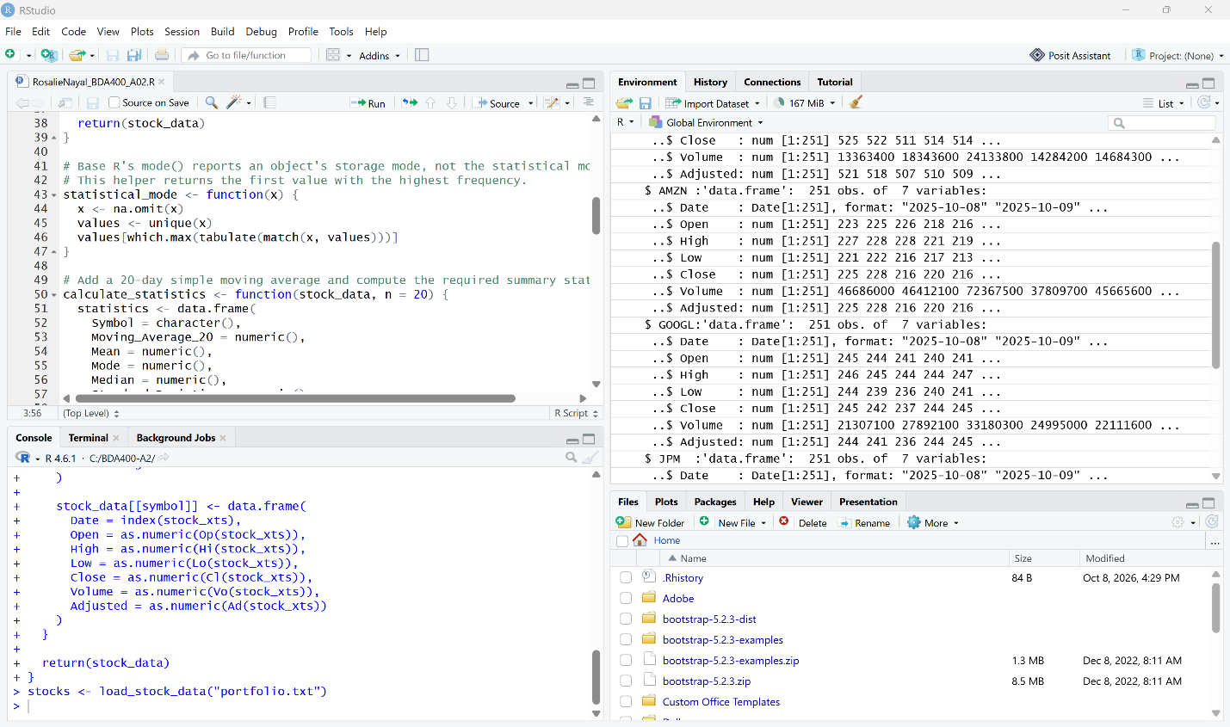

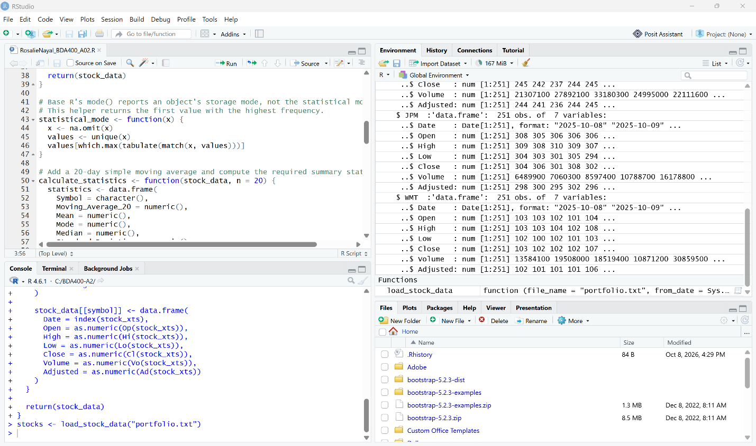

Step 6 – Writing Functions to Compute Basic Statistics
I used the calculate_statistics() function to calculate the required statistics for each stock: a 20-day moving average, mean, mode, median, and standard deviation. A helper function named statistical_mode() was used to calculate the statistical mode. The calculated results were stored in a structured data frame, while the updated stock data and statistics were returned together in a list for further analysis and display.

Selected and Highlighted Lines 41–80 and Clicked Run

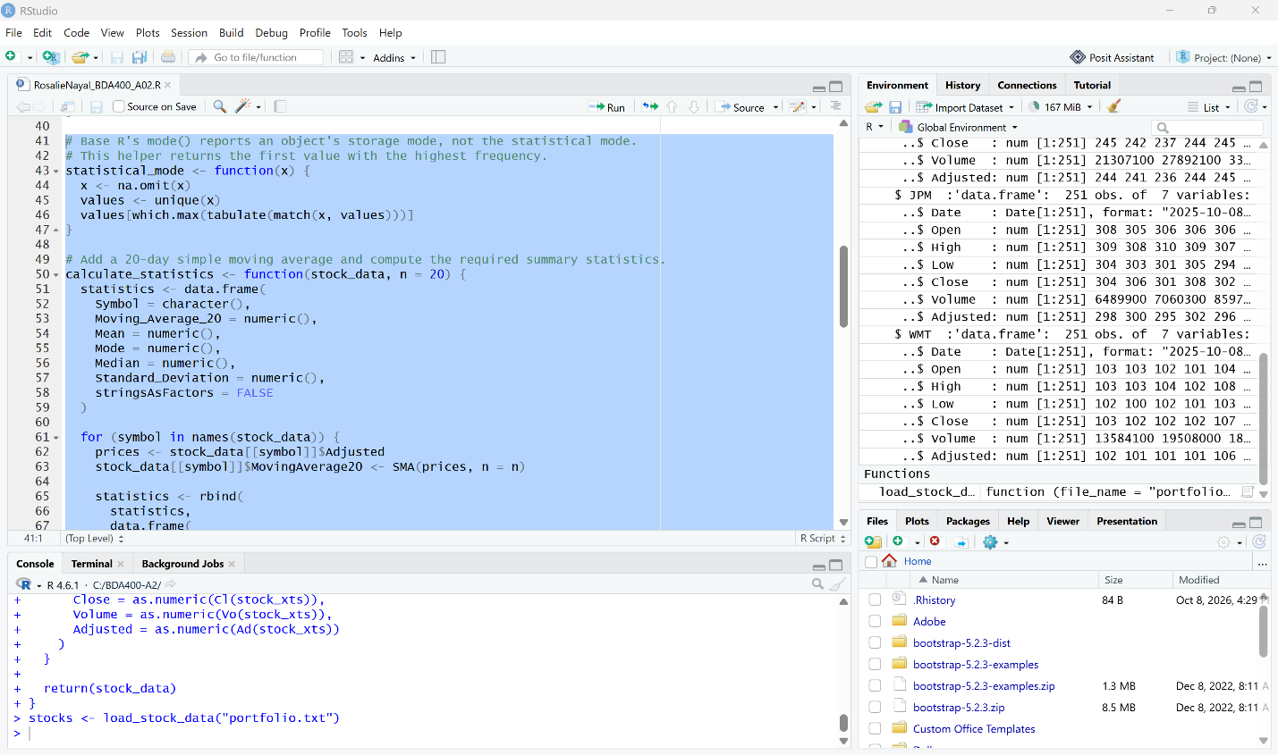

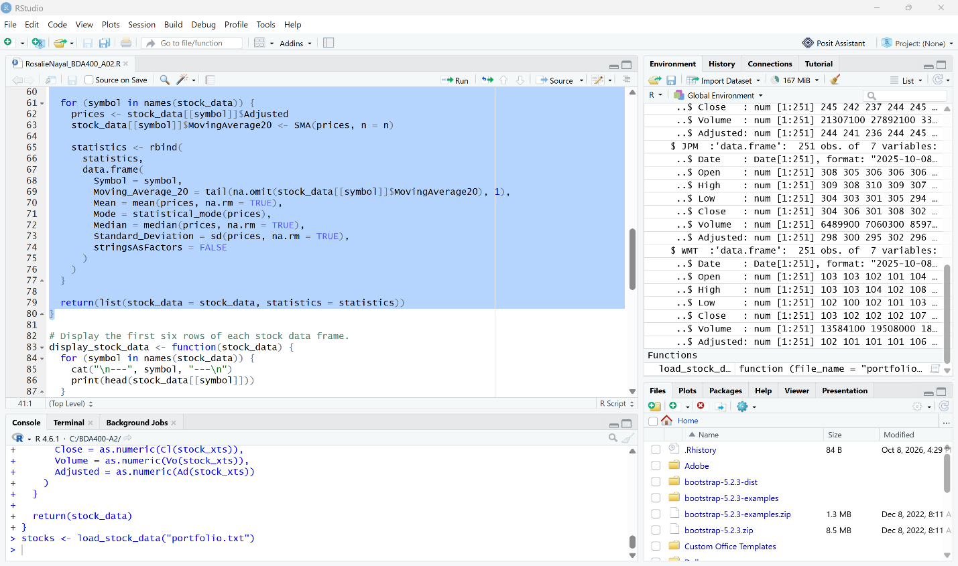

Run Lines 41–80 to Load the Step 6 Statistics Functions
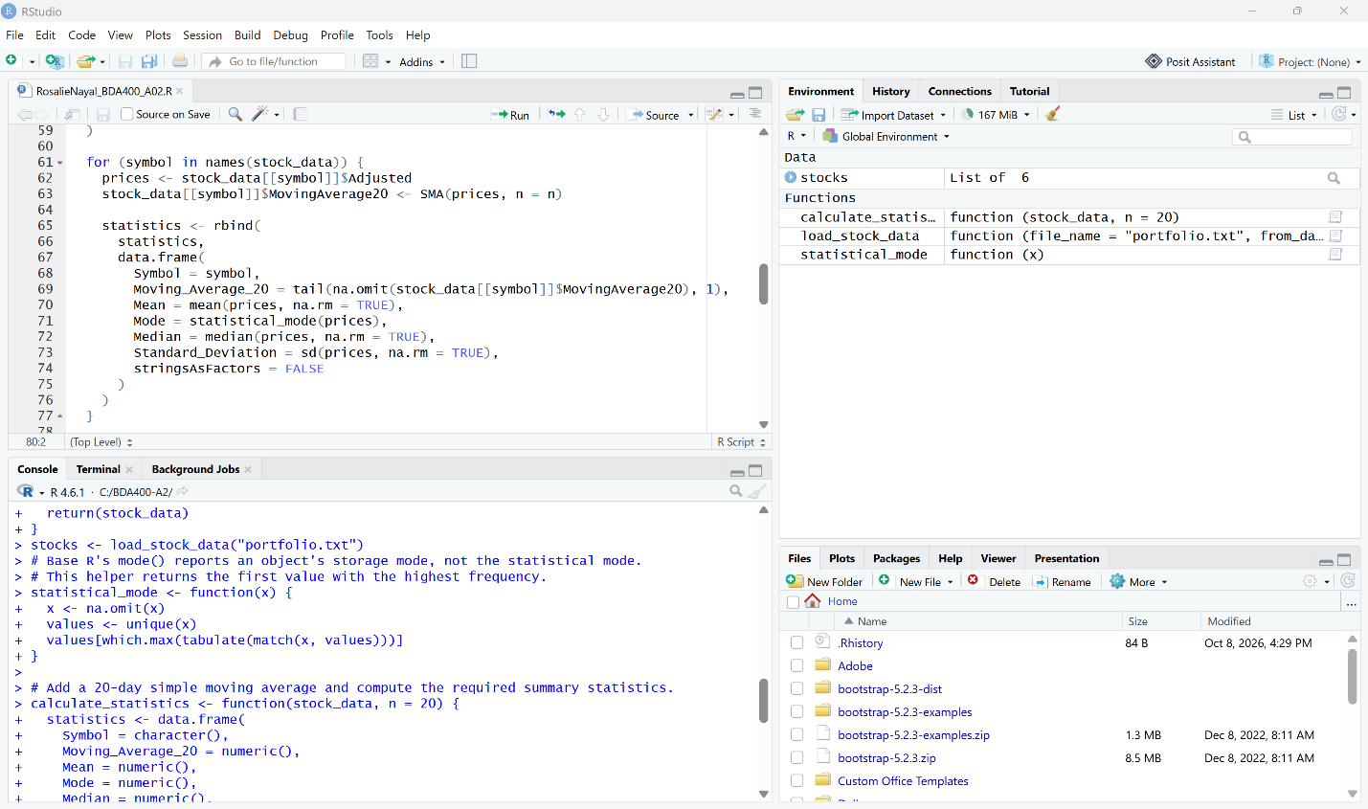

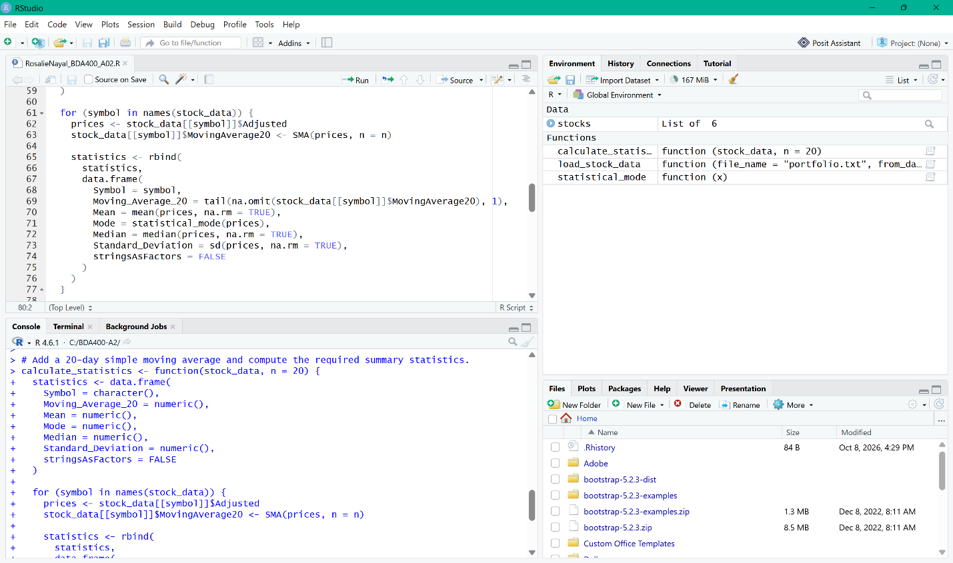

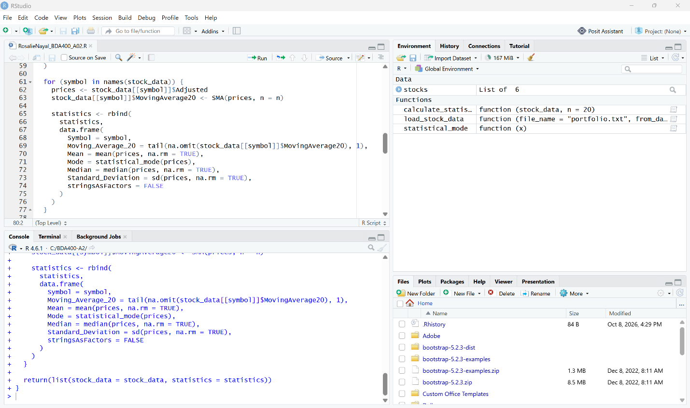

Run calculate_statistics() and Store the Results in analysis
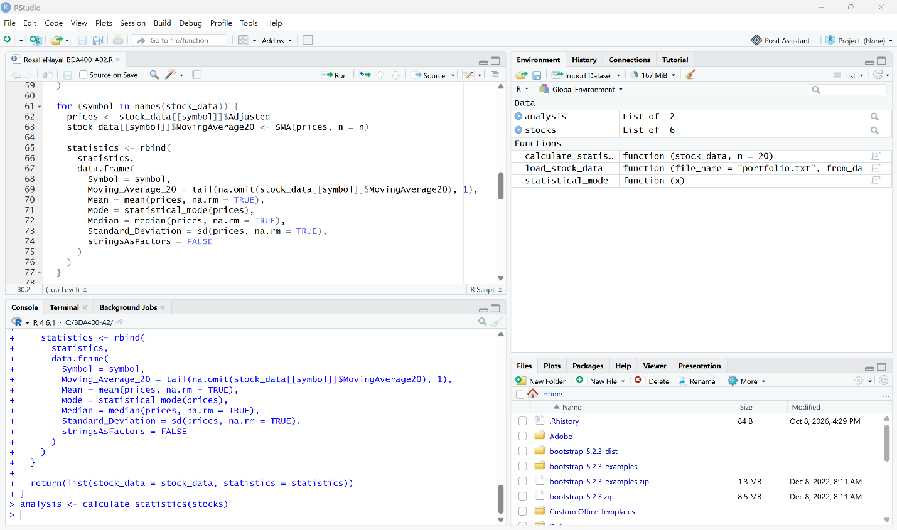

Expand the Analysis to Verify the Stock Data and Statistics Results
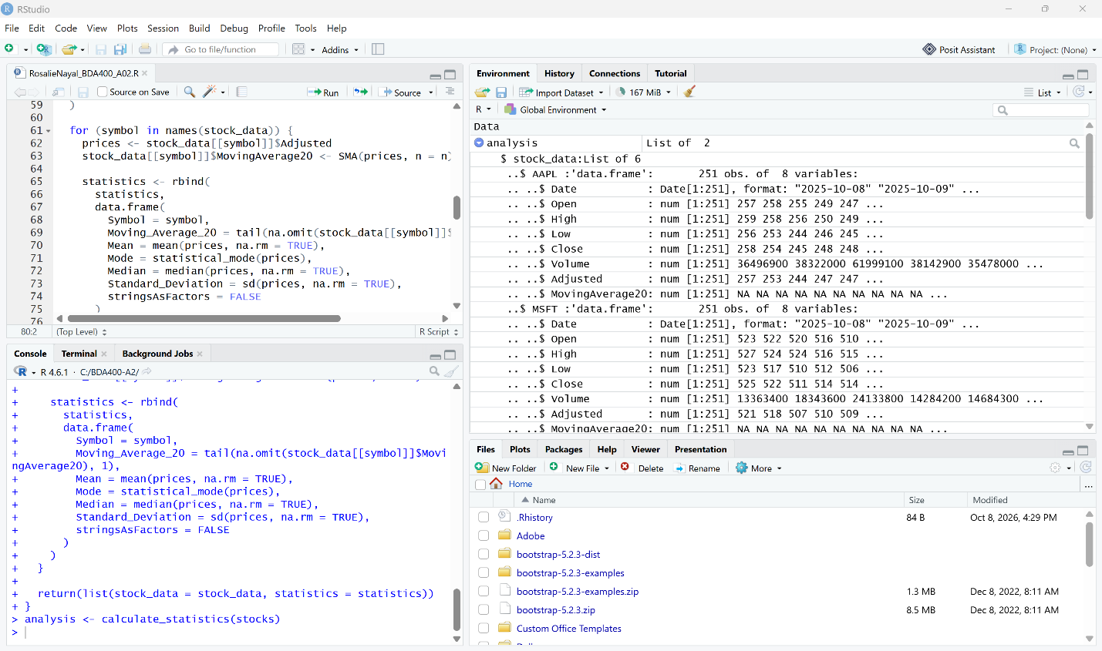

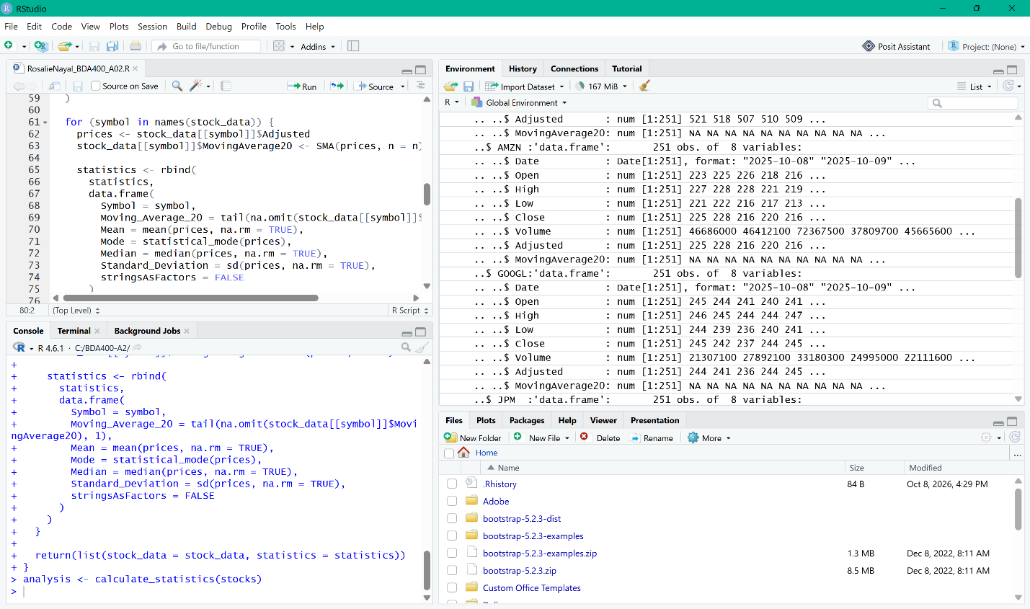

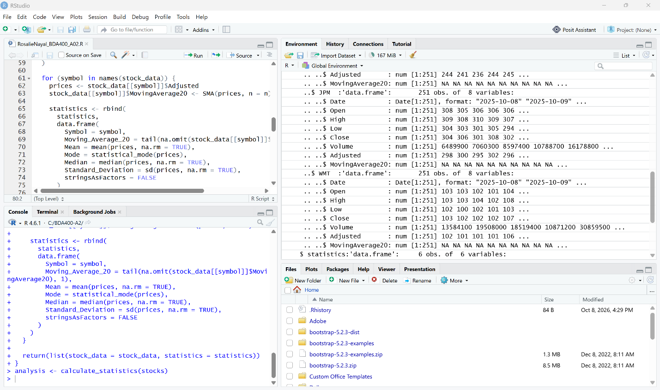

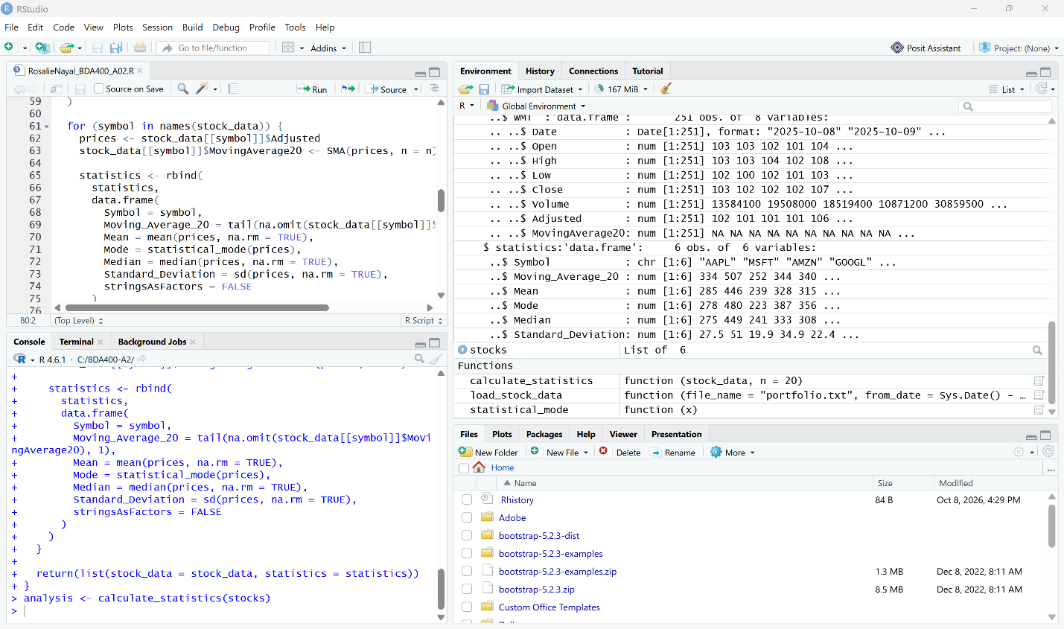

Extract the Statistics Data Frame from the analysis Results
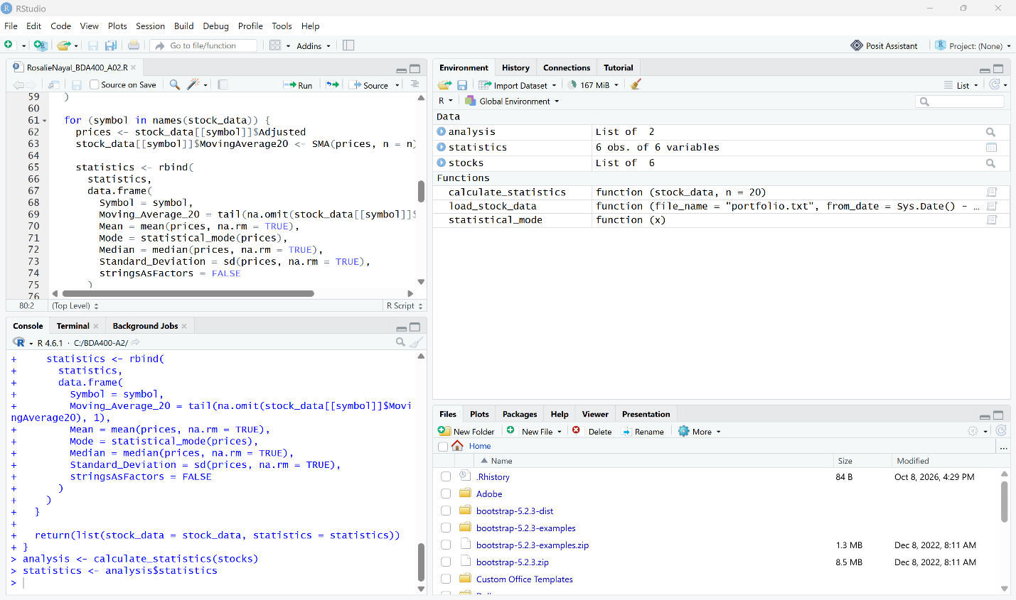

Expand the statistics Data Frame to Verify the Six Required Variables
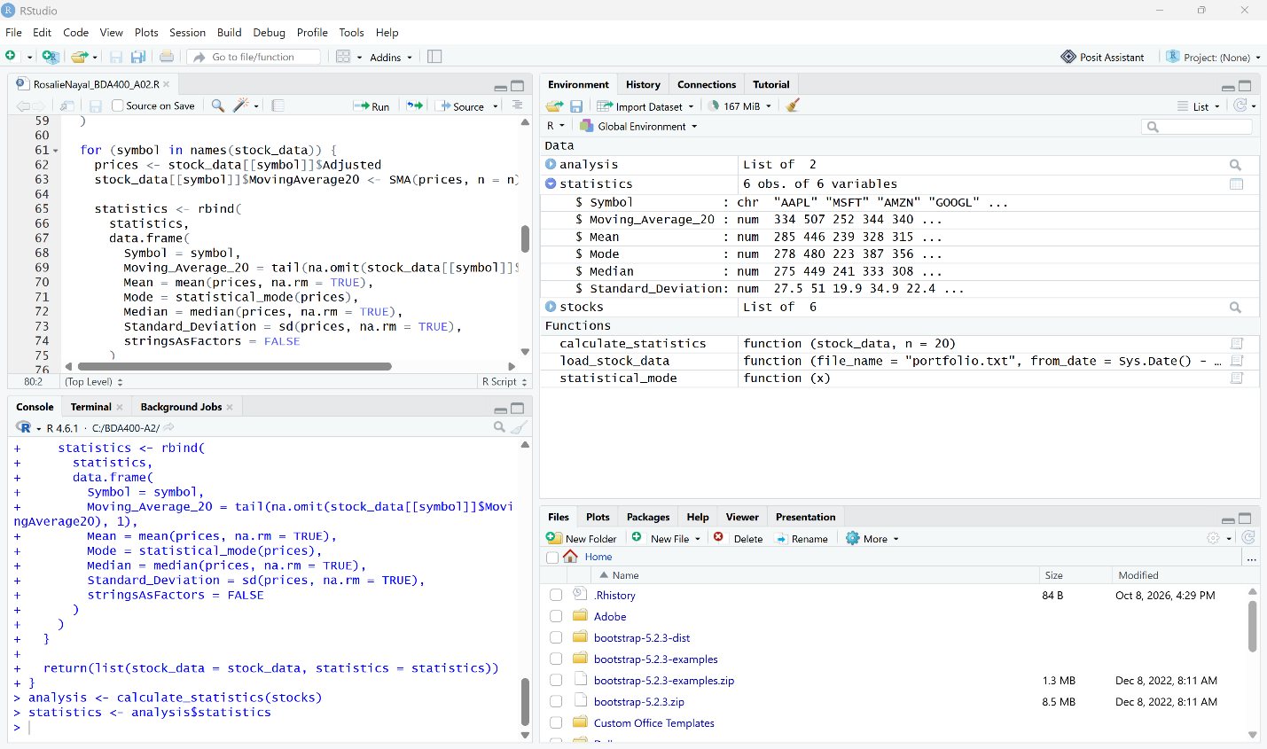

Print the Complete Statistics Table for All Six Stocks
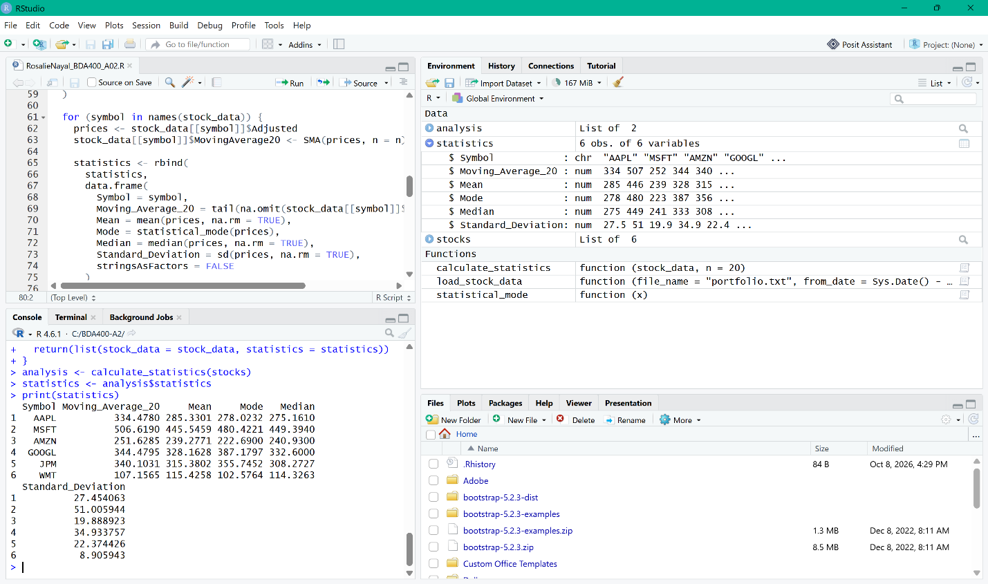

Table 1. Basic Statistics for 6 Portfolio Stocks

Symbol | 20-Day Moving Average | Mean | Mode | Median | Standard Deviation
AAPL | 334.4780 | 285.3301 | 278.0232 | 275.1610 | 27.454063
MSFT | 506.6190 | 445.5459 | 480.4221 | 449.3940 | 51.005944
AMZN | 251.6285 | 239.2771 | 222.6900 | 240.9300 | 19.888923
GOOGL | 344.4795 | 328.1628 | 387.1797 | 332.6000 | 34.933757
JPM | 340.1031 | 315.3802 | 355.7452 | 308.2727 | 22.374426
WMT | 107.1565 | 115.4258 | 102.5764 | 114.3263 | 8.905943

Step 7 – Write Utilities to Display Output
I used two customized functions to display the stock data and visualization results. The display_stock_data() function displays the first six rows of each stock data frame so that the imported information can be reviewed for all six portfolio stocks. The plot_stock_data() function creates a visualization for each stock showing the Adjusted Close price together with its 20-day moving average. These utilities provide both a tabular display of the loaded stock information and a visual view of the stock price trends.

Selected Lines 82–116 and Run the Step 7 Display Functions
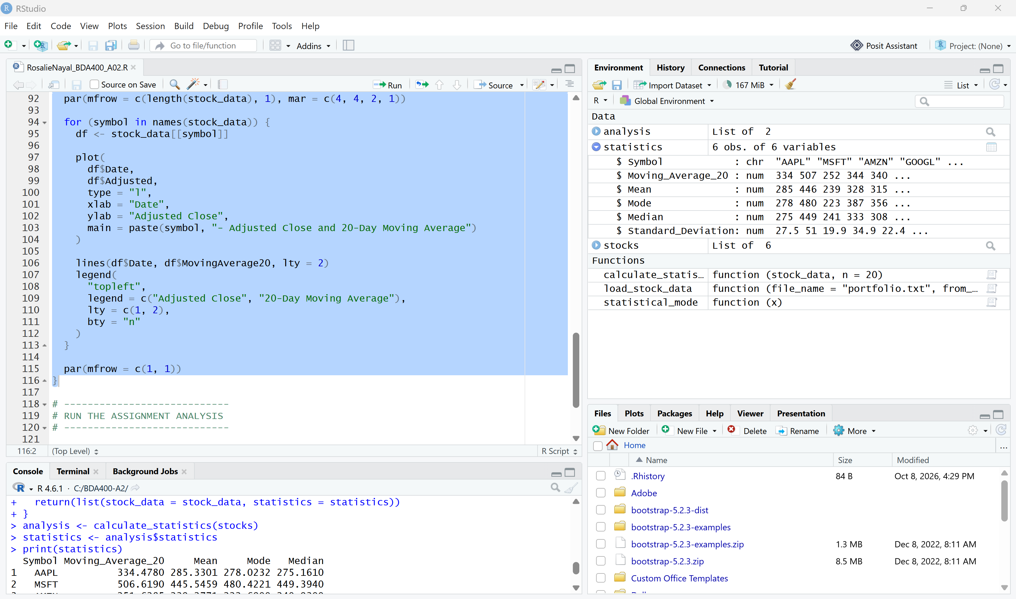

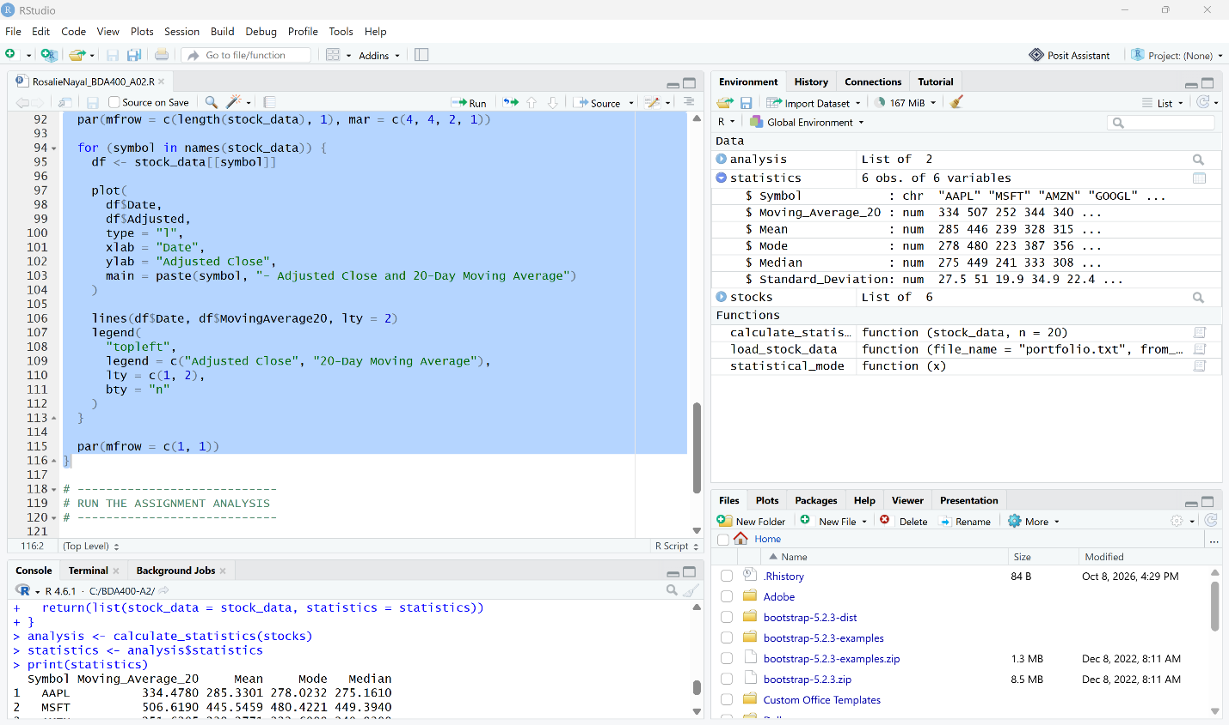

Run Lines 82–116 to Load the Step 7 Display Functions
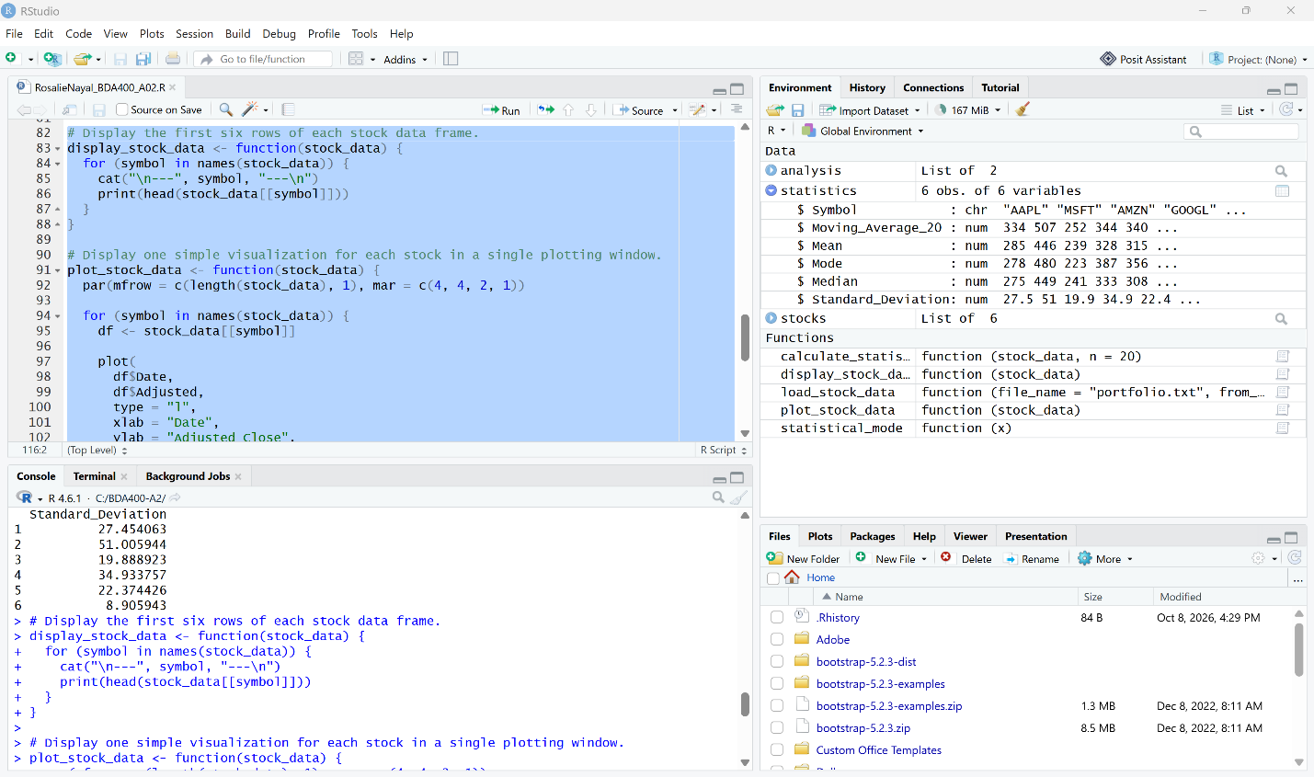

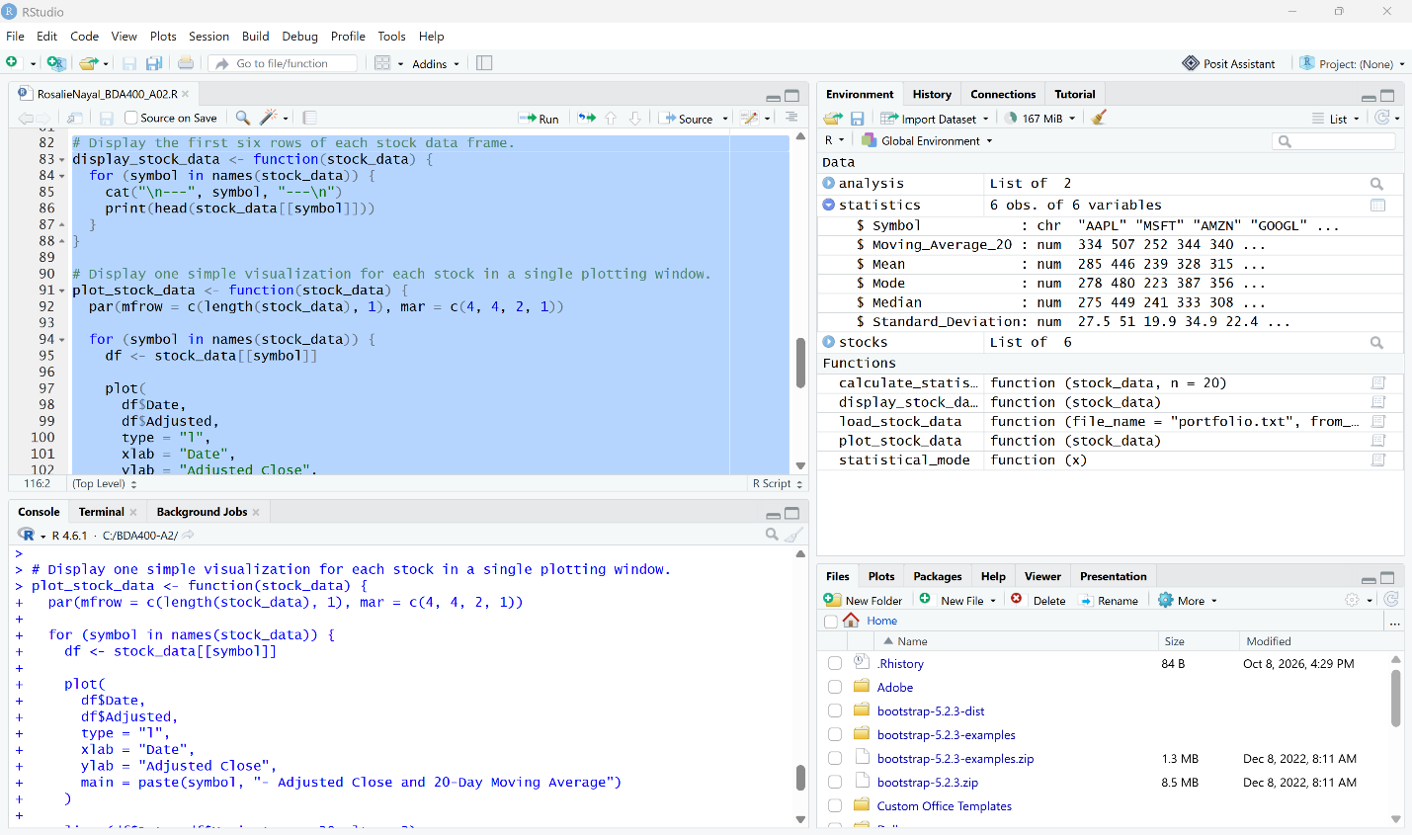

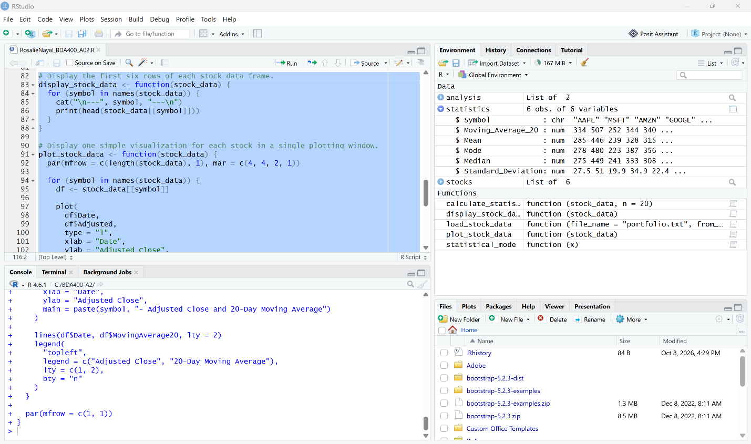

Update the stocks Object with the Calculated Moving Average Data
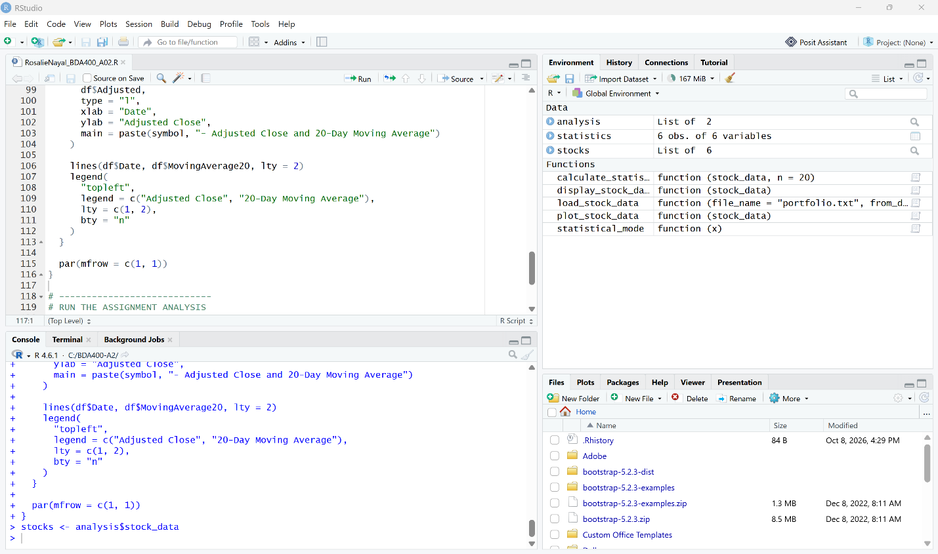

Display the First Six Rows of Each Stock Data Frame. The first rows show NA for the 20-day moving average because 20 observations are required before the first moving-average value can be calculated.
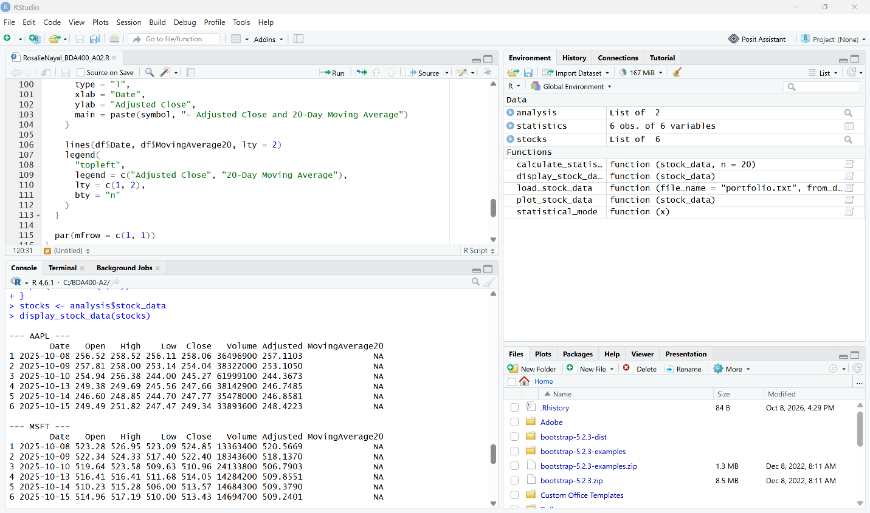

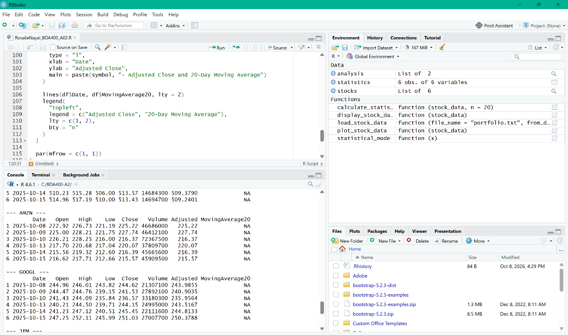

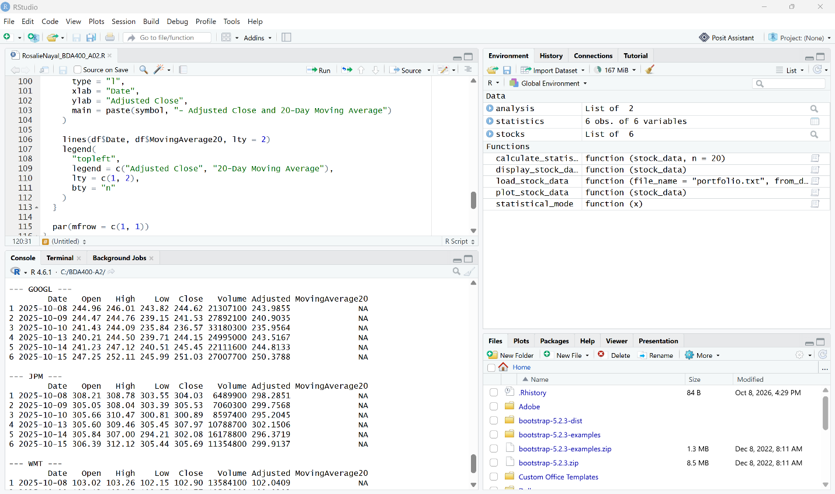

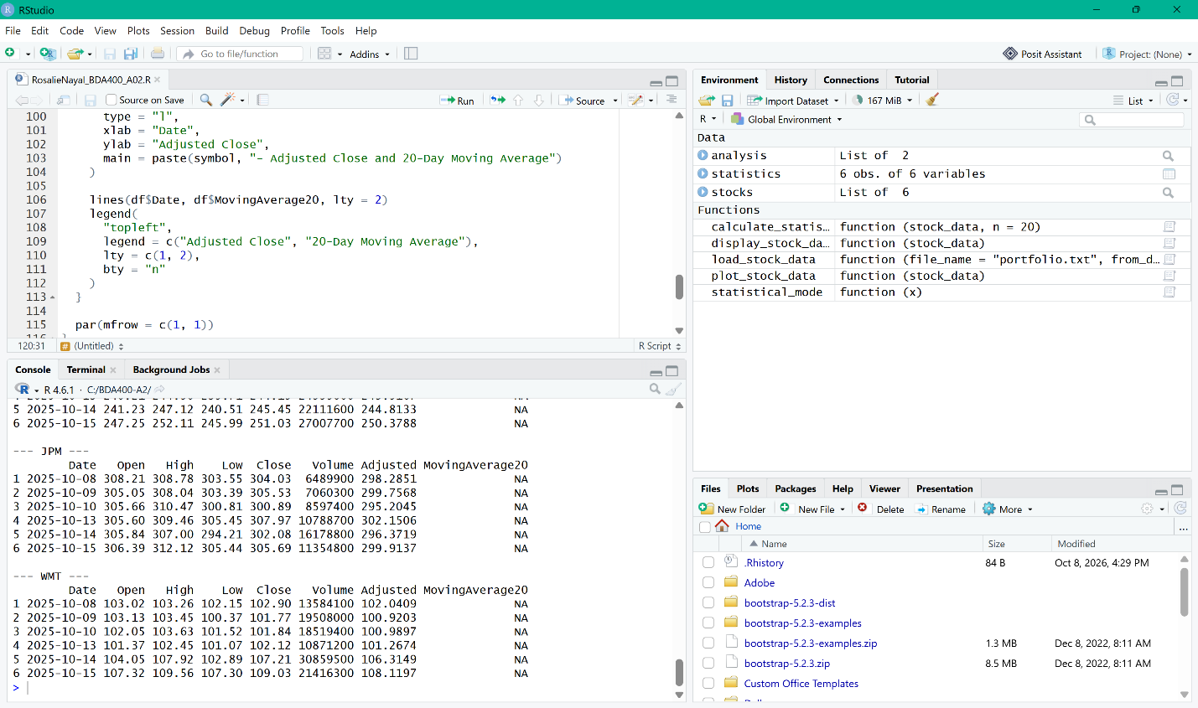

Plotting Error Encountered
When I ran plot_stock_data(stocks), RStudio returned the error Error in plot.new(): figure margins too large. The error occurred while attempting to display the six stock visualizations in the available plotting area.
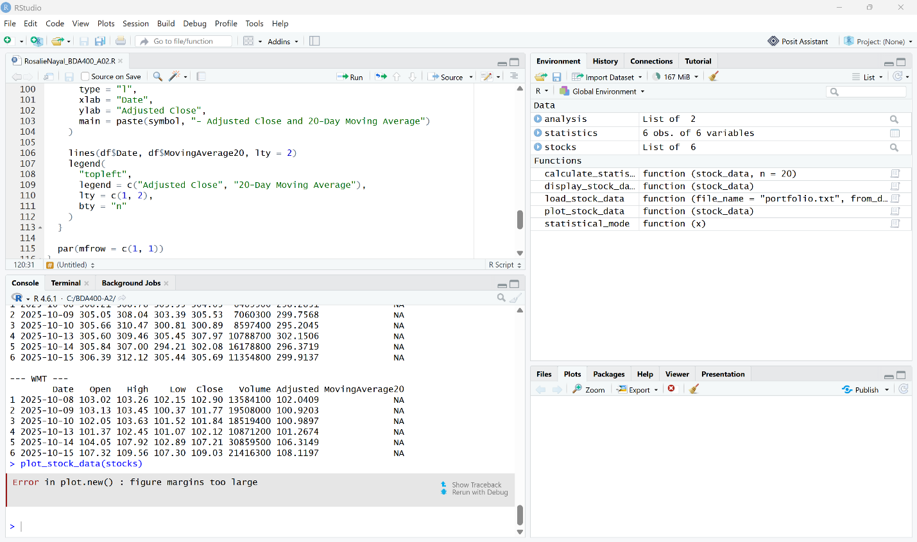

Troubleshooting the Plotting Error
I consulted ChatGPT for assistance after RStudio returned the error Error in plot.new(): figure margins too large. I was advised to enter the command windows(width = 10, height = 12) in the RStudio Console to open a larger graphics device. After running the command, a new separate R Graphics window opened successfully. The new window was initially empty because it had only created a larger plotting area and the plotting function had not yet been run again.

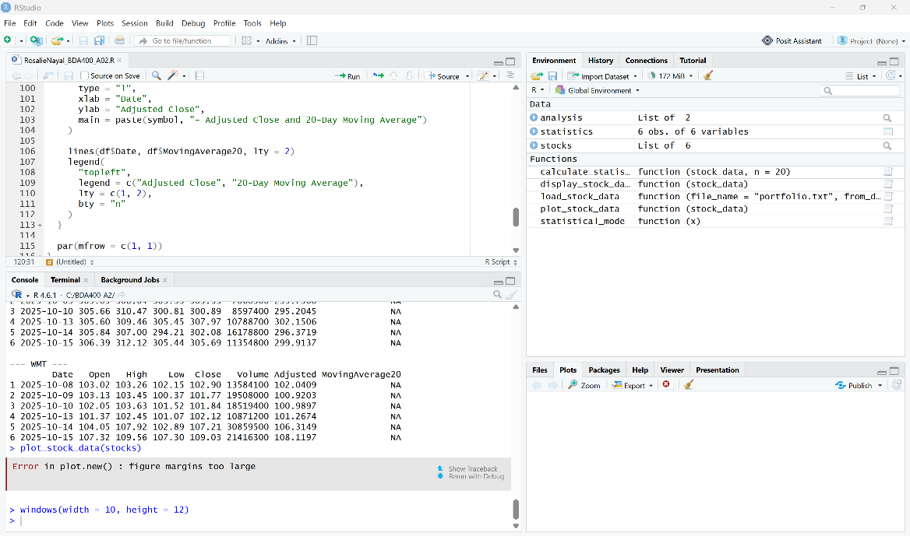

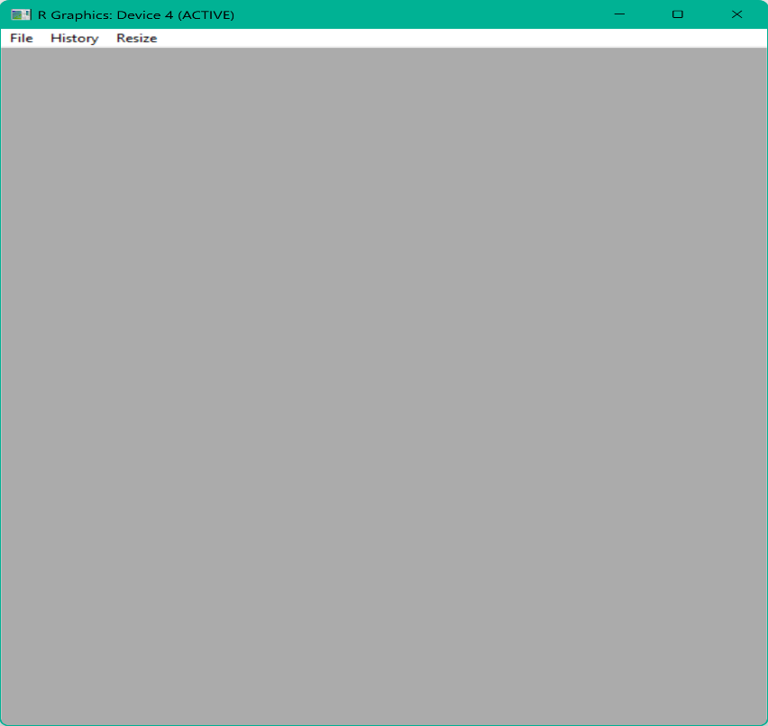

Display the Six Stock Visualizations with 20-Day Moving Averages

Rerun the Plotting Function in the Larger Graphics Window
I reran plot_stock_data(stocks) command prompt from the RStudio Console. The command completed without another plotting error, confirming that the larger graphics device provided enough space for the six visualizations. After, the larger R Graphics window was opened,

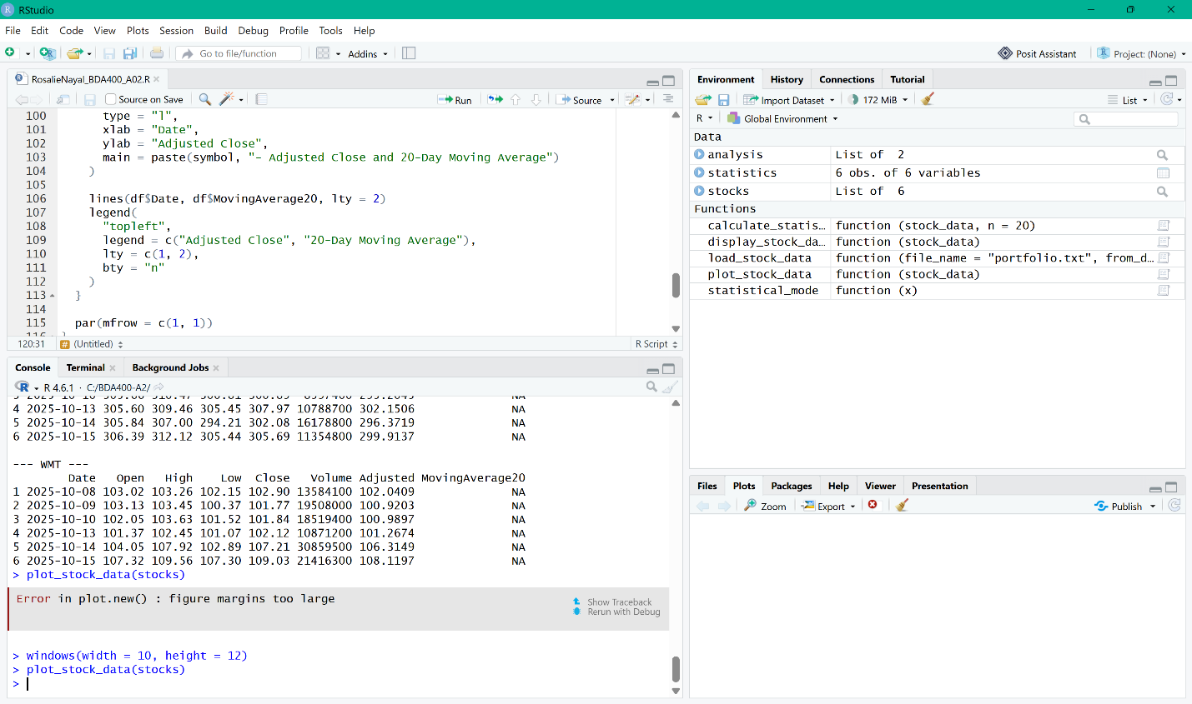

Six-Stock Adjusted Close and 20-Day Moving Average Visualization

The final visualization displays one year of daily market data for the six portfolio stocks: AAPL, MSFT, AMZN, GOOGL, JPM, and WMT. Each stock is shown in its own graph, with the Adjusted Close represented by the solid line and the 20-Day Moving Average represented by the dashed line. The moving-average line smooths the short-term daily price changes and makes the broader direction of each stock easier to see. Across the period shown, the stocks demonstrate different price patterns: AAPL generally trends upward, MSFT declines during the first part of the period before recovering strongly, AMZN shows several rises and declines, GOOGL rises substantially before leveling off, JPM trends upward for much of the period before easing near the end, and WMT rises earlier in the period and then declines later. Displaying all six graphs together provides a single consolidated view for comparing the price movements and their corresponding 20-day moving averages.

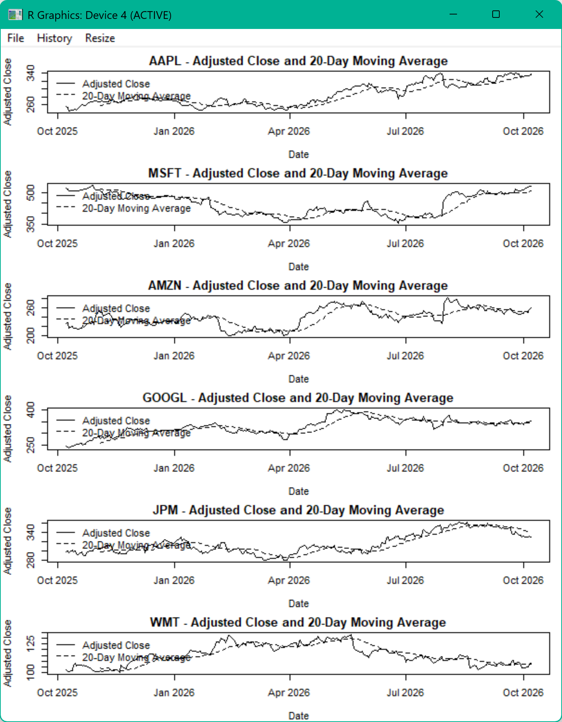

Conclusion and Reflection
This assignment provided a complete introduction to setting up and using R for technical stock analysis. I created the TechnicalAnalysis GitHub repository, installed and configured R and RStudio, installed the required technical-analysis packages, and created a portfolio containing six stock symbols. Using the load_stock_data() function, I imported market data for AAPL, MSFT, AMZN, GOOGL, JPM, and WMT and stored the information in separate data frames. I then used the calculate_statistics() function to calculate the 20-day moving average, mean, mode, median, and standard deviation for each stock. Finally, I displayed the imported stock data and created visualizations comparing the adjusted closing price with the 20-day moving average for all six stocks.

Completing the assignment also showed me the importance of testing and verifying each part of an R workflow instead of assuming that a command worked correctly. I encountered several technical issues during the setup and visualization stages, including package-installation problems and an error caused by the available plotting area. By reviewing the error messages, consulting troubleshooting assistance when needed, following the suggested steps, and verifying the results in RStudio, I was able to confirm that each part of the analysis was functioning correctly. The assignment helped me become more familiar with the RStudio interface, R functions, data frames and lists, package use, and the basic process of importing, analyzing, and visualizing stock-market data. It also created a working foundation that can be reused and expanded in the later stages of the Technical Analysis project.

