Ross Angus
2244073A
Systems Coursework 2: Concurrent Dependency Discoverer

Status:

As it currently stands I believe I have implemented a multi threaded solution to the problem. I loop over only the work queue in my solution when creating and killing the threads because I feel that this is the only part that needs to be multi threaded as this will deploy multiple threads who each have a task from the work queue so they should continue to work independently until their task is done at which point they’ll each return for another task. I can tell this method works as I have an output inside the loop which shows what task each thread is working on and the work queue size increasing and decreasing until all tasks are done. However, I have been unable to implement a thread safe struct for the unordered map due to compilation errors caused by my inability to pass in the key value pair for the insert method, but the general work of the threads is hopefully still clear, even if multiple threads end up trying to write to the same address at the same time which is not guaranteed to happen but very possible. The time to execute the program is almost always 0.00 probably due to caching. I don’t have a virtual machine on my laptop so I wasn’t able to view some non zero times but I did add a sleep function to the loop so that it can be seen that the time to empty the work queue greatly reduces with each thread, it doesn’t really prove much in terms of real performance but it does show that the queue is worked on by multiple threads as 8 threads empty the queue in an eighth of the time it takes 1 thread.

The general idea of my implementation was to implement multiple threads on the work queue and then encapsulate all the methods of the queue inside a thread safe struct using mutex’s. I also obviously wanted to make the map thread safe but I was unable to, but this shouldn’t affect the multi threading implementation, just the effectiveness of the program to complete the given task.

Some Proof that I ran this myself, my name is Ross and my PC’s satan. Also, proof that it ran the makefile without compilation errors . I CLANG’d C++17 in the CLION IDE on my fedora running laptop.

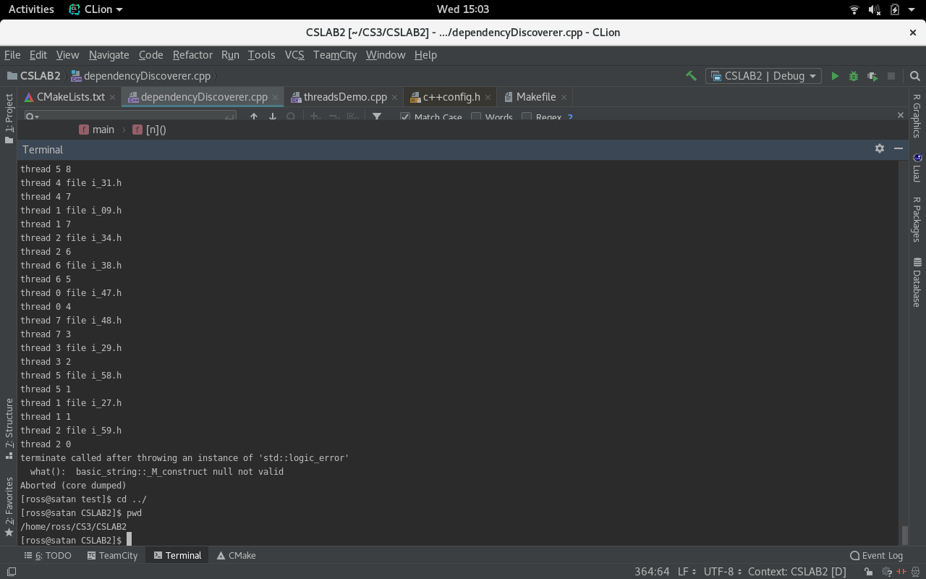

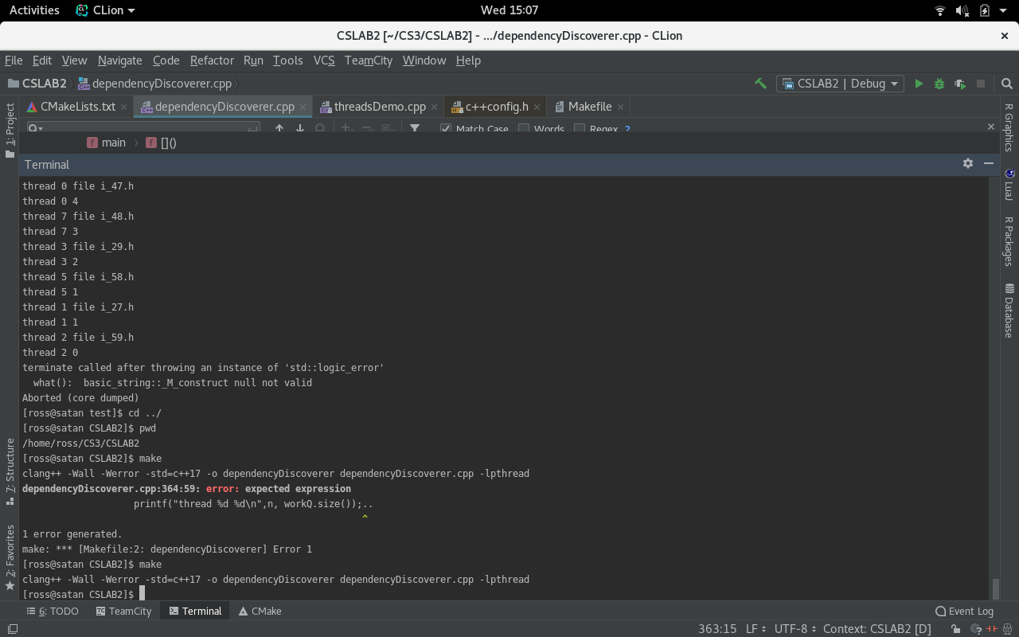

Sequential / Single thread:
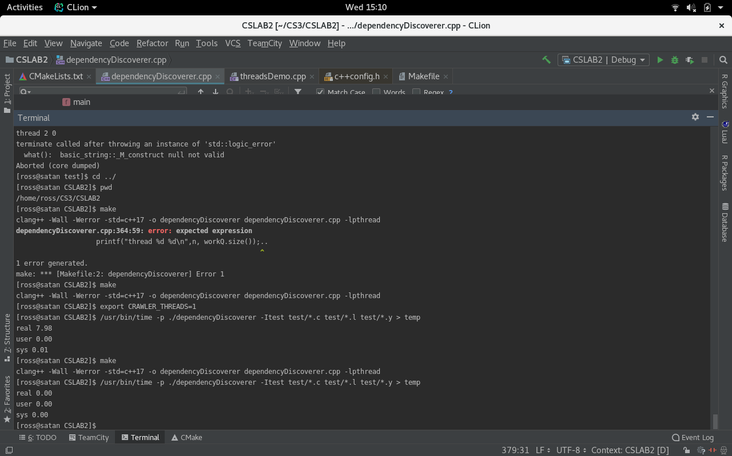

This time reading is the same for running both sequentially and with one thread.

Multiple Threads (PWD):
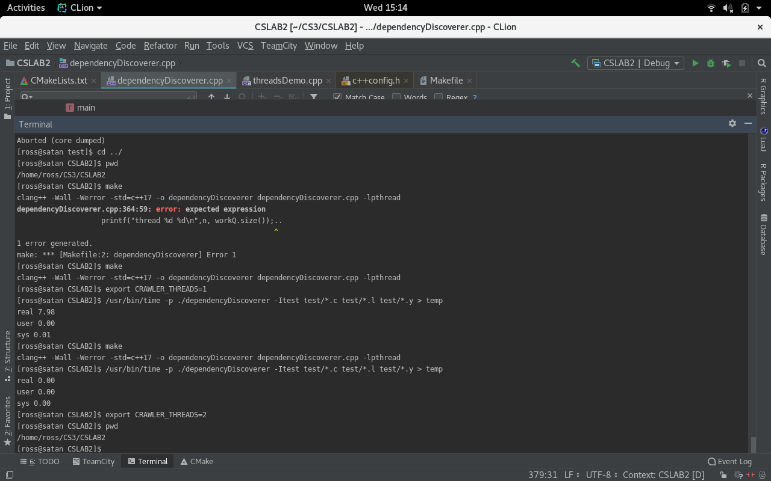

Timings:

I’ll include the setting of the environment variable for proof of threads. I’m also going to do everything twice: first with the my working fastest code and secondly with a sleep inside my work queue so that its clearer to see an improvement in performance.
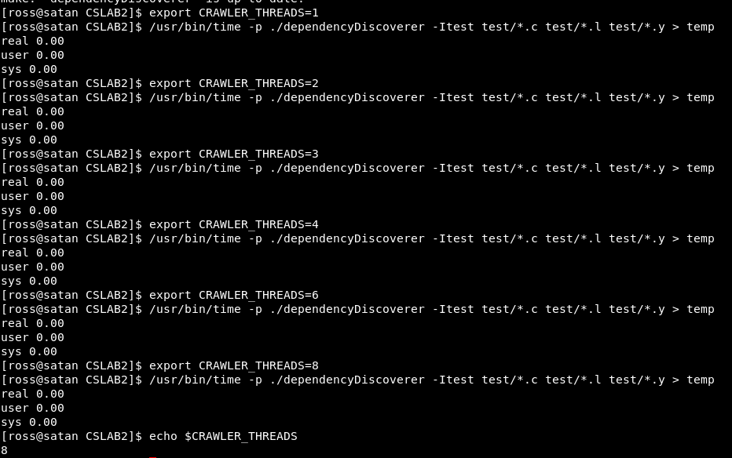

CRAWLER | 1 | 2 | 3 | 4 | 6 | 8
_THREADS | Elapsed Time | Elapsed Time | Elapsed Time | Elapsed Time | Elapsed Time | Elapsed Time
Execution 1 | 0.00 | 0.00 | 0.00 | 0.00 | 0.00 | 0.00
Execution 2 | 0.00 | 0.00 | 0.00 | 0.00 | 0.19 | 0.00
Execution 3 | 0.00 | 0.00 | 0.00 | 0.00 | 0.00 | 0.22
Median | 0.00 | 0.00 | 0.00 | 0.00 | 0.00 | 0.00

There were a couple random results but the median shows it usually results in 0.00 seconds.
The program itself is very fast to run because of caching. Most people I know have decided to submit these 0.00 times as their results which is pretty reasonable, they represent the real time taken to execute on a regular machine (not a virtual machine) so I think its a fair thing to present as most people would run it this way. However, I do still think it is important to display my results using ‘sleep’ because it shows if nothing else that the work queue is reduced at a much greater rate the more threads are used.

Would the times be greater if I had implemented a thread safe map? Probably not on my machine but I think they would be greater on a VM as the threads would encounter yet another layer of locks

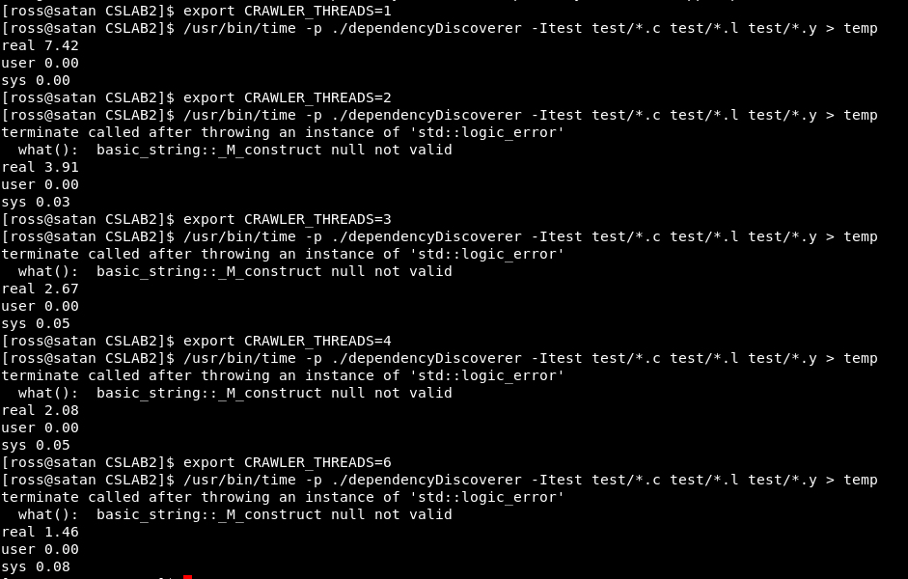
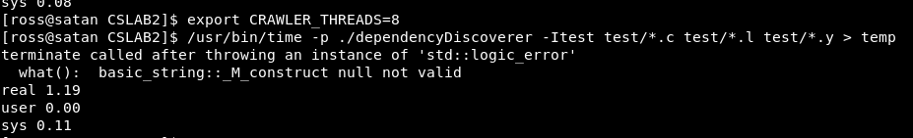
**there wasn't enough space on my screen for all the timings to 8 threads is separate**

CRAWLER | 1 | 2 | 3 | 4 | 6 | 8
_THREADS | Elapsed Time | Elapsed Time | Elapsed Time | Elapsed Time | Elapsed Time | Elapsed Time
Execution 1 | 7.42 | 3.91 | 2.67 | 2.08 | 1.46 | 1.19
Execution 2 | 7.42 | 3.76 | 2.72 | 2.08 | 1.46 | 1.18
Execution 3 | 7.43 | 3.87 | 2.72 | 2.08 | 1.51 | 1.17
Median | 7.42 | 3.87 | 2.72 | 2.08 | 1.46 | 1.18

As you can see the improvement in times from 1 thread as a percentage is as follows

1 thread = 7.42 seconds
2 threads = 52% of 1 thread’s time
3 threads = 37% of 1 thread’s time
4 threads = 28% of 1 thread’s time
6 threads = 20% of 1 thread’s time
8 threads = 16% of 1 thread’s time (1/8)

so 8 threads is 8 times faster than 1 thread but this was to be expected as my wait function will wait 8 times less in theory so it doesn’t really show the real time improvements of multi threading.

In conclusion, I enjoyed this task much more than the first, and felt it more mentally challenging rather than syntactically challenging like the first. I enjoyed learning about C++ .

