**Augmented Reality in Education**

Ross Cawley

14511223

Review article for CS275 2015

B.Sc. Computer Science and Software Engineering



Department of Computer Science

National University of Ireland, Maynooth

Co. Kildare

Ireland

*A review article was submitted in partial fulfillment of the requirements for the continuous assessment of the Directed Reading in CSSE module CS275 on the B.Sc. Computer Science and Software Engineering*

Lecturer: Mr. Joseph Duffin

# Declaration

I hereby certify that this material, which I now submit for assessment on the program of study as part of the continuous assessment for module CS275, is *entirely* my own work and has not been taken from the work of others - save and to the extent that such work has been cited and acknowledged within the text of my work.

Signed: Ross Cawley Date: 30/01/2016

# Abstract

Augmented Reality gives the user a direct view of a real world environment that is supplemented by some computer generated input such as sound, video or graphics. It is thought that this technology can be used to great effect in the classroom, as it gives students a more interactive experience with their education. This review will look in-depth at how Augmented Reality can be used across various areas of education, the benefits of using it over more traditional techniques. It will also examine the criticisms or arguments against Augmented Reality. There will be four main subtopics in regards to the broader topic; Augmented Reality in primary, secondary, tertiary education. With this approach, it is possible to examine the effectiveness of Augmented Reality from the youngest of students to those studying to obtain a degree. One other goal of the review is to determine whether the use of augmented reality in the classroom is a viable practice in the long term, or whether it is just a passing concept that will fade from function in the future.

The success of this innovative technology in education lays entirely in the hands of the students. If the results come exam time do not reflect well upon Augmented Reality, it will scrapped entirely, like so many technologies before it. However, due to its entertainment like nature, this is unlikely to be the case, due to the fact that so many will treat it like a game, even if they do not realise it is so much more than that.

Table of Contents

Declaration i

Abstract ii

Introduction 1

Discussion 2-8

- What is Augmented Reality?................................................ 2

- Augmented Reality in Primary Education……………… 2-4

- Augmented Reality in Secondary Education…………….4-5

- Augmented Reality in Tertiary Education……………… 5-7

Future Developments………………………………………...8

Conclusion……………………………………………………9

References………………………………………………......10

Introduction

The intention of this review is to investigate how augmented reality is currently integrated in education. We will inspect its uses in different areas of education and how it differ from one subject to another, depending on said subjects demand.

With sources currently available for public viewing, this review aims to go into detail on how augmented reality is used in the classroom, but more importantly whether or not is effective and received well by the students who use it day in, day out. It is important to note that even if the technology is effective, its success lies entirely in how the students treat it; this is something that could destroy its use in education if it is not received well on a near universal level.

The sources used in this review were found on Science Direct and Google Scholar and formatted using Mendeley. Great emphasis was placed on using factual, peer-reviewed information to avoid using any false or inaccurate information.

Discussion

**What is Augmented Reality?**

Augmented Reality is an exciting, rapidly evolving technology. Simply put, it superimposes a computer-generated image over the user’s view of the real world, creating what is essentially a modified version of that view. With the rapid rise of mobile technology on a global scale, the popularity and use of Augmented Reality on smartphones and tablets has also skyrocketed (Nincarean, Alia, Halim, & Rahman, 2013). This increase in popularity is due to the ease of which Augmented Reality can be utilised; using apps and the user’s phone camera for example, is all needed to utilise this technology.

The newly discovered popularity of this technology translates well into the area of education. It provides an authentic, realistic and engaging environment for the student to learn with, something that is argued to be lacking in many curriculums around the world today. It also a fun way to learn information, which is not to be understated, especially when dealing with younger students. According to the ­­Emerging Technology Initiatives of New Media Consortium in the Horizon Reports, Augment Reality is “one of the emerging technologies that might have potential and impact on learning and education” (NMC 2010, 2011, 2012).

**Augmented Reality in Primary Education**

Primary education (age’s four to twelve) is perhaps the most vital stage of development when it comes to understanding the material that is presented. It is essential that students of this age grasp the basic ideas that will lay the foundations for their later studies. To help with this process, Augmented Reality can provide examples that make this learning experience less abrupt, using concepts that are easier for younger students to grasp. (Chen, Ho, & Lin, 2015) mention in their paper that a study conducted in 2005 created an Augmented Reality game whose learning content concerned the marine life food chain. The purpose of the game, which was conducted on a desktop PC within the classroom, was to find appropriate baits for the target fish and also to collect as many species as possible. The study examined the teamwork skills, learning motivation and learning achievement, and found that all students who had partaken in the study performed at a very high level, while remaining engaged with the core concepts that were outlined.

When it comes to children of elementary age, it is important not to completely overwhelm them with rote learning techniques, even if this form of technique may be useful later in their schooling career. In this way, Augmented Reality and the uses of it, like those mentioned above, can really benefit the student by bringing together important intellectual information.

Of course, Augmented Reality will be more useful­­ in certain subjects than others. In the area of science in particular, it has a huge place to grow and expand into. For primary school students, the basics of human and indeed other species anatomy can be taught in great detail through the use of Augmented Reality. Also in astronomy can this technology be used in great ways; something that is so alien to us on paper can be taught far more credibly if the student can interact with what they are learning. With this technology, the students can experience and study in great detail concepts that would not be as appreciated if read in a book. For example, (Kerawalla, Luckin, Seljeflot, Woolard, 2015) carried out an experiment with a group of elementary school students which tasked the students to look at and determine the time of day based on the sun’s location in the sky. They utilised Augmented Reality here by creating a visual representation of the earth that students could interact with and view from different angles. It is this type of utilisation of Augmented Reality that makes it a superior tool to simply studying a textbook or similar learning tool.

**Augmented Reality in Secondary Education**

As students get older, they are pushed toward the idea that school is about getting the good grades and that is the main focus, not actually understanding the material, but just learning it off to get a good mark in an exam. This is the true problem at the heart of the current education syllabus, where rote-learning is promoted in place of practical learning. In a study, (Jamali, Shiratuddin, Wong, & Oskam, 2015) aim to provide a tool that helps students at a secondary level actually interact with the material that they are learning; human anatomy (namely the skeletal structure). The prototype created, called the Human Anatomy in Mobile Augmented Reality or HuMAR, allows students to view and learn about the human skeletal structure in a far more hands on way. Instead of simply reading about the human skeletal structure in a book, without any real scale or context on what they are viewing, it is very difficult to grasp the material being portrayed. Inventions such as HuMAR look to put an end to this way of learning, by giving students a hands-on experience that teaches and tests their knowledge of human anatomy.   
 An important thing to note when talking about Augmented Reality is the visual perception that students have, and how they can utilise it (Jeřábek, Rambousek, & Wildová, 2014). It is important to not only allow students to use these apps and gadgets, but to also teach them how to view and understand what they are being shown. While Augmented Reality may be a very useful tool, it can be rendered useless if the user doesn’t know how to analyse the material. This may be a stopping point in getting Augmented Reality to be a common feature in the classroom, as the utility and ease of use that comes with studying books may be too great a challenge to overcome for Augmented Reality. Also important to note is how teachers can adapt to this new way of teaching. Many teachers are so ingrained with the traditional way of teaching that the leap may be too great to make to this ‘futurised’ way of teaching. This raises the question over whether or not the use of Augmented Reality should be brought into the teacher’s training. At this point it is too early to tell, as we are still in the infancy of this debate. Perhaps when there has been more developments we can make a more concrete estimation as to whether this should truly be considered.

However, despite how teachers react to it, it is important that the students move away from the rote way of learning that has truly hampered the education syllabus across mostly all areas of education. The main sticking point therefore of Augmented Reality in this argument is that it can truly help the student actually understand the core material that is being thought rather than just learn it, only to forget it once the exam on it is finished.

**Augmented Reality in Tertiary Education**

As students get older and move on to third level education, the material that is studied is at a far higher level than they have seen before, due to it being more specialised or tailored to what they are interested in. While they may have used more traditional techniques to study before, going into a more specialised field will certainly introduce new ways of learning, depending on the area of study.

Of course, when studying languages or theory heavy material, the potential use of Augmented Reality is quite limited due to the nature of these subjects. However, in more practical areas, Augmented Reality is and can be utilised to a great degree. For example, students studying any Science subjects interact with complex scenarios every day, whether it be simulating how certain particles interact with each other in chemistry (Cai, Wang, & Chiang, 2014) or allowing the simulation of real world scenarios with welding in the engineering sector of education by allowing the user to experience the peripherals of a welding helmet and the feel or use of a welding torch (Okimoto, Okimoto, & Goldbach, 2015). Even in theory heavy subjects such as languages, Augmented Reality can be used to a great degree; in (Perry, 2015), it is used to aid the student by creating a game out of learning French, which can be very useful at any age. It makes the experience fun, which is important for students in primary education all the way up to tertiary education.

Interestingly, a study (Souza-Concilio & Pacheco, 2013) showed that while many students had heard of Augmented Reality, the vast majority had no experience utilising it.

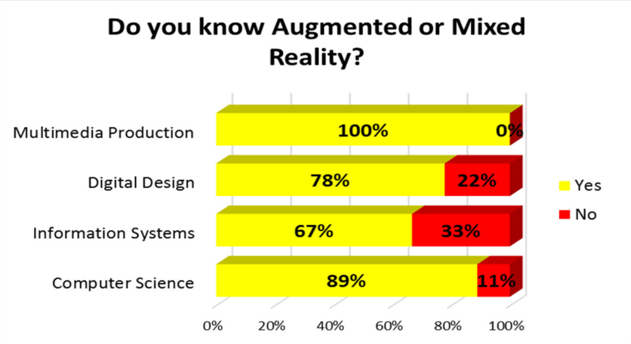

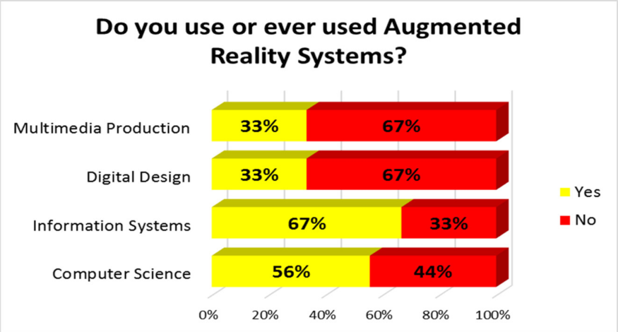

The fact that so many students in the Computer Science area of a third level institute had not used Augmented Reality indicates that the vast majority of students in other areas of education would certainly not have used Augmented Reality in any form. This fact indicates that while it may be useful, it may not be worth the time and effort to teach these students how it works, along with their other studies, if it only benefits them in a very small way. It would need to have been introduced at an earlier stage to have any noticeable effect on the average student. The above study also mentions that the students who did not have experience with Augmented Reality would not be inclined to use it in their studies. For many, it is off-putting to use a completely alien tool to aid them in something that they have done in one single way for their whole lives. This is another case for augmented reality being introduced at an early age, so it is ingrained in these students from the start.

**Conclusion**

In conclusion, the topic of Augmented Reality in education is a very interesting one. On the one hand, it is very difficult to implement due to lack of practical use by teachers, or in some parts of the world lack of resources to utilise its many assets. However, if we ignore these drawbacks, the benefits of augmented reality are truly too great to ignore. It is far superior to the strict syllabus at work today, and if used in conjunction with the present syllabus, will produce far greater results, both in terms of grades, but also in student understanding of coursework.   
 Through the discussions presented in this review, the arguments sway largely in favour of Augmented Reality, and its potential use in education. It needs to be said however, that the technology is absolutely not all there yet, and there is much left to be desired with Augmented Reality.

Future research may examine the actual benefits of using Augmented Reality. Most research today outlines how it could be used to great effect, but very little actual evidence that it has any greater benefit to the traditional style of learning. For Augmented Reality in education to truly take off, there needs to be no doubt that it is a better form of learning than that of traditional learning.

Future Development

As discussed in the introduction portion of this review, the success of this technology in the area of education lays directly in the hands of the students who use it every day. Because of its practicality and likeness to a form of entertainment, it is likely that it will be revered among students and teachers alike.

Indeed, it is the practicality of this technology that makes it such an interesting phenomenon. Any person with a smartphone or similar device effectively has access to any application that uses augmented reality. As ease of use is such an important factor with any new technology, perhaps it is the practicality of augmented reality that will make it an ever present tool in the future of education. Certainly, this technological will continue to grow and improve as the years wear on, and it will be interesting to see how the education system adapts to this potentially great tool.

## Conclusion

The topics discussed in this review give a detailed insight into how augmented reality is currently used in education. This technology has the ability to completely revolutionize the current curriculums in place, and this notion will only become more impactful as advances in the technology behind augmented reality continue.

As with any concept or idea that is introduced into any curriculum, it is not the ease of use and supposed popularity (to a certain extent) of that concept that determines the success of it. Instead, it’s the effectiveness that is analysed and scrutinised. The ‘cool’ factor of augmented reality will prove meaningless if exam results do not reflect well on it. Of course, it is perhaps premature to discuss whether or not the technology will remain when it is a rarity to find any curriculum who uses augmented reality frequently today.

I really enjoyed examining how Augmented Reality has and will in the future impact education. I feel like I argued my points in an objective manner and backed up the information provided with an array of sources.

References

Cai, S., Wang, X., & Chiang, F.-K. (2014). A case study of Augmented Reality simulation system application in a chemistry course. *Computers in Human Behavior*, *37*, 31–40. http://doi.org/10.1016/j.chb.2014.04.018

Chen, C. H., Ho, C.-H., & Lin, J.-B. (2015). The Development of an Augmented Reality Game-based Learning Environment. *Procedia - Social and Behavioral Sciences*, *174*, 216–220. http://doi.org/10.1016/j.sbspro.2015.01.649

Jamali, S. S., Shiratuddin, M. F., Wong, K. W., & Oskam, C. L. (2015). Utilising Mobile-Augmented Reality for Learning Human Anatomy. *Procedia - Social and Behavioral Sciences*, *197*, 659–668. http://doi.org/10.1016/j.sbspro.2015.07.054

Jeřábek, T., Rambousek, V., & Wildová, R. (2014). Specifics of Visual Perception of the Augmented Reality in the Context of Education. *Procedia - Social and Behavioral Sciences*, *159*, 598–604. http://doi.org/10.1016/j.sbspro.2014.12.432

Nincarean, D., Alia, M. B., Halim, N. D. A., & Rahman, M. H. A. (2013). Mobile Augmented Reality: The Potential for Education. *Procedia - Social and Behavioral Sciences*, *103*, 657–664. http://doi.org/10.1016/j.sbspro.2013.10.385

Okimoto, M. L. L. R., Okimoto, P. C., & Goldbach, C. E. (2015). User Experience in Augmented Reality Applied to the Welding Education. *Procedia Manufacturing*, *3*, 6223–6227. http://doi.org/10.1016/j.promfg.2015.07.739

Kerawalla, Luckin, Seljeflot, Woolard, (2015). “Making it real”: Exploring the potential of Augmented Reality for teaching primary school science. http://sro.sussex.ac.uk/2170/1/Luckin2006Making163.pdf

Perry, B. (2015). Gamifying French Language Learning: A Case Study Examining a Quest-based, Augmented Reality Mobile Learning-tool. *Procedia - Social and Behavioral Sciences*, *174*, 2308–2315. http://doi.org/10.1016/j.sbspro.2015.01.892

Souza-Concilio, I. de A., & Pacheco, B. A. (2013). The Development of Augmented Reality Systems in Informatics Higher Education. *Procedia Computer Science*, *25*, 179–188. <http://doi.org/10.1016/j.procs.2013.11.022>