2024-08-19

**DESIGN BRIEF - 1**

**Project:**

**COMPANY´S WEBSITE -**

Create a one page website showcasing a product or service from a company or project of a person close to you.

**Project Overview**

**Current Stage:** The company or project you select to take as a possible client doesn’t currently count with a website to promote its services or advertise its main product.

**Design project goals and objectives**

**Goal:** Design and upload a *basic* one page website that shows the services or products of a company (selected by the student).

**Objectives:**

* Create a basic responsive one page website using HTML5 and CSS3
* Select color scheme that represents the company
* Add a header
* Add a Navbar
* Add a Hero image that represents the intentions of the company
* Add a Call to Action
* Add content selling and informing about the product or service
* Add a footer

**Project Method:**

We will be using the Waterfall method to develop our website, progressing step by step until its completion. Our first goal is to identify the target audience for our cake shop. Understanding our audience will guide us in creating relevant website content.

Our website will facilitate online ordering, allowing customers to easily place orders for cakes to be picked up at our shop. We'll incorporate clear Call-to-Action (CTA) buttons to enhance the ordering process and include social media links to encourage customers to engage with us on those platforms.

Once we have defined these elements, we will focus on the design and layout, including selecting a suitable color palette. Next, we will establish the site architecture, create a sitemap, and outline the content.

Following this, we will develop wireframes and prototypes to visualize the website’s structure and functionality. So waterfall method is suitable for this site development

**Cake Away**

About Us

Welcome to our delightful cake shop, where every slice tells a sweet story! Nestled in the heart of the city, our bakery is a haven for cake enthusiasts seeking a slice of happiness.

Indulge in a symphony of flavors meticulously crafted by our skilled bakers, each cake a masterpiece of taste and texture. From classic favorites like rich chocolate fudge and velvety red velvet to exotic creations like mango passionfruit and decadent tiramisu, there's a cake for every craving.

Our shop is not just a place to buy cakes; it's a destination where celebrations come to life. Whether you're marking a special occasion or simply treating yourself to a moment of bliss, our cakes are designed to elevate every moment.

Step into our world of confectionery wonders and let the aroma of freshly baked treats whisk you away to a realm of sugary delight. Experience the magic of our cakes, where every bite is a celebration!

**Contact**

email:

phone contact:

shop address:

facebook/ IG

**Services**

1. wedding cake
2. birthday cake
3. Valentine’s Cake
4. cupcake

**Target audience and competitors**

**Target audience**

Main: Lady

and Men buy for Lady

ages: 20-40

**Competitors:**

1. <https://www.dalloyau.hk/collections/whole-cakes>
2. <https://www.thecakery.com/?srsltid=AfmBOord0wle648C1TkTeB2zg2ap6EugiInEqgKcNMciA90U8W8RiDJf>
3. <https://www.cakeaholichk.com/?locale=en>
4. <https://infinitic.com.hk/en/collections/infinitic-cake-collections?srsltid=AfmBOop4ogflciZ18ZsqHMJvIFzZxSIss_nLW1piBme2nP-E1tfkB6qm>
5. https://mioamoreshop.com/collections/ready-to-go-cakes

**Budget**

Possible low cost when buying domain and hosting

**Project's schedule**

As presented in the [calendar.](https://canvas.instructure.com/calendar#view_name=month&view_start=2023-09-17)

**Outline the project's deliverables**

* HTML code
* CSS Style Sheet
* Images used
* Basic Structure of the website in Graphic and Text
* Wireframe
* Prototype
* Finalized Uploaded Website

- Design and layout

- Site architecture

The parts of a Website outline are:

1. The goals of the website

Develop a responsive webpage to effectively showcase and sell a variety of delicious cakes, creating an engaging and user-friendly online shopping experience for customers.

1. The target audience

Main: Lady

and Men buy for Lady

ages: 20-40

1. Website Content - To give a website platform for customers to order take away cake. To have different kinds of products provides to customer to choose for various occasion, With our social media link to keep track our latest news and product launch

Text: Verdana,sans-serif

Color schemes is as below:

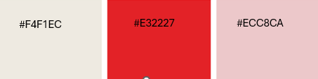

Below 1000px width:

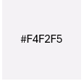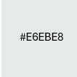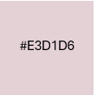

Below 450px width:

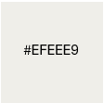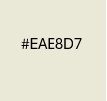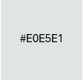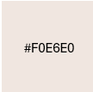

1. Navigation -

CTA on hero image section to redirect customer to purchase page

Quick links - social media (facebook and IG)

1. Design and layout

A simple, direct and attractive design for the website, the color palette is 2024 favour color combination, The layout is simple, introduce we are online order take away cake shop with different type of cake for different occasion,

The website will be designed very attractive, looks delicious and convenient. We are able to provide beautiful, delicious and convenient cake to customer to enjoy the most delicious cake

1. Site architecture

An one page design cake shop, from cake away shop introduction, product ordering, about us and social media in all one page for easy reading on desktop, tablet and mobile devices

CREATE THE WEBSITE MAP

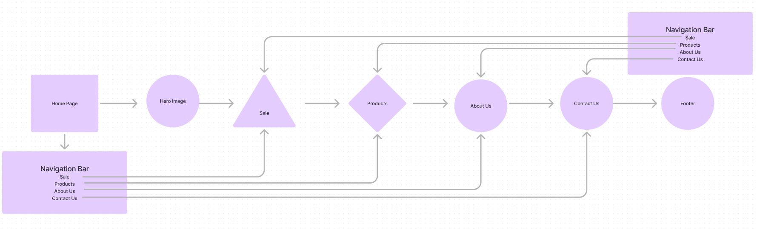

<https://www.figma.com/board/VZHebjXoxUcYI9ns3aaOLc/Untitled?node-id=0-1&node-type=CANVAS&t=GKq7DcgZOYt2SXSX-0>

WireFrame and Proto

<https://www.figma.com/design/jMfRXfsqf6rztkND1WXquE/Untitled?node-id=0-1&node-type=CANVAS&t=PyfnJk7d4ZN7Wwh6-0>

WEBSITE CONTENT OUTLINE

1. Hero Image - Main Visual with CTA(Shop Now)

To introduce our cake away is an online order and pick up at our shop with hero image and CTA

1. Service Page - cake products

Different kind of products are showed in auto slider to have products photos demonstration, there is a form below the slider which can be ordered by customers online. The form have different types of cake, order person, contact phone number, pick up date and message box that can leave any special messages.

1. About Page - about us content. A cake takeaway shop offers convenient, fresh, and customizable cakes, quick service, quality treats, and affordable indulgence for on-the-go customers.
2. Contact Page - as we are picked up shop, we will leave a serial contact to customer that can contact us conveniently. Such as, phone number, email,opening hours and address.
3. Social Media - like facebook and IG, that customers can keep looking at our latest new, information and products.
4. Footer - a bottom navigation bar to reach different section of the website
5. Header
   1. The logo of the website will be presented on the top-left corner
      1. <https://upload.wikimedia.org/wikipedia/en/thumb/1/13/Canadian_Tire_Logo.svg/220px-Canadian_Tire_Logo.svg.png>
      2. Navbar
         1. Hero Visual
         2. Sale
         3. Products
         4. About Us
         5. Contact
6. Hero Visual
7. CTA - Try it now
8. Products-

* wedding cake
* birthday cake
* cupcake
* Valentine’s Cake

1. About Us
2. Contact - phone number, whatsapp and email
3. Social Media - fb and IG

WireFrame and Proto

<https://www.figma.com/design/jMfRXfsqf6rztkND1WXquE/Untitled?node-id=0-1&node-type=CANVAS&t=PyfnJk7d4ZN7Wwh6-0>