The shape of kelp: environmental influences on kelp morphology

Table of Contents

## Introduction

Kelps are a group of large seaweeds of the order Laminariales (Ochrophyta), which despite their relatively low taxonomic diversity of species in genera (Bolton 2010), nevertheless form the basis of one of the most productive ecosystems globally (Mann 1973). Kelps generally have a dependence on cool, temperate and arctic seawater temperatures (Santelices 2007, Bolton 2010), and dominate the nearshore biomass within the rocky shallow coasts in both hemispheres (Steneck et al. 2002). Outside of these latitudes, they are also found in cool, deep water towards the tropics (Graham et al. 2007): this deeper tropical water, due to its water clarity, also allows for suitable photon flux and a nitrate concentration (Zimmerman and Kremer 1984, Lüning 1990, Dayton et al. 1999), the two other environmental variables that support kelp productivity. Although kelps have a low taxonomic diversity, their size and complex morphology provide a heterogeneous habitat structure (Steneck et al. 2002) that accommodate a multitude other turf and subcanopy seaweed species, and diverse assemblages of sessile and mobile invertebrates and vertebrates (**???**, Mann 1973, Steneck et al. 2002), each depending on a wide suite of ecological services provided by the kelp habitat (Gaines and Roughgarden 1987, Bologna and Steneck 1993, Levin 1994, Anderson et al. 1997).

Kelps are sessile species and have to adapt to local environmental conditions in order to persist and survive. The resilience of kelps is evident through their distribution, which spans a range of environmental conditions that vary spatially and temporally. Wave exposure and temperature are regarded as important environmental drivers with regards to macroalgae, and play a role in the growth, reproduction, and survival of kelp species. Wave exposure is recognised as the main cause of kelp mortality, which may manifest itself through dislodgment of individuals or breakage of important morphological structures. These mechanisms usually occur during times of high wave energy or pulse disturbance events, such as storms. Kelps are able to reduce the probability of dislodgment or breakage through morphological adaptation, which may involve several strategies. Kelps can either reduce drag, increase attachment strength or increase flexibility in order to survive high wave energy environments.

The biogeographic distribution of kelp is limited by seawater temperature (Bolton 2010), where increasing temperature gradients reduce kelp distribution. Due to this limiting factor, the two main species of kelps in southern African waters, *Ecklonia maxima* and *Laminaria pallida*, are distributed along a section of the south coast from De Hoop, extending west around the Cape Peninsula, and thriving north into Namibia (**???**, Stegenga et al. 1997). This distribution follows a temperate gradient, where sea temperatures increase as one moves south from Namibia, around Cape Point and towards De Hoop. Although the two species occur together for the majority of the coast, their basic morphologies and resource needs vary to a degree. The larger species, *Ecklonia maxima*, is distributed from Lüderitz to Cape Agulhas (Bolton and Levitt 1985, Probyn and McQuaid 1985, Bolton and Anderson 1987, Bolton et al. 2012). Characterised by a large distal swollen bulb filled with gas, and smooth fronds, this species grows to approximately 10 meters (Bolton and Anderson 1987). There was, however, a 17-meter specimen collected in 2015 off Cape Point (Smit, unpubl. data).This species of kelp not only dominate the biomass of the South African nearshore, but plays an important ecological role (Bustamante and Branch 1996). The estimated productivity of *Ecklonia maxima* within South Africa varies between 350 and 1500g Cm-2yr-1 (Mann 1982). Across the majority of the coastline, *Laminaria pallida* remains a subsurface kelp, dominating the kelp biomass at depths greater than 10 meters (Field et al. 1980a, Bolton and Anderson 1987, Molloy and Bolton 1996). This species is distributed from Danger Point, east of the Cape Peninsula, to Rocky Point in northern Namibia, and reaches depths of greater than 20 meters (**???**, Field et al. 1980a, Molloy and Bolton 1996, Stegenga et al. 1997). Towards the north along the west coast, from around Hondeklipbaai, *Laminaria pallida* replaces *Ecklonia maxima* as the dominant kelp species (Velimirov et al. 1977, Stegenga et al. 1997) and it also occupies increasingly shallower subtidal regions. The northern populations also exhibit an increase in stipe hollowness, compared to the solid stipe morphs in the species’ southern distributions (Molloy and Bolton 1996). This variation in morphology was thought to represent two distinct species, with the northern populations formerly described as *Laminaria schinzii* Foslie (Molloy and Bolton 1996). Genetic work has subsequently shown that the two morphs are in fact the same species (Rothman et al. 2017). In southern African waters, the primary production of *Laminaria pallida* is between 120 and 1900g C m2yr1, similar to that of *Ecklonia maxima* (Mann 1982). Primary production is not the only pathway.

The aim of this study is, therefore, to understand how environmental drivers such as temperature and wave energy can influence morphoplasticity in two species of kelps around South Africa. This will be achieved by initially understanding the variation in abiotic parameters, and morphometrics of *Ecklonia maxima* and *Laminaria pallida*, around the Western Cape coast. Thereafter we will look at how the abiotic parameters both correlate and influence each other in the nearshore environment of our study region. Finally, we will investigate which abiotic parameters best describe the morphological variation of the two kelp species, using statistical tools. It is predicted that higher wave energy environments will exhibit kelps with reduced undulations, possessing strap-like blades, opposed to low flow regimes that will show greater undulations in frond morphology. An increase in temperature is predicted to influence specific morphological traits that rely on nutrient uptake, as temperature and nutrients share an inverse relationship. An increase in temperature is also predicted to reduce the dominance of the colder water kelp, *Laminaria pallida*, at depth, with a total absence of *Laminaria pallida* as one approaches the eastern boundary of sample sites.

### Study area

Due to the Cape Peninsula’s temperate latitude, winter months bring an increased frequency of frontal depressions that originate from the Southern Ocean (Reason et al. 2006). These low pressures are joined by large swells with increased wave energy. The nearshore environment, with the accompanied biota, therefore experiences high wave energy events, with increased frequency in winter. The large peninsula acts as an obstruction for large south westerly swells, providing decreased wave energy along the west side of False Bay (Shipley 1964). Conversely, the west coast of Cape Point is battered by these large swells at full force. Multiple sites, therefore, exist where kelps grow in diverse temperature and wave energy climates, in close proximity.

## Methods

### Morphometrics collection

Between October 2014 and April 2015, morphological measurements of *Laminaria pallida* and *Ecklonia maxima* were collected at 18 sites along the Western Cape coast of South Africa (Fig. 1). Eleven samples were collected per morphology, for each species (Table 1, 2). These varying morphometrics allowed measurements such as weight, length and thickness to be compared between sites. Because the macroalgae differ in morphological features, species-specific morphometrics were included. These sites span across the majority of the south-west coast, in varying thermal and wave energy regimes.

A list of morphology measurements that were collected to investigate how environmental drivers may influence the morphology of *Ecklonia maxima* . Units for each morphometric are included.

|  |  |
| --- | --- |
| Morphometric | Unit measurement |
| Frond mass | Grams (g) |
| Primary length | Millimeters (mm) |
| Primary width | Millimeters (mm) |
| Frond length | Millimeters (mm) |
| Stipe mass | Grams (g) |
| Stipe length | Millimeters (mm) |
| Stipe circumference | Millimeters (mm) |
| Number of tufts | Grams (g) |
| Epiphyte length | Millimeters (mm) |
| Total length | Millimeters (mm) |

A list of morphology measurements that were collected to investigate how environmental drivers may influence the morphology of *Laminaria pallida*. Units for each morphometric are included.

|  |  |
| --- | --- |
| Morphometric | Unit measurement |
| Lamina weight | Grams (g) |
| Lamina length | Millimeters (mm) |
| Lamina thickness | Millimeters (mm) |
| Stipe mass | Grams (g) |
| Stipe length | Millimeters (mm) |
| Stipe diameter | Millimeters (mm) |
| Number of digits | Count |
| Thallus mass | Grams (g) |
| Total length | Millimeters (mm) |

### Sites

Sites were chosen to represent an array of morphological differences seen within *Ecklonia maxima* and *Laminaria pallida*. Sites were also chosen to reflect locations that displayed variable wave and temperature regimes (Fig. 2-5), to allow us to robustly test our hypothesis of environmental drivers influencing kelp morphology. St. Helena Bay and Betty’s Bay constituted the north western and south eastern boundary sites respectively. These sites are roughly 300km apart, and lie within separate marine provinces, as outlined above. The Cape Peninsula provides an interesting topographical boundary that shelters the coast in False Bay. Sites were therefore chosen to represent an array of environments, from offshore reefs (Batsata Rock), to sheltered intertidal zones (Miller’s Point). West of Cape Point, a number of sites were chosen to highlight the presence of upwelling (Oudekraal, Kommetjie), as well as kelps growing in protected bays (Hout Bay).

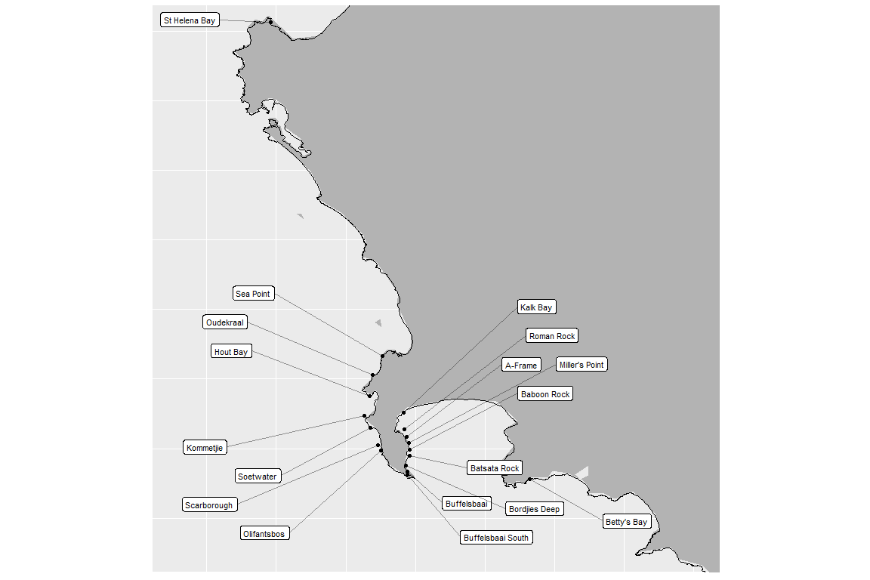

A map indicating the sites where morphometric measurements were collected for *Ecklonia maxima* and *Laminaria pallida*.

### Abiotic parameters

In order to compare abiotic parameters for sites around the coast, large historical databases for both temperature and wave energy were accessed. Shallow water temperatures were sourced from the South African Coastal Temperature Network (SACTN) website (<https://github.com/ajsmit/SACTN>). Seven different organisations within South Africa contribute to the SACTN, where *in situ* temperature measurements are made around the South African coast using either hand-held thermometers or digital temperature recorders positioned underwater. The mean duration of the 135 daily time series is 19.7 years, and these *in situ* data are preferred over satellite SST, which have shown to exhibit large biases (Smit et al. 2013). Linear interpolated SST were calculated for sites where *in situ* recorders were absent. Wave energy data formed part of the South African Coastal Vulnerability Assessment, presented to the Department of Environmental Affairs (**???**). These data are first forecasted using NOAA Wave Watch III (WWIII), with National Centers for Environmental Predictions (NCEP) product as the numerical input (**???**). Hindcast data from WWIII span from 1994-2013 at a 3-hour resolution. The data are then used to model short –crested waves generated by the wind into the coastal environment, using Simulating Waves in the Nearshore (SWAN; **???**). SWAN allows one to extract wave parameters from specific gridded locations in the nearshore. For False Bay, a resolution of 200 meters was modelled, at both 7 meter and 15 meter contours. A 200 meter resolution was used as False Bay was nested within a larger grid area for the research from where the data were sourced. For Table Bay and east of Cape Hangklip the resolution 500 meters at 7 meters and 15 meters. For this study the 7 meter contours were used.

### Statistical analyses

To compare how kelp morphology varies around the coast, boxplots were constructed to summarise descriptive statistics for all the morphometrics of both species.These boxplots highlight five different descriptive statistics (Minimum, 25th percentile, median, 75th percentile and maximum), as well as the interquartile range. These allow us to visually identify variations and differences in morphology, and to provide evidence that kelp morphologies vary around the coast.Pairwise correlations were plotted to compare the abiotic parameters and understand if wave and temperature parameters correlate with one another around the coast. Therefore fluctuations such as minimum, maximum, range and standard deviations were included as temperature parameters, and standard deviations were included as wave parameters. Median calculations were made for wind and wave direction, as issues arise when calculating mean and standard deviation for compass metrics. Redundancy Analyses (RDA) were performed to understand how kelp morphology is driven by environmental drivers. An RDA performs multiple linear regressions between explanatory and response variables. This allows the user to calculate the amount of variation in response variables explained for by explanatory variables. Therefore response variables are influenced by explanatory variables. Response variables were represented by morphology measurements, with wave and temperature variables selected as explanatory variables. Temperature and wave parameters were modelled separately, to fully understand and tease apart which abiotic variables most strongly explain kelp morphology variation. This was therefore performed for each species, equating to four RDA’s in total.

## Results

### Temperature parameters

The temperature parameters around the Western Cape coast vary among sites and seasons. During February and August, the west side of Cape point experiences decreased temperatures (Fig. 2). This region also experiences lower mean and maximum temperatures when compared to False Bay, a region known as east of Cape Point. The range of temperatures within False Bay are larger in winter (August) compared to summer (February) (Fig. 3). The sites north of Kommetjie on the west side display larger temperatures ranges than sites south of Kommetjie on the west side.

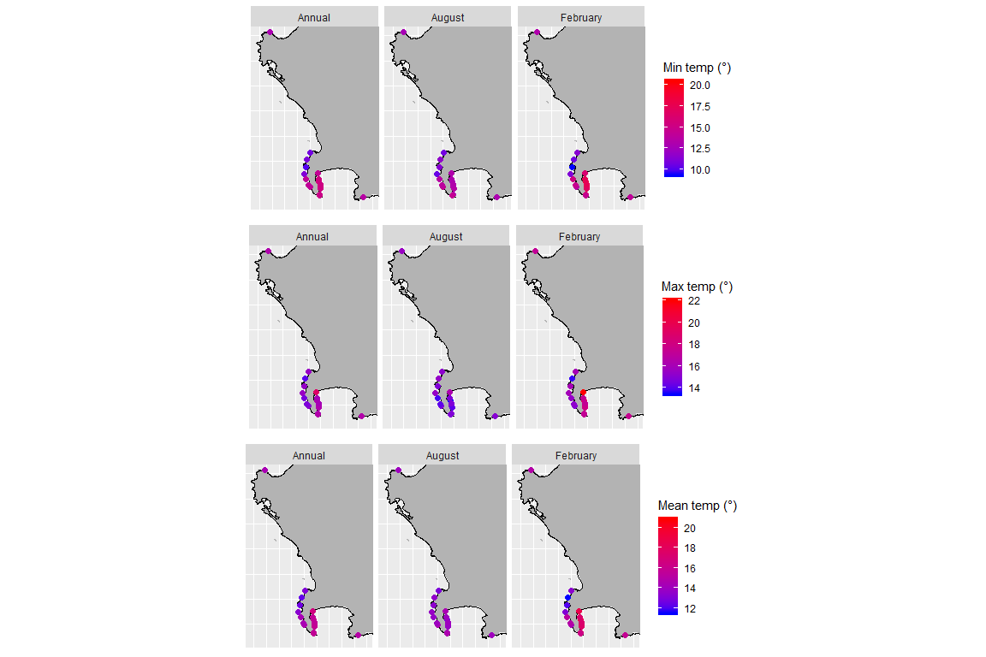

Morphometric site locations represented by various temperature parameters. Temperature parameters include minimum, maximum and mean temperatures (° Celsius). These site locations are coloured by the temperature statistic relative to the legends provided. Each temperature parameter is also divided into August (winter) and February (summer) as well as the annual mean.

## $`1`

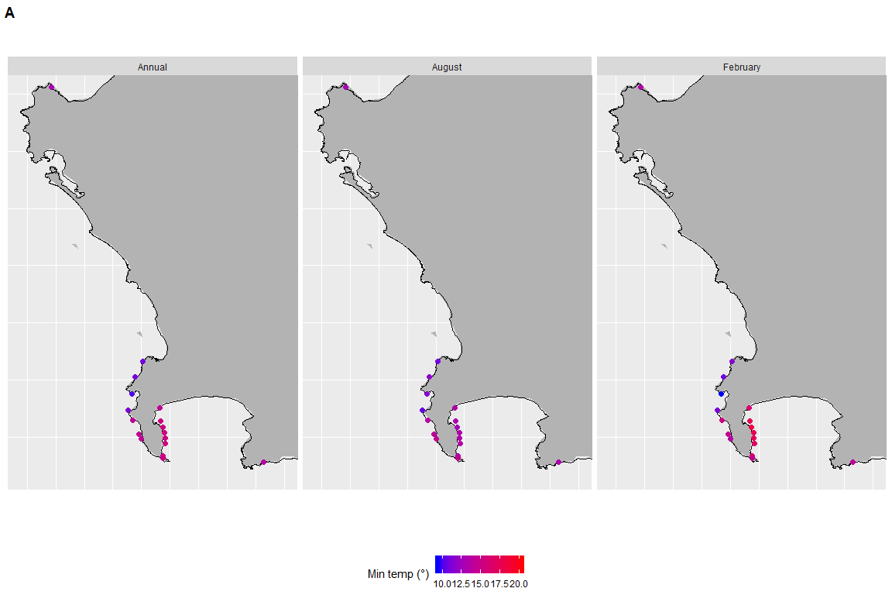

Morphometric site locations represented by various temperature parameters. Temperature parameters include minimum, maximum and mean temperatures (° Celsius). These site locations are coloured by the temperature statistic relative to the legends provided. Each temperature parameter is also divided into August (winter) and February (summer) as well as the annual mean.

##   
## $`2`

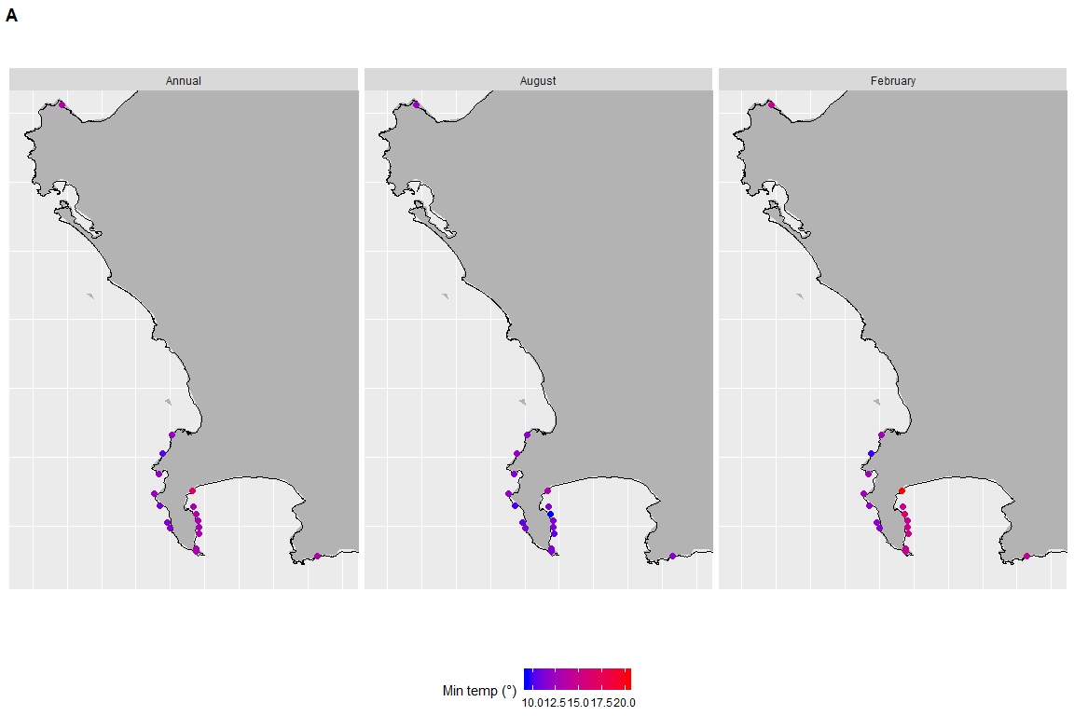

Morphometric site locations represented by various temperature parameters. Temperature parameters include minimum, maximum and mean temperatures (° Celsius). These site locations are coloured by the temperature statistic relative to the legends provided. Each temperature parameter is also divided into August (winter) and February (summer) as well as the annual mean.

##   
## $`3`

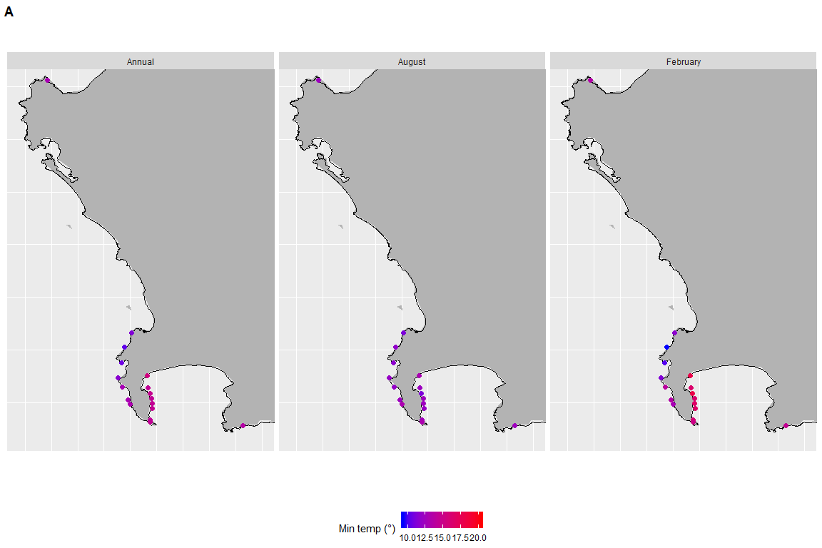

Morphometric site locations represented by various temperature parameters. Temperature parameters include minimum, maximum and mean temperatures (° Celsius). These site locations are coloured by the temperature statistic relative to the legends provided. Each temperature parameter is also divided into August (winter) and February (summer) as well as the annual mean.

##   
## attr(,"class")  
## [1] "list" "ggarrange"

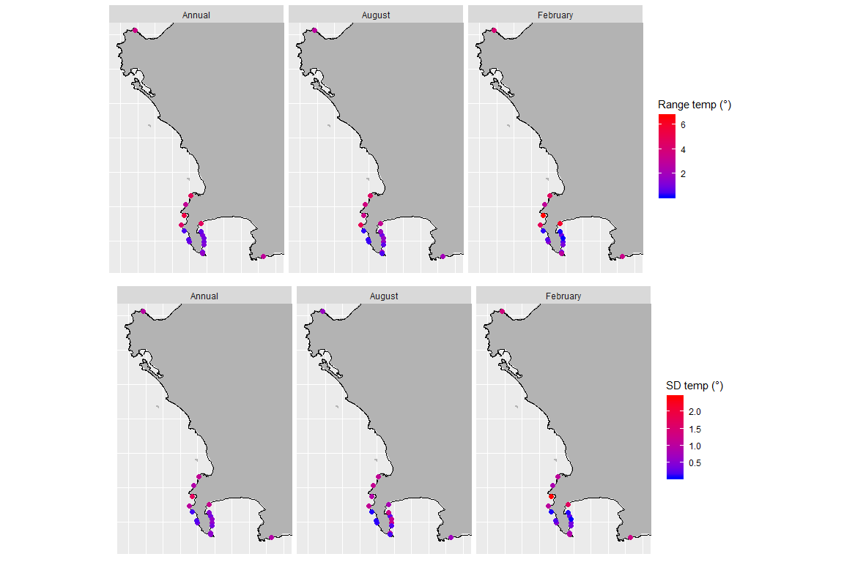

Morphometric site locations represented by various temperature parameters. Temperature parameters include temperature range as well as standard deviation (° Celsius). These site locations are coloured by the temperature statistic relative to the legends provided. Each temperature parameter is also divided into August (winter) and February (summer) as well as the annual mean.

### Wave and wind parameters

Not only do the temperature parameters display seasonal fluctuations, but we see similar observations for wave parameters. The west side of Cape Point exhibit increased median direction, SD and mean significant wave height compared to within False Bay (Fig. 4). Sites within False Bay however display increased standard deviations of wave period. Median wind direction is northerly in winter (Fig. 5), and turns southerly in summer.

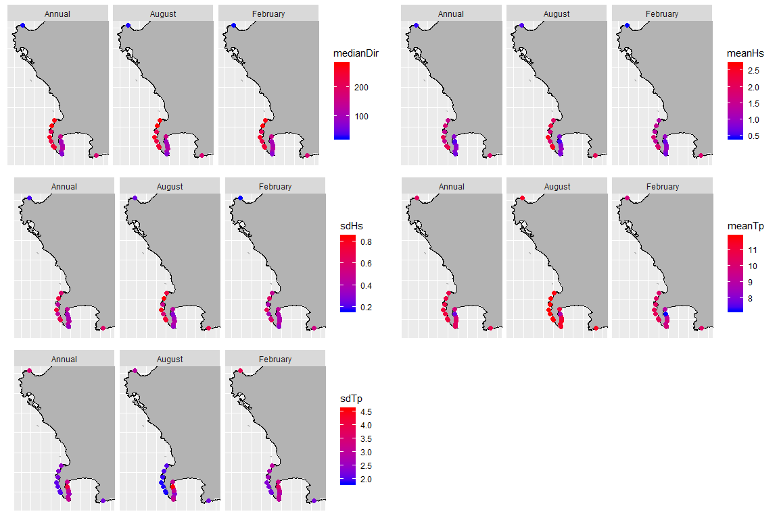

Wave parameters relative to each morphometric collection site around the Western Cape coast. These wave parameters include mean and standard deviation of wave direction (° True north), significant wave height (Meters) as well as wave period (Seconds). Sites are colour-coded by the parameter statistic provided by the legend. Each wave parameter is also divided into August (winter), February (summer) and annual means, to visualise seasonal differences.

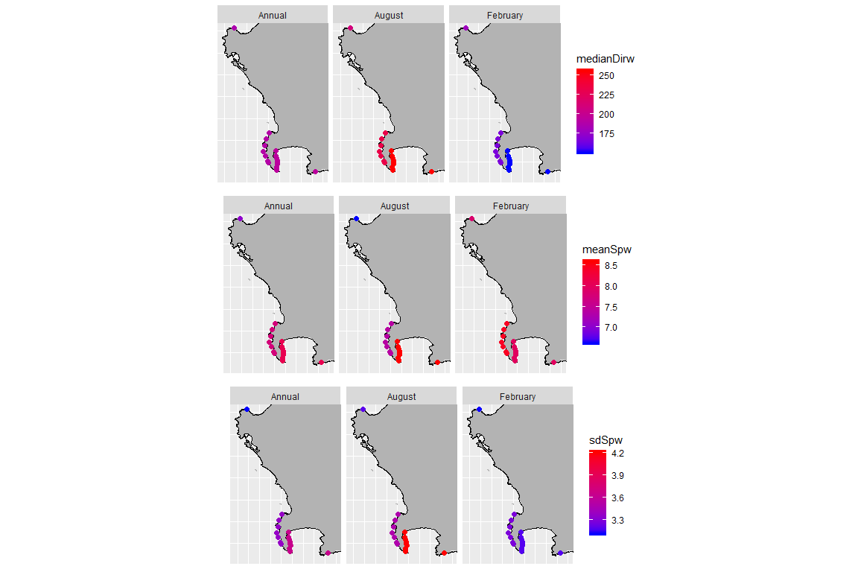

Wind parameters relative to each morphometric collection site around the Western Cape coast. These wind parameters include mean and standard deviation of wind direction (° True north) as well as wind speed (Meters/ second). Sites are colour-coded by the parameter statistic provided by the legend. Each wave parameter is also divided into August (winter), February (summer) and annual means, to visualise seasonal differences.

### Morphologies

#### *Laminaria pallida*

Lamina length for laminaria pallida showed no geographical pattern moving from west to east. Kommetjie, Olifantsbos and Batsata Rock showed great variability in lamina length, and both Buffels Bay and Betty’s Bay were visually different to Miller’s Point and Roman Rock, when comparing summary data (Fig.6). Lamina thickness showed great variation across sites, with Baboon Rock, Miller’s Point, A-Frame and Roman rock displaying large lamina thickness, significantly different to the rest of the sites. Lamina weight was observed to vary for Baboon Rock and Betty’s Bay. Neighbouring sites A-Frame and Roman Rock also showed visual difference when comparing boxplot summary statistics. An increase in the number of digits was observed as one moved from Cape Point north along the western side of False Bay. This ceased at Batstata Rock, which exhibited significantly less digits compared to the previous site, Bordjies reef North. Stipe diameter showed some geographical grouping, with west of Cape Point sites exhibiting larger stipe diameters compared to False Bay sites.

Stipe diameter decreased as one rounded the point into False Bay, where a sudden, significant difference was seen between Bordjies reef North and Batsata Rock. Greater variation of stipe length was observed for sites outside of False Bay (Kommetjie, Olifantsbos and Betty’s Bay). Baboon Rock, Miller’s Point, A-Frame and Roman Rock were again grouped together exhibiting the lowest stipe lengths, that were all significantly different to sites found west of Cape Point. Stipe mass displays similar patterns to stipe length, with larger stipe lengths west of Cape Point compared to within False Bay. The thallus mass of *Laminaria pallida* was observed to be greater for sites around Cape Point, with an observed difference between Batsata Rock and Bordjies reef North, similar to the number of digit patterns. Larger total lengths were observed around Cape Point and Betty’s Bay, with the smallest total lengths at sites that exhibited the greatest lamina thicknesses (Baboon Rock, Miller’s Point, A-Frame and Roman Rock).

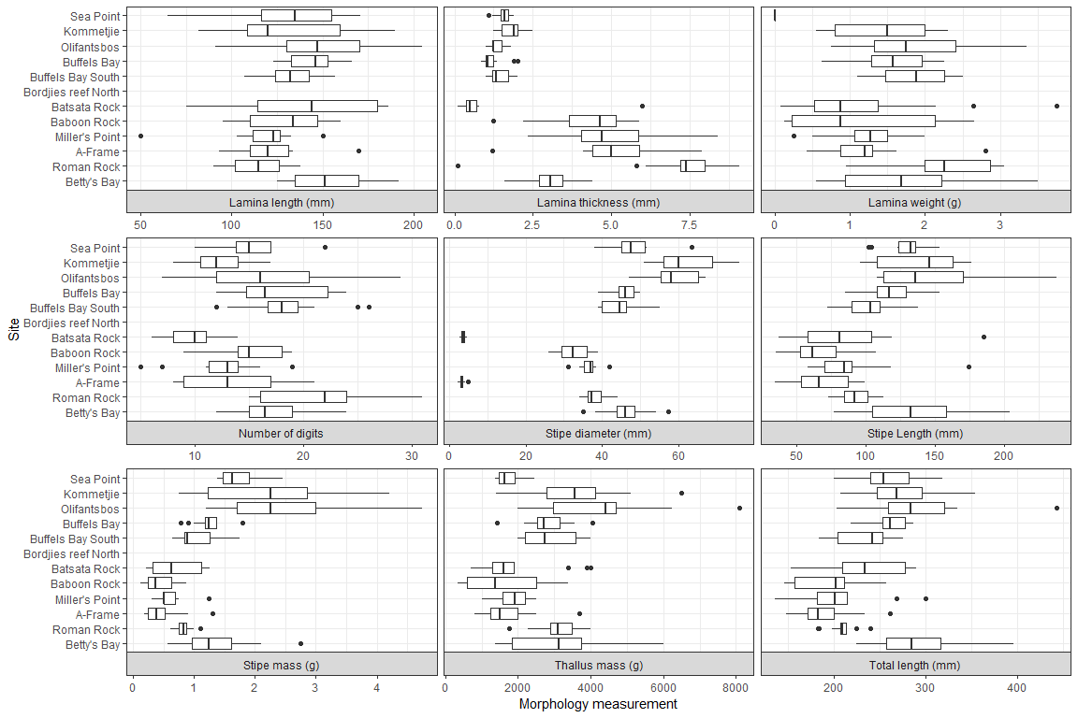

Boxplots representing the different *Laminaria pallida* morphometrics measured around the Western Cape coastline, with the X-axis depicting the specific morphology measured, with units provided. Boxplots represent the minimum, 25th percentile, median and 75th percentile of the morphometrics measured. Interquartile range can be deduced as the different between the 75th and 25th percentiles, and dots represent outliers in the data. Sites are ordered sequentially on the Y-axis by location along the coast. The top site is Sea Point and is located at the north western boundary, and Betty’s Bay as the bottom site is located at the south eastern boundary, from our sample region.

#### *Ecklonia maxima*

For frond length, frond mass, stipe circumferences, stipe length and total length of *Ecklonia maxima* morphometrics, we see a gradual increase in value as one moves south from St. Helena Bay to Kommetjie and Soetwater (Fig. 7). Hout Bay, Kommetjie and Soetwater show similarities in their stipes lengths to Buffels Bay, Batsata Rock and Betty’s Bay, and are significantly different to west of Cape Point counterpart sites such as Oudekraal and Scarborough. A difference for the majority of the morphologies are seen between Soetwater and Scarborough, with significant differences for epiphyte length, frond length, frond mass, stipe length, stipe mass and total length. A separation along the same stretch of coast (west of Cape Point) for stipe mass shows that Hout Bay, Kommetjie and Soetwater are again significantly different to neighboring west side sites such as Oudekraal and Scarborough.

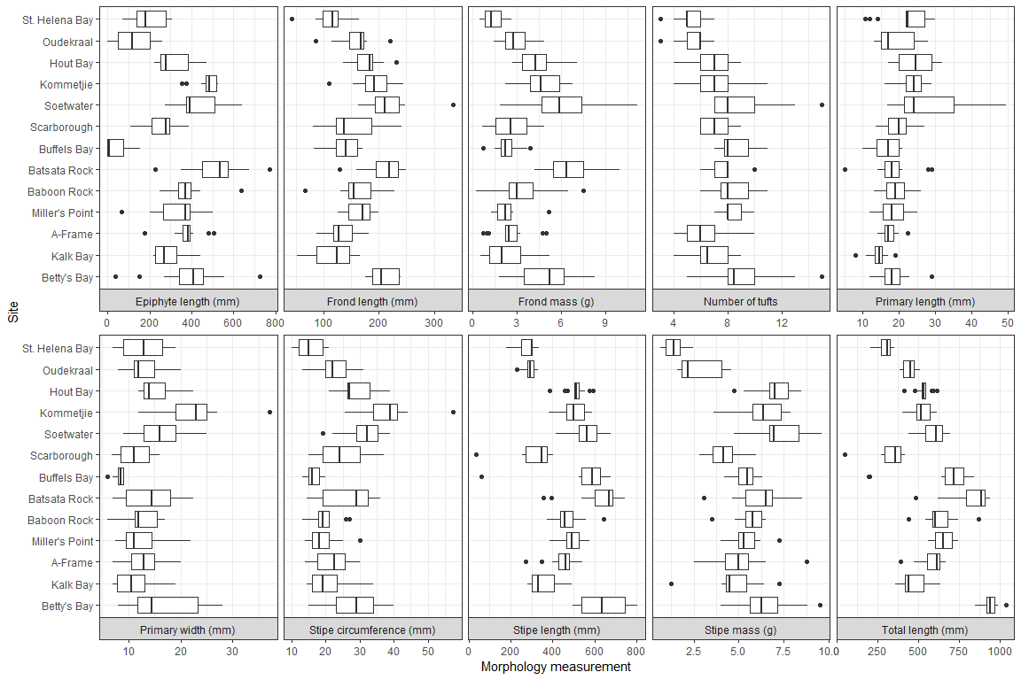

Boxplots representing the different *Ecklonia maxima* morphometrics measured around the Western Cape coastline, with the X-axis depicting the specific morphology measured, with units provided. Boxplots represent the minimum, 25th percentile, median and 75th percentile of the morphometrics measured. Interquartile range can be deduced as the different between the 75th and 25th percentiles, and dots represent outliers in the data. Sites are ordered sequentially on the Y-axis by location along the coast. The top site is St. Helena Bay and is located at the north western boundary, and Betty’s Bay as the bottom site is located at the south eastern boundary, from our sample region.

### Abiotic correlations

There are various strong correlations within the temperature parameters, and within the wave parameters on an annual time scale (Fig. 8). SD Significant wave height (Hs) and mean Hs showed a strong positive correlate(0.92), as well as SD wave period (Tp) and mean Hs with a strong negative correlation(-0.9) For SD wind speed and mean wind speed a strong positive correlation existed (0.967). Minimum and mean temperatures correlate strongly (0.918), as well as SD wind speed and median wind direction (0.999). A strong correlation exists between SD temperature and temperature range (0.942). Median wind direction and mean wind speed are also correlated well (0.954). We however see no strong correlations between wave and temperature parameters.

These correlations vary through the three timescales (Annual, August and February). Although there are no strong correlations between temperature and wave parameters, we see interesting differences between the seasonal timescales The mean temperature and mean wind speed are weakly correlated in August (0.253)(Fig. 9), but are observed to be more strongly negatively correlated in February (-0.788)(Fig. 10). The same is seen for minimum temperature and median wind direction in August (0.129) compared to February (-0.715).

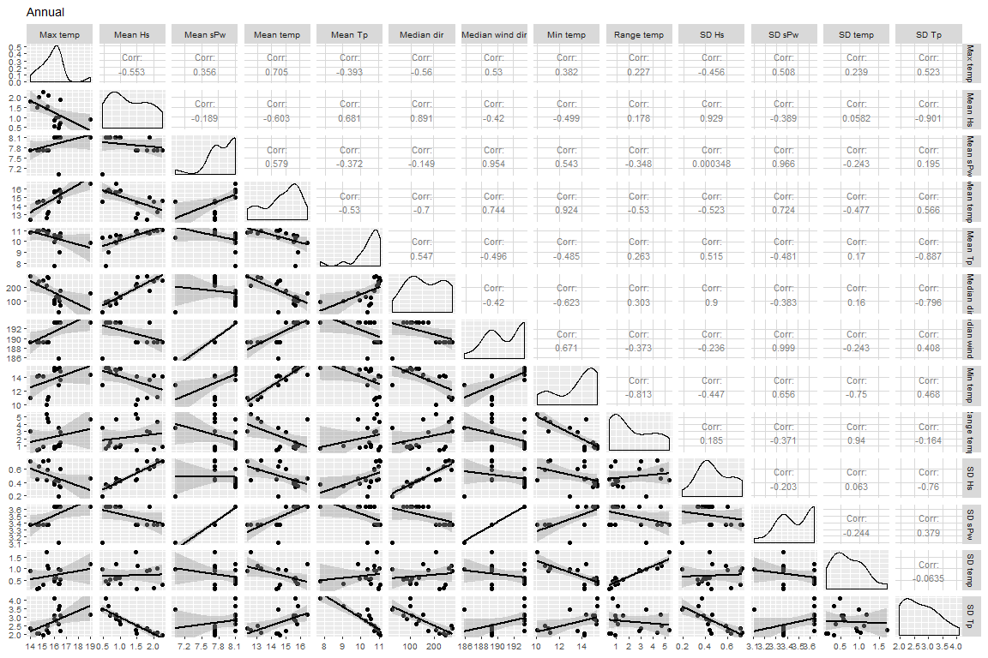

A correlation graph depicting the relationships that various temperature and wave parameters share, at an annual timescale. The left Y-axis as well as bottom X-axis represent the measurements for the parameters, while the top X-axis and right Y-axis depict the abiotic parameter name. The top right section of the graph represents correlation coefficients between abiotic parameters. The bottom left section provides individual linear regressions between each abiotic parameter, with a fitted line. Each point of each linear graph represents a collection site. The diagonal density plots represent the spread of the data for each abiotic relationship.

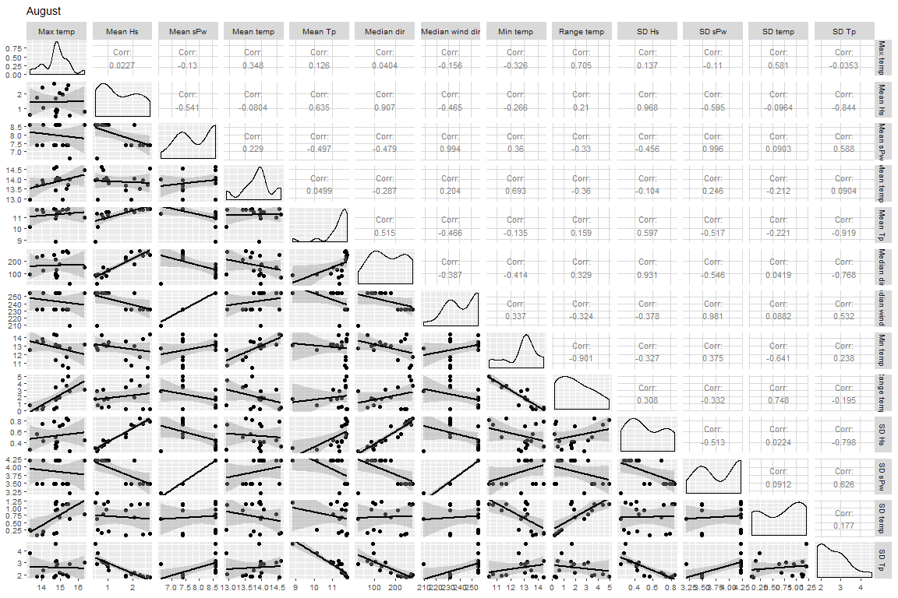

A correlation graph depicting the relationships that various temperature and wave parameters share, during August. The left Y-axis as well as bottom X-axis represent the measurements for the parameters, while the top X-axis and right Y-axis depict the abiotic parameter name. The top right section of the graph represents correlation coefficients between abiotic parameters. The bottom left section provides individual linear regressions between each abiotic parameter, with a fitted line. Each point of each linear graph represents a collection site. The diagonal density plots represent the spread of the data for each abiotic relationship.

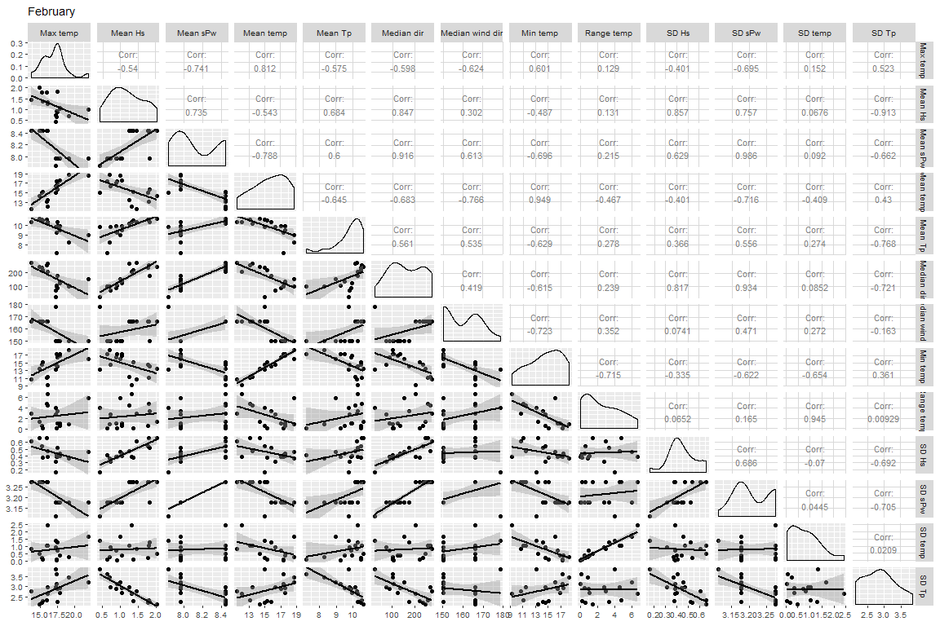

A correlation graph depicting the relationships that various temperature and wave parameters share, during February. The left Y-axis as well as bottom X-axis represent the measurements for the parameters, while the top X-axis and right Y-axis depict the abiotic parameter name. The top right section of the graph represents correlation coefficients between abiotic parameters. The bottom left section provides individual linear regressions between each abiotic parameter, with a fitted line. Each point of each linear graph represents a collection site. The diagonal density plots represent the spread of the data for each abiotic relationship.

### Redundancy analyses

#### Waves as a driver of *Ecklonia maxima* morphometrics

The morphometrics of *Ecklonia maxima* were explained more by wave parameters (75%), than temperature parameters (66%), when separate RDA’s were constructed (Fig. 11). The first two axes for wave parameters driving *Ecklonia maxima* morphology explained 34% of the variation. Stipe circumference was positively influenced by both mean and SD annual significant wave height as well as annual mean wave direction. There was also a negative influence by annual SD of wave period and wave direction (which correlate with one another) on stipe circumference. The primary length of *Ecklonia maxima* was influenced positively by annual mean wind direction, and negatively explained by annual SD wind direction.

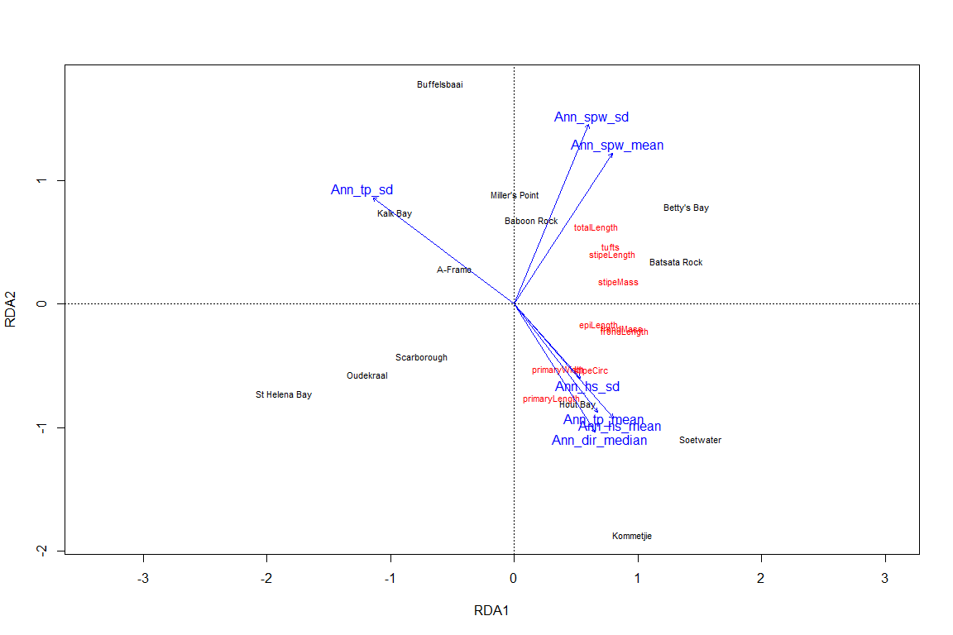

An RDA, represented by the first two RDA axes, depict the influence that annual wave parameters have on the morphology of *Ecklonia maxima* sporophytes. Environmental (explanatory) variables, in this case annual wave parameters, are represented by blue vectors extending from the origin. Response variables, in this case *Ecklonia maxima* morphologies, are representing by red points ordinated across the plane. Sites are represented in black. The top X-axis and right Y-axis represent the explanatory variable axes, while bottom X-axis and left Y-axis represent the response variables axes

#### Temperature as a driver of *Ecklonia maxima* morphometrics

Although temperature parameters for *Ecklonia maxima* showed some influence of the morphometric data, the explanation of morphology was not strong, with an R2 value of 0.662 and a negative adjusted R2 value (-0.138)(Fig. 12). Adjusted R2 values are modified R2 values to include the number predictors in a model. A negative adjusted R squared values equate to low explanatory power. This is supported by the lack of relationships between environmental (temperature) and response (morphology) variables (Fig. 12).

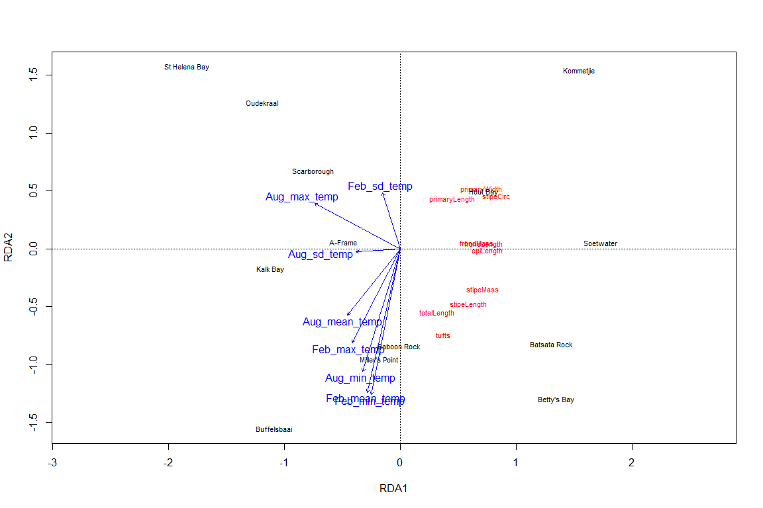

An RDA, represented by the first two RDA axes, depict the influence that seasonal temperature parameters have on the morphology of *Ecklonia maxima* sporophytes. Environmental (explanatory) variables, in this case seasonal temperature parameters, are represented by blue vectors extending from the origin. Response variables, in this case *Ecklonia maxima* morphologies, are representing by red points ordinated across the plane. Sites are represented in black. The top X-axis and right Y-axis represent the explanatory variable axes, while bottom X-axis and left Y-axis represent the response variables axes.

#### Waves as a driver of *Laminaria pallida* morphometrics

For *Laminaria pallida*, the percentage of explained data by wave parameters was 89%, compared to temperature parameters explaining 82% (Fig. 13). By using adjusted R2 values, the first two axes for wave parameters driving *Laminaria pallida* morphology explained 57% of the variation of morphology in this species. An increase in annual SD of wave period and wave direction was a strong influence on lamina thickness of *Laminaria pallida*. Annual mean wave period (which negatively correlates with both annual SD of wave period and wave direction) saw a strong positive influence on lamina length, and a negative influence on lamina thickness. Stipe mass of *Laminaria pallida* was influenced by annual mean wind direction, as well as annual mean significant wave height, wave direction and SD of significant wave height. The Total length of *Laminaria pallida* specimens were similarly explained by annual mean significant wave height, wave direction and SD of significant wave height.

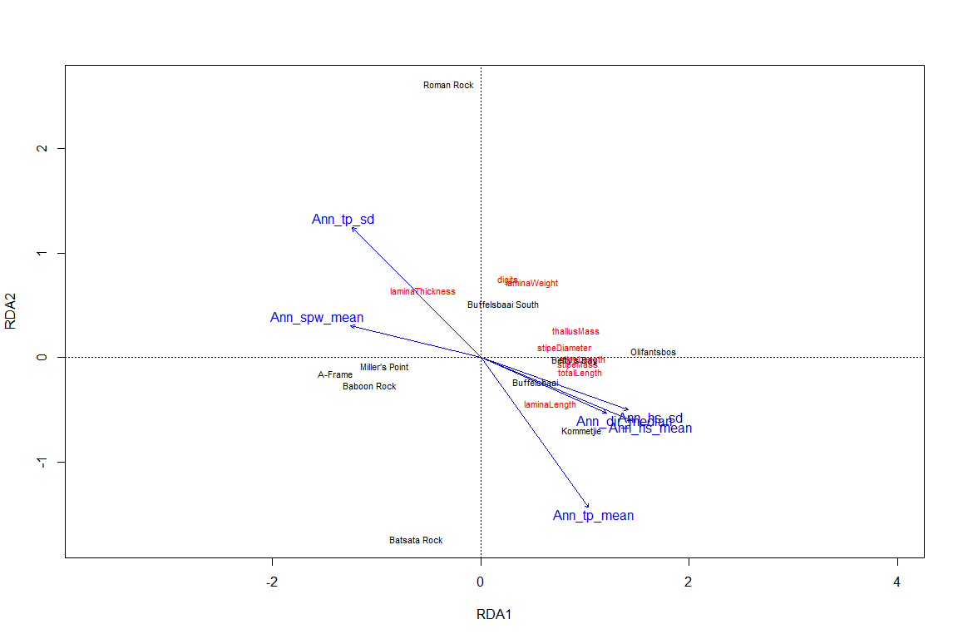

An RDA, represented by the first two RDA axes, depict the influence that annual wave parameters have on the morphology of *Laminaria pallida* sporophytes. Environmental (explanatory) variables, in this case annual wave parameters, are represented by blue vectors extending from the origin. Response variables, in this case *Laminaria pallida* morphologies, are representing by red points ordinated across the plane. Sites are represented in black. The top X-axis and right Y-axis represent the explanatory variable axes, while bottom X-axis and left Y-axis represent the response variables axes.

#### Temperature as a driver of *Laminaria pallida* morphometrics

Provided by adjusted R2 values, the first two axes of temperature effect on *Laminaria pallida* morphologies amounted to only 11%, but exhibited a stronger influence than on *Ecklonia maxima* (Fig. 14). The mean and minimum temperatures during February were observed to negatively influence *Laminaria pallida* morphologies such as stipe mass, stipe length and stipe diameter, as well as thallus mass and total length. Maximum august temperatures however were observed to positively explain stipe diameter of *Laminaria pallida*.

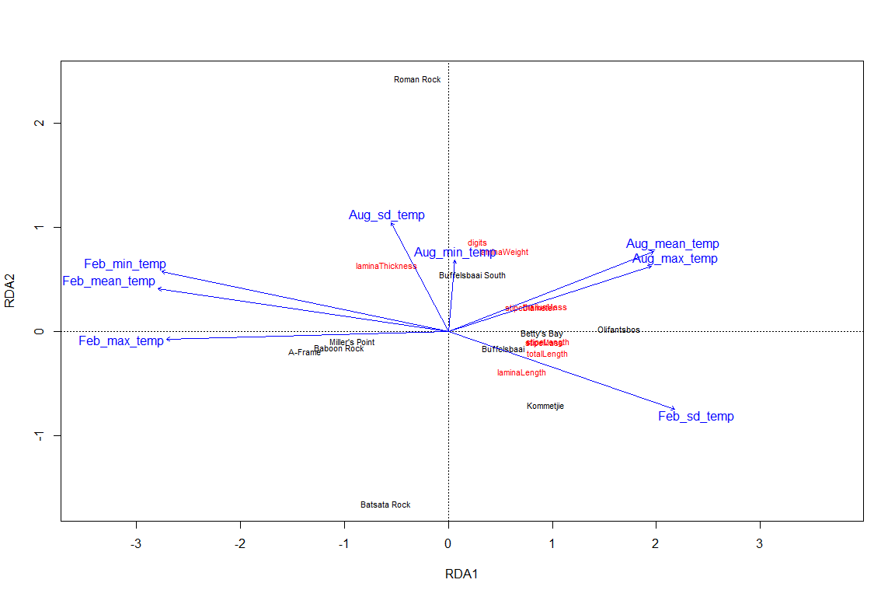

An RDA, represented by the first two RDA axes, depict the influence that seasonal temperature parameters have on the morphology of *Laminaria pallida* sporophytes. Environmental (explanatory) variables, in this case seasonal temperature parameters, are represented by blue vectors extending from the origin. Response variables, in this case *Laminaria pallida* morphologies, are representing by red points ordinated across the plane. Sites are represented in black. The top X-axis and right Y-axis represent the explanatory variable axes, while bottom X-axis and left Y-axis represent the response variables axes.

## Discussion

Kelps, in particular brown seaweeds, are robust and resilient organisms that have been shown to adapt their morphology to suit local environmental conditions. Wave exposure has been shown to be the main driver of morphological variation in brown seaweeds as a strategy to reduce drag and ultimately dislodgement. Although wave exposure is regarded as an important abiotic variable that drives kelp morphology it does not act independently. For instance, a study by Wernberg and Thomsen (2005) investigated the effect of wave exposure on the morphology of *Ecklonia radiata* of six locations along 1100 km of the southwest Australian coastline. The authors concluded that wave exposure was the main driver of kelp morphological adaptation in the study, however the authors also noted the variation in morphology between sites was not consistent and concluded that wave parameters may play different roles in determining kelp morphology. The results from this current study confirm the idea that kelp morphology is driven by specific wave parameters, particularly significant wave height, wave period and wave direction.

Seasonal variations in significant wave height (Hs), wave period and wave direction were observed from the data (Fig. 4, 5). The direction of swell swings to the south west in winter, generated by strong low pressures that originate from the southern ocean (Reason et al. 2006). These swells were found to correlate with increased wave period (Tp), wave direction and Hs. False Bay is therefore shielded by these south westerly swells by the Cape Peninsula (Shipley 1964). In summer, these swells rotate anticlockwise and are able to enter False Bay, providing an explanation for increased variability of Hs and Tp. The wind speed and wind direction support the presence of upwelling in summer, where southerly winds blow parallel to the coast and trigger upwelling (Field et al. 1980b). This is supported by the decreased in temperature in summer (Fig. 2, 3), specifically along the west side of Cape Point. We however see a differentiation of median wind directions in summer, with the western coast of False Bay experiencing south easterly winds, compared to the west side of Cape Point experiencing south westerly winds. It is hypothesised that the topography and elevation along the Cape Peninsula channels, shields winds along the strip of land. This is however absent in winter, where strong northerly winds are experiences from St. Helena Bay to Betty’s Bay (Field et al. 1980b). St. Helena bay experiences decreased median wave directions, and is protected by a headland, similar to the sites found along the western side of False Bay, that are shielded by the Cape Peninsula. There is however increased variability in the wave direction from both False Bay sites and St. Helena Bay, which is encouraged by refraction of waves.

Morphological adaptation due to water motion may manifest itself in a number of ways to high wave energy environments. For instance, reduction of blade thickness, blade elongation, increase of stipe length, and stipe circumference increase and force of attachment. Although this study did not measure force of attachment, other morphological responses to wave parameters was evident. An increase in mean annual wave period saw an increase of lamina length of *Laminaria pallida*, but a decrease in lamina thickness (Fig. 13). By decreasing the thickness of the lamina, and increasing the length of the lamina (directly increasing surface area), a larger more flexible kelp can survive in environments with greater wave period. Increased thickness of cortical tissues within the lamina aid photosynthetic ability (**???**), however increased wave exposure deceases the boundary diffusion layer (**???**). Therefore *Laminaria pallida* in increased wave period sites may be able to reduce the need for thick lamina for photosynthesis, as the increased wave period provide longer wave events, which decreases the diffusion boundary layer and allow easier nutrient uptake. Conversely we see that sites with reduced wave height and wave period, such as Baboon Rock, Miller’s Point, A-Frame and Roman Rock displayed the greatest lamina thickness, with better photosynthetic ability, for *Laminaria pallida*. Pace (**???**) however studied the effect of wave exposure on *Macrocystis pyrifera* morphologies, and found that lamina thickness had a strong positive relationship with wave exposure. This may be species specific, with *Macrocystis pyrifera* attaining larger sizes, but with incomparable stipe and lamina morphologies to *Ecklonia maxima* and *Laminaria pallida*.

Lamina thickness showed positive correlation with annual SD wave period (Fig. 13). Although this variable may just negatively correlate with annual mean wave period, another reason may exist. The greatest variation of wave period and wave direction occurs in August along the western side of False Bay. Kelps at these sites may have developed thicker lamina, with a possible strategy of maximising photosynthesis at the expense of maybe being dislodged through rare increased wave energy events. The ‘spreading out’ of the lamina may also suggest a ‘go with the flow’ tactic, to reduce breaking by being less stiff (Friedland and Denny 1995). Denny et al. (1997) explored the stress forces that wave period played on *Nereocystis luetkeana* by exposing various kelp plant sizes to a range of wave period that would be found in coastal environments. Results showed that for shorter kelps (smaller stipe lengths), the maximum stress on a plant occurs at 10s wave periods, but only at 5.5s for larger kelps that are similar in length to the water depth. Similar results were observed for kelps with larger blades, with maximal stress forces occurring at approximately 8s, compared to a stress ratio of only 0.4 at 16s wave periods.

Mean annual significant wave height (Hs) was observed to influence *Ecklonia maxima* stipe circumference, with increased stipe circumference at larger Hs (Fig. 11). An increase in Hs saw greater wave actions as waves are larger, as well as greater wave periods that are positively correlated with Hs. An increase in stipe circumference provides *Ecklonia maxima* with a more rigid structure to withstand the onslaught of waves. These greater stipe circumferences of *Ecklonia maxima* were observed at west side sites such as Soetwater and Kommetjie. While these sites experience increased Hs, they also are subject to seasonal upwelling events (**???**), that bring with it cold clean water. *Ecklonia maxima* are thought to be influenced greatly by light attenuation (Rothman et al. 2017), and thus have developed increased (stronger) stipe circumferences to be able to cope in large Hs environments, to access cleaner, nutrient-filled water. The same patterns are observed in *Laminaria pallida* morphologies, that display increased stipe diameters at Soetwater and Kommetjie as well (Fig. 13). This increase in stipe diameter correlates with stipe mass of *Laminaria pallida*, providing evidence that this species has developed thicker, strong stipes to persist in this region. Denny et al. (1997) found that the stress ratio decreased as stipe lengths increases, in a fixed depth. Therefore adult *Ecklonia maxima* sporophytes would experience a lower stress ratio compared to adult *Laminaria pallida* sporophytes in the same environment, where *Laminaria pallida* is often a subsurface species to *Ecklonia maxima*.

Stipe circumference for *Ecklonia maxima* were explained by annual wave direction (Fig. 11). For *Ecklonia maxima*, the sporophytes may be producing stipes that have a greater circumference to cope with increased wave energy. The west side of the peninsula is more exposed to significant wave heights during winter due to the direction of swell, while other sites such as Betty’s Bay and Basata rock are more protected due to their location along the coast and the presence of headlands which refract wave parameters.

Temperature parameters were not found to be a significant driver of kelp morphology in this study. Although temperature plays an important role in distribution of kelp and physiological functioning of adults and gametophytes, there is little evidence that temperature is a driver of morphological variation in kelps. Although turbidity is not a direct wave or temperature parameter, turbidity is influence by various abiotic variables. Increased swells around sandy beaches increase sedimentation and turbidity (**???**), however wind direction and speed can encourage upwelling, with brings to the surface cold, clean, nutrient-rich water (**???**). Increased wind speed at sites along the west side of the peninsula in a southerly direction trigger upwelling events (**???**). We however see a lack of upwelling events for sites such as Betty’s Bay and Batsata Rock. These two sites display *Ecklonia maxima* sporophytes with the largest total lengths (Fig. 7), as well as Betty’s Bay displaying the largest total length of *Laminaria pallida* sporophytes(Fig. 6). The effect of depth on stipe length is regarded as insignificant in this study as all kelp were sampled at similar depths. Stipe elongation has been shown to be a morphological adaptation in wave exposed environment, as a longer kelp has time to extend back and forth in swell reducing the tension on the holdfast. Stipe lengths of *Ecklonia maxima* from Kommetjie, Hout Bay and Soetwater are similar to Batsata rock and Betty’s Bay, but differs to west side neighbours such as Oudekraal and Scarborough (Fig. 7). Oudekraal and Scarborough experience more variability in wave direction, however they are observed to experience smaller annual mean significant wave heights, when compared to Kommetjie, Hout Bay, Soetwater, as well as Batsata Rock and Betty’s Bay (Fig. 4).Friedland and Denny (1995) found that longer kelps were able to reduce drag and tension as the sinusoidal displacement of most waves would not ‘stretch’ a kelp out long enough before falling. The ability to grow longer stipes would provide the kelp with a structure that could surpass most wave heights without the risk of dislodgement.

# References

Anderson, R. J. et al. 1997. Holdfasts of adult kelp Ecklonia maxima provide refuges from grazing for recruitment of juvenile kelps. - Marine Ecology Progress Series 159: 265–273.

Bologna, P. and Steneck, R. S. 1993. Kelp beds as habitat for American lobster Homarus americanus. - Marine … in press.

Bolton, J. J. 2010. The biogeography of kelps (Laminariales, Phaeophyceae): A global analysis with new insights from recent advances in molecular phylogenetics. - Helgoland Marine Research 64: 263–279.

Bolton, J. J. and Levitt, G. J. 1985. Light and temperature requirements for growth and reproduction in gametophytes of Ecklonia maxima (Alariaceae: Laminariales). - Marine Biology 87: 131–135.

Bolton, J. J. and Anderson, R. J. 1987. Temperature tolerances of two southern African Ecklonia species (Alariaceae: Laminariales) and of hybrids between them. - Marine Biology 96: 293–297.

Bolton, J. J. et al. 2012. South African kelp moving eastwards: the discovery of Ecklonia maxima (Osbeck) Papenfuss at De Hoop Nature Reserve on the south coast of South Africa. - African Journal of Marine Science 34: 147–151.

Bustamante, R. H. and Branch, G. M. 1996. The dependence of intertidal consumers on kelp-derived organic matter on the west coast of South Africa. - Journal of Experimental Marine Biology and Ecology 196: 1–28.

Dayton, P. K. et al. 1999. Temporal and spatial patterns of kelp demography: The role of Oceanographic climate. - Ecological Monographs 69: 219–250.

Denny, M. et al. 1997. Flow and Flexibility: II. THE ROLES OF SIZE AND SHAPE IN DETERMINING WAVE FORCES ON THE BULL KELP NEREOCYSTIS LUETKEANA MARK. - Journal of Experimental Biology 200: 3165–3183.

Field, J. G. et al. 1980a. Variation in Structure and Biomass of Kelp Communities Along the South-West Cape Coast. - Transactions of the Royal Society of South Africa 44: 145–203.

Field, J. G. et al. 1980b. Upwelling in a nearshore marine ecosystem and its biological implications. - Estuarine and Coastal Marine Science 11: 133–150.

Friedland, M. T. and Denny, M. W. 1995. Surviving hydrodynamic forces in a wave-swept environment: consequences of morphology in the feather boa kelp, Egregia menziesii (Turner). - Journal of Experimental Marine Biology and … in press.

Gaines, S. D. and Roughgarden, J. 1987. Fish in offshore kelp forests affect recruitment to intertidal barnacle populations. - Science 235: 479–481.

Graham, M. H. et al. 2007. Global Ecology of the Giant Kelp Macrocystis : From Ecotypes To Ecosystems. - Oceanography and Marine Biology 45: 39–88.

Levin, P. S. 1994. Fine-scale temporal variation in recruitment of a temperate demersal fish: the importance of settlement versus post-settlement loss. - Oecologia 97: 124–133.

Lüning, K. 1990. Seaweeds: their environment, biogeography, and ecophysiology (C Yarish and H Kurkman, Eds.). in press.

Mann, K. H. 1973. Seaweeds: Their Productivity and Strategy for Growth. - Science 182: 975–981.

Mann, K. H. 1982. Ecology of Coastal Waters: A Systems Approach. in press.

Molloy, F. J. and Bolton, J. J. 1996. The effects of wave exposure and depth on the morphology of inshore populations of the Namibian kelp, Laminaria schinzii Foslie. - Botanica Marina 39: 525–531.

Probyn, T. and McQuaid, C. 1985. In-situ measurements of nitrogenous nutrient uptake by kelp (Ecklonia maxima) and phytoplankton in a nitrate-rich upwelling environment. - Marine Biology 88: 149–154.

Reason, C. J. C. et al. 2006. Seasonal to decadal prediction of southern African climate and its links with variability of the Atlantic ocean. - Bulletin of the American Meteorological Society 87: 941–955.

Rothman, M. D. et al. 2017. Geographical variation in morphology of the two dominant kelp species, Ecklonia maxima and Laminaria pallida (Phaeophyceae, Laminariales), on the west coast of Southern Africa. - Journal of Applied Phycology 29: 2627–2639.

Santelices, B. 2007. The discovery of kelp forests in deep-water habitats of tropical regions. - Proceedings of the National Academy of Sciences 104: 19163–19164.

Shipley, A. 1964. Some aspects of wave refraction in False Bay. - South African Journal of Science 60: 115–120.

Smit, A. J. et al. 2013. A coastal seawater temperature dataset for biogeographical studies: Large biases between in situ and remotely-sensed data sets around the coast of South Africa. - PLoS ONE in press.

Stegenga, H. et al. 1997. Seaweeds of the South African west coast. - Contributions of the Bolus Herbarium 18: 3–637.

Steneck, R. S. et al. 2002. Kelp forest ecosystems: biodiversity, stability, resilience and future. - Environmental Conservation 29: 436–459.

Velimirov, B. et al. 1977. The ecology of kelp bed communities in the Benguela upwelling system - Analysis of biomass and spatial distribution. - Helgoländer Wissenschaftliche Meeresuntersuchungen 30: 495–518.

Wernberg, T. and Thomsen, M. S. 2005. The effect of wave exposure on the morphology of Ecklonia radiata. - Aquatic Botany 83: 61–70.

Zimmerman, R. C. and Kremer, J. N. 1984. Episodic nutrient supply to a kelp forest ecosystem in Southern California. - Journal of Marine Research 42: 591–604.