Using numerical modelling to investigate temperature and wave exposure as drivers of morphological characteristics of the kelps, Ecklonia maxima and Laminaria pallida

R. Coppin, C. Rautenbach, T. Ponton and A.J Smit

**Abstract**: Macroalgal morphological variation is determined to a large extent by a combination of environmental factors, with wave exposure and temperature perhaps the main influences as they are key environmental properties to which a species becomes locally adapted. Macroalgae have shown to exhibit different responses to different magnitudes of exposure to waves, such as reduction in overall size and strength increasing traits. In terms of temperature, warmer environments have been shown to reduce the overall size of resident and transplanted species. However, none of the past studies have identified specific wave and temperature metrics responsible for the morphological adaptation macroalgae exhibit. Past research has often used simple or two-dimensional models of wave exposure, which do not take into account important aspects of the nearshore environment such as wave breaking, refraction and diffraction. Furthermore, past studies have often used satellite-derived datasets as sources for temperature data; however, such data have been shown to have large bias when applied to the nearshore environment. This study used *in situ* temperature data and wave power metrics calculated from a 3D-numerical model to identify specific temperature and wave metrics responsible for morphological adaptation of the kelp, *Ecklonia maxima* and *Laminaria pallida*. The results identify wave exposure as the main driver of morphological adaptation while identifying specific wave metrics. Furthermore, the results show differences in wave metrics between species; and between deep and shallow populations.

# Introduction

Kelps are a group of large seaweeds of the order Laminariales (Ochrophyta), which despite their relatively low taxonomic diversity of species in genera (Bolton 2010), form the basis of one of the most productive ecosystems globally (Mann 1973). Kelps generally have a dependence on cool-temperate and arctic seawater temperatures (Bolton 2010; Mohring et al. 2014; Cavanaugh et al. 2011; Dayton 1985), and dominate the nearshore biomass within the rocky shallow coasts in both hemispheres (Steneck et al. 2002). Their size and complex morphology provide a heterogeneous habitat structure (Steneck et al. 2002) that accommodate a multitude of turf and sub-canopy seaweed species, and diverse assemblages of sessile and mobile invertebrates and vertebrates (Mann 1973; Steneck et al. 2002), each depending on a wide suite of ecological services provided by kelp forests (Gaines and Roughgarden 1987; Paul and Steneck 1993; Levin 1994; Willis and Anderson 2003; Anderson et al. 1997; Dayton 1985). Wave exposure and temperature are regarded as important environmental drivers of kelp forests, and play a role in their distribution (Gorman et al. 2013), abundance (Cavanaugh et al. 2011; Dayton et al. 1998), diversity (Wing et al. 2007; Wernberg and Goldberg 2008), composition (Leliaert et al. 2000; Dayton 1985; Norderhaug et al. 2012; Harley et al. 2012), growth (Cousens 1982) and productivity (Pedersen and Nejrup 2012; Dayton et al. 1998; Krumhansl and Scheibling 2012).

Given that kelps are cool-temperate organisms which are vulnerable to dislodgement under high wave exposure scenarios, increases in storm frequency and magnitude, and changes in ocean temperature, changes in these influences pose a direct threat to their survival; which is a concern considering that these variables are known to be affected by climate change(Russo et al. 2014; Reguero, Losada, and Méndez 2019; Weisse 2010; Rose, Smale, and Botting 2012; Rummukainen 2012). Warmer temperatures reduces the resilience of kelp individuals to storm disturbance (T. Wernberg et al. 2010), causes fragmentation through weakening tissues (Simonson, Scheibling, and Metaxas 2015) and reduces growth and productivity (Bearham, Vanderklift, and Gunson 2013; Gerard 1997; Gao et al. 2013; Zimmerman and Kremer 1986); while storms and high wave energy dislodge and break kelps (Byrnes et al. 2011; Graham 2004; Seymour et al. 1989). Despite these threats and disturbances kelps persist across a broad range of environments which is largely due to their morphological plasticity (Fowler-Walker, Wernberg, and Connell 2006; T. Wernberg and Vanderklift 2010). A study by Wernberg et al. (2003) investigated the morphology of *Ecklonia radiata* (C. Agardh) J. Agardh. in order to quantify the morphological variation and whether it was dependent on spatial differences along the Australian coast. They found no correlation between spatial distance and morphological similarity; rather the morphology of the kelps was representative of multiple environmental forcings on different morphological characters at different spatial scales (Wernberg et al. 2003). Due to the complex effects of environmental drivers on kelp morphology, one can also expect differences in morphology between deep and shallow water populations of the same species. Deep and shallow water environments may differ in abiotic processes such as the degree of water column mixing (Smit et al. 2013), solar heating (Dellatorre et al. 2012; Dunne and Brown 2001) and effects of wave dampening (Kobayashi, Raichle, and Asano 1993; Ma et al. 2013; Dubi and Tørum 1995).

Although multiple environmental factors play a role in kelp morphological adaptation, wave exposure and temperature have been identified as the main drivers across various kelp species (Bekkby et al., n.d.; Wernberg and Thomsen 2005; Denny and Gaylord 2002; Hurd 2000; Fowler-Walker, Connell, and Gillanders 2005; Thomsen, Wernberg, and Kendrick 2004; Mabin, Gribben, and Fischer 2013). For example, a study by Serisawa et al. (2002) compared the morphology of *Ecklonia cava* Kjellman growing at warmer and cooler sites, and showed wrinkling of the blade and reduced size to be a characteristic of higher temperature ranges. Warmer temperature affects important kelp physiological processes such as photosynthesis and respiration, which influences growth and productivity and ultimately leads to a reduction in size (Bearham, Vanderklift, and Gunson 2013; Gerard 1997; Gao et al. 2013; Zimmerman and Kremer 1986). Past research has shown that in highly wave exposed areas kelp morphology tends to take on characteristics which reduce drag, increase strength and increase flexibility (Denny and Gaylord 2002; Hurd 2000; Fowler-Walker, Connell, and Gillanders 2005; Thomsen, Wernberg, and Kendrick 2004). For example, a study by Wernberg and Thomsen (2005) examined the consistency of wave exposure as a driver of *E. radiata* across a broad geographic range, and showed trends towards drag-reducing (small size, narrow laterals and blades, low spinosity) and increased strength (large holdfast, thick stipe and thick blades and lamina) at high wave exposure sites.

Measures of wave exposure in ecological studies often incorporate integrative measures of hydrodynamic conditions at a particular site which are based on cartographical models of exposure. Cartographical models of wave exposure are ‘fetch-based-models’ which measure the length of open water associated with a particular site in a straight line, and are regarded as simple measures of wave exposure. Advances in numerical modelling based on physical/linear wave theory incorporate more complexity (wind forcing, wave-wave interactions, wave breaking, diffraction and variation in wave direction) into the models and allow for a quantitative, reproducible approach for characterising the hydrodynamic environment. Although Mabin, Gribben, and Fischer (2013) investigated kelp morphological characteristics using a 2D WAM model, currently no studies investigating macroalgal morphological characteristics in relation to the wave environment have incorporated 3D spectral numerical modelling. Furthermore no studies have identified specific wave metrics that drive kelp morphological characteristics, which the current work will aim to achieve. Other considerations such as possible differences in morphology between sub-canopy and canopy species, and shallow and deep water kelp populations have not been considered using advanced numerical and statistical tools.

The kelps *Laminaria pallida* Greville and *Ecklonia maxima* (Osbeck) Papenfuss are important habitat forming seaweeds that exist around the coast of South Africa and offer a unique opportunity to investigate the drivers of macroalgal morphological characteristics between canopy and sub-canopy species, as well as between deep and shallow water environments. Although both these species exist in the sub-tidal, *L. pallida* dominates deeper waters while *E. maxima* forms dense surface canopies in the shallow sub-littoral. Therefore, *E. maxima* may be exposed to variations in wind driven surface waves, swell waves and temperature, while *L. pallida* is exposed to variations in swell waves and temperature. Molloy and Bolton (1996) investigated the effect of depth and wave exposure on *L. pallida* at different depths and wave exposure and showed that depth had a greater effect than wave exposure when considering all the morphological characteristics; when considering individual characteristics, however, wave exposure had the most significant effect on blade thickness. Another study by Rothman et al. (2017) investigated the changes in morphology in shallow populations of *L. pallida* and *E. maxima* along the South African coastline and into Namibia; *E. maxima* exhibited no morphological changes along the coast but the stipes of *L. pallida* become increasingly hollow further north along the coastline. The authors suggested that turbidity in relation to light attenuation was the environmental driver responsible for this change.

The aim of this study is, therefore, to understand how temperature and wave exposure can influence the morphology of sub-canopy and canopy kelps, as well as between deep and shallow populations of the same species. The current study will also aim to identify specific temperature and wave metrics which drive kelp morphological characteristics. This will be achieved by initially understanding the variation in temperature and waves using an advanced numerical model. The numerical model will then be used as a basis for investigating the consequences for morphological characteristics of *E. maxima* and *L. pallida* using advanced statistical tools.

# Materials and methods

## Site selection

Sites were chosen to represent an array of temperature and wave gradients, as indicated in figure . St. Helena Bay and Betty’s Bay constituted the north-western and south-eastern boundary sites, respectively. These sites are roughly 300 km apart, lie within separate marine provinces Smit, Bolton, and Anderson (2017), and span the majority of the south-west coast, in varying thermal and wave energy regimes. The region is dominated by kelp communities that persist in contrasting abiotic environments. The west coast region has been termed cool-temperate, which is defined as a region where mean monthly temperatures are always above 10°C and below 15°C (Smit et al. 2013). East of Cape Point marks the beginning of an overlap or transition area, which is also referred to as the Benguela-Agulhas Transition Zone (Smit et al. 2013). The Agulhas Marine Province is characterised by a wide temperature range of up to 7°C difference between mean monthly temperatures between summer and winter and is classified as warm-temperate (Smit et al. 2013).

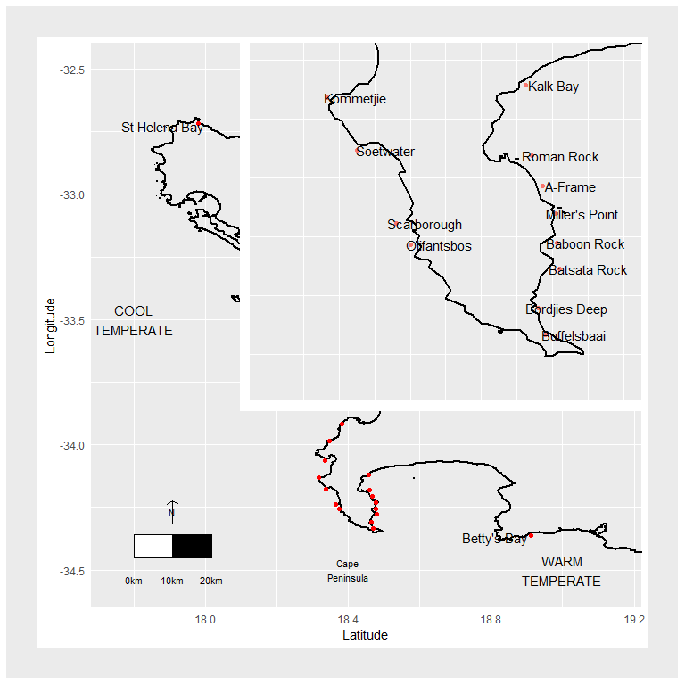

Map of the study area and sampling sites. The red dot indicates the position of Cape Town for sake of reference.

The annual and seasonal patterns in both wind influence the thermal regime around the coastline by inducing upwelling. Upwelling brings deep, cool nutrient-rich water to coastal areas which causes a decrease in temperature (Field et al. 1980; Andrews and Hutchings 1980; Gill and Clarke 1974; Cram 1970; Rouault, Pohl, and Penven 2010; Blanke et al. 2002). The wind speed and wind direction help drive upwelling in summer on the western side of the Cape Peninsula, where southerly winds blow parallel to the coast and trigger upwelling events (Field et al. 1980; Rouault, Pohl, and Penven 2010). This is not the case for False Bay, which is shielded from the dominating wind and swell that the Cape Peninsula is subjected to. In the winter months, upwelling becomes more favourable in False Bay due to the change in swell and wind direction, causing lower temperatures to dominate during this time (Rouault, Pohl, and Penven 2010; Andrews and Hutchings 1980). Due to the Cape Peninsula temperate latitude, winter months bring an increased frequency of frontal depressions that originate from the Southern Ocean (Reason, Landman, and Tennant 2006). These low pressures are joined by large swells with increased wave energy. The nearshore environment, with the accompanied biota, therefore experiences high wave energy events, with increased frequency in winter (Veitch et al. 2019). The large peninsula acts as an obstruction for large south westerly swells, providing decreased wave energy along the west side of False Bay (Shipley 1964). Conversely, the west coast of Cape Point is battered by these large swells. Multiple sites, therefore, exist where kelps grow in diverse temperature and wave energy climates, in close proximity and on the same side. The topography and elevation along the Cape Peninsula channel and shield winds along False Bay. This is, however, absent in winter, when strong northerly winds are prevalent from St. Helena Bay to Betty’s Bay (Field et al. 1980; Jury, Kamstra, and Taunton-Clark 1985; Andrews and Hutchings 1980; Jury 1980).

## Abiotic environment

In order to compare abiotic variables for sites around the coast, large historical databases for temperature, wave energy and wind were accessed.

### Temperature

Shallow water temperatures were sourced from The South African Coastal Temperature Network (SACTN) website (<https://github.com/ajsmit/SACTN>). In terms of nearshore temperature, *in situ* data are preferred over satellite SST, which have shown to exhibit large biases (Smit et al. 2013). Linear interpolated SST were calculated for sites where *in situ* recorders were absent. These data were used to group sites into ‘Cool temperate’ and ‘Warm temperate’ categorisations to investigate the possible effect of thermal regime on kelp morphological characteristics.

### Wave environment

Wave model variable data formed part of the South African Coastal Vulnerability Assessment, presented to the Department of Environmental Affairs (DEA) and produced by the Council for Scientific and Industrial Research (CSIR) (Rautenbach 2015). The South African wave climate was modeled via 20 spectral numerical wave models that simulated the offshore wave climate to the nearshore. The boundary conditions of these models were obtained by using the NOAA Wave Watch III (WWIII) model output, distributed via the National Centers for Environmental Prediction (NCEP) product (Office of the Director 2000; Environmental Modeling Center / Marine Modeling Branch 2005). The particular hindcast product utilised during the DEA-CSIR study spans 1994-2013 at a 3-hour resolution. These data were then used to model swell propagation into the coastal models while wind waves (seas) were generated via stationary computations in the Simulating Waves in the Nearshore SWAN model (Booij, Holthuijsen, and Ris 1997). The assumption of stationary computations is acceptable as the model domains were small enough so the temporal variation of the model boundary was slower than the time it takes for that boundary condition to propagate to the coast. SWAN allows one to extract wave variables from specific gridded locations in the nearshore. For False Bay, a resolution of 200 meters was modelled and output produced at both the 7 meter and 15 meter isobaths. A 200 meter resolution was used as the False Bay computational grid was nested within a larger 1 kilometer resolution grid. This allowed for a computational effective wave resolution of increasing resolution, from the NCEP, low resolution output to nested, high resolution coastal output. For Table Bay and east of Cape Hangklip the resolution was 500 meters and also had output at the 7 meters and 15 meter isobaths. These contour outputs were chosen in the original study by the CSIR as most engineering run-up calculations require wave parameter information at these contour depths and were the main focus of the original study. For this study the 7 meter contours were used. These data were then used to calculate over all wave power (kW/m) as this was considered the best measure of overall wave exposure. Annual wave power was plotted and categorised into different wave exposure categories which ranged from fully sheltered to extremely exposed.

### Collection of kelp morphological characteristics

The morphological characteristics of both species are presented in figure . *Laminaria pallida* is characterised by a single smooth blade which is divided longitudinally into sections, and develops from a single meristematic region located at the junction between the blade and the stipe (Dyer 2018). This species has a solid stipe along the south-west coast but develops a hollow stipe along the west coast northward and into Namibia (Rothman et al. 2017). *Ecklonia maxima* consists of a single primary blade which develops above a gas-filled float and a hollow stipe below. Secondary blades are produced laterally from the primary blade from several meristematic regions along the margins of the primary blade (Dyer 2018). Both species are held to the substrate by finger-like haptera, collectively known as the holdfast.

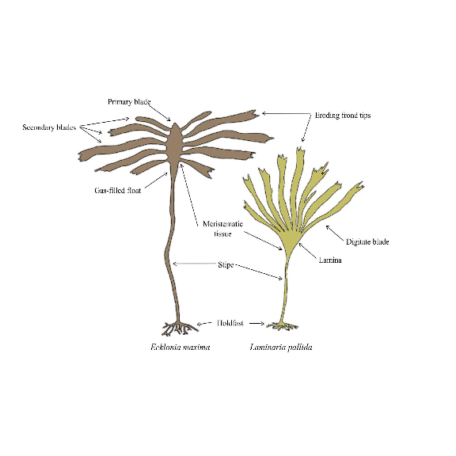

Schematic of *Laminaria pallida* and *Ecklonia maxima* morphology (Dyer 2018).

Morphological measurements of *L. pallida* and *E. maxima* were collected at 18 sites along the Western Cape coast of South Africa (Fig. 1) between October 2014 and April 2015. In each instance only the 13 largest individuals were sampled to ensure that only mature and fully grown sporophytes were measured. In instances where one of the species was not present a site, the nearest population of the missing species was sampled. Because the macroalgae differ in morphological features, species-specific morphological characteristics were included and are presented in Tables 1 and 2. Between February 2017 and November 2018, morphological measurements for *E. maxima* individuals in shallow water (<1m) at seven sites along the Western Cape coast of South Africa were also collected. The same morphological characteristic measurements were taken as for the deeper *E. maxima*, and this allowed comparison between morphological characteristics between deep and shallow individuals within sites. Measurements were not collected for *L. pallida* in the shallow depths, as this species is largely absent from the shallow in this portion of the South African coastline.

## Statistical analyses

Summary statistics were calculated for each site and region for each of the environmental variables considered in this study, and are presented in Table 3. In addition, annual median wave and wind direction were also calculated. The median was calculated for wind and wave direction, as issues arise when calculating the mean and standard deviation for compass metrics. Summary statistics for wind was not plotted and instead are discussed, as the data were course relative to the other environmental variables considered in this study.

Morphological characteristics in relation to temperature and wave exposure were investigated using non-parametric statistical methods. Morphological characteristics were categorised according to temperature regime and wave exposure category for each species and population of kelp in this study. Significant differences between temperature regimes and across wave exposure categories were tested with Wilcox tests and Kruskal tests, respectively, and notched boxplots allowed comparison between individual categories of wave exposure. In order to investigate specific drivers of morphological characteristics a distance-based redundancy analysis (db-RDA) was performed using the *rda* function in the *vegan* software package (Oksanen et al. 2015) in R (R Core Team, 2019). The abiotic data covered all study sites for both species of kelp. Both morphology and abiotic data (temperature, waves and wind) were standardised using the *decostand* function in the *vegan* software package; morphology data were used as response variables and the abiotic data as explanatory variables. To determine the explanatory variables that best describe patterns in the response data, a full RDA was performed using a complete set of explanatory variables. Forward selection was then used to reduce the number of explanatory variables, as well as prevent the inflation of overall Type I error. To further improve the model, pairwise coefficients and Variance Inflation Factor (VIF) were calculated to identify variables with high multicollinearity. The computation of the parsimonious RDA was followed by permutation tests of the adjusted *R*2 to assess significance of constraints.

# Results

## Abiotic environment

### Temperature

The mean annual coastal water temperature for the study sites located on the western side of the peninsula ranged from 14.5 ± 0.9 ℃ (mean ± SD) at St. Helena Bay, the most northern site on the western side of the peninsula, to 14.6 ± 0.3 ℃ at Olifantsbos, the most southern site on the western side of the peninsula (see figure A). For sites located on the eastern side of the peninsula (within False Bay), the annual mean coastal water temperatures ranged from 15.5 ± 0.9 ℃ at Buffelsbaai to 15.0 ± 0.9 ℃ at Betty’s Bay, the most eastern site on the coastline in this study (see figureA). Oudekraal had the lowest annual mean coastal water temperature of 12.3 ± 0.9. Annual maximum coastal temperatures for study sites located on the western side of the peninsula ranged from 16.3 ℃ at St. Helena Bay to 15.1 ℃ at Olifantsbos. For sites located east of the peninsula, annual maximum coastal water temperatures ranged from 16 ℃ at Buffelsbaai to 16.5 ℃ at Betty’s Bay. Amongst all sites, Kalk Bay had the highest annual maximum temperature of 19 ℃. Annual minimum coastal water temperatures for the study sites on the western side of the peninsula ranged from 12.9 ℃ at St. Helena Bay to 14.1 ℃ at Olifantsbos, and on the western side of the peninsula ranged from 15.0 ℃ at Buffelsbaai to 13.6 ℃ at Betty’s Bay. The annual range in temperature on the western side on the peninsula was 3.4 at St. Helena Bay to 0.9 at Olifantsbos, and on the eastern side on of the peninsula was 1.0 at Buffelsbaai to 2.9 at Betty’s Bay.

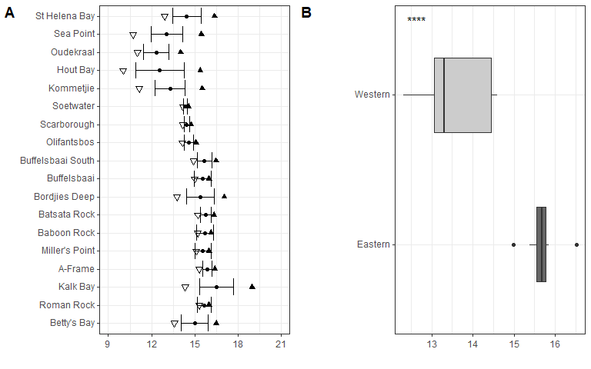

Temperature variables at the collection sites around the Cape Peninsula are represented in plot A. Temperature variables include minimum represented by inverted triangles, mean represented by black dots, maximum by black triangles, and whiskers standard deviation. Summary of temperature data for sites grouped by region are represented in plot B.

In general, the mean temperature increases for sites located within False Bay with less variation around the mean temperature compared to sites on the western side of the peninsula(A). This is verified by figureB, which shows a significantly lower (*p* < 0.05, figure B) mean temperature and less variation in temperature for sites located on the western side of the peninsula compared to sites on the eastern side.

### Wave environment

Our data show the western side of the peninsula experiences higher significant wave heights and variation in wave heights compared to the eastern side of the peninsula on both an annual scale (see figure ). Mean significant wave height ranged from 0.5 ± 0.2 m (mean ± SD) at St. Helena Bay to 2.3 ± 0.7 m at Olifantsbos on the western side of the peninsula, and on the eastern side of the peninsula it ranged from 0.9 ± 0.4 m at Buffelsbaai to 1.9 ± 0.6 m at Betty’s Bay (see figure A). The maximum significant wave height ranged from 1.4 m at St. Helena Bay to 4.7 m at Olifantsbos on the western side of the peninsula, and on the eastern side ranged from 2.6 m at Buffelsbaai to 4.2 m at Betty’s Bay. Mean peak period for sites on the western side of the peninsula ranged from 10.3 ± 3.5 s at St. Helena Bay to 11.0 ± 2.0 s at Olifantsbos, and ranged from 10.6 ± 3.0 s at Buffelsbaai to 10.8 ± 2.2 s at Betty’s Bay (see figure B). The data show no trend in mean peak period for the coastline. These data show that the western side of the peninsula has a lower variation (SD) compared to the eastern side, with Miller’s Point showing the highest variation across timescales. Maximum peak period ranged from 18.9 s at St. Helena Bay to 18.4 s at Olifantsbos for the western side of the peninsula, and ranged from 18.0 s at Buffelsbaai to 18.0 s at Betty’s Bay on the eastern side of the peninsula. When wave variables were grouped by region significant differences were found for both mean significant swell height and mean peak period. The western region experiences a significantly higher mean significant swell height (*p* < 0.05; see figure C) and mean peak period (*p* < 0.05; see figure D).

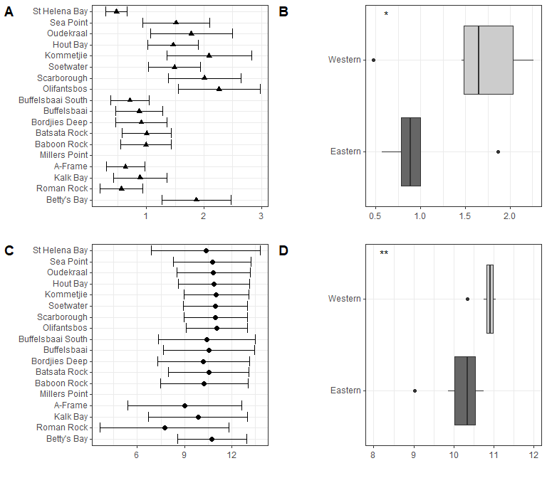

Mean significant wave height and mean significant peak period across sites and by region. Mean significant wave height across sites is presented in plot A and is represented by solid triangles and standard deviation by the whiskers. Differences in mean significant wave height between regions are presented in plot B. Mean significant peak period across sites is presented in plot C and is represented by solid dots and standard deviation by whiskers. Differences in mean significant peak period between regions are presented in plot D.

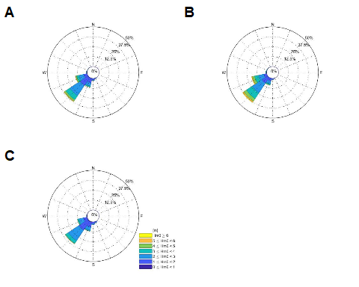

The total and seasonal wave roses of the directional wave buoy just offshore from Cape Town is given form the years 2000 till end 2017 (the period for which directional wave spectra was available). Total (A), Austral winter (B) and Austral summer (C) respectively

Data for median wave direction showed no trend across timescales; however, the variation (SD) in wave direction is lower on the western side of the peninsula compared to the eastern side both annually and for winter. Summer data were the exception and showed lower variation for the eastern side of the peninsula (see figure ).

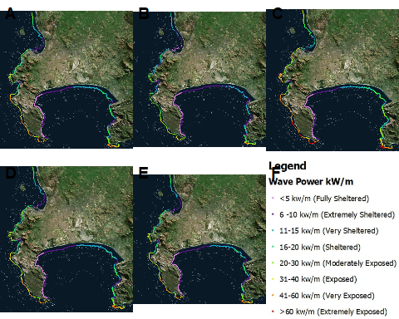

The total coastal wave exposure of the Cape Peninsula is given in terms of wave energy (kW per meter wave crest length. Total (A), summer (B), winter (C), spring (D) and autumn (E).

In figure the total coastal wave exposure of the Cape Peninsula is given in terms of wave energy (kW per meter wave crest length). The classification from fully sheltered to extremely exposed is based on the total wave energy upper and lower limits. The western periphery of the Cape Peninsula is almost continuously exposed to high wave exposures while the eastern periphery of the peninsula (western coastline of False Bay) revealed sheltered wave exposures (see figure ). There the marked seasonality, with higher energy waves during winter, may be clearly observed once more.

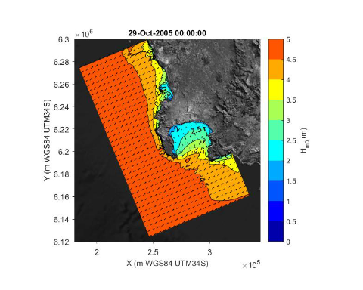

The propagation of a typical offshore wave spectrum is given as produced from a single time-step in SWAN.

To clarify the averaged wave exposure maps presented in figure , the propagation of a typical offshore wave spectrum as produced from a single time-step in SWAN is presented in figure . Tracing the wave height contours into False Bay its clear why this bay’s western periphery is predominantly sheltered.

## Drivers of kelp morphological characteristics

Significant differences were found between cool temperate and warm temperate regimes for most *L. pallida* morphological characteristics with lamina length, number of digits and thallus mass the exceptions (see figure ). Certain morphological characteristics such as stipe mass, stipe length, total length and stipe diameter had significantly higher means for kelp from the cool temperate regime when compared to kelp from the warm temperate regime. Conversely, lamina weight and lamina thickness had significantly lower means for kelp from the cool temperate regime compared to kelp from the warm temperate regime. When *L. pallida* morphological characteristics were grouped to wave exposure categories Kruskal-Wallis tests revealed significant differences amongst categories for most morphological characteristics with lamina length, number of digits and thallus mass the exceptions (see figure ref{fig:lamanaria wave plots}). The morphological characteristics that were significantly different amongst sites exhibited similar patterns, with increasing mean values from the fully sheltered to extremely sheltered categories and a decrease in mean values for the remainder of the categories. Two morphological characteristics, namely lamina thickness and stipe diameter, both exhibited higher variations for the exposed categories compared to other morphological characteristics.

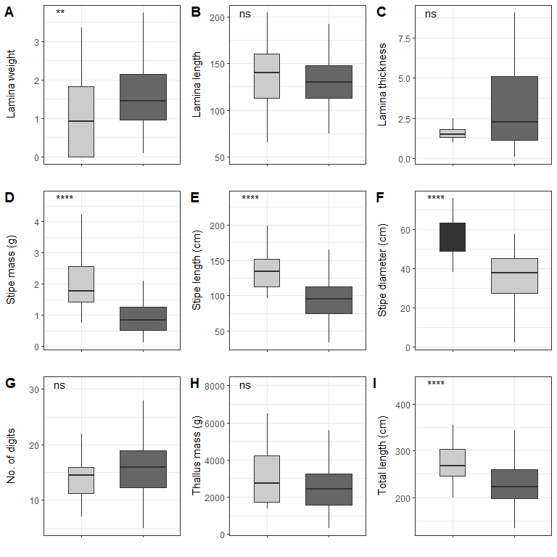

Boxplots representing *L. pallida* morphological characteristics grouped by temperature regime measured around the Western Cape coastline, with the *y*-axis depicting the specific morphology measured, with units provided. The lower and upper “hinges” correspond to the first and third quartiles. The whiskers represent the range, solid black lines represent the median and black dots are outliers. Light grey boxes represent cool-temperate and dark grey warm-temperate.

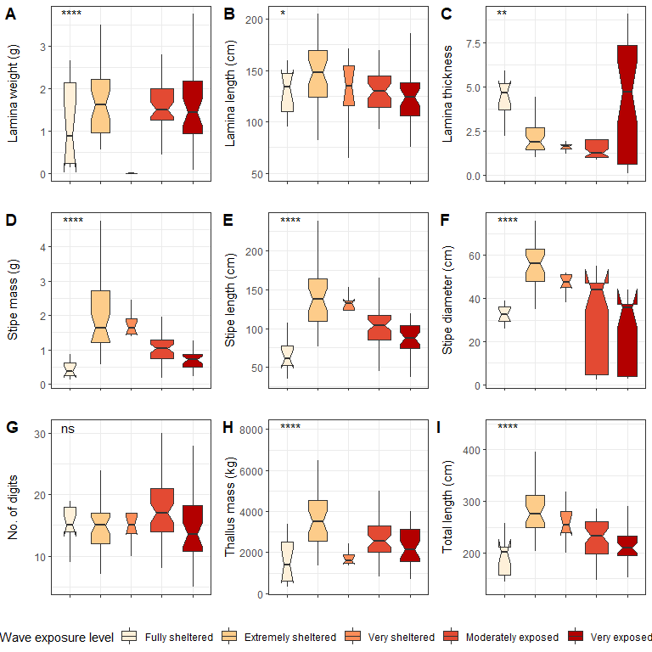

Boxplots representing *L. pallida* morphological characteristics grouped by wave exposure category measured around the Western Cape coastline, with the *y*-axis depicting the specific morphology measured, with units provided. The lower and upper hinges correspond to the first and third quartiles. The whiskers represent the range, solid black lines represent the median and black dots are outliers.

Six out of the ten deep *E. maxima* morphological characteristics showed differences between cool temperate and warm temperate regime except for frond mass, frond length, stipe mass and epiphyte length. Mean values for primary length, primary width and stipe circumference were significantly higher for kelp from the cool temperate regime than for kelp from the warm temperate regime (see figure . The remaining morphological characteristics, stipe length, number of tufts and total length had significantly lower means for kelp from cool temperate compared to kelp from the warm temperate regime (*p* < 0.05; see figure ). Significant differences amongst wave exposure categories were found for all morphological characteristics of deep *E. maxima* populations. Certain morphological characteristics showed a gradual increase in mean value with increasing degree of wave exposure. The remaining morphological characteristics exhibited decreased means for only the higher wave exposure categories, followed by a sharp increase in mean value for the highest wave exposure category.

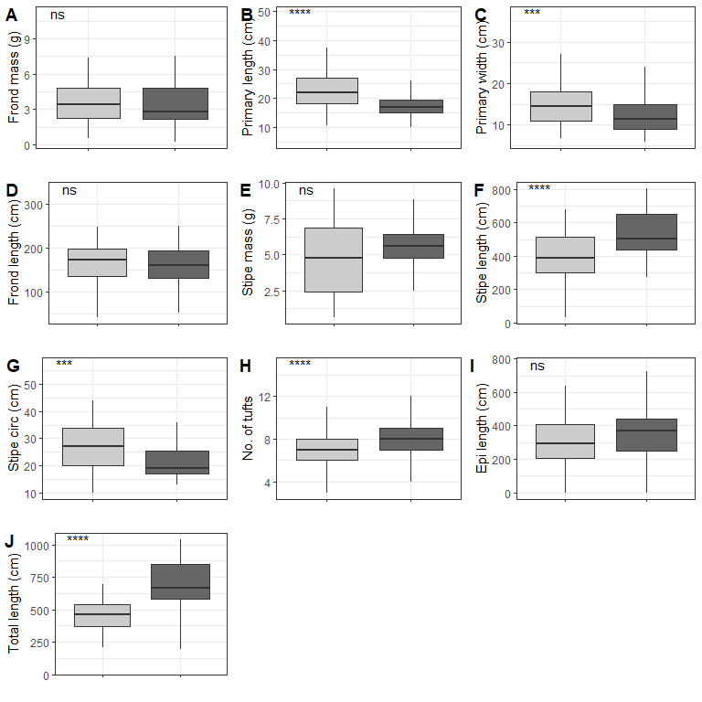

Boxplots representing deep population *E. maxima* morphological characteristics grouped by temperature regime measured around the Western Cape coastline, with the *y*-axis depicting the specific morphology measured, with units provided. The lower and upper hinges correspond to the first and third quartiles. The whiskers represent the range, solid black lines represent the median and black dots are outliers. Light grey boxes represent cool-temperate and dark grey warm-temperate.

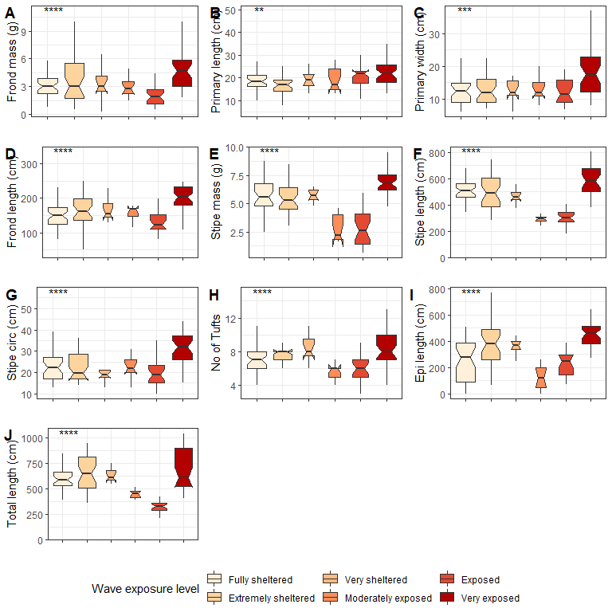

Boxplots representing deep *E. maxima* morphological characteristics grouped by wave exposure category measured around the Western Cape coastline, with the *y*-axis depicting the specific morphology measured, with units provided. The lower and upper hinges correspond to the first and third quartiles. The whiskers represent the range, solid black lines represent the median and black dots are outliers.

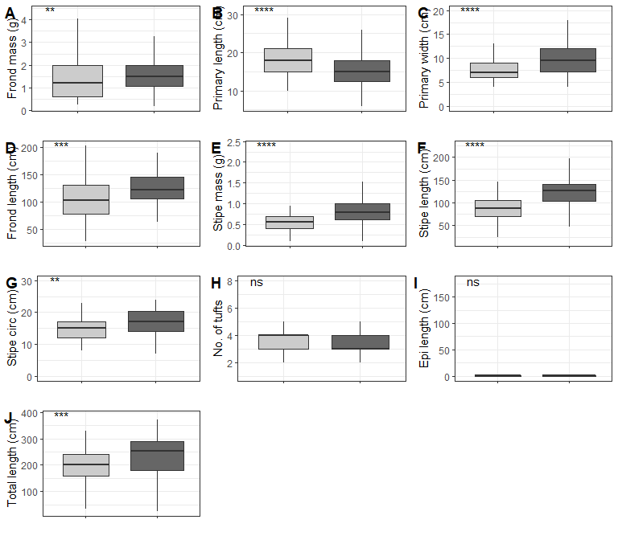

Boxplots representing shallow *E. maxima* morphological characteristics grouped by temperature regime measured around the Western Cape coastline, with the *y*-axis depicting the specific morphology measured, with units provided. The lower and upper hinges correspond to the first and third quartiles. The whiskers represent the range, solid black lines represent the median and black dots are outliers. Light grey boxes represent cool-temperate and dark grey warm-temperate.

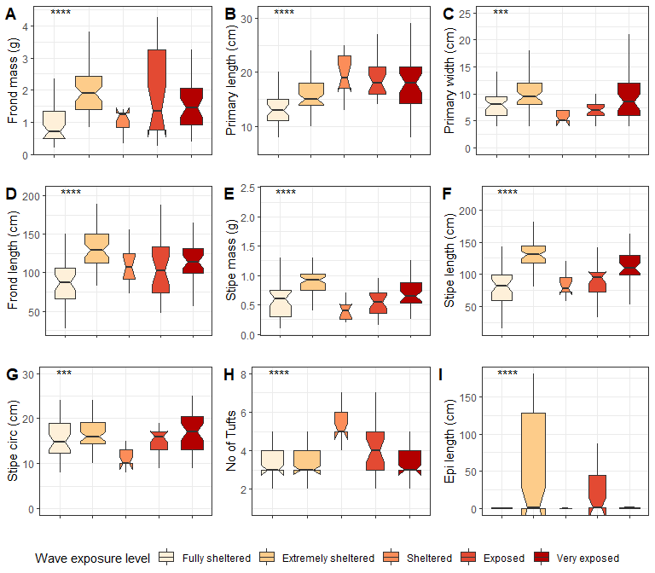

Boxplots representing shallow *E. maxima* morphological characteristics grouped by wave exposure category measured around the Western Cape coastline, with the *y*-axis depicting the specific morphology measured, with units provided. The lower and upper hinges correspond to the first and third quartiles. The whiskers represent the range, solid black lines represent the median and black dots are outliers.

When grouped by temperature regime, shallow *E. maxima* exhibited significant differences between temperature regimes for frond mass, primary length, primary width, frond length, stipe mass, stipe length, stipe circumference and total length (*p* < 0.05; see figure ). All of the significantly different morphological characteristics, except primary length, had lower values for the western region compared to the eastern region. When shallow *E. maxima* were grouped by wave exposure category significant difference were found for all morphological characteristics (*p* < 0.05; see figure ). In general, values of the various morphological characteristics increase for the lower wave exposure categories, followed by a sharp decrease and a gradual increase in value.

### Abiotic drivers of *L. pallida* morphological characteristics

Forward selection, assessment of VIF and an examination of pairwise Pearson correlation coefficients allowed us to retain the most parsimonious descriptors of *L. pallida* morphological characteristics with an adjusted *R*2 of 0.49, explaining 72% of the variation (global permutation test on final model: d.f = 1, *F* = 8.51, *p* = 0.008). RDA1 was the only significant axis in the model and explained 48% of the variation while RDA2 was not significant and explained 63% of the variation. Total length, stipe length, stipe diameter and stipe mass were positively influenced (*i.e.* increased size corresponding with the environmental driver) by *hs_mean* and *dir_median* for kelp mostly from the western region and negatively influenced (i.e., decreased size corresponding with the environmental driver) by *tp_sd* and *mean_temp* for kelp from the eastern region. Although sites from from the western region did not cluster as closely as eastern region study sites, grouping according to region was still evident.

### Abiotic drivers of *E. maxima* morphological characteristics

Forward selection, assessment of VIF and Pearson correlation coefficients allowed us to retained as the most parsimonious descriptors of deep *E. maxima* morphological characteristics with an adjusted *R*2 of 0.39, explaining 67% of the variation (global permutation test on final model: d.f = 5, *F* = 2.4, *p* = 0.026). RDA1 was the only significant axis in the model (*p* = 0.03) and explained 72% of the variation. Primary length, primary width and stipe circumference were positively influenced by *hs_mean*, *tp_mean* and *dir_median* for for kelp from the western region. The remaining morphological characteristics were positivist influenced by *min_temp* and negatively influenced by *tp_sd* for kelp from the eastern region.

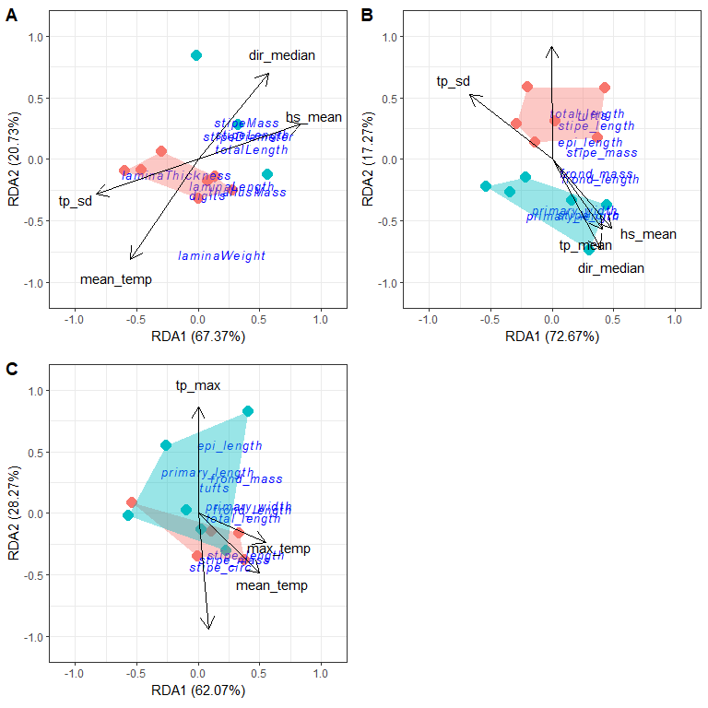

RDA output for *L. pallida* (A), deep *E. maxima* (B) and shallow *E. maxima* (C). The blue cluster represnts sites from the western region and the red represents sites from the eastern region.

Forward selection, assessment of VIF and Pearson correlation coefficients allowed us to retain the most parsimonious descriptors of shallow *E. maxima* morphological characteristics with an adjusted *R*2 of 0.36, explaining 61% of the variation (global permutation test on final model: d.f = 4, *F* = 2.41, *p* = 0.013). The model consisted of one significant axis, RDA1 (*p* = 0.02) and explained 62% of the variation. Stipe length, stipe mass and stipe circumference were positively influenced by *max_temp* and *mean_temp* along RDA1, and explained 50% and 55% of the variation respectively. The remaining morphological characteristics were positively influenced by *tp_max* and negatively influenced by *dirw_median* along RDA2 and explained 86% and 94% of the variation respectively. There was overlapping of clusters according to region with no clear patterns in sites evident.

# Discussion

This study considered important drivers of the morphology of *Ecklonia maxima* and *Laminaria pallida* arpound tehe Cape Peninsula. These abiotic variables, namely temperature and wave exposure, have been identified in previous research (Fowler-Walker, Wernberg, and Connell 2006; Miller, Hurd, and Wing 2011; Fowler-Walker, Connell, and Gillanders 2005; Stewart et al. 2009; Wing et al. 2007; Molloy and Bolton 1996; Pedersen and Nejrup 2012; Wernberg and Thomsen 2005; Thomsen, Wernberg, and Kendrick 2004). The complex geomorphology of the western Cape coastline creates an ideal natural laboratory for studies of kelps in interaction with their environment. Unlike previous research, this study used a numerical model to provide the various variables of wave exposure. We also considered wind in addition to temperature and wave variables, since wind is an important component of wind-driven surface gravity waves (Holthuijsen 2010). The results show that specific variables of wave exposure are the main drivers of kelp morphology with temperature playing only a minor role. Furthermore, the investigation of differences in morphological characteristics between shallow and deep populations of *E. maxima* suggests that in low wave exposure environments the role of temperature as a morphological driver increases; this is particulary the case for False Bay.

There were clear patterns and clines in both the temperature and wave exposure data. The thermal and wave exposure regimes around the Cape Peninsula are driven by a complex interaction between wind, temperature and wave metrics, which do not act independently but instead influence one another. The hydrodynamic regime is modulated by the relative sheltering against the predominant south-westerly swell direction and the size of the fetch for local wave generation. The direction of the dominant swell changes to the south west in winter, generated by strong low pressures that originate from the southern ocean (Reason, Landman, and Tennant 2006), which False Bay is sheltered from (Shipley 1964; Atkins 1970; Dufois and Rouault 2012). In summer, these swells rotate anticlockwise and are able to enter False Bay, providing an increased variability of swell height and peak period in this region. It should be noted that what is classified as sheltered around the South African coastline (a high energy coastline) might be classified as exposed in other regions of the world (Norderhaug et al. 2012; Leliaert et al. 2000). It is due to the near consistent south-westerly swell and the complex orography around the peninsula that the wave energy distribution around the Cape Peninsula varies significantly over a small geographical area. The directional sheltering effect of the Cape Peninsula, against the dominant swell direction is clearly observed in the wave exposure maps. It should be mentioned that some of the annual winter frontal depression systems pass the Cape Peninsula from the west to east, resulting in wave propagating towards the continent from much more southerly directions. This results in positive and negative wave exposure anomalies all around the peninsula. Increased wind speed at sites along the west side of the peninsula in a southerly direction trigger upwelling events along the western side of the peninsula (Rouault, Pohl, and Penven 2010; Field et al. 1980). In general, the western side of the peninsula is more exposed than the eastern side (False Bay) and experiences significantly higher mean significant swell height and mean significant peak period. This was also reflected in the wave exposure categories which show a trend of decreasing wave exposure (wave power) around the peninsula and into False Bay. There are also differences between the types of waves that each side of the peninsula experiences. The wave analysis shows the western side of the peninsula is not only more exposed but the hydrodynamics are largely swell driven, while on the eastern side most of the wave energy is driven by a combination of swell and wind with the latter being the predominant driver.

We provide strong support that variations in the environmental variables, particularly wave exposure variables, are driving kelp morphological characteristics around the Cape Peninsula. Morphological adaptation due to water motion may manifest in a number of ways in high wave energy environments. For instance, reduction of blade thickness, blade elongation, increase of stipe length, increase in stipe circumference and force of attachment (Fowler-Walker, Wernberg, and Connell 2006; Wernberg and Thomsen 2005; Friedland and Denny 1995; Denny and Gaylord 2002; Bekkby et al., n.d.; Denny, Gaylord, and Cowen 1997) have been identified in previous studies. Although this study did not measure force of attachment, other morphological responses to temperature and wave variables were evident. Species-specific responses are evident in both wave exposure and temperature. In cool temperate environments *L. pallida* tended to show increases in certain morphological characteristics (stipe mass, stipe length and stipe diameter) while in the warm-temperate environments these were significantly lower. This was also true for deep *E. maxima* populations, which had longer, thinner stipes for kelp from the warm temperate compared to kelp from the cool temperate. Reduction in certain morphological characteristics has been attributed to temperature by Serisawa et al. (2002) in the kelp *E. cava*, which was smaller and shorter in warmer sites compared to cooler sites. The reduction in size of adult may be a response to low nutrient conditions, which has been shown to reduce growth rate and overall morphology (Simonson, Scheibling, and Metaxas 2015). Warmer temperatures are associated with low nutrient concentrations (Waldron and Probyn 1992) and the low frequency of upwelling conditions in False Bay (low nutrient supply) coupled with warmer temperatures may be a contributing factor. It should be noted however, that from these analyses that in general the cool temperate region is more exposed to waves than that of the warm-temperate region. Therefore, the significantly larger morphological characteristics for kelp from the cool temperate region may overlap with responses to wave exposure. The response of kelp morphological characteristics to wave exposure was evident and both species exhibit tactics based on the magnitude of wave exposure. Strength increasing traits were exhibited for lower exposure levels while a ‘go-with-the-flow’ tactic for moderate levels of wave exposure. This suggests that how morphological characteristics manifest themselves is dependent on the magnitude of wave exposure. When grouped by wave exposure category, *L. pallida* characteristics showed a significant increase in length for the ‘extremely sheltered’ category compared to the fully sheltered category, which may be a ‘go-with-the-flow’ tactic (Denny, Gaylord, and Cowen 1997; Denny and Gaylord 2002; Hurd 2000). Kelp are able to increase flexibility by increasing stipe length which increases the extension capabilities of kelp to a passing wave (Denny and Gaylord 2002; Hurd 2000). However, increasing stipe length is only beneficial under lower exposure levels as a long stipe actually increases overall drag on the plant under high wave exposure (Denny and Gaylord 2002; Denny, Gaylord, and Cowen 1997). This is reflected in the *L. pallida* morphology which shows an overall reduction of morphological characteristics suggesting a size reducing tactic to cope with higher levels of wave exposure. The results suggest that deep *E. maxima* populations exhibit a different response, as well as a higher wave exposure threshold. Unlike *L. pallida*, *E. maxima* exhibits a size reducing tactic with increasing wave exposure by decreasing stipe mass, stipe length, stipe circumference, total length and frond length. A magnitude related response has been suggested by T. Wernberg and Vanderklift (2010) who investigated the temporal and spatial variations of various environmental drivers of the kelp *E. radiata*. The authors identified wave exposure as the most important driver of kelp morphological characteristics and that the type of response elicited is dependent on the magnitude of wave exposure.

A size reduction tactic has been shown before (Fowler-Walker, Wernberg, and Connell 2006; Denny and Gaylord 2002; Hurd 2000; Fowler-Walker, Connell, and Gillanders 2005) and is regarded as a strategy to reduce overall drag on the plant. However, *E. maxima* morphological characteristics changed significantly as wave exposure increases. When grouped to the higher wave exposure levels, *E. maxima* morphology exhibited a strength and flexibility increasing trait. Furthermore, the morphological response of *E. maxima* to wave exposure only occurs at the ‘Moderately exposed’ (20-30 kW/m) level compared to *L. pallida* which exhibits a response at a lower wave exposure level. This suggests that *E. maxima* can tolerate higher exposure levels before having to exhibit a morphological response. The redundancy analysis performed confirms the patterns and responses observed as well as identifying specific temperature and wave variables as drivers of kelp morphology. Kelp morphology characteristics are largely wave driven for both species but differ in terms of specific temperature and wave metrics. For instance, both species morphological characteristics are determined by swell direction (*dir_median*), standard deviation in peak period (*tp_sd*) and mean significant swell height (*hs_mean*), but *L. pallida* temperature driver is mean temperature (*mean_temp*) and *E. maxima* by minimum temperature (*min_temp*). Minimum temperature as an important metric for *E. maxima* may be related to nutrient availability. Low temperatures are often associated with upwelling events which bring cool, nutrient rich water into the nearshore. False Bay has comparatively little upwelling events compared to the western side of the peninsula, and so nutrients may be a limiting factor for *E. maxima* populations within False Bay, hence the identification of minimum temperature (*min_temp*) as a driver. Mean temperature identified as a driver for *L. pallida* may be related to diurnal temperature fluctuations in the water column. Solar heating of the water surface in combination with wind-driven transport causes fluctuations within the water column, which can occur daily or seasonally (Kaplan et al. 2003). Vertical mixing of the water column for inshore regions are driven by several abiotic processes: (1) turbulence of breaking waves inside or outside of the surf zone (2) convective mixing through a combination of cooling and evaporation; and (3) wind driven currents and (4) tidal mixing (Smit et al. 2013). These abiotic processes cause effective vertical mixing of surface and deeper water stratification which leads to a homogeneous thermal environment, which in this study may be interpreted as the mean temperature. Therefore, the homogeneous thermal regime of inshore regions may be a reason why mean temperature is driver of *L. pallida* morphological characteristics. The difference in canopy type between the species may be the reason why *E. maxima* is driven by multiple wave metrics compared to *L. pallida*. Since *E. maxima* is a canopy-kelp, it is exposed to all components of a wave compared to *L. pallida* which occurs deeper in the water column.

Temperature variables were not a significant driver of kelp morphology in this study. Although temperature plays an important role in distribution (Bolton 2010; Miller, Hurd, and Wing 2011; Rinde et al. 2014) of kelp and physiological functioning of adults and gametophytes (Mohring et al. 2014; Steneck et al. 2002; Gerard 1997; Bearham, Vanderklift, and Gunson 2013; Smale and Moore 2017), there is little evidence in this study that temperature is an important driver of morphological variation. However, we suggest that temperature plays a larger role in determining kelp morphology at sites where wave energy is low enough not to elicit a response in morphological characteristics. Temperature metrics influence stipe length and frond length in shallow *E. maxima* individuals located at sites within False Bay; which was not the case for deeper *E. maxima* individuals as well as *L. pallida* which were largely driven by wave variables. The shallow *E. maxima* individuals may not experience the same amount of wave energy as do deeper populations. This may be due to wave dampening from deeper populations of *E. maxima*, which attenuate the wave energy entering coastal environments (Kobayashi, Raichle, and Asano 1993; Jackson 1984; Mork 1996). The morphological variations in characteristics for deep *E. maxima* populations are not seen for shallow *E. maxima* populations. The lack of variation in shallow *E. maxima* populations was also found in previous research by (Rothman et al. 2017) who identified light as a significant driver. This influence of light may suggest photosynthetic ability and nutrient uptake as important drivers in shallow environments. Wave exposure may be reduced in shallow environments due to the wave damping effect of deep kelp and seaweed populations (Kobayashi, Raichle, and Asano 1993; Mork 1996; Jackson 1984) thereby reducing the need to adapt morphological characteristics to reduce drag. Furthermore, the reduction in differences between deep and shallow *E. maxima*  at wave exposed sites on the western of the peninsula compared to sites in False Bay provides further evidence that wave exposure is not an important driver of shallow *E. maxima* populations. Increased temperatures corresponded with a reduction in stipe circumference, frond length, stipe length, total length and stipe mass resulting in slim or ‘skinny’ kelp individuals, which supports findings from previous research by (Mabin, Gribben, and Fischer 2013; Serisawa et al. 2002). These findings were confirmed by the redundancy analysis which showed the contribution of wave variables as a driver of kelp morphological characteristics was lower compared to temperature variables. The sites do cluster by region but almost overlap entirely, further indicating wave variables are not the main driver. Although wave variables were not identified as an important driver, it is important to note the wave variables identified in the RDA differ to deep *E. maxima*. The identification of median wind direction (*dirw_median*) suggests that surface gravity waves as a driver compared to swell waves (*dir_median*) identified for *L. pallida* and *E. maxima*.

Kelps living in warmer environments have been shown to have a lower resilience to purbutation, such as storms (T. Wernberg et al. 2010). The kelps in False Bay, may therefore be more vulnerable to dislodgment under high wave exposure scenarios compared to kelps on the western side of the Cape Peninsula, which experiences higher wave energy on a regular basis. In South Africa, the main contributing factors to the hydrodynamic environment are the Southern Annular Node (SAM) and El Nino Southern Oscillation (ENSO), while the latter is also the main source of variability (Veitch et al. 2019). These climate systems are expected to alter storm frequency and magnitude under future climate scenarios, which may increase the overall wave power around the Cape Peninsula. The magnitude-specific response of the kelp species to wave exposure in this study suggests there is a limit to morphological adaption in reducing the probability of dislodgement. Therefore, if this limit is reached and exceeded in future climate scenarios, kelp populations may risk being reduced over time. Furthermore, although recent studies suggest a cooling trend of coastal waters around South Africa (Rouault, Pohl, and Penven 2010; Smit et al. 2013), the impact of marine heat waves may reduce the resilience of kelps to storms and high wave energy. Although this study identifies specific wave and temperature metrics that drive morphological adaptation and suggests a possible wave exposure threshold, it does not identify the metrics or magnitude of wave exposure required to dislodge kelp. Therefore, future studies should consider using advanced numerical methods to investigate the specific wave power needed to dislodge kelp, and ideally, given a specific set of morphological measures. These types of studies in conjunction with forecasting studies can be used to determine the vulnerability of kelp populations to future climate scenarios.

# Conclusion

Past research shows that macroalgal morphological characteristics are largely driven by a wave exposure while others have suggested a complex interaction between various environmental variables. We confirm that wave variables are the main driver of kelp morphological characteristics in both *E. maxima* and *L. pallida* populations around the Cape Peninsula, and differences in morphological characteristics between shallow and deep populations of *E. maxima* may reflect differences in hydrodynamic and temperature regimes. This study also confirms the findings of previous research which shows morphological adaptation is dependent on the magnitude of wave exposure, but provides quantitative, reproducible measure of wave exposure while identifying the specific wave metrics and wave energy thresholds involved. Furthermore, the current study highlights the need to understand how kelp populations, which are not exposed to high wave energy and morphological characteristics are largely driven by temperature, are vulnerable to changes in storm frequency and magnitude. Kelp populations located in low wave energy environments, such as False Bay, may be more vulnerable to increased storm frequency and magnitude in future climate scenarios.

# Conflict of Interest Statement

The authors declare that the research was conducted in the absence of any commercial or financial relationships that could be construed as a potential conflict of interest

# Author Contributions

RC conceptualised the scope of the research reported in this paper, collected samples, undertook the majority of numerical and statistical analyses, made the first round of interpretation, and did the majority of the writing. AS and CR provided guidance in terms of writing, statistical analyses, and the final draft of the paper.

# Funding

The research was funded by the South African National Research Foundation (<http://www.nrf.ac.za>). Funding number is CSRP170430229220

Aside from funding provided, the funders had no role in the study design, data collection and analysis, decision to publish, or preparation of the manuscript.

# Acknowledgments

Thank you to AS and CR for their guidance, and the honours class of 2014-2015 that aided in fieldwork. Carla Louise for making the GIS plot etc.

# Appendix

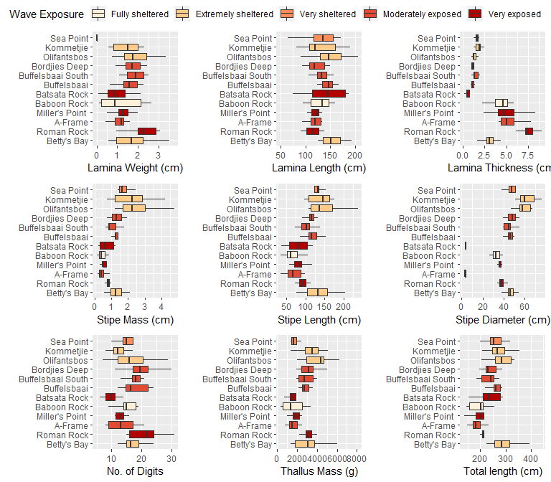

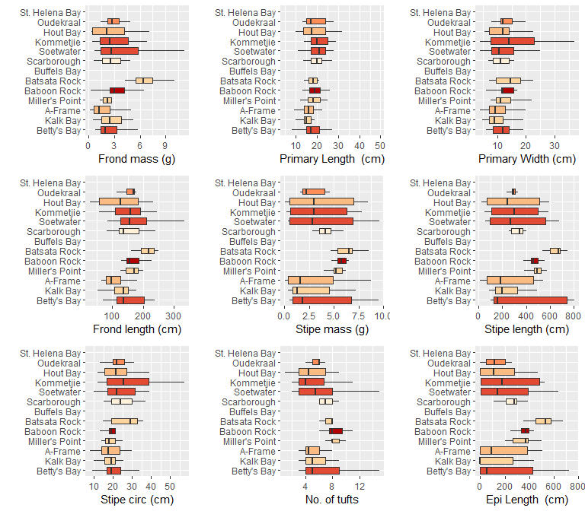

# References

Anderson, RJ, P Carrick, GJ Levitt, and A Share. 1997. “Holdfasts of Adult Kelp *Ecklonia Maxima* Provide Refuges from Grazing for Recruitment of Juvenile Kelps.” *Marine Ecology Progress Series* 159: 265–73.

Andrews, WRH, and L Hutchings. 1980. “Upwelling in the Southern Benguela Current.” *Progress in Oceanography* 9 (1): 1–81.

Atkins, G R. 1970. “Winds and Current Patterns in False Bay.” *Transactions of the Royal Society of South Africa* 39 (2): 139–48.

Bearham, Douglas, Mathew A Vanderklift, and Jim R Gunson. 2013. “Temperature and Light Explain Spatial Variation in Growth and Productivity of the Kelp *Ecklonia Radiata*.” *Marine Ecology Progress Series* 476: 59–70.

Bekkby, Trine, Eli Rinde, Hege Gundersen, Kjell Magnus Norderhaug, Janne K. Gitmark, and Hartvig Christie. n.d. “Length, strength and water flow: Relative importance of wave and current exposure on morphology in kelp hyperborea.” *Marine Ecology Progress Series*, 61–70. <https://doi.org/10.3354/meps10778>.

Blanke, Bruno, Claude Roy, Pierrick Penven, Sabrina Speich, James McWilliams, and Greville Nelson. 2002. “Linking Wind and Interannual Upwelling Variability in a Regional Model of the Southern Benguela.” *Geophysical Research Letters* 29 (24): 41–41.

Bolton, J J. 2010. “The biogeography of kelps (Laminariales, Phaeophyceae): A global analysis with new insights from recent advances in molecular phylogenetics.” *Helgoland Marine Research* 64 (4): 263–79. <https://doi.org/10.1007/s10152-010-0211-6>.

Booij, N, L H Holthuijsen, and R C Ris. 1997. “The "SWAN” wave model for shallow water.” In *Coastal Engineering 1996*, 668–76. ascelibrary.org.

Byrnes, Jarrett E, Daniel C Reed, Bradley J Cardinale, Kyle C Cavanaugh, Sally J Holbrook, and Russell J Schmitt. 2011. “Climate-Driven Increases in Storm Frequency Simplify Kelp Forest Food Webs.” *Global Change Biology* 17 (8): 2513–24.

Cavanaugh, K C, D A Siegel, D C Reed, and P E Dennison. 2011. “Environmental controls of giant-kelp biomass in the Santa Barbara Channel, California.” *Marine Ecology Progress Series* 429: 1–17.

Cousens, R. 1982. “The Effect of Exposure to Wave Action on the Morphology and Pigmentation of *Ascophyllum nodosum* (L.) Le Jolis in South-Eastern Canada.” *Bontanica Marina* 25 (4): 191–95.

Cram, D L. 1970. “A suggested origin for the cold surface water in central False Bay.” *Transactions of the Royal Society of South Africa* 39 (2): 129–37.

Dayton, P K. 1985. “Ecology of Kelp Communities.” *Annual Review of Ecology and Systematics* 16 (1): 215–45. <https://doi.org/10.1146/annurev.es.16.110185.001243>.

Dayton, P K, M J Tegner, P B Edwards, and K L Riser. 1998. “Sliding baselines, ghosts, and reduced expectations in kelp forest communities.” *Ecological Applications*.

Dellatorre, Fernando G, Juan P Pisoni, Pedro J Barón, and Andrés L Rivas. 2012. “Tide and Wind Forced Nearshore Dynamics in Nuevo Gulf (Northern Patagonia, Argentina): Potential Implications for Cross-Shore Transport.” *Journal of Marine Systems* 96: 82–89.

Denny, Mark, and Brian Gaylord. 2002. “The mechanics of wave-swept algae.” *Journal of Experimental Biology* 205 (Pt 10): 1355–62.

Denny, M, B Gaylord, and E Cowen. 1997. “Flow and Flexibility: II. The roles of size and shape in determining wave forces on the bull kelp Nereocystis luetkeana.” *Journal of Experimental Biology* 200: 3165–83.

Dubi, Alfonse, and Alf Tørum. 1995. “Wave Damping by Kelp Vegetation.” In *Coastal Engineering 1994*, 142–56.

Dufois, François, and Mathieu Rouault. 2012. “Sea surface temperature in False Bay (South Africa): Towards a better understanding of its seasonal and inter-annual variability.” *Continental Shelf Research* 43 (July): 24–35.

Dunne, R, and B Brown. 2001. “The Influence of Solar Radiation on Bleaching of Shallow Water Reef Corals in the Andaman Sea, 1993–1998.” *Coral Reefs* 20 (3): 201–10.

Dyer, David Clifford. 2018. “Stable Isotope Ecology of South African Kelp Forests.” Edited by John Bolton, Robert Anderson, and A J Smit. PhD thesis, University of Cape Town.

Field, J G, C L Griffiths, E A Linley, R A Carter, and P Zoutendyk. 1980. “Upwelling in a nearshore marine ecosystem and its biological implications.” *Estuarine and Coastal Marine Science* 11 (2): 133–50. <https://doi.org/10.1016/S0302-3524(80)80037-5>.

Fowler-Walker, M J, S D Connell, and B M Gillanders. 2005. “To what extent do geographic and associated environmental variables correlate with kelp morphology across temperate Australia?” *Marine and Freshwater Research* 56 (6): 877–87. <https://doi.org/10.1071/MF05042>.

Fowler-Walker, M J, T Wernberg, and S D Connell. 2006. “Differences in kelp morphology between wave sheltered and exposed localities: Morphologically plastic or fixed traits?” *Marine Biology* 148 (4): 755–67. <https://doi.org/10.1007/s00227-005-0125-z>.

Friedland, M T, and M W Denny. 1995. “Surviving hydrodynamic forces in a wave-swept environment: consequences of morphology in the feather boa kelp, *Egregia menziesii* (Turner).” *Journal of Experimental Biology* 190: 109–33.

Gaines, S D, and J Roughgarden. 1987. “Fish in Offshore Kelp Forests Affect Recruitment to Intertidal Barnacle Populations.” *Science* 235 (4787): 479–81.

Gao, Xu, Hikaru Endo, Kazuya Taniguchi, and Yukio Agatsuma. 2013. “Combined Effects of Seawater Temperature and Nutrient Condition on Growth and Survival of Juvenile Sporophytes of the Kelp *Undaria Pinnatifida* (Laminariales; Phaeophyta) Cultivated in Northern Honshu, Japan.” *Journal of Applied Phycology* 25 (1): 269–75.

Gerard, Valrie A. 1997. “The Role of Nitrogen Nutrition in High-Temperature Tolerance of the Kelp, *Laminaria Saccharina* (Chlorophyta).” *Journal of Phycology* 33 (5): 800–810.

Gill, A E, and A J Clarke. 1974. “Wind-induced upwelling, coastal currents and sea-level changes.” *Deep Sea Research and Oceanographic Abstracts* 21 (5): 325–45.

Gorman, Daniel, Touria Bajjouk, Jacques Populus, Mickaël Vasquez, and Axel Ehrhold. 2013. “Modeling kelp forest distribution and biomass along temperate rocky coastlines.” *Marine Biology* 160 (2): 309–25.

Graham, Michael H. 2004. “Effects of Local Deforestation on the Diversity and Structure of Southern California Giant Kelp Forest Food Webs.” *Ecosystems* 7 (4): 341–57.

Guiry, MD, and GM Guiry. 2019. *AlgaeBase: World-Wide Electronic Publication*. National University of Ireland, Galway.

Harley, C, K M Anderson, K W Demes, J P Jorve, R L Kordas, T Coyle, and M H Graham. 2012. “EFfects of Climate Change on Global Seaweed Communities.” *Journal of Phycology* 48 (5): 1064–78. <https://doi.org/10.1111/j.1529-8817.2012.01224.x>.

Holthuijsen, Leo H. 2010. *Waves in Oceanic and Coastal Waters*. Cambridge University Press.

Hurd, Catriona L. 2000. “Water Motion, Marine Macroalgal Physiology, and Production.” *Journal of Phycology* 36 (3): 453–72.

Jackson, G A. 1984. “Internal Wave Attenuation by Coastal Kelp Stands.” *Journal of Physical Oceanography*. [https://doi.org/10.1175/1520-0485(1984)014<1300:IWABCK>2.0.CO;2](https://doi.org/10.1175/1520-0485(1984)014%3C1300:IWABCK%3E2.0.CO;2).

Jury, Mark R. 1980. “Characteristics of summer wind fields and air sea interactions over the Cape Peninsula upwelling region.”

Jury, M R, F Kamstra, and J Taunton-Clark. 1985. “Synoptic summer wind cycles and upwelling off the southern portion of the Cape Peninsula.” *South African Journal of Marine Science* 3 (1): 33–42.

Kaplan, David M, John L Largier, Sergio Navarrete, Ricardo Guiñez, and Juan Carlos Castilla. 2003. “Large Diurnal Temperature Fluctuations in the Nearshore Water Column.” *Estuarine, Coastal and Shelf Science* 57 (3): 385–98.

Kobayashi, Nobuhisa, Andrew W Raichle, and Toshiyuki Asano. 1993. “Wave attenuation by vegetation.” *J. Waterway Port Coast. Ocean Eng.* 119 (1): 30–48.

Krumhansl, Kira A., and Robert E. Scheibling. 2012. “Production and fate of kelp detritus.” *Marine Ecology Progress Series* 467: 281–302. <https://doi.org/10.3354/meps09940>.

Leliaert, F, R J Anderson, J Bolton, and E Coppejans. 2000. “Subtidal Understorey Algal Community Structure in Kelp Beds around the Cape Peninsula (Western Cape, South Africa).” *Botanica Marina* 43 (4): 359–66. <https://doi.org/10.1515/BOT.2000.036>.

Levin, P S. 1994. “Fine-scale temporal variation in recruitment of a temperate demersal fish: the importance of settlement versus post-settlement loss.” *Oecologia* 97 (1): 124–33.

Ma, Gangfeng, James T Kirby, Shih-Feng Su, Jens Figlus, and Fengyan Shi. 2013. “Numerical Study of Turbulence and Wave Damping Induced by Vegetation Canopies.” *Coastal Engineering* 80: 68–78.

Mabin, CJT, PE Gribben, and A Fischer. 2013. “Variation in the morphology, reproduction and development of the habitat-forming kelp Ecklonia radiata with changing temperature and nutrients.” *Marine Ecology Progress*. <http://www.int-res.com/abstracts/meps/v483/p117-131>.

Mann, K H. 1973. “Seaweeds: Their Productivity and Strategy for Growth.” *Science* 182 (4116): 975–81.

Miller, Sheryl M, Catriona L Hurd, and Stephen R Wing. 2011. “Variations in Growth, Erosion, Productivity, and Morphology of *Ecklonia Radiata* (Alariaceae; Laminariales) Along a Fjord in Southern New Zealand.” *Journal of Phycology* 47 (3): 505–16.

Mohring, M B, T Wernberg, J T Wright, S D Connell, and B D Russell. 2014. “Biogeographic variation in temperature drives performance of kelp gametophytes during warming.” *Marine Ecology Progress Series* 513: 85–96.

Molloy, F J, and J J Bolton. 1996. “The effects of wave exposure and depth on the morphology of inshore populations of the Namibian kelp, *Laminaria schinzii* Foslie.” *Botanica Marina* 39: 525–31.

Mork, Martin. 1996. “The effect of kelp in wave damping.” *Sarsia* 80 (4): 323–27.

Norderhaug, K M, H Christie, G S Andersen, and T Bekkby. 2012. “Does the diversity of kelp forest macrofauna increase with wave exposure?” *Journal of Sea Research* 69: 36–42.

Oksanen, Jari, F Guillaume Blanchet, Roeland Kindt, Pierre Legendre, Peter R Minchin, R B O’hara, Gavin L Simpson, et al. 2015. “Package ‘Vegan’.” *Community Ecology Package, Version* 2 (9).

Paul, A X, and Robert Steneck. 1993. “Kelp Beds as Habitat for American Lobster *Homarus americanus*.” *Marine Ecology Progress Series* 100 (40545): 127.

Pedersen, M F, and L B Nejrup. 2012. “Effects of wave exposure on population structure, demography, biomass and productivity of the kelp *Laminaria hyperborea*.” *Marine Ecology Progress Series* 451: 45–60.

Rautenbach, C. 2015. “Southern African Coastal Vulnerability Assessment.” In *Southern African Coastal Vulnerability Assessment*, edited by CSIR.

Reason, CJC, W Landman, and W Tennant. 2006. “Seasonal to Decadal Prediction of Southern African Climate and Its Links with Variability of the Atlantic Ocean.” *Bulletin of the American Meteorological Society* 87 (7): 941–56.

Reguero, Borja G, Iñigo J Losada, and Fernando J Méndez. 2019. “A Recent Increase in Global Wave Power as a Consequence of Oceanic Warming.” *Nature Communications* 10.

Rinde, E, H Christie, C W Fagerli, T Bekkby, H Gundersen, K M Norderhaug, and D Hjermann. 2014. “The influence of physical factors on kelp and sea urchin distribution in previously and still grazed areas in the NE Atlantic.” *PLoS ONE* 9 (6). <https://doi.org/10.1371/journal.pone.0100222>.

Rose, TH, DA Smale, and G Botting. 2012. “The 2011 Marine Heat Wave in Cockburn Sound, Southwest Australia.” *Ocean Science* 8 (4): 545–50.

Rothman, M D, J J Bolton, M S Stekoll, C J T Boothroyd, F A Kemp, and R J Anderson. 2017. “Geographical variation in morphology of the two dominant kelp species, *Ecklonia maxima* and *Laminaria pallida* (Phaeophyceae, Laminariales), on the west coast of Southern Africa.” *Journal of Applied Phycology* 29 (5): 2627–39.

Rouault, M, B Pohl, and P Penven. 2010. “Coastal oceanic climate change and variability from 1982 to 2009 around South Africa.” *African Journal of Marine Science* 32 (2): 237–46.

Rummukainen, Markku. 2012. “Changes in Climate and Weather Extremes in the 21st Century.” *Wiley Interdisciplinary Reviews: Climate Change* 3 (2): 115–29.

Russo, Simone, Alessandro Dosio, Rune G Graversen, Jana Sillmann, Hugo Carrao, Martha B Dunbar, Andrew Singleton, Paolo Montagna, Paulo Barbola, and Jürgen V Vogt. 2014. “Magnitude of Extreme Heat Waves in Present Climate and Their Projection in a Warming World.” *Journal of Geophysical Research: Atmospheres* 119 (22): 12–500.

Serisawa, Yukihiko, Hideki Akino, Kazuyo Matsuyama, Masao Ohno, Jiro Tanaka, and Yasutsugu Yokohama. 2002. “Morphometric study of *Ecklonia cava* (Laminariales, Phaeophyta) sporophytes in two localities with different temperature conditions.” *Phycological Research* 50 (3): 193–99.

Seymour, RJ, MJ Tegner, PK Dayton, and PE Parnell. 1989. “Storm Wave Induced Mortality of Giant Kelp, Macrocystis Pyrifera, in Southern California.” *Estuarine, Coastal and Shelf Science* 28: 277–92.

Shipley, A. M. 1964. “Some aspects of wave refraction in False Bay.” *South African Journal of Science* 60 (6): 115–20.

Simonson, EJ, RE Scheibling, and A Metaxas. 2015. “Kelp in Hot Water: I. Warming Seawater Temperature Induces Weakening and Loss of Kelp Tissue.” *Marine Ecology Progress Series* 537: 89–104.

Smale, D A, and P J Moore. 2017. “Variability in kelp forest structure along a latitudinal gradient in ocean temperature.” *Journal of Experimental Marine Biology and Ecology* 486: 255–64. <https://doi.org/10.1016/j.jembe.2016.10.023>.

Smit, A J, M Roberts, R J Anderson, F Dufois, S Dudley, T Bornman, J Olbers, and J J Bolton. 2013. “A coastal seawater temperature dataset for biogeographical studies: Large biases between in situ and remotely-sensed data sets around the coast of South Africa.” *PLoS ONE* 8 (12). <https://doi.org/10.1371/journal.pone.0081944>.

Smit, Albertus J, John J Bolton, and Robert J Anderson. 2017. “Seaweeds in Two Oceans: Beta-Diversity.” *Frontiers in Marine Science* 4: 404.

Steneck, R S, M H Graham, B J Bourque, D Corbett, J M Erlandson, J A Estes, and M J Tegner. 2002. “Kelp forest ecosystems: biodiversity, stability, resilience and future.” *Environmental Conservation* 29 (04): 436–59. <https://doi.org/10.1017/S0376892902000322>.

Stewart, H L, J P Fram, D C Reed, S L Williams, M A Brzezinski, S Maclntyreb, and B Gaylord. 2009. “Differences in growth, morphology and tissue carbon and nitrogen of *Macrocystis pyrifera* within and at the outer edge of a giant kelp forest in California, USA.” *Marine Ecology Progress Series* 375: 101–12. <https://doi.org/10.3354/meps07752>.

Thomsen, M S, T Wernberg, and G A Kendrick. 2004. “The effect of thallus size, life stage, aggregation, wave exposure and substratum conditions on the forces required to break or dislodge the small kelp *Ecklonia radiata*.” *Botanica Marina*.

Veitch, Jennifer, Christo Rautenbach, Juliet Hermes, and Chris Reason. 2019. “The Cape Point Wave Record, Extreme Events and the Role of Large-Scale Modes of Climate Variability.” *Journal of Marine Systems*, 103185.

Waldron, HN, and TA Probyn. 1992. “Nitrate Supply and Potential New Production in the Benguela Upwelling System.” *South African Journal of Marine Science* 12 (1): 29–39.

Weisse, Ralf. 2010. *Marine Climate and Climate Change: Storms, Wind Waves and Storm Surges*. Springer Science & Business Media.

Wernberg, T, M Coleman, A Fairhead, S Miller, and M Thomsen. 2003. “Morphology of *Ecklonia radiata* (Phaeophyta: Laminarales) along its geographic distribution in south-western Australia and Australasia.” *Marine Biology* 143 (1): 47–55.

Wernberg, T, and N Goldberg. 2008. “Short-term temporal dynamics of algal species in a subtidal kelp bed in relation to changes in environmental conditions and canopy biomass.” *Estuarine, Coastal and Shelf Science* 76 (2): 265–72. <https://doi.org/10.1016/j.ecss.2007.07.008>.

Wernberg, Thomas, Mads S Thomsen, Fernando Tuya, Gary A Kendrick, Peter A Staehr, and Benjamin D Toohey. 2010. “Decreasing Resilience of Kelp Beds Along a Latitudinal Temperature Gradient: Potential Implications for a Warmer Future.” *Ecology Letters* 13 (6): 685–94.

Wernberg, Thomas, and Mathew A Vanderklift. 2010. “Contribution of Temporal and Spatial Components to Morphological Variation in the Kelp *Ecklonia* (Laminariales).” *Journal of Phycology* 46 (1): 153–61.

Wernberg, T, and M S Thomsen. 2005. “The effect of wave exposure on the morphology of *Ecklonia radiata*.” *Aquatic Botany* 83 (1): 61–70. <https://doi.org/10.1016/j.aquabot.2005.05.007>.

Willis, T J, and M J Anderson. 2003. “Structure of cryptic reef fish assemblages: relationships with habitat characteristics and predator density.” *Marine Ecology Progress Series* 257: 209–21.

Wing, S R, J J Leichter, C Perrin, S M Rutger, M H Bowman, and C D Cornelisen. 2007. “Topographic shading and wave exposure influence morphology and ecophysiology of *Ecklonia radiata* (C. Agardh 1817) in Fiordland, New Zealand.” *Limnology and Oceanography* 52 (5): 1853–64.

Zimmerman, Richard C, and James N Kremer. 1986. “In Situ Growth and Chemical Composition of the Giant Kelp, Macrocystis Pyrifera: Response to Temporal Changes in Ambient Nutrient Availability.” *Marine Ecology Progress Series* 27 (2): 277–85.