Prof. Albertus J. Smit

University of the Western Cape

Department of Biodiversity and Conservation Biology

Private Bag X17, Belville, 7535, South Africa

Tel: +27 (0) 21 959 3783, Fax: +27 (0) 21 959 2312/1237

ajsmit@uwc.ac.za

**21 August 2018**

To Whom it May Concern,

Attached, please find the final report of the CAPE HIGHER EDUCATION CONSORTIUM (CHEC) AND CITY OF CAPE TOWN (CCT) COLLABORATION—ANNUAL CHEC-CCT RESEARCH PROGRAMME 2017/2018 INSTITUTIONAL AND MULTI-INSTITUTIONAL PROJECT:

Title:

**What can kelp loss processes and beach-cast patterns tell us about sandy beach management?**

Thematic area:

**Infrastructure, New Technologies and Sustainability.**

Sincerely,

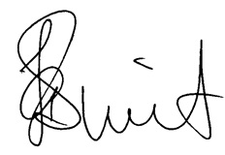

_______________________________­­­­___­­­__

A/Prof. Albertus J. Smit