**Manual**

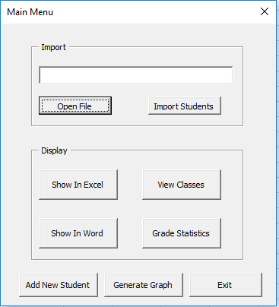

**Import (To import Students):**

Open File – This will bring up a file dialog to pick a csv file where students and grades can be imported

Import Students – Once the file has been opened and the directory of it is in the text box, then import the students to insert them into the database

**Display (To Display information):**

Show in Excel – This will write all information about students and their grades inside the database to the “Grade View” worksheet

Show in Word – This will write the same information as the excel sheet to a word document  
 View Classes – A list will appear of all the course ID’s, codes, and names and show which ID’s correspond to each code and name

Grade Statistics – Two lists will appear where you must pick between a course and one of the assignments/ tests. Then you can display Statistics, where it will show the highest, the lowest and the average grade.

**Add new Student:**

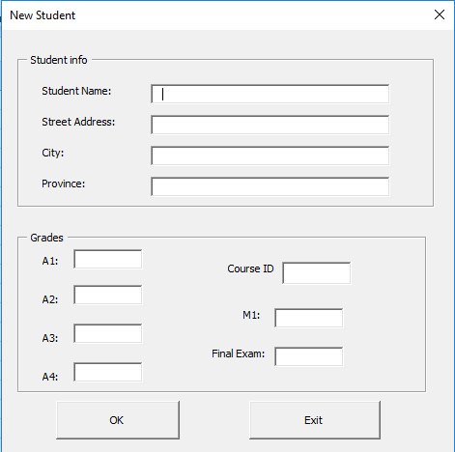

Adding a new student brings up this user form where all the information can be added in the shown boxes. Then Pressing ok will add a new student

**Other:**

Exit- Closes the main menu

Generate Graph – Not fully functional yet, pressing it does nothing