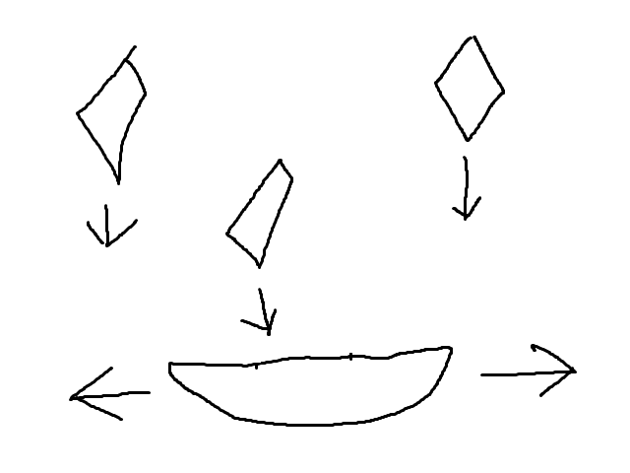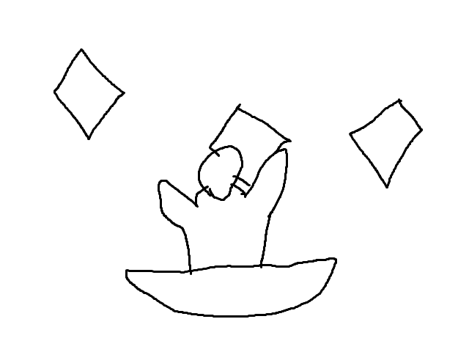

The player must move left and right to catch the falling objects. Pressing space causes the pirate to reach out and grab.

Music: Game theme music plays. Sound Effect: Short jingle plays

Props: Falling objects Props pirate object reaches out to grab

Characters: Player boat